Welcome to the College of Engineering and Mathematical Sciences!
We are a community of students, faculty, teaching assistants, and staff, working together to address complex problems for the betterment of humankind. We educate students to be leaders in their professions and their communities.
We appreciate the many views and backgrounds that our students bring to the classroom and the open and active curricula allows for numerous pathways toward desired learning outcomes. Our students view each other as collaborators, not competitors, and both graduate and undergraduate students work on cutting edge research with our faculty.
CEMS students graduate and work in jobs that can critically impact people’s lives. As such, standards of the highest integrity are critical. We embrace Our Common Ground and expect that everyone in our community treats each other with respect. We all take responsibility for our actions, and we encourage open and constructive communication that helps improve the environment and success of our community of scholars.
This guide is an articulation of our collective desire to model professional behavior in CEMS. It is consistent with the University of Vermont Student Code of Conduct. We hope it helps us maintain our pathway to success, inclusion, and improve quality of education.

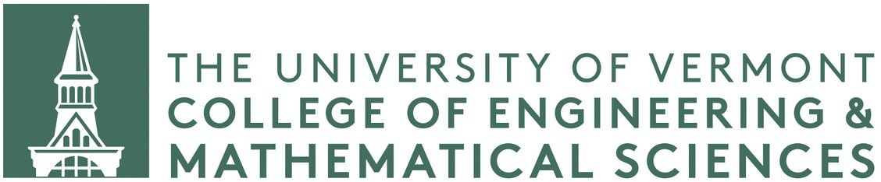
THE CEMS COMMUNITY

Faculty, staff, and students are expected to conduct themselves in an ethical and professional manner. As a result, we expect students to:
- Put forward their best effort academically and reach out for help with their coursework when they need it. The faculty and teaching assistants are committed to helping.
- Meet at least twice a year with their faculty advisor to ensure they are on a pathway to success and to gather mentoring advice.
- Model Our Common Ground.
- Interact with each other and faculty in a respectful manner. This includes communication by email or in person. Constructive feedback is always welcome.
- Refrain from behavior that substantially or repeatedly disrupts the classroom or learning environment.
- Uphold the University’s policy on discrimination, harassment and sexual misconduct.
- Familiarize themselves with the professional code of ethics for their chosen field. Below are some examples:
  - Engineering
  - Mathematics
  - Statistics
  - Computer Science
ACADEMIC INTEGRITY

Paramount to our success as a community of scholars is academic integrity. All students are expected to follow The University of Vermont Code of Academic Integrity [PDF] and to ask questions if they are unclear about expectations.

- The standards for academic honesty and integrity apply to all students enrolled at the University of Vermont in any work performed in furtherance of a particular course or course of study.
- The principal objective of The University of Vermont Code of Academic Integrity [PDF] is to promote an intellectual climate and support the academic integrity of the University. Academic integrity is an essential part of learning at UVM.
- Violations of the Code of Academic Integrity [PDF] are serious offenses and will not be tolerated.
- Suspected violations of the Code will be forwarded to the Center for Student Conduct. Please also reference the information on the Center for Student Conduct webpage.

ADDRESSING CONCERNS RAISED BY STUDENTS
If a student has a concern about unprofessional or inappropriate conduct by another member of the UVM community, the following are several avenues available for reporting and support.
- If a student feels they have been harassed or been the victim of any of the policies addressed above, they should immediately report the incident to their Department Chair, Director of Student Services, or the Dean, who will assist them with reporting to the appropriate University office. Students can also report directly to the UVM office of Affirmative Action and Equal Opportunity by filling out an AAEO and Bias response reporting form (discrimination, harassment, sexual misconduct, and incidents of bias), Center for Student Conduct incident form (violations of the Code of Student Conduct), or the UVM Police incident reporting form (violations of criminal law and safety).
- If you are concerned about a UVM community member or are concerned about a specific event and are looking for support, students can fill out a CARE form, which will be submitted to the Dean of Students Office.
- For other concerns, students should discuss their concerns with the relevant party. Meeting directly with the person whose policy or action is in question is always the best first step since it addresses the concern where it arises.
- Discuss concerns with their advisor. Staff and faculty advisors are always happy to meet with students and discuss a range of issues and concerns.
- Discuss concerns with the Department Chair. The Department Chairs are available to meet to discuss concerns that you may have about any aspect of your program.
- Contact the Office of Student Services in the College of Engineering and Mathematical Sciences at cems.student.services@uvm.edu, 802/656-3392.
- Request a meeting with the Director of Student Services or the Dean to share concerns and discuss possible solutions. This step represents an action that goes beyond the Department and might be helpful for issues concerning basic Department policies that may differ from the College guidelines, or if you believe the Department mechanism would not be sufficient. To request a meeting, e-mail Matthew.Manz@UVM.EDU.
- Students with a grievance about a course grade should follow the instructions outlined in the UVM Grade Appeal Policy.
- Please note, in some circumstances, depending on the nature of the concerns shared, University faculty and staff may have an obligation to notify additional University offices of the behavior or concerns raised to ensure appropriate response and supports are offered. Before doing so, UVM faculty and staff will make the student aware of the need to share information. Examples of such concerns include allegations of discrimination, harassment, sexual misconduct, and criminal behavior.

ADDRESSING STUDENT BEHAVIOR OF CONCERN
In the event that faculty or staff become concerned about a student’s behavior, students should know that faculty and staff may:
- Engage with the student to discuss the concerning behavior either through email, Navigate, or a dedicated and documented meeting to communicate the need for the student to discontinue the concerning behavior and resolve any associated issues, especially when those issues disrupt the classroom and/or learning environment.
- Communicate the issue to the Department Chair or Dean.
- Submit a CARE report and inform CEMS Student Services.
- If the faculty or staff member is concerned for their own or the student’s safety, they will call UVM police services, and contact their Department Chair and the Director of Student Services.
- File an incident report with the Center for Student Conduct or the Office of Affirmative Action and Equal Opportunity, as applicable, for consideration of policy violations.

