Oxidative Stress / H₂O₂ treatment

Defense mechanisms in Saccharomyces cerevisiae:
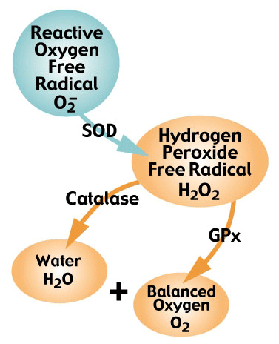
Aerobic organisms utilize oxygen, so they have developed defense mechanisms to combat the effects of Reactive Oxygen Species (ROS).

Oxidative Stress: When the concentration of ROS present in the cell exceeds the capacity of the cells ability to detoxify or to repair damages

Oxidative Stress: H₂O₂ Overload
When the H₂O₂ exceeds the capacity of Catalase and Gulathione peroxidase, it can be reduced to form a hydroxyl radical ·OH.
The hydroxyl radical is highly reactive and can lead to:
DNA Degradation
Protein Peroxidation
Lipid Peroxidation

SOD: Superoxide dismutase GPx: Glutathione peroxidase
http://www.fluidessentials.com/images/glisodin-chart.gif
Hydrogen Peroxide is formed from an oxygen radical and considered to be an (ROS) because it has the ability to form ·OH in the presence of metal ions.

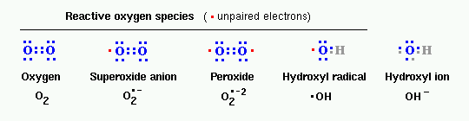
http://www.vivo.colostate.edu/hbooks/pathphys/misc_topics/ros.gif

