

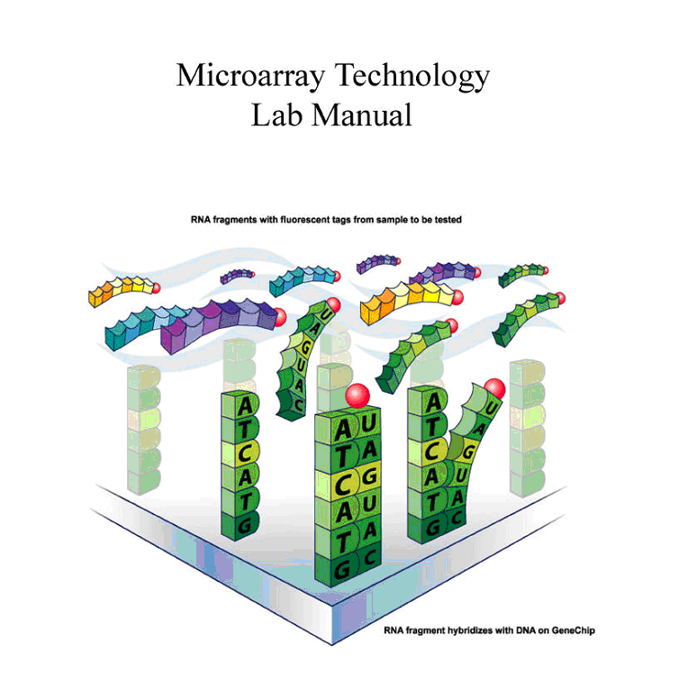

Instruction Team:

Scott Tighe, Tim Hunter, Pat Reed, and Janet Murray

Manual Version pombe 09182007st-fujitsu

Overview

In this module, students will learn how gene expression in yeast (Schizosaccharomyces pombe) is changed after exposure to oxidative stress caused by the addition of hydrogen peroxide (H₂O₂), an oxidizing agent. Experimentally, the yeast will be grown for 48 hours in 1/2x YPD broth containing 3x glucose. The culture will be split into a control and treated group. The control will be exposed to Hanks Buffered Saline Salt (HBSS) only, while the treated yeast are exposed to 0.5mM H₂O₂ for 1 hour. RNA will be extracted and prepared for use on Affymetrix® GeneChips. The final synthesis product is taken back to the UVM Microarray Core Facility and hybridized to the yeast GeneChips. The resulting gene expression data will be uploaded into special bioinformatic data analysis software where students are taken through complex data analysis procedures.
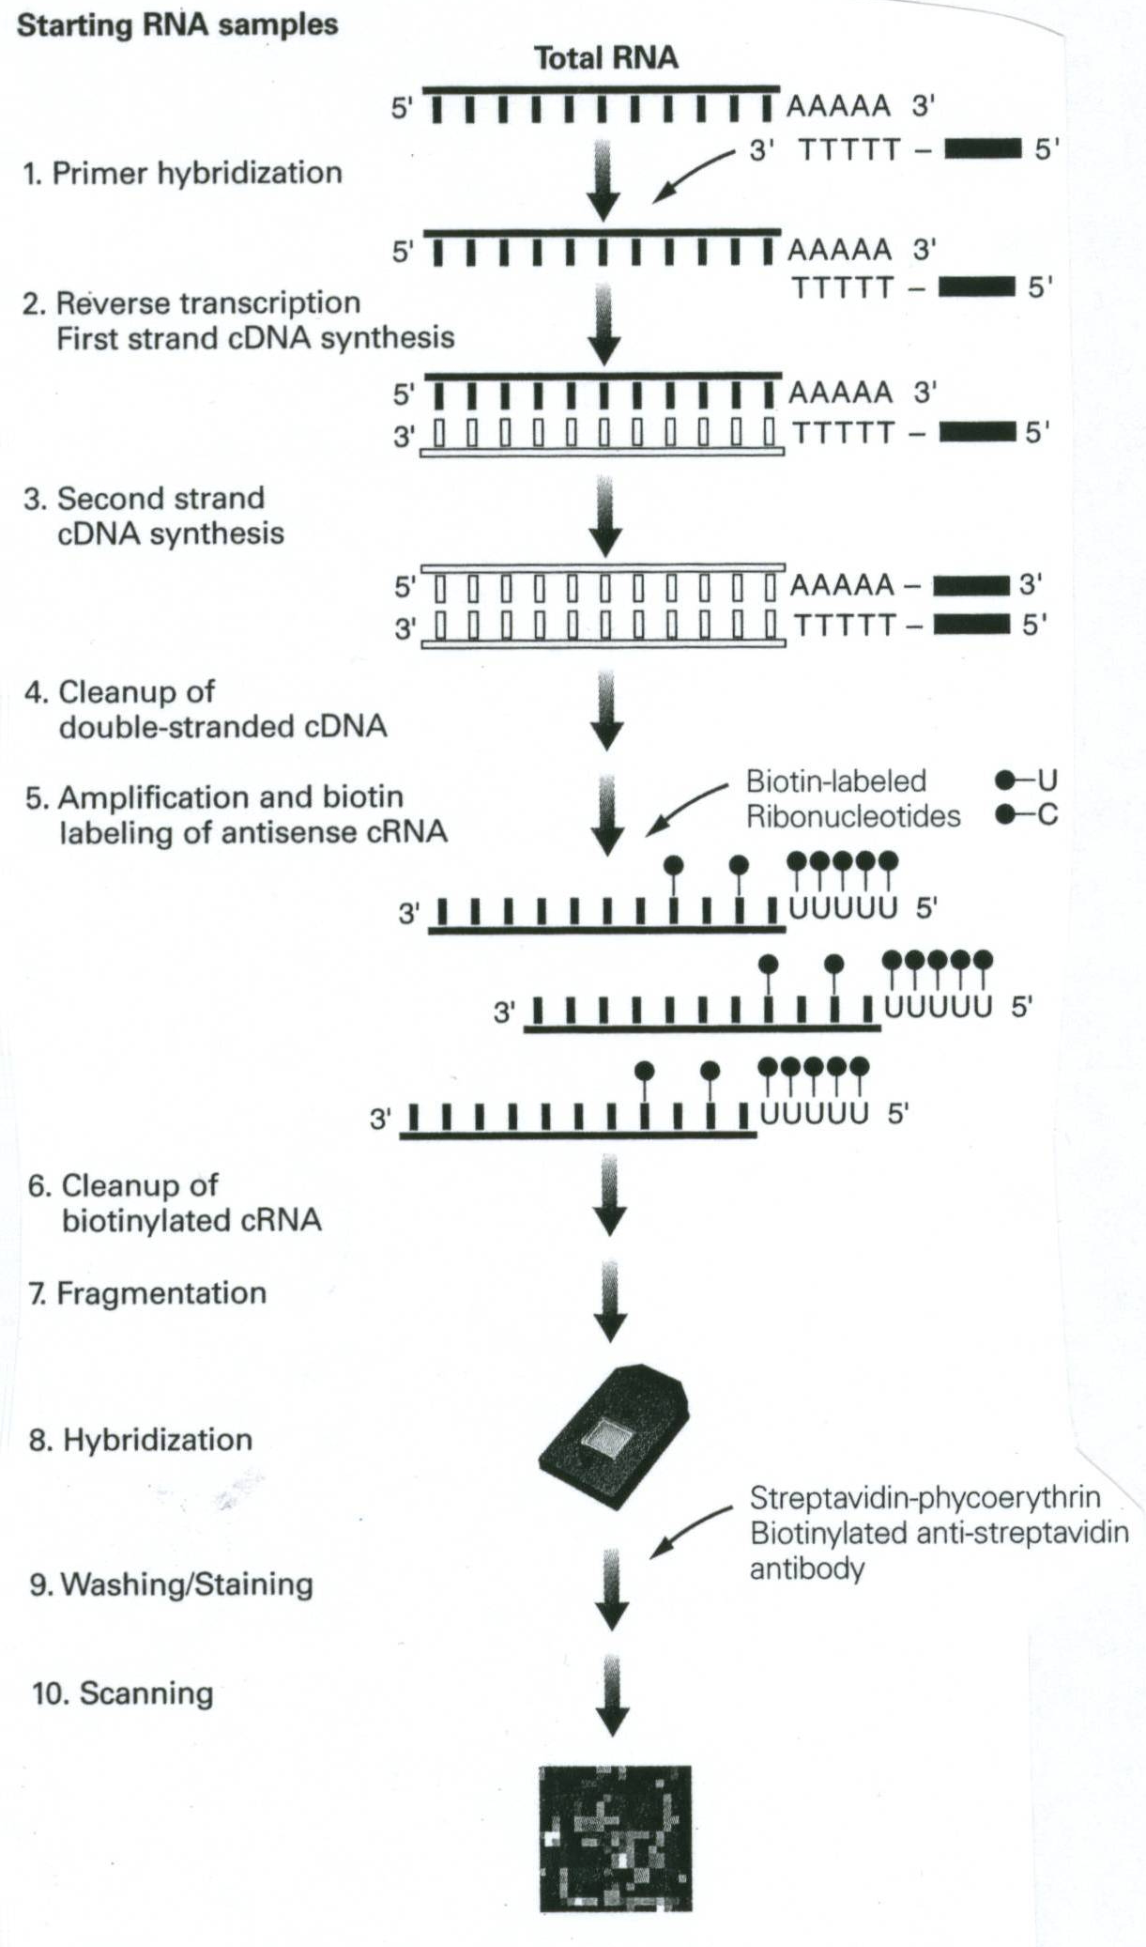

Special Notes- Important!

1] RNase-free water is DEPC water and the terms maybe used interchangeably throughout the protocol.

2] Record all data in notebooks.

3] Label the tops and sides of tubes with:
Sample ID/Initials
Date
What is in the tube…ie cDNA, RNA, etc.
Concentration

4] Check off boxes on the lab manual as you go.

5] Read Technical Discussion section before each day. This is fair game for quiz questions.

6] MSDS safety sheets are available for each chemical in the front of the room.

7] RPM on a Centrifuge does NOT equal G-force. See the conversion chart below
8] Use RNase Zap anytime you want, better safe then sorry!

Microarray Data Sheet

Name:____________________ Sample ID(used on tubes):_________________Date:______________

Sphearoplast generation with SDS:_____________

1) Total RNA data:

Spec conc:_____________260/280:__________Agilent Bioanalyzer Quality:_______________

2) cDNA synthesis and clean-up:

Vol RNA used: _________ μg RNA used^{[B]} ___________Resuspension Volume________ Visible Pellet_________

3) RNA InVitro transcription:

Volume of cDNA used in IVT reaction: ________

4) cRNA clean-up:

Final resus. vol^{[C]}: __________ Concentration: ____________ Total amt RNA(μg): ____________^{[A]}

Final Adj RNA concentration: _________________ Formula= A-B/C

5) cRNA Fragmentation:

Amt Fragmented:___________ Conditions:___________

Attach Gel images and Spec data below

Set-up before day 1: Instructor

Note: The broth culture must be inoculated about 48 hours before the treatment procedure of day 1 with a log phase culture of the yeast [See appendix A].
Note : The H2O2 treatment procedure must be performed 0.5 hour before class

Protocol for Preparing Yeast Cultures for Microarray Analysis
(3-4 days prior to day 1)

Necessary Supplies
Autoclave (tape, tinfoil)
Inoculating loop (or sterile swabs) and Bunsen burner
Sterile flasks containing stir bars that are the same size: (1) 1000 ml flask, (2)125 ml flasks
(2) Stir plates
5 and 25 ml pipets (sterile) Tape and sharpies for labeling

Supplies provided by VGN
Yeast Stain Schizosaccharomyces pombe [NRRL Y-128 or ATCC38366]
1/2xYPD+3x glucose nutrient media (modified powder –Fisher Scientific-This is pre-made by VGN staff. (12.5gram YPD powder+10g glucose+500ml water)
30% Hydrogen Peroxide (H₂O₂)
Sterile DI Water
HBSS without Ca, Mg, or dye

Notes:
The broth culture must be inoculated 48 hours before the treatment procedure of day 1. Incubation should be conducted in a room that is 70-80°F. It is best to inoculate this culture from a pre-culture that is in log phase.

Plan the treatment of the cultures so that the 1 hour treatment is complete 30 minutes AFTER the start of class on Day 1.

Please read through all instructions before proceeding.
______________________________________________________________________________________________________________________________________________________________________________________________________________________________________________________________________________________________________________________________________________________________________________________________________________________________________

A) Making the growth media and sterilizing [2] 500 ml flask with stir bars.

____1) Prepare 500 ml of 1/2x YPD-3x Glu broth [this powder is premade] in a 1000ml flask (use 22.5gm/500ml). Place a stir bar in the flask, wrap tin foil loosely around the top, label the flask, and autoclave under standard conditions (15 psig at 121°C) for 15 minutes.
_______________________________________________________________________________________________________________________________________________________________________________________________________________________________________

____2) Also autoclave (2) 125 ml flasks each containing the same size stir bar. Wrap top in foil.
_______________________________________________________________________________________________________________________________________________________________________________________________________________________________________

It is important not to autoclave LONGER than 15 minutes as the sugars will caramelize and degrade.

B) Inoculating the parent culture

____1) Remember to use sterile technique throughout procedure. Bacterial contamination will be undetectable throughout the rest of the experiment and will adversely affect the final results.
__________________________________________________________________________________________________________________________________________________________

____2) The parent culture should be inoculated 48 hrs before class of day 1 from a log phase pre-culture. See appendix A. Use a good size inoculum!!
__________________________________________________________________________________________________________________________________________________________

____3) Wearing gloves, aseptically transfer a colony of an actively growing yeast using an inoculating loop to the broth. Alternatively, if a liquid pre-culture is used, a 500 μl aliquot can be transferred to the new media using a P1000 micropipet with a sterile aerosol resistant tip.
________________________________________________________________________________________________________________________________________________________

____4) Uncap and tilt the 500 ml flask at a 30 degree angle [or so] and inoculate the 1/2x YPD-3x Glu broth .
__________________________________________________________________________________________________________________________________________________________

Remember that you want to minimize the time the flask is open AND you do not want your hands or sleeves over the flask opening. Broth is easily contaminated and it will not be possible to detect this until the very end of the experiment.

____5) Flame the mouth of the flask and place the tinfoil cap back on the flask. Replace the tinfoil around the mouth of the flask, but not too tightly as it is necessary for oxygen to get in. It is important that the yeast grow aerobically as respiration is the metabolic process that builds cell mass.

____6) Place flask on stir plate and stir approximately 48 hours at a medium speed at room temp (22-25°C). Do not have the speed so high that there is foaming.

C) Treatment of yeast cultures (must be started 0.5 hr before class on day 1)

____1) From the 48 hour old culture, aseptically transfer 40.0 ml of the broth culture into two (2) sterile 125 ml flasks each containing a stir bar using a sterile 50 ml pipet.
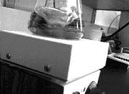
____2) Label one flask as “treated” and aseptically add enough H₂O₂ from the “working stock" to achieve a final H₂O₂ of 0.5mM [See below]. Label the control flask as “control” and add an equal amount of HBSS as you did H₂O₂.

Preparing and Determining the Concentration of H₂O₂

Preparation of H₂O₂ Stock Solution: Combine 5.0μL of 30% H₂O₂ and 495 μL of Hanks Balanced Saline Salt [HB without phenol red, Mg, or Ca. Vortex.

Working H₂O₂ solution : Make a 1:10 dilution by combining 100μL H₂O₂ stock solution with 900μL HBSS and vortex. Use this for spectrophotometer measurement and for the experiment.

Blank the spectrophotometer with HBSS

Measure the absorbance at 240nm.
Concentration of H₂O₂ in Working Solution : (Ab₂₄₀) x 229 = ____mM of H₂O₂ [B].
Example: H₂O₂ to add to 40 ml flask= A/B x 40ml x1000 = ul of working solution to use in experiment
Where A=0.5mM B=your concentration in working solution

____3) Place each flask on separate stir plates and stir at room temperature for 1 hour at [as close as] the same speed as possible. Cultures should be ready for harvest 30 min after the start of the first class period. Therefore, H₂O₂ is added 30 minutes before the start of the class.

DAY 1
Isolating Total RNA from the Yeast, Schizosaccharomyces pombe, Using Enzymatic Lysis Protocol.

Technical Overview:

Today we will be treating the yeast Schizosaccharomyces pombe (a haploid fission yeast) with hydrogen peroxide [H₂O₂] to understand the gene expression effects during oxidative stress conditions in this simple eukaryote. The H₂O₂ treated yeast, and an untreated control will be lysed using a combined procedure employing a lyticase enzyme and a buffer containing guanidinium isothiocyanate after the 1-hour treatment procedure. The first step uses lyticase which degrades the poly-β-1,3 glucan bonds in the cell wall of fungi, resulting in the formation of spheroplasts (a fungal cell without a cell wall). The second step uses RLT buffer (guanidinium isothiocyanate) that ruptures the cell membrane thereby allowing recovery of total RNA on a common silica gel spin column manufactured by Qiagen.

Please read through all laboratory procedures prior to lab.

The Silica Column Chemistry

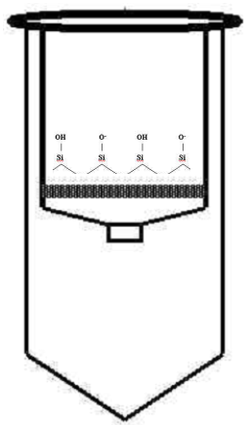
Guanidium isothiocyanate (GITC or GSCN) is a chaotropic salt at about 5 M in the RLT buffer. This solution at a reduced pH (6.4) and used in conjunction with ethanol and water disrupts the molecular characteristics of water and forces the RNA to be less soluble. This promotes nucleic acids to electrostatically bind to the silica. A stoichiometric balance of GITC, ethanol, pH, and water controls the binding of either RNA or DNA to the silica. Therefore, changes in this stoichiometry will select a majority of either one or the other. This not a 100% selective procedure and DNase treatment is required. The use of ethanol in rinse RPE buffer maintains the bond between the silica and RNA. The recovery of RNA off the membrane is accomplished with water because RNA is very soluble in water and can no longer maintain an electrostatic bond with the silica once the water structure has been re-established.

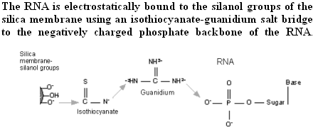

Isolating total RNA from Schizosaccharomyces pombe using Enzymatic Lysis

Materials:
Axygen MCT150C 1.7ml tubes
P1000, P200, and P20 pipets
Yeast Lytic Enzyme-VWR # IC15352710-MP Biomedical 153527-10,000 units)
100 % Ethanol
DEPC water (aka RNase-free water)
Qiagen Mini RNeasy kit
Qiagen DNase Kit
Vortex
Microcentrifuge
Spectrophotometer
Eppendorf UVettes
2 ml microcentrifuge tubes
2% SDS

____1. Prepare an RNase-free work zone. This will be demonstrated by the instructor.
__________________________________________________________________________________________________________________________________________________________________________

____2a. Prepare fresh lytic enzyme at 10 Units/μl by adding 1 ml of DEPC water directly to the lyticase vial. Vortex well and invert several times to insure complete mixing. This solution is stable for 12 hours.
Instructor will perform this task.

10,000 U Lyticase
1 ml DEPC Water
__________________________________________________________________________________________________________________________________________________________

____2b. Prepare fresh DNase I solution using the Qiagen DNase kit and store on ice.

__________________________________________________________________________________________________________________________________________________________
Instructor will perform this task.

10 μl DNase I
70 μl Buffer RDD
80 μl per reaction

____3. Spin down 1.5 ml of yeast culture at 8000x g for 2 minutes using an Axygen 1.7 ml tube in a microcentrifuge at room temperature.

____4. Carefully remove supernatant (without disturbing pellet) using a P1000 micropipet, discard supernatant

. **** Repeat step 3 if cell pellet size is too small or if indicated by instructor.****
_________________________________________________________________________________________________________________________________________________________________________

____5. Add 1 ml of sterile DEPC water, vortex, and spin again at 8000 x g for 2 minutes, and then remove and discard supernatant. This time be sure to remove as much of the liquid as possible from the yeast pellet. You may need to use a smaller pipet to get any remaining liquid.
________________________________________________________________________________________________________________________________________________________

____6. Add the following to the yeast pellet and gently vortex: SG buffer 100 μl Lyticase solution (10U/μl) 30 μl

____7. Incubate for 30 min at room temp (22-25°C).

____________________________________________________________________________________________________________________________________________________________

____8. Gently swirl tube every 10 minutes to generate spheroplasts. Spheroplasts must be handled gently. [optional] …Check sphearoplasting by placing 10ul of cells on a slide with 10ul of 2% SDS. These and can be swirl mixed with a pipet tip right on the slide.
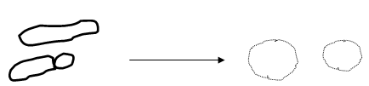

__________________________________________________________________________________________________________________________________________________________

____9. Add 350 µl b-RLT buffer to lyse spheroplasts and vortex vigorously for 1 minute. Ensure your tube is tightly capped by holding lid closed while vortexing.
__________________________________________________________________________________________________________________________________________________________

____10. Add 250 µl of 100% ethanol to the tube and briefly vortex. Do not centrifuge. A precipitate may form after the addition of ethanol, but this will not affect the RNeasy procedure.
________________________________________________________________________________________________________________________________________________________

____11. Apply the entire sample to an RNeasy mini column. Close the tube gently and centrifuge for 15 sec at full speed.
________________________________________________________________________________________________________________________________________________________

____12. Discard the flow through tube and place the RNeasy column into a new 2 ml capture tube.
________________________________________________________________________________________________________________________________________________________

____13. Add 350 µl RW1 buffer to the RNeasy column to wash the column. Close the tube gently and Centrifuge for 15 sec at full speed.
__________________________________________________________________________________________________________________________________________________________________________

____14. Apply 80 μl of DNase I solution to the middle of the Qiagen column membrane. Incubate at room temp for 15 min.
__________________________________________________________________________________________________________________________________________________________________________

____15. Transfer RNeasy column to a new 2 ml capture tube.
________________________________________________________________________________________________________________________________________________________________________

____16. After the 15 minute incubation, add 350 μl RW1 buffer to the RNeasy column and spin at full speed for 15 seconds.
__________________________________________________________________________________________________________________________________________________________________________

____17. Discard the flow through tube and place the RNeasy column into a new 2 ml capture tube.
__________________________________________________________________________________________________________________________________________________________________________

____18. Pipet 500 µl RPE buffer onto the RNeasy column to wash the column. Close the tube gently and centrifuge for 15 seconds at full speed.
__________________________________________________________________________________________________________________________________________________________________________

____19. Discard the flow through tube and place the RNeasy column into a new 2 ml capture tube.
_________________________________________________________________________________________________________________________________________________________________________

____20. Add another 500 µl RPE buffer to the RNeasy column. Close the tube gently and centrifuge for 15 sec at full speed.
__________________________________________________________________________________________________________________________________________________________________________

____21. Place the RNeasy column in a new 2 ml capture tube and centrifuge in a microcentrifuge at full speed for 1 minute to “dry” the silica membrane.
__________________________________________________________________________________________________________________________________________________________________________

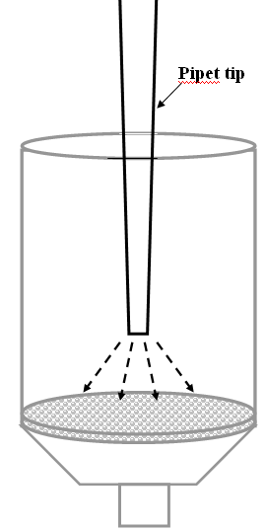
____22. To recover the RNA, transfer the RNeasy column to a new 1.7 ml microcentrifuge tube. Pipet 30 μl of DEPC water directly onto the very center of the RNeasy silica-gel membrane DO NOT TOUCH THE SILICA GEL MEMBRANE. Look closely as you perform this step. Use both hands when pipeting, one on top and one down by the tip to guide the pipet. Make sure the water was evenly distributed on the membrane.
________________________________________________________________
________________________________________________________________

____23. After allowing the water to incubate on the membrane at room temp for 1 minute, centrifuge at full speed for 30 seconds. ________________________________________________________________________________________________________________________________________________________________________

____24. Carefully remove the 30 μl which is recovered in the 1.7 ml tube and pipet it back onto the center of the silica membrane of the same column. Place column back in to the same 1.7 ml tube and spin again for 1 minute at full speed. This double elution ensures that the entire membrane was extracted.
__________________________________________________________________________________________________________________________________________________________________________

____25. Transfer the recovered RNA to a new 1.7 ml tube and label it with date, sample name, and what it is. Write clearly!!
__________________________________________________________________________________________________________________________________________________________________________

____26. Transfer 4 μl of RNA to a new tube for transport back to UVM for Nanodrop quantification and RNA assessment. Label this tube carefully with date, name, and RNA.
__________________________________________________________________________________________________________________________________________________________________________

____27. Keep the samples on ice and quantify samples using the spectrophotometer at a 1 to 50 dilution (1μl sample + 49μl H2O). This will be demonstrated by the instructor.

[Sample concentration:_________ ] [Write this on your tube]

__________________________________________________________________________________________________________________________________________________________

____28. Evaluate the RNA by agarose gel electrophoresis . This will be done as a class. Pre-run the gel for 2 minutes and turn off. Add 14 μl of water to each well on the E -gel. Add 1μl of each sample to each well and pipet up and down to mix. Run the gel for 20 minutes.
__________________________________________________________________________________________________________________________________________________________________________

____29. Samples should be labeled properly for return to UVM and analyzed using the Agilent Bioanalyzer 2100. This instrument is used to determine the condition of the RNA. Only fully intact RNA is eligible for microarray analysis. Why?

RNA Analysis using the Agilent 2100 Bioanalyzer

The Agilent bioanalyzer 2100 is an automated instrument that employs the use of Lab-on-a-Chip technology for analyzing RNA. This provides highly resolved data regarding the integrity of the RNA. The system is similar to an agarose gel where RNA is added to a well containing a gel and high-resolution electrophoresis is conducted through microfluidic channels. The use of an intercalating dye allows the RNA to be detected with an Nd-YAG diode-pumped laser.
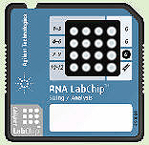
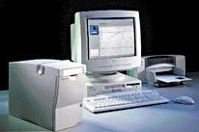

DAY 2
Microarray Target Preparation- cDNA synthesis

Technical Overview:

Today you will be starting to prepare the target for the Genechip analysis. This is a lengthy procedure and will be broken down over several lab periods. In short, you will be starting with mRNA, which comprises 0.5-2% of the total RNA in typical eukaryotic cells. First, you will generate the first complementary DNA (cDNA) strand from the mRNA. This is called the first strand cDNA synthesis. This step utilizes a primer with a sequence of 24 T's in a row and is called oligo d(T), which binds to the poly A tail of eukaryotic mRNA. The primer also contains the consensus-binding site for T7 RNA polymerase (T7 promoter sequence). Once the primers have been hybridized to the poly-A mRNA, reverse transcriptase is added and the first strand of cDNA is synthesized. It is important to note that the 5s, 5.8s, 18s, and 25s rRNA do not have a poly-A tail and will not be primed or synthesized in this procedure.
The sequence of T7 Oligo d(T)24 is:

The next step in the cDNA reaction is the synthesis of the second cDNA strand from the first cDNA strand. This is done by adding RNase H, DNA polymerase I, and DNA ligase. The RNase H causes many strand nicks in the phosphodiester bonds of the bound mRNA strand creating the availability of 3'OH groups. DNA polymerase uses these 3’ OH groups as a priming site; thus synthesizing another cDNA strand until it reaches another nicked site. The DNA polymerase can only displace RNA, not DNA. After cDNA has been synthesized from all the nicks, the areas between the nicks need to be filled in or ligated. This is accomplished using DNA ligase. After the two hour synthesis process, all the RNA has been replaced with cDNA and ligated to form one large cDNA strand. However, because the DNA polymerase does not synthesize completely to the end of the strand, a T4 DNA polymerase is added. This ensures the synthesis of the T7 promoter site from the original T7 oligo d(T) primer used in the first synthesis reaction.

Synthesis of cDNA:

The starting material for your target preparation will be high quality, fully intact, total RNA from yeast. The minimum concentration to start with is 100-270 ng/μl. After isolation and purification of the yeast RNA, the concentration is determined by absorbance at 260 nm on a spectrophotometer (1 O.D.= 40 µg/mL RNA). The A260/A280 ratio should be approximately 1.8-2.1. We are checking the quality of the RNA by running an aliquot on the Agilent Bioanalyzer 2100 (performed prior to class at UVM core) and running on an agarose gel (EGEL) prior to starting the assay. More appropriately, a denaturing formaldehyde gel would be used, but we will not have time to perform this.

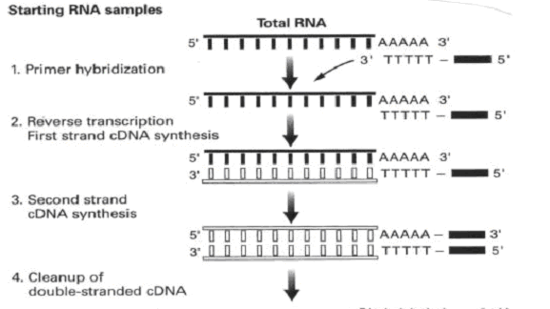
Overview of cDNA Synthesis Reactions
DAY 2
Microarray Target Preparation- cDNA synthesis

First Strand cDNA Synthesis

Note: Spin all reagent tubes before starting as some have only 1 μl in them!!!!

____1. Adjust 1-3 μg (determined by instructor) of RNA to 11μl with DEPC water in a RNase-free 0.5ml tube. Keep the tube on ice.
_______________________________________________________________________________________________________________________________________________________________________________

____2. Primer Hybridization: Combine the following reagents, vortex, and spin in microcentrifuge [full speed] for 5 second and put in a thermocycler at 70°C for 10 minutes.

T7 oligo d(T)24 2μl
RNA(1-3 μg) 10μl →Incubate 70°C 10 min. then
place on ice.
_______________________________________________________________________________________________________________________________________________________________________________

____3. While the 70C incubation is in progress prepare the following master mix. Add the following reagents IN ORDER to make the first strand master mix. Vortex and spin in microcentrifuge [full speed] for 5 second and place on ice.

First Strand Buffer 5X 4 μl
0.1M DTT 2 μl
10mM dNTP 1 μl
Superscript II 1μl

_______________________________________________________________________________________________________________________________________________________________________________

____4. After the 70C step, add the master mix to the RNA primer tube and incubate in a thermocycler at 42°C for 60 minutes. After the incubation, place on ice. During this incubation, prepare the second strand master mix.
_______________________________________________________________________________________________________________________________________________________________________________

Second Strand cDNA Synthesis

____1. Make the following master mix in a separate tube. Keep it on ice. All tubes may need to be centrifuged to get the contents to the bottom of the tube because some tubes only contain 2ul of enzyme!

DEPC Water 91 μl
Need a P2 micropipet for some of these enzymes.
5x Second Strand Buffer 30 μl dNTP(10mM) 3 μl E.coli DNA Ligase (10U/μl) 1 μl E.coli DNA Polymerase I (10U/μl) 4 μl
E.coli RNase H (2U/μl) 1 μl
Total volume to be added to First Strand tube 130 μl

____2. Vortex master mix and perform a 5 second quick spin in the microcentrifuge [full speed].
_______________________________________________________________________________________________________________________________________________________________________________

____3. Add this 130 μl second strand master mix to first strand tube after the 42C incubation. Vortex and perform a 5 second quick spin. Incubate for 2 hours at 16°C in thermal cycler.

_______________________________________________________________________________________________________________________________________________________________________________

The next two steps may be performed by the instructor

____4. At the end of 2 hours and while the sample is still at 16°C, add 2μl of T4 DNA polymerase and incubate for exactly 5 minutes. Mix well. Do not incubate longer then 5 minutes or the quality of the cDNA may decrease due to the 3’ to 5’ exonuclease activity of the polymerase.
_______________________________________________________________________________________________________________________________________________________________________________

____5. At the end of the 5 minute incubation, add 10 μl of 0.5 M EDTA to stop the reaction. Store sample at -20°C.
_______________________________________________________________________________________________________________________________________________________________________________

Day 3
Cleaning the cDNA and setting up the IVT

Technical Overview:

Cleaning the cDNA:

After synthesis of the cDNA, it will need to be purified before proceeding to the next step. This will be accomplished using a solution of phenol-chloroform-isoamyl alcohol (PCI) at a specific pH. The underlying principle is that both phenol and chloroform cause proteins/enzymes to become denatured and subsequently soluble in the organic phase, while the cDNA will remain in the aqueous phase. This is performed by mixing the cDNA sample with PCI and transferring the full volume to a phase lock gel tube. The phase lock gel tube is centrifuged allowing separation of the aqueous and organic phases with a gel barrier. This allows for easy recovery of the cDNA in the aqueous phase. It is important to note that the pH of the PCI is important because this will determine which layer the cDNA will be retained in (the aqueous or organic phase). To ensure the cDNA is in the aqueous phase, the pH of the PCI needs to be basic, which is accomplished through a layer of TRIS pH 8.3 over the PCI solution.

The aqueous phase is further purified through a precipitation step using ethanol [an alcohol] and ammonium acetate [a salt]. Because DNA is negatively charged, salt is used to mask the charge, causing it to precipitate. The ethanol is used in conjunction with the salt because it is non-polar and DNA will not readily dissolve in it. This reaction is sometimes done at -20°C to encourage maximum DNA precipitation. After the precipitation, the cDNA is centrifuged to a pellet with a visualization agent called Pellet Paint, an additive that contains glycogen (a co-precipitate) and a dye. This helps form a high quality visible pellet on the bottom of the tube. The pellet is then washed several times with 80% ethanol, dried, and resuspended in DEPC water.

The In vitro Transcription (IVT):

The IVT step uses the T7 promoter site that is attached to the T7 Oligo d(T)24 primer used in the first strand cDNA synthesis. A T7 RNA polymerase binds to this site and copies the opposing cDNA strand, synthesizing an antisense cRNA using the two standard nucleotides, A and G and two modified nucleotides; biotinylated uracil and cytosine. This generates a complementary cRNA [antisense] strand to the original mRNA with biotinylated nucleotides. These biotinylated nucleotides will be needed in the next step for staining of the RNA using strepavidin phycoerytherin.

Safety Considerations for Phenol Chloroform Isoamyl:

Note: Phenol Chloroform Isoamyl Alcohol is at a ratio of 25:24:1 and saturated with 10 mM Tris- HCl pH 8.3. Phenol is an organic acid and care must be used when handling. Phenol can burn skin and be absorbed into the circulatory system and cause health problems. Chloroform is an organic solvent and should be used in a hood.

Phenol
– Corrosive
– Local anesthetic
– Can severely damage eyes and skin
– Can cause severe burns of the skin and eye
– Poisonous if ingested-can be fatal

Chloroform
– Can cause irreversible corneal injury
– Fatal if swallowed
– Flammable

Isoamyl Alcohol
– Flammable
– Poisonous

Day 3
Precipitating the cDNA

____1. Centrifuge a Phase Lock Gel tube at full speed for one minute. DO NOT VORTEX.
_______________________________________________________________________________________________________________________________________________________________________________

____2. Add 162 μl of the bottom layer from the Phenol Chloroform Isoamyl Alcohol (PCI) to the cDNA synthesis reaction and vortex for 2 seconds. Hold cap tightly as leaking can occur during the vortex.

Note: PCI tends to leak out of the pipet so work quickly.
_______________________________________________________________________________________________________________________________________________________________________________

____3. Transfer the cDNA-PCI mixture to the phase lock gel tube. DO NOT VORTEX the phase lock gel tube.
_______________________________________________________________________________________________________________________________________________________________________________

____4. Centrifuge at full speed for 2 minutes.
_______________________________________________________________________________________________________________________________________________________________________________

____5. Transfer the top layer to a 1.7 ml microcentrifuge tube.

_______________________________________________________________________________________________________________________________________________________________________________

____6. Add the following to the 1.7 ml microcentrifuge tube and vortex.

Ethanol (100%) 405 μl
NH4OAc (7.5M) 80 μl
Pellet Paint 1 μl

_______________________________________________________________________________________________________________________________________________________________________________________________

____7. Centrifuge at 12000 x g [full speed] for 20 minutes at room temp.
_______________________________________________________________________________________________________________________________________________________________________________

____8. GENTLY remove the tube from the Centrifuge being careful not to disturb the cDNA pellet. The pellet should be pink and approximately the size of a grain of salt. Put on ice and immediately proceed to next step. Keep your tube on ice.

Is there a pellet?____________
**At this point a tiny pink visible pellet should be present on the bottom of the tube. If not, see the instructor.**

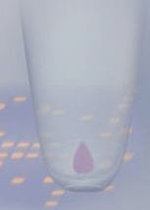

______________________________________________________________________________________________________________________________________________________________________________________________________________________________________________________________________________________________________________________________________________________________

Cleaning the cDNA Pellet:

____1. Using a micropipet, carefully remove the liquid from the tube being very careful not to disturb the pellet. Tip the tube to enable removal of as much liquid as possible. Remember that the pellet is your sample!
____________________________________________________________________________________________________________________________________________________________

____2. Add 500μl of ice cold [-20C] 80% ethanol to the tube with the pellet. Gently cap tube and invert slowly several times. Watch your pellet very closely. Place tube back in rack and let the pellet settle to the bottom of the tube for a minute. Alternately, you may Centrifuge the tube at full speed for 15 seconds to get the pellet back down to the bottom of the tube. [See video on website for this technique]
____________________________________________________________________________________________________________________________________________________________

____3. Using a 1 ml micropipet, carefully remove the ethanol being very careful not to disturb the pellet. Tip the tube to enable removal of as much liquid as possible.
____________________________________________________________________________________________________________________________________________________________

____4. Repeat steps 2 and 3 with a new aliquot of 80% ethanol.
____________________________________________________________________________________________________________________________________________________________

____5. Finally, remove all of the ethanol. Centrifuge the tube again [full speed] for about 5 seconds and using a smaller pipet such as a P20 or P200, remove the last few microliters. The goal is to remove as much ethanol as possible without disturbing you pelleted cDNA.
____________________________________________________________________________________________________________________________________________________________

____6. Place the tube with the pellet in a drying box for 10 minutes to evaporate all of the ethanol. The dried pellet is easily lost once it is dry. Be very careful to handle the tube gently. Close the cap gently. Visualize the dried pellet to confirm it is present in the tube.

____________________________________________________________________________________________________________________________________________________________

____7. Resuspend the pellet in 22 μl of DEPC water and put on ice.
____________________________________________________________________________________________________________________________________________________________________________________________________________________

In Vitro Transcription (IVT): Synthesis of biotin labeled cRNA from cDNA using the Enzo Kit

____1. Using the ENZO bioarray kit, a master mix for the entire class will be prepared as follows. The instructor will prepare this mix or designate someone from the class. This must be done an RNase-free area free from air currents.

Amt/sample #Samples Total
Instructor will perform this task.
Reagent 1 [10x Reaction buffer] 4 μl Reagent 2 [10x Biotin nucleotides] 4 μl Reagent 3 [10x DTT] 4 μl Reagent 4 [10x RNase Inhibitor] 4 μl
Reagent 5 [20x T7 RNA polymerase] 2 μl _____ _____
Total Volume 18 μl

NOTE: Be sure to make extra for this step. Add enoμgh for 1 more reaction
_______________________________________________________________________________________________________________________________________________________________________________

____2. Combine the following in a 0.5 ml microcentrifuge tube and pipet up and down several times to mix. Spin in Centrifuge full speed for 5 seconds.

Clean cDNA 22 μl Enzo master mix [from above] 18 μl
Total Volume 40 μl

_______________________________________________________________________________________________________________________________________________________________________________

____3. Incubate the above mixture at 37°C for 16 hours in the thermocycler. Store the sample at -20 C after the 16 hour incubation is complete (to be done by instructor).
_______________________________________________________________________________________________________________________________________________________________________________

Day 4
Cleaning and fragmenting the biotinylated cRNA
Using the Qiagen RNeasy system, the biotinylated cRNA must be purified. The cRNA needs to be free of enzymes, dNTP's, reducing agents such as DTT [dithiothreitol] and resuspended in DEPC water. The clean cRNA can then only be accurately quantified. Remember that enzymes and dNTP's also have an absorbance at 260 and/or 280nm that will affect the quantitation of the molecμle of interest. That is why [for instance] you cannot quantify a raw PCR reaction before and after thermocycling, because all components are still there, just assembled differently.
The cleaning is performed by adding beta-mercaptoethanol, ethanol, and a buffer to the cRNA mix to reduce the proteins. These reagents aid in the solubilization of proteins and prepares the cRNA for binding to a silica-based spin column (pink basket of the RNeasy kit). The cRNA is washed and eluted using DEPC water. The cRNA is then quantified using a spectrophotometer at 260nm for nucleic acids and 280nm for proteins. A 260/280nm ratio of 1.8-2.1 indicates a clean cRNA sample that can be used for subsequent steps. 260/280 ratios of less than 1.8 indicate that the cRNA is contaminated with too much protein and should be purified again.
Day 4
Cleaning the biotinylated cRNA using the Qiagen RNeasy Kit

____1. Transfer the cRNA sample to a 1.7 ml microcentrifuge tube and add 60 μl of DEPC water and 350 µl BME-RLT and vortex.
_____________________________________________________________________________________________________________________________________________________________________________

____2. Add 250 µl ethanol (96–100%) and lightly vortex again.
_______________________________________________________________________________________________________________________________________________________________________________

____3. Apply the sample (700 µl) to an RNeasy mini column placed in a 2 ml collection tube (supplied). Close the tube gently and Centrifuge for 15 s at full speed.
_______________________________________________________________________________________________________________________________________________________________________________

____4. Remove the pass-through liquid from the tube and reapply it to the same RNeasy mini column again. Close the tube gently and Centrifuge for 15 s full speed. Transfer the RNeasy column into a new 2 ml collection tube and discard the flow-through and collection tube.
_______________________________________________________________________________________________________________________________________________________________________________

____5. Pipet 500 µl of RPE buffer onto the RNeasy column. Close the tube gently, and Centrifuge for 15 s at full speed to wash the column. Transfer the RNeasy column into a new 2 ml collection tube. Discard the flow-through and collection tube.
_________________________________________________________________________________________________________________________________________________________________________

____6. Add another 500 µl RPE buffer to the RNeasy column. Close the tube gently and Centrifuge for 15 s at full speed to dry the RNeasy silica-gel membrane.
_______________________________________________________________________________________________________________________________________________________________________________

____7. Transfer the RNeasy column into a new 2 ml collection tube and Centrifuge in a microcentrifuge at full speed for 1 min.
____________________________________________________________________________________________________________________________________________________________

____8. Transfer the RNeasy column into a new RNase-free 1.7 ml microcentrifuge tube.
_______________________________________________________________________________________________________________________________________________________________________________

____9. To recover the RNA from the membrane, pipet 30 µl of DEPC water onto the RNeasy silica-gel membrane and wait 1 minute. Make sure the DEPC water contacts the entire membrane. Do not touch the membrane. Close the tube and Centrifuge for 1 min at full speed to elute.
_______________________________________________________________________________________________________________________________________________________________________________

____10. Remove the eluted RNA and apply it to the membrane again. Close the tube gently and Centrifuge for 1 min at full speed to elute. This double elution results in a slightly higher cRNA yield.
_______________________________________________________________________________________________________________________________________________________________________________

____11. Transfer the cRNA to a new microcentrifuge tube. This is because the lid of the tube that was used is now contaminated. Why?
_______________________________________________________________________________________________________________________________________________________________________________

____12. Quantify samples using the spectrophotometer. Add 49 μl of water to a Uvette and add exactly 2 μl of sample. Pipet up and Down to ensure all cRNA has been expelled (2μl sample + 48 μl H2O). Use a p200 pipet set to 25ul and mix by pipetting up and down to mix well. Tap out all bubbles from Uvette.
[Sample concentration:_________ ]

______________________________________________________________________________________________________________________________________________________________________________________________________________________________________________________________________________________________________________________________________________________________

Calculating the Adjusted cRNA Concentration
Calculation of the adjusted cRNA concentration must be done in order to subtract out the original untranscribed RNA [i.e. tRNA, 5s, 18s, and 25s rRNA]. The cRNA is fragmented using a metal-induced hydrolysis reaction to create cRNA fragments of 35-250 bp to be used in hybridization to the yeast GeneChip. Both the unfragmented and fragmented cRNA are visualized on an agarose gel. This is important because we need to ensure that the unfragmented cRNA is not degraded from contamination during the handling steps leading up to this point.

____13. Calculate the Adjusted cRNA concentration using the following formμla:

ADJ cRNA= {Amount of clean cRNA} - {Total amt RNA used at start}

Example: 52.9μg –2μg=50.9μg or 50,900ng

A) What is the concentration of your cRNA in ug [not ng] per μl: __________ ug/μl
B) How many μl do you have:__________μl
C) How many μg of total RNA did use on day 1:__________μg

[AxB]-C = adjusted cRNA concentration
B

Fragmenting the cRNA for Target Preparation
Affymetrix recommends that the cRNA used in the fragmentation procedure be sufficiently concentrated to maintain a small volume during the procedure. This will minimize the amount of magnesium in the final hybridization cocktail. The cRNA must be at a minimum concentration of 600 ng/µL. The fragmentation buffer contains a basic solution of TRIS acetate, magnesium acetate, and potassium acetate which causes a metal induced RNA hydrolysis at high temperature.

____1. Setup the following fragmentation reaction in a 0.5 ml Centrifuge tube. Use a 0.5 ml tube for this reaction

Adj cRNA concentration: __________ ng/μl 10μg=___________μl

Volume Volume (μl)
10 μg of adj cRNA 1-16 μl
5x fragmentation buffer 4 μl
DEPC water (as needed to make the final volume 20 μl)
Total reaction volume 20 μl 20 μl

____________________________________________________________________________________________________________________________________________________________
_________________

____2. Vortex and Centrifuge briefly. Incubate at 94°C for 30 minutes in a thermocycler. Put on ice following the incubation.
_____________________________________________________________________________________________________________________________________________________________________________________

Fragmentation: Hammerhead Cleavage
.

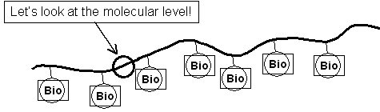

Fragmentation buffer 94C for 30 minutes
Lets look at the molecμlar level
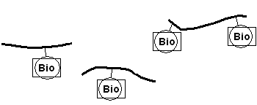
50-200 bp fragments

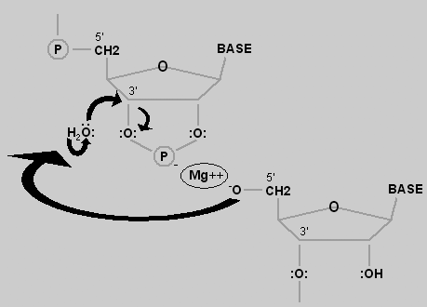
The intermediate product is a 2’, 3’ cyclic nucleotide. The next step is hydrolysis at the 3’ carbon.
The cyclic nucleotide is now a 2’-nucleotide.
Hydrolysis at the 2’ carbon produces the 3’-nucleotide.

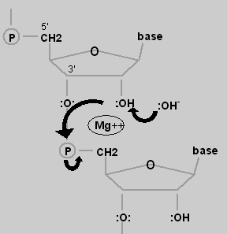

This is a heat-catalyzed hydrolysis reaction, mediated by magnesium ion

Evaluating The Samples on a Standard Agarose Gel

This procedure will evaluate your unfragmented and fragmented cRNA. Samples will be loaded on a precast E-GEL and allowed to run for 20 minutes.

____1. Remove a E-Gel from pouch and place on E-Gel base. Pre-run the gel for 2 minutes by pressing the button continuously for 10 seconds. You will see the light start to blink indicating it is in a pre-run mode. It will beep and stop after 2 minutes.

____2. Add 15 μl of water to each well on the E-gel.

____3. Add 2μl of each sample to each well and pipet up and down to mix well. Run both the fragmented and unfragmented cRNA.

____4. Load 4 μl of Ladder

____5. Run the gel for 20 minutes.

____6. Visualize the E-gel on a transilluminator. Take pictures.

Note: The fragmented sample should be a smeared band at the bottom of the gel indicating fragments of RNA between 35 and 250bp. The unfragmented sample should be a smear from the top to the bottom of the gel. The total RNA [if you run them] should be two bands at the middle of the gel indicating the 25s and 18s ribosomal RNA units. See picture below.

ladder 2000, 1200, 800, 400, 200, 100bp

Notes: _________________________________________________________________________________________________________________________________________________________________________________________________________________________________________________________________________________________________________________

To Be Performed at the University
These steps will be performed at the University of Vermont Microarray Core Lab and will be show as a powerpoint presentation.

Preparing the Hybridization Mix
The hybridization mixture contains several internal controls that provide information about the success of the hybridization procedure. These controls are the B2 oligo for which there are several hundred probes along the outer edge of all expression arrays and a checkerboard pattern in each corner. These predefined patterns provide signals for the Affymetrix® Microarray Suite software to perform automatic grid alignment during image analysis. They can also be used to align the grid manually. The fluorescence intensities for control oligo B2 are not used for analyzing data. The bioB, bioC, and bioD are biotinlylated gene fragments much like your sample which represent the biotin synthesis pathway from the bacteria E. coli. The cre control is the recombinase gene from P1 bacteriophage. These biological controls are prepared at standardized concentrations and signal intensities obtained on these genes provide information on how well the hybridization, washing, and staining procedures have performed.

____1. Prepare the following:

Fragmented cRNA [10μg] ? Control B2 Oligo 3.3 μl
20x Eukaryotic Control mix [bio B, bio C, bio D, Cre] 10 μl Herring Sperm DNA [10mg/ml] 2 μl Acetyleted BSA [50mg/ml] 2 μl
2x Hybridization Buffer 100 μl
Water [QS to 200μl] ___

____2. After preparing the hybridization mixture, store the mixture at -20°C.

Hybridization to the Yeast 2.0 GeneChip

After the hybridization mixture has been made, it is denatured at 94C for 5min and injected in to the genechip through the injection ports on the back of the chip [see diagram below]. The genechip is then placed in a
hybridization oven and the biotinylated target that you prepared is allowed to bind [hybridize] to the sequence specific probes on the array.
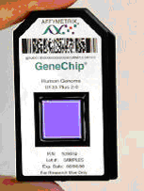

Staining the Yeast 2.0 Genechip

The staining procedure involves using a fluidic station designed to accommodate GeneChips. Two solutions are prepared; a strepavidin- phycoerytherin dye (SAPE) and a biotinylated anti-phycoerytherin antibody (BAP). Before placing the GeneChip into the fluidic station, the fragmented cRNA hybridization mixture is manually removed and replaced with buffer.

The chip is placed in the fluidics station and an automatic process of washing and staining occurs for about 2 hours. The procedure starts by first staining with SAPE. The SAPE will bind the biotinylated cRNA that is hybridized to the probes on the chip. It is washed and then stained again with BAP. BAP will bind to the SAPE. The chip is washed again and another SAPE staining is carried out to bind to the BAP. The double staining procedure is employed to amplify the signal intensities. This allows for the detection of low transcript mRNAs that might otherwise not be detected. After staining, the sample is washed and ready for scanning.

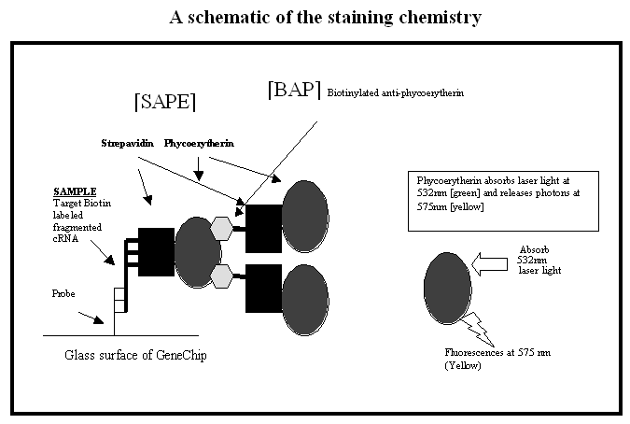

Scanning the Yeast 2.0 Yeast GeneChip
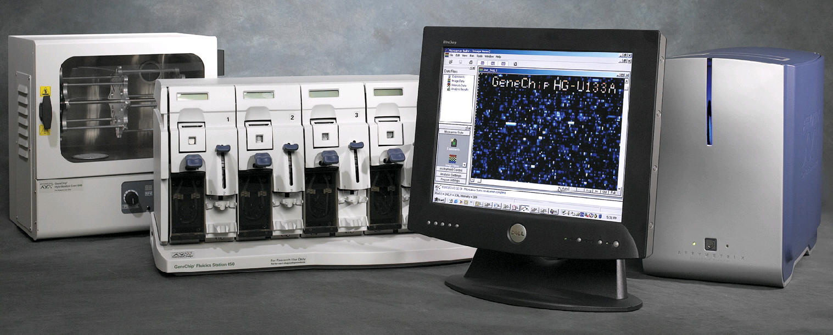
The GeneChip is scanned after the wash and staining protocols are complete. The chip is placed in the high resolution GS3000 scanner which is equipped with a diode-pumped, frequency-doubled Nd-YAG laser (532 nm) and the 3.5 um beam is scanned back and forth across the glass surface at a pixel resolution of approximately 2.5 um. Fluorescence is detected using a high sensitivity photomultiplier tube [PMT]. This enables high resolution detection of fluorescence from the probe set feature [pixel] that is only 11 um square. There are approximately 1 million probe areas on each chip!

GeneChip The Affymetrix GeneChip System

Images from the GeneChip scanner

The image on the left is all 1,000,000 probes. The image to the right is zoomed up 20,000 times to show approximately 500 probes. White indicates strong signal [high level of a mRNA in original sample], while dim or no signal indicate little to no mRNA in original sample.

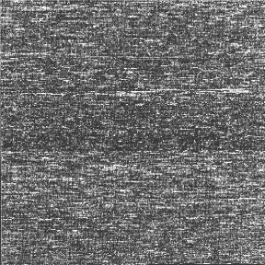

Bioinformatics

After collecting and analyzing the image data, the results are archived and burned on to a CD. Because the data files are so large, it is necessary to analyze it using special microarray analysis software. This software can handle tens of thousands of data points at one time and data analysis can be time consuming. Therefore, it is critical that the data meet specific quality control specifications before performing this extensive analysis.

Notes: ________________________________________________________________________________________________________________________________________________________________________________________________________________________________________________________________________________________________________________

Example Expression Report From MAS 5.0

Date: 04:46PM 01/16/2004______________________________________________________________
Filename: UVM -test-Yeast.CHP
Probe Array Type: Yeast S98
Algorithm: Statistical
Probe Pair Thr: 8
Controls: Antisense
______________________________________________________________________
Alpha1: 0.04
Alpha2: 0.06
Tau: 0.015
Noise (RawQ): 2.970
Scale Factor (SF): 1.367
TGT Value: 150
Norm Factor (NF): 1.000
______________________________________________________________________
Background: Avg: 84.82 Std: 2.37 Min: 77.40 Max: 90.40
Noise: Avg: 3.16 Std: 0.15 Min: 2.70 Max: 3.80
Corner+ Avg: 163 Count: 32
Corner- Avg: 11225 Count: 32
Central- Avg: 6612 Count: 9
______________________________________________________________________

The following data represents probe sets that exceed the probe pair threshold and are not called "No Call".

Total Probe Sets: 14010
Number Present: 5227 37.3%
Number Absent: 8406 60.0%
Number Marginal: 377 2.7%
Average Signal (P): 648.4
Average Signal (A): 32.6
Average Signal (M): 112.0
Average Signal (All): 264.5
______________________________________________________________________

Housekeeping Controls:
Probe Set Sig(5') Det(5') Sig(M') Det(M') Sig(3') Det(3') Sig(all) Sig(3'/5')
18S_RRNA 18.3 A 67.8 P 82.9 P 56.33 4.54
ACTIN 2983.0 P 7075.1 P 3976.6 P 4678 1.33
GAPDH 436.2 P 1217.7 P 1692.1 P 1115 3.88
DROS-EIF-4A 4443.5 P 10464.4 P 7337.3 P 7415 1.65
________________________________________________________ ______________

Spike Controls:
Probe Set Sig(5') Det(5') Sig(M') Det(M') Sig(3') Det(3')
BIOC 331.0 P 155.8 P 243.38 P
BIODN 244.2 P 1490.2 P 867.20 P
CREX 2554.0 P 5413.1 P 3983.52 P

Appendix A: Preparing the pre-culture

1] All work must be done in a HEPA hood such as those involved with tissue culture! Always wear gloves that have been rinsed with alcohol!

2] Transfer an entire colony of yeast to a broth culture of 1/2x YPD with or without glucose. It is not important as long as we get some growth as indicated by turbidity at 48 hrs.

3] After incubation, aseptically remove a drop of the culture and examine on the microscope to ensure there is no contaminating bacteria. Remember that bacteria will be 1/5 the size of the yeast. So look for small rods or cocci beyond the yeast.

4] To inoculate the experimental culture to be used in class, aseptically transfer 0.5 ml of this culture to the 1/2x YPD-3xGlu broth 48hrs before day 1. It is advisable to use aerosol resistant pipet tips.

Alternatively:

You may streak a YPD agar plate 4 days prior and then inoculate your experimental culture with a whole colony 48 hours prior to day 1 class.

