Number 45 Summer, 2008
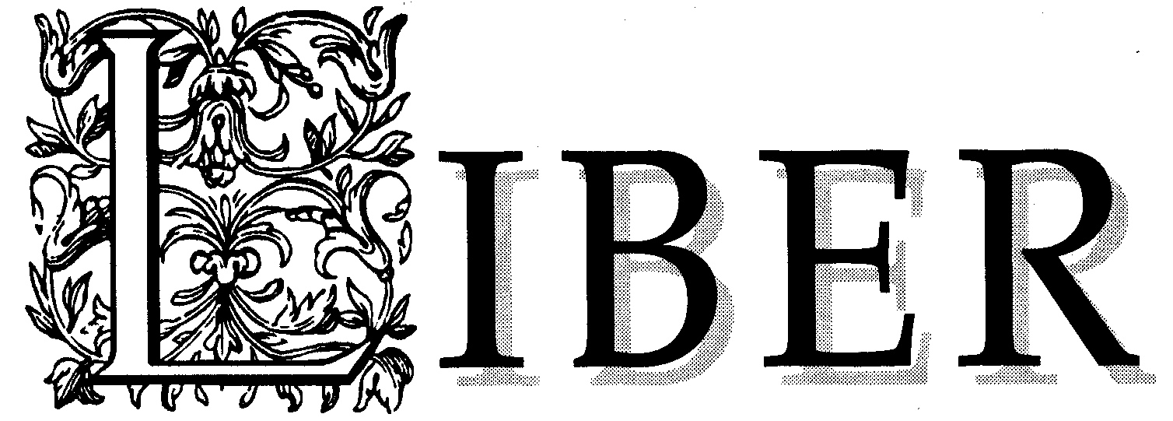

A Newsletter for the Friends of Special Collections, Bailey/Howe Library, University of Vermont

SPECIAL COLLECTIONS SCREENS FILMS AT EXPO

There was almost always a crowd in front of the Special Collections booth at the ninth annual Vermont History Expo, held June 21-22, 2008 at the Tunbridge Fairgrounds. Special Collections joined other cultural heritage organizations in the Genealogy and Archives Research Center (also known as Floral Hall) to showcase collections that document Vermont’s rich and diverse history.
Prompted by the 2008 Expo theme of “Industry and Innovation,” Special Collections premiered three recently preserved films that were produced by the Vermont Agricultural Experiment Station in the 1940s as part of rural sociologist Robert M. Carter’s study of hay harvesting techniques and costs.
Carter investigated the efficiency of different hay harvesting methods and analyzed a variety of tasks. He looked at the time spent on each task, the cost of the equipment, crew size, idle time, time spent repairing equipment, the interrelationships between jobs, and the production yield. Because these haying jobs were tasks performed in motion, the use of film to evaluate and demonstrate harvesting methods was an invaluable asset.
As historical documents, the three films are exceptionally rich sources of evidence. While there are many photographs and written descriptions of hay harvesting methods, there are very few films widely available on the subject. The post-World War II years were a time of great consolidation and increased mechanization of dairy farms in Vermont, and the films capture the agricultural sector during that period of intense change.
Special Collections was able to have the hay harvesting films preserved with generous support from the National Film Preservation Foundation (NFPF). Congress created the nonprofit organization in 1996 “to promote and ensure the preservation and public accessibility of the nation’s film heritage held at the Library of Congress and other public and nonprofit archives throughout the United States.” Institutions in 45 states, the District of Columbia and Puerto Rico have stepped forward to preserve 1,322 historically and culturally significant films with support from the NFPF. The Special Collections grant marks the first time that the NFPF funded a Vermont institution.
Visitors to the History Expo were drawn to the Special Collections booth by very large still photographs showing hay harvesting, the smell of fresh hay bales generously provided by a neighboring exhibitor, and the opportunity to sample switchel, the traditional, thirst-quenching haymaker’s punch. They stayed to watch “Using the One-Man Pick-up Baler,” “Hay Harvesting Methods: The Buckrake, Windstalker and Field Chopper in Use,” and “Hay Harvesting Methods: Hand Methods of Harvesting Hay”—all in living color.

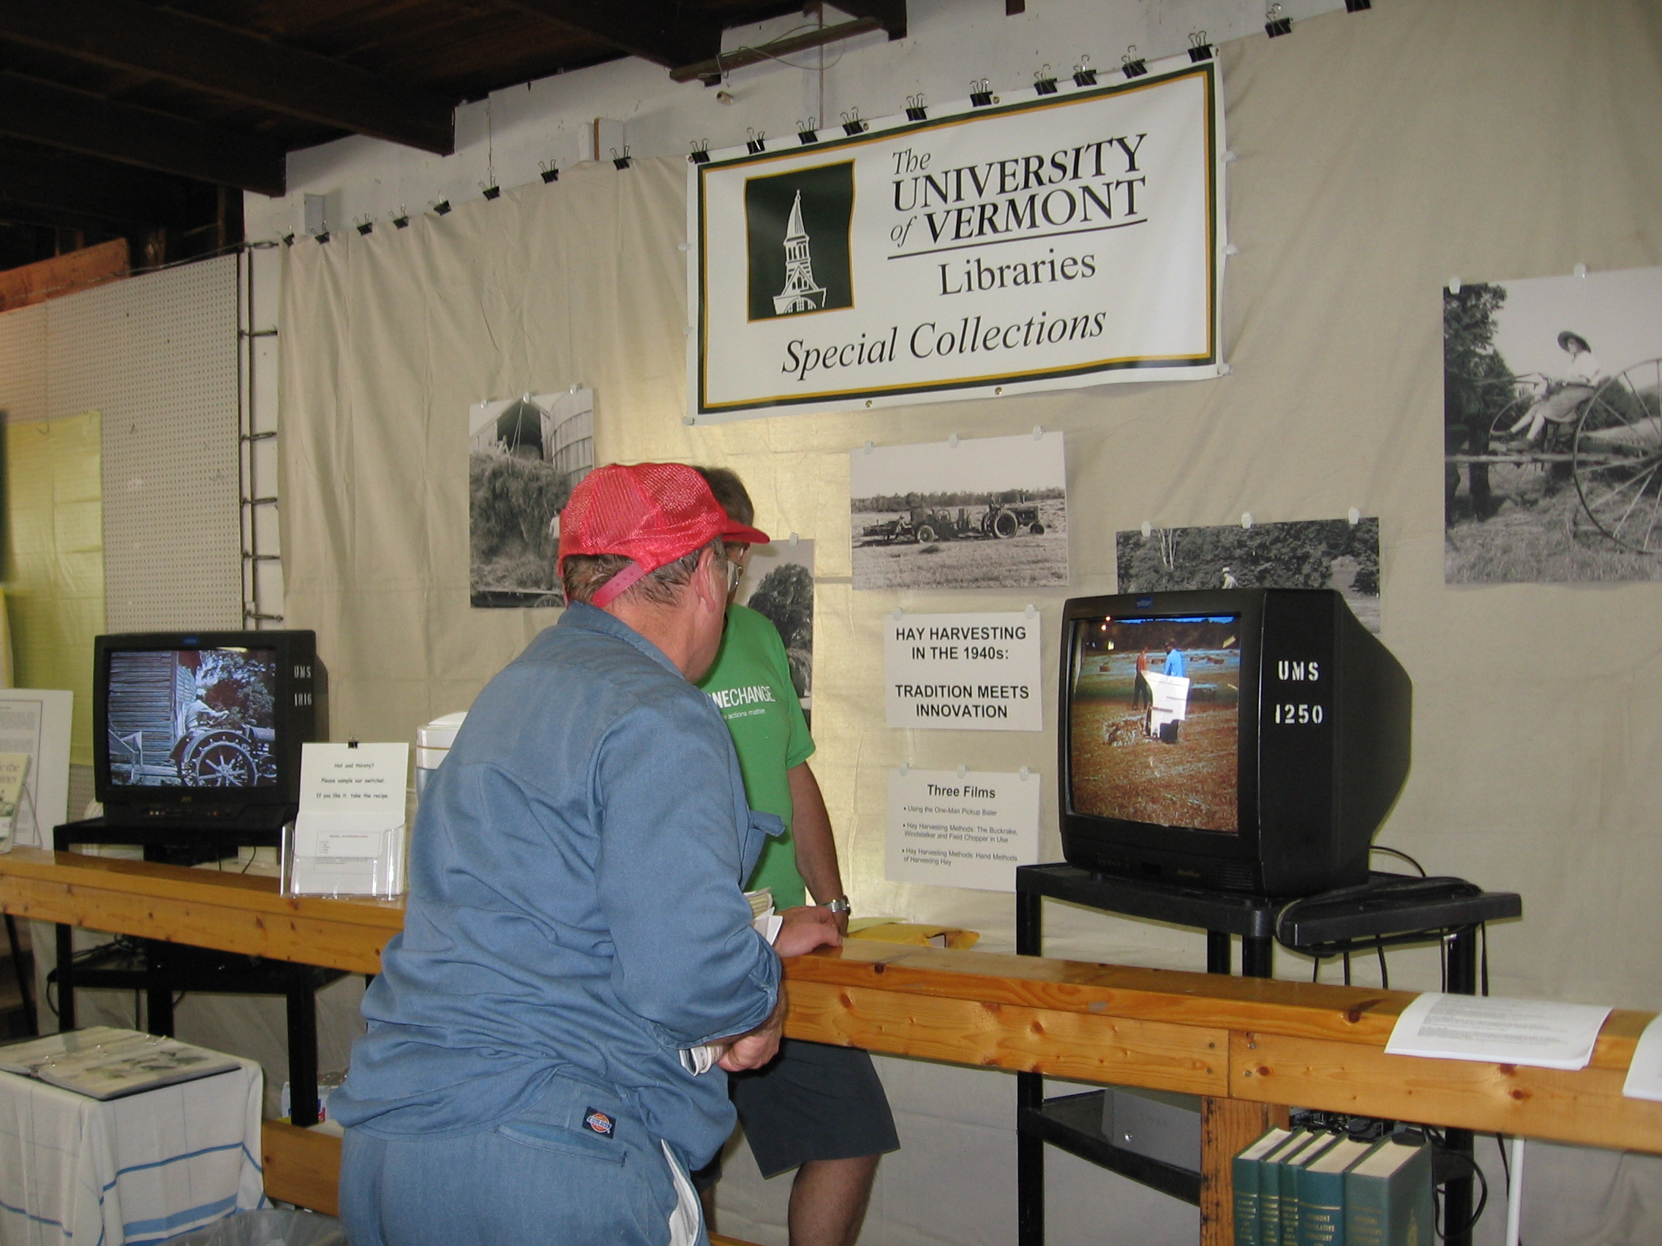
The films do not have a sound track, but the viewers provided running commentary as they remembered their haying days, reflected on the immense amount of physical work required, or questioned the wisdom of moving to farm consolidation and increased mechanization dependent on petroleum products. An overwhelming majority of tasters voiced approval for the gingery switchel, and many took copies of the recipe.
A number of the viewers asked if copies of the films would be available for purchase or if other showings were planned. Inspired by the enthusiastic reception at the History Expo, Special Collections staff members will definitely arrange future screenings.

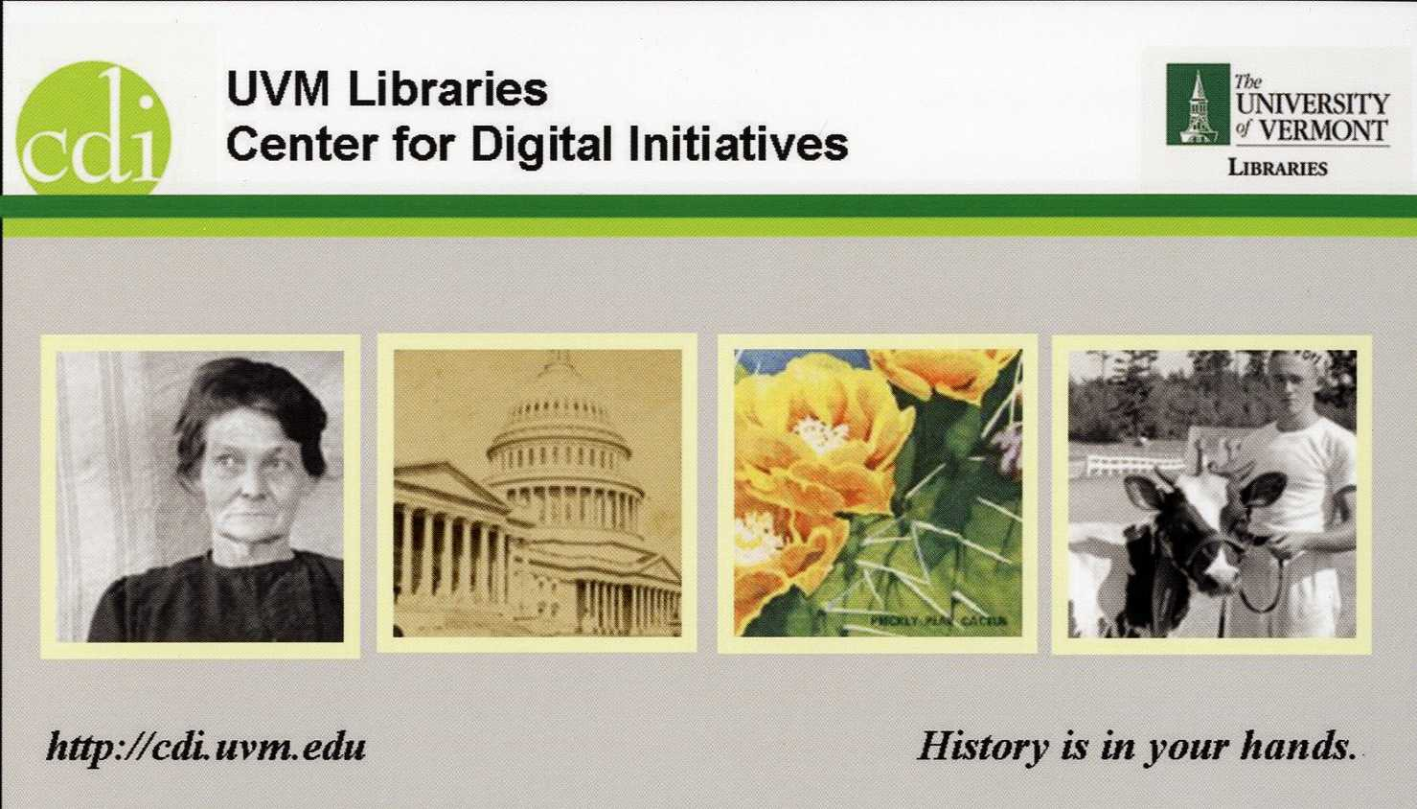

UVM LIBRARIES RECEIVE SECOND GRANT FOR THE CDI

In March 2008, Special Collections received official notification that the University Libraries had received a federal grant of $383,187 to support our Center for Digital Initiatives (CDI). Sponsored by Senator Patrick Leahy, the grant will be funded through the Institute of Museum and Library Services (IMLS), as was our initial grant in 2005. The mission of IMLS is “to create strong libraries and museums that connect people to information and ideas.” This is the essence of the CDI, through which we are making research materials easily available to people around the globe via the Internet.
The first grant allowed us to purchase hardware and software, hire Digital Initiatives Librarian Winona Salesky, and begin digitizing collections for our CDI website. Those collections went live in April 2007, just as we opened the new CDI facility on the third floor of Bailey/Howe Library. With the second grant we plan to follow our initial success with an outreach campaign to potential researchers and collaboration with on- and off-campus partners to digitize additional materials.
Our primary focus in the first phase of the CDI was on Vermont Congressional collections. We built a “Letters Home from Congress” collection featuring letters from congressmen Samuel Crafts (1768-1853), Jacob Collamer (1791-1865), and Warren Austin (1877-1962). “Dairy and the U.S. Congress” highlights documents relating to Vermont’s most important agricultural industry. “Congressional Portraits” features images of 41 Vermont congressmen. “Congressional Speeches” is a selection of 81 speeches by Vermont members of Congress from 1812 to the present.
We have also built an online collection of the Tennie Toussaint photographs taken in northeastern Vermont near the beginning of the twentieth century, and we are in the process of adding the frequently used photos from the collection of Louis L. McAllister, a Burlington photographer who worked from the 1910s to the 1960s. Over 1,000 McAllister photographs are now available.
With the first digital collections and the technical infrastructure in place, we are prepared to advance the CDI to the next stage. Thanks to the help of Senator Leahy and his staff, and the generous support of the Institute of Museum and Library Services, the CDI has become an integral part of our operations in Special Collections.

A REPORT OF MAJOR GIFTS AND PURCHASES IN 2007

The year 2007 was an especially good one for book and manuscript acquisitions in Special Collections. It would be difficult to describe all of the many acts of generosity from which we benefited during the year, and therefore it is necessary to confine this review to a few of the outstanding gifts, as well as purchases that were made possible by our gift funds and endowments. We are extremely grateful to all who have helped us build our collections last year and every year. Thanks, also, to Connell Gallagher for the description of the Yeats material.

BOOKS

The Julian Ira Lindsay Collections

We are pleased to acknowledge the donation of two book collections from the library of Julian Ira Lindsay, Professor of English at UVM from 1915 to 1952, the gift of Robert and Sally Fenix of Burlington. Robert inherited the books through his first wife, the late Mary Lindsay Fenix, Professor Lindsay’s daughter. Professor Lindsay had a passion for books, and he could often be found in the Treasure Room of Billings Library, where the rarest of our books from such collectors as George Perkins Marsh and Lucius Chittenden were kept. Lindsay himself purchased some great treasures, as evidenced by two collections donated by Robert and Sally.
The first collection contains 93 first and early-edition titles of William Butler Yeats and 95 titles by Yeats’s contemporaries, mostly relating to him. More than 30 titles bear the Cuala or Dun Emer (Dublin) imprint, books printed by Yeats’s sister Elizabeth on a hand press, and they are some of the most collectible and desirable volumes in the Yeats bibliography. There are three letters from the printer with the books as well. The Yeats collection includes a perfect copy of the June 1886 issue of The Dublin University Review, valuable because it includes the first issue of Yeats’s first published work, the verse play Mosada. Two editions of Poems, published in 1895 and 1901 by T. Fisher Unwin, are among the treasures of the collections, as is The Poems of W. B. Yeats (London: Macmillan, 1949), a two-volume set printed in an edition of 375 copies signed by the author.
The second collection is more eclectic, but contains many wonderful examples of late medieval and early Renaissance bookmaking. Among these are two bound manuscripts by Bartholomew of San Concordia (ca.1260-1340; also known as Pisanus), one an incomplete copy of the other. They appear to be early fifteenth-century copies of his most famous work, “Summa de Casibus Conscientiae,” a digest of canon law. The collection also contains one incunabulum, Petrarch’s De Vita Solitaria, printed in Milan in 1498. Four works from the sixteenth century include Symphorien Champier’s Galliae Celtica (Lyon: Trechsel, 1537); Desiderius Erasmus’s Moriae Encomium (Lyon: Gryphium, 1540); Thomas Palfreyman’s (after William Baldwin), A Treatise of Morall

Kauffer illustration from A Song for Simeon,
donated by Fraser Drew.
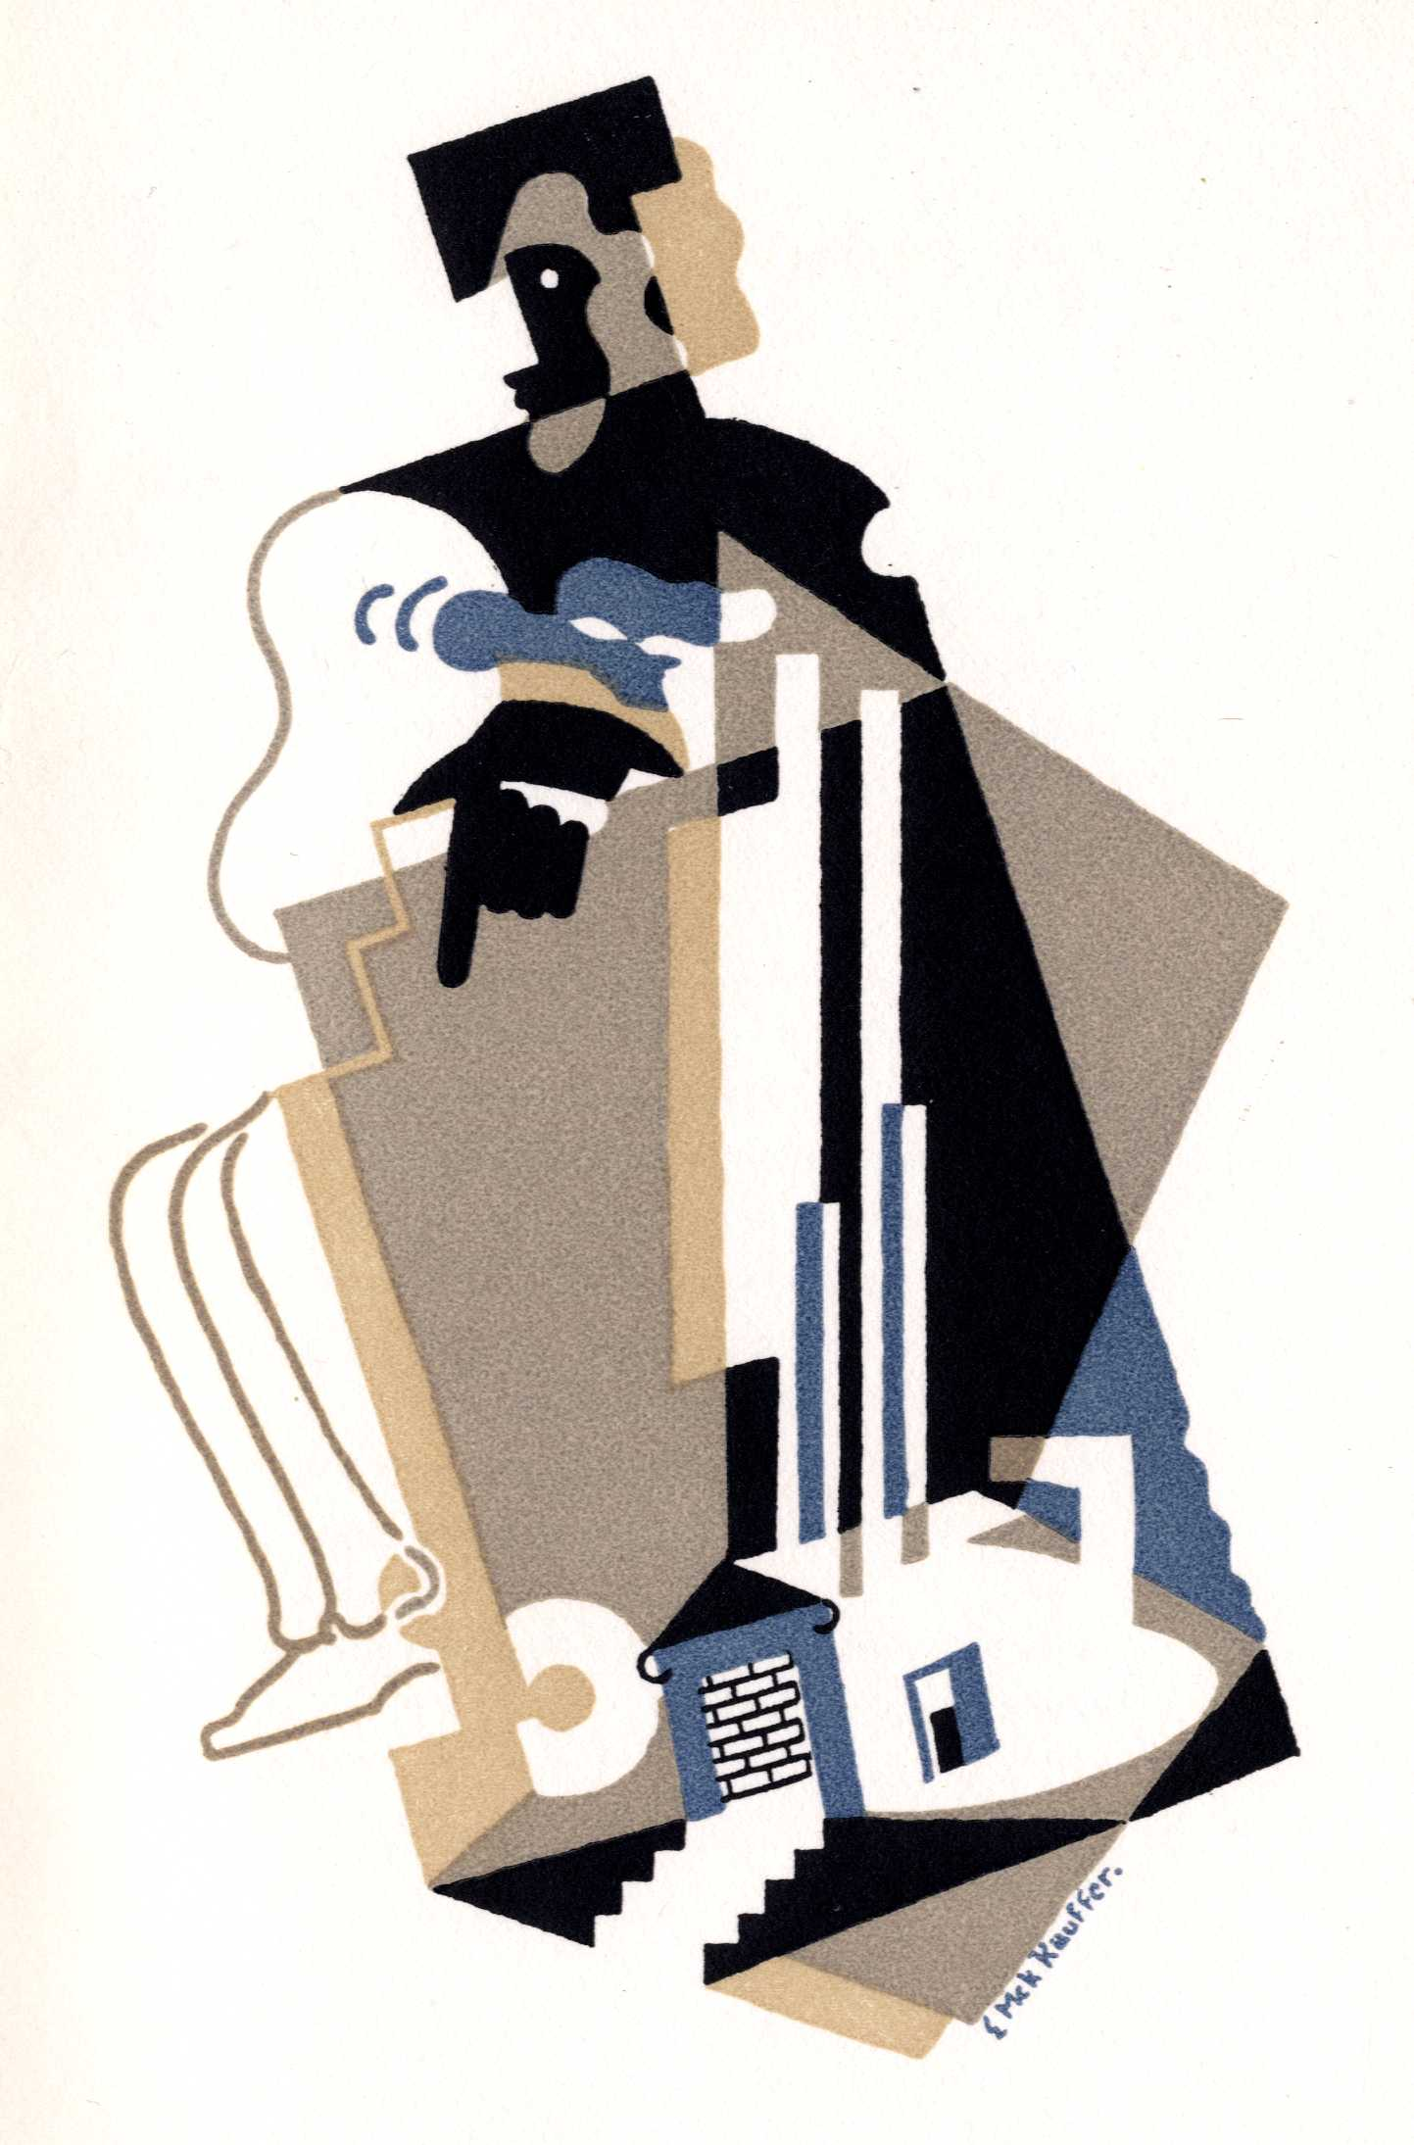
Philosophie Containing the Sayings of the Wise (London: Richard Totelli, 1587); and Petrarch’s Con L'Espositione d'Alessandro Vellutello (Venice: Gabriel Giolito de Ferrari, 1545). One of the nicest volumes, though, is the deluxe edition of Poems of William Wordsworth (London: E. Moxon, 1847), bound in full leather with a lock of the author’s hair encapsulated in the front cover.
The Lindsay books significantly enhance our book history and modern literature collections, and are very much appreciated.

Fraser B. Drew Books

Like Julian Lindsay before him, Fraser B. Drew has had a distinguished career as a professor of literature—having retired from the faculty of Buffalo State University many years ago—in combination with a passion for books. Professor Drew has done more to build the modern literature collection in Special Collections than anyone, with his generous donations over the years of books, correspondence, and other materials of John Masefield, Robinson Jeffers, T. S. Eliot, and many others. A significant percentage of the books are first editions inscribed by the authors. In 2007, Fraser Drew donated a large assortment of (primarily) poetry books by Louise Townsend Nicholl, John Masefield, T. S. Eliot, Rupert Brooke, and many others. Among the most notable items is Edward Marsh’s Georgian Poetry: 1911-1912, including a letter signed “Eddie Marsh.” Eliot’s A Song for Simeon (London: Faber & Gwyer, 1928), signed by the poet, is another rarity. A Song for Simeon, Number 16 in “The Ariel Poems” series, has a full-page color illustration by E. McKnight Kauffer in the cubist style; this copy is number 350 of 500 large-paper copies.
Fraser Drew has been a faithful and generous supporter of Special Collections for decades, as well as an occasional contributor of memoirs and sketches to Liber.

David Richardson Collection

David Richardson of Hanover, New Hampshire, has generously donated hundreds of books to Special Collections over the last several years. Born in Charles River Village (Needham, Massachusetts), David combined a remarkable career in foreign aid organizations, starting with the Alliance for Progress in 1941 and retiring from the World Bank in 1985, with a passion for books. While he has never thought of himself as a collector, David tended to purchase books on particular topics as his interests changed, from New England colonial history and Native Americans to England in the Middle Ages, myths and fables, Latin grammar, and modern literature.
Among the books David donated in 2007 are many treasures. The four-volume set of The Humorist: A Collection of Entertaining Tales (London, 1819), illustrated by George Cruikshank, is an early work by one of the great illustrators of the nineteenth century. Robert Darlington’s Aphorismes Civill and Militarie Amplified with Authorities…Out of the First Quaterne of Fr. Guicciardine (London, 1629) is a rare copy in very good condition of a manual written as a guide to diplomatic and ethical conduct for the future monarch Charles I. Guicciardini’s The History of Guicciardin; Containing the Warres of Italie and Other Parts (London, 1599) is the second edition of this highly influential work; we have the third edition already. Among the Americana titles is a fine set of four volumes bound in contemporary calf of the first edition of Thomas Jefferson Randolph’s Memoir, Correspondence and Miscellanies from the Papers of Thomas Jefferson (Charlottesville, 1829).
We will soon announce recent additional gifts from David Richardson.

Linda M. Kruger Books

Linda Markson Kruger (UVM ’58) has donated a valuable collection of books and materials that she accumulated over the years as a teacher of rare book and “History of the Book” courses, including hundreds of color slides, private press ephemera, articles and pamphlets. For many years a Special Collections librarian herself, Linda has helped us develop our collection of “books about books” as well as fine examples from renowned presses from Kelmscott to Gehenna. The 2007 materials include Souvenir: Serge Diaghilieff’s Ballet Russe, a folio of photographs and drawings by Leon Bakst and others, in excellent condition. The donation also includes numerous Grolier Club exhibit catalogs and hard-to-find pamphlets on printers, collectors, and book designers. An exhibition of significant items from Linda Kruger’s donations will be on display in the Bailey/Howe lobby through the summer.

Book Purchases

Divide and Conquer

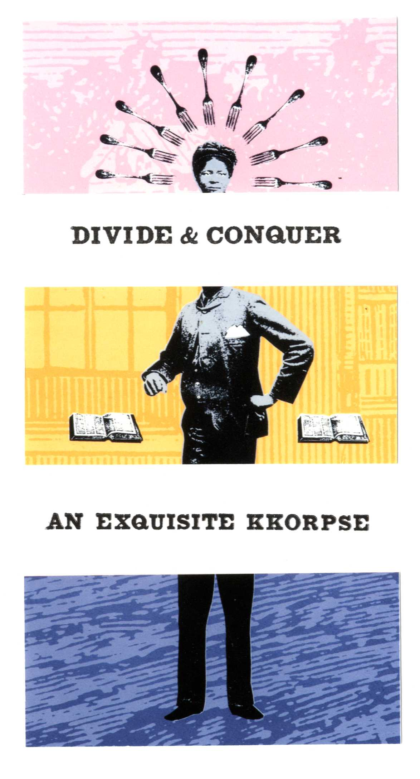
Many of our standing-order book artists produced fine work in 2007 (or works that we purchased in 2007), but space allows mention of only a few. The ELM Press produced The Inconstant Moon: Poems to the Moon, by a number of contemporary poets as well as a “Homeric Hymn translated by Apostolos N. Athanassakis.” The book is beautifully illustrated with full-page lithographs of the moon by Enid Mark. Maureen Cummins brought out an edition of 40 copies of an exquisite corpse-style book, Divide and Conquer, which explores the impact of the early Ku Klux Klan on the lives of its victims, based on testimony given in congressional hearings in 1871. Carolee Campbell’s Ninja Press published Breyten Breytenbach’s The Intimate Stranger. As the prospectus states, Breytenbach “charts the geography of the land while, on a shifting plane, he conjures the landscape of the human heart.” One might add that the book itself is a landscape, the flax paper made by Bridget O’Malley at Cave Paper suggesting the shades and texture of earth as each turned leaf reveals an altered horizon.
We purchased the 1793 edition of Patrick Campbell’s Travels in the Interior Inhabited Parts of North America (Edinburgh: printed for the author, and sold by John Guthrie), a rare and entertaining account of the author’s explorations in the years 1791 and 1792. Scotsman Campbell summarized it as “an account of the manner and customs of the Indians…the mode of life and systems of farming among the new settlers of both Canadas, New York, New England, New Brunswick, and Nova Scotia.” In his preface Campbell claimed that he never intended to publish his account, but was persuaded to do so by friends who read and enjoyed his journal. Inveighing against the Salt Tax, which he considered the greatest obstacle to industry in northwest Scotland, Campbell hoped that the Travels might allow those considering emigration to be better informed, whether they decided to emigrate or not. The book is a valuable addition to our collection of North American travel and exploration accounts.

MANUSCRIPTS

Harlan Paige Civil War Letters
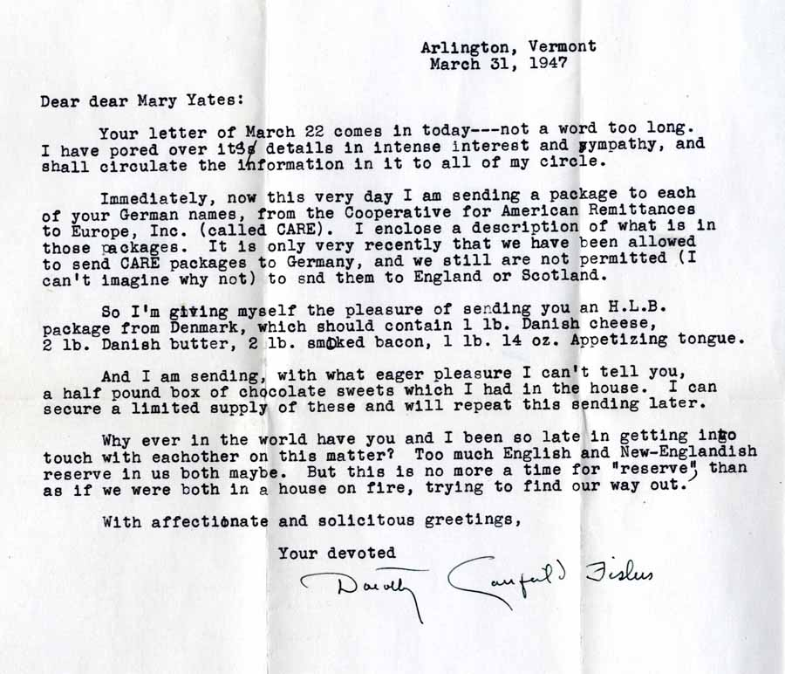
One of the largest and most interesting Civil War collections we have added in some time, the Harlan Paige collection is the gift of Ms. Carlin Paige Holden of San Francisco, great-granddaughter of Lieutenant Harlan Paige. Born in Barnard, Vermont, Harlan Paige (1838-1901) enlisted in Company E of the Fourth Vermont Infantry Regiment in August 1861 and resigned on May 9, 1865 as First Lieutenant of Company C of the same regiment. During that time he wrote at least 250 letters home describing battles and camp life and offering opinions on issues such as the draft, re-enlistment, and the army’s morale. Although he insisted that he would not re-enlist, at the end of March 1864, Paige announced that he had changed his mind and signed on for another three years in the Fourth. Besides getting a generous bounty, he wrote, “an Orderly Sgt. is next to a Lieutenant and I stand a good chance for a commission by and by.” To his good fortune, re-enlistment also came with a thirty-day furlough, and he was away from the regiment for most of the terrible Overland Campaign in May 1864. He returned in time to receive a minor wound at Cold Harbor on June 3, and once again experienced a stroke of good luck when his company avoided capture at the Weldon Railroad on June 23—most of his compatriots in the Fourth were surrounded and marched off to Andersonville Prison. Paige finally received his lieutenant’s commission in February 1865, and participated in the final siege of Petersburg on April 2. The collection includes an equal number of letters written to Paige’s father, A.H. Paige, by soldiers from the Barnard area. It also includes fifty cartes-de-visite photographs of (mostly) Vermont soldiers, numerous other family photographs and family papers dating from 1824 to 1913, and a large quantity of genealogical material.

Dorothy Canfield Fisher Letters

Among the bedrock manuscript collections in Special Collections, the papers of Dorothy Canfield (or Dorothy Canfield Fisher, as she often signed her personal letters), continue to accrue new materials since the original collection came to UVM some fifty years ago. The latest is a series of 71 letters that the Arlington author wrote to one of her foreign pen-pals, Mary Yates of Rydal, Westmorland, England. Miss Yates was a poet and artist, but it is unclear how the two met. The correspondence begins in 1937 and is perhaps most notable for its commentary on WWII and its aftermath, including the news of the death of Fisher’s son Jimmie, an Army Ranger physician in the Philippines. Always curious and well-informed about world events, Dorothy wrote of public and private news through the 1950s until her death in November 1958. Mary Yates visited the Fishers in October, 1955, taking time to paint a pastel of the Arlington countryside, which is included in the collection. The letters and painting were acquired from Miss Yates’s grand-nieces in England.

Grace Goodhue Coolidge Letters

With substantial help from alumnus A. Peter Low (class of 1963) we purchased a collection of 154 letters and cards written by Grace Goodhue Coolidge (UVM class of 1902) to her friend Molly K. Shuman. The collection spans the years 1919 to 1945, with most falling between 1927 and 1940. We have not yet discovered when or how Molly K. (as Mrs. Coolidge often addressed her) met the future first lady, or anything substantial to further identify her. Most of the notes and letters include a thank-you for some gift or gifts of flowers, jewelry, perfume, or clothing. But many of the longer letters reveal details about Grace’s daily life in the White House, family matters, and post-White House adjustments. The topics she wrote about most frequently were family, friends, and social obligations. She mentioned Mr. and Mrs. Frank Stearns frequently; Frank Stearns was a Boston businessman who played a key role in Calvin Coolidge’s political career, but the Stearnses were evidently close friends of the Coolidges as well. Grace wrote joyfully about the marriage of son John to Florence Trumbull in 1929, and the birth of granddaughter Cynthia in 1933. Although Grace makes no explicit mention of the deaths of her son, Calvin, Jr., in 1924 and Calvin, Sr. in 1933, Molly evidently spent time with her at the Coolidge house in Northampton, Massachusetts, immediately after the President died.
The Coolidges spent the warmer months at the family homestead in Plymouth, Vermont. The simpler life in Plymouth undoubtedly pleased both of them, but Grace was happy to report late in 1931 that there was “talk of an addition, a bath and electric lights” for the old farmhouse. Financially comfortable, the ex-presidential couple was nonetheless deeply concerned about the course of national and international affairs. “I, too, feel that 1932 is going to see us coming out of our difficulties,” Grace wrote at the beginning of the year, “with a greater realization of our inter-dependence, as individuals and as nations. Man cannot live unto himself alone. No more can a nation.”
The Grace Coolidge letters will be added to our collection of Coolidge memorabilia (much of which is on display in the Grace Coolidge Room in the Waterman Building) and to Grace’s book collection.

LINDA MARKSON KRUGER BOOK COLLECTION EXHIBIT

Former Director of Special Collections Connell Gallagher returned this summer to curate an exhibit of fine press books from the collection of Linda Markson Kruger, an avid collector who graduated from the University of Vermont in 1958. For the past 30 years Linda Kruger has been donating books from her voluminous collections of art, literature and fine printing to UVM.
Kruger graduated from UVM with a double major in history and literature and went on to complete an M.A. in art history from Boston University and a Ph.D. in librarianship from Columbia. Kruger became a rare book librarian at the New York Public Library and then at Columbia University, where she made her career at the Avery Architectural Library and teaching the History of the Book.
The exhibit includes a diverse sample of Kruger’s many gifts that have richly enhanced the University’s book collections. Although the exhibit includes examples of early British presses such as the Kelmscott Press of William Morris and fine Italian presses such as Giovanni Mardersteig’s Officina Bodoni, it focuses on the modern American fine presses that are Kruger’s main interest.
Gallagher devoted one case to showcase the fine materials used by the Allen Press, including their Persian Stories from the Arabian Nights (1980), printed in an edition of 140 copies with title page calligraphy stamped in 23 carat gold. Another case contains examples of the beautiful books of the Bird and Bull Press of Henry Morris, all produced on handmade paper with interesting and beautiful bindings.
Kruger is particularly interested in the great modern wood engravers, and Gallagher selected a number of fine examples from her donations to include in the exhibit. John DePol, the famous wood engraver who was a favorite of Linda Kruger, is represented with several examples of his collaboration with the Yellow Barn Press, where he illustrated over a dozen books with more than 70 wood engravings. Michael McCurdy, an acclaimed printer, book designer, and wood engraver who designed Kruger’s bookplate, is represented by two examples from his Penmaen Press, Dove at the Windows (1973) and To Eberhart from Ginsburg (1976). Two books are typical of the early works produced at the Leonard Baskin’s Gehenna Press, Aesopic: Twenty Four Couplets by Anthony Hecht to Accompany the Thomas Bewick Wood Engravings for Select Fables (1967) and A Letter from William Blake (1964).
The Kruger Book Collection exhibit will be on display in the Bailey/Howe Library lobby until September 15, 2008.

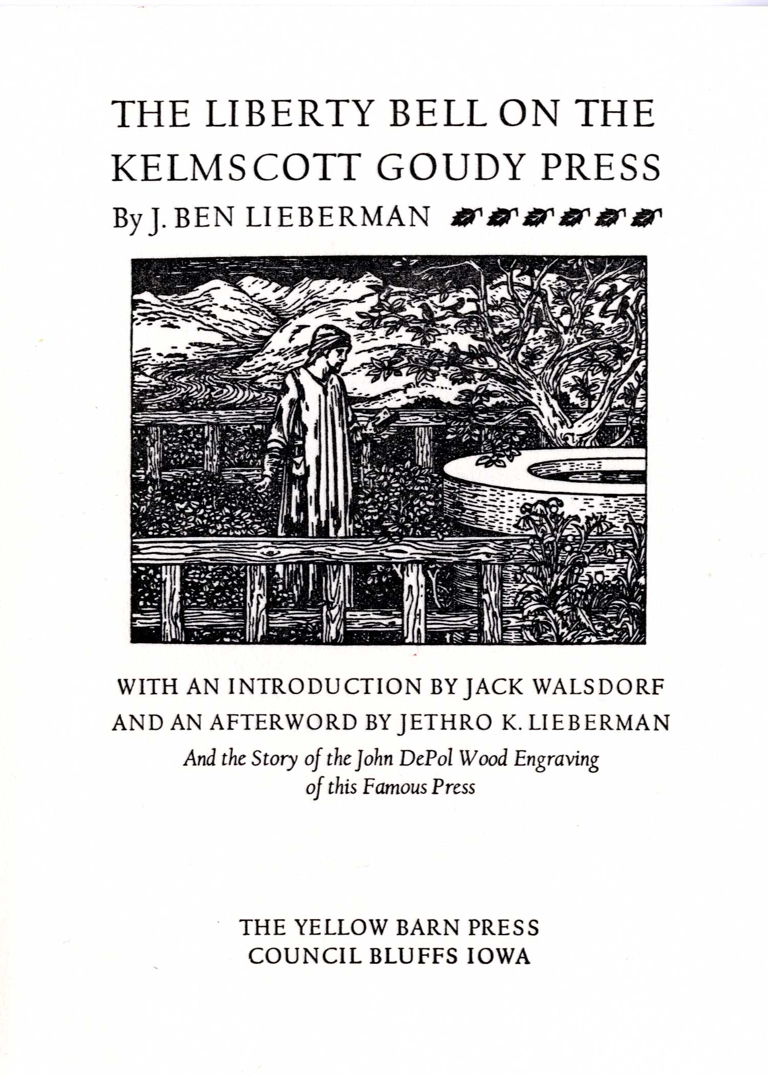

DOHERTY JOINS LIBRARY FACULTY

A nationwide search over the winter months led the University Libraries back to its home turf this spring as our own Prudence Doherty was chosen to be the new Special Collections Librarian for Public Services. This library faculty position was redesigned to put greater emphasis on the Department’s reference and instruction services, access issues, and outreach. Prudence impressed everyone involved in the search with her solid grasp of issues concerning reference service and instruction in the modern special collections library.
Prudence joined the Special Collections staff in 2000 as a Reference Specialist after more than twenty years with UVM’s Consulting Archaeology Program. Over the last seven years she became familiar with a wide range of library functions, and was so inspired by the challenges and opportunities in the field that she enrolled in the School of Library and Information Science at the University of Illinois. She received her master’s degree in 2005. Prudence previously earned a B.A. in history and an M.A. in geography from the University of Chicago.
Among her new tasks, Prudence will work with faculty members to find new ways to use Special Collections materials in the classroom. She brings some great experience to this effort. In 2006 Prudence arranged to be an “embedded librarian” for a history course taught by Professor Dona Brown, attending many of the classes and working with instructor and students as they explored primary sources relevant to the course topic. In 2007 she coordinated a “service learning” component for another history course as forty students undertook projects that provided a benefit to Special Collections. These are the kind of innovative approaches that the Department hopes to continue offering through Prudence’s efforts.
Congratulations, Prudence!

SENATOR LEAHY RECEIVES ARCHIVES ADVOCACY AWARD

Senator Patrick Leahy of Vermont was given the New England Archivists’ Archives Advocacy Award at the organization’s spring meeting in Newport, Rhode Island. Chris Burns, Special Collections Librarian and NEA President, presented the award to Colleen Mason, who serves as the senator’s archivist. Gregory Sanford, State Archivist of Vermont, nominated Senator Leahy for the award.
NEA grants the Archival Advocacy Award (AAA) to an individual or institution demonstrating extraordinary support of New England archival programs and records, either politically, financially or through public advocacy. Senator Leahy received the award in recognition of his sustained support for the historical record and accessible public records.
Senator Leahy has been a leader in encouraging the active management of senatorial records. In 1989 he temporarily added former NEA president and Distinguished Service Award recipient Connell Gallagher to his staff to begin applying archival management practices to his senatorial records. In 2007 he brought Mr. Gallagher back to work on his records within the Senate Judiciary Committee. Senator Leahy now has an archivist, Colleen Mason, as part of his staff. This commitment to archival management will facilitate the ultimate transfer of his records to the University of Vermont and is a model for other congressional offices.
Senator Leahy has long been active in support of Vermont’s historical records. He helped raise a million dollars for the Vermont Historical Society’s new History Center. He was a supporter of the Vermont Historical Society’s successful nomination for the IMLS’s 2007 National Medal for Museum and Library Services. In recognition of his parent’s support for the study of Vermont history, the VHS recently named its research library the Howard and Alba Leahy Library. Senator Leahy was also principally responsible for two grants to support the creation of the University of Vermont’s Center for Digital Initiatives, which is actively engaged in the digitization and online dissemination of historical records.
The Senator is by no means narrowly provincial in his support of the archival record and is a sponsor of S. 259 to establish the Henry Kuualoha Giuyni Kupuna Memorial Archives at the University of Hawaii. The archives would preserve and keep accessible documentation of native Hawaiian cultures.
Senator Leahy’s advocacy of open public records and government transparency has been particularly welcome at a time when there is pressure to restrict our right to know. His sponsorship of the FOIA Open Government Act (S. 2488), recently signed into law by President Bush, has improved access to government records. As the Newspaper Association of America noted, the act “creates a tracking system and hotline for requesters; imposes real consequences on federal agencies for missing statutory deadlines; creates an ombudsman to help requesters use FOIA and mediate disputes; and makes it easier for the public to recover legal fees when litigation is the catalyst for the release of records.”
Senator Leahy is also a sponsor of S. 886, which would amend the presidential records act in favor of greater access and remove restrictions on access established under Executive Order 13233. The Senator has also sponsored numerous other bills to promote greater access to records, preserve Internet neutrality, and make Congressional Research Service reports available online.


Special Collections
Bailey/Howe Library
University of Vermont
Burlington, VT 05405

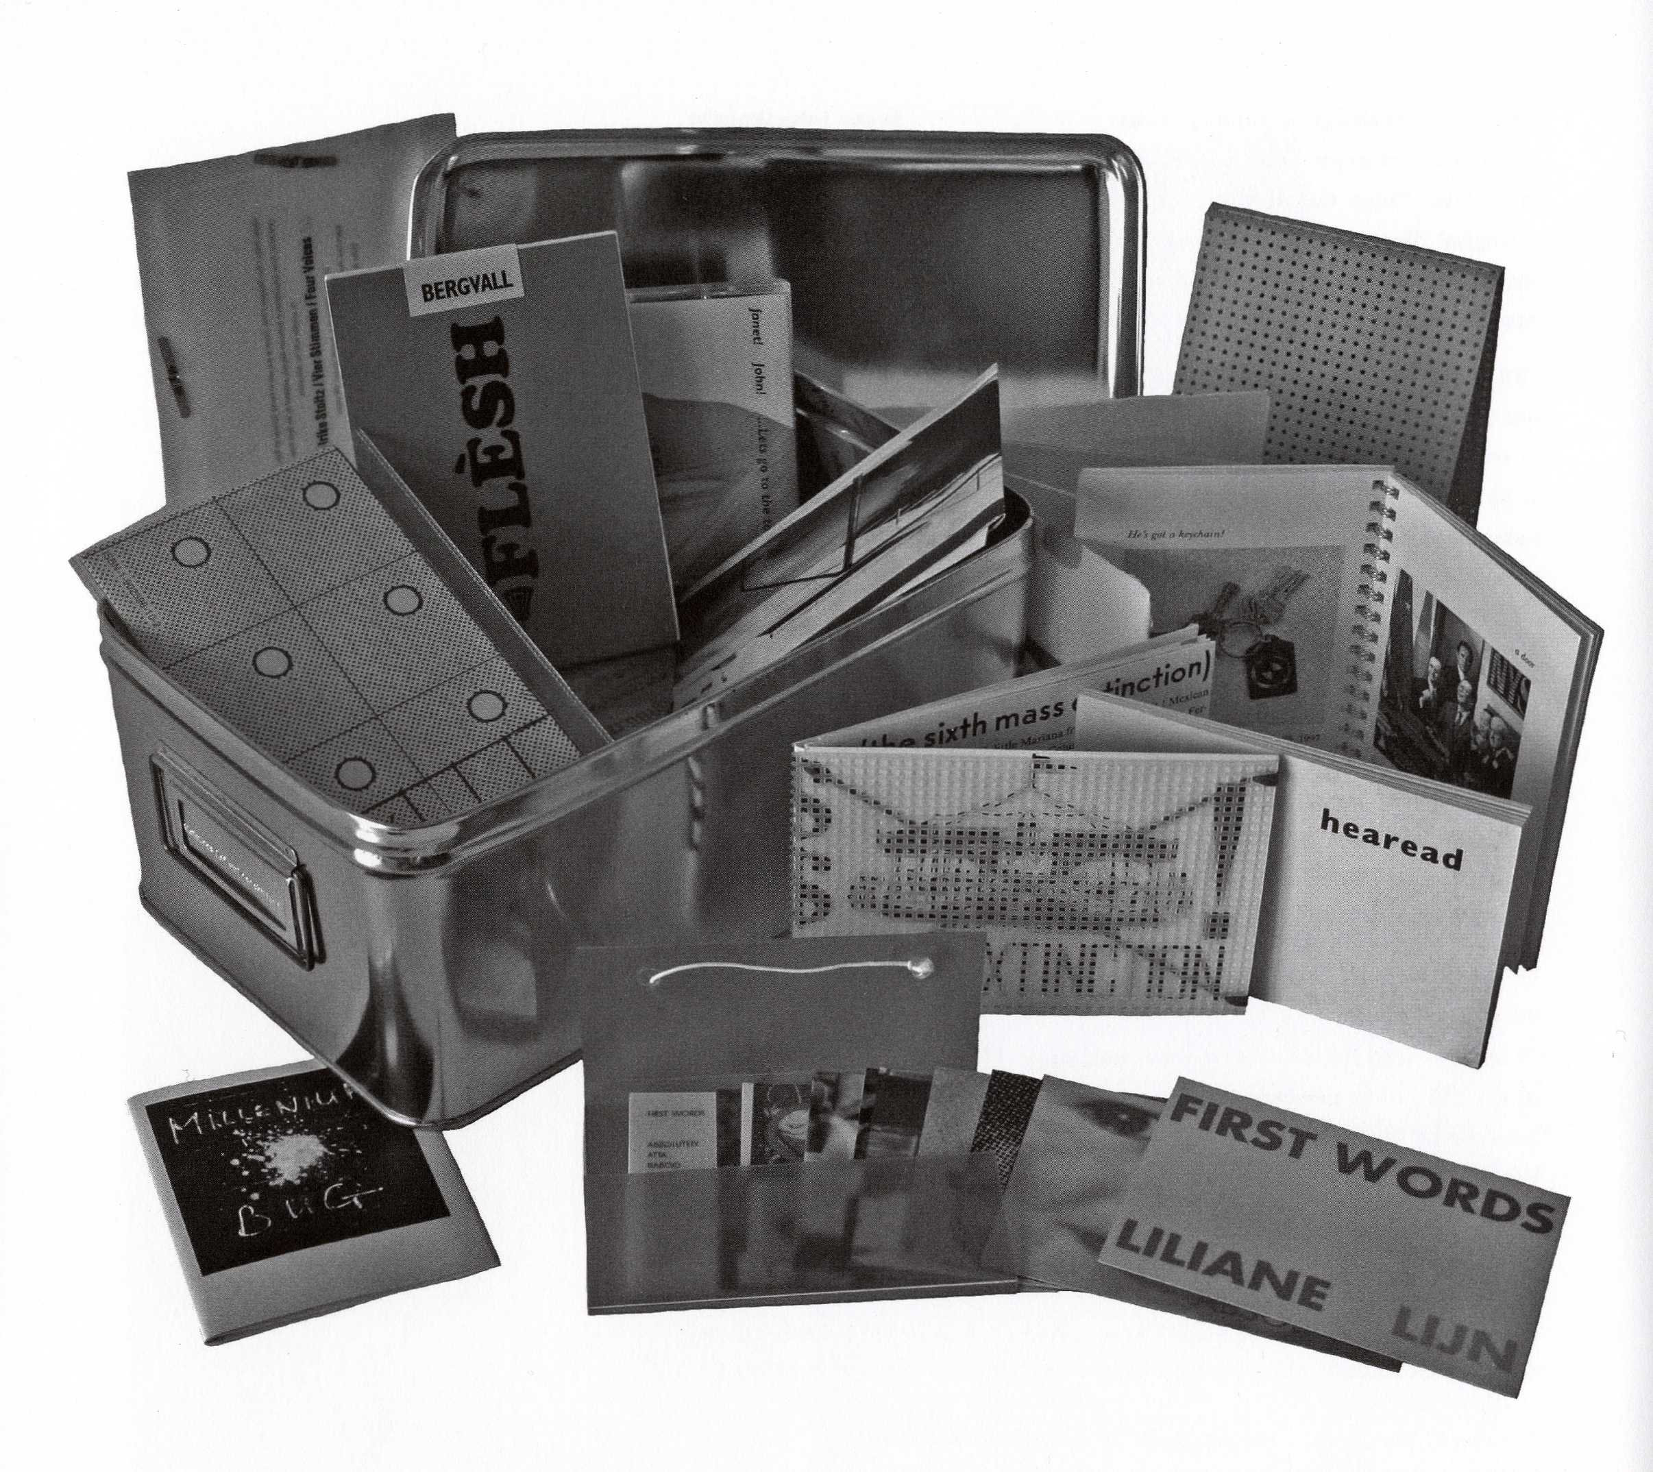

Volumes (of vulnerability). Twenty-three artists’ books contained in a battered tin.

Now available!

Gefn Press
Catalogue Raisonné 1977-2007
with essays by Redell Olsen, Katharine Meynell
and Susan Johanknecht

$25.00

To obtain a copy, please contact us:

Special Collections
Bailey/Howe Library
538 Main Street
Burlington, VT 05405
802-656-2138
uvmsc@uvm.edu

