The Friends of Special Collections,
the Center for Research on Vermont,
and the New England Archivists

are pleased to present

Katherine Paterson

speaking on

“Why Historical Fiction?”

Friday, October 14, 2005

Billings North Lounge
5:00 to 8:00 P.M.

University of Vermont

Katherine Paterson is the critically acclaimed author of fourteen novels for children and young adults. She has won numerous awards, including two Newbery Medals, two National Book Awards, and the prestigious international Hans Christian Andersen Medal. Her books are set in a variety of places and time periods, including feudal Japan, China, and contemporary Virginia. Lyddie, Jip: His Story, and Preacher’s Boy are stories about nineteenth-century Vermont children.

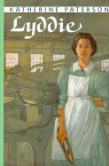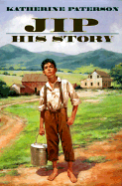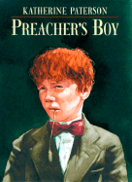

Appetizers will be provided, and there will be a cash bar.
For more information, please call 802-656-2138 or e-mail uvmsc@uvm.edu.

