Name ____________________________ Date ______________ Pre-assessment / Post-assessment

(Please circle one above.)

SWAC – Weather Balloon Launch Workshop KEY

1. How do scientists actually study conditions in the atmosphere? Try to add at least 3 different ideas.

*Starter idea: weather balloons*

ANSWERS WILL VARY BUT COULD INCLUDE:

1. SATELLITES (GOES AND POES)
2. DOPPLER RADAR
3. DIRECT WEATHER OBSERVATIONS (CLOUD FORMATION, WEATHER STATIONS, PILOT OBSERVATIONS, ETC.)
4. UPILOTED DRONES
5. HUMAN FREE FALL JUMPS
6. Does the atmosphere have “layers?” Why or why not?

* YES, THE ATMOSPHERE HAS LAYERS.
* FROM THE GROUND TO SPACE THEY ARE: TROPOSPHERE, (TROPOPAUSE), STRATOSPHERE, (STRATOPAUSE), MESOPHERE, (MESOPAUSE), THERMOSPHERE, (THERMOPAUSE), EXSOPHERE
* THE LAYERS ARE DIFFERENTIATED BY THE ALTERNATING DIRECT AND INVERSE RELATIONSHIPS BETWEEN TEMPERATURE AND ALTITUDE.
  + TEMPERATURE DECREASES WITH INCREASING ALTITUDE IN THE:
    - TROPOSPHERE (HEATED FROM THE “BOTTOM UP”) AND
    - MESOPSHRE (FEW MOLECULES TO RETAIN HEAT)
  + TEMPERATURE INCREASES WITH INCREASING ALTITUDE IN THE:
    - STRATOSPHERE (HEATED WHEN OZONE ABSORBS UV RADIATION) AND
    - THERMOSPHERE / EXOSPHERE (HEATED BY INTENSE EMR)
  + TEMPERATURE REMAINS STEADY WITH INCREASING ALTITUDE IN THE “PAUSES”

1. Using what you know, please **draw a line or curve** to show what happens to each variable (temperature and pressure) as you **increase in altitude** in the atmosphere.

***Atmospheric Temperature vs. Altitude Atmospheric Pressure vs. Altitude***

*ALTITUDE*

*low high*

*cold warm*

*TEMPERATURE*

C:\Documents and Settings\lenorovitzk\Local Settings\Temporary Internet Files\Content.IE5\740YPR8E\MC900083557[1].wmf

C:\Documents and Settings\lenorovitzk\Local Settings\Temporary Internet Files\Content.IE5\YZ98YGFI\MC900232066[1].wmf

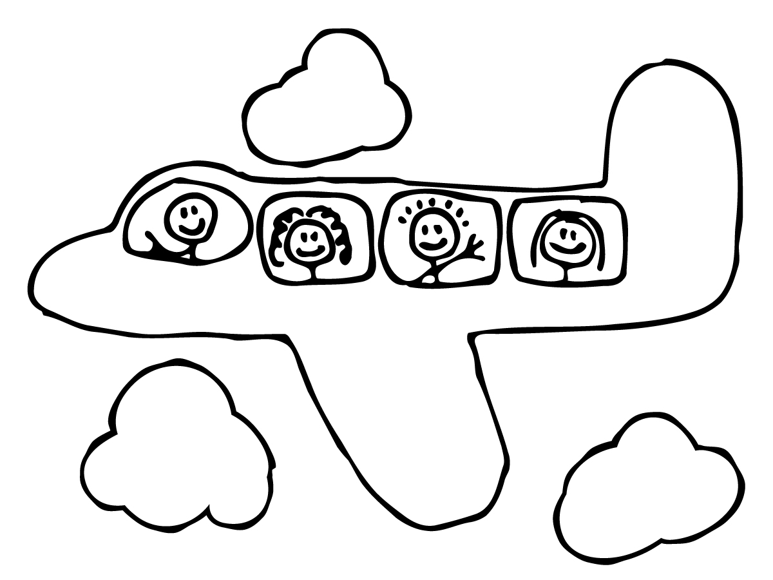

*ALTITUDE*

*low high*

*low high*

*PRESSURE*

C:\Documents and Settings\lenorovitzk\Local Settings\Temporary Internet Files\Content.IE5\YZ98YGFI\MC900232066[1].wmf

C:\Documents and Settings\lenorovitzk\Local Settings\Temporary Internet Files\Content.IE5\740YPR8E\MC900083557[1].wmf



1. What kind(s) of information do weather balloons help meteorologists collect? Why are they helpful?

* WIND SPEEDS AND DIRECTIONS IN BOTH THE UPPER AND LOWER ATMOSPHERE
* TEMPERATURE
* DEW POINT

1. How do scientists “get” the information collected by a weather balloon?

* COMMUNICATED BY RADIO SIGNAL

1. Use the information below to fill in the blanks on the following chart.

|  |  |  |  |
| --- | --- | --- | --- |
| **(how to convert)** | **🡪 (°F – 32) x 5/9 = °C 🡪 °C + 273 = K**  **°F = (°C x 9/5 ) + 32** 🡨 **°C = K - 273** 🡨 | | |
|  | **Temperature (°F)** | **Temperature (°C)** | **Temperature (K)** |
| **melting point of water** | 32 | 0 | 273 |
| **human body temperature** | 98.6 | 37 | 310 |
| **boiling point of water** | 212 | 100 | 373 |

1. Why might scientists choose to use the Kelvin (K) scale to communicate temperature data?

* KELVIN IS A CLEANER WAY TO COMMUNICATE COLDER TEMPERATURES BECAUSE IT DOESN’T REQUIRE NEGATIVE NUMBERS.
  + IN A WEATHER BALLOON LAUNCH, IT FACILITATES COMMUNICATING THE COLDER TEMPERATURES OF THE UPPER ATMOSPHERE AS TONES VIA RADIO SIGNAL.

1. How might you incorporate a weather balloon launch into your teaching?

ANSWERS WILL VARY

1. Please answer the appropriate questions below:
   1. What’s one thing you hope to gain from today’s workshop? (pre-assessment only)
   2. What’s one thing you did gain from today’s workshop? (post-assessment only)
   3. What questions do you have after today’s workshop? (post-assessment only)

ANSWERS WILL VARY