Predicting Impacts of Future Human Population Growth and Development on Forest-Dependent Species

Running head:

Keywords:

MICHELLE L. BROWN*†, THERESE M. DONOVAN‡, SCOTT, AND THEOBALD?

*Vermont Cooperative Fish and Wildlife Research Unit, University of Vermont, Aiken Center, Burlington, Vermont, 05405, USA

‡U.S. Geological Survey, Vermont Cooperative Fish and Wildlife Research Unit, University of Vermont, Aiken Center, Burlington, Vermont, 05405, USA

†email mbrown19@uvm.edu

Abstract: Forest loss and fragmentation are among the largest threats to forest-dwelling wildlife species today and projected increases in human population growth are expected to increase forest loss and fragmentation in the next century. We combined spatially-explicit human growth models with wildlife distribution models to predict the effects of human development on the ovenbird (Seiurus aurocapillus), a forest-dependent species in Vermont. Using single-species occupancy models, we derived the probability of occupancy for ovenbird across Vermont. We used a spatially-explicit growth model to simulate human population growth for each decade through the year 2050. At each decade time interval, we applied the species occupancy models to the “new” landscape and analyzed the effect of increased development on ovenbird. In the face of predicted human growth, the overall occupancy of ovenbird decreased by 1% in Vermont through the year 2050. Although the mean average decline in occupancy was low, up to 36% of ovenbird occupancy was lost in certain places, highlighting the value of spatially-explicit models. Reduced habitat amount centered on the perimeters of cities and towns and decreased the large forest cores in the center of Vermont. This spatial approach to wildlife planning provides data to evaluate trade-offs between development scenarios and forest-dependent wildlife species viability.

Introduction

Forest loss and fragmentation are among the largest threats to forest-dwelling wildlife species today. These processes can change the distribution and abundance of wildlife, as well as critical population parameters such as birth rates, mortality rates, and movement (Lindenmayer and Franklin 2002); Fahrig 1998). It has been suggested that forest loss has the greatest consequence to species viability (Lindenmayer and Franklin 2002) because the distribution of many forest-dwelling species is dependent on amount of forestland (Hargis, Bissonette et al. 1999). Habitat amount affects population structure and the ability of species to disperse to other viable habitat patches and maintain healthy subpopulations (Forman 1995; Chapin, Harrison et al. 1998). Per capita birth rates, nesting success, and abundance of nesting success have been correlated with amount of forested habitat (Donovan and Flather 2002; Cornell and Donovan In review). Landscapes with low amounts of forest cover have significantly more nest predation than unfragmented landscapes (Robinson, Frank et al. 1995; Donovan, Jones et al. 1997) as well as altered bird distribution and population structure (Rosenberg, Lowe et al. 1999). As habitat patch size decreases, not only is the total amount of available habitat smaller, but the functional area of available habitat may also be smaller.
Similar to forest loss, forest fragmentation can also have negative effects on wildlife. Perhaps the most detrimental fragmenting feature in the northeast is roads. Roads have been shown to modify species behavior altering immigration and emigration of animals’ populations and gene flow between subpopulations (Kasworm and Manley 1990; Forman, Sperling et al. 2003; Beazley, Smandych et al. 2005). Direct mortality from road kill can also have population level consequences for wildlife (Forman 1995; Forman, Sperling et al. 2003).
Forest loss and fragmentation are expected to increase as human populations grow in the northeast. Vermont is predicted to grow 16.9% between the years 2000 and 2030 (U.S. Census). This population growth will increase the conversion rates of forest and likely the degradation of forest-dependent wildlife. Importantly, it is not the growth rate of the human population, but growth rate of developed land cover classes that most threatens wildlife in Vermont. Currently, the rate of land conversion is happening 260 times faster than population growth (Sprawl 1999), and for the first time in over a century, a negative trend in forest cover change is being observed (Foster, Donahue et al. 2010). The drivers of this negative trend vary geographically, but a common cause for modern forest loss across New England is the permanent conversion of forest to developed parcels (Foster, Donahue et al. 2010).
Wildlife biologists are pressed to estimate the risk fauna populations will face in response to this projected human growth and growth in developed land cover classes. They are responsible for setting quantitative targets for the management of species populations (i.e. population size) and they need to understand how projected human growth and development will affect their ability to meet those targets. In the absence of planning for projected human growth and development, species face the risk of decreased viability due to habitat loss.
Because many wildlife species are responsive to both forest loss and fragmentation, there is a great need to understand where human growth and development is going to occur, and to develop quantitative metrics that allow decision makers to link these changes with changes in forest-dependent wildlife species. The goals of our study were to spatially quantify projected increases in human housing units in Vermont to the year 2050, forecast potential landscape change scenarios based on projected human housing growth, and quantify the changes in probability of occupancy for ovenbird, a forest-dependent species in Vermont.

Methods

Human Housing Density Projections

Projections of human housing density in Vermont were derived from the Spatially Explicit Growth Model (SERGoM) (Theobald 2005; EPA 2009). SERGoM used historic population data and growth patterns to project housing density at 10-year intervals from the years 2000 to 2050. Overall, there were two main components to SERGoM, calculating current housing density and calculating future housing density. The first phase of SERGoM estimated historic and current housing density on the landscape (defined as the number of housing units per hectare; Figure 2g) in three steps. First, the number of housing units per census block in the year 2000 was obtained from the U.S. Census Bureau (Figure 2a). The number of housing units per census block was determined by census data, but the spatial allocation of those housing units within the census block was not specified. To make these spatially explicit so the final output is the number of housing units per hectare, SERGoM used a GIS raster that reflected historic patterns of growth upon which the new housing units were allocated (Figure 2j). Step 2, required the identification of land potentially available for development (Figure 2e). Water features such as lakes, reservoirs, and wide rivers were removed to ensure no housing units are placed on those features (Figure 2c). Like the water features, housing units should not be placed on lands that prohibit development like parks and other public lands (Figure 2b). Finally, step 3 reflected the influence of roads on the spatial distribution of housing units within a census block. Existing major roads (Figure 2d) were converted to road density, defined as the density of roads within 800 meters of any pixel (Figure 2f), where open lands with a high road density tend to be more readily developed. Thus, the final allocation of housing units per hectare for year 2000 (Figure 2g) will be the result of developable lands and road density.
The second phase of SERGoM estimated projected housing density for each hectare for the next time step (Figure 2l). SERGoM used a county-level population forecast (Figure 2k) to estimate the increased population size for each county. This was a non-spatial rate of growth and needed to be applied spatially in terms of housing units per hectare. Two factors contributed to the spatial allocation of new housing units. The first was the historic rate of growth for that pixel (Figure 2h), derived from current and historic housing density. The second factor was proximity to urban areas (Figure 2i), expressed in the amount of travel time from an urban center along roads (0-10, 10-30, 30-60, and >60 minutes). The average growth rates were computed per pixel by using a GIS moving neighborhood analysis for the combined land cover classes. This resulted in a GIS raster that reflected historic patterns of growth called allocation weights (Figure 2j). New housing units were allocated based on this new raster. The final step in forecasting future housing unit density was to add the newly allocated housing units to a map of current housing units. In other words, the calculated housing units for time t + 1 were added to the housing units at time t. The final outputs from SERGoM were spatially-explicit GIS rasters showing the predicted number of housing units per each one hectare pixel across the state of Vermont each decade from the years 2000 – 2050 (Figure 3).
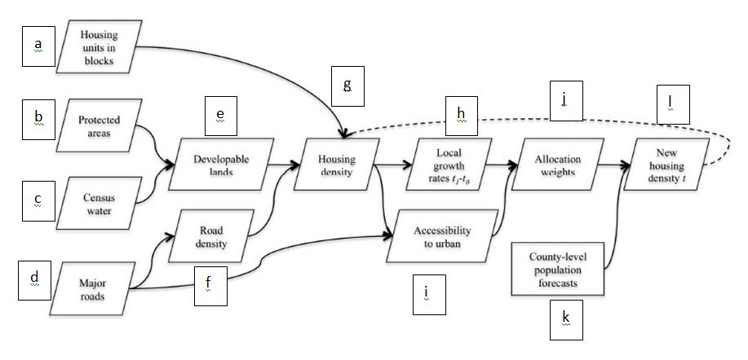 Figure 2. The functional flow of SERGoM illustrating how the model works (based on EPA 2009).

Ovenbird Occupancy Model

The ovenbird is a common bird throughout eastern North American forests. It is characterized as a forest-interior species that may prefer climax forests, lots of structure, high canopy closure (60 – 90%), and large blocks of continuous forest (McGowan and Corwin 2008). While limited forest amount has a demonstrated negative impact on ovenbird fecundity, recent work has highlighted the contribution of other variables, like roads and behavior, to nesting success (Ortega and Capen 1999).
We developed a single-species occupancy model for ovenbird based on Schwenk and Donovan (in press). Occupancy models utilize a likelihood framework to estimate the probability of a species occurring in a landscape (psi), the probability of detecting a species, and the effect of environmental covariates on species occupancy (Burnham and Anderson 2002). Birds were observed at 693 points across Vermont and environmental covariates were generated at these same locations. Thirty-two a priori models were generated for ovenbird based on six covariates that reflected major habitat features likely to be important for multiple species, human influences on the landscape, and that were not highly correlated (Schwenk and Donovan in press): forest (binary), topographic wetness index (TWI), distance to edge, percent evergreen forest within 300m, percent forest, and road density (Table 1).

Table 1. Covariates used in ovenbird occupancy model.
Covariate | Description | Scale
Forest | Binary value of whether the point was forested | 25m radius
TWI (Topographic Wetness Index) (Theobald 2007) | Continuous variable of local landforms and water retention | 30m pixel
Edge | Distance from the point to the nearest edge of different land cover | 0 – 1000m
Evergreen | Percent evergreen forest within 300m | 300m radius
Percent forest | Percent forest cover within 1km | 1km radius
Roads | Road density within 1km | 1km radius

The equation for the model containing all occupancy covariates was:

logit(ψ) = β₀ + β₁(forest) + β₂(TWI) + β₃(TWI)² + β₄(edge) + β₅(edge×forest) + β₆(evergreen) + β₇(evergreen)² + β₈(Percent_forest) + β₉(Percent_forest)² + β₁₀ (roads) + β₁₁ (roads)²

The quadratic terms, which were always paired with their corresponding unsquared terms, allowed assessment of a nonlinear relation between the covariates and occupancy. The edge×forest interaction term, always paired with edge, allowed the relation between occupancy and edge distance to vary as a function of whether the point was located in a forest patch.
The models were evaluated in a multimodel inference framework with Akaike’s Information Criterion (AIC; Burnham and Anderson 2002). Rather than identifying a single “best” model, we drew inferences from the full model set. The support for each model was represented by its AIC weight and the sum of the AIC weight for all models equaled 1. We used the weights to calculate model-weighted average betas for each covariate across all individual sites and for the entire study area (for the models comprising the top 95% of model weight). We assessed model fit by running bootstrap goodness-of-fit tests (MacKenzie and Bailey 2004) for the ovenbird in program PRESENCE (Hines and MacKenzie 2004).

Landscape Change Scenarios

We assumed that if human housing density was increasing in the landscape, some other land class was decreasing. We evaluated three landscape change scenarios to examine how the increase in percent developed land class can result in forest loss and fragmentation. The first scenario assumed that all of the predicted development occurred in forestland. The second scenario assumed that 40% of the predicted development occurred in forestland and 60% occurred in agriculture, which follows how past development has occurred in Vermont (Vermont Forum on Sprawl). The third scenario changed the landscape in the same proportion that it existed in 2000; roughly 75% forest cover, 2% developed cover, and 13% agriculture.
To accomplish this objective, we reclassified the National Land Cover Dataset (NLCD) into developed (1) and non-developed (0). There are four developed land classes in the NLCD: open space, low intensity, medium intensity, and high intensity differentiated by the percent of total cover within a pixel (Homer, Huang et al. 2004). Open space is defined as areas with mostly lawn vegetation and impervious surfaces that account for <20% of the total cover in a given pixel. Low intensity cover types contain a mix of vegetation and constructed materials with impervious surfaces that account for between 20 – 49% of total cover. Medium intensity land cover is defined as areas of mixed constructed materials and vegetation with impervious surfaces that account for between 50 – 79%. Lastly, the high intensity class is defined as highly developed areas where people work or reside in high numbers and impervious surfaces account for between 80 – 100% of total cover. We combined the low, medium, and high intensity classes into one developed class and calculated the mean percent development within a 1km window for each pixel.
We used logistic regression to estimate the statistical relationship between road density within a 1km area and percent development within a 1km area. Then we used this statistical relationship to forecast spatially the changes in percent development through the year 2050. To calculate the total amount of change in developed land between 2000 and 2050 we subtracted the 2050 developed dataset from the 2000 developed dataset. Finally, using the difference in development as the absolute amount of change, we used the three landscape change scenarios to determine how much of each cover class to reduce in the landscape. The first scenario assumed all the increases in development occurred on forest, the second scenario assumed the increases in development occurred on 40% forestland and 60% agriculture, and the third scenario reduced forest cover by 75%, and agriculture by 13%.

Predicted Change in Ovenbird Occupancy

To examine the change in ovenbird occupancy based on projected increases in human housing density we applied the ovenbird occupancy models to two time periods of human housing density, the years 2000 and 2050. To accomplish this, we converted human housing density to road density. This was for two reasons; the ovenbird model was derived using road density in 30m² pixels and the effects of development to wildlife are described in the literature using road density and land cover, not number of human housing units. We used logistic regression to estimate the statistical relationship between the number of housing units within a 1km area and the road density within a 1km area. Then we used this statistical relationship to forecast spatially the increases in road density through the year 2050.
To create a new occupancy model for ovenbirds in 2050 we used the original ovenbird occupancy logit formula, but replaced the roads data from 2000 with the new roads data from 2050 and replaced the percent forest cover from 2000 with the new percent forest cover from 2050 for each of the landscape change scenarios. The new equation for ovenbird occupancy in 2050 was:

logit(ψ) = β₀ + β₁(forest) + β₂(TWI) + β₃(TWI)² + β₄(edge) + β₅(edge×forest) + β₆(evergreen) + β₇(evergreen)² + β₈(Percent_forest_2050) + β₉(Percent_forest_2050)² + β₁₀ (roads_2050) + β₁₁ (roads_2050)²

Conserved Lands and Ovenbird Habitat – use Terri’s clique paper

We are currently considering using a recently accepted paper to go one step further. We would analyze how much habitat is available for populations of ovenbirds. In other words, right now we know the probability of occupancy, but this is not related to species viability. We could assess how the probability of occupancy relates to the viability of the species and suggest how much current conserved land is contributing to ovenbird populations. This is appealing to me because it adds a direct conservation implication....

Results

Human Housing Density Projections

We developed human housing density projections for each decade between the years 2000 and 2050. The pattern of development in Vermont is predicted to follow similar development patterns as in other parts of the United States (Theobald xxxx). The areas outside of cities and towns are expected to gain the most housing units, whereas many rural places in Vermont are not predicted to grow at all. Chittenden County is expected to see the most growth with the highest human housing densities from 7295 housing units per km to 7537 housing units per km.

Ovenbird Occupancy Model

The average probability of ovenbird occupancy across Vermont was 59% for the year 2000. We used the year 2000 as our baseline year from which to compare change because it most closely represents when the ovenbird data were collected in the field (2003-04), the “current” state of the housing density data, and a close approximation of when the NLCD dataset was created (2001), which derived many of the ovenbird model covariates.
Of the 32 models, 13 contributed to the 95% model set, and were used to calculate the model-averaged betas for ovenbird occupancy. In terms of the strengths of the covariates in predicting whether an ovenbird would be found at a random site, forest presence, percent forest cover, and percent conifer cover with 300m were the best predictors (Table x). In general, occupancy probability was greatest when the site was forested, contained greater than 80% forest cover, and 35% conifer cover.

Table x. Parameter estimates for model-averaged betas obtained through maximum-likelihood analysis of ovenbird.
Parameter | Beta estimate
Psi intercept | -3.053
Topographic Wetness Index | 0.024
Topographic Wetness Index² | -0.004
Edge Distance | -0.010
Forest * Edge | 0.011
Percent Forest (1km) | 5.773
Percent Forest (1km)² | -2.958
Road density (1km) | -0.071
Road density (1km)² | -0.008
Percent conifer | 2.804
Percent conifer² | -4.204
Forest (binary) | 1.055

Landscape Change Scenarios

The model that best predicted the relationship between mean road density and mean percent developed land classes in a 1km radius window explained approximately 75% of the variance (R² = 0.7533, P < 0.0001). We used this model to develop future land scenarios that resulted from predicted housing unit development. The overall mean proportion of roads increased from 1.09 roads per km to 1.30 roads per km, and the maximum amount of road density present anywhere in the study area increased from 10.85 to 15.25 roads per km. The mean proportion of developed land increased from 2% to 3%. For the three landscape change scenarios, the most dramatic forest loss was observed at roughly 1% when all development increase occurred on forestland.

Predicted Change in Ovenbird Occupancy

Ovenbird occupancy was predicted to decrease by 1% on average across the study area, from about 59% average occupancy to 58% average occupancy. In some places in Vermont, ovenbird occupancy declined by as much as 36% (Fig. 1). Most of the changes in predicted ovenbird occupancy occurred on the outskirts of cities and towns. In general, the predicted impact of the landscape change scenarios on ovenbird occupancy was greatest in the scenarios that “developed” at least 75% of the forestland.
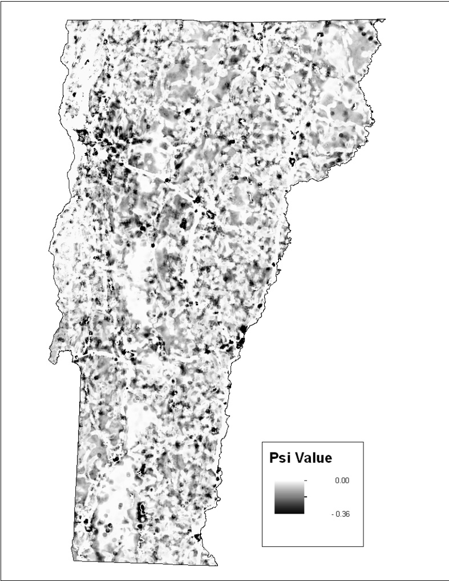
Fig. 1. The change in probability of ovenbird occupancy between the years 2000 and 2050 in Vermont.

Ovenbird Population Viability and Conserved Lands

I think we need to do this, especially given the overall occupancy reduction is so low on average across the state. This could help make a case for species viability and conservation (versus solely occupancy) and much of the predicted development increases are happening on the fringe on conserved lands.

Discussion

Recent studies suggest that urban land in the United States is projected to increase by 5% and forestland is projected to decrease by about the size of Pennsylvania in the next 50 years (Nowak and Walton 2005). Given these development and forest loss trends, the viability of native fauna is threatened. The question of how wildlife will respond to eminent land-use change is widespread, and requires tools and methods for understanding population responses as well as management recommendations for conservation. This study integrated wildlife habitat modeling with GIS models of human population growth and quantified how ovenbird will respond to projected increases in human population growth for the state of Vermont. The results provide decision-makers with replicable, spatially explicit information (GIS layers) about the risks of development that largely, to date, have been unavailable. These tools will allow pro-active and adaptive land planning in Vermont.
- Need to make a case for why this is important given the extremely small predicted changes in Vermont
- Need to discuss assumptions and limitations of models and highlight why spatially-explicit models are important for planning (i.e. low change overall, but high change in certain places)
- Need to discuss conservation implication of development encroaching on large forest blocks
- Need to clarify the difference between spatially explicit land use change models and landscape change scenarios
- Incorporate ex-urban development story in introduction and discussion
Literature Cited (Need to add McGarigal and Kays)
Beazley, K., L. Smandych, et al. (2005). "Biodiversity Considerations in Conservation System Planning: Map-Based Approach for Nova Scotia, Canada." Ecological Applications 15(6): 2192-2208.
Burnham, K. P. and D. R. Anderson (2002). Model selection and multimodel inference: a practical information-theoretic approach, 2nd edition. New York, Springer-Verlag.
Chapin, T. G., D. J. Harrison, et al. (1998). "Influence of Landscape Pattern on Habitat Use by American Marten in An Industrial Forest." Conservation Biology 12(6): 1327-1337.
Cornell, K. and T. M. Donovan (In review). "Effects of Spatial Habitat Heterogeneity on Habitat Selection and Demography for a Forest Songbird." Landscape Ecology.
Donovan, T. M. and C. H. Flather (2002). "Relationships among North American Songbird Trends, Habitat Fragmentation, and Landscape Occupancy." Ecological Applications 12(2): 364-374.
Donovan, T. M., P. W. Jones, et al. (1997). "Variation in Local-Scale Edge Effects: Mechanisms and Landscape Context." Ecology 78(7): 2064-2075.
EPA, U. S. E. P. A. (2009). Land-Use Scenarios: National-scale housing-density scenarios consistent with climate change storylines. G. C. R. Program. Washington, DC, National Technical Information Service, Springfield, VA.
Forman, R. T. T. (1995). Land Mosaics: The Ecology of Landscape and Region. Cambridge, United Kingdom, Cambridge University Press.
Forman, R. T. T., D. Sperling, et al. (2003). Road Ecology: Science and Solutions. Washington, D.C., Island Press.
Foster, D. R., B. M. Donahue, et al. (2010). Wildlands and Woodlands: A vision for the New England Landscape. Petersham, MA, Harvard Forest, Harvard University.
Hargis, C. D., J. A. Bissonette, et al. (1999). "The Influence of Forest Fragmentation and Landscape Pattern on American Martens." Journal of Applied Ecology 36(1): 15.
Hines, J. E. and D. I. MacKenzie (2004). "PRESENCE, version 2.0. Available at <www.mbr-pwrc.usgs.gov/software.html>."
Homer, C., C. Huang, et al. (2004). "Development of a 2001 National Landcover Database for hte United State. ." Photogrammetric Engineering and Remote Sensing 70(7): 11.
Kasworm, W. F. and T. L. Manley (1990). "Road and Trail Influences on Grizzly Bears and Black Bears in Northwest Montana." Bears: Their Biology and Management 8: 79-84.
Lindenmayer, D. B. and J. F. Franklin (2002). Conserving Forest Biodiveristy: A Comprehensive Multiscaled Approach. Washington, D.C., Island Press.
McGowan, K. J. and K. Corwin (2008). The second atlas of breeding birds in New York State.
Nowak, D. and J. T. Walton (2005). "Projected Urban Growth (2000-2050) and its Estimated Impact on the U.S. Forest Service. ." Journal of Forestry: 6.
Ortega, Y. K. and D. E. Capen (1999). "Effects of forest roads on habitat quality for ovenbirds in a forested landscape." The Auk 116(4): 937-946.
Robinson, S. K., R. T. Frank, III, et al. (1995). "Regional Forest Fragmentation and the Nesting Success of Migratory Birds." Science 267(5206): 1987-1990.
Rosenberg, K. V., J. D. Lowe, et al. (1999). "Effects of Forest Fragmentation on Breeding Tanagers: A Continental Perspective." Conservation Biology 13(3): 568-583.
Schwenk, W. S. and T. M. Donovan (in press). "A multi-species framework for landscape conservation planning." Conservation Biology.
Sprawl, V. F. o. (1999). Economic, social, and land use trends related to sprawl in Vermont. Burlington, VT.
Theobald, D. M. (2005). "Landscape Patterns of Exurban Growth in the USA from 1980 to 2020." Ecology and Society 10(1): 32.

