**Supporting Information for Publication**

*Title:* Declining Acidic Deposition Begins Reversal of Forest-Soil Acidification in the Northeastern U.S. and Eastern Canada

Gregory B. Lawrence1*, Paul W. Hazlett2, Ivan J. Fernandez3, Rock Ouimet4, Scott W. Bailey5, Walter C. Shortle6, Kevin T. Smith6, and Michael R. Antidormi1

1U.S. Geological Survey New York Water Science Center, 425 Jordan Road, Troy, New York 12180 USA

2 Natural Resources Canada–Canadian Forest Service 1219 Queen St. E., Sault Ste. Marie, Ontario P6A 2E5 Canada

3University of Maine, School of Forest Resources, Deering Hall, Orono, Maine 04469-5722 USA

4Direction de la recherche forestière, ministère des Forêt, de la Faune et des Parcs du Quèbec, Complexe scientifique, 2700 Einstein Street, Quebec City, Quebec G1P 3W8 Canada

5USDA Forest Service, Northern Research Station, Hubbard Brook Experimental Forest, 234 Mirror Lake Road, North Woodstock, New Hampshire 03262 USA

6 USDA Forest Service, Northern Research Station, 271 Mast Road, Durham, NH 03824, USA

**SUMMARY of SUPPORTING INFORMATION**

**Pages: 11**

**Figures: 3**

**Tables: 2**

*Corresponding Author ([glawrenc@usgs.gov](mailto:glawrenc@usgs.gov); phone 518-285-5664; fax 518-285-5601

**Supporting Information**

**Section S1 Methods of Sampling and Analysis**

Soil collections were made in 1985, 1990, and 1995 through the Canadian Forest Service Acid Rain National Early Warning System (ARNEWS) with the specific purpose of measuring soil changes caused by acidic deposition 1. Although no further sampling was done in that program, eight of the permanently marked 0.04 ha ARNEWS plots were resampledin 2009. The plots were originally selectedto provide variation in soils, vegetation and acidic deposition history. At each plot, five sampling stations were re-established to represent the overall plot. Samples of the Oe (F in the Canadian System) were collected with a knife at 10 random locations within an approximate 5-metre radius of each sampling station center stake. Data from the Oe horizon of the four hardwood plots was not used in this paper because at these plots the Oe horizon was too thin to collect without mixing with the underlying mineral soil. For the mineral soil, five soil pits were dug within a 5-meter radius of each sampling station and subsamples of the most abundant A and upper B horizons were collected from each pit face. Oe, A and B horizon samples were composited by station. This sampling design yielded 5 samples for chemical analysis from each horizon (n = 5). Documentation from the previous samplings was used to assure comparable horizon sampling. Sufficient volume of field sample was collected in plastic bags to yield approximately 500 cm3 of fine-earth (<2 mm).

All samples from ARNEWS plots were analyzed at the Great Lakes Forestry Center Laboratory, Sault Ste. Marie, ON. Samples from the Oe horizon were oven dried at 70 o C then ground (< 2 mm). Mineral soil samples were air dried and sieved to remove the > 2 mm fraction prior to chemical analysis. Methods of chemical analysis for samples collected in 2009 were identical to those collected in 1985, 1990 and 1995. Field moist samples were analyzed for pH in 0.01 M CaCl2 by glass electrode 2. Samples collected in 1985, 1990 and 1995 were archived, air-dried, in sealed plastic jars that were stored in a building without temperature control. The archived samples were reanalyzed for exchangeable cations along with the 2009 samples and were used to compare the initial and final sampling. Exchangeable Ca, Mg, K, Na, Fe and Al were determined in unbuffered 1 M NH4Cl solution obtained from a mechanical vacuum extractor 2. Solution concentrations were determined by inductively coupled argon plasma emission spectrometry (ICP). Cation exchange capacity used for the calculation of base saturation was determined by NH4 replacement and titration after distillation 2.

Soils originally sampled in 1992-93 to evaluate acidic deposition effects on red spruce at six locations in NY, VT, NH and ME (Kossuth, ME; Howland, ME; Crawford Notch, NH; Bartlett, NH; Groton, VT, Big Moose, NY) were resampled in 2003-2004. Plots were relocated in 2003-2004 by aluminum tags that had been nailed onto the base of trees within the sampling area during the first sampling. Results of this resampling were presented in Lawrence et al. 3, but are included here for additional analysis and regional comparison. Two additional plots sampled in the red spruce study in 1992-93 were resampled in either 2009 (Sleepers River, VT) or 2010 (BB-TMT, CF). Because the initial sampling at BB-TMT, CF was done in 1992-93, and treatments began in 1989, the percent SO42- reduction was based on deposition data 3-4 years prior to the initial sampling. Samples from the Oa horizon and upper 10 cm of the B horizon were collected in the initial and final samplings to yield 12 samples from each horizon in each sampling (n = 12). Samples collected in 1992-93 were archived, air-dried, in plastic bags within cardboard cartons at room temperature. Samples collected in 1992-93 were analyzed in 1992-94 at the University of Illinois (UI) under the supervision of Mark David. All samples collected in 1992-93 were also archived and reanalyzed in 2007-2008 along with the samples collected in 2003-04, in the USGS New York Water Science Center Laboratory (USGS) under the supervision of Gregory Lawrence. All samples collected in both periods were analyzed for moisture content (oven drying at 65° C and 105° C for organic and mineral samples, respectively), exchangeable Ca2+, Mg2+, Na+ and K+ (unbuffered 1 M NH4Cl vacuum extraction), and pH (0.01 M CaCl2 slurry) following USEPA standard methods 4. Exchangeable Al was determined by 1 M KCl batch extraction and measurement by ICP. Exchangeable acidity was determined by 1 M KCl batch extraction and measurement by titration 5. Exchangeable H was calculated by subtracting exchangeable Al from exchangeable acidity. Data from the USGS laboratory reanalysis was used to compare the initial and final sampling, with the exception of pH and exchangeable H, for which the UI laboratory data was used because previous studies 6-8 had shown changes that suggested possible storage effects. Details of this comparison are given in Lawrence et al. 3.

S1

As part of ongoing Adirondack region monitoring within the Buck Creek drainage, soil samples were collected in 1997 in a mixed-forest watershed and in 1998 in a northern hardwood watershed. In each of these watersheds, samples were collected from the Oa horizon and upper 10 cm of the B horizon at 28 locations distributed along transects perpendicular to the stream channel. Sampling locations were permanently marked with stakes. The mixed forest watershed was resampled in 2009-2010 and the hardwood watershed was resampled in 2014. Samples were analyzed without compositing (n = 28). All samples were analyzed in the USGS New York Water Science Center Laboratory (USGS) using the same methods as the red spruce study described above, with the exception of exchangeable Al, which was analyzed by ICP after batch extraction with 1 M KCl. Exchangeable H was calculated by subtracting exchangeable Al from exchangeable acidity. Distinguishing between Oa and A horizon soil in the field was difficult in some profiles in the hardwood watershed. Laboratory analysis identified carbon concentrations less than 20 percent in two samples identified in the field as Oa in the 1998 sampling and five samples identified in the field as Oa in the 2014 sampling. These samples were excluded from this analysis, which resulted in n = 26 for 1998 Oa samples, and n = 23 for 2014 Oa samples.

Samples from the original Buck Creek collections were archived in plastic bags at room temperature. Analysis of a subset of archived samples from the original collections (15 Oa, samples and 14 B samples collectively from the HW and MF watersheds) was done in conjunction with analysis of the final collections to evaluate the possibility of analysis bias between initial and final collections. Significant differences (P < 0.10) determined by paired t-tests were found for exchangeable Al in Oa samples, and exchangeable Al, Ca and K in B horizon samples. Values obtained for the analyzed subset of archived samples were used to replace original data. To adjust data for original samples not reanalyzed, linear regression was used to develop equations that related original data to data obtained from the recent analysis of archived samples. A relatively small (original pH=3.78; archive pH=3.66), but significant difference (P < 0.01) was also observed for B horizon pH, but original data were not adjusted because of the potential for storage effects, as discussed above.

Soil sampling at the treated (BB-TMT) and untreated (BB-REF) Bear Brook, ME watersheds was also done in 1996 at 10 locations each in hardwood and softwood stands within each watershed. Samples were collected from the O and upper 5 cm of the B horizons using the quantitative pit approach (71 x 71 m frame) as detailed in Fernandez et al. 9 to yield 10 samples from each horizon for each watershed and stand type (n=10). In 2006, resampling was done at all 40 locations, approximately 2 m east of the original pit located as a measured distance and aspect from grid point stakes. In the resampling, the O was quantitatively sampled with a 30 cm x 30 cm frame, and the B horizon sample was collected from a pit face. Soil samples were air-dried, sieved (2-mm sieve for mineral soils; 6-mm sieve for organic soils), and homogenized prior to sub-sampling for analysis. Sub-samples were oven-dried at 105◦C and 70◦C for mineral and organic soils. Soils were analyzed for pH using 0.01 M CaCl2 10. Exchangeable base cations (Ca, Mg, K, Na, and Al), were extracted with unbuffered 1 M NH4Cl and measured by ICP at the Maine Agricultural and Forest Experiment Station Analytical Laboratory. Exchangeable acidity was extracted with 1 M KCl and measured by titration 5. Exchangeable H was calculated by subtracting exchangeable Al from exchangeable acidity. All sampling, resampling and chemical analysis was done under supervision of Ivan Fernandez.

S2

Soil sampling at the Duchesnay Experimental Forest Station was done as part of a forest acidification and alkalinization experiment in 1990 11. In the present project, soils were sampled in the two control plots in June 1989. Four replicates of complete O horizon (Oe and Oa) were collected per plot (n=8) and two replicates were collected per plot from the upper 10 cm of the B horizon n=4). In 2009, 8 replicates were collected from each plot for both O and upper 10 cm of the B. At the Laurentian Forestry Center Laboratory, soil pH was measured with deionized water at a soil:solution mass ratio of 1:2.5. Exchangeable cations (Ca, Mg, K, Na, Al and H) were extracted with unbuffered NH4Cl solution (1 M, 12 h vacuum extraction) and measured by ICP except for H (measured by pH probe). Exchangeable acidity was determined by summing the H and Al concentrations of the extracts. The original samples were archived in a heated warehouse. Analyses that compared the original and recent analyses of the original (initial) soil samples showed no differences other than an increase in pH (by 0.35 unit) , which was considered a storage effect. Thus the recent analyses of the original soil samples were used to compare with the recently collected (final) soil samples, with the exception of pH.

In a regional study of sugar maple health and growth study, plots were established in mature northern hardwood forests (Hubbard Brook and Jeffers Brook, NH, Sleepers River and Mount Equinox, VT). Based on reconnaissance soil observations, one representative pit per stand was described and sampled by genetic horizon in 1996-1998. Pits were backfilled and marked by an aluminum cap over a piece of buried rebar and precisely located by GPS with post-processing to achieve meter level precision. In 2009, the original sampling sites were relocated and new pits established approximately 2m from the edge of the original pit in each of four cardinal directions. Soil profile description and sampling by genetic horizon followed original protocols as described in Hallett et al. 12 and Long et al. 13. Samples from both periods were analyzed for pH in a 0.01M CaCl2 solution and extractable cations by ICP following vacuum extraction with 1M NH4Cl.

S3

**References for Supporting Information**

1. D'Eon, S. P.; Power, J. M. *The Acid Rain National Early Warning System (ARNEWS) plot network. Inf. Rep. PI-X-91*; Canadian Forest Service, Petawawa National Forestry Institute Chalk River, Ontario, 1989.

2. Kalra, Y. P.; Maynard, D. G. *Methods manual for forest soil and plant analysis. Northw. Region Inf. Rep. NOR-X-319. Forestry Canada, Northern Forestry Center, Edmonton, AB*; 1991.

3. Lawrence, G. B.; Shortle, W. C.; David, M. B.; Smith, K. T.; Warby, R. A. F.; Lapenis, A. G. Early indications of soil recovery from acidic deposition in U.S. red spruce forests. *Soil Sci. Soc. Am. J.* **2012,** *76*, 1407-1417.

4. Blume, L. J.; Schumacher, B. A.; Schaffer, P. W.; Cappo, K. A.; Papp, M. L.; van Remortal, R. D.; Coffey, D. S.; Johnson, M. G.; Chaloud, D. J. Handbook of methods for acid deposition studies: Laboratory analyses for soil chemistry. In U.S. Environmental Protection Agency, EPA/600/4-90/023: Washington, D.C., 1990.

5. Thomas, G. W. Exchangeable cations. In Methods of Soil Analysis, part 2. In *Agronomy No. 9*, 2nd ed.; Page, A. L., Ed. ASA: Madison, WI, 1982; pp 159-166.

6. Bailey, S. W.; Horsley, S. B.; Long, R. P. Thirty years of change in forest soils of the Allegheny Plateau, Pennsylvania. *Soil Sci. Soc. Am. J.* **2005,** *69*, (3), 681-690.

7. Blake, L.; Goulding, K. W. T.; Mott, C. J. B.; Poulton, P. R. Temporal changes in chemical properties of air-dried stored soils and their interpretation for long-term experiments. *Eur. J. Soil Sci.* **2000,** *51*, 345-353.

8. Billett, M. F.; Parker-Jervis, F.; Fitzpatrick, E. A.; Cresser, M. S. Forest soil chemical changes between 1949/50. *J. Soil Sci.* **1990,** *41*, (1), 133-145.

9. Fernandez, I. J.; Rustad, L. E.; Lawrence, G. B. Estimating total soil mass, nutrient content and trace metals in soils under a low elevation spruce-fir forest. *Can. J. Soil Sci.* **1993,** *73*, 317-328.

10. Fernandez, I. J.; Rustad, L. E.; Norton, S. A.; Kahl, J. S.; Cosby, B. J. Experimental acidification causes soil base cation depletion in a New England forested watershed. *Soil Sci. Soc. Am. J.* **2003,** *67*, 1909-1919.

11. Ouimet, R.; Moore, J.-D.; Duchesne, L. Effects of experimental acidification and alkalinization on soil and growth and health of Acer saccharum Marsh. *J. Plant Nutr. Soil Sci.* **2008,** *171*, 858-871.

12. Hallet, R. A.; Bailey, S. W.; Horsley, S. B.; Long, R. P. Influence of nutrition and stress on sugar maple at a regional scale. *Can. J. For. Res.* **2006,** *36*, 2235-2246.

13. Long, R. P.; Horsley, S. B.; Hallet, R. A.; Bailey, S. W. Sugar maple growth in relation to nutrition and stress in the Northeastern United States. *Ecol. Appl.* **2009,** *19*, 1454-1466.

S4

**Table S1**. Forest type, U.S. and Canadian Soil Great Groups and horizons sampled at each study site. BB stands for Bear Brook; TMT stands for BB sites that received experimental additions of (NH4)2SO4annually. REF refers to untreated sites at BB. CF stands for northern conifer stands; HW northern hardwood stands; MF stands for mixed conifer-hardwood stands.



S5

**Table S2**. Mean values (initial – final) and results of tests for differences between intial and final measurements for O, A and upper B horizons for (a) Ca, and BS (base saturation), and (b) pH and Al, for each soil investigation. P values > 0.10 are indicated as ns (not significant). Boxes with dashed lines indicate no data. BB stands for Bear Brook; TMT stands for BB sites that received experimental additions of (NH4)2SO4annually. REF refers to untreated sites at BB. CF stands for northern conifer stands; HW northern hardwood stands; MF stands for mixed conifer-hardwood stands.

a.



S6

b.



S7

**Figure S1**. Location of soil resampling investigations in eastern Canada and the northeastern United States. Two resampling investigations were done at Buck Creek and Sleepers River and five resampling investigations were done at Bear Brook.

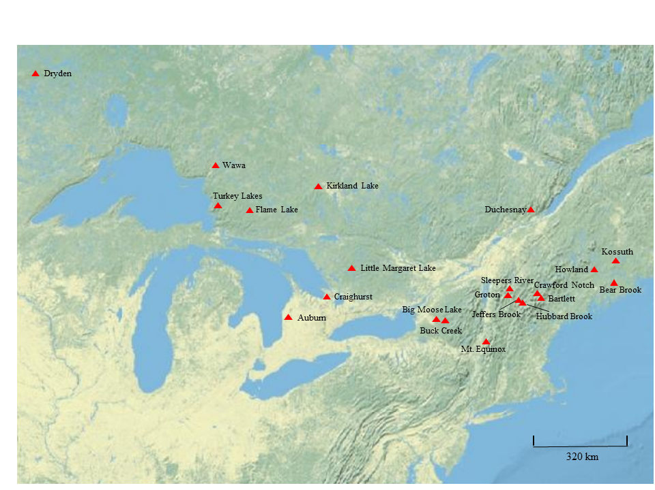

S8

**Figure S2**. Wet atmospheric deposition of SO42- based on the monitoring site nearest to each soil sampling site, with the exception of Ontario sites, where these data were calculated by distance weighting deposition values from several proximate stations. BB stands for Bear Brook; TMT stands for BB sites that received experimental additions of (NH4)2SO4annually. REF refers to untreated sites at BB. CF stands for northern conifer stands; HW northern hardwood stands; MF stands for mixed conifer-hardwood stands. The black bars represent the annual deposition value for the year of the final sampling. The sum of the black and gray bars represents the annual deposition value 4 years prior to the initial sampling. The numbers at the ends of the bars give the initial and final years of deposition monitoring. At site BB-TMT CF, the initial year of treatment (1989), was 3-4 years prior to the initial soil sampling.



S9

**Figure S3**. Trends in wet deposition of SO42-, and soil measurements of base saturation, pH and Al for Oe, A and upper B horizons at Wawa, ON. 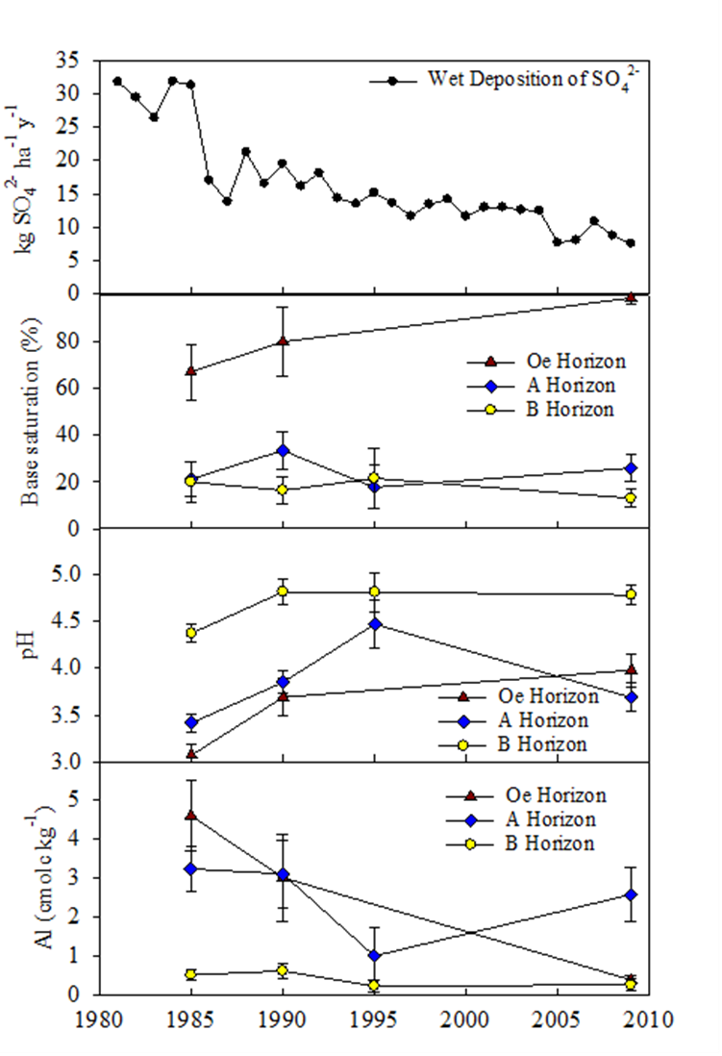

S10