Exhibiting the "Good Death": Sacredness and Trauma in the Public Display of Nazi "Euthanasia" Crimes in Germany and Austria
Lutz Kaelber, Associate Professor of Sociology, University of Vermont
Email: lkaelber at uvm.edu

On Jan. 18, 1940, a new page opened in the history books. A group of male psychiatric patients left the Bavarian psychiatric clinic Eglfing-Haar for a small facility called Grafeneck in Wurttemberg. The patients had met a set of criteria: they had lived in a hospital, psychiatric clinic, old-age home, or sanatorium for the last five years, they were Jewish, or been diagnosed with schizophrenia, epilepsy, or a list of other conditions. Within a day or two they had all been murdered in a gassing shed and their bodies were burning in the crematorium. The first name on the transport list of this first group systematically murdered in a gassing facility of program T4, named after the location its administration in the Tiergartenstrasse 4 in Berlin after 1940, was Ludwig “Israel” Alexander.
Do individuals, groups, nations, and even cultures commemorate such trauma, and if so, how? If coming to terms with the Nazi euthanasia program means documenting it, teaching it, and commemorating it, how has this happened? What are the master narratives that exist in the nations that have dealt with it, West Germany, East Germany, and Austria, and what do these master narratives—the ensemble of which are called “memory regimes” (Langenbacher)—tell us about the political and socio-cultural identity of these nations?
The presentation consists of four components:
- Types of “Euthanasia” Crimes
- Memory Regimes and Commemoration in Austria and in East and West Germany
- Exhibits at Specific Sites: Examples of Sacred Space and Sight Sacralization
- Conclusion

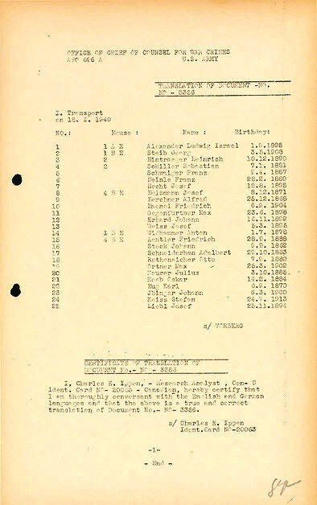
Source: Harvard Law School Library, “Nuremberg Trial Project,” Item No. 109. Available at http://nuremberg.law.harvard.edu/php/pflip.php?caseid=HLSL_NMT01&docnum=209&numpages=1&startpage=1&title=List+of+patients+transported+from+the+Eglfing-Haar+asylum+[in+the+euthanasia+program].&color_setting=C

As a preface to my remarks, the clarification of a few terms and concepts seems appropriate. “Euthanasia” is a term of Greek origins that has the literal meaning “good death.” In Germany under National Socialism, this term refers to the systematic assembly-line, hence industrialized, murder of the old, frail, sick, disabled, and other (such as criminals or those termed a-social). It was the outgrowth a of social Darwinist ideology that viewed the disabled, in particular, as “empty shells” and “life forms that burdened society.” They were said to use valuable resources without providing a contribution to society, and to contaminate the gene pool, to use a term in use today, by passing on deficient characteristics to the next generation.

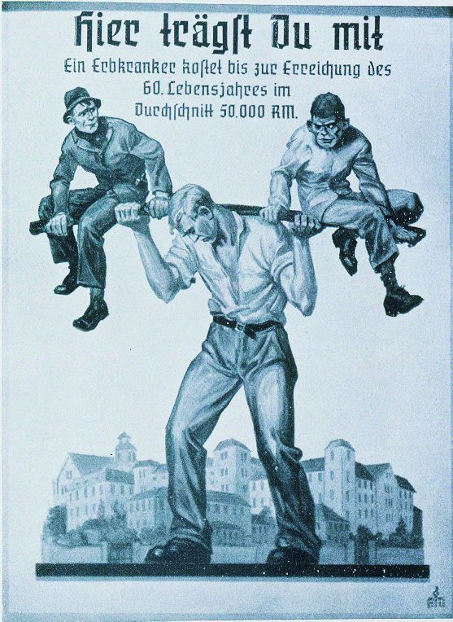 “You carry this burden as well! One hereditarily ill person has on average incurred a cost of 50,000 Reichsmark by the time he reaches 60.”
Source: Jüdisches Museum Berlin, “Tödliche Medizin: Rassenwahn im Nationalsozialismus.“ Propagandaplakat. Available at http://www.juedisches-museum-berlin.de/site/zips/pressebilder/toedliche-medizin/plakat.zip

This view on disability and illness was adopted and proffered by the elite of German medicine and particularly psychiatry, whose members more often than not were reform psychiatrists believing in the power of medicine to alleviate social problems through innovative therapies—provided that the patients did not have conditions that put them beyond the reach of medicine. Those cases merited “delivery” from their sickness or disability by means of deliberate killing of those considered “unworthy of living.” Physicians became racial warriors who healed the body of the people by rooting out disability and sickness and other forms of what they considered irreparable deficiencies by screening the population for such deficiencies as part of a gigantic pseudo-scientific enterprise. They were in the service of the state, which functioned what historian Hans-Walter Schmuhl has termed a “bio-political development dictatorship,” that is, as a dictatorship eager to determine its current state and future via bio-politics. Euthanasia was a precursor to the Holocaust. The first Jewish victim was gassed at Grafeneck as part of the “Euthanasia” program some time before the implementation of the Holocaust of the Jews had crystallized or even been decided.
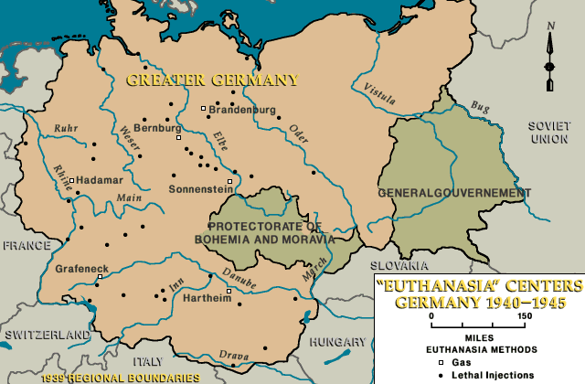
Source: United States Holocaust Memorial Museum, Holocaust Encyclopedia, “The Holocaust: Euthanasia Centers, 1940-1944.” Available at http://www.ushmm.org/wlc/media_nm.php?lang=en&ModuleId=10005143&MediaId=374

Types of “Euthanasia” Crimes
Historians distinguish between five components of the “euthanasia” program (see, e.g., Süss), of which only those put in bold are further addressed here in terms of their role in public memory:
- Children’s euthanasia. Summer/fall 1939 – May/June 1945. Ages up to 17. Physicians and other health care personnel reported (1) idiocy and mongolism, especially cases associated with blindness and deafness; (2) microcephaly [the presence of small head that coincides with mental disability]; (3) hydrocephalus of severe and progressive type [accumulation of fluid in the brain that coincides with a large head and mental disability]; (4) malformations of every type, especially absence of limbs and severe cleft formations of the head or the spine; (5) palsies, including Little’s disease. Places: about 30 “special children’s wards.” Method: barbiturates, withholding of treatment, neglect, starvation. Victims: 5,000+.
- Murder of psychiatric patients in Germany’s then Prussian provinces and occupied areas in western Poland, fall 1939-summer 1941. Methods: Shooting, gassing in mobile gas vans. Victims: 10,000+.
- “Aktion T4”: Murder of hospitalized psychiatric patients, January 1940-August 1941. Places: 6 killing centers. Method: stationary gas chamber. Victims: 70,000+.
- Murder of inmates of concentration camps who were sick, old, or otherwise unable to work in the “special treatment 14f13,” 1941-44 Method: gassing. Victims: 20,000+.
- Decentralized killing (“wild euthanasia”), 1942-45. Methods: drugs, withholding of treatment, neglect, starvation. Victims: 100,000+.

Memory Regimes and Commemoration in Austria and in East and West Germany
How nations and cultures have dealt with the legacy of Nazi atrocity and the issue of responsibility has varied greatly across space and time.
1. Communist East Germany: “Land of Resistance Fighters”/Universalizing National Socialism
According to leading East German ideologues, National Socialism and fascism were seen as but two expressions of international monopoly capitalism, and therefore National Socialism was only one aspect of a more universal phenomenon, the dictatorship of capital. Since the East German republic embraced socialism and rejected capitalism, it had ipso facto broken with fascism as well. East Germany saw itself as rising out of a culture of socialist/communist resistance fighters (hence, the title). It considered the atrocities of the Nazis as not ones that it was responsible for. The victims of National Socialism were neither remembered nor celebrated unless they had been resistance fighters, and the state itself dictated and orchestrated the contents and means of commemoration. Euthanasia victims were not remembered until the end of the German Democratic Republic, especially since the East German state had provided cover for some Nazi euthanasia doctors. Doctors were in high demand, and these doctors in particular had since embraced socialism and been celebrated in public for their achievements for socialist medicine. The disclosure of their past would have been very embarrassing for the state. Things have changed since the mid-to-late 1980s, as people in the East German states have been active in researching and documenting Euthanasia crimes in the East German territories.
2. Austria: “Land of Victims”/Externalizing the Nazi past
The picture of a very belated coming-to-terms with the Nazi past is even more accurate for Austria. Austria founded itself on the myth to have been the first victim of Nazi, that is, German, aggression. Even though historians have pointed out that perpetrators of the Holocaust and other related atrocities were disproportionately Austrian, Austrians decided that Nazism was really a German thing for which there were not responsible and that they had merely become victims of. After a brief period of anti-fascism after WWII, Austria rapidly integrated former Nazis and their activities or Austria’s involvement in Nazi crimes became a taboo topic. Austria’s memory regime continued to function this way in the 1980s, when the Waldheim affair (concerning the then President claimed not having known about atrocities in the immediate vicinity of Waldheim’s military post in World War II), which in the eyes of the public tended to cement Austria’s victim status as much as it did to help break it up, and only began to change in the second part of the 1990s. Pressure from the outside increased on Austria to acknowledge its involvement in the Holocaust, and when the governing Social-Democratic party began to come to terms with its own past in dealing with the revelation that Heinrich Gross, one of the worst perpetrator of euthanasia crimes, had been a member and protected by the party, and it needed to differentiate from the right (FPÖ [Freedom Party]) and its apologetic view of the Nazi past. Since the late 1990s groups in Austria have been very active in catching up with the commemoration of euthanasia crimes.
3. West Germany: “Land of the Perpetrators”/Internalizing the Nazi past
West Germany could not deny responsibility for the Holocaust, but its dealing with its Nazi past was soon overshadowed and overwhelmed by its attempt to rebuild the economy and the political Cold War against communism as part of the Western alliance. Sometimes called the period of restoration under Adenauer (chancellor), the era was characterized by the fact that Germany’s leadership could and would not deny Germany’s responsibility for WWII and the Nazi crimes. On the popular level, however, people rejected what they perceived as outsiders’ attribution of a collective guilt and tended to locate the roots of Nazi evil in the personalities of the Nazi leadership alone. Moreover, many Germans came to see themselves as victims of war as well and continued to see the victims of Nazism as “the other” (Jews or “alien” populations in Eastern Europe). Only in the late 1970s did this picture change significantly, when mostly from the political left younger generations questioned the old guard and a popular Television event “Holocaust” brought attention to the Holocaust in a way that the more sterile accounts of historians and other academics had not done. In the next decade there were numerous memory conflicts about how Germany should come to terms with its past: either by “normalizing” the past pushed by conservative groups and politicians, which relativized the status of the Holocaust in Germany’s history, and a culture of contrition (see, e.g., Art). The latter won out. The culture of contrition was also reflected in the 1980s’ emergence of numerous local incentives to commemorate Euthanasia crimes, sometimes against the continued attempts at other local groups to normalize the past and not portray local communities and places in a negative light.

Exhibits at Specific Sites: Examples of Sacred Space and Sight Sacralization
Employing a comparative perspective, I analyze practices by which past trauma in the form of NS-“Euthanasia” crimes is commemorated, memorialized, and shown to visitors in exhibits. I focus on four types of exhibits. For each one, I can only highlight a few of the ways in which the exhibit creates “sacred space” (see Chidester/Linenthal), in the Durkheimian sense of physical manifestations or representations of past trauma being set apart and demarcated, visually and/or linguistically, from the ordinary and thus being stripped of their “profane” qualities. I use the term “sight sacralization” (MacCannell) to denote ways in which exhibit sites and their creators and guides manage, and involve visitors in, a process by which a trauma sight, or something culturally deemed “worth” seeing by a “sightseer” (here, a visitor), is transformed into a commemorative object or experience in the context of “Euthanasia.”

(1) All six “T4” killing centers are sites of permanent exhibits, attracting between 1,000 and more than 15,000 visitors a year. One is located in Austria (Hartheim), while two are located in the western states of Germany (Hadamar and Grafeneck) and three in its former eastern states (in Pirna and Bernburg, and in Brandenburg/Havel, which is currently being expanded). The exhibits tend to vary significantly in scope and focus, due to differences in their historical emergence, funding, and didactic concerns of curators and staff. Hadamar, where the killing facilities remain largely intact, is one of the oldest exhibits yet possibly the most pedagogically innovative; more recently, it has included tours of its exhibit that focus on the needs of visitors with mental disabilities and even younger children. Grafeneck’s exhibit devotes a significant part to self-reflection, as part of its exhibit addresses changes in commemoration of “Euthanasia” crimes and their public exhibit over time. Hartheim’s exhibit is different still, as it addresses in an exhibit the past and current societal treatment of people with disabilities. Pirna’s exhibit features a recreation of the cremation oven as well as a hall of victims. Bernburg offers a tour through premises that are relatively unadulterated.
The Bernburg and Hadamar memorials in particular engage in sight sacralization via the presentation or creation of auratic thana-spots as part of their exhibit. Thana-spots refer to physical places marked by traumatic events, spots which, when inscribed in landscape, constitute “traumascape” (Tumarkin). Visits to traumascape, particularly by relatives of victims or their descendants, are often described in the language of (religious) pilgrimage (Jacobs). The material manifestation of sacred space, they have a physical presence and can be physically experienced. Thana-spots are the gas chambers and other rooms that mark the path the victims once took, concluding with the crematorium oven. The state of these memorial contrast starkly with that of almost all death camps of the Holocaust, which present themselves in a landscape of ruins today. In their motion through the stations of death, visitors begin with the ante-room where the victims had to undress, and conclude with a view at the crematorium oven (which no longer exists and is depicted through an actual-size photograph. In Bernburg there are also pictures of victims in the crematorium room. By virtue of the preservation of original death space, these exhibits therefore are apt to create a distinctive “mood of memory” that is impossible to construct or replicate at other memorials.
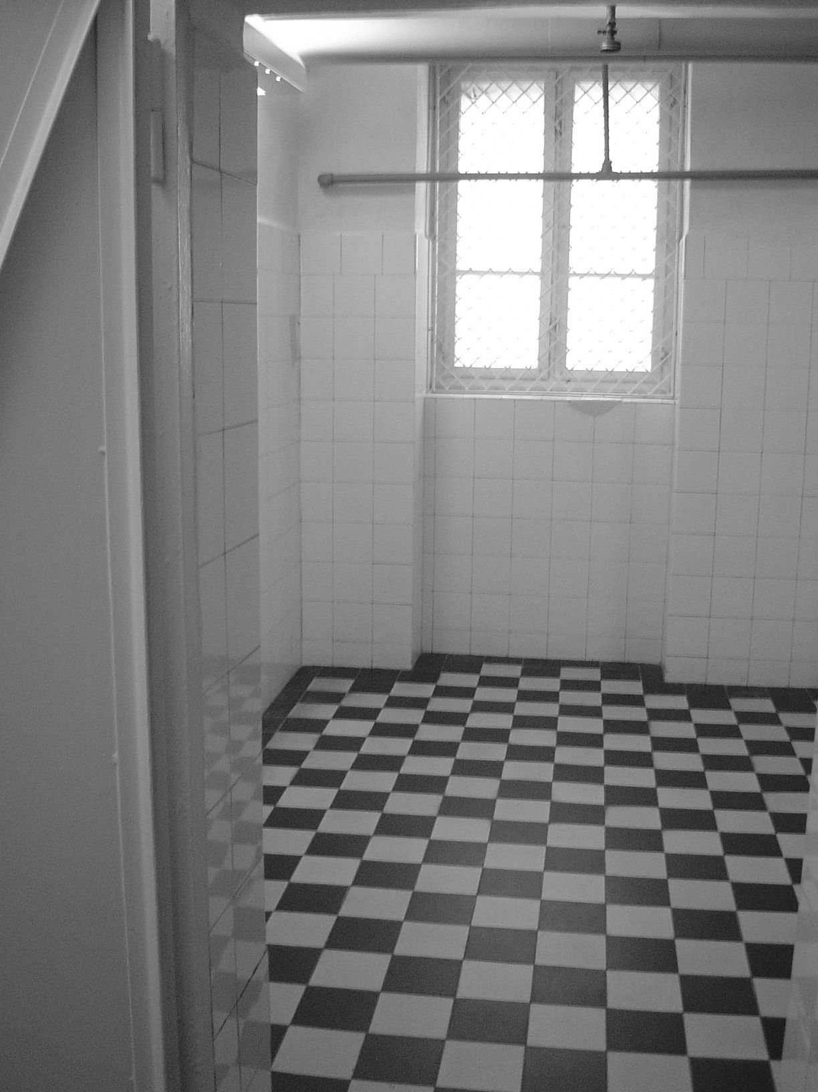 Gas chamber in Bernburg
Source: Stiftung Sächsischer Gedenkstätten (available at http://www.sachsen-anhalt.de/LPSA/index.php?id=33311)
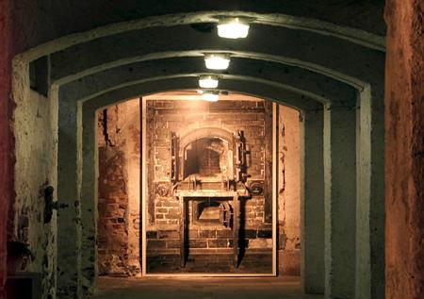 Picture of the crematorium oven, Hadamar
Source: Focus.de online (available at http://www.focus.de/wissen/bildung/kz-gedenkstaetten_did_13170.html)
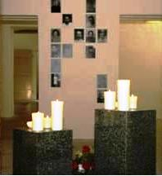 Pictures of victims in the crematorium room, Bernburg
Source: Author

(2) Of the approximately thirty “special children’s wards,” four offer permanent exhibits on site (a few more offer information in their clinic-museums). These are the exhibits in Vienna, Görden/Brandenburg, Idstein, and Lüneburg. In all of them, the focus is on the involvement of a clinic or ward in the selection and killing of sick and disabled children. Idstein and Lüneburg include a limited number of display panels in their exhibits. Görden includes multimedia elements and some original artifacts, whereas Vienna’s exhibit has recently been expanded and re-conceptualized. The number of visitors on site range from a few hundred per year to several thousand. Three of the four exhibits have been in existence for less than ten years, and many visitors participate in guided tours.
One example of sight sacralization is the exhibit on Nazi medical crimes in Vienna (which includes “child euthanasia” with more than 700 victims). This exhibit originally existed in a temporary form and has recently been revised and expanded. In the original exhibit the visitor encountered a form of commemoration unique to this memorial. Upon entering the exhibit facilities, the visitor immediately saw a set-off circular display of child victims facing inward and open only to one side. Now this display has been removed and given way to an open area with objects in the room and expanded textual and visual displays on the walls. The online component is extensive and uses pictures to highlight and emphasize the Nazi treatment of the “inferior.”

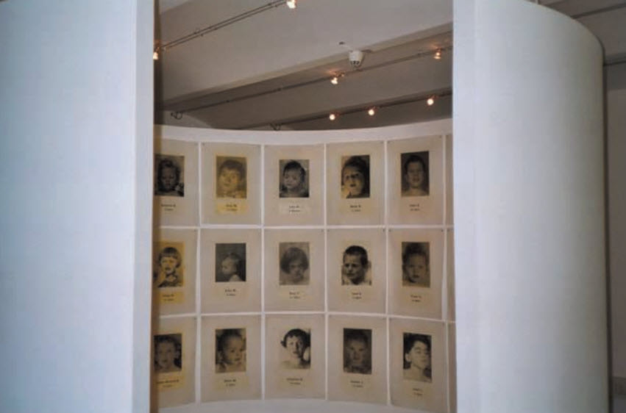 Original exhibit
Source: Martens, Debra. 2004. “Unfit to live.” Canadian Medical Association Journal, September 14, 2004.
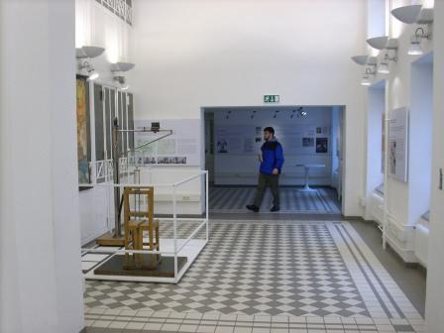 Revised exhibit
Source: Author.

(3) Internet exhibits have become more prevalent, either as on-line components of embodied exhibits or as exhibits that are entirely on-line. While traditional exhibits have relied on Internet sites that supplement physical travel by providing information about the place, how to get there, and so forth, in on-line or virtual exhibits the main exhibit or a significant part thereof is meant to take place online. The number of visitors at such sites can exceed 100,000 per year, as is the case with Vienna’s exhibit on the children’s ward at Am Steinhof. One example of an exhibit that carries on via the Internet is “Ausgelöscht: Opfer der NS-‘Euthanasie’ aus Tirol, Vorarlberg, und Südtirol” (Exterminated: Victims of NS-Euthanasia from Tyrol, Vorarlberg, and Southern Tyrol, Austria; since 2004, http://www.zeitschatten.info/). They often employ sight sacralization by way of personalizing the victims described in the next section, and by providing hyperlinks and multimedia in a way to reinforce messages in the text.

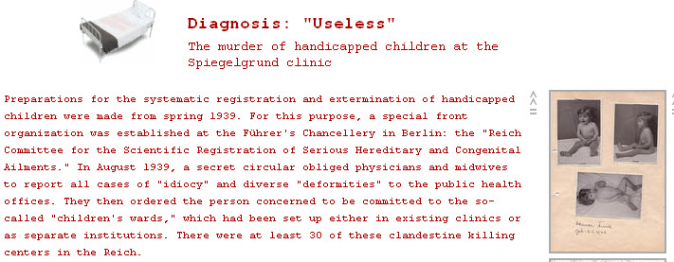
Online exhibit (revised)
Source: http://www.gedenkstaettesteinhof.at/en/index.shtml

(4) There are several traveling and a few permanent exhibits not associated with memorial sites that feature notable characteristics. Some reflect the outcome of projects carried out by high school students who explored the involvement of their community and health organizations in Nazi crimes, whereas others emerged as part of the findings by historians and scholars in the field of medicine who examined newly discovered or accessible health records of the time. A brief list is included.
- Totgeschwiegen (Silenced to death; in Berlin, since 1988; reconceptualized 2009)
- Überweisung in den Tod: NS-‘Kindereuthanasie’ in Thüringen (Transfer to Death: Children’s Euthanasia in the State of Thuringia; since 2003)
- Lebensunwert - zerstörte Leben (Not Worth Living – Lives Destroyed; Association of Compulsorily Sterilized Persons and Euthanasia Victims, since 2003)
- NS-Euthanasie in der Steiermark (NS-Euthanasia in the Steiermark [Austria]; since 2004)
- Lebens(un)wert ([Not] Worth Living; Austria, since 2006)
- 505: Kinder-Euthanasieverbrechen in Leipzig (505: NS-Children’s Euthanasia Crimes in Leipzig, Saxony; since 2007)
- NS-Euthanasie im Bregenzerwald (NS-Euthanasia in the Bregenzerwald, Austria; since 2008)

What sets most of these exhibits apart is their connection to local events and populations; hence, the local and regional resonance to these exhibits has often greatly surprised exhibit creators and the journalists who reported on the exhibits. Almost all of the exhibits have been developed and shown to the public in the last five years. One particular aspect of sight sacralization in these exhibits is both the focus on local victims as well as an emphasis on the victims’ humanity and daily lives before it was destroyed by Nazi health policy. The effects on families and relatives are also sometimes addressed. As the following two examples illustrate, the depiction of loss are apt to make a haunting impression.
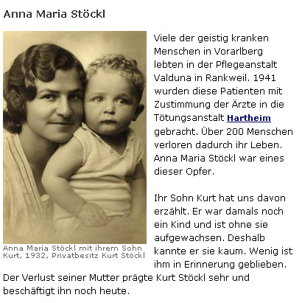
Text (excerpt): Many of the mentally ill in the Vorarlberg region lived in the clinic Valduna… Over 200 lost their lives [in Hartheim]. Anna Stoeckl was one of the victims. Her son Kurt told us about it…The loss of his mother had a large impact on him and concerns him to this day.
Source: http://www.zeitschatten.info
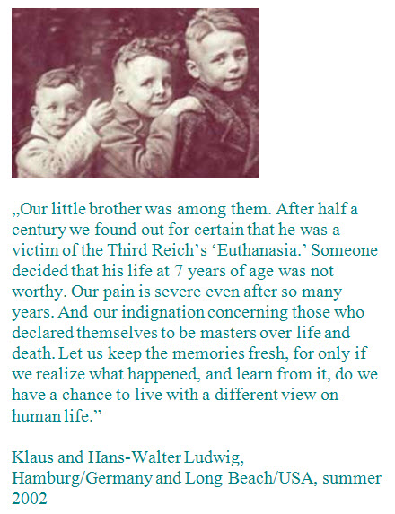
Source: Exhibit: “Transfer Referral to Death: NS-Children’s ‘Euthanasia’” in Thuringia, 2005

Conclusion
Exhibits on “Euthanasia” crimes play a role in what some scholars have called grappling with the Holocaust as a “moral universal”: as the Holocaust has become understood as a generalized symbol of human suffering and moral evil, it provides an opportunity for humanistic learning (Alexander). Exhibits on “euthanasia” promise to contribute to the understanding of events that set the path to the Holocaust as well as to humanist learning, especially since many of these exhibits seek to draw attention to discrimination against people with disabilities in both past and present.

Literature
Alexander, Jeffrey. 2002. "On the Social Construction of Moral Universals: The 'Holocaust' from War Crime to Trauma Drama." European Journal of Social Theory 5(1):5-85.
Art, David. 2006. The Politics of the Nazi Past in Germany and Austria. Cambridge: Cambridge University Press.
Chidester, David and Edward T. Linenthal, eds. 1995. American Sacred Space. Bloomington: Indiana University Press.
Gehring-Münzel, Ursula, ed. 2007. Medical Ethics and the Holocaust: How Healing Becomes Killing: Eugenics, Euthanasia and Extermination. Houston: Holocaust Museum Houston.
Hammerstein, Katrin. 2008. "Schuldige Opfer? Der Nationalsozialismus in den Gründungsmythen der DDR, Österreichs und der Bundesrepublik Deutschlands." Pp. 39-61 in Nationen und ihre Selbstbilder: Postdiktatorische Gesellschaften in Europa, edited by Regina Fritz, Carola Sachse, and Edgar Wolfrum. Göttingen: Wallstein Verlag.
Jacobs, Janet. 2004. "From the Profane to the Sacred: Ritual and Mourning at Sites of Terror and Violence." Journal for the Scientific Study of Religion 43(3):311-15.
Langenbacher, Eric. 2003. "Changing Memory Regimes in Contemporary Germany?" German Politics and Society 21(2):46-68.
Lepsius, M. Rainer. 1993. "Das Erbe des Nationalsozialismus und die politische Kultur der Nachfolgestaaten." Pp. 229-45 in Lepsius, Demokratie in Deutschland. Göttingen: Vandenhoeck & Ruprecht.
MacCannell. 1999. The Tourist: A New Theory of the Leisure Class. 3d ed. Berkeley: University of California Press.
Neugebauer, Wolfgang. 2000. "Zum Umgang mit der NS-Euthanasie in Wien nach 1945." Pp. 107-25 in NS-Euthanasie in Wien, edited by Eberhard Gabriel and Wolfgang Neugebauer. Vienna: Böhlau.
Reichel, Peter. 2007. Vergangenheitsbewältigung in Deutschland: Die Auseinandersetzung mit der NS-Diktatur von 1945 bis heute. 2d ed. Munich: Beck.
Schmuhl, Hans-Walter. 2009. "Das ‘Dritte Reich’ als biopolitische Entwicklungsdiktatur: Zur inneren Logik der nationalsozialistischen Genozidpolitik.“ Pp. 8-21 in Tödliche Medizin: Rassenwahn Im Nationalsozialismus, edited by Jüdisches Museum Berlin. Göttingen: Wallstein.
Süss, Winfried. 2000. "Krankenmord. Forschungsstand und Forschungsfragen Zur Nationalsozialistischen 'Euthanasie'." Pp. 47-86 in NS-Diktatur, DDR, Bundesrepublik: Drei Zeitgeschichten Des Vereinigten Deutschland, edited by T. Bauer and W. Süß. Neuried: Ars Una.
Thünemann, Holger. 2005. Holocaust-Rezeption und Geschichtskultur: Zentrale Holocaust-Denkmäler in der Kontroverse: Ein deutsch-österreichischer Vergleich. Idstein: Schulz-Kirchner Verlag.
Tumarkin. 2005. Traumascapes: The Power and Fate of Places Transformed by Tragedy. Melbourne: Melbourne University Press.

