Learning Services Participant Guide
Session Title: |  | Basic Excel
Target Audience: |  | This class was designed with the basic user in mind.
Time Allotted: |  | 2 hours
Instructor: |  | Henrietta M. Menzies
Objectives:
Overall: | To instruct basic users on how to enter, format and manage data in MS Excel.
Specific: | Participant will…  - Format the data as text, numbers, currency, etc.  - Format tables to better manage the data  - Create various charts and graphs  - Select pre-defined templates for organizing data

Welcome and Agenda | Notes
- Introductions
- Understanding the Ribbon and Backstage View
- Creating a Workbook
- Adding, Deleting and Modifying Worksheets
- Adding Data
- Formatting Cells
- Choosing Styles
- Adding and Modifying Charts and Graphs
- Printing
- Putting it all together

Exercise #1: Matching Quiz | Notes
Match the following statements with the number of the icons under the “Notes” section to the right.

- To quickly save the work I’ve done in Excel, I click this button. ___
- I click this button to increase the indent within a specific cell. ___
- I’m not the best speller in the world. I can run a spell check from here. ___
- I go here when I want to open a recently viewed document. ___
- I want to add a visual representation of my data. To add a chart I click here. ___
- After copying rows from an Excel worksheet, I click this button to paste it in another. ___
- Oops! I changed the formatting on accident. This button will undo my last action. ___
- Clicking this icon will get me a closer look at the data by zooming in. ___
- I click here when I want to change the page breaks for printing. ___
- This icon allows me to open Microsoft Excel. ___
- One of the cells in my worksheet needs a little clarification. By clicking this icon, I can add a comment. ___
- To add emphasis to text in this cell, I’d like to change the font and make it bold. This is where I click. ___

Creating a New Workbook and Opening an Existing One | Notes
To save a workbook, click on the Office Icon (File tab in 2010) at the top of the page to access the backstage view. Click on Save As along the left-side of the page, name the file and select an appropriate location.

To create a new workbook while another Excel file is open, go to the Office Icon (File tab in 2010) and click on New along the left-side of the page. At this point, you can either create a blank workbook or select a document template.

To open an existing workbook while another Excel file is open, go to the Office Icon (File tab in 2010) and click on the Open file icon.

Understanding the Ribbon and the Backstage View | Notes
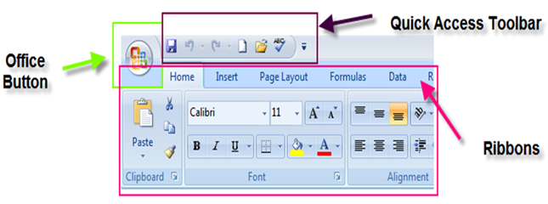

Office Button
- Combines all of the non-editing related tasks
- customize Excel Options - Minimize the ribbon, Move the quick access toolbar above or below the ribbon, Customize the quick access toolbar to add or remove commands

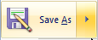 Save As

From the office button you can choose to save your file as:
- Pdf
- email
- earlier version of excel

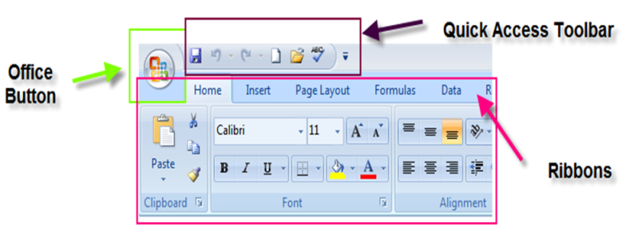
Quick Access Toolbar
- located in the top left hand corner of the screen
- Fully customizable.
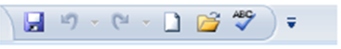

  - Ribbon (tabs)
Home Tab– The most used functions in Excel. Change font size, text color, alignment, type of text, increase or decrease decimal place, apply cell styles, insert rows or columns, delete rows or columns, format cells, sort and filter, find feature.
Insert Tab– Charts, Graphs, pictures, text boxes, pivot tables, text boxes, header, footer, word art, signature line
Page layout Tab– Themes, page set up, margins, page orientation, gridlines, headings
Formulas Tab– Functions, formulas, calculation options
Data Tab– sorting and filtering, external data options, group, ungroup
Review Tab– spell-check, comments, sheet security
View Tab– workbook views, zoom, freeze and unfreeze panes, macros

Groups
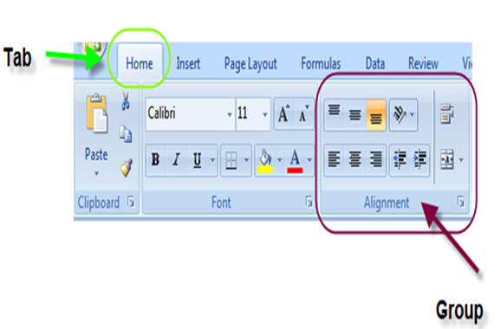
- Organize individual commands
- Take the place of the dialogue style boxes in earlier versions of Excel
Spreadsheet Basics
- Columns
- Rows
- Formatting is applied to highlighted cells

Keyboard shortcuts
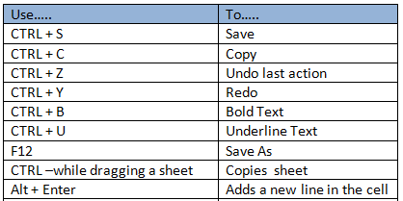

Cell address bar

See totals, average and count automatically without entering a formula
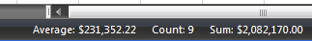
- The average, sum and count of a selected group of cells are displayed in the bottom right corner of your screen.
- These figures are updated each time another set of numbers is highlighted.

Automatically adjust column width
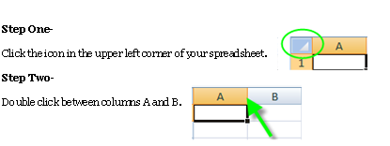
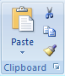

Clipboard Group

- Paste: Copy the selection onto the clipboard
- Paste Values: Paste the results of formulas rather than the formulas themselves
- Cut: delete the selection and place it onto the clipboard
- Copy: put the selected values onto the clipboard- does not delete the text
- Format Painter: copies the font, color and other cell formatting and applies to another cell or cells

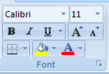
Font Group

- Change the way the worksheet cells appear
- Font size, font type
- Text and number formatting
- Color of cell fill
- Text color
- Choose the way the cell outline appears
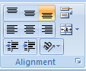

Alignment Group

- Set horizontal and vertical placement of text within the cell
- Merge and center
- Wrap text
- Change the direction of text
- Increase or decrease indent

Merge and Center
To merge and center text across a worksheet or a group of cells:

- Select the text as well as the area to merge and center across.
- Click Merge and Center
- The cell containing the text is now merged as one cell fitting the area selected
Wrap Text
Wrapping text will display a larger amount of text on more than 1 line within the cell.

- Highlight the cell, row or column you’d like to wrap.
- From the home tab/alignment group click wrap text.
- Note: You may need to adjust column width to see the results.
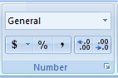

Number Group

- Change the way a number is formatted within the cell
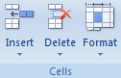

Cells Groups

- Insert or delete rows or columns
- Format cells: brings together the row/column formatting commands

Adding Deleting and Modifying Worksheets | Notes
To change the name of the worksheet, either double-click on the tab or right-click on it and choose Rename. When the title is highlighted in black, begin typing. You may use up to 31 characters including spaces and symbols in each tab. When you are finished typing, either press Enter or click inside the worksheet.

To add a new worksheet, click the Insert Worksheet tab, which is located after the last worksheet tab in your workbook. You’ll notice that the shortcut (Shift + F11) is listed on the insert worksheet tab. You may use this command as well. Another option is to right-click on the existing worksheet tab you would like the new worksheet to precede. Choose Insert… and then select Worksheet from the Insert window. Click OK.

To delete a worksheet, right-click on the tab you wish to delete and select delete.

To move a worksheet from one position to another in the same workbook, click and hold the tab you wish to move. After a brief moment, a blank document symbol will appear beneath your mouse pointer and a small, black triangle will appear between tab you are moving and the one directly preceding it. Without lifting up on the mouse button, drag the tab to its desired location and release the mouse button.

To move or copy a worksheet within the same workbook or into a different workbook, right-click on the appropriate tab and select Move or Copy… Within the Move or Copy dialogue box, first choose the To book: location. All Excel workbooks that are currently open on your machine will be listed as will be the option to move or copy the sheet to a new workbook. Make your selection. Next, choose the location of the worksheet in the Before sheet: section. The existing worksheets in the workbook you chose from the previous section will be displayed. The worksheet you are moving or copying will appear before the tab you choose in this section. You may also select (move to end). Finally, if you wish to create a copy of the worksheet rather than move it from its current position, click the Create a copy radio button.

Exercise #2: Entering Data | Notes
- Access the Dunder Mifflin Sales 2010 workbook.
- Manually type the sales information from the Q1 Sales tab into the appropriate column in the Summary-Annual Sales tab.
- Copy the sales information from the Q2 Sales and Q3 Sales tabs and paste it into the appropriate columns in the Summary-Annual Sales tab.
- Link the sales information from the Q4 Sales tab with the appropriate column in the Summary-Annual Sales tab.
- Bonus: Auto Sum the columns and rows to show the totals.

Exercise #3: Formatting Text, Cells and Worksheets | Notes
- Access the Dunder Mifflin Sales 2010 workbook.
- Align column A text to the right.
- Align rows 3 and 11 to the center.
- Make the three “Totals” cells bold.
- Change the “Number” type of all the sales figures and totals to “Accounting” and specify zero decimals.
- Double underline all the totals.
- AutoFit width of columns A and F
- Merge and center cells 1C and 1D, increase the font size to 16, make the text bold and AutoFit the height of row 1.
- Select cells 3A through 12F and format it as a table using the style of your choice.
- Make the Sheet Name the center header.
- Make the left footer the Current Date, the center footer the Page Number and the right footer the Current Time.

Page Layout Tab | Notes
Commands related to way things fit onto a page. Margins, paper size, print area, view gridlines, print gridlines.
- Options set on this tab are set for the active sheet only. To set the Page Layout for the entire workbook use Excel Options.

Page Setup Group
  - 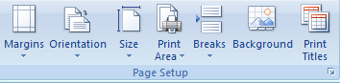
Margins
  - 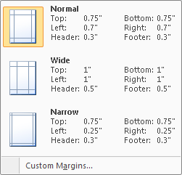
- Excel 2007 has several preset margin options to choose from.
- Define custom margins by clicking on custom margins and selecting criteria.

Orientation
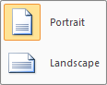
- Choose the way the spreadsheet is prints on the paper

Print Area
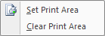
- Setting the print area to print just part of a worksheet
- To Remove Print area settings, click on clear print area.

- Select the text that you wish to print
- Choose Print Area> Set Print Area.
Insert and Remove Page Breaks
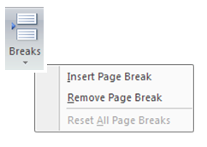
- You can adjust page breaks with the Set/Remove page breaks option.

Alternative: choose the page break preview option and manually adjust the page breaks

- At the bottom right corner of your spreadsheet, click on the Page Break Preview Button.

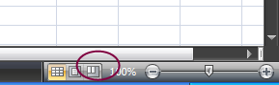

- Your spreadsheet view will change.

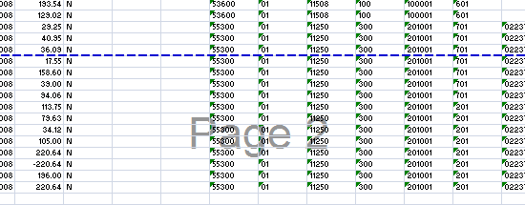

- To change your page breaks, click and drag the dotted blue lines.

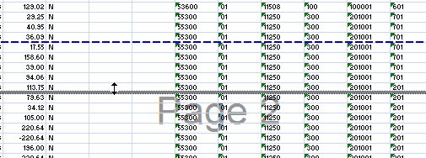

Print Titles
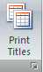
This feature will allow you to automatically print headings at the top of every page.

- Click on Print Titles from the Page Layout Tab, Page Setup Group
- Enter the Print area and rows to repeat in the Page Setup dialogue box. You can do this by typing in the cell references or simply by clicking on the appropriate columns/rows.
- Select Row and column headings and then click Ok.
  - 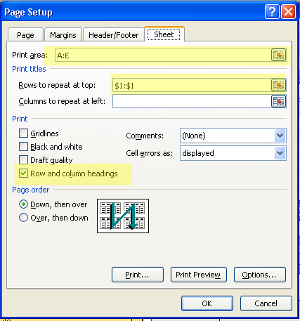
Scale to Fit Group
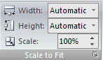
- Automatically fit a spreadsheet onto a certain size paper
Sheet Options Group
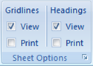
- Set options for printing and viewing gridlines and headings

Exercise #4: Adjusting Print and Page Settings | Notes
- Access the Dunder Mifflin Sales 2010 workbook.
- Change the orientation of the page to Landscape.
- Assign Wide Margins to the document.
- Ensure the document will print in the proper manner by using either the set print area function or the Page Break View.
- Examine the document in the Print Preview.

Creating Charts and Graphs | Notes
To create a chart, access the Insert tab. You can begin either by selecting the data range you wish to display, or by selecting the type of chart or graph you wish to create. There are a number of charts and graphs from which to choose. Once you have chosen to create a graph, you can make changes by right-clicking on the chart window. Modifications can be made to the chart type, the data and its location.

Exercise #5: Putting it All Together | Notes
You have been asked to present this year’s results of four local farmers at the Future Farmers of America conference. You have been given the raw data and you must put together a slick report for conference goers including charts and graphs.

Raw Data:
- Farmer Friedman harvested 62 tomatoes, 104 onions, 28 heads of lettuce and 32 green peppers.
- Farmer Martinez harvested 44 tomatoes, 86 onions, 34 heads of lettuce and 58 green peppers.
- Farmer Smith harvested 27 tomatoes, 43 onions, 16 heads of lettuce and 31 green peppers.
- Farmer Liang harvested 84 tomatoes, 73 onions, 58 heads of lettuce and 46 green peppers

Additional Resources | Notes
To contact me directly:

Henrietta Menzies
hmenzies@uvm.edu

Additional Resources:

Learning Services maintains a webpage with additional resources and practice spreadsheets. It can be found here:

http://www.uvm.edu/~tmessie1/Basic%20Followup/end%20of%20class.html

