AUTOMOTIVE INDUSTRY

Industrial Convergence - Foxconn MIH EV Platform
01. July 2021 | magility
Cross-industry approaches allow exciting new business models to be established
Industrial convergence stands for the demand-induced convergence of industries and goods markets from different sectors of the economy that previously had no or only sparse interaction. Markets are coming together that were previously clearly separated from one another and had few or hardly any points of contact. As a result, previously existing industry boundaries are becoming blurred. In some areas, new market segments are developing as a result of this merging, which means that customers can be offered new, hybrid opportunities. Cross-industry approaches also allow exciting new business models to be established.

When does industrial convergence occur?
Basically, industrial convergence occurs when innovations emerge at the interface of demarcated markets. This triggers structural changes and increased economic momentum. The logical consequence that arises in this context is the at least partial convergence of previously delimited markets.

The Foxconn MIH EV Platform
The Foxconn MIH EV platform is a suitable example of the convergence of the industry. This is primarily about building an open platform for electric vehicles (EVs). On the platform, companies from a wide range of industries up that have not been in contact with each other until now can liaise. This is intended to accelerate innovation and development in the EV industry. According to the MIH website, 1,718 members are currently working on this common platform for electric vehicles.

The MIH platform has 4 main features:
- The structure of the platform is fully modularized, scalable and easily customizable.
- The chassis is made of the latest lightweight materials with a unibody design that optimizes the EV’s performance.
- The platform provides a high-performance electrical structure for all application levels.
- The platform is designed to promote the development of autonomous driving technologies.

Risks of traditional automotive industry enable opportunities of MIH
According to its founders, the MIH platform represents the solution to some key problems of the traditional automotive industry. Three key issues are highlighted as challenges facing the traditional automotive industry:
- High development costs
- Long lead times
- Frequent lack of resources
The Electric Vehicle (EV) Platform is designed to help partners and third-party developers to evolve functional features and systems, which will strengthen the growth of the overall electric vehicle market. This can provide a foundation for developers to be able to create a complete ecosystem for the electric vehicle industry.
THE MOST IMPORTANT4.0.

Industry 4.0 and the industrial convergence of IT and OT
The intelligent networking of products and information technologies represents the technological goal of Industry 4.0. It not only takes on the task of increasing efficiency, but also serves as a transmission channel for cross-technology and cross-industry business models. Briefly, Industry 4.0 takes over the digital networking of the entire economy. This requires the merging of IT and OT. Operational technology (OT) describes the monitoring, controlling and steering of the processes of physical machines. For a long time, these processes were not connected to networks – unlike industrial technology (IT). In order to establish a network between the processes of operational technology and thus to be able to achieve the goals of Industry 4.0, IT and OT convergence is unavoidable. It is necessary to develop a sustainable strategy and to analyze the opportunities and risks for the company and its respective market environment.
We at magility will be happy to advise you on new business models for your company. Get in touch with us!

A Closer Look at Foxtron’s "EVKit" Electric-Vehicle Platform
April 29, 2021
The company that builds iPhones for Apple launches an open platform for EVs—called MIH—and has plans for a solid-state battery by 2024.
Murray Slovick
Related To: Electronic Design
What you'll learn:
- Who are the players in the MIH EV platform and ecosystem?
- Specifics of Foxtron's EVkit, including the different controllable units.
- Powertain dev agreement between Foxtron and Nidec.

For decades, the automakers behind EV production were heading in only one direction—using a closed system to develop their electric vehicles. But now Foxtron, Foxconn's electric car brand, is building an open EV platform called MIH that already has an ecosystem of partners behind it. They include Arm, Bosch, Texas Instruments, STMicro, Microsoft and Amazon Web Services, as well as semiconductor manufacturer Infineon Technologies; Japan's Nidec, Murata Manufacturing, and NTT; and Chinese battery maker CATL.
Foxtron and Hua-chuang Automotive Information Technical Center under Yulon Motor have established Foxtron Vehicle Technologies, a joint venture to operate MIH, which is an open hardware/software-integrated platform for developing EVs. In exchange for access to the free platform, auto companies will contract out all production to Foxconn.
Foxtron's software and hardware open platformaims to position itself as the “Android system of the EV industry,” with which any automaker can alter the design to meet specific requirements. The MIH platform will allow the main features of an EV, such as the wheelbase, the wheel track, ground clearance, battery-pack sizes, and the suspension system, to be customized to meet all customer requirements.

Ecosystem EVkit
MIH’s EVKit uses drive-by-wire technology. This gives Autonomous Driving ecosystem partners a method to perform their system development and design, and for driving system developers, a starting point for their work.
The Autonomous Driving architecture is divided into two parts. The first part, the "sensors and decision-making system," utilizes information collected from the autonomous controller, HMI, and communication modules with sensors such as cameras, radars, LiDAR, and vehicles states to make calculations and actionable decisions. The second part is wire-controlled hardware, which receives the commands from the sensors and decision-making system to perform braking, steering, and acceleration/deceleration actions.
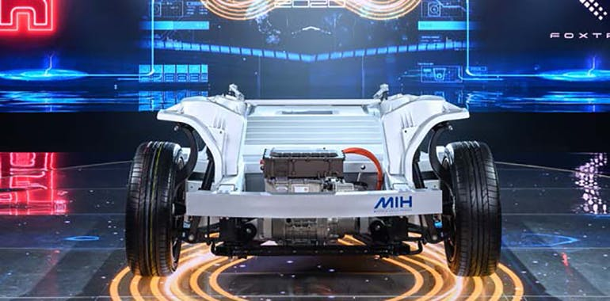Foxtron aims to capture 10% of the global electric-vehicle market, about 3 million EVs, by 2027. (Source: Foxtron)

The software platform would be connected to Foxtron’s cloud and have an "EVkit" SDK that automakers could plug into their vehicles to control and use the battery pack and platform. Mass production is expected to begin in 2023. The company hopes to introduce a solid-state battery by 2024 and capture 10% of the global electric-vehicle market, about 3 million EVs, by 2027.
In the meantime, Foxtron Electronics also is developing lithium-iron-phosphate (LFP) batteries for use in electric vehicles.

Vehicle General Information (Source: Foxtron)
- Length × width × height (mm): 4410 × 1785 × 1605
- Wheelbase (mm): 2650
- Front/rear tread (mm): 1505/1520
- Weight (kg): 1625~1645
- Motor type: permanent-magnet synchronous motor
- MCU max. current (A): 525
- MCU max. operating voltage (V): 400
- Maximum torque (Nm): 250
- Maximum power (kW): 130
- Transmission fixed gear ratio: 1:9.07
- Maximum rotating speed (rpm): 12,000
- Battery type: ternary lithium battery
- Battery pack (Ah): 153
- Range (km): 360
- Energy (kWh): 50
- Fast charge time: 20% to approx. 80% (48 min.)
- Slow charge time: 0%~90% (408 min.)
- Drive type: front wheel drive
- Front suspension: MacPherson
- Rear suspension: twist Beam
- Front/rear brakes: disc
- Tire size: 215/55 R17
- Turning circle (m): 5.7

Drivetrain (Source: Foxtron)
- Drivetrain type: independent front, electric motor through gearbox, open differential
- Performance: ≤ 150-kph speed
- Wheel side torque: 2267 Nm ≤ 500 ms for response time, command to wheel torque, ≤ 5% steady-state tracking error
- Commands: 10 ms, wheel torque, ECU desired state/mode
- Feedback: 10 ms, max. motoring/regen torque, pack SOC
After raw sensor data is processed by the Autonomous Driving system and control signals are sent to the wire-control system, different dynamic controllers will require different input signals and control sequences to operate as intended.

Controllable Units
The hardware interface of the EVKit development platform reserves power supply and signal wiring harnesses to connect to external devices, while a 120-Ω terminal resistor is required between the vehicle and the connecting hardware. EVKit controllable units include the VCU (Vehicle Control Unit for gearing and powertrain), ESC (Electronic Stability Control for braking), EPS (Electric Power Steering for steering) and BCM (for Body components such as doors).
The ESC brake control is divided into AEB control and deceleration control mode. When the ESC receives the AEB control command, it will brake with the maximum clamping force of about 1.0 G = 9.8 m/s². When the ESC receives the deceleration control, it will operate according to the requested deceleration. The ESC brake control has no starting conditions. It will act as long as it meets the requirements of the control command. Therefore, special care must be taken when using this function so as not to be triggered by mistake.
EPS steering control is divided into angle-control and torque-control status, which can’t be executed at the same time. EPS steering angle control is applicable for vehicle speeds below 10 km/h.
The hardware will be modular and flexible to meet the needs of automakers. Wheelbase, width, and height are all adjustable, according to Foxtron. The modules have front-, rear-, and all-wheel-drive variants with a variety of motors ranging from 95 up to 340 kW.
Foxtron has signed a memorandum of cooperation (MoU) with motor manufacturer Nidec Corp. for powertrain development in its next generation of electric vehicles and to strengthen the performance of the MIH open platform.
Nidec's powertrain system is known for its small-size, light weight, and high efficiency. Its motor products now cover the range from 50 to 200 kW, which is sufficient for most future electric vehicles. The company is targeting 40% to 45% of the global EV powertrain system market share by 2030.
Both companies are working on a plan that includes passenger vehicles and commercial vehicles. They intend to reveal initial results and demonstrations in the fourth quarter of 2021.
Battery packs take up about 30% of the total cost for an EV and up 50% of the total weight of an EV. If the weight of battery packs is reduced by 50%, an EV’s endurance running distance can be increased by 25%, implying the importance of decreasing weight and production costs for EV-use batteries.
According to Foxtron chairman Young-way Liu, the company plans to unveil sample EV-use solid-state batteries in 2021 and put such batteries into commercial use in 2024. Solid-state batteries can charge quicker and have a larger storage capacity than the lithium-ion batteries found in current vehicles. Foxtron has been working with battery supplier CATL and solid-state battery company SES.

Foxconn Unveils First EV Concepts With Up To 466 Miles Of Range

Ford won't like this: they're called the Model C, Model E, and Model T.
Oct 18, 2021 at 11:35am ET
26
By: Dan Mihalascu
Taiwan’s Hon Hai Technology Group (Foxconn) today introduced its first electric vehicle concepts under the Foxtron brand, a joint venture between the largest Apple iPhone producer and Taiwan’s biggest carmaker Yulon Motor.
Announced at the Hon Hai Tech Day 2021 event in Taipei, the three EVs are all based on Foxconn’s MIH electric vehicle open platform. They are the Model C recreational vehicle, Model E sedan, and Model T electric bus.
Right off the bat, we need to address the issue of these names. Chances are that Ford’s top management won’t be thrilled to hear them, and we’re willing to bet that Foxconn will hear from Dearborn’s legal department—remember when Ford blocked Tesla from using the Model E name?
Back to these new EVs, Foxconn says they underline its commitment to become “a global next-generation automotive manufacturer.”
According to Hon Hai founder Terry Gou, who appeared on stage driving the Model E (check out the entire presentation in the above video), the electric vehicle has become the world’s largest and most expensive smart electronic device. He believes Taiwan can play a key role in the development of EVs given the country’s strong capabilities in electronic manufacturing, including semiconductors, modules, precision machinery and operation.

Model C crossover
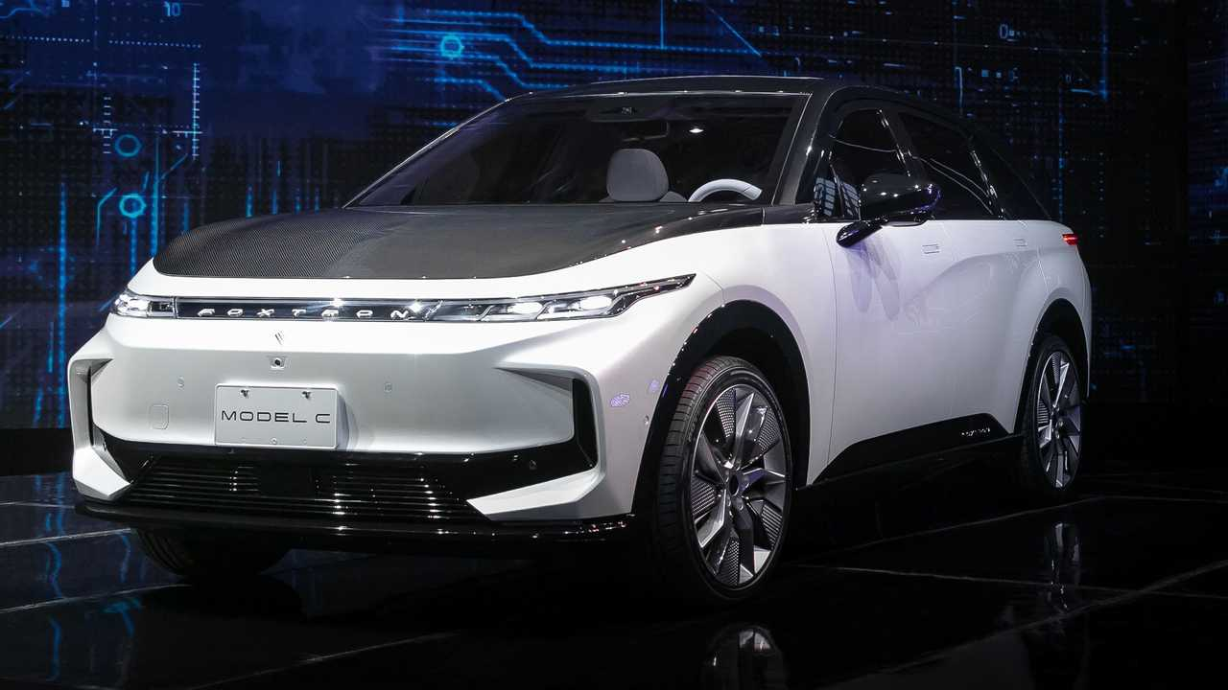
The first EV built on Hon Hai’s electric vehicle open platform is the Model C, marketed as “the intrinsically optimized electric SUV with pure electric nature.”
It is 4.64 meters (182.6 inches) long and has a wheelbase of 2.86 m (112.6 in), offering 5+2 seats and “plenty of storage space.” The Model C is said to deliver an extended range of 700 km (435 miles), a 0–100 km/h (62 mph) time of 3.8 seconds.
Foxconn also says the EV has a low 0.27 drag coefficient, high efficiency and intelligence, as well as “a reasonable price comparable to a fuel-powered car.”

Model E luxury sedan
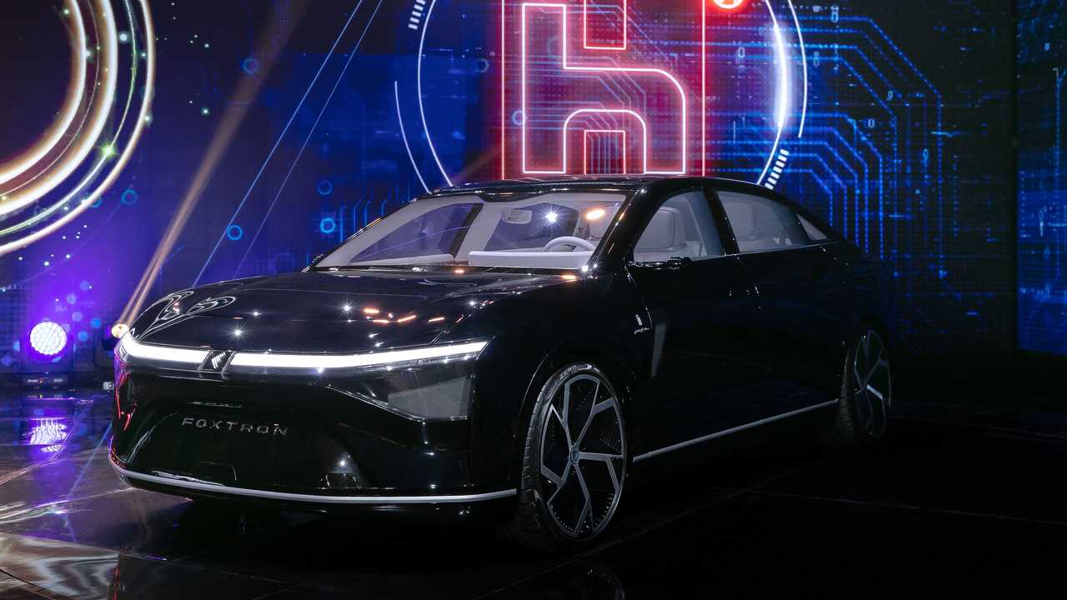
Moving on to the Foxtron Model E, Foxconn describes it as “a technologically innovative luxury flagship sedan” for middle and high-end consumers. Jointly developed by Hon Hai and Italian design powerhouse Pininfarina, the Model E offers a power output of about 750 horsepower, 0–100 km acceleration in 2.8 seconds, and a 750-km (466-mile) range.
Inside, the EV flagship’s rear seat area can transform into a dedicated mobile office, with personal mobile devices seamlessly connected to the passenger car. This is said to enable smart applications like face recognition door opening, smart windows and vehicle and environment interfaces.

Model T bus
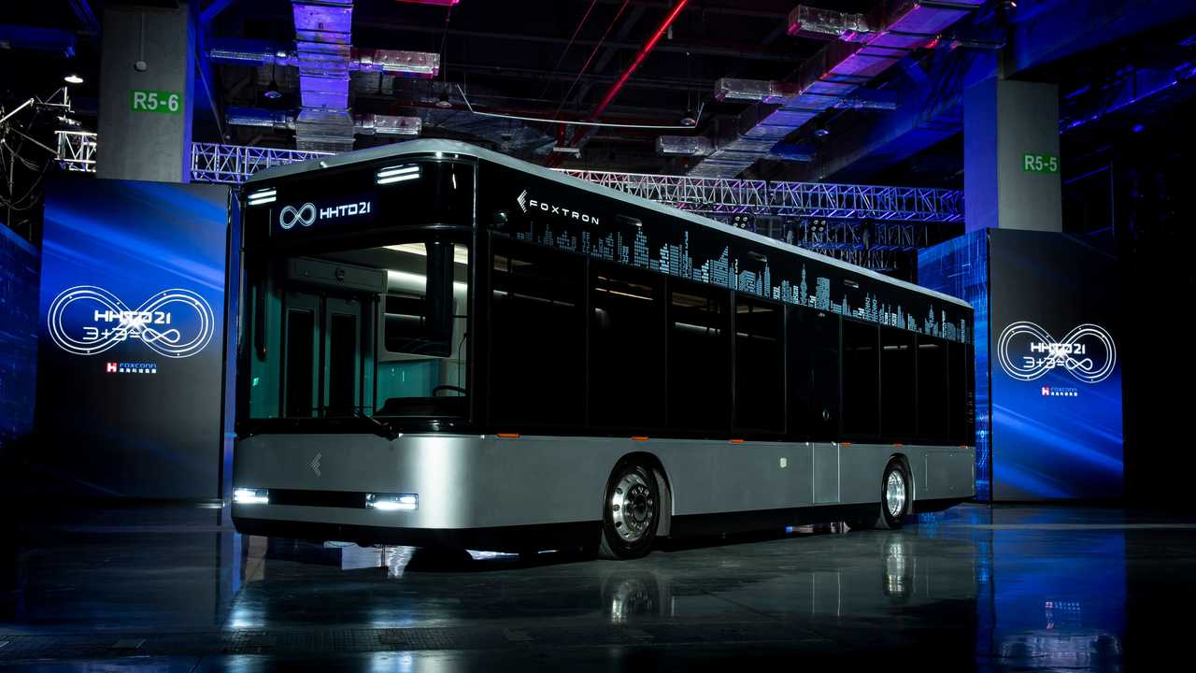
Finally, the Model T is a “stylish urban bus” envisioned as an intelligent transportation solution. Interestingly, Foxtron says the high rigid body design and protection meet Federal Transit Administration (FTA) regulations and standards, hinting at plans to sell it in the United States.
The battery is said to enable a range of more than 400 kilometers (248 miles) and can withstand temperatures of up to 400 degrees Fahrenheit (204 degrees Celsius). The electric bus can reach a top speed of 120 km/h (75 mph). Foxconn said it will start delivering the bus to a local transportation provider next year.
As for the electric passenger car concepts, the tech giant will build them for automotive customers rather than under its own automotive brand. Bloomberg reports that the Model E sedan will be sold by an unspecified automaker outside Taiwan in the coming years (Fisker maybe?), while the Model C utility will be sold in Taiwan under one of Yulon's brands from 2023. It remains to be seen whether Foxconn will build any of these EVs at its newly acquired plant in Lordstown, Ohio.

Foxconn Made the iPhone in Your Hand and Wants to Make the EV in Your Garage

Smartphone assembler sees Lordstown factory as potential maker of other brands’ vehicles


The Mount Pleasant, Wisc., campus of Foxconn Technology Group, the world’s largest electronics contract manufacturer.
PHOTO: MARK HERTZBERG/ZUMA PRESS
By
Yang Jie
and
Stephanie Yang
Oct. 1, 2021 10:58 am ET
PRINT
TEXT
Listen to article
Length5 minutes
The Taiwanese company that assembles iPhones wants to become a top contract maker of electric vehicles too, a plan boosted by the purchase of Lordstown Motors Corp.’s RIDE -5.72% electric truck factory in Ohio.
Foxconn Technology Group, 2317 -0.46% the world’s largest electronics contract manufacturer, is known for assembling products sold by big technology brands such as Apple Inc., Amazon.com Inc. and Alphabet Inc.’s GOOG -2.91% Google.
It now hopes to expand into a pricier piece of technology. Foxconn’s chairman has said he wants to be able to supply three million electric vehicles annually by 2027, which he estimated would be about 10% of the global market then.
It has made a flurry of deals in recent years to get a foothold throughout the auto-supply chain, including semiconductors, components, software and assembly. Partners include Jeep and Chrysler maker Stellantis NV and Los Angeles-based EV startup Fisker Inc., FSR -3.69% which is looking to make more than 250,000 vehicles a year in the U.S. with Foxconn’s help.

NEWSLETTER SIGN-UP

The 10-Point.
A personal, guided tour to the best scoops and stories every day in The Wall Street Journal.
PREVIEW
SUBSCRIBE

Now Foxconn has reached a deal to buy the Ohio factory of Lordstown Motors, the electric-truck startup that acquired a former General Motors Co. plant but has had trouble delivering a product. Lordstown Motors said Foxconn would make Lordstown-branded vehicles including its debut pickup truck, the Endurance.
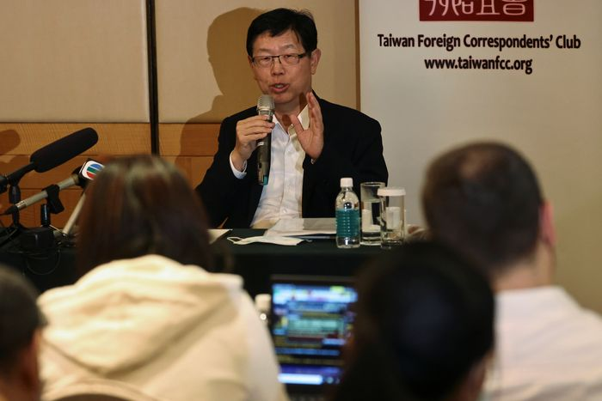

Foxconn Chairman Young Liu, speaking in March in Taiwan, has said he wants to be able to supply three million electric vehicles annually by 2027.
PHOTO: ANN WANG/REUTERS
Chairman Young Liu said the Lordstown factory would accelerate Foxconn’s timeline for having EV production capacity in North America. People familiar with plans for the factory said its capacity could be used for other brand-name clients too.
Analysts said there was plenty of profit to be made if Foxconn figures out low-cost assembly of EVs that sell for $40,000 or $50,000. And the rise of EV startups brings a pool of potential customers looking to tap Foxconn’s manufacturing expertise to challenge incumbent auto makers.
But a car is more than an iPhone on wheels.
“You need a better and bigger supply chain,” said analyst Bakar Sadik Agwan of GlobalData, a consulting firm. “EV manufacturing is a bit more complex than smartphone manufacturing.”
Mr. Liu, the Foxconn chairman, said in March that Foxconn felt at home making EVs because they rely heavily on electronics and software rather than a gasoline-powered engine. Foxconn’s main advantage over traditional auto manufacturers is speed, as well as a drive to prove it could succeed at the toughest manufacturing tasks, he said.
“Foxconn is the new kid in town. We need to build up our capabilities as soon as possible,” Mr. Liu said.
He told investors in August that the company planned to mass-produce EVs in the U.S. and Thailand starting in 2023 and was in talks about several potential locations in Europe.
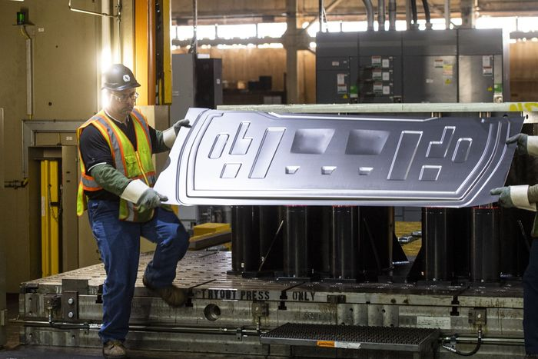

Lordstown Motors’ employees show the stamping process of the metal used to make their Endurance truck in Lordstown, Ohio.
PHOTO: NATE SMALLWOOD FOR THE WALL STREET JOURNAL
Looming over Foxconn’s plans is the possibility of an Apple EV, a project the Silicon Valley company has been working on for years but has never announced.
“The relationship between Apple and Foxconn might extend from phones to cars,” said Soumen Mandal, an analyst with Counterpoint Research. However, Mr. Mandal observed that Foxconn has a joint venture in Taiwan set to make cars and start selling them in 2023, which could make Foxconn a competitor to a possible future Apple EV.
It remains unknown whether Apple will put its brand name on a vehicle. If it did, it would likely look at making cars for American consumers in the U.S., given the political sensitivities about having auto production overseas in countries like China.
Foxconn’s Mr. Liu has said the expansion in manufacturing in the U.S. is to fulfill customer needs. Apple declined to comment.
Foxconn, known formally as Hon Hai Precision Industry Co., has taken a broader view of the EV business than simply vehicle assembly, planning for a future in which brand-name clients seek its help on certain aspects of car-making rather than the whole process. Most big car makers in developed markets like the U.S. still like to manufacture their cars themselves.

Related
Tesla vs. NIO: Battle for the World’s Largest EV Market
YOU MAY ALSO LIKE
UP NEXT
0:00 / 6:28
0:00
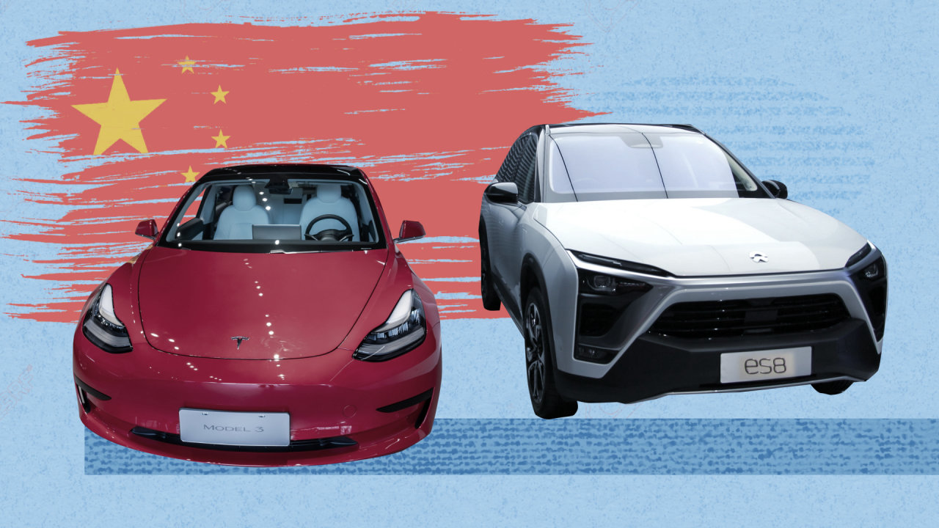
Tesla vs. NIO: Battle for the World’s Largest EV Market
Gone are the long waits at charging stations: Chinese electric-vehicle startup NIO is pioneering battery-swap systems, challenging Tesla and other rival car makers. Here’s how NIO and Tesla are racing for the world’s largest EV market in China. Photo illustration: Sharon Shi
Foxconn has made deals with EV battery and materials suppliers and in August bought a Taiwan semiconductor factory to make car chips. Mr. Liu said in September he hoped to build a comprehensive EV supply chain in Taiwan and leverage better semiconductor and battery technology to overcome the main hurdles to EV adoption: long charging time, inadequate range and high prices.
“Through these preparations, our EV customers won’t have any more capacity issues,” he said.
William Wei, a former Steve Jobs ally at Apple, was hired by Foxconn last year and now supervises the development of a software and hardware platform for EVs, essentially a starter kit that manufacturers could customize to build electric and self-driving cars.
Mr. Wei said at a company event a year ago that he wanted Foxconn to be the Android of EVs, a reference to the Google operating system used by smartphone manufacturers around the world.
Write to Yang Jie at jie.yang@wsj.com and Stephanie Yang at stephanie.yang@wsj.com
Copyright ©2021 Dow Jones & Company, Inc. All Rights Reserved. 87990cbe856818d5eddac44c7b1cdeb8
Appeared in the October 2, 2021, print edition as 'Foxconn Makes Bold Move on Electric Autos.'

2 Companies Accelerating the Race Toward EVs

The shift to electrification continues to gain ground.

Rhian Hunt
(TMFRhianHunt)
Oct 21, 2021 at 10:47AM
Author Bio

Key Points
- Stellantis, owner of Jeep and Chrysler, is building a 40 gigawatt battery factory in North America.
- Foxconn, partner of several EV startups, unveiled prototype electric vehicles on Oct. 18.
- Both moves are part of, and contributing to, the rapid expansion of EV production and demand.
October's third week opened with announcements from two very different players in the electric vehicle (EV) market. Stellantis (NYSE:STLA), the multinational owner of Jeep, Ram, Dodge, Chrysler, Fiat, Peugeot, and many other car brands, announced plans for a new North American EV battery factory. Foxconn (OTC:FXCNF), a Taiwanese electronics manufacturer now allied with EV start-ups Fisker (NYSE:FSR) and Lordstown Motors (NASDAQ:RIDE), showed the world a trio of EV prototypes. The market's reaction to all this was mixed, but the ongoing activity points to a bullish trend for the planet's vehicular electrification.

Stellantis is upping its battery capacity
Though the agreement exists as a memorandum of understanding (indicating an intention to work together but not a legally binding contract), LG Energy Solution intends to partner with Stellantis to manufacture batteries in North America. The partnership plans to launch a joint venture making 40 gigawatt-hours (GWh) of EV batteries yearly. They will start making batteries in 2024 if all goes according to plan. The press release notes the intention is to "help power Stellantis' goal of realizing more than 40% of its sales in the U.S. comprised of electrified vehicles by 2030." The factory's location hasn't yet been decided on.
While the planned battery plant is a significant step in EV manufacturing, Stellantis' investment still looks relatively limited and hesitant compared to the plans of other EV makers, present or potential.
Ford (NYSE:F), for example, is working on Blue Oval City and several battery factories, which together will crank out 129 GWh of batteries yearly. This is over three times Stellantis' commitment, while the Gigafactory that Elon Musk's Tesla (NASDAQ:TSLA) will soon launch near Berlin will manufacture over 50 GWh of batteries annually.
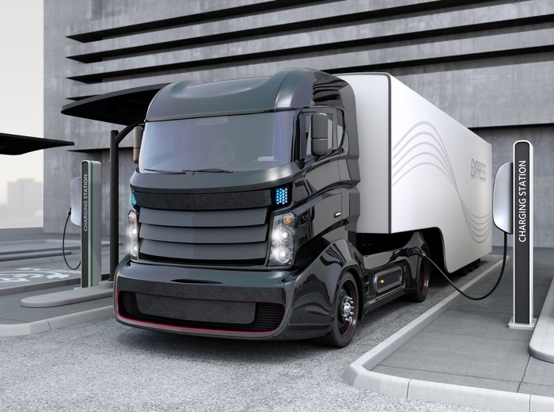
IMAGE SOURCE: GETTY IMAGES.
With the Gigafactory's 50 GWh expected to power around 500,000 cars, Stellantis' 40 GWh factory will presumably build the power units for approximately 400,000 EVs every year. This is a significant number, but still far short of even Tesla's current production target of roughly 1 million vehicles for 2021.

Foxconn's big reveal
Foxconn's three new EV prototypes include a large 750-horsepower sedan, an SUV, and a passenger bus. The Model E sedan is listed as having a range of 466 miles, 61 miles more than Tesla's longest-range vehicle.
The vehicles, much like Stellantis' batteries, are slated to be manufactured by a joint venture. Foxconn means to partner with a car company from Taiwan, Yulon Group, to build the three vehicles. Remarks made during the five-hour presentation indicate the vehicles, which bear the Foxtron nameplate, are more of a proof of concept of Foxconn's EV platform and technology than the final models it may offer for sale.
Two EV start-ups -- Fisker, which plans to make the affordable Ocean SUV, and struggling Lordstown Motors -- are closely linked with Foxconn. The news about Foxconn's prototype exhibition boosted Fisker's stock, though Lordstown shares dropped despite its potentially close ties with the Taiwanese company. Foxconn's aggression in continuing to push its EV ambitions is certainly a potentially good sign for its two allies. On the flip side, however, the company's chairman Young Liu said, "Our biggest challenge is we don't know how to make cars" during the unveiling event. That's not the most reassuring forecast of Foxconn's ability to get its newly acquired Lordstown assembly plant to churn out Fisker Oceans or Lordstown Endurance pickups in the next year or two.

Is this acceleration a plus for investors?
Stellantis' shares nosed down around 2% after it announced its battery plans, though its stock value has still risen about 10.88% over the past six months. Fisker, on the other hand, gained about 2.5% immediately after Foxconn's announcement, while Foxconn's shares jumped 11% within hours of its news release. The stock market reaction appears somewhat rational, at least in this instance, since Stellantis' entry into EVs appears slow and hesitant, while Foxconn's boldness and speed could help it secure market share at a crucial time in the next year or two.
Looking beyond the short-term moves, the rapid increase in EV investment among Stellantis' long-established car brands and upstarts like Foxconn or Fisker seem to be creating a positive feedback loop for the sector. More production, or even widely publicized production plans, could generate more consumer interest in EVs. Greater consumer interest and demand, in turn, encourages more production and a faster changeover from internal combustion engines to EVs.
As the old proverb says, a rising tide lifts all boats -- though in this case, it might be more accurate to say a rising current charges up all EV stocks. More, and faster, activity is very likely bullish for these stocks and the portfolios holding them, and the positive repercussions of these latest moves will likely extend beyond the companies directly involved.
This article represents the opinion of the writer, who may disagree with the “official” recommendation position of a Motley Fool premium advisory service. We’re motley! Questioning an investing thesis -- even one of our own -- helps us all think critically about investing and make decisions that help us become smarter, happier, and richer.

Assignment #2

Please prepare a report, 3-5 pages, analyzing the concept of MIH and the potential of MIH in terms of SWOT.

https://www.mindtools.com/pages/article/newTMC_05.htm

The report is due in a week.

