Thomas Aquinus, Summa Theologiae; First Part of the Second Part, Question 93: The eternal Law, accessed (http://www.domcentral.org/summa/summa-I-IIq93.html)

Note here that all below quotations are from Aquinus' answers, not from objections, so as to represent his opinions and not those he endoxically analyzes.
a. 1 "Just as in every artificer there pre-exists a type of the things that are made by his art, so too in every governor there must pre-exist the type of the order of those things that are to be done by those who are subject to his government."
a. 1 " Wherefore as the type of the Divine Wisdom, inasmuch as by It all things are created, has the character of art, exemplar or idea; so the type of Divine Wisdom, as moving all things to their due end, bears the character of law. Accordingly the eternal law is nothing else than the type of Divine Wisdom, as directing all ac tions and movements."
a.2 " For every knowledge of truth is a kind of reflection and participation of the eternal law, which is the unchangeable truth"
a.2 "In another way we speak of a superior judging of a subordinate by a kind of practical judgment, as to whether he should be such and such or not. And thus none can judge of the eternal law."
a.5 "God is said to command the whole of nature, according to Psalm 148:6: "He hath made a decree, and it shall not pass away." And thus all actions and movements of the whole of nature are subject to the eternal law"
a.6 "There are two ways in which a thing is subject to the eternal law, as explained above (Article 5): first, by partaking of the eternal law by way of knowledge; secondly, by way of action and passion"
a.A thing is maintained in the end and moved towards the end by one and the same cause: thus gravity which makes a heavy body rest in the lower place is also the cause of its being moved thither. We therefore reply that as it is according to the eternal law that some deserve happiness, others unhappiness"
History of the Summa Theologica:
In many ways a sequel to his earlier thought, the Summa Theologica represents all of Aquinus' thought and argument about catholic doctrine stripped down and written in a single composition. It is, unlike many other works of antiquity, thankfully quite easy to find its origins, as it was written at a catholic university which published and copied it hundreds of times. Copies from less than a century after his death are still in circulation, as pictured below. It had multiple printings in the fifteenth century based on hand editions copied both in scriptoriums and as part of the "pecia" rental system whereby parts of a text were loaned to students to copy. As such, our text is both likely accurate and full.
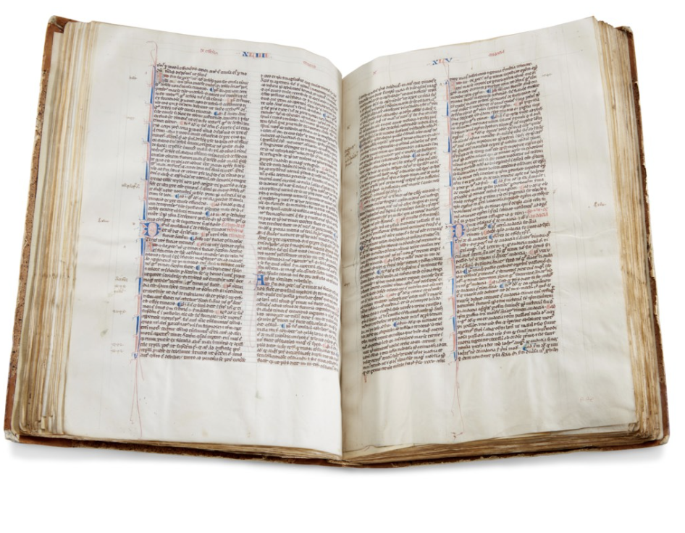

Quotes From De Legibus
Laws 1, 6:19 - "Well then, the most learned men have determined to begin with Law, and it would seem that they are right, if, according to their definition, Law is the highest reason, implanted in Nature, which commands what ought to be done and forbids the opposite."
Laws 1, 6:19 "the origin of Justice is to be found in Law, for Law is a natural force"
Laws 1, 7:23 "Your admission leads us to this: that animal which we call man, endowed with foresight and quick intelligence, complex, keen, possessing memory, full of reason and prudence, has been given a certain distinguished status by the supreme God who created him; for he is the only one among so many different kinds and varieties of living beings who has a share in reason and thought, while all the rest are deprived of it. But what is more divine, I will not say in man only, but in all heaven and earth, than reason? And reason, when it is full grown and perfected, is rightly called wisdom. Therefore, since there is nothing better than reason, and since it exists both in man and God, the first common possession of man and God is reason, must also have right reason in common. And since right reason is Law, we must believe that men have Law also in common with the gods. Further, those who share Law must also share Justice (note: Justice to cicero is a product of law); and those who share these are to be regarded as members of the same commonwealth."
Laws 1, 10:29 "we are born for Justice, and that right is based, not upon men’s opinions, but upon, Nature."
Laws 1, 12:33 "For those creatures who have received the gift of reason from Nature have also received right reason, and therefore they have also received the gift of Law, which is right reason applied to command and prohibition."
Laws 1, 15:43 "For Justice is one; it binds all human society, and is based on one Law, which is right reason applied to command and prohibition. Whoever knows not this Law, whether it has been recorded in writing anywhere or not, is without Justice."
Laws 1, 19:51 "And what shall we say of this? Is it possible for us to call those chaste who are kept from lewdness by the fear of disgrace, when the disgrace itself results from the inherent vileness of the deed? For what can properly be either praised or blamed, if you have disregarded the nature of the thing which in your opinion deserves praise or blame? Are bodily defects, if very conspicuous, to offend us, but not a deformity of character?"
Laws 1, 20:55 "of the Old Academy concluded that everything which is in accordance with nature and which helps us in the conduct of life, is a good, while Zeno thought that nothing is a good except what is honourable."
Laws 1, 22:59 "(Note: refering to philosophy and being able to know one's self) This precept is so important and significant that the credit for it is given, not to any human being, but to the god of Delphi. For he who knows himself will realize, in the first place, that he has a divine element within him, and will think of his own inner nature as a kind of consecrated image of God; and so he will always act and think in a way worthy of so great a gift of the gods, and, when he has examined and thoroughly tested himself, he will understand how nobly equipped by Nature he entered life, and what manifold means he possesses for the attainment and acquisition of wisdom. For from the very first he began to form in his mind and spirit shadowy concepts, as it were, of all sorts, and when these have been illuminated under the guidance of wisdom, he perceives that he will be a good man, and, for that very reason, happy."
Laws 2, 4:11 "For reason did exist, derived from the Nature of the universe, urging men to right conduct and diverting them from wrongdoing, and this reason did not first become Law when it was written down, but when it first came into existence; and it came into existence simultaneously with the divine mind. Wherefore the true and primal Law, applied to command and prohibition, is the right reason of supreme Jupiter."
Laws 2, 4:13 "What of the many deadly, the many pestilential statutes which nations put in force? These no more deserve to be called laws than the rules a band of robbers might pass in their assembly. For if ignorant and unskilful men have prescribed deadly poisons instead of healing drugs, these cannot possibly be called physicians’ prescriptions; neither in a nation can a statute of any sort be called a law, even though the nation, in spite of its being a ruinous regulation, has accepted it. Therefore Law is the distinction between things just and unjust, made in agreement with that primal and most ancient of all things, Nature"
Laws 3, 1:3 "Nothing, moreover, is so completely in accordance with the principles of justice and the demands of Nature (and when I use these expressions, I wish it understood that I mean Law) as is government, without which existence is impossible for a household, a city, a nation, the human race, physical nature, and the universe itself. For the universe obeys God; seas and lands obey the universe, and human life is subject to the decrees of supreme Law."
Laws 3, 12:28 "for the immortal gods have often put down unjust assertions of the people’s will by means of the auspices"
Laws 3, 14:32 "For, if you will turn your thoughts back to our early history, you will see that the character of our most prominent men has been reproduced in the whole State"
De Legibus History and Commentary
De Legibus by Marcus Tullius Cicero is the primary text which we will frame this history on. The two most important fragments of De Legibus which have transmitted the work to the modern day were collected by esteemed librarian and collector Isaac Vossius, court librarian of Amsterdam. The details of his many, many purchases can be found in his letters, accessed at (The Correspondence of Isaac Vossius – EMLO) These fragments of De Legibus in particular potentially being purchased and delivered to him by Johann Georg Greffe from an unknown Dutch seller. (Early Modern Letters Online : Work). Another major but more fragmentary piece was found in the collection of scholar Nicolaus Heinsius, which is currently stored along with the Vossius fragments in the Vatican library.
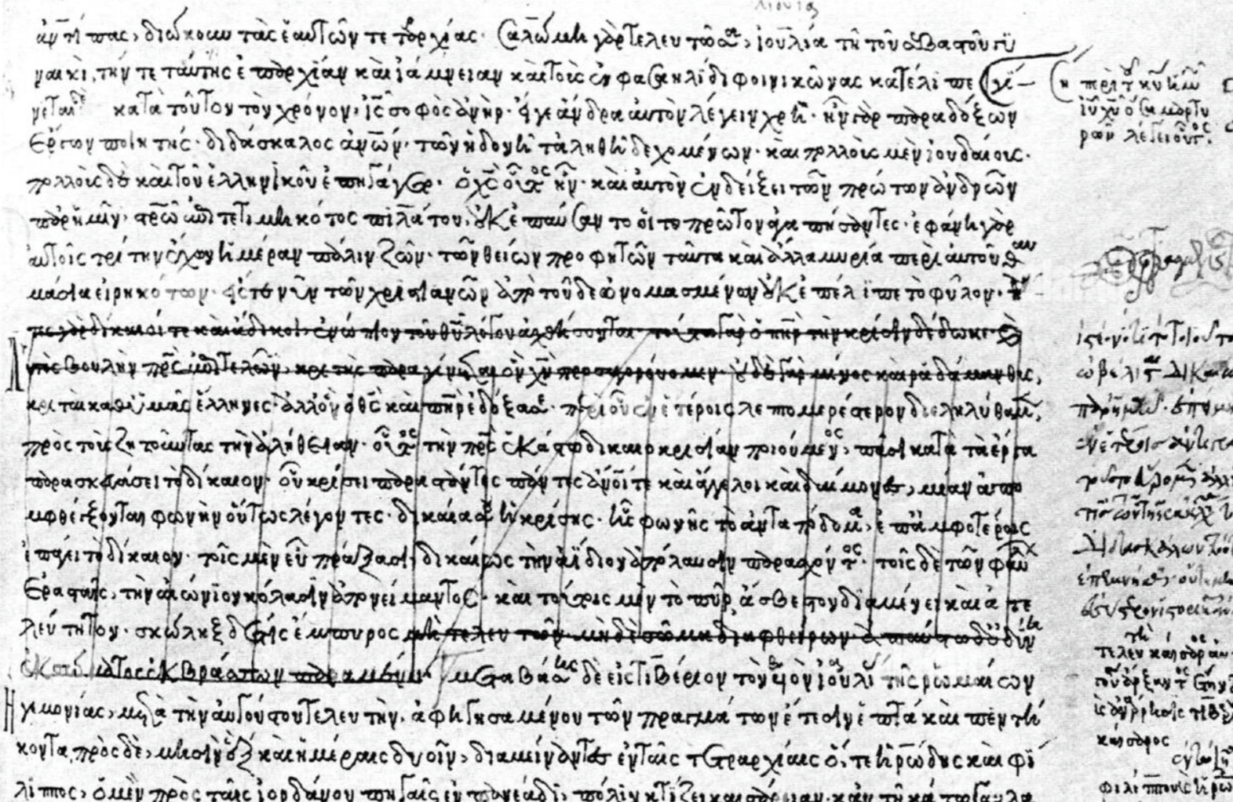
(note particularly the guidelines)

Aristotle, Various Works
Magna Moralia, 1198 a: "And so the natural kind of virtue, being of itself irrational, when divorced from any such Rule is a slight thing and fails to win praise; but when it is associated with a Standard and a deliberate Choice, the result is the full and complete sort of virtue. In producing virtue, therefore, the natural impulse collaborates with the Rule, and does not reach completeness apart from it"
Nichomachean Ethics, VII 2: "A rule of justice is natural that has the same validity everywhere, and does not depend on our accepting it or not[.]"
Nichomachean Ethics, III 18: "[A] man of good natural disposition is a man well endowed by nature in this respect; for if a thing is the greatest and noblest of gifts, and is something which cannot be acquired or learnt from another, but which a man will possess in such form as it has been bestowed on him at birth[.]"
Nichomachean Ethics, III 19: "Both for the good man and the bad man alike, their view of their end is determined in the same manner, by nature or however it may be; and all their actions of what ever sort are guided by reference to their end as thus determined. Whether then a man’s view of his end, whatever it may be, is not given by nature but is partly due to himself, or whether, although his end is determined by nature, yet virtue is voluntary because the good man’s actions to gain his end are voluntary, in either case vice will be just as much voluntary as virtue[.]"
Nichomachean Ethics, I 6: "If therefore among the ends at which our actions The ultimate End, which is the Supreme Good, is the End of Political Science. aim there be one which we wish for its own sake, while we wish the others only for the sake of this, and if we do not choose everything for the sake of something else (which would obviously result in a process ad infinitum, so that all desire would be futile and vain), it is clear that this one ultimate End must 2be the Good, and indeed the Supreme Good"
Notes: I have only included a scant number of direct quotes here because Aristotle’s conception of natural law is far more in the movements of logic than in particular explicit language. I think generally, his conception of natural law is not quite as developed as Cicero’s will become and runs something like this: An object has an ideal type which is either divinely or universally inspired, and its good is to aim towards this object. To aim towards that object which is its ideal is natural for an object, and laws which enhance the ability of the individual to ascertain to the achievement of their natural good, which is itself natural law, are positive law.

History of Aristotle’s Nichomachean Ethics
The Nichomachean ethics are, like many other works of antiquity, available only through manuscript translation. Aristotle and the Arabic Tradition, (https://en.pusc.it/sites/default/files/fil/2023/ARISTOTLE%20AND%20THE%20ARABIC%20TRADITION-Full%20Version.pdf), notes early Syriac translations by major Arabic philosophers Al-Fārābī and Averroes in the ninth century, among others. I was not able to locate online versions of these translations, and so cannot provide quotations from them, but they are likely the oldest surviving versions of the text. Arabic scholars translated huge amounts of Aristotle’s works through interchange with Greece, which suggests that at the time the text was still preserved in mainstream tradition. A later translation by bishop Robert Grosseteste formed the basis of the medieval understanding of the work, and an even later by philosopher Leonardo Bruni formed the basis of the first printed editions.

The Instructions of Sharuppag and The Maxims of Ptah-Hotep
Note: I have grouped these together to show the transformation of logical to natural law. This is not meant to imply that these two texts are immediately related, but instead to show how dialogue can be framed differently depending on era through contrasting the much older Sharuppag to the still ancient Ptah-Hotep. As such, quotes are out of order, meant to be read from top to bottom.
The Instructions of Sharuppag, lines 35-38: “You should not pick a quarrel; you should not disgrace yourself. You should not [lost text] lies; [lost text] You should not boast; then your words will be trusted. You should not deliberate for too long (?); you cannot bear [lost text] glances.”
The Maxims of Ptah Hotep, Maxim 6: “Cause not fear among men; for [this] the God punisheth likewise. For there is a man that saith, 'Therein is life'; and he is bereft of the bread of his mouth. There is a man that saith, 'Power [is therein]'; and he saith, 'I seize for myself that which I perceive.' Thus a man speaketh, and he is smitten down.”
The Instructions of Sharuppag, lines 204-207 “To have authority, to have possessions and to be steadfast are princely divine powers. You should submit to the respected; you should be humble before the powerful. My son, you will then survive (?) against the wicked.”
The Maxims of Ptah Hotep, Maxim 10: “If thou be lowly, serve a wise man, that all thine actions may be good before the God.”
The Instructions of Sharuppag, lines 94-96: “The palace is like a mighty river: its middle is goring bulls; what flows in is never enough to fill it, and what flows out can never be stopped.”
The Maxims of Ptah Hotep, Maxim 13: “The council-chamber acteth by strict rule; and all its plans are in accordance with method. It is the God that advanceth one to the seat therein;”
The Instructions of Sharuppag, lines 172-174: “The elder brother is indeed like a father; the elder sister is indeed like a mother. Listen therefore to your elder brother, and you should be obedient to your elder sister as if she were your mother.”
The Maxims of Ptah Hotep, Maxim 38: “That which is desired by the God is obedience; disobedience is abhorred of the God.”
History of Ptah-Hotep and Sharuppag
The Maxims or Instructions of Pta-Hotep were compiled during the Egyptian Middle Kingdom, about 2100 B.C.E., and were for some time believed to be the oldest longform prose still in existence. The Pisse Papyrus that contained them was purchased in 1843 by Emile D’avennes from an unknown Theban seller, potentially a graverobber, and is among the best preserved works of ancient literature. Ptah-Hotep is focused on an externally basic form of what could be called natural law stemming from the goddess Ma’at, the great spirit of balance. He insists that a natural property of the world decrees the outcomes of virtuous or evil decisions.
The Instruction of Sharuppag was discovered in Abu Salabikh, near modern day Baghdad, during an archeological expedition in 1963, dated to between 2600 and 2500 B.C.E.
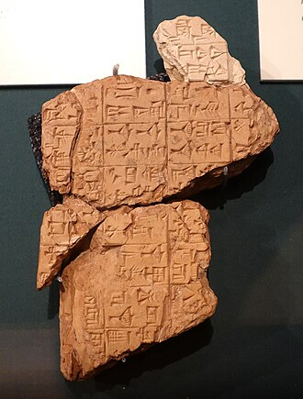

Works, Cited
Aquinus, T. (n.d.). Ia IIae q. 93. Retrieved April 20, 2026, from http://www.domcentral.org/summa/summa-I-IIq93.html
Aristoteles latinus. (n.d.). Hoger Instituut Voor Wijsbegeerte KU Leuven; Hoger Instituut. Retrieved April 20, 2026, from https://hiw.kuleuven.be/dwmc/research/al/
ARISTOTLE, Nichomachean Ethics, in the Latin translation of Leonardo Bruni. (n.d.). Les Enluminures. Retrieved April 20, 2026, from https://www.textmanuscripts.com/medieval/aristotle-nichomachean-ethics-60321
Biggs, R., & Hansen, D. (1974). Inscriptions from tell abu salabikh. The University of Chicago Press, 99.
Buning, R. (n.d.). The correspondence of isaac vossius – EMLO. Retrieved April 20, 2026, from https://emlo-portal.bodleian.ox.ac.uk/collections/?catalogue=isaac-vossius
Early modern letters online : Work. (n.d.). Retrieved April 20, 2026, from https://emlo.bodleian.ox.ac.uk/profile/work/615b2df4-2c32-404e-81e6-b0fc79d2e5c1?people=vossius&let_con=de+legibus&start=1&numFound=2&type=advanced
Gunn, B. (2009, November 20). The project gutenberg e-text of the instruction of ptah-hotep, by battiscombe G. Gunn. https://www.gutenberg.org/files/30508/30508-h/30508-h.htm
Hayes, J., & Alwishash, A. (Eds.). (2015). Aristotle and the arabic tradition. Cambridge University Press.
Mark, J. J. (2022). The instructions of shuruppag. World History Encyclopedia.
The instructions of Shuruppag: Translation. (n.d.). Retrieved April 20, 2026, from https://etcsl.orinst.ox.ac.uk/section5/tr561.htm

