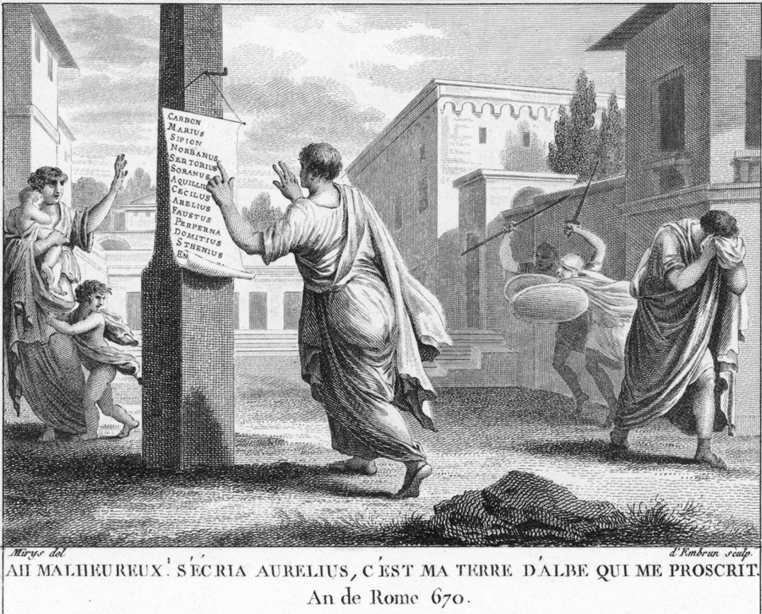
The Proscriptions

What Were the Proscriptions
The Proscriptions were incidents of state
sanctioned murders against hundreds of
individuals. Lists of names were published
throughout Rome, and those who were on the
lists were marked for death, and their
property was confiscated by the state.
Anyone could freely execute a person on the
list, without a trial, and receive an incredibly
large cash reward and keep a portion of the proscribed’s estate if they could provide the deceased’s head. Similarly, those who provided information against a proscribed person were also handsomely rewarded. Further, the children and grandchildren of those who were proscribed were barred from running for public office.

Sulla’s Proscriptions
In the spring of 83 BCE. Lucius Cornelius Sulla, proconsul of the republic, labeled an enemy of the Roman Republic by Cinna, sailed back to Rome from the east. He stood in front of a highly trained, extremely battle-hardened army and had amassed massive wealth in the four years he was gone. Despite his political enemies, Cinna and Marius having already deceased, war was declared between Sulla and the Cinno-Marian faction. He decisively destroyed them at the Battle of the Colline Gate on November 1^{st,} 82. He was subsequently appointed dictator. Two days later, the first list of proscriptions went up.
While Sulla had originally desired the senate to approve/sanction these assassinations against his political rivals, after failing to receive their support, he turned to the popular assembly, which voted the bill into law. The first list of only 80 names contained Sulla’s greatest political enemies. Only nobles were proscribed. The lists were sorted by official rank, with those who had held the consulship at the top. Almost every single person elected to public office since he departed for the east was included on the list. Sulla was reportedly easily swayed to include names on the lists, and a second and third lists went up on the 5th and 6th of November that included 440 names. While the lists were definitive(as in no name could be crossed out once they were proscribed) and made by Sulla himself, they were often manipulated in the months in which they were continuously reposted by individuals hoping to satisfy personal grudges. The heads of the most prominent victims were displayed on the rostra in the forum. Only 75 names of the over 520 men proscribed survive today.

The Second Triumvirates Proscriptions
The Second Triumvirate was a group of three powerful Caesarians formed in the aftermath of the assassination of Julius Caesar. The group comprised Marcus Lepidus, Mark Antony, and Caesar’s adopted son Octavian (the future founder of the Roman Empire). Their proscriptions carried out in 43 BC were done with the goal of solidifying their hold over the Roman state and to avenge Caesar’s murder.

While those marked for death by the Triumvirate were fewer than Sulla (around 300 or so), thousands more individuals had their property seized by the state, effectively politically neutering them. Their proscriptions also named more influential/powerful individuals, including Cicero, Sextius Pompey, Cassius, and, of course, Marcus Junius Brutus. 2500 drachmae were given as a reward for the head of free men, while 1000 were offered for the head of named slaves. Rewards of similar size were given to informants. Much of the confiscated funds was used to pay their troops.

Most ancient sources portray Octavian at the bare minimum as initially reluctant to enact this mass murder, placing the lions share of the blame onto Antony and Lepidus. It is important to remember that soon after this event, the Triumvirate fell apart, war was waged, Antony was declared an enemy of the state, Lepidus was stripped of his positions and power, and Octavian became Augustus, the first Emperor of Rome.

