[DRAFT] Simplicity S8941: Possible alterations (5/7/2019)
Hope Greenberg, http://www.uvm.edu/~hag/regency/s8941/s8941.pdf

Simplicity has produced a delightful new pattern that is based on the over- and under-gown style of the late 1790s. I expect many people will be creating lovely gowns based on this pattern. However, there are a couple alterations you may like to try to make it both more historically accurate and to improve the fit.

If you compare this gown to extant gowns or even some fashion plates you will notice three things about the back of the gown:
1) it uses a deeply curved seam that ends at the armscye whereas actual gowns of this period tend to have straight, or only slightly curved, back side seams
2) it has a modern armscye--drops straight down from the shoulder point--whereas these early gowns tend to have a sleeve that reaches closer to the center back, and
3) it has more gathers than many (not all) of these early gowns.

If you use the pattern but try to make the gown as close-fitting and as body-hugging as the fashion plates would have us believe was the ideal, you will find that you can barely move your arms—certainly not raise them very much. If you make it so that you can raise your arms you may find the bodice to be “baggier” than you like.

The key factor is the armscye. Note the different between the pattern and these examples. (And if you are, at this moment, wearing a top that has the same modern construction, see what happens if you raise your arms or elbows—your entire blouse or jacket will probably raise up.) By placing the armscye in a curve that reaches closer to the center back you are ensuring that your shoulder joint is contained within the sleeve, not the bodice back. When the seam is closer to your center back you can make the bodice more fitted, and have less gathering--thus making the sleeve less “puffed--while still retaining a good range of motion that will not distort the bodice as you move.

But how? Well, that’s the tricky part. There are no doubt calculations for drafting a sleevehead and armscye like this but I must admit to being a “try by doing” kind of person. Draw a curve on the pattern (or a tracing of the patter or muslin if you don’t want to ruin the pattern with experiments!). Then cut away the crescent–shaped sliver between the line you drew and the edge of the original pattern and add it to the sleeve head in the appropriate spot. Where, exactly, do you draw? It’s easiest if you have a friend to help. Make a muslin of the back, pin it to your shirt along your neck and shoulders, then raise your elbows, and move them forward and back. Your friend should be able to find the resulting crease between your arm and back, and draw that curve on the muslin. Voila!

Another trick: make the underarm higher. This seems counterintuitive: how does making the armhole tighter actually make the sleeve feel looser? Olves aligning the sleeve seam with where your joint is. Fortunately, Andrea Schewe has a wonderful video that shows just how that works:
https://www.threadsmagazine.com/2016/01/25/video-how-to-modify-sleeves-for-better-arm-mobility

As women’s gowns changed from the 18th century pieced and fitted back with a lower waistline to the higher waist, there were many experiments. Some involved pleating and some still used piecing. It’s harder to find examples of backs with seam details in fashion plates but there are a few. As we move closer to the end of the century the design seems to settle into a central diamond-shaped center back with the back side seams beginning fairly high on the armscye, and then gradually lowering as the century progresses. That is, in many earlier examples the shoulder seam and the top of the side back seam actually meet, while in later examples they do not—but there is still plenty of experimentation in this design, not a steady and even progression.

Turning a modern-designed back into the historic “diamond-shaped” back is fairly straightforward. Tape the bodice back and side back together—remember you may have to “gather” or “pleat” the side back a tiny bit with your fingers to get it to fit onto the center back panel if the seam is at all curved to make the ends come out even and let the pattern still lie flat on a table. Then draw a straight diagonal line from the armscye to waist. How wide do you want the bit at the waist? How high do you want the line to go on the armscye? That is entirely up to you. You are customizing the gown so you get to make the decision!

Here are some examples of this evolution in back and sleeve design.:

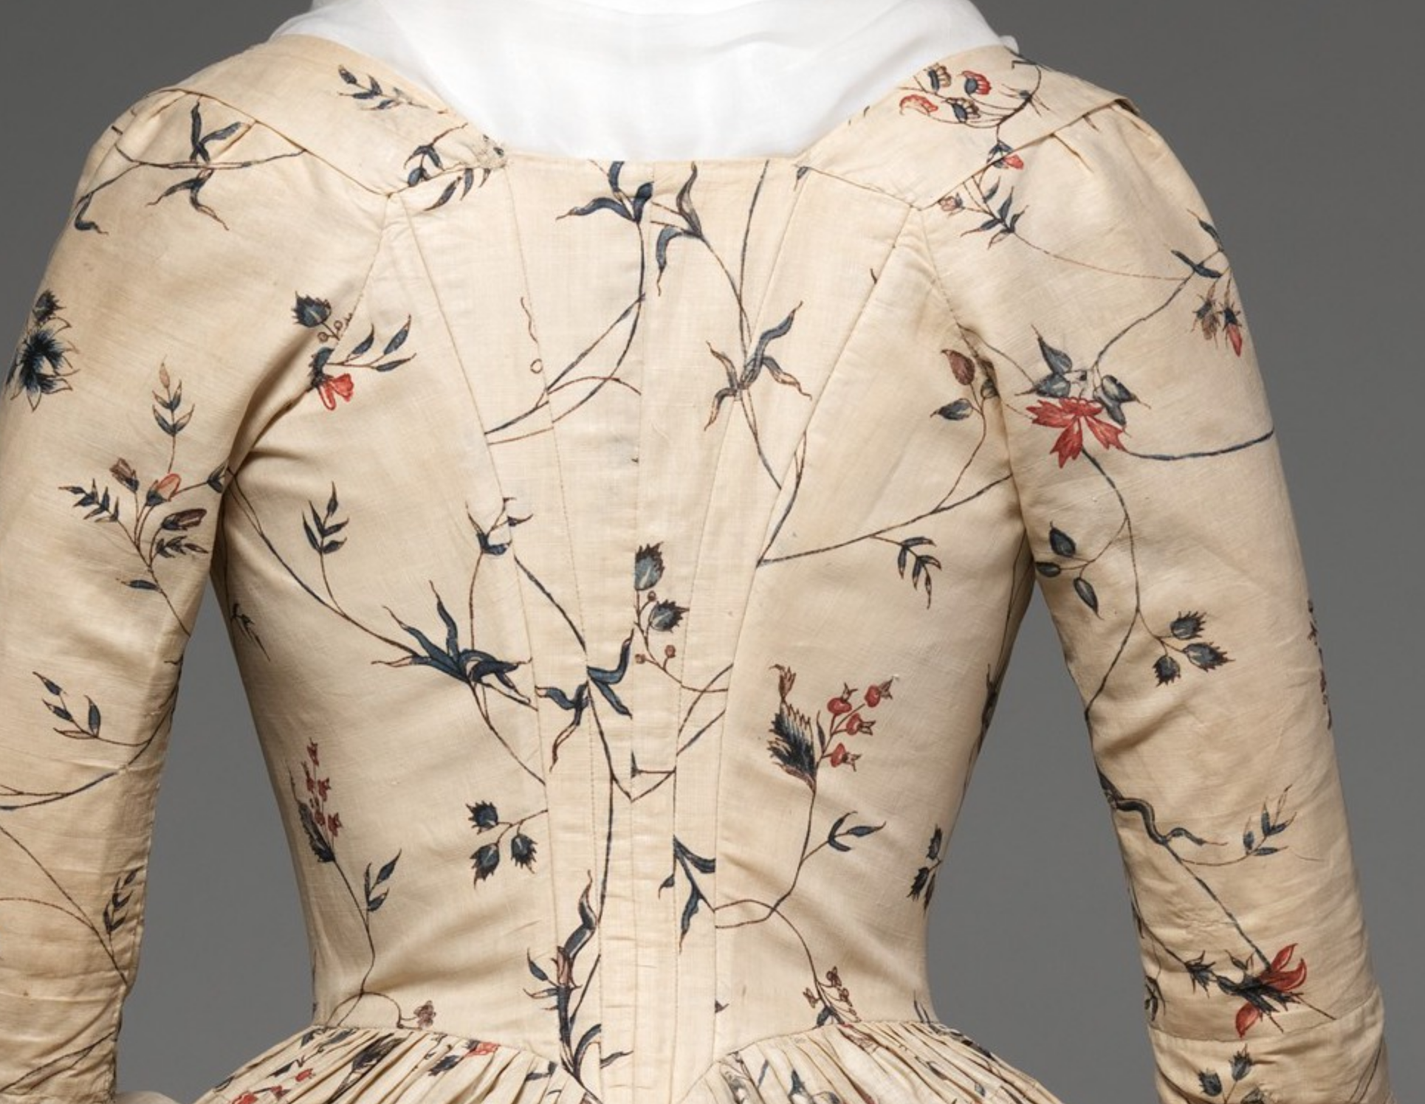
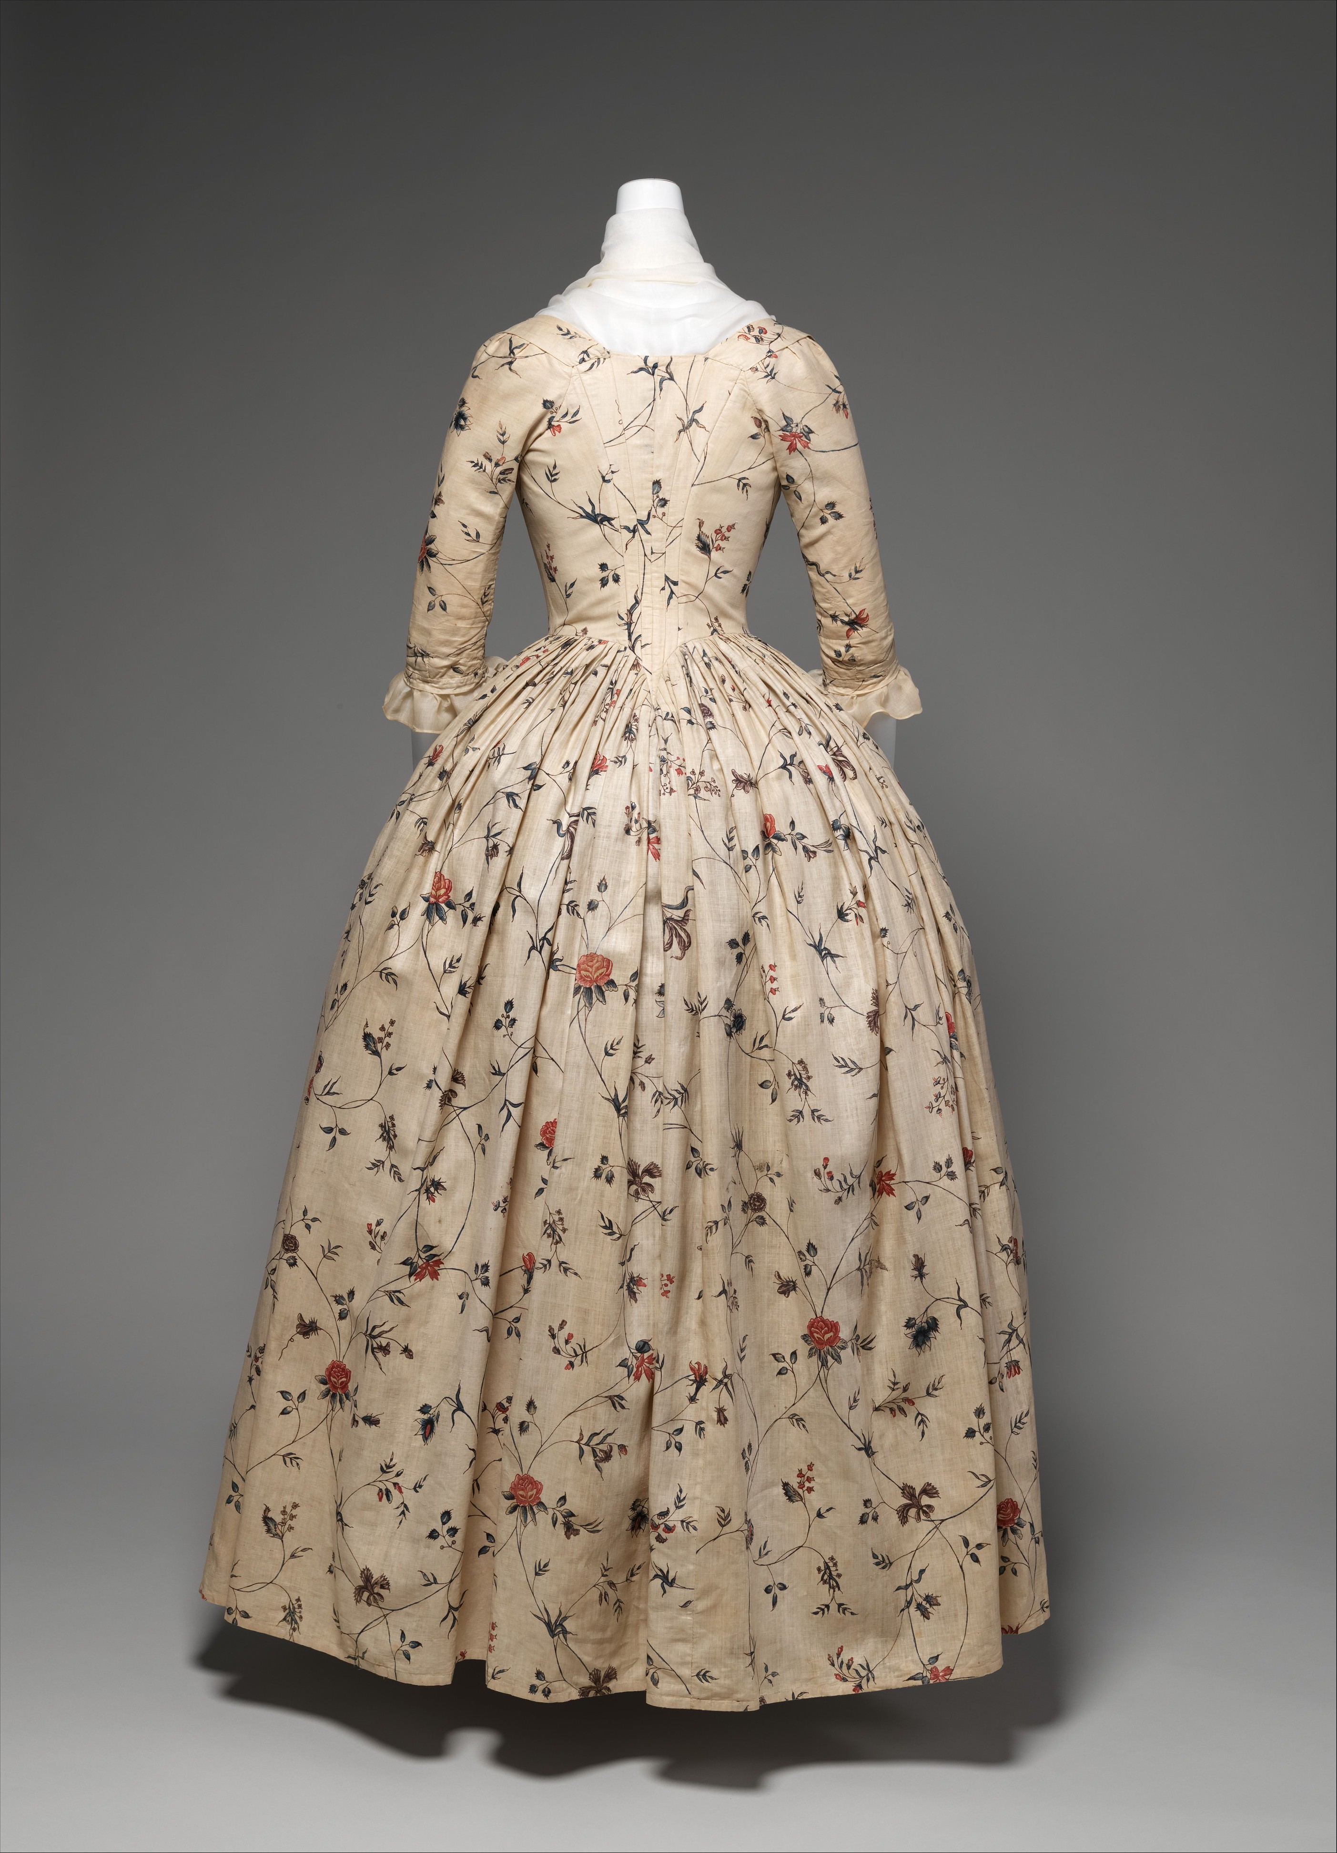
A common design for this period: The back is constructed with curved, shaped, pieces to achieve a fitted look. The sleevehead is very flat, with only a couple tiny pleats, and is attached to the shoulder pieces.
1785-1795, Metropolitan Museum of Art, Robe á l’anglaise 09.300.647

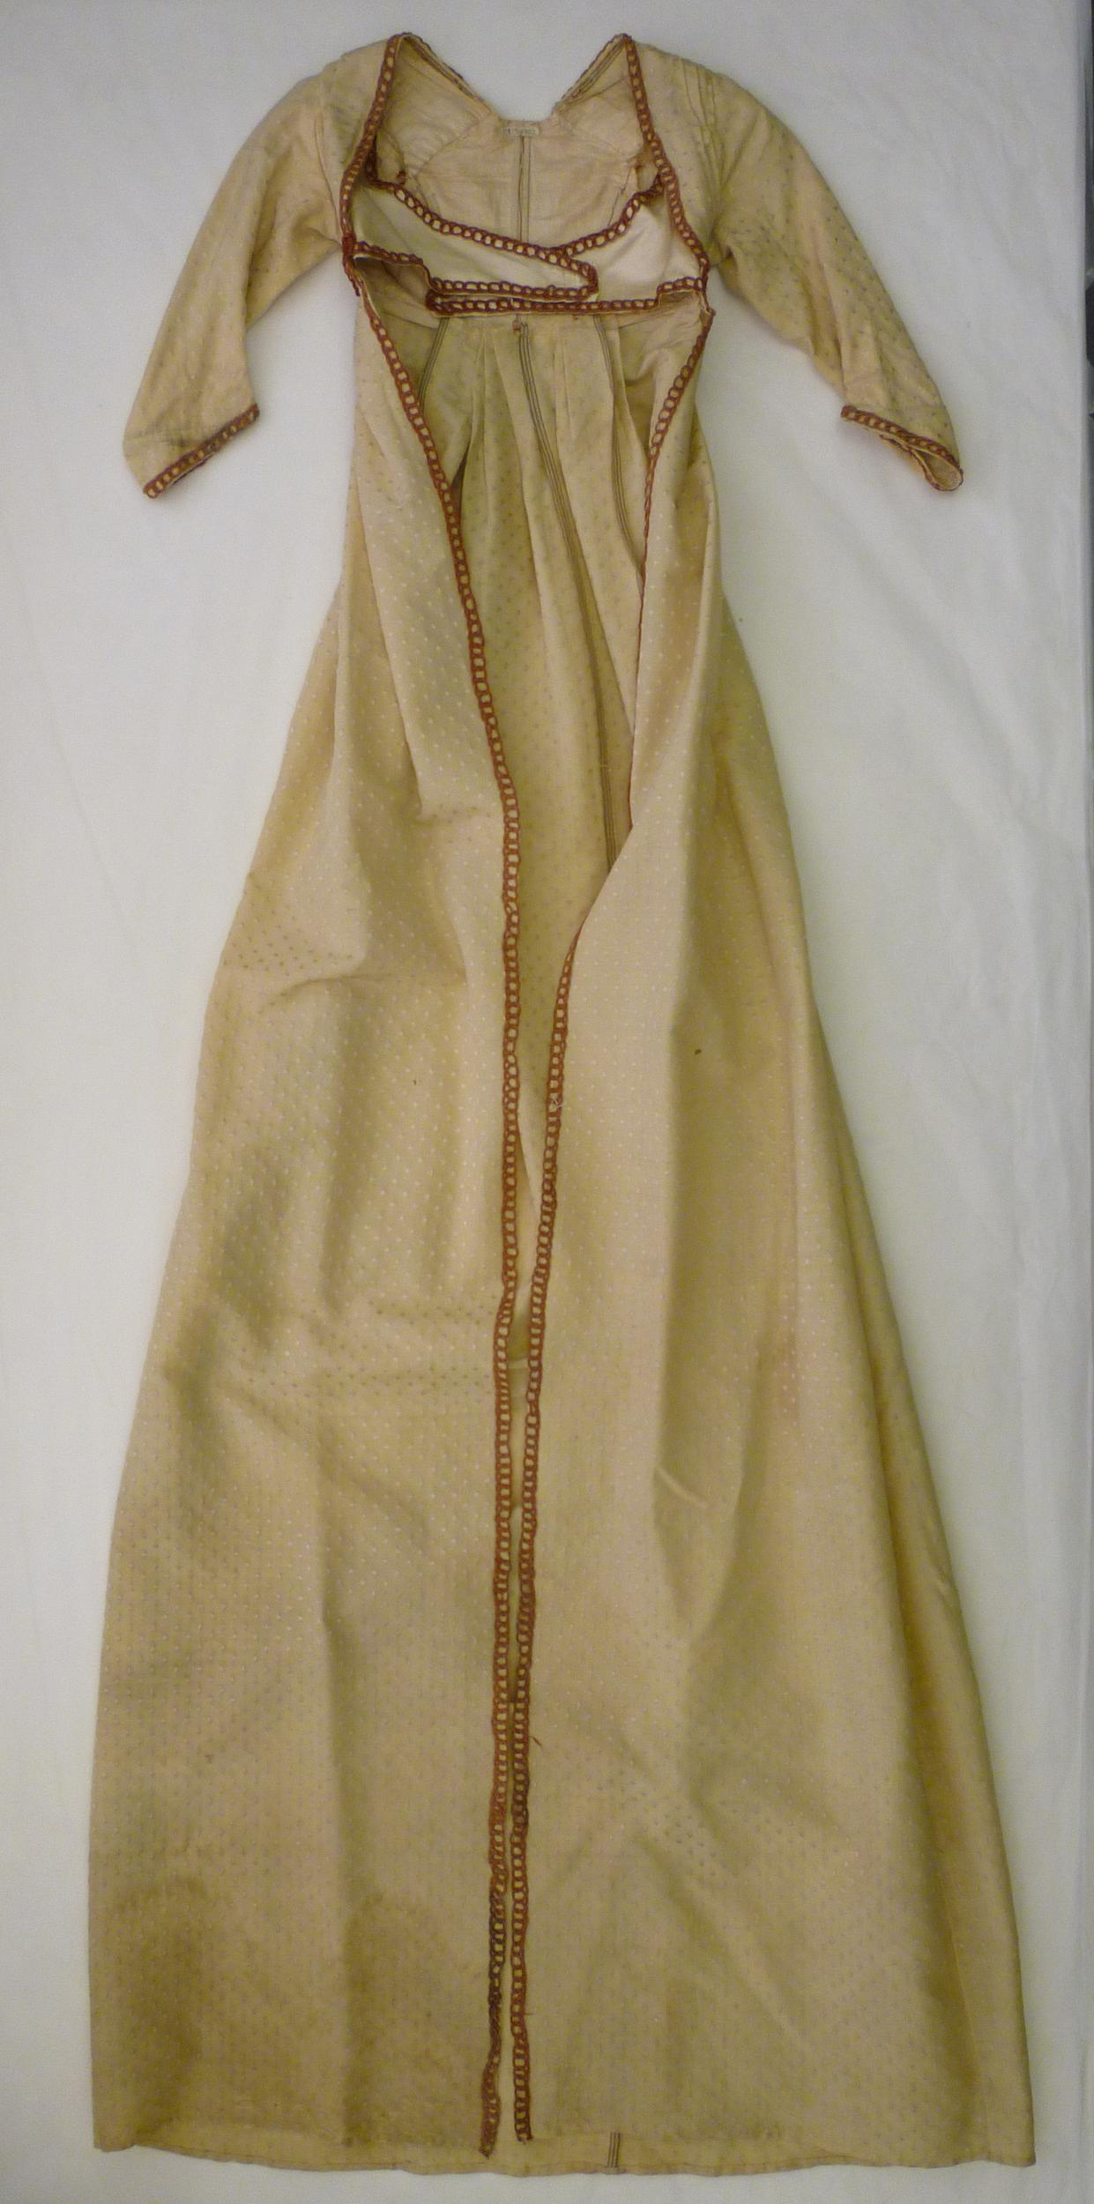
The waist is higher and the narrow center back pieces are fewer and wider.

1795-1799, Victoria and Albert Museum, London, Gown 513-1902

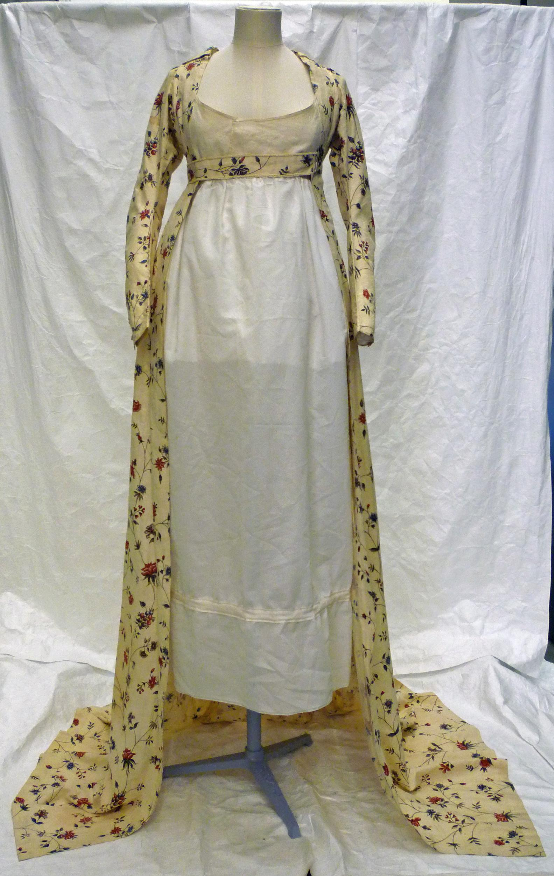
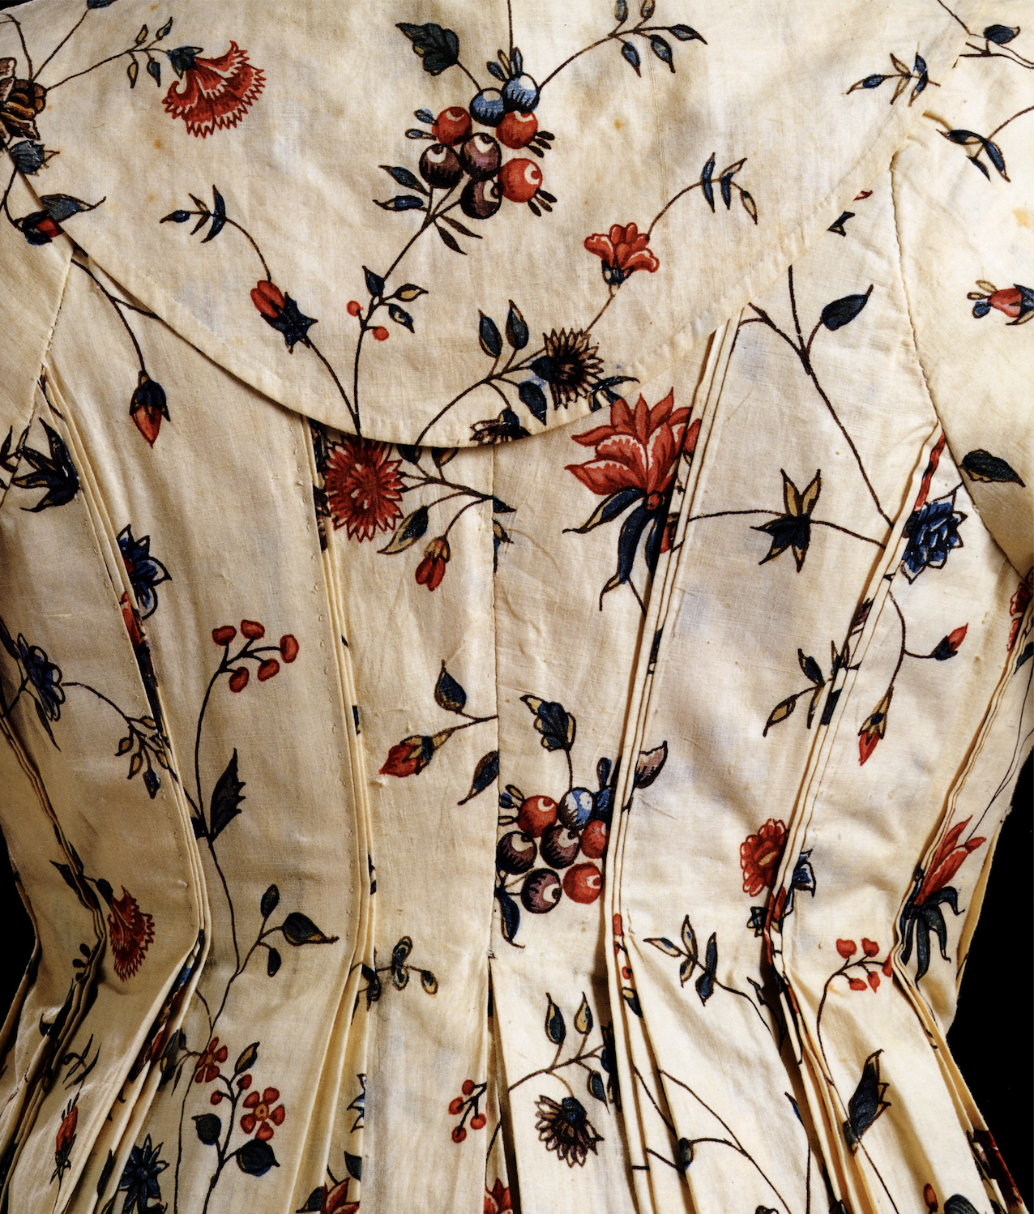
Another transitional gown experiment, this time a beautiful open-front gown that uses tiny tucks to achieve the fit.

1795-1800, Victoria and Albert Museum, London, Gown T.121-1992

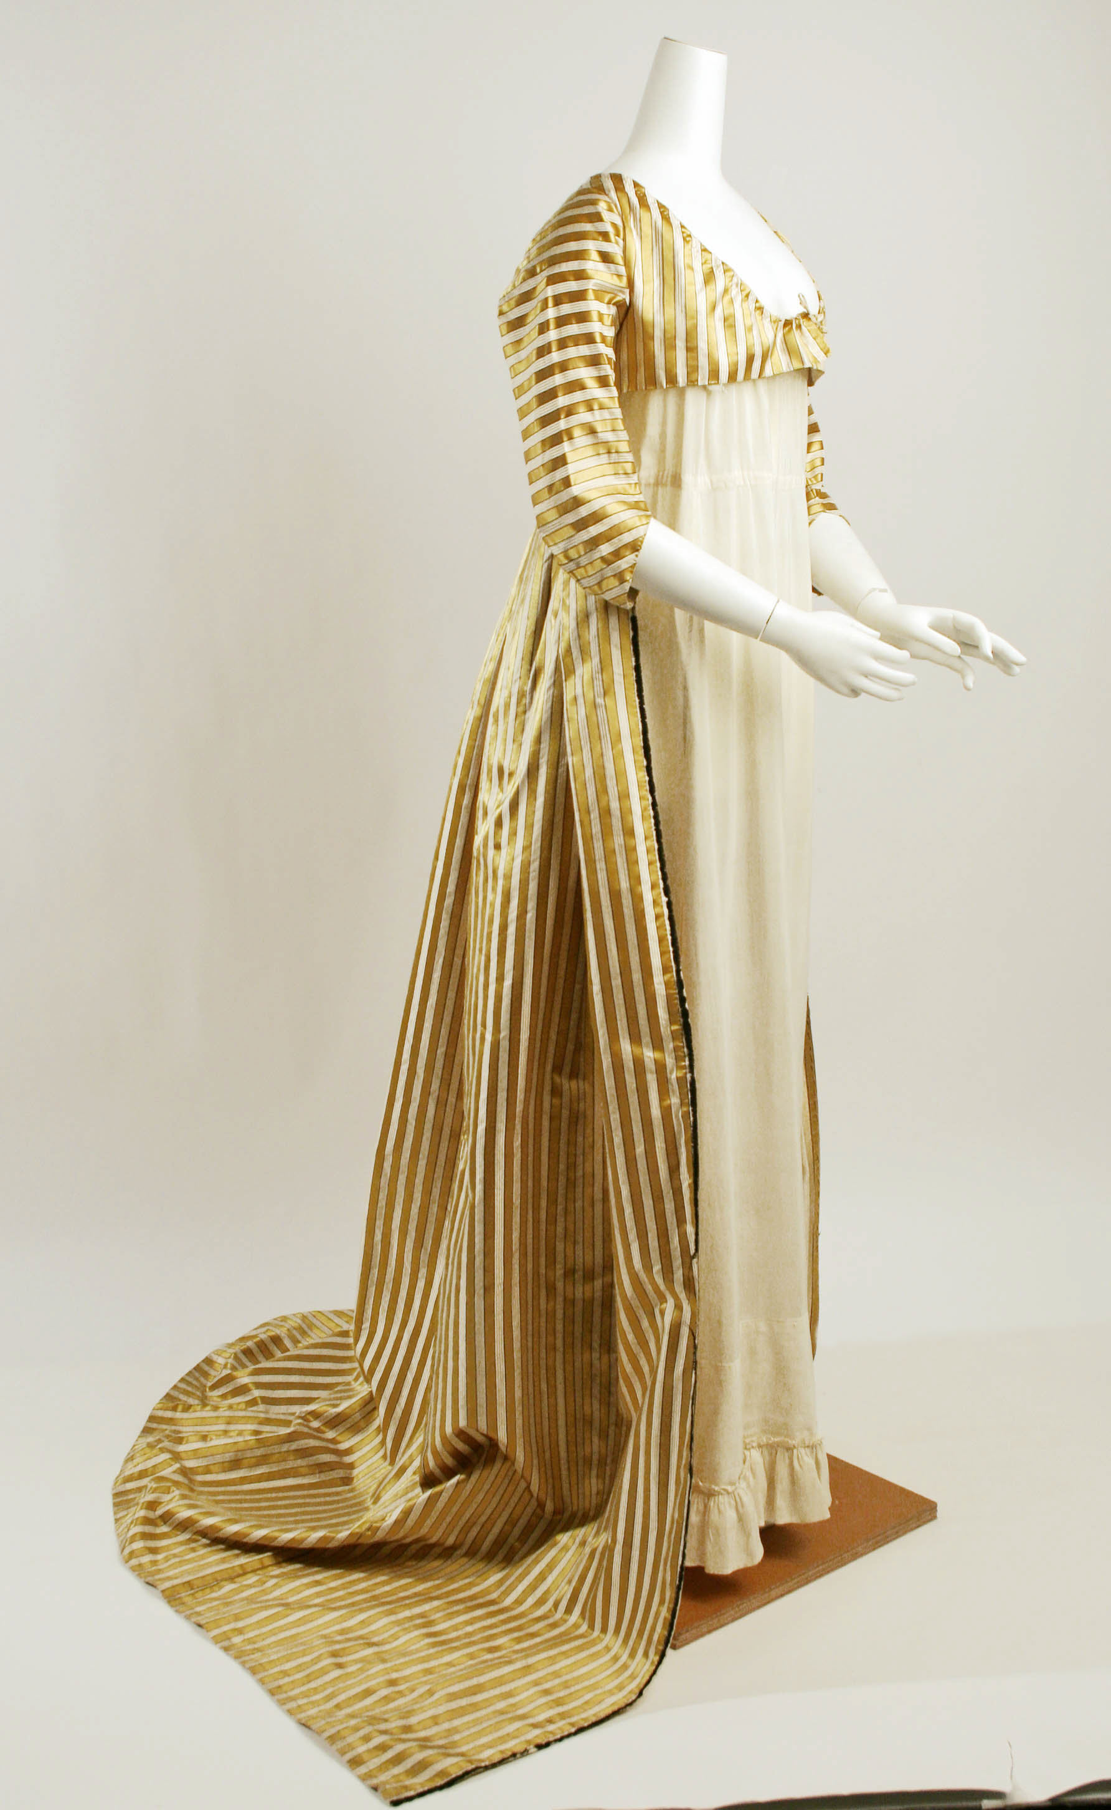

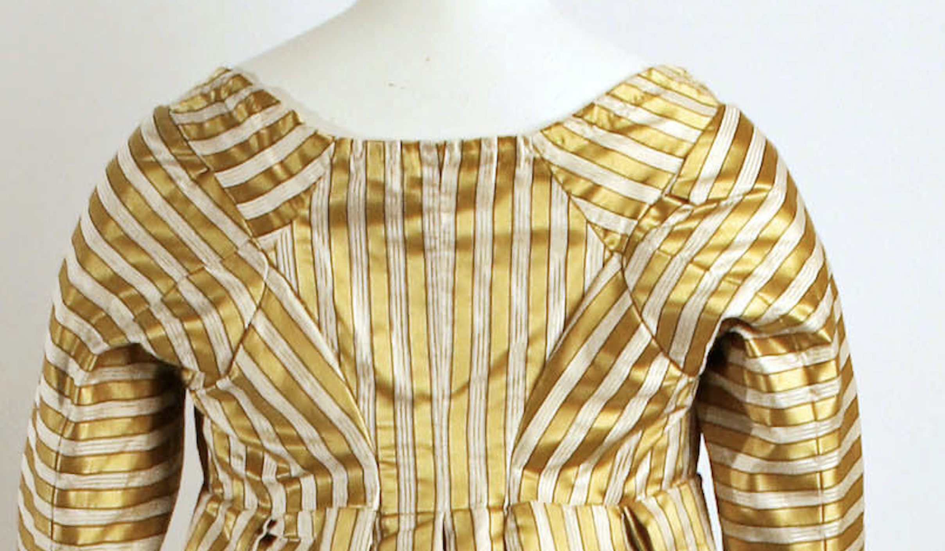

In this gown we see the move towards what will become a standard back design – the diamond back. In the early examples the shoulder piece and the side back seam meet at corner of the diamond. In later examples the back seam will be a bit lower so that the center back panel no longer has a those points—an inch or more of that panel will be along the armhole seam.

c. 1797 Metropolitan Museum of Art, Dress 1984.85

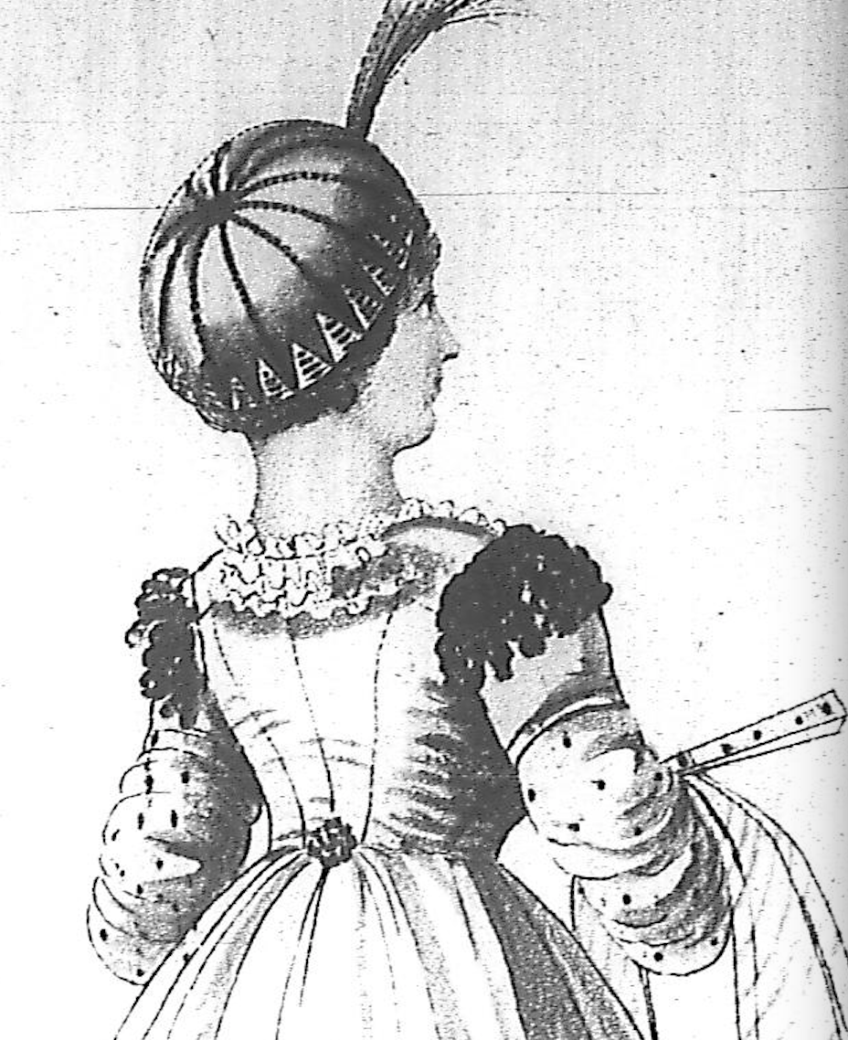
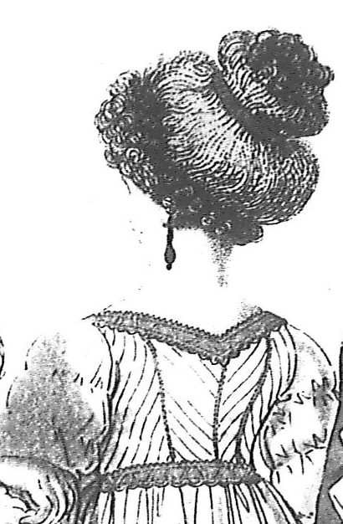
Two examples of gown backs from Heideloff’s Gallery of Fashion, a monthly publication, that show the non-diamond-back style. As with earlier robe a l’angaise styles, the back seams go up into the neckline.
At left: Muslin gown with “body” (an overbodice) April 1798
At right: Muslin gown with “epaulettes” (which in this case does not refer to the trim on top of the shoulder but to the short sleeve itself) May 1799

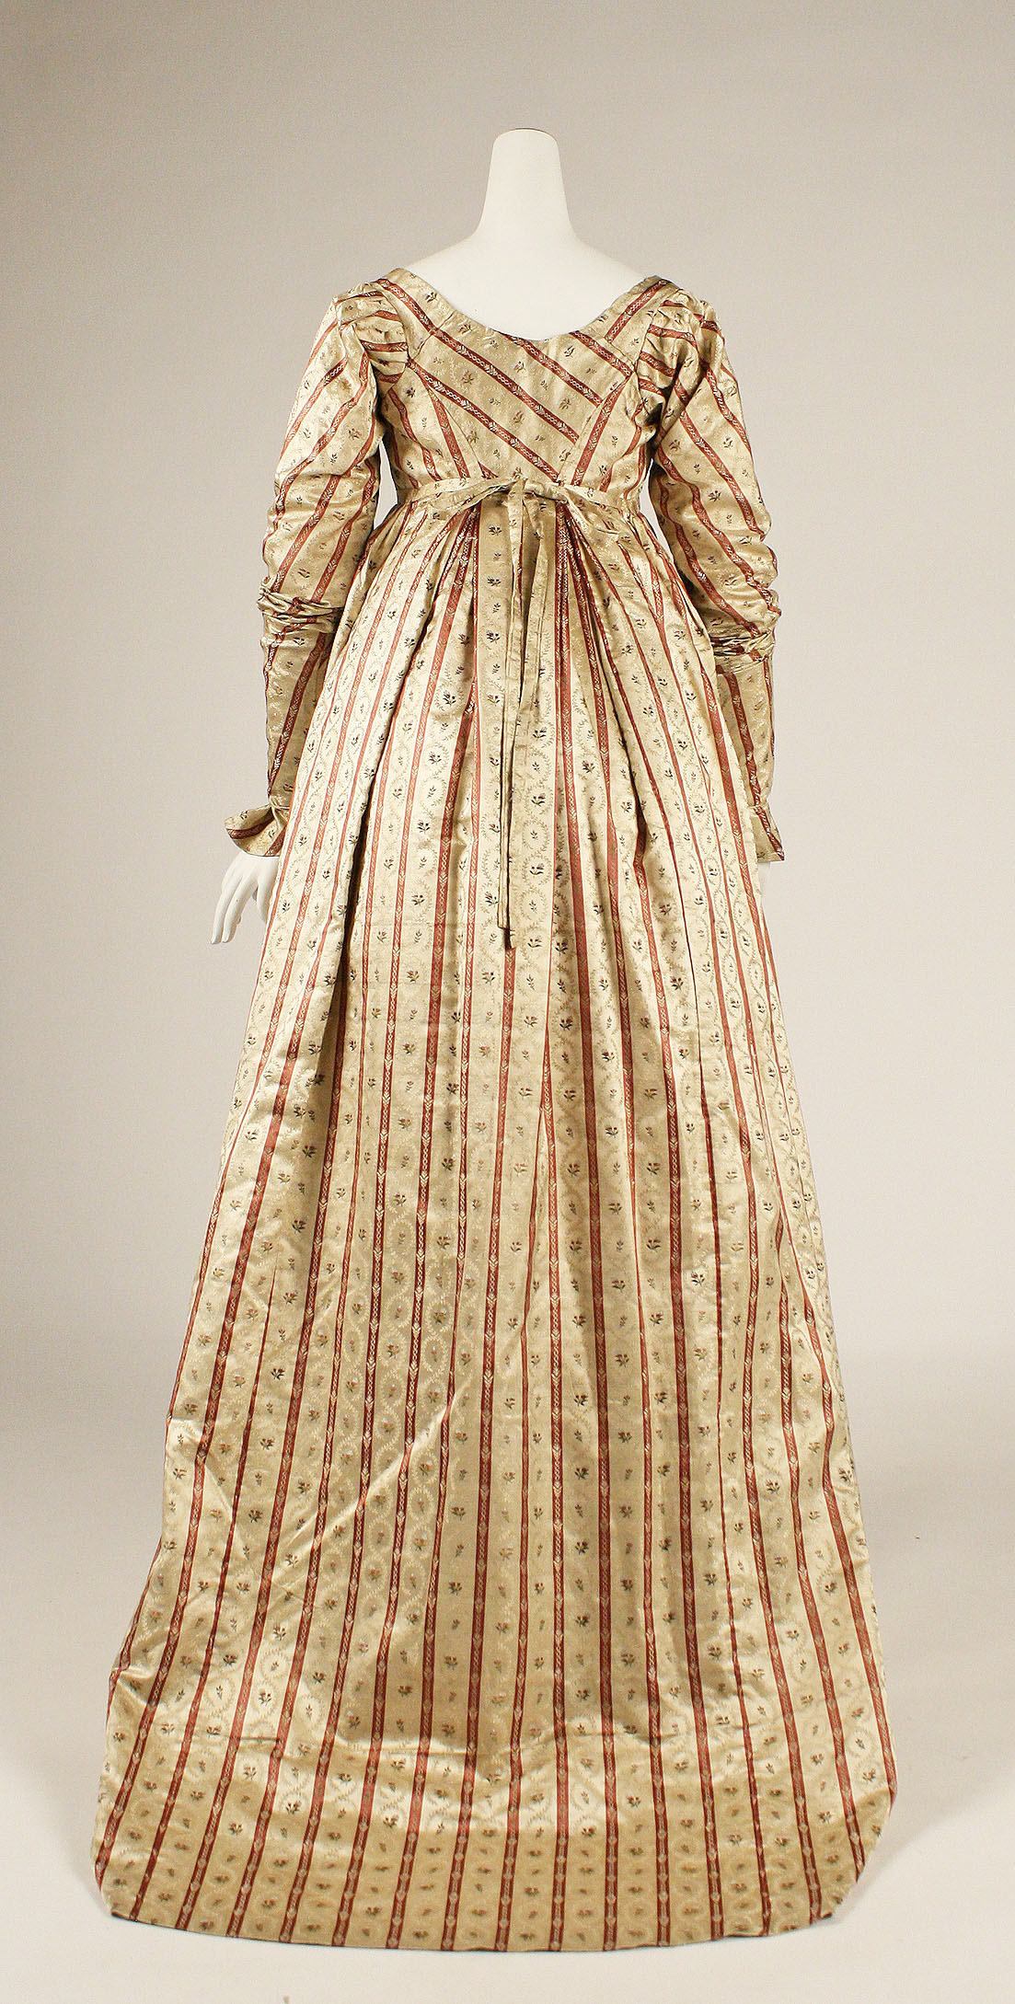
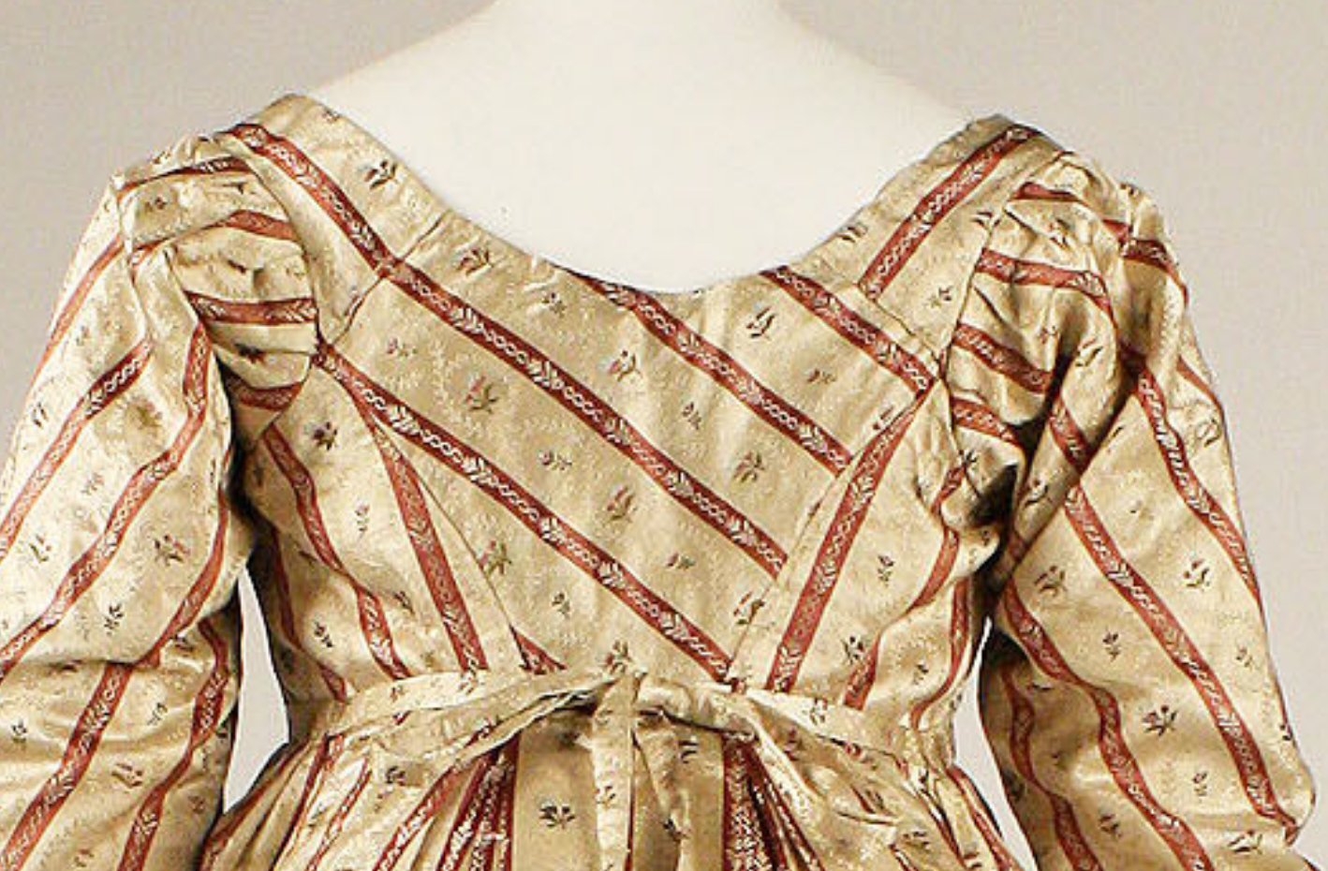

This diamond back, as well as being cut on the bias, has a very slight curve in the back seam.

c. 1800 Metropolitan Museum of Art, Dress, CI39.13.106

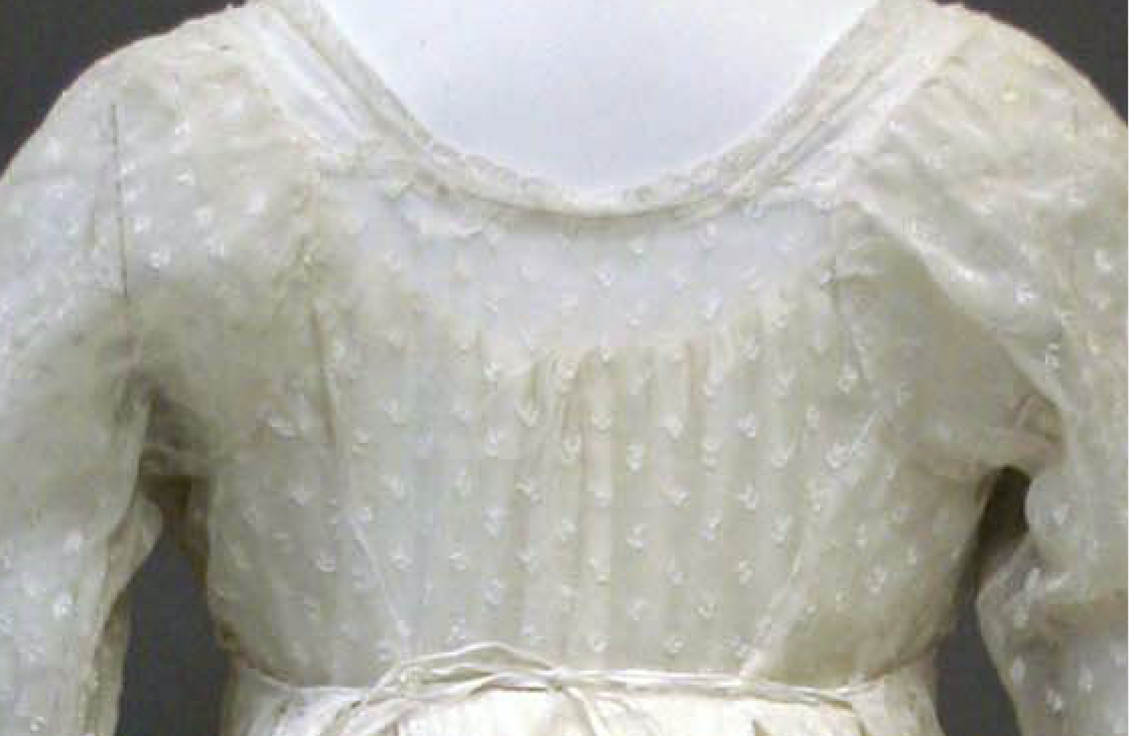
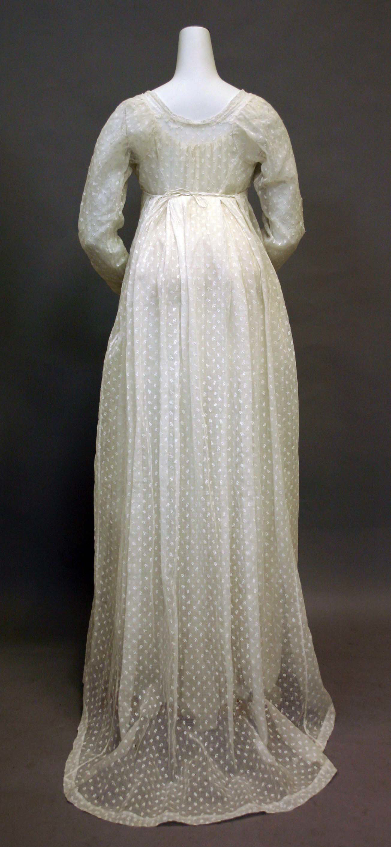
The diamond back opens up: the shoulder seam does not meet the top of the side back—there is no longer a single point. Instead, some of the center back panel now runs along the armhole. The side back seam is straight. The sleeve head needs hardly any gathers. This will be a very common construction for the next decade or more.

Note also how far the sleeve extends into the back. You can just see where the mannequin’s left joint is and that is it very close to where a modern armhole seam would be. The sleevehead on this gown extends more than an inch from that line

c. 1800 Metropolitan Museum of Art, Dress 2010.150

So, if you want to give it a try here are two images to compare. The first is the above gown with the seams marked out in blue. The red line shows where a modern armscye would be and as you can see it is about where the Simplicity pattern has it. Note also that the neckline is a slightly different shape, and is higher, in the Simplicity pattern but you can adjust that as you choose.

