Making a Toque Frame and Cover

Materials:
1) Heavyweight buckram: at least ½ yard @ 44”
2) Crinoline bias tape: 3 yards
3) Rayon covered wire: 2 yards
4) Craft muslin for making your pattern: 1 yard
5) Silk: 1 yard
6) Thread, extra sewing machine needles, millinery hand sewing needles, plastic clips, tape measure that has centimeters marked, scotch tape or wire end joiners, a compass or pencil and string to make a circle. Extras: wire cutters, a zipper foot.

Measuring:
Measure your head where you would like to wear the toque. I start almost to the bottom of hairline in back, over my ears, and to the bottom of the hairline in front. Others prefer to wear their toque higher or lower on their forehead. The measuring tape should not be so tight that you struggle to get it off your head, or so loose as to fall down on your nose. Don’t forget to take into account how you will be wearing your head.

Make a pattern:
You will need 5 pattern pieces: 1) a circle for the buckram tip (the circular top of the toque), 2) a circle with additional seam allowance, 3) a rectangle for the buckram side-crown (the main upright cylindrical part), 4) a rectangle for the fabric cover’s side-crown, and 5) a bias strip to finish the edge.
1) The tip: using a compass or a pencil with string tied to it, draw a circle the circumference of your head (probably easiest to do on paper first). Sizing chart:
Hat Size  (in inches) | Tip Radius  (in centimeters)
19.5” | 7.9 cm
20” | 8.1 cm
20.5” | 8.3 cm
21” | 8.5 cm
21.5” | 8.7 cm
22” | 8.9 cm
22.5” | 9.1 cm
23” | 9.3 cm
23.5” | 9.5 cm
24” | 9.7 cm

2) The tip cover: Make a pattern piece that is 3/4“ larger all around than your tip
3) The buckram side-crown: cut a pattern piece that is as long as your head measurement and as wide as you would like your toque’s height to be. 4” to 5” is a common height.
4) The side-crown cover: cut a pattern piece that is 2 inches larger than your head measurement and twice the height of the buckram side crown.
5) The bias band: cut a pattern piece that is 3 inches wide and 2 inches longer than your head measurement.

Cut the buckram:
Cut a tip and side-crown of buckram. Since buckram is hard to pin I usually just trace the pattern pieces onto the buckram and cut.

Cut the crinoline tape:
1) the length of tip’s diameter plus 1”
2) the long side of your buckram side-crown plus 1”
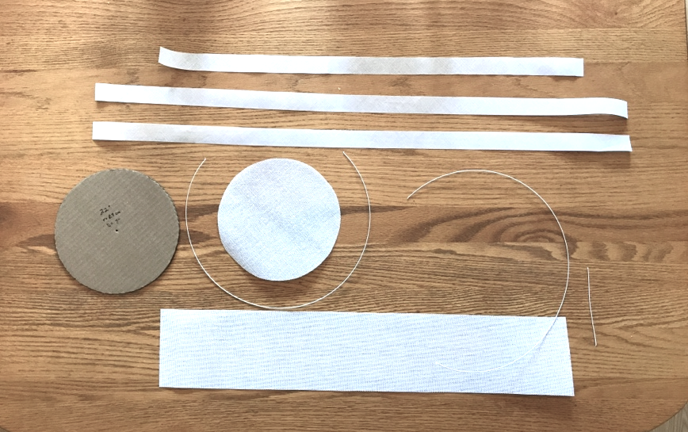
3) 2 inches plus three sides around the buckram side crown (2 short sides and one long side)

Cut the wire:
3 pieces:
1) the diameter of the tip
2) one long-side length
3) one short-side length
T
he image shows all the pieces plus a cardboard circle that I use for a pattern.

Wire the tip:
1) Wrap a small piece of scotch tape or a wire end joiner around each end of the 3 wires.
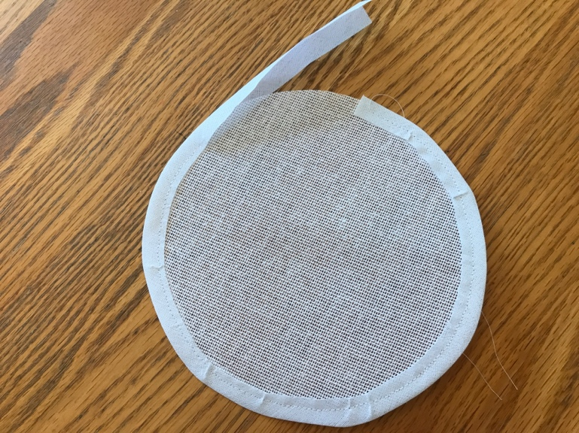
2) Sew the crinoline tape around the tip far enough from the edge to make a channel. You will be passing the wire through this channel so make sure your stitches don’t get too close to the edge—there needs to be room for the wire and its covered ends.
3) Gently but firmly, push the wire through the channel. It’s tricky. If it gets stuck, try to move the wire end slightly by pushing it side-to-side inside the channel. Leave 4-5 inches of crinoline unsewn until the wire is all the way through.
If it is really too tight don’t force it and kink the wire. Just use a seam ripper to remove a few of the tight stitches, then re-sew that bit.

Binding and Wiring the Side-crown:
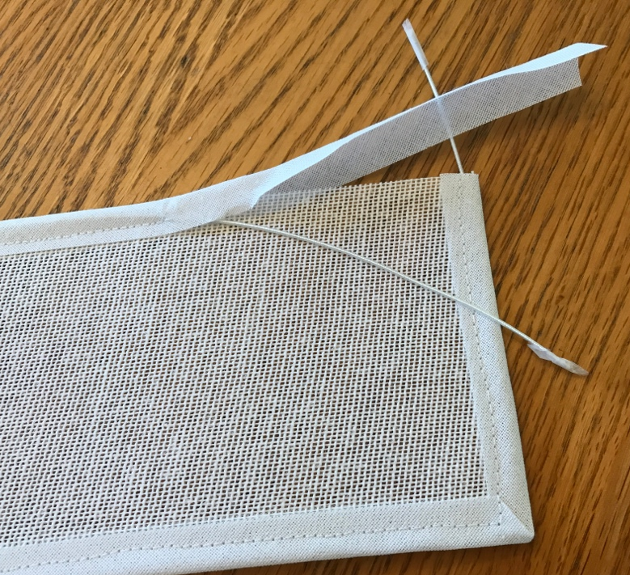
1) Starting at the top of a short side, wrap the longest piece of crinoline tape around around that short side and sew it down. Leave it open at the top so you insert the short wire.
2) Continue binding the edges by folding and turning the corner and sewing the long side. Fold and turn the next corner and sew a short side. Fold and turn the last corner and sew down the last couple of inches.
3) Starting at that last corner, sew the last piece of crinoline along the remaining long edge, overlapping the tape that is already at the beginning of that side. Leave a couple of inches unsewn at the end.
4) Insert the short wire into the short end and the longer wire into the longer end.
5) Now stitch the remaining open end. (Be careful—go slowly so you don’t hit the wire and break a needle. This is where a zipper foot is useful!!)

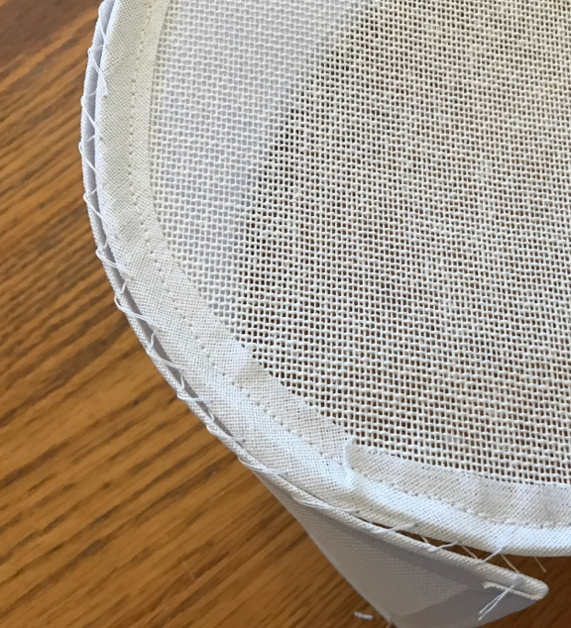
Joining the pieces:
Hold the tip’s edge up to the left top edge of a long side of a the rectangle that does not have wire in it. The tip should face you and the rectangle should be behind it. IMPORTANT>>>One edge has a wire and one doesn’t, i.e. the tip has a wire but the side-crown edge that will be joined to it should not have the wire. The wire should be at the head opening instead.
2) Using a whip stitch, sew left to right.
3) As you sew, keep moving your fingers along to pinch together the tip and the side-crown. This is a slow and laborious process because round things do not like to be attached to straight things, but just keep pinching close to where you stitch.
Your stitches will probably end up leaving gaps but you can use a fork to pull up the threads to get them tighter. Again, a tedious process but it really does make a difference.
4) Sew the back seam together with a whip stitch. You can overlap the edges as needed to accommodate the tip.

Cutting the cover:
To make a bias strip, fold one corner of your fabric up to make a 45-degree angle.
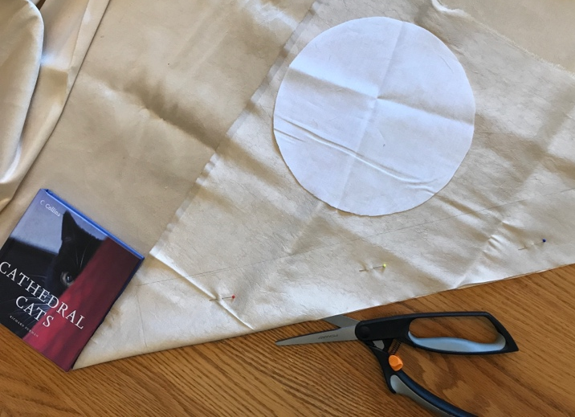
You can use a book to get the correct angle. (The book does not have to be about cats.) Place one edge of the book along the selvedge and fold the corner of the fabric up until it aligns with the other edge of the book. The resulting triangle does not have to be the full width of the fabric. It just needs to be big enough to cut out a circle (tip with added seam allowance) and a strip 3” wide and the length of your side-crown cover (i.e. buckram side-crown width plus 2”). WARNING>>>WARNING>>>Make you are using the pattern piece of the tip that has the seam allowance!
Don’t cut the pieces yet! You only need one tip and one bias strip. Pin along the diagonal fold to keep the fabric from shifting, then carefully cut along the diagonal fold to separate the triangle from the rest of the fabric. Once cut, move the remainder of the fabric out of the way and pin and cut your tip with seam allowance and the bias strip from the triangle.

Sewing the Cover:
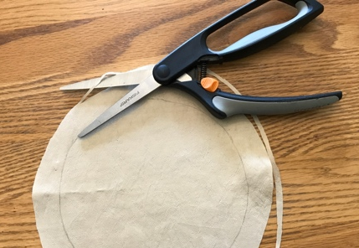
1) The object is to cover the tip evenly and smoothly. To help get an accurate cover, place the togue upside down on the fabric tip cover and trace around it exactly. Also, mark where the back seam is. If there is excess, just trim it away so that your seam allowance is even all around.
2) Stay stitching: Sew all the way along the line you traced in step 1 so your fabric will not warp and stretch.
2) Next, on one long side of the crown cover, double fold, press and stitch a narrow hem.
3) With right sides together, line up the back seam mark on the tip cover with a point about 1” in from the top left corner of the side-crown corner. Be sure you are sewing the tip cover on to the long raw edge of the side-crown cover, not the edge you just hemmed.
THIS IS THE PART THAT REQUIRES PATIENCE. Go slowly.
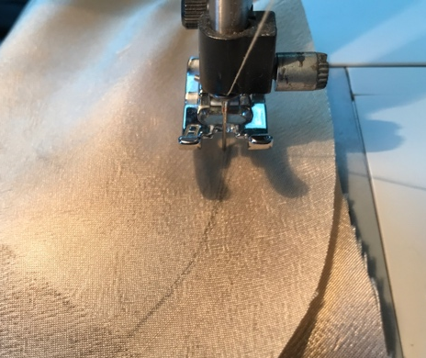
As you stitch the round tip cover to the straight crown side cover the fabric will want to bunch and pull. When the round edge starts to move away from the straight edge, carefully realign them. Don’t pull and twist. You want the inside and outside to remain smooth--no crimping or puckering. You can also stop stitching, sink the needle and raise the presser foot to hold the fabric steady, then line up the pieces again before you continue.
Give yourself plenty of time. In some places you may have to re-adjust after every couple stitches so be patient. The care will pay off.

The back seam:
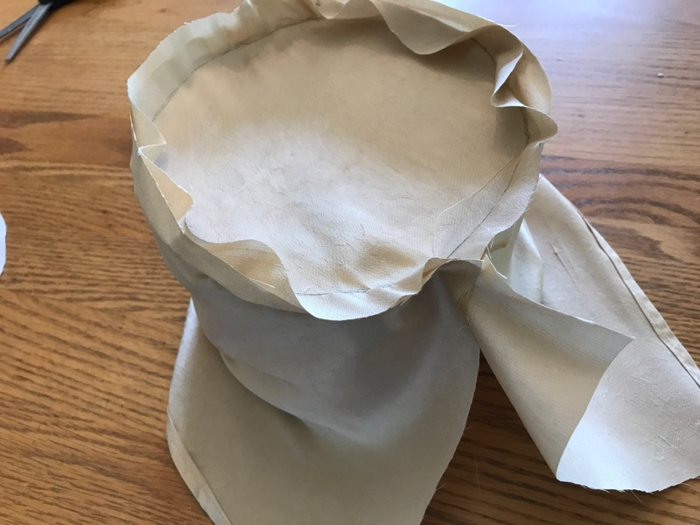
Before sewing the back seam together pull the cover over the toque frame to see how it fits. Smooth the sides and pin the back seam together. You can trim the edges so that the seam allowance is even. Sew the back seam then try the cover on the frame again. It should be smooth and snug but not so tight as to warp the frame. Adjust the backseam as needed.
Once the cover fits nicely, zigzag stitch, overcast, or use pinking shears to trim off excess. Also, being careful not to cut into the seam, make little slashes around the circle every inch or two of the so that it will lay flat.
Smooth and tuck the side-crown cover into the toque. You will want to pull the fabric firmly but gently without making the buckram buckle. Use clips to hold it in place. Suggestion: Once I have placed the clips I like to leave the toque for an hour or two so that the fabric can “settle” before I sew on the final bias band. That way I can give the outside one final smoothing. The inside does not have to be perfectly smooth.
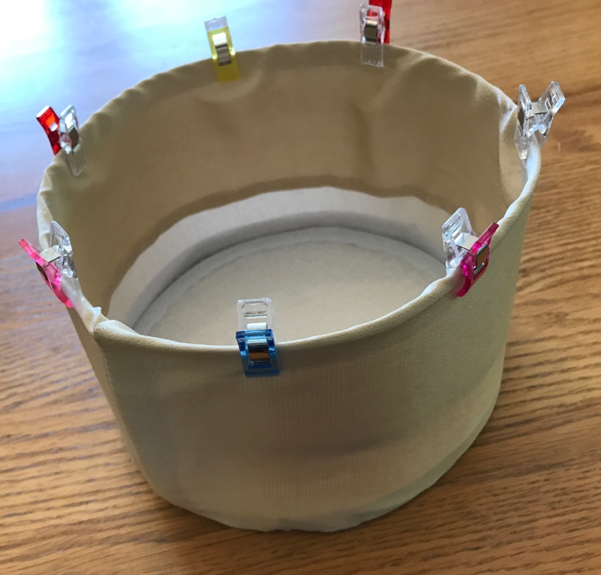

The band:
The nice thing about handstitching is that, unlike a machine, stitches can be different sizes on the inside and outside. On the outside you can have a tiny stitch by sending the needle back through in almost the exact place it came out. On the inside—well, what goes on inside a toque is nobody’s business but yours--your stitches can be bigger and not perfect.
1) Fold and press the 3” bias strip lengthwise and carefully press it. Then open it, fold each half to the center, press each edge. Then fold it in half and press it once more to get the folded edges to lay flat. (It is bias—it will try to stretch so don’t pull too hard.)
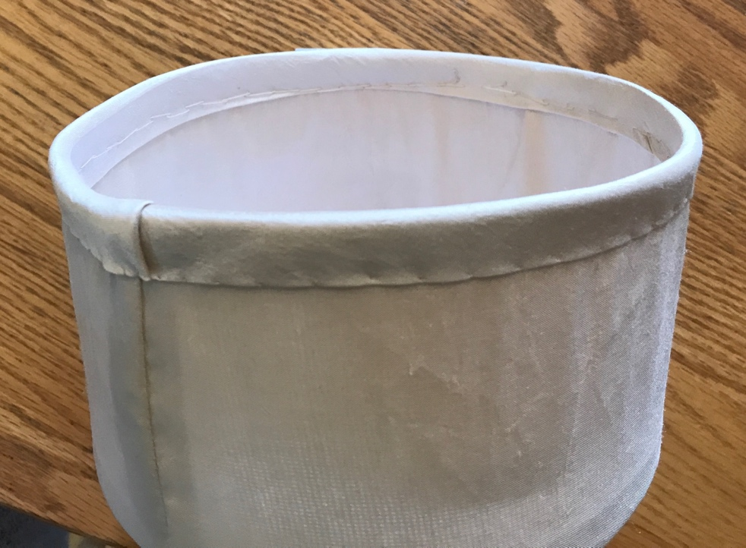
2) Starting just a bit left of the backseam, wrap the folded strip around the edge being careful not to dislodge the rest of the cover, and clip it in place.
3) Continue around, smoothing and clipping the band to the toque’s edge. When you reach the backseam again, trim off the excess end leaving about an inch that you can then fold over and tuck to make a smooth finish.

What’s next?
Decorating! Fancy trim around the edges, poofs, rosettes, bows, covering the whole thing in tulle (my favorite), a couple tassels—your choice.
You can also make a lining for your toque. I never do because I like to dance in toques and a lining just makes it warmer.

Sources:
The following are all available from JudithM millinery https://www.judithm.com/
For buckram, I use the JudithM heavyweight. Be aware that many weights and types of buckram exist. In fact, Judithm also makes a medium weight--too light for toques--and a double weight which is far too stiff and heavy. Fabric stores like Joanns carry a buckram that is designed to be used in clothing but not in millinery. If you find another supplier try to bet a swatch.
Crinoline bias tape is slightly stiffened, open weave, lightweight, flexible and 1” wide. Do not use regular cotton bias tape—too dense and thick.
Rayon covered wire comes in different thicknesses. The lower the number the heavier the wire. I use #21 for toques but have also used #19 for toques or heavier hats.

Silk:
Prices are crazy. I usually look for lightweight taffeta or slubless Dupioni. Always leave enough time to order swatches so you can see the actual quality, the actual color, and if it is washable.
Puresilks https://www.puresilks.us/
Good service and reasonable timeframe given that they ship from overseas.
Fabric Mill https://www.fabricmill.com/
The store is in Plainview, Long Island, but they also do online orders. Their half price sales are great!
Renaissance Fabrics https://renaissancefabrics.net/
Specializing in historic-looking fabrics and trims.

Inspiration:

