Reticule examples

Name key: Dates are approximate. 1800s usually means 1795-1810. Where possible, accession numbers have been added. MMA – Metropolitan Museum of Art; MFA – Museum of Fine Arts, Boston; Augusta – Augusta Auctions; Ladies – Ladies Monthly Museum; Ack – Ackermann’s Repository of Arts, McCord – McCord Museum, Montreal; LACMA – Los Angeles County Museum of Art. Some dimensions are included.
For more: http://www.uvm.edu/~hag/regency/00-all-costume-fashion-images/0-reticules/
(user: hagregency, password hagregency )

1800-mfa-reticule-13.49.14 (17x11.5)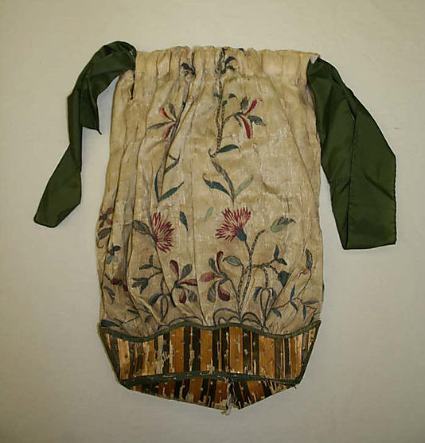 | 1800-1825-mma-reticule-purse-2009.300.2437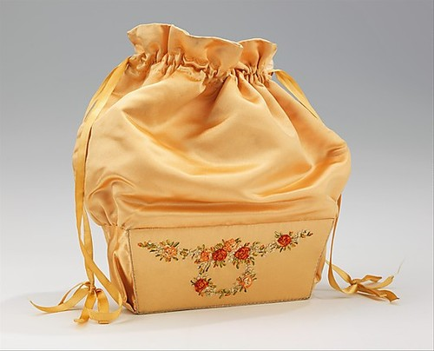

1810-mma-reticule-french-c.i.59.4 (10 in.)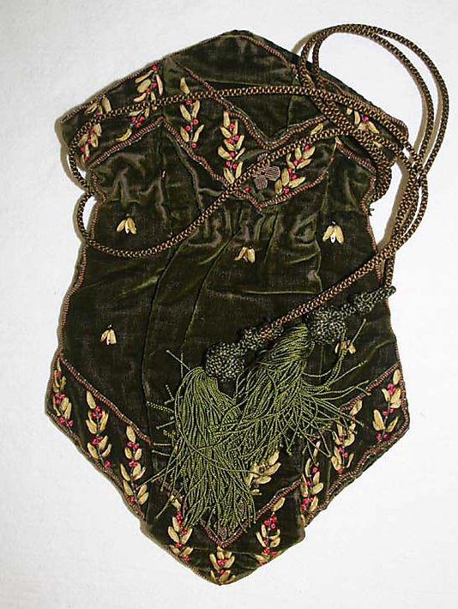 | 1800s-mfa-reticule-51.2412 (8.7x11)  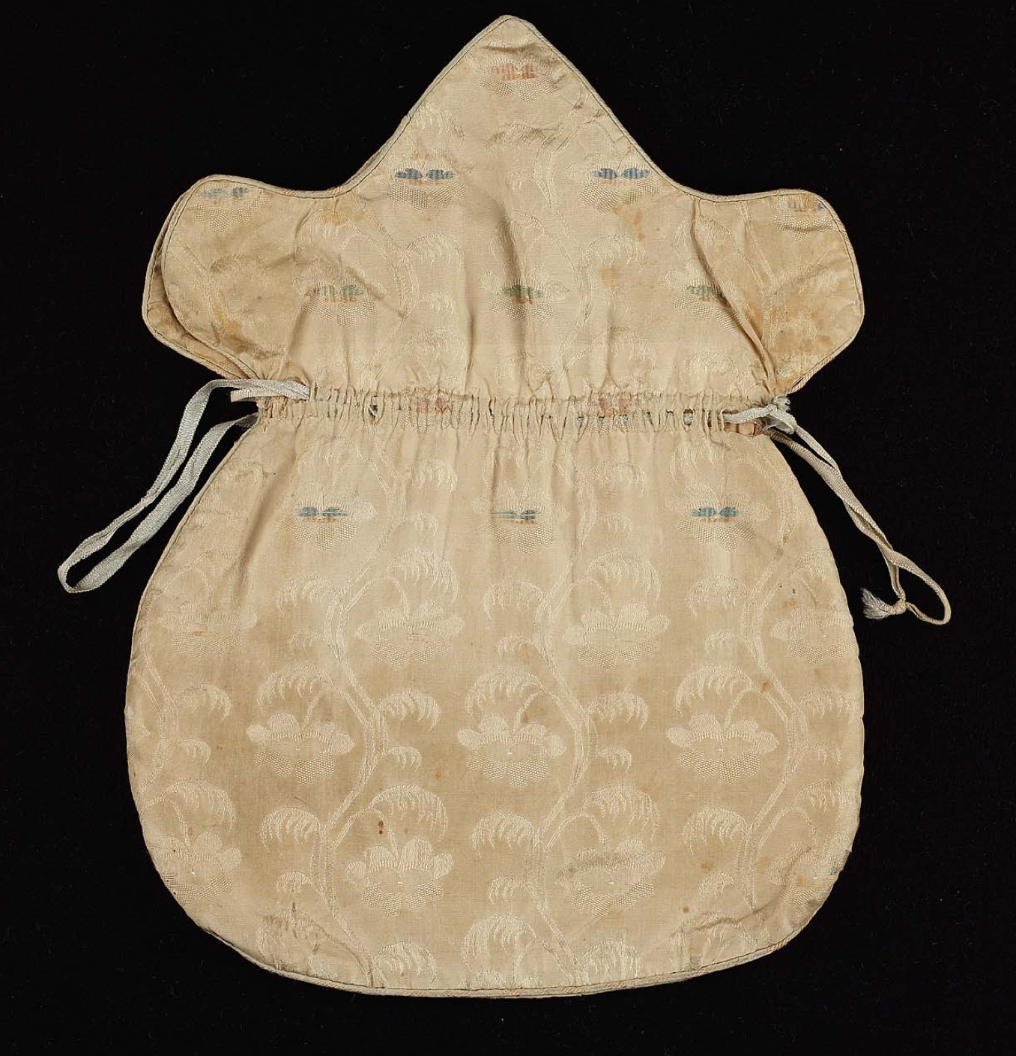

1795-1800-mma-1980.445.11_F (16.5 in)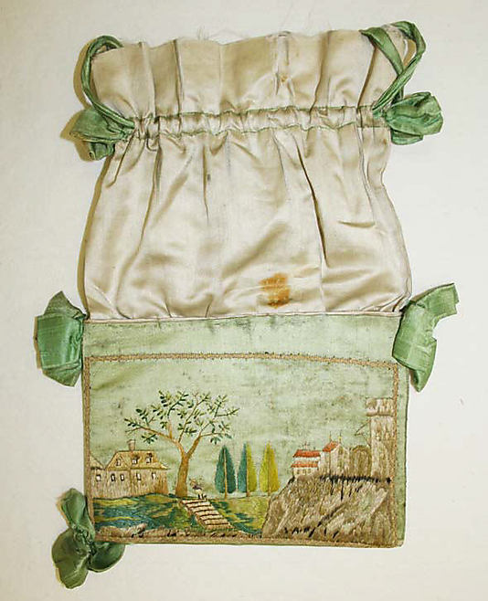 | 1800s-mma-reticule-1980.445.18 (23 in.)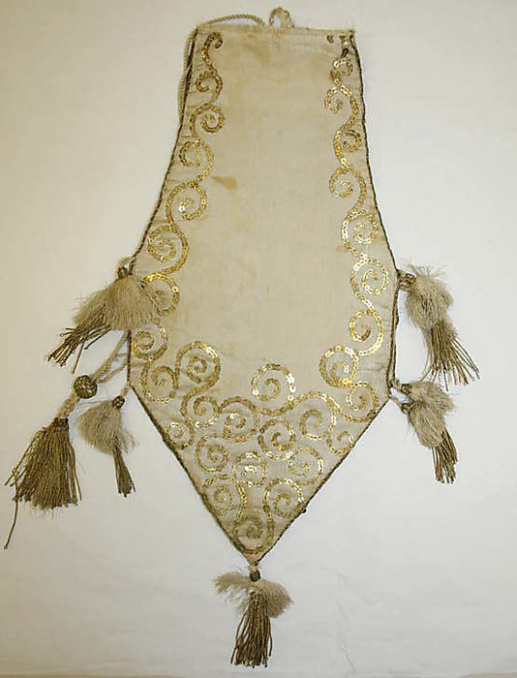

1800-1810-mma-reticule-C.I.39.13.63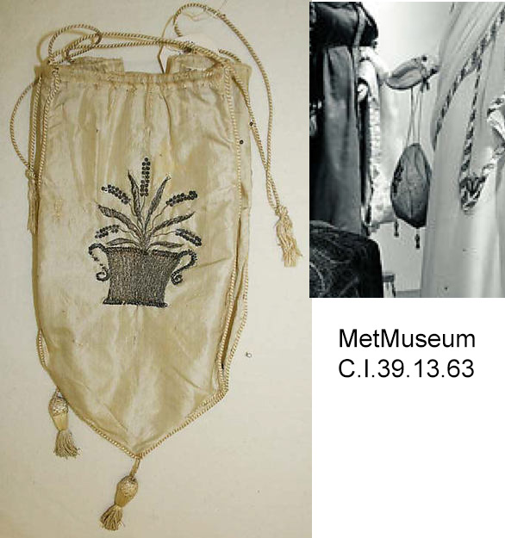 | 1800-reticule-mfa-48.1222  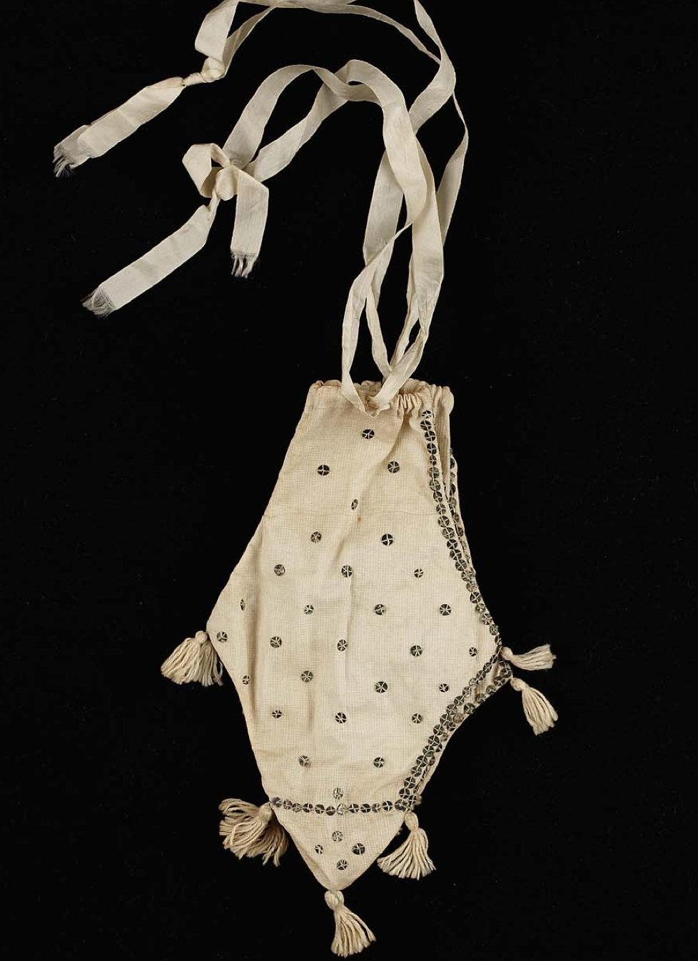

1810  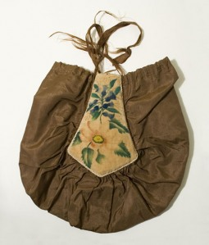 | 1800s Antique Textiles  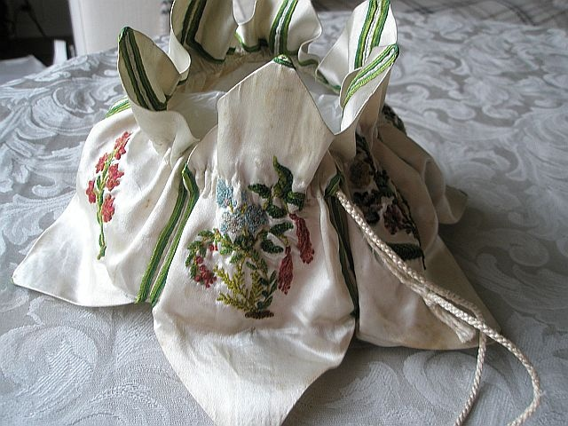

1800-augusta-reticule (9.5x9.5)  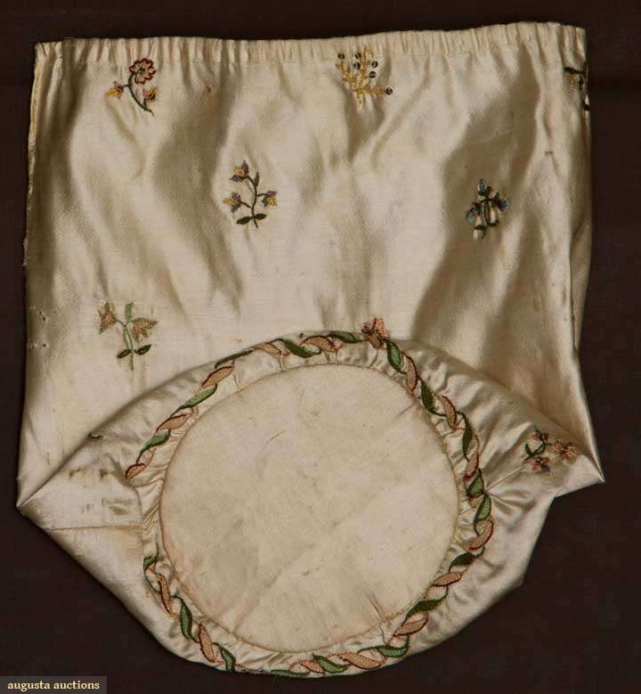 | 1800s-mfa-reticule-09.367 (7x8)  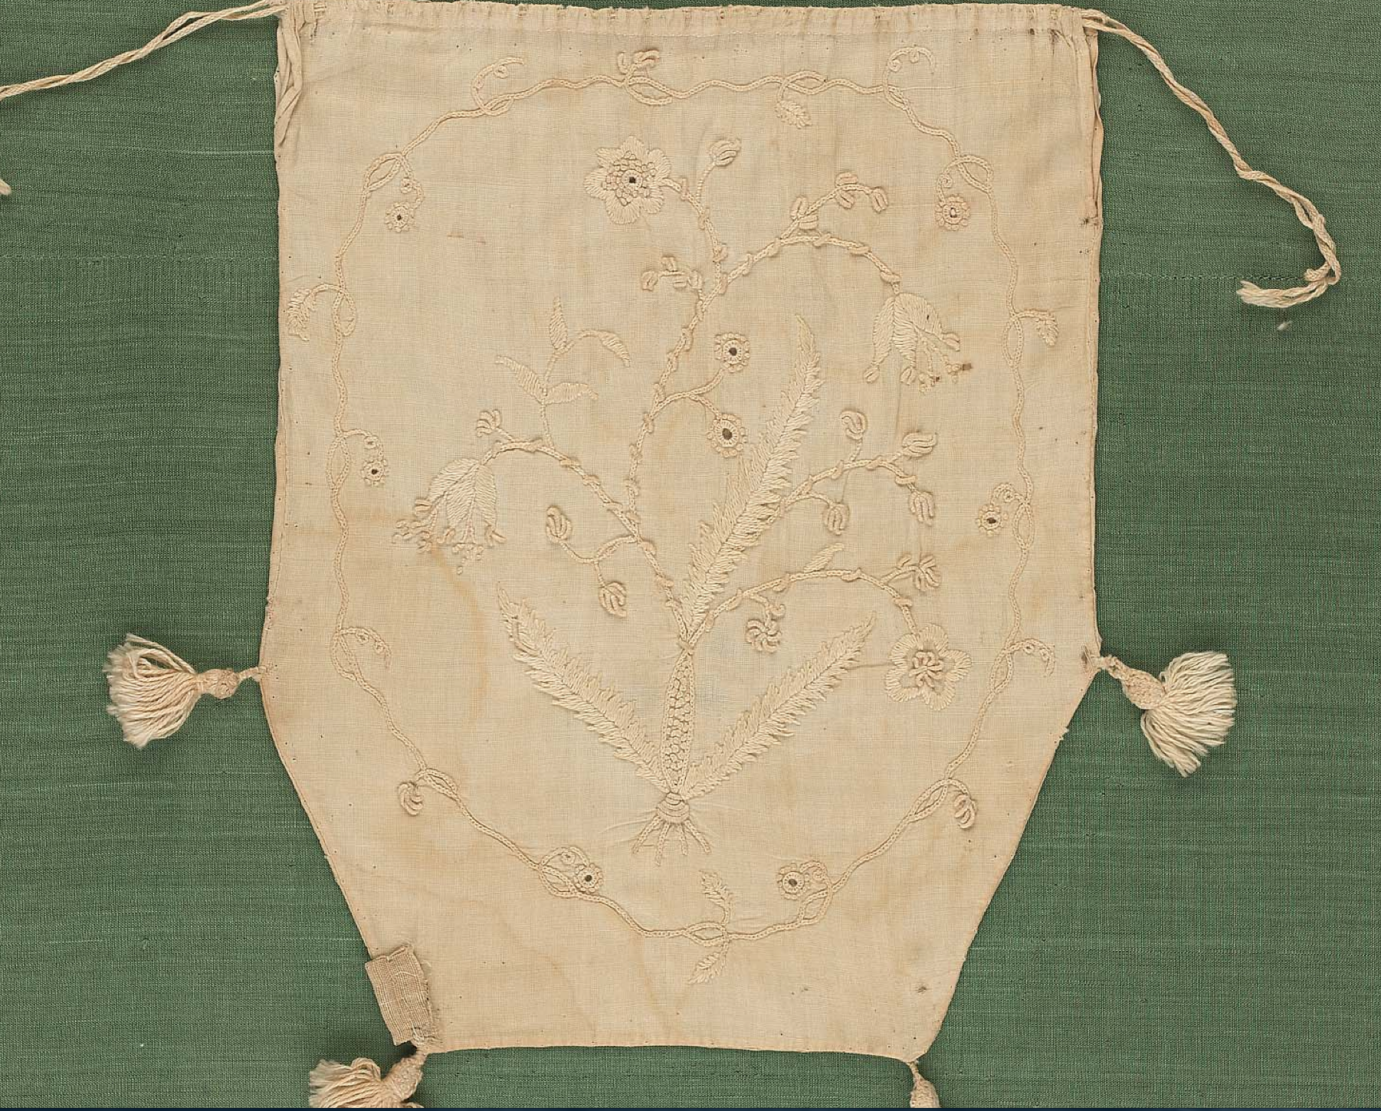

1815-mma-american-2009.300.2382 (8x8)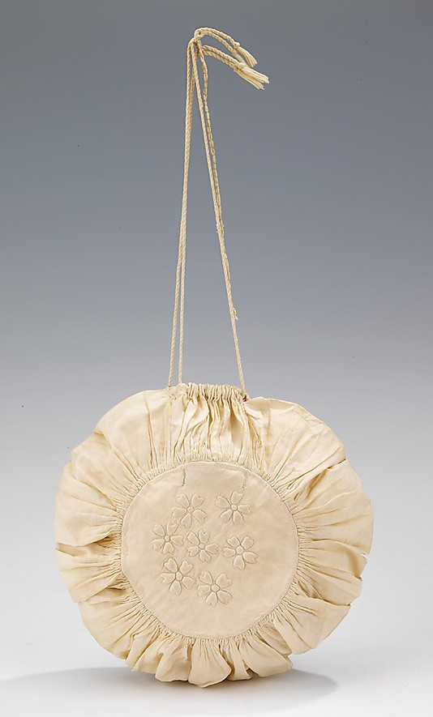 | 1820s-lacma-purple-reticule-M2007_211_253_2  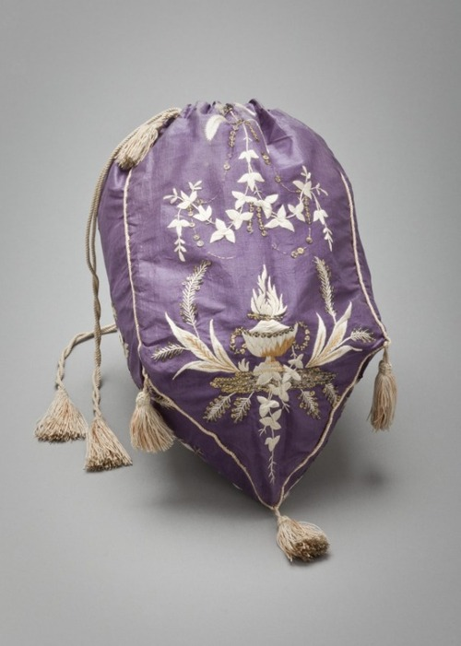

1800s-mfa-reticule-53.2251 (9.7x8.25)  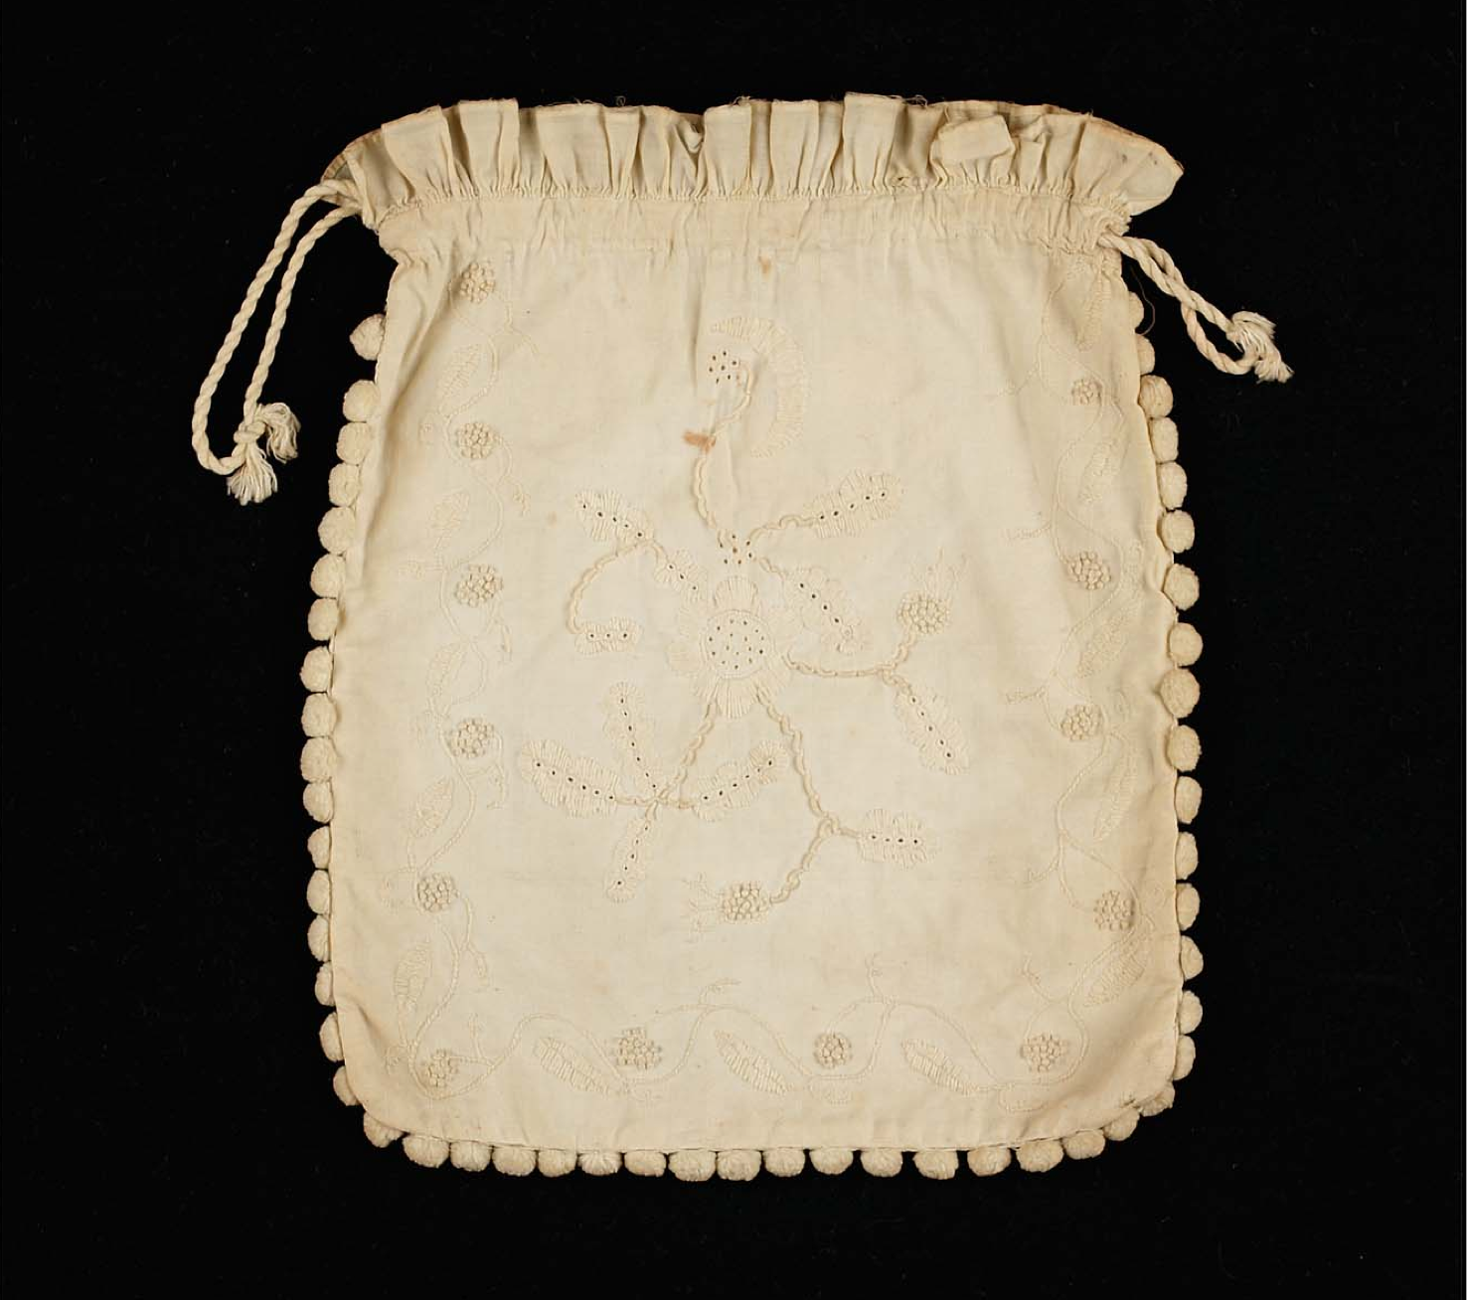 | 1800s-mfa-reticule-46.314  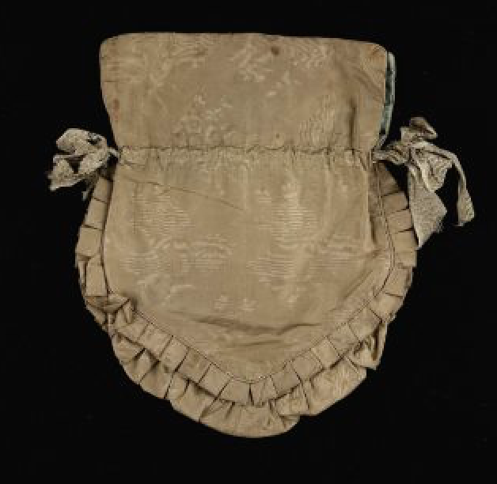

1811-mma-martha-kittredge-2005.272-10x7.5  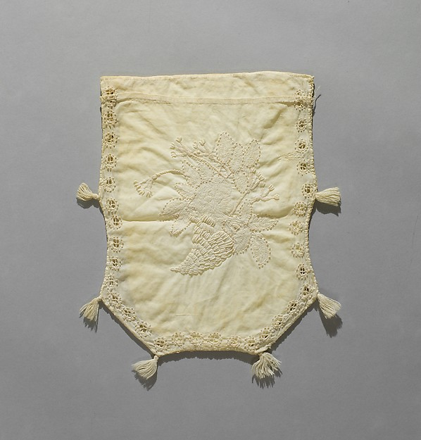 | 1812-02-ack-reticule-pink-embroidered  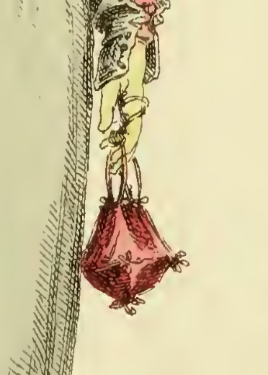

1800s-mfa-reticule-49.993 (10.5 in)  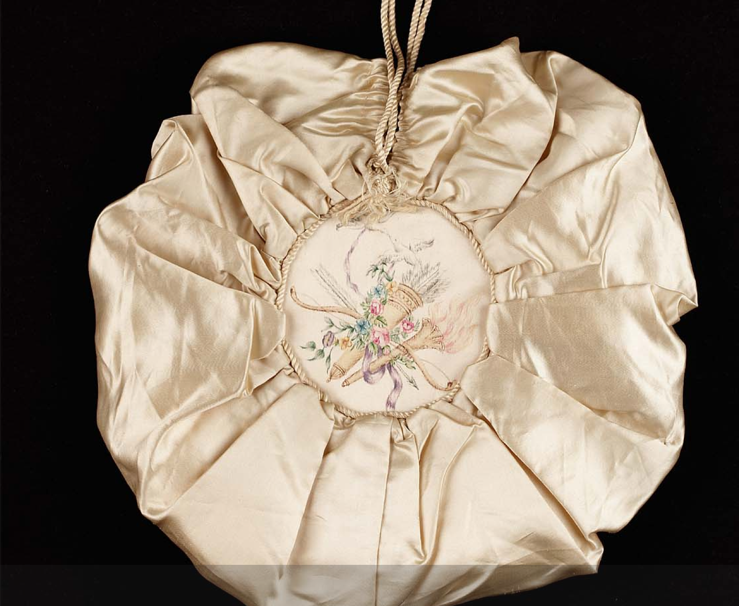 | 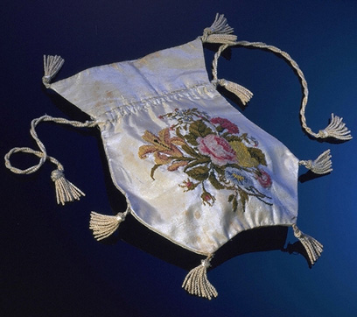

1814-mccord-reticule-M966.92.8  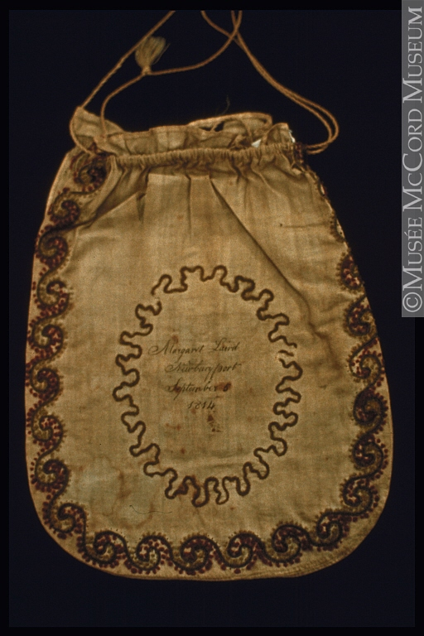 | 1816-12-ack-reticule-black-silk-shawl-ends  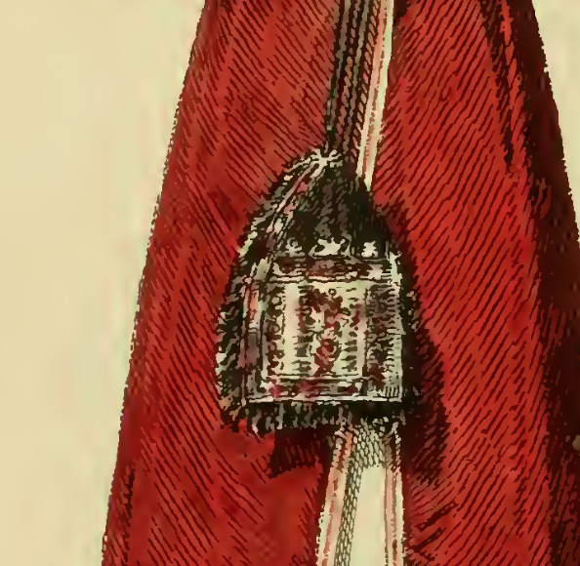

1816-ladies-month-reticule-caped-pelisse  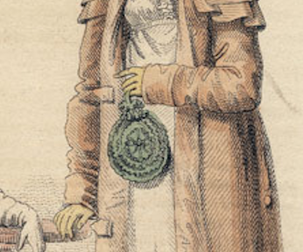 | 1812-01-ack-reticule-rose-velvet  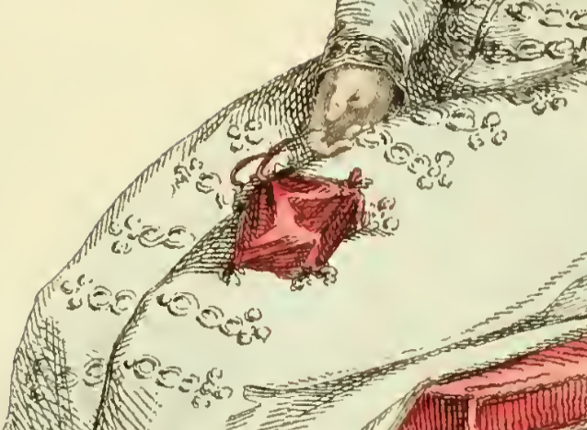

1810-1825-mma-1984.325  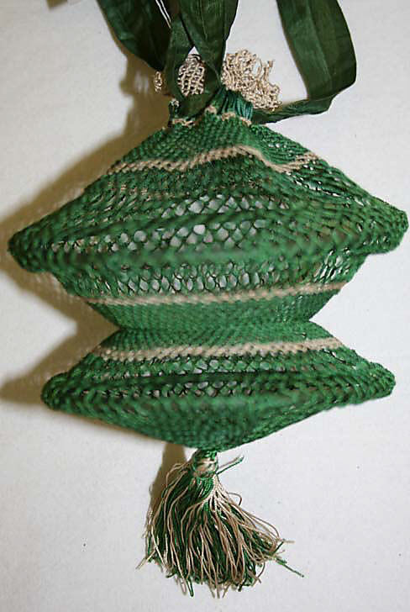 | 1800s-mma-reticule-CI44.8.26 (4 5/8 in.)  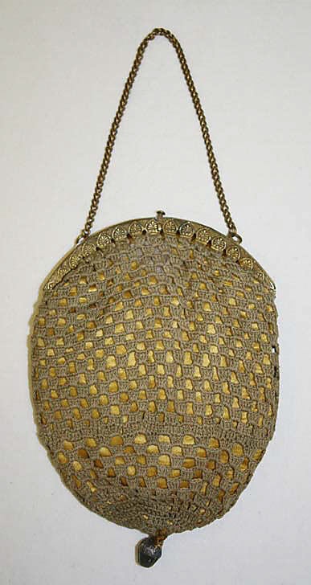
1810-1825-mma-1996.160.1  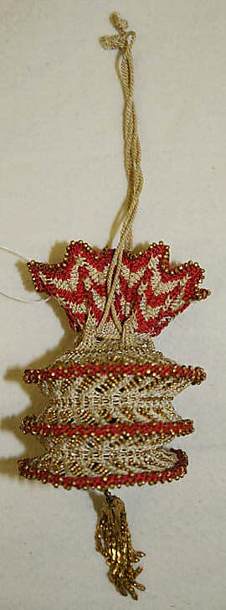 |  | 1800s-mma-reticule-net-2009.300.2197  