Examples of Austen Era Bandeaux
Hope Greenberg

“I wore at the Ball your favorite gown, a bit of muslin of the same round my head, border’d with Mrs. Cooper’s band—and one little Comb.” (1 November 1800)

The following examples of bandeaux show how a simple decorated band—or two or three bands—could enhance a hairstyle. They had the added advantage of being more comfortable to wear while dancing than a cap, hat, or turban. Most were shown in fashion plates as evening or ball wear. Placed in chronological order, they show how the fashion of headdresses evolved along with the clothing and hairstyles, with earlier versions accommodating “Grecian” hair (i.e., hair pulled to the back of the head) and later accommodating “Roman” hair (i.e. that which was piled on top).

Key to file names:
CP/JDM: Costume Parisien in the Journal des dames et des modes. Republic alternative calendar (ex.: An10, An11), and plate number where available. https://gallica.bnf.fr/ark:/12148/cb32799510k/date
LBA: La Belle Assemblée from the Hathi Trust. https://babel.hathitrust.org
ACK: Ackermann’s Repository of the Arts, etc. from the Internet Archive https://archive.org/

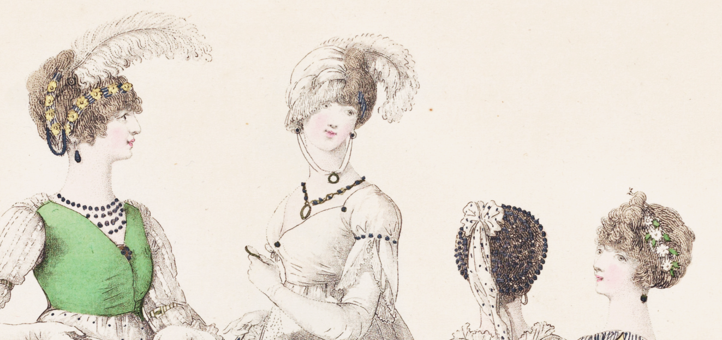

1800-02 Heideloff, (#1, #4) bandeaux with flowers
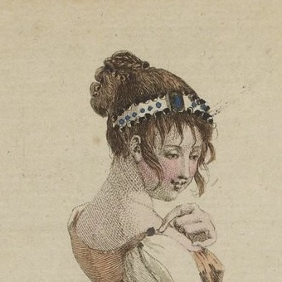  1801-12-21 #351 CP/JDM, Ornée de Perles | 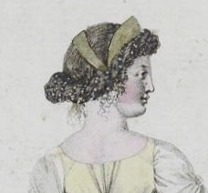  1801 #320 CP/JDM, Coeffure Antique
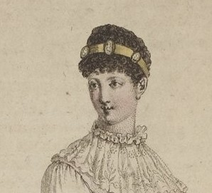  1803-09-17 (An11) #499 CP/JDM, Cameos | 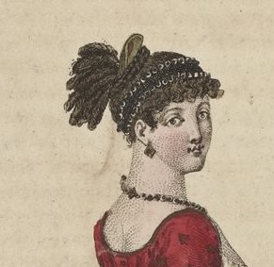  1803-10-23 (An12) #506 CP/JDM, Schall Turque
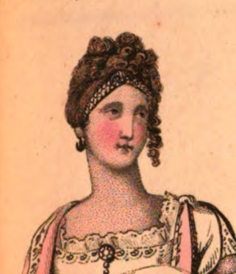  1807-04 LBA, Evening Dress | 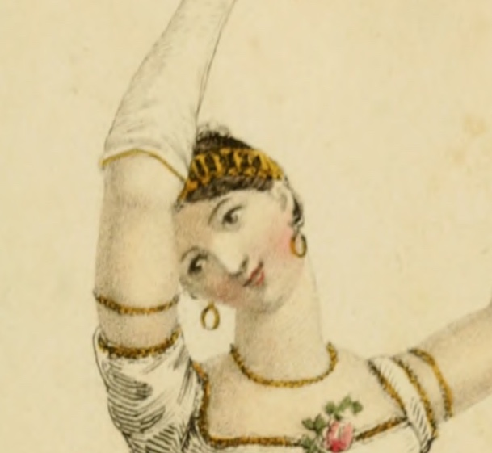  1809-02 ACK, Dancing Dress
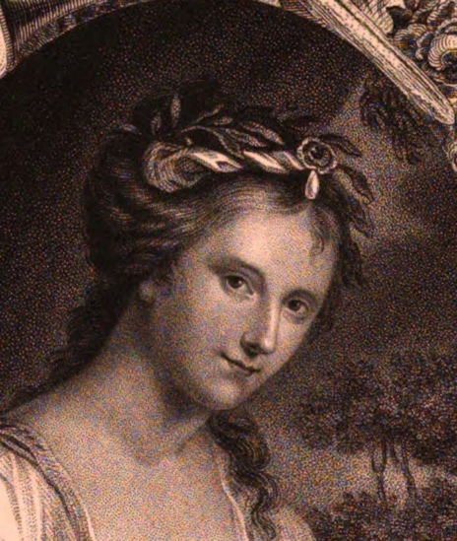  1810-03 LBA, The Hon. Mrs. Damer | 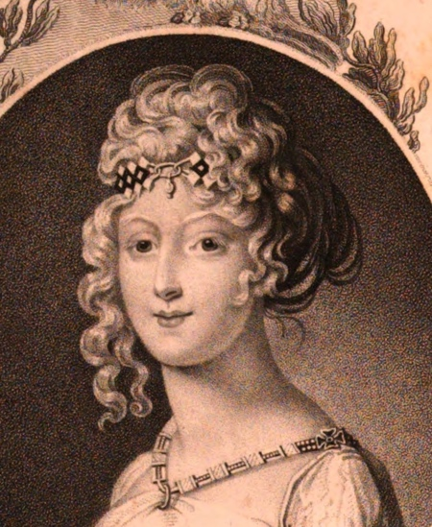  1810-07 LBA, Empress Marie Louise
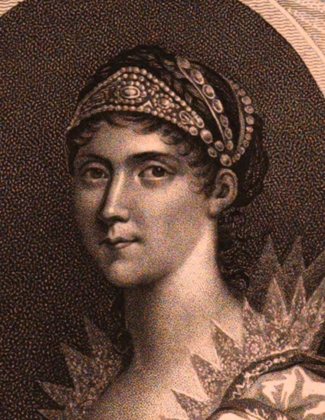  1810-10 LBA, Empress Josephine | 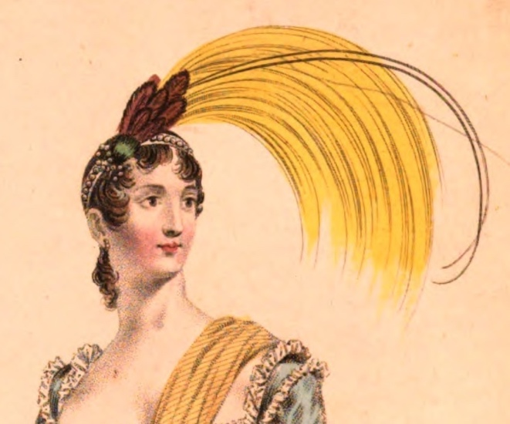  1810-11 LBA, Evening Dress
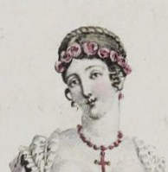  1810 #1039 CP/JDM, Costume de Bal | 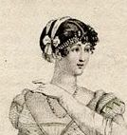  1810 #1054 CP/JDM, Bandeau de Diamans
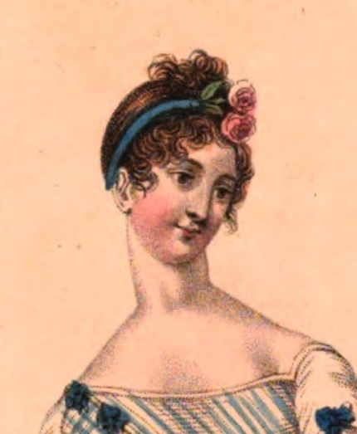  1811-03 LBA, Ball Dress | 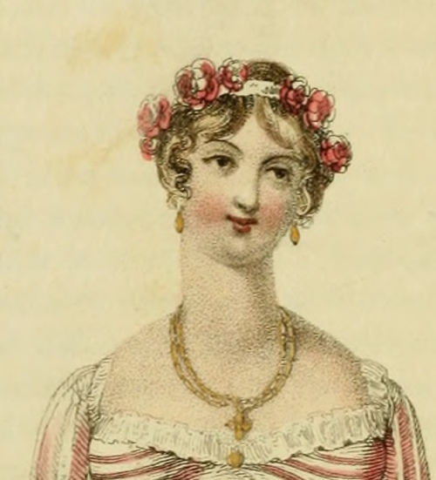  1811-05 ACK, Full Dress
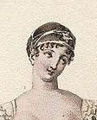  1811 #1123 CP/JDM, Ornée de Bandelettes | 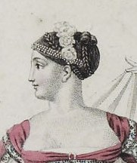  1811 #1124 CP/JDM, Ornée de Perles
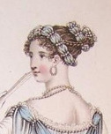  1811 LBA, Evening Dress | 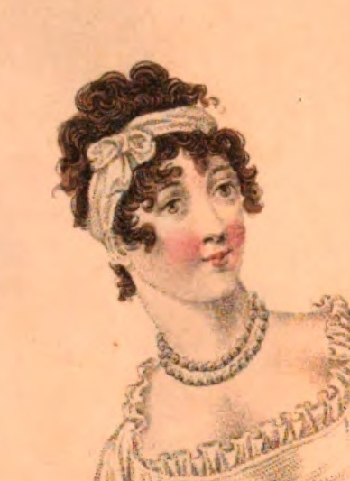  1812-02 LBA, Morning Dress
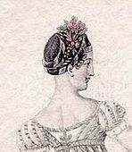  1812 #1205 CP/JDM, Bandeau de Ruban-Or | 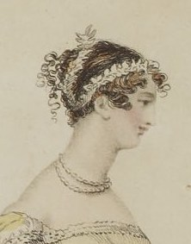  1813-01 LBA, Evening Dress
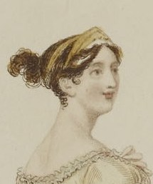  1813-02 LBA, Evening Dress | 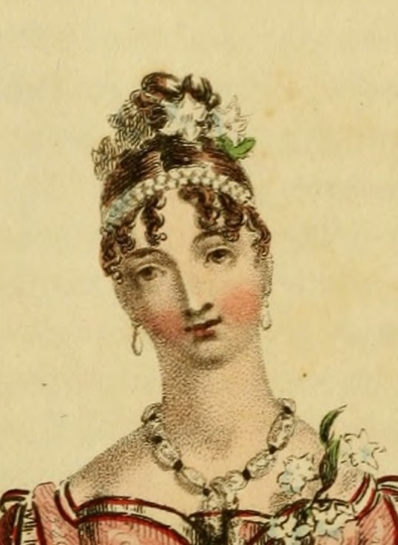  1815-12 ACK, Evening Dress
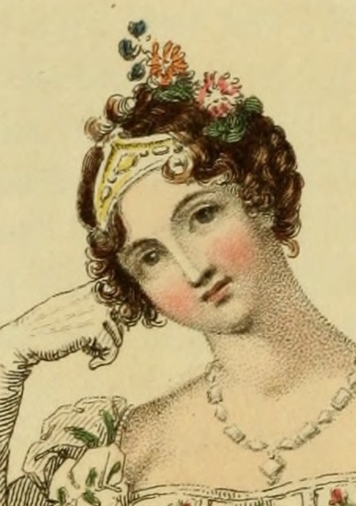  1816-06 Ack, Bridal Dress | 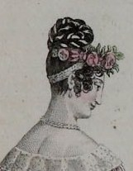  1817 #1700 CO/JDM, Demi-Chinoise
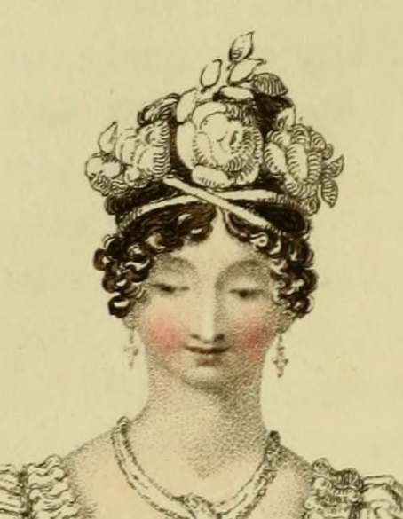  1818-03 ACK, Bridal Dress | 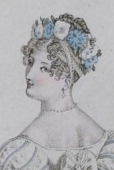  1819-10 #1794 CP/JDM, Ball Gown
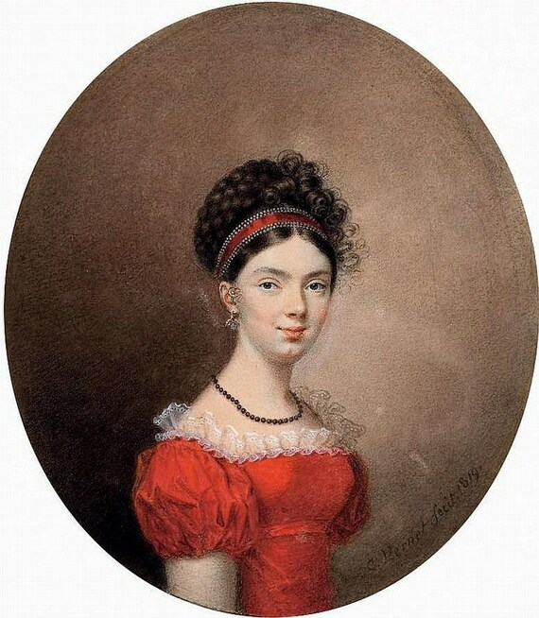

1819 C. Vernet, Countess Maria Ivanovna de Traversay

Instructions for Making a Bandeau

Materials:
¼ yd. lightweight but firm silk or faux silk.
¼ yd. of cotton batting (fabric-style on a bolt.)
Shears
Thread
Needles for hand sewing (I like Milliner size – longer than embroidery type))
Measuring tape
Turner tubes (EX: Dritz® Quick Turn Fabric Tube Turners, 3ct.)
An iron

Step 1: Measure!

Be sure to measure your head with any hair pieces or in the style you will be wearing with it.

Wrap a tape measure around your hair at the location you would like to wear the bandeau. It should be loose enough not to pinch, but tight enough to not fall down.

Add 3” to that measurement.

Step 2: Cutting

You will be folding the band in half, lengthwise, and including a seam allowance. So, a 4” strip of fabric, with 1/2” seam allowance will yield a 1.5” band (4” folded in half minus ½” seam allowance on both sides. A 3” strip of fabric will yield a 1” band.

Cut a strip of cotton batting a little shorter in length and the same size as the expected finished width (or a tiny bit less).

Step 3: Sewing (A sewing machine is easier than hand sewing for this part.)

Fold the strip lengthwise, wrong sides together and press.

Open the strip and put the batting on the edge of the fold. Stitch just over the batting holding it as deep into the fold as you can as you sew.

Refold the strip so that right sides are together and sew the outer edge.

Sew one end to close it. Clip and trim the corner.

Use the turner to turn the band right side out.

Press carefully.
The 2023 Wiawaka Bandeaux Breakout

1) Choose your band. You can use one that has trim clipped on or choose an undecorated one and choose a different trim.

2) Before sewing, be sure you have used plenty of clips to hold your trim straight.

3) Hand sew the trim on using a tiny tiny tiny stitch on the right side and a larger stitch (ex: ½ inch) on the wrong side.

4) When done, trim off the ends to make them even—leave about an inch on both ends—then wrap the band around your head. You can certainly experiment with placement. When placed, pin the ends together.

A note about fitting: wearing a hairpiece or putting up your hair later? Be sure to make the band big enough to accommodate that. Too snug? It may pop off your head. Too loose? It may fall down.

5) Tuck and tidy the ends. Then sew them together.

6) Decorate it. You can use cockades, flowers, ribbon, bows, a tassel—get creative! Try layering for even more fun.

Questions? Hope.greenberg@uvm.edu,

