1790s: Evening Gown
From: The Genesis of the Modern Opera Glove: Fashions of the Regency/Napoleonic Era,
http://www.operagloves.com/Fashion/RegencyFashion/regency.html
(Original source unknown. May be a redrawing)

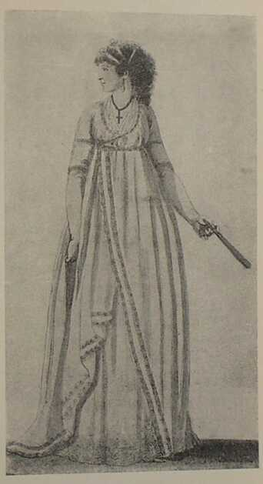
1795 Gowns
From: From: University of Columbia Theatre Department Online Gallery, http://www.columbia.edu/itc/barnard/theater/kirkland/3136/Early_19th_Century_Gallery/
Original Source: Gallery of Fashion, April 1, 1795. Druesedow, Jean. In Style. p. 25

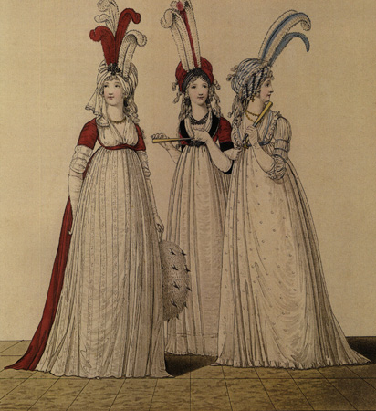
1797: Opera Gown
From: The Genesis of the Modern Opera Glove: Fashions of the Regency/Napoleonic Era,
http://www.operagloves.com/Fashion/RegencyFashion/regency.html
(Original source unknown. Appears to be a re-drawing.)
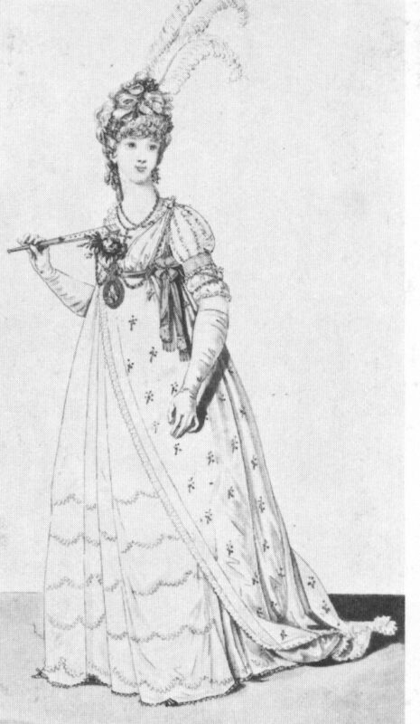

1795-1800: Purple silk evening gown with embroidery and sequins
From: Kyoto Costume Institute, http://www.kci.or.jp/collection/collset-e.html
Also see book “Revolution in Fashion”

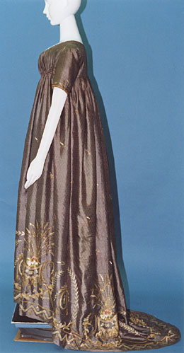

1800: Ball Gown
From: The Genesis of the Modern Opera Glove: Fashions of the Regency/Napoleonic Era,
http://www.operagloves.com/Fashion/RegencyFashion/regency.html
(Original source unknown. Appears to be a re-drawing.)

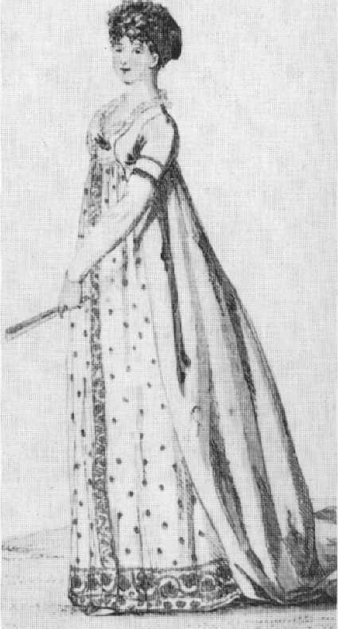
1800 Muslin Gown
From: Demode: Real Women’s Clothing 1750-1919, http://demode.tweedlebop.com/realvict/1800s.html
Original Source: Victoria and Albert Museum
A detailed drawing of this gown is available in Bradfield: Costume in Detail.

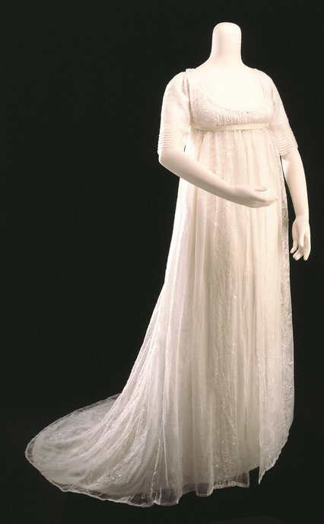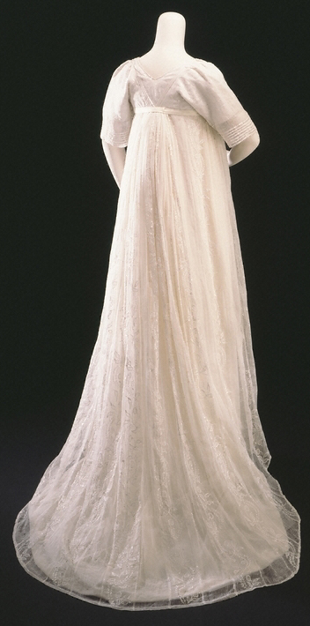
1803: Evening Dresses
From: The Genesis of the Modern Opera Glove: Fashions of the Regency/Napoleonic Era,
http://www.operagloves.com/Fashion/RegencyFashion/regency.html
(Original source unknown.)

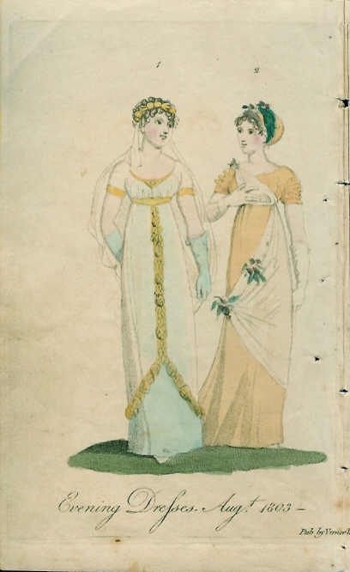
1802 Evening Gown
From: Kyoto Costume Institute, http://www.kci.or.jp/collection/collset-e.html

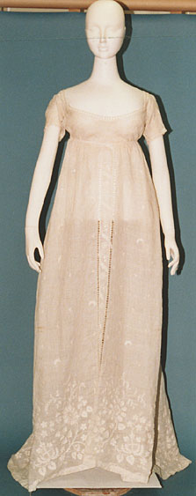
1804: Embroidered Muslin Evening Gown
From Metropolitan Museum of Art, http://www.metmuseum.org/Works_of_Art/department.asp?dep=8

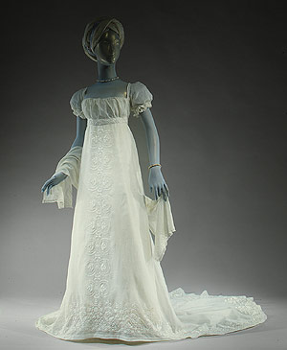

1804 Ball Gowns
From:
Original Source:Ladies Monthly Museum
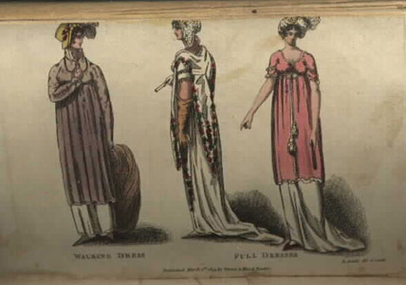
1800-1810: Pink Silk Day or Evening Gown
From: Charles A. Whitaker Auctions, http://www.whitakerauction.com/
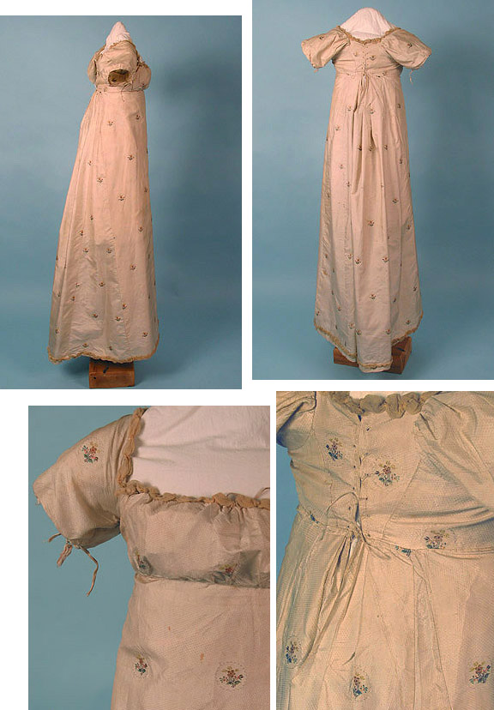
1805 White Muslin Gown (left)
1805 Figured Silk Gown (right)
From: Kyoto Costume Institute, http://www.kci.or.jp/collection/collset-e.html

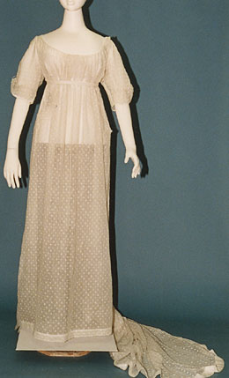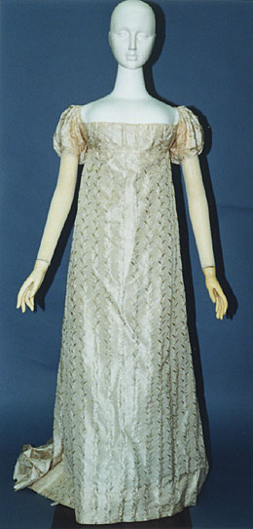
1806-1807 Embroidered Muslin Gown
From: Centraal Museum, Netherlands. http://www.centraalmuseum.nl/database/Kleur.phtml?GeenTerug=1&ItemId=17

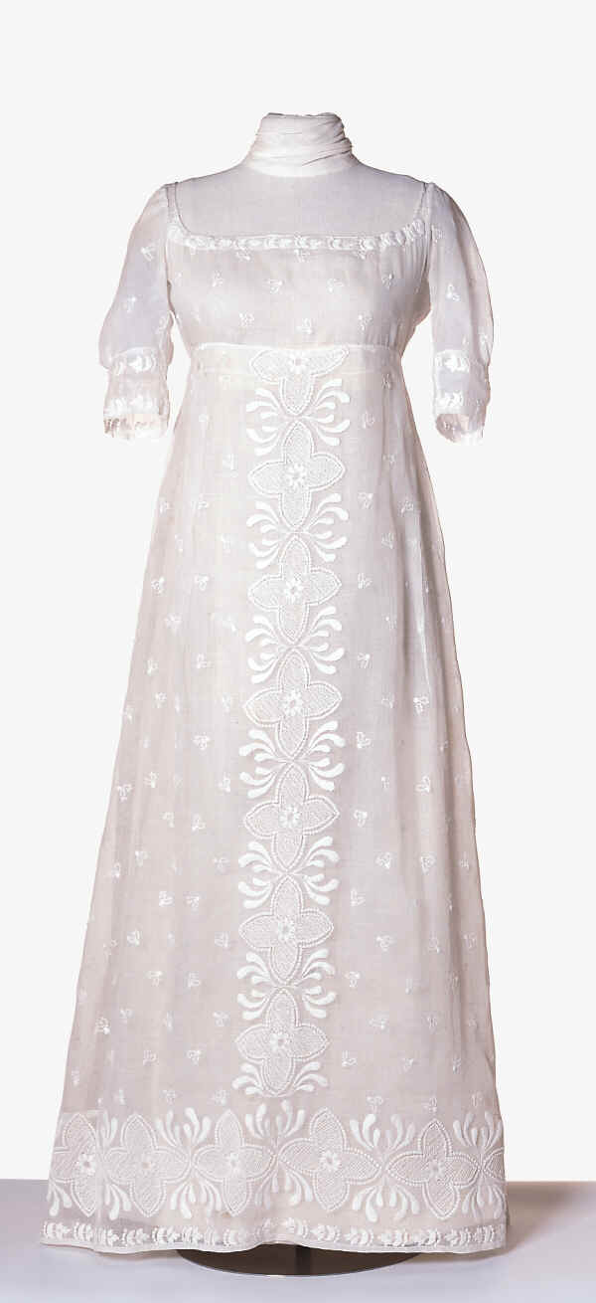
1809 Evening Full Dress, Plate
From: University of Washington, Fashion Plate Collection

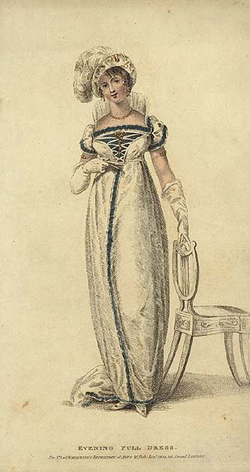

ca. 1810, Couples Dancing, source unknown
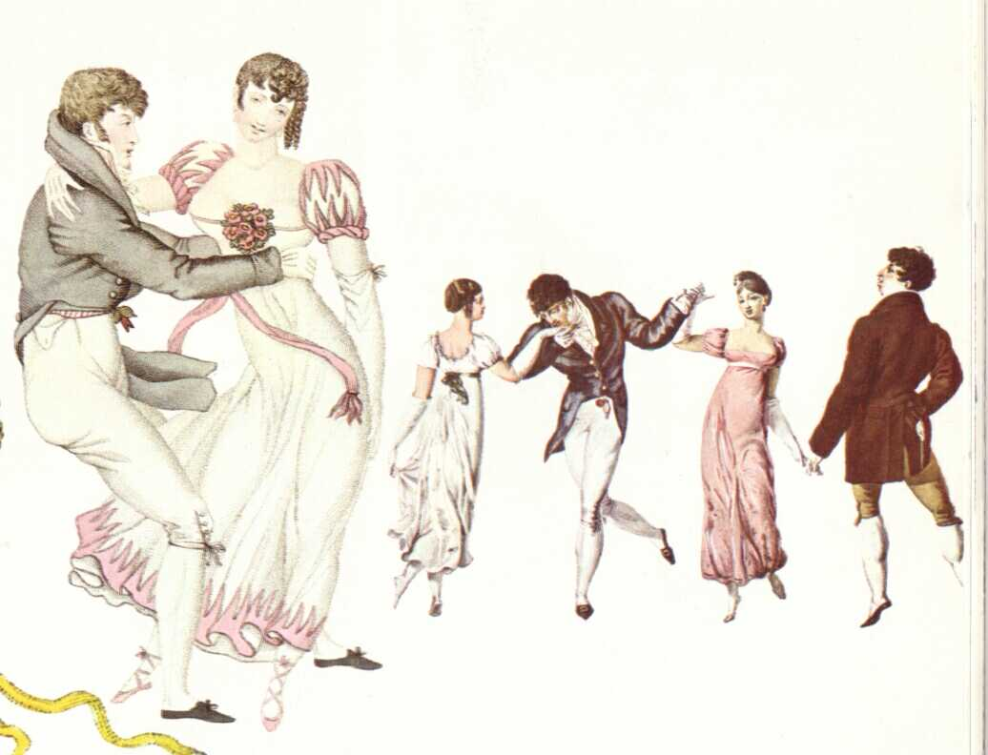
1808-1810 Muslin Gown
From: Centraal Museum, Netherlands
http://www.centraalmuseum.nl/database/Kleur.phtml?GeenTerug=1&ItemId=19

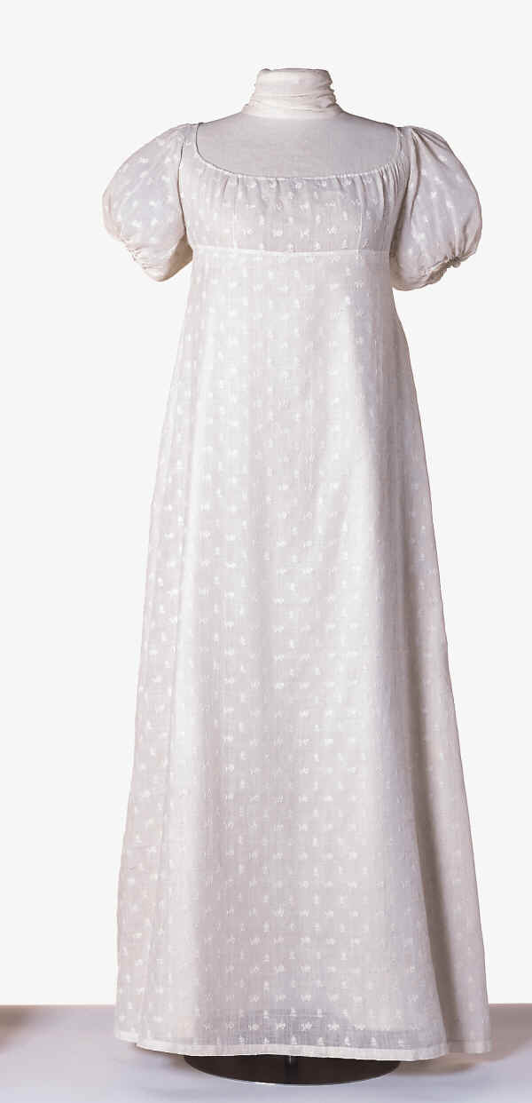
1807-1811 Red Net Gown with Chenille Embroidery
shown with red silk undergown, detail with white silk undergown
From: Victoria and Albert Museum, search on T.194-1958. http://images.vam.ac.uk/

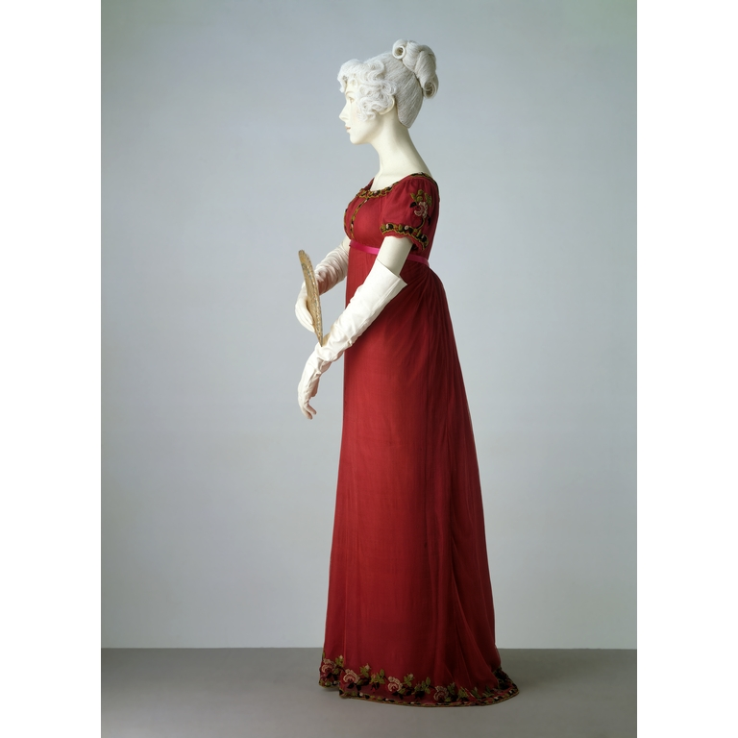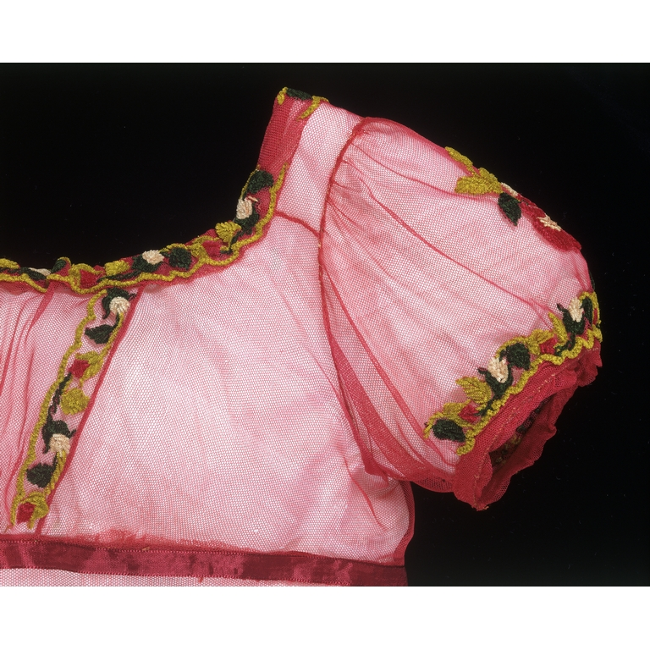
1810 Yellow Silk Gown (left)
From: University of Columbia Theatre Department Online Gallery, http://www.columbia.edu/itc/barnard/theater/kirkland/3136/Early_19th_Century_Gallery/
Original Source: Druesedow, Jean. In Style.

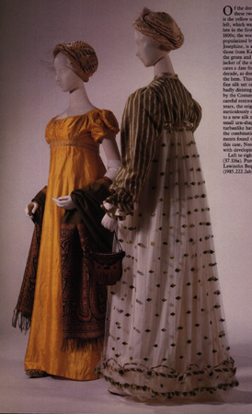
ca. 1810 Two French Dresses
From: Metropolitan Museum of Art, http://www.metmuseum.org/toah/hd/god1/hob_1983.6.1,07.146.5.htm

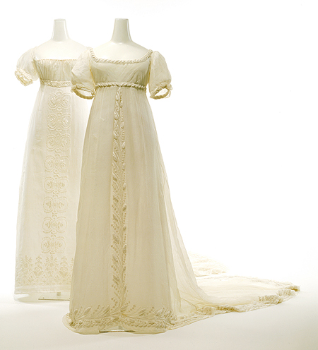
1810 Muslin Gown
From: Manchester City Gallery of Costume, #951.352 http://www.manchestergalleries.org/html/costume/goc_home.jsp

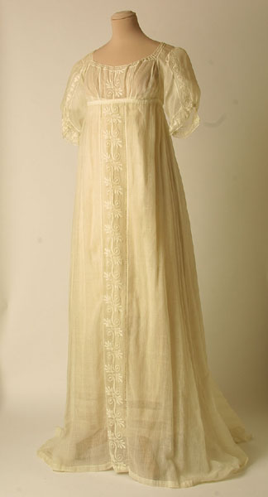
1810 Muslin Gown with Red Embroidery
From: Kyoto Costume Institute,
http://www.kci.or.jp/cgi-bin/collection.cgi?lang=e&path=1800/05-000292_a

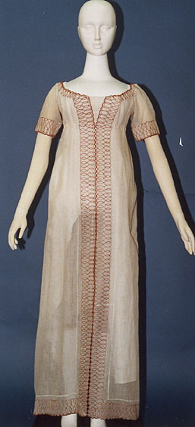

ca. 1810 Gold Silk Sarcenet Gown
From: Musee McCrod, Montreal,
http://www.mccord-museum.qc.ca/en/collection/artifacts/M982.20.1

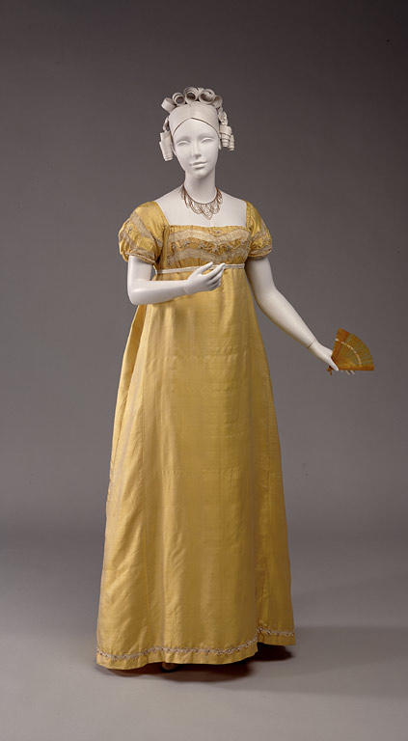
1810 White Mull with hammered silver foliate diaper-patterned and red silk thread embroidery
From: Metropolitan Museum of Art, http://www.metmuseum.org/toah/hd/orie/ho_1976.137.1.htm

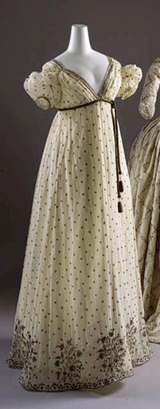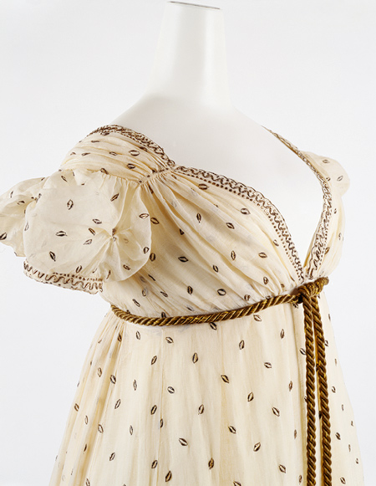
Bibliography

Books:
Bradfield, Nancy. Costume in Detail: Women’s Dress, 1730-1930. (Boston: Plays, Inc., 1968.)

Druesedow, Jean. In Style: Celebrating Fifty Years of the Costume Institute. (NY: Metropolitan Museum of Art, 1987.)

Starobinski, Jean, ed. Revolution in Fashion: European Clothing, 1715-1815. (New York: Abbeville Press, 1989.)

Web Sites:
Decker, Cathy. The Regency Page: Collection of Links to Multiple Sites. http://locutus.ucr.edu/~cathy/reg.html

University of Washington. Fashion Plate Collection. http://content.lib.washington.edu/costumehistweb/index.html

Victoria and Albert Museum.
http://images.vam.ac.uk/

