Mob Caps in Ackermann’s “Repository of Arts” from 1809-1820
Hope Greenberg

The following images are all caps that include the term “mob” in their descriptions. These images are all “Morning Dress” i.e. outfits that would be worn during the day, before dinner or promenade hours. They are not necessarily the modern day equivalent of loungeware—one could receive visitors in these outfits—but they are primarily designed to be worn at home. Other caps designed to be worn as morning dress are also shown in Ackermann’s, described with different terms. For instance, in 1810 there is a “helmet cap” and a “cottage cap.” After 1817, some caps that include “mob” in part of the description are also seen in half-dress instead of exclusively in morning dress.

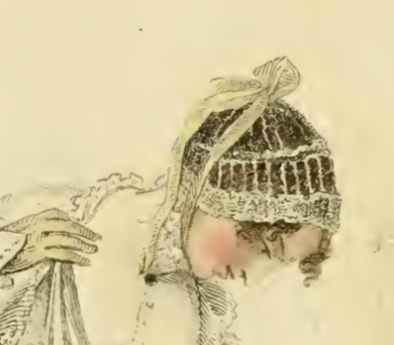  Morning Dress, November 1809  “A matron mob, or cap of point lace, ornamented with shaded yellow, or lemon-colored ribbons.” | 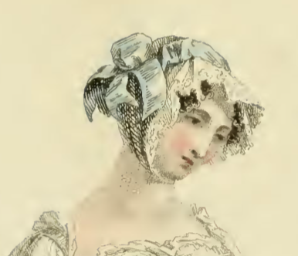  Domestic, or Morning Costume, May 1812  “Parisian mob cap, of fine lace confined around the head, and terminated on one side with a celestial blue, or silver-grey, ribbon.”
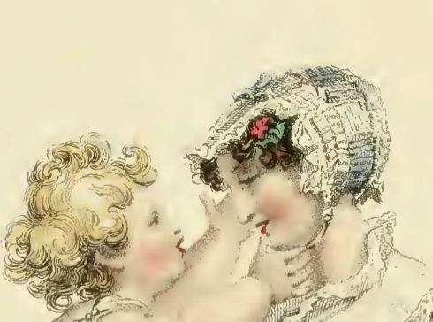  Domestic, or Morning Costume, June 1812  A foundling mob cap, composed of lace, and ribbon the colour of the pelisse.” | 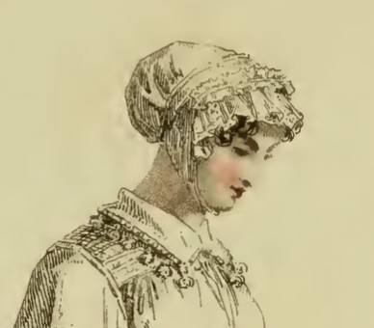  Morning Dress, May 1813  “Brunswick mob cap, composed of net and Brussels lace.”
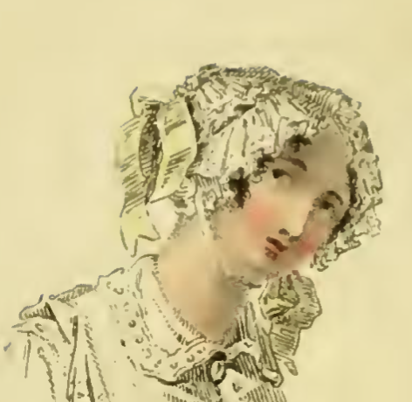  Morning Dress, January 1814  “The flushing mob cap composed entirely of lace, ornamented with lemon-colored ribband, which also confines it under the chin.” | 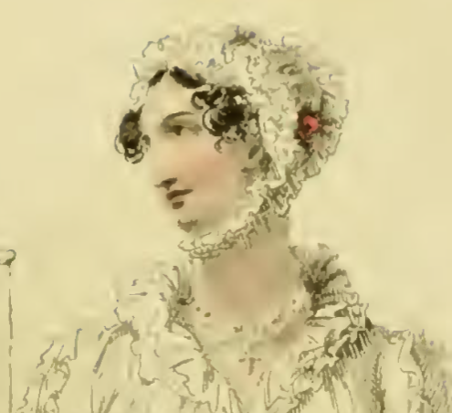  Morning Dress, April 1814  “Bourdeaux mob cap composed of lace, with treble full borders, narrowed under the chin.”
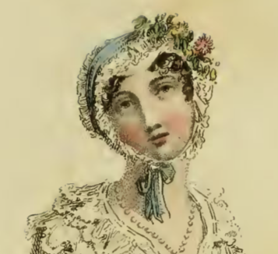  Morning Dress, February 1815  “A French mob cap, composed of white satin and blond lace, tied under the chin with celestial blue satin ribband, and ornamented with a wreath of flowers.” | 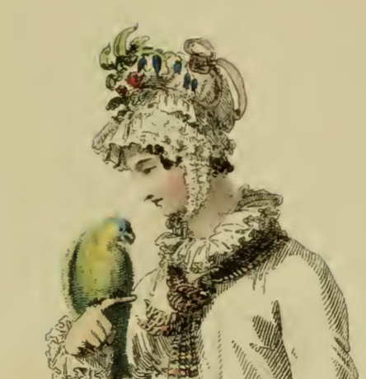  Morning Dress, April 1815  “A mob cap, composed of net and Brussels lace, decorated with a cluster of flowers, and bows of satin ribbon.”
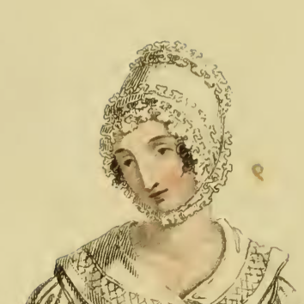  Morning Dress, November 1815  “A French mob cap composed of satin and quilled lace.” | 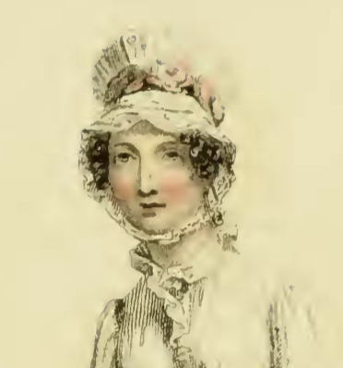  Morning Dress, July 1816  “The cornette worn with this dress is of the mob kind, and by much the most becoming we have ever seen: it is composed of white lace, and tastefully ornamented by roses.”
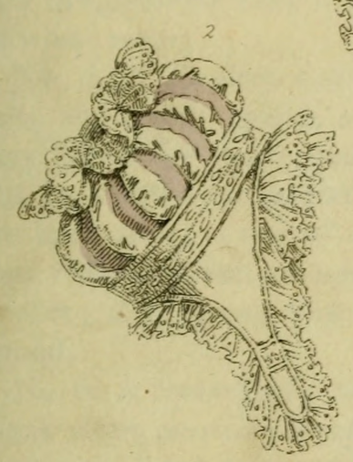  Parisian Head-Dresses, January 1817  “No. 2. A morning cornette, composed of worked muslin; the lower part a mob, the crown round, made very full and divided into compartments by drawings [N.B. gathering]. The top of the crown is edged with lace; the boarder corresponds. No ornament.” | 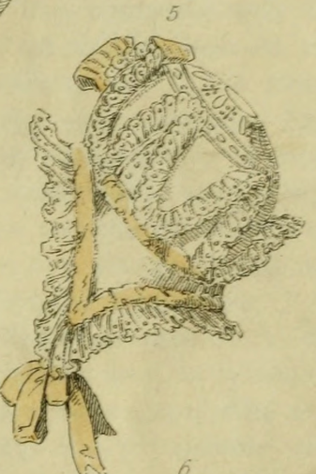  Parisian Head-Dress, January 1817  “No. 5. A cornette composed of tulle, the crown round, and made very high; the lower part a mob, cut in a different manner to any we have seen; a row of straw-colour ribbon is run in next to the border; strings and bow to correspond.”

