Reticules 1795-1820s

Note: The image caption includes the date (actual or as assigned by the source), the source abbreviation, the item, and, where possible, an accession number. Key to the abbreviations:
Ack – Ackermann’s Repository of Arts, etc. Augusta – Augusta Auctions; CP – Costume Parisien from Journal des dames et des modes; ladiesmonth – Ladies Monthly Magazine; LACMA – Los Angeles County Museum of Art; mccord – McCord Museum, Montreal; MFA – Museum of Fine Arts, Boston; MMA – Metropolitan Museum of Art; NYPL – New York Public Library; VANDA – Victoria and Albert Museum, vinatagetextiles – Vintage Textiles Auction.

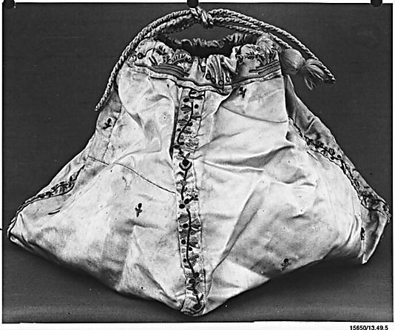  1790s-mma-reticule-13.49.5-8x10 | 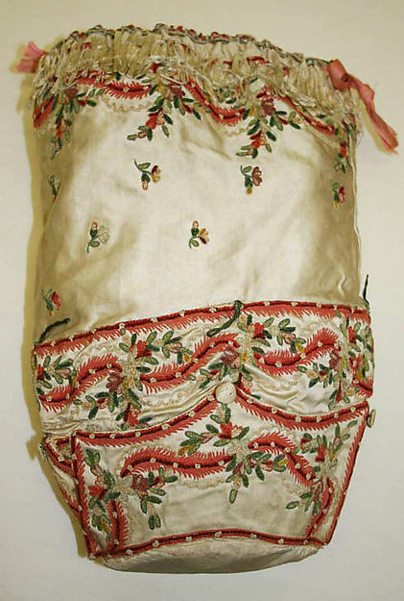  1795-mma-reticule-1981.352.2 | 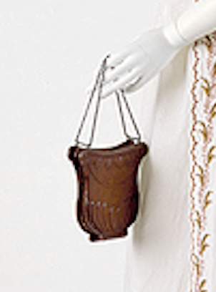 1798-mma-embroid-openrobe-reticule-detail
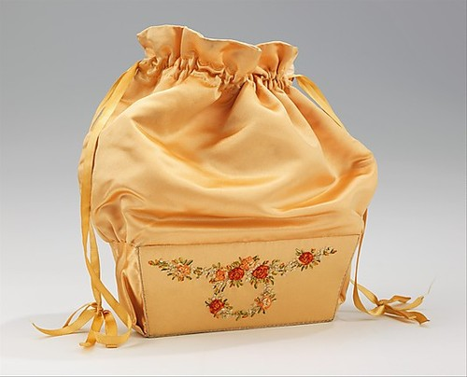  1800-25-mma-reticule-purse-2009.300.2437 | 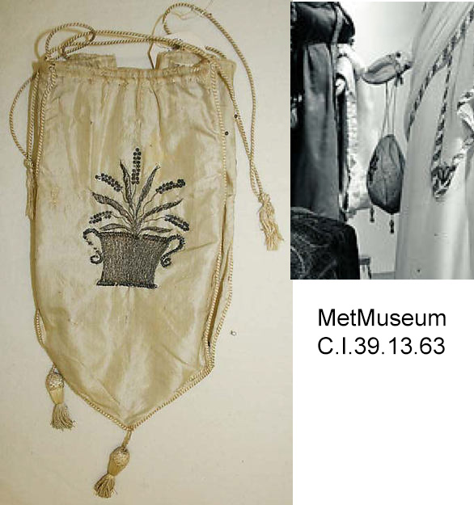  1800-1810-mma-reticule-C.I.39.13.63 | 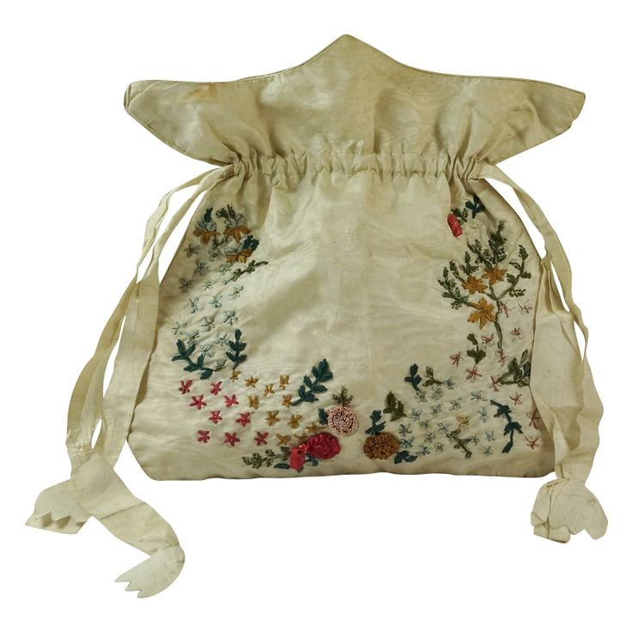  1800-1810-rubylane-reticule

