1. Turn the top edge of each piece down ½ an inch, pin it, and hem stitch it. Leave the ends open – that’s where the ribbon drawstrings will go.
2. Trim: If you plan to have the trim go across the reticule, sew it on before connecting the two pieces of reticule.
If you plan to run the trim along the reticule’s edges, sew the two pieces together about 75%, then sew on the trim leaving a sufficient amount hanging, then sew the rest of the edges together, then sew on the trim. (If you sew the edges together completely it will be hard to get your hand and needle into the reticule to sew on the trim.
If you plan to add a tassel or trim that will be hanging outside the reticule (ex: an edge of lace or ruffle) you can stitch it on before joining the two sides. Just make sure it is facing inside so that when you turn the reticule right sides out it will end up on the outside.
3. Pin the pieces right sides together and use a backstitch to sew them securely. Don’t forget to leave the holes open for the ribbons to pass through.
4. Take two pieces of ribbon of equal length. Using the bodkin, pass one ribbon through a top hem left to right, then continue by passing back through the other, right to left. Take the second length of ribbon and pass it through the top hem right to left, then back through the other, left to right. (You may wish to fray-check the ends.) Tie or stitch the ends of each ribbon together so you end up with two circular loops.
5. Ask me for the special surprise items I have to go in your reticule.

Stitches

Hem stitch

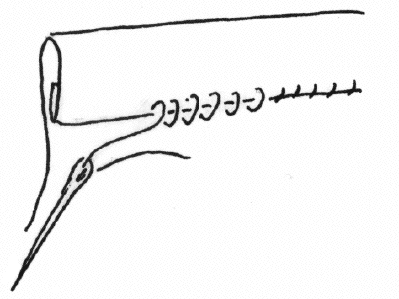

Back Stitch

- Come up from the back.
- Insert the needle to the right a tiny bit (1/10”).
- Bring needle up from back about 1/10” to the left of the original.
- Insert the needle in the hole of the first stitch (this keeps things neat and tidy).

