What would Jane wear?

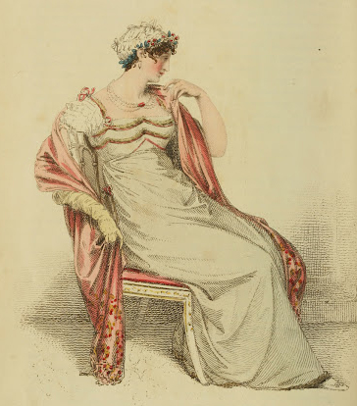

A beautiful gown is any gown that makes us feel beautiful, but pursuing historical accuracy in our Austen-era creations can be rewarding.

Let’s exchange tips, ideas, and questions as we discuss creating looks that Austen herself would recognize.

**What:** An impromptu fashion meeting.

**When:**

**Where:**