**Upcoming Project: Blue silk evening gown, late 18-teens, early 1820s**

This gown features the ornate bodice, piped trim and gothic influence sleeves that characterize the late 18-teens. However, it also appears to have a slightly lower waist and wide rounded neckline that may indicate a slightly later date.

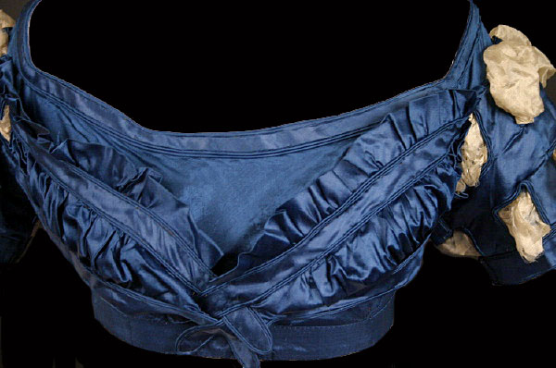

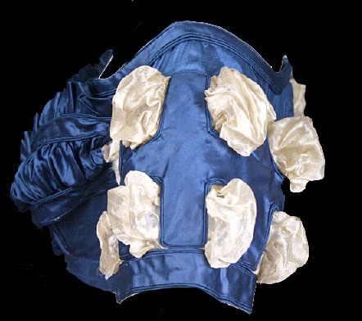

Image from vintagetextiles.com

**Upcoming Project: Red silk ball gown**

Another 1820s gown, with ornate sleeves and decorative piping.

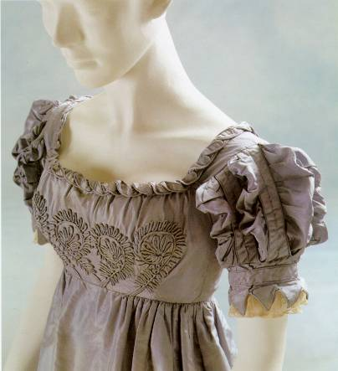**Upcoming project: 1822 ball gown in green silk**

This amazingly detailed gown shows the widening skirt of the early 1820s along with the bodice and hem detail that characterize that era.

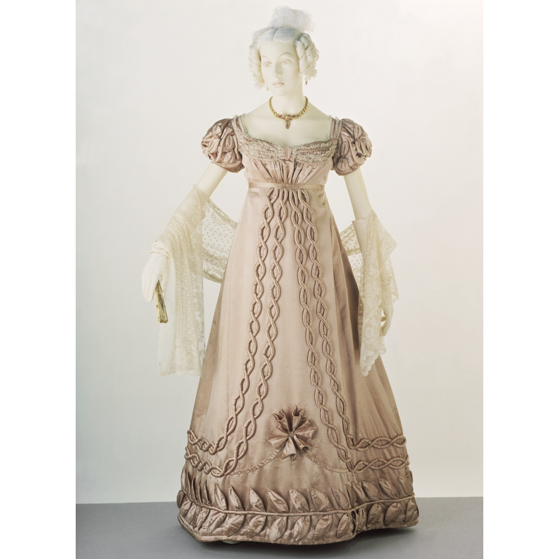

Image from the Victoria and Albert Museum

The inspiration for this gown: from the McCord Museum, Montreal:

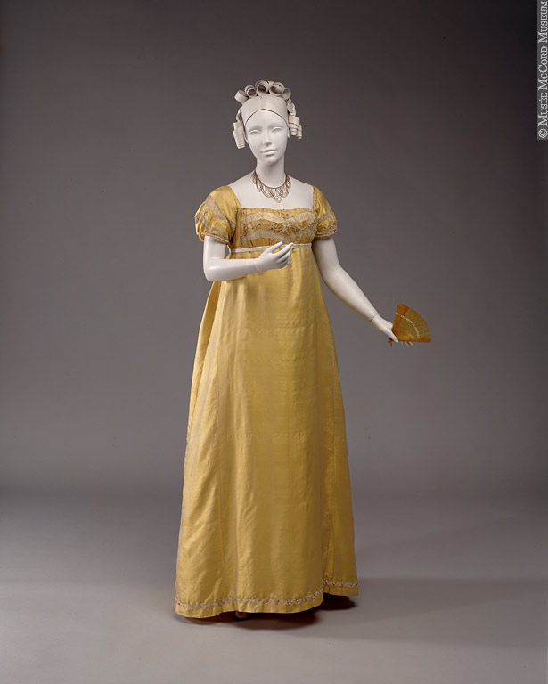

Partial inspiration for this gown. The sleeves are drawn from another gown as depicted in a fashion plate.

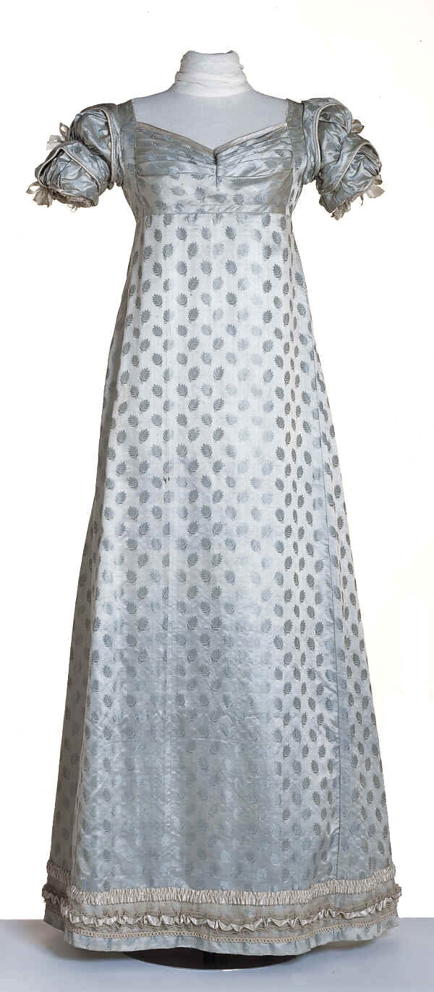

Image from the Victoria and Albert Museum