Whites: Tuckers, Frills, and Caps
Hope Greenberg

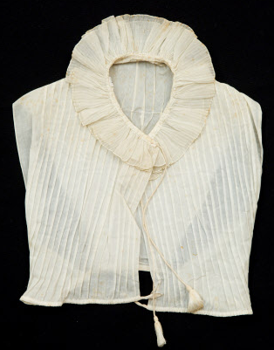
1815 Chemisette, Snowshill Museum, 1349950.
It is not surprising that a culture that associates cleanliness with the whiteness of one’s linen, and that eschews sunburnt or weathered skin, would encourage daywear accessories that cover the skin with fine white fabric. Known for their ability to survive harsh laundering and excessive pressing, linen and cotton can also be created in light elegant weights. For a lady of the 18th century, the round neckline of a typical gown could be filled in with a voluminous handkerchief or fichu. For a lady of the early 19th century pursuing a fashion that required a narrower silhouette, the tucker, later called the chemisette, was the solution.

The objects followed the fashion evolution of the time. Early chemisettes were plain with either no collar or a simple collar. As the century progressed these became more elaborate, with tucks, pleats, ruffled necklines or wider collars edged with lace or ruffles. After about 1812 when fashion demanded more elaborate bodices to balance the elaborate borders on skirts, and outer garments like spencers or pelisses followed suit with wider or taller collars, both chemisettes and detached ruffs, or frills as they were often called, developed even more layers and height to fill in the neckline. The chemisette continued to be worn throughout the 19th century and the shape and collars continued to follow the general design of the dresses with which they were worn.

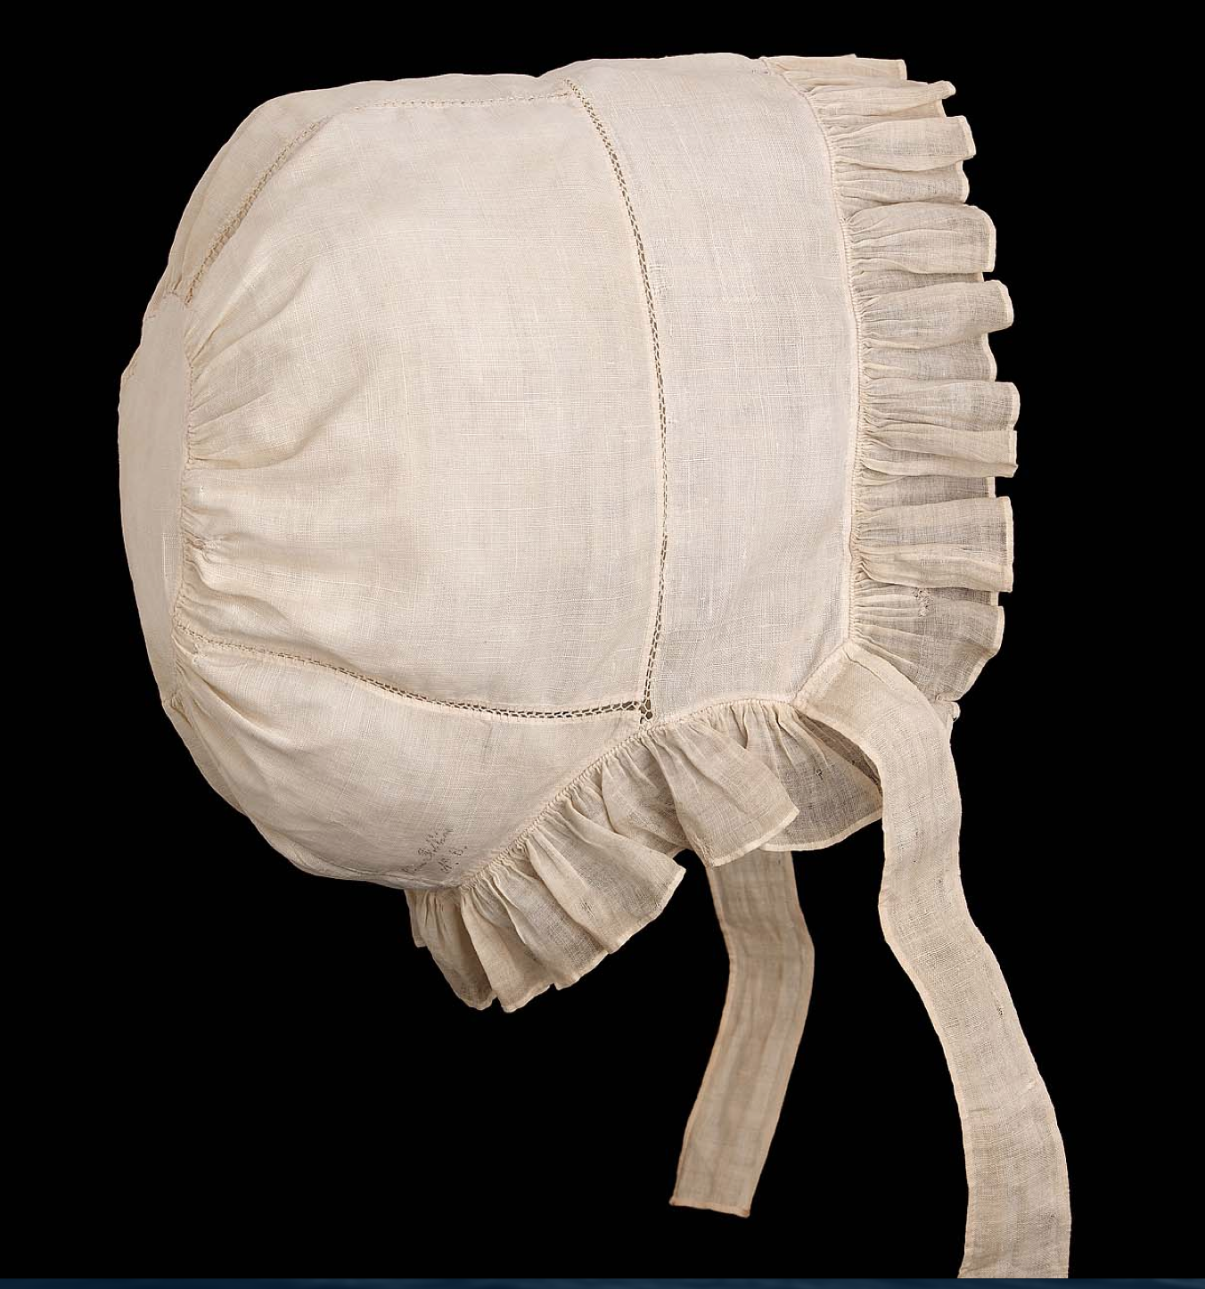
A simple linen cap. Fine Arts Museum, Boston. 99.664.31
Throughout this period it was the standard for women, particularly adult women, to wear caps. These could be made of fine lawn, mull, or tulle—that is, with cottons that were semi-transparent. More rare, for high fashion daytime wear at least, are caps made of linen. Caps, too, followed the fashion and accommodated current hairstyles. Early 19th century hairstyles, and the caps that covered them, tended to pull the volume of the hair to the back of the head in ‘Grecian’ style. Caps from this era tend to lie close to the head on top and be longer at the back. As the century progressed that volume moved to the top of the head in ‘Roman’ style, becoming more detailed. Caps from this era leave room on top. Like the movement towards more ornate bodices, caps, too, became more ornate as the century progressed, trying to keep pace with the amazing styles of the 1830s.

Caps were worn in a variety of situations. For a lady, a simple sleeping cap might give way to a morning cap. Meant to be seen by visitors, the decorative cap might contain lace, ribbons, ruffles, puffs of tulle, elaborate embroidery and all manner of airy decorations. During the first decade of the 19th century it is even difficult to tell the difference between some bonnets and morning caps as white bonnets were constructed of cotton and highly decorated. (Generally, bonnets were not transparent, were rather heavier and often stiffened in some way, if only with cording.) During the years when larger bonnets came into fashion (roughly 1812 and onward), daytime caps were worn under a bonnet with a bit of white, or even a deep ruffle or bit of lace, framing the face. Evening caps might be mere wisps of embroidered net.

Caps

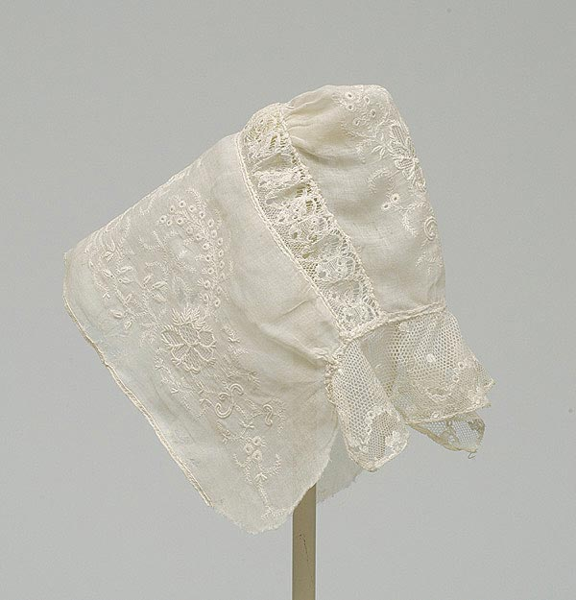 | 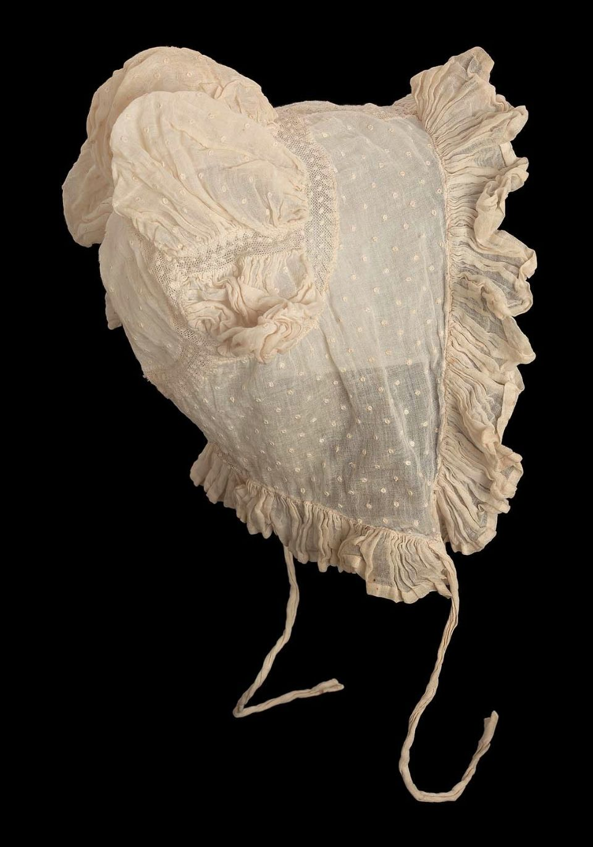 | 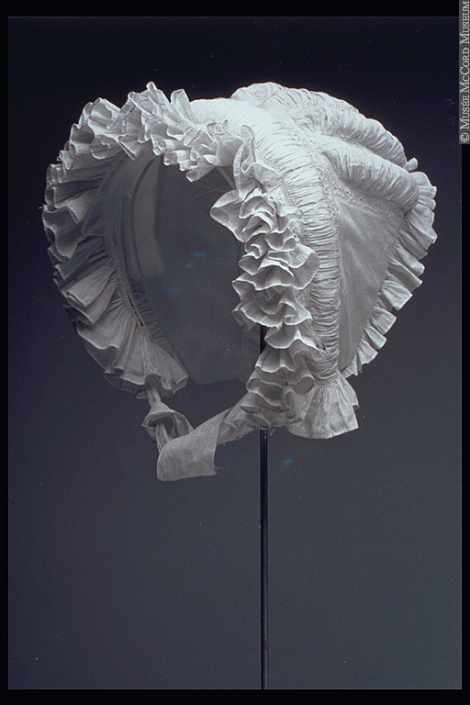
1800-1820 Embroidered mull (fine cotton) | c1814 Fine Arts Museum, Boston, 46.1242 | 1825-30 McCord Museum lawn, M9677

Frills/Ruffs

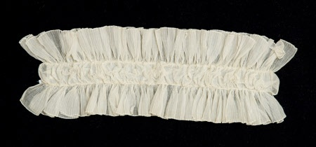 | 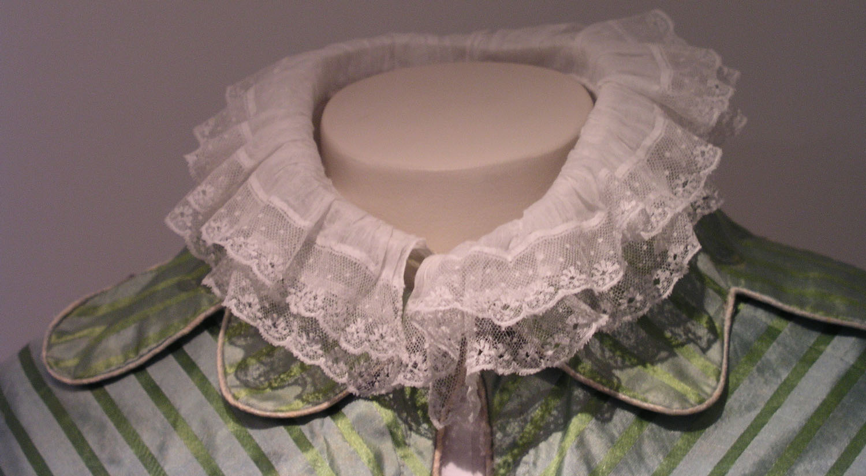
c1815 Snowshill Museum | 1810-20 Museum of London

Tuckers/Chemisettes

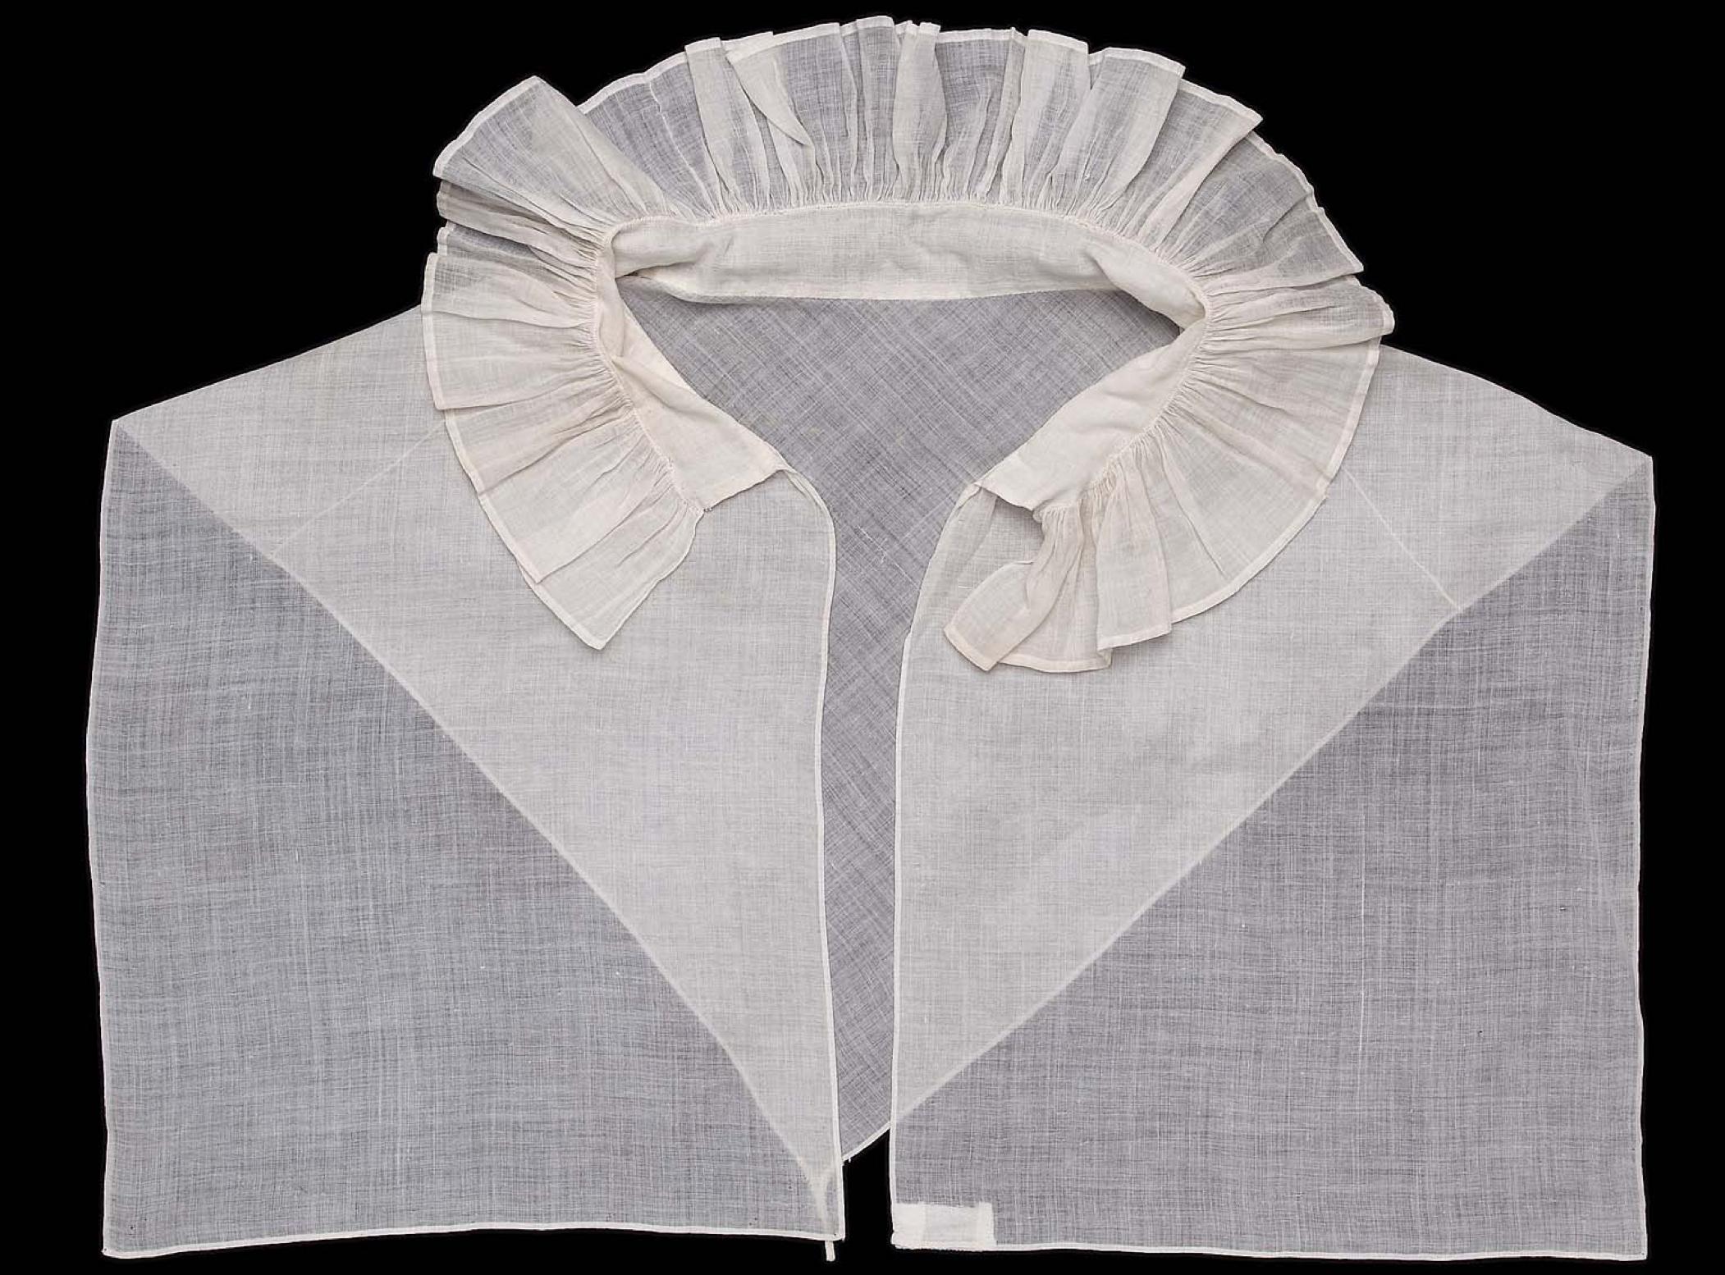 | 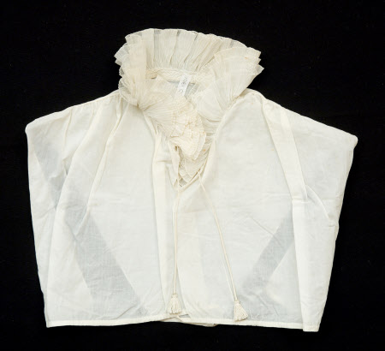
Museum of Fine Arts, 99.664.46 | Snowshill Museum
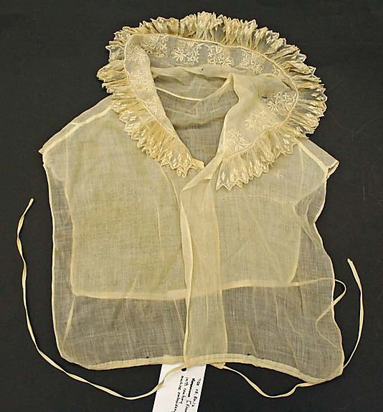 | 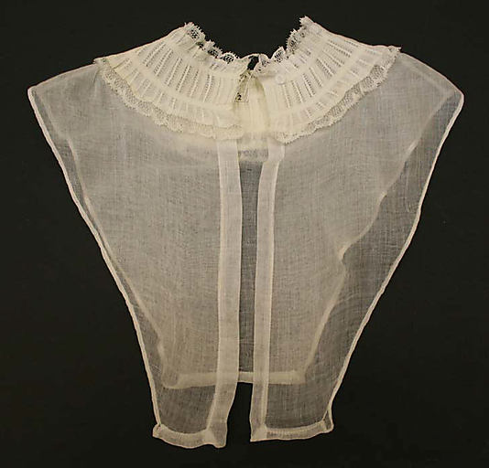
c1815 Vintage Textiles | c1818 Metropolitan Museum of Art
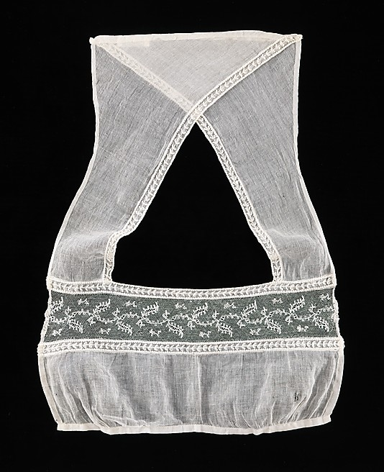 | 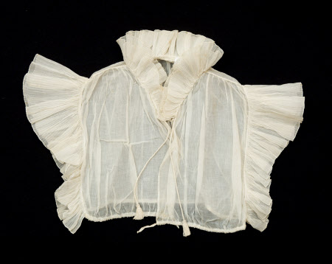
1815-20 Museum of Fine Arts | 1820-25 Snowshill (meant to be worn over gown)

Fashions from Ackermann’s “Repository of Arts”
Full issues available at: https://archive.org/search.php?query=ackermann%20repository

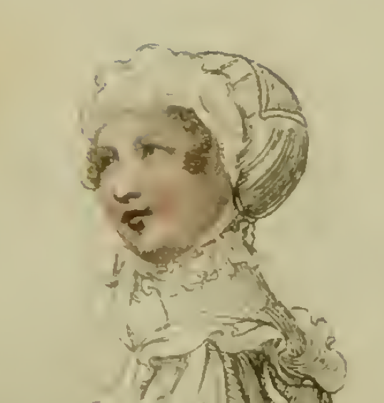  November 1810, Morning Dress | 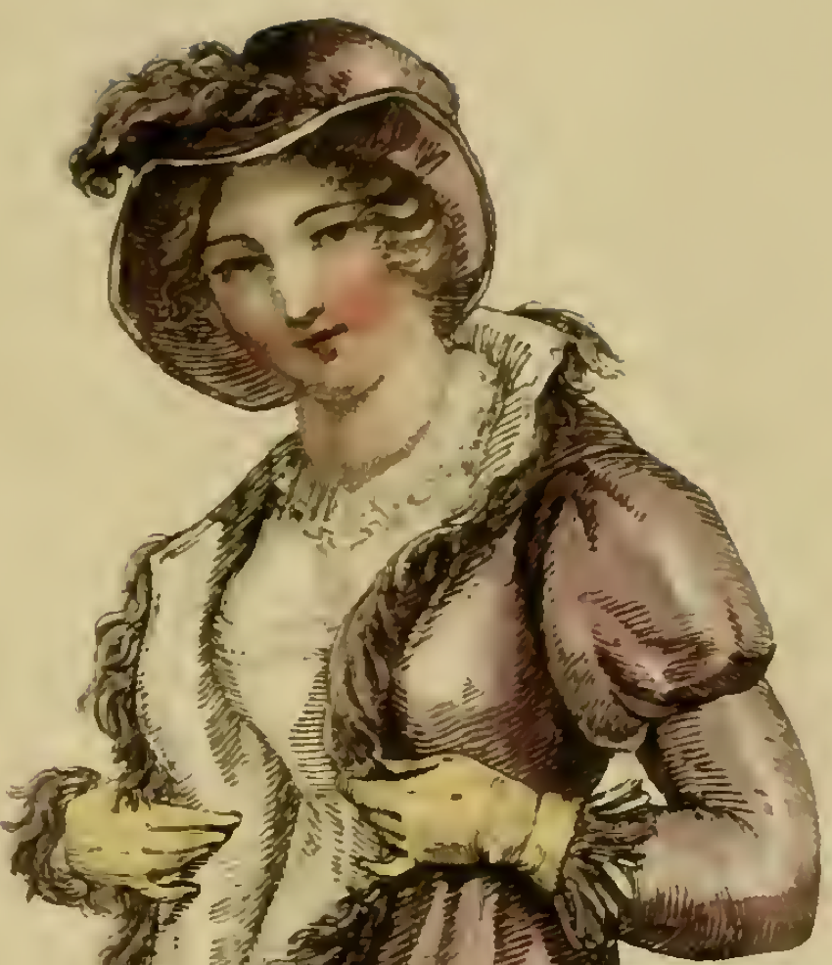  April 1811, Walking Dress
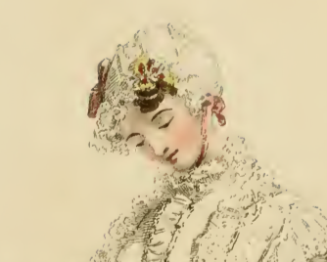  September 1811, Morning Dress | 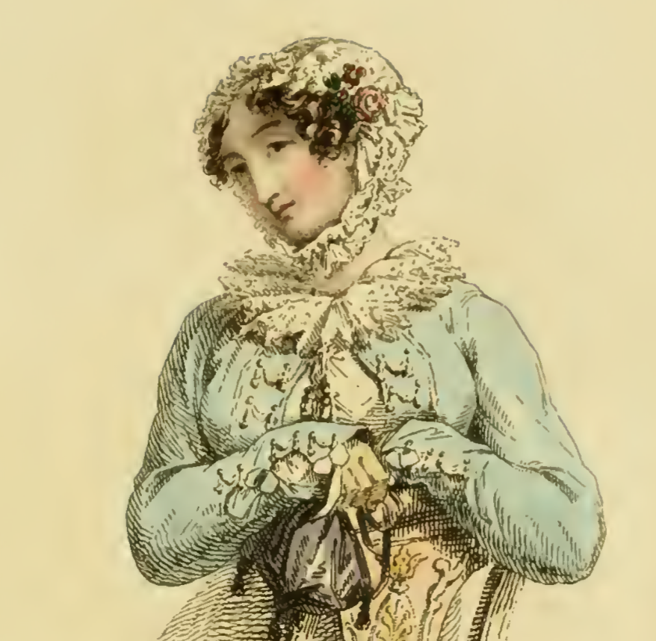  October 1811, Carriage or Morning
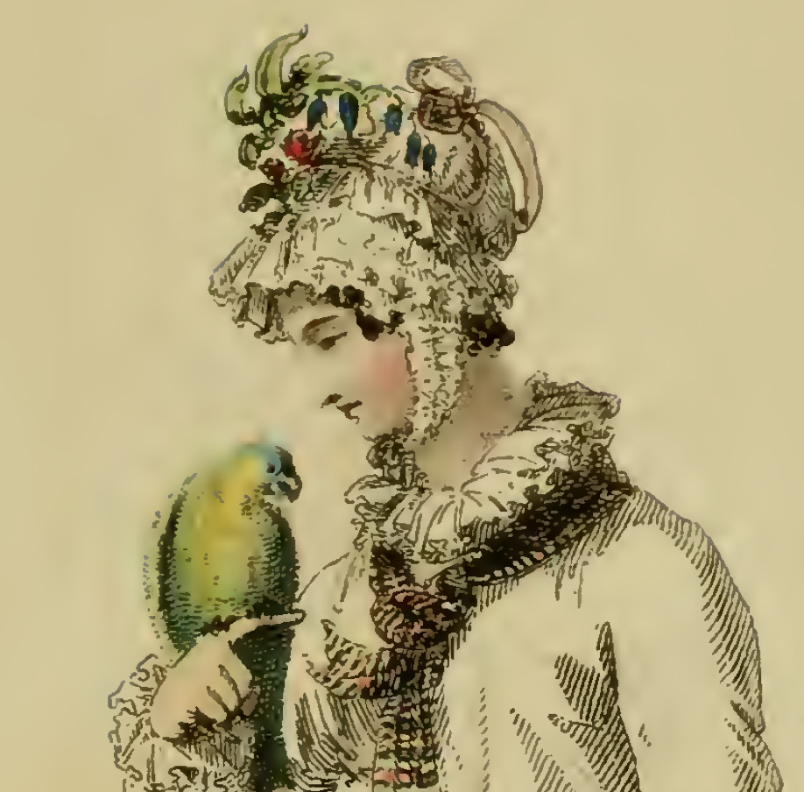  April 1815, Morning Dress | 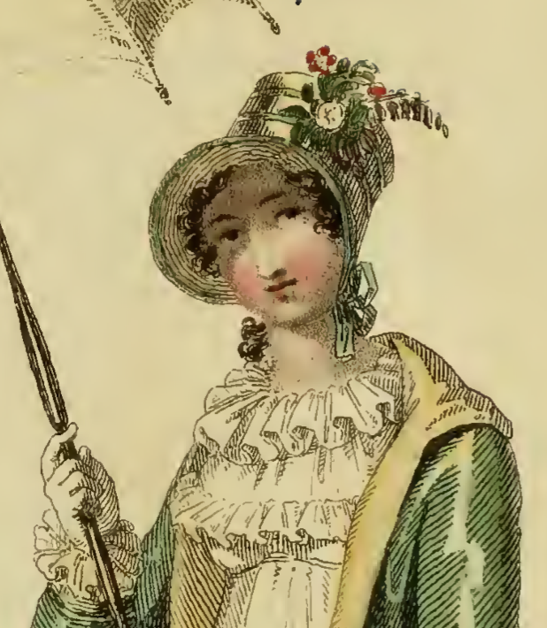  May 1815, Walking Dress
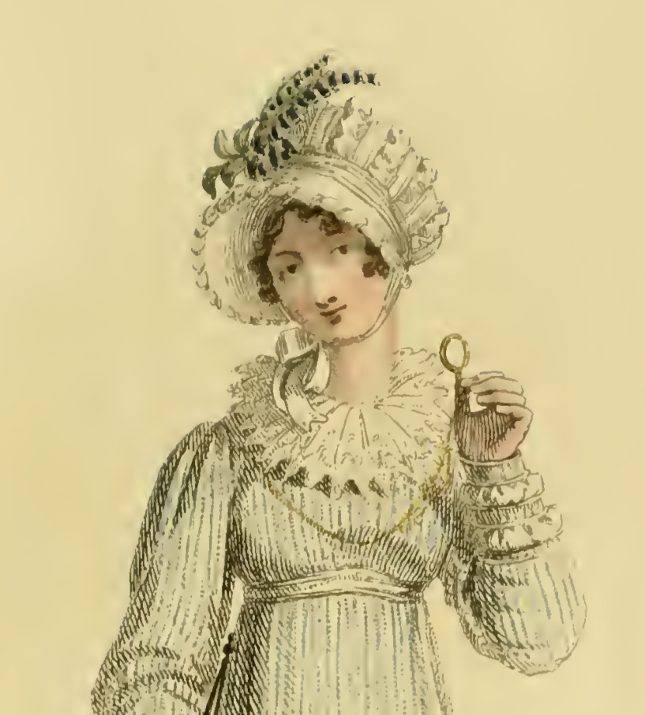  August 1815, Walking Dress | 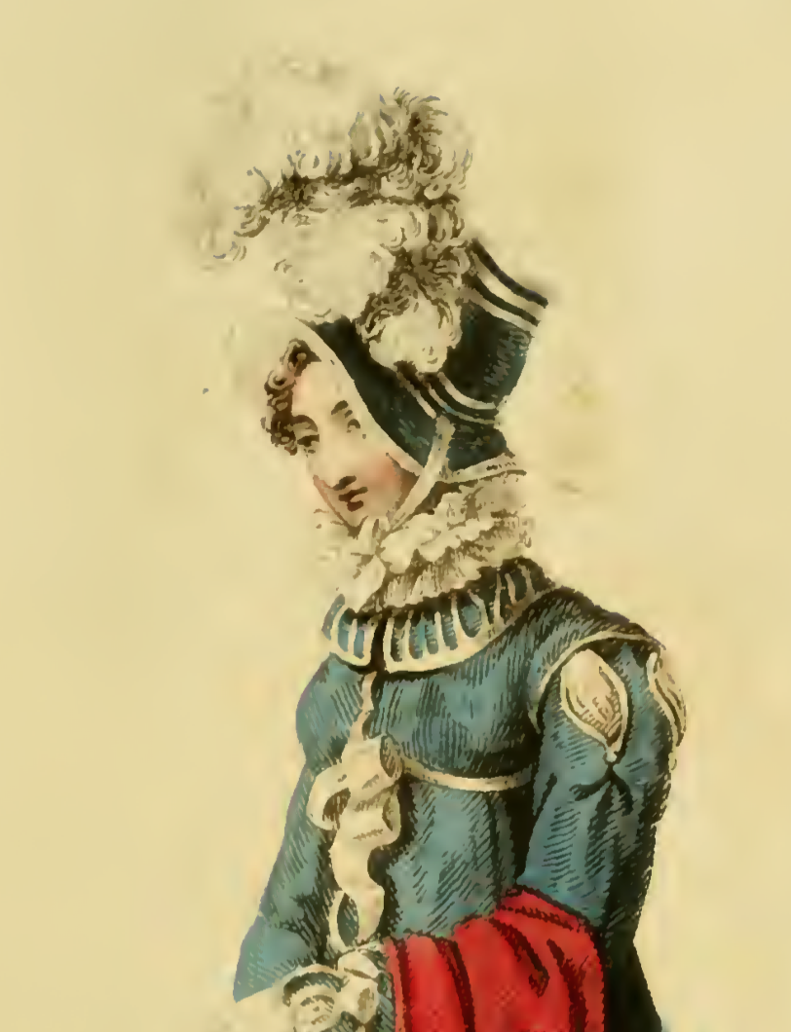  December 1815, Walking Dress
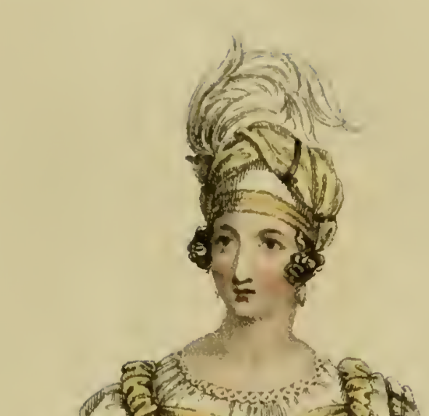  April 1818, Evening Dress (Cambridge Toque) | 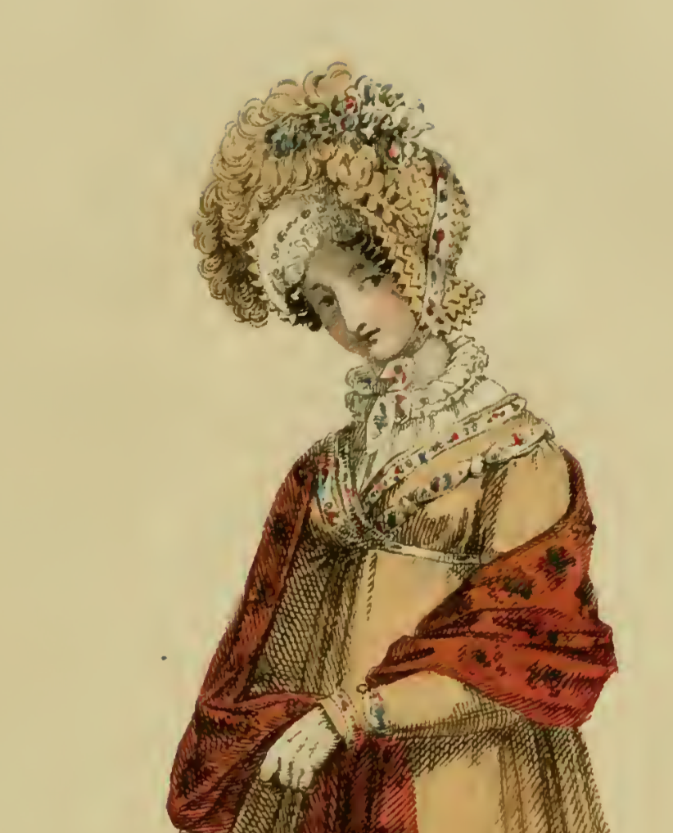  March 1818, Walking Dress
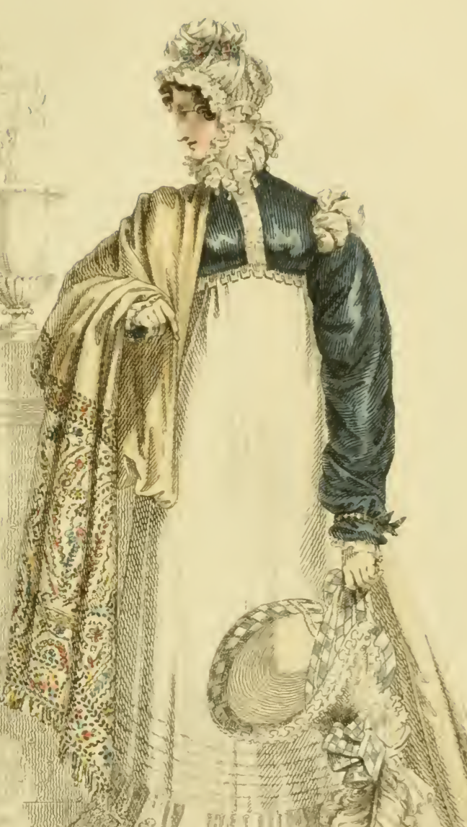  October 1818, Walking Dress | 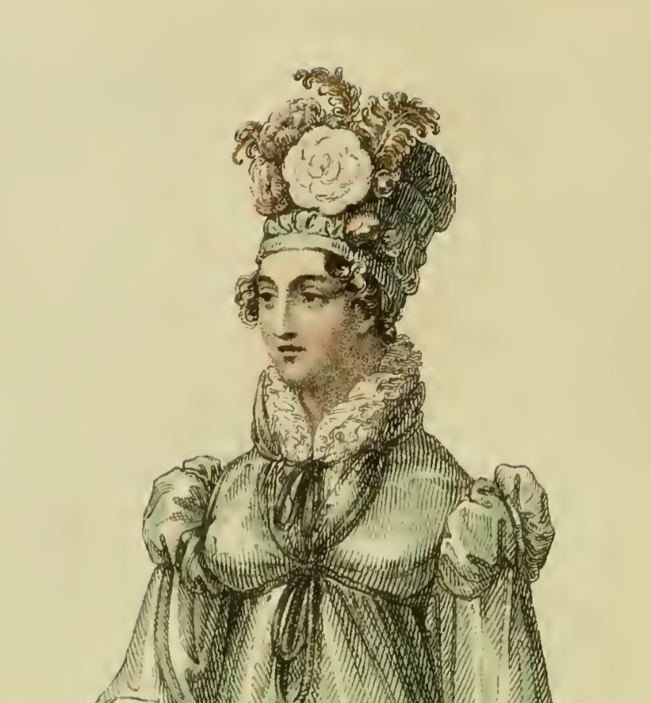  June 1818, Walking Dress (Collarette, Toque)
Cap Patterns (Measurements are for my head! Adjust for your own.)

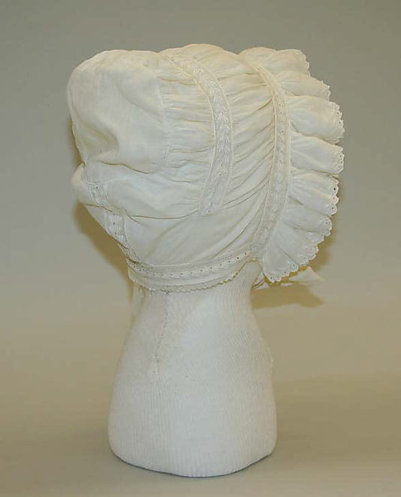  1812-20 Metropolitan Museum of Art C137.45.16 | Style #1  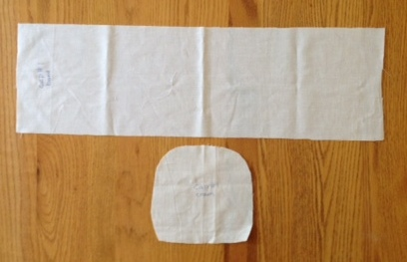  Band: approx 8 x 26” Crown: approx 7” x 7”
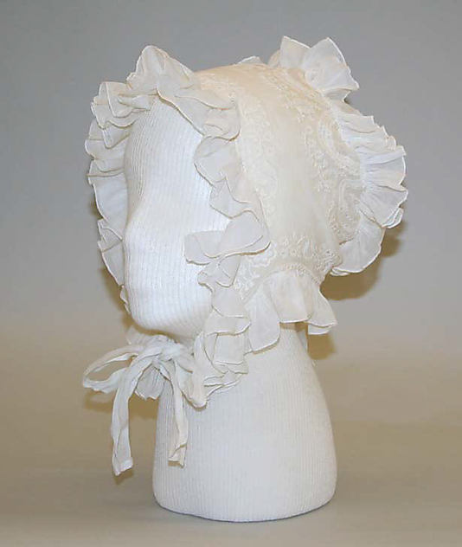  1812-18 Metropolitan Museum of Art, C169.32.16C169.32.16 | Style #2:  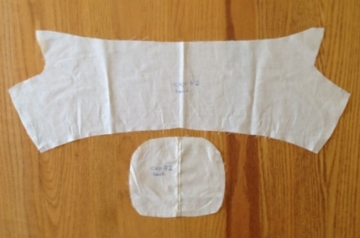  Band: widest points 8” x 24” Crown: 6” x 7”
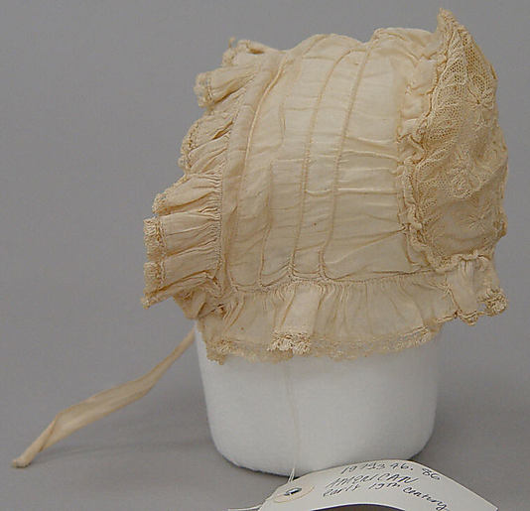  1800-10 Metropolitan Museum of Art, 1979.346.86 | Style #3  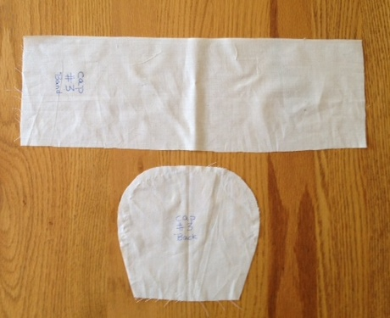  Band: 6” x 16” Crown: 5” at bottom widening to 7” x 6.5”

