Cutting a Regency Era Gown Skirt Without a Pattern (DRAFT)

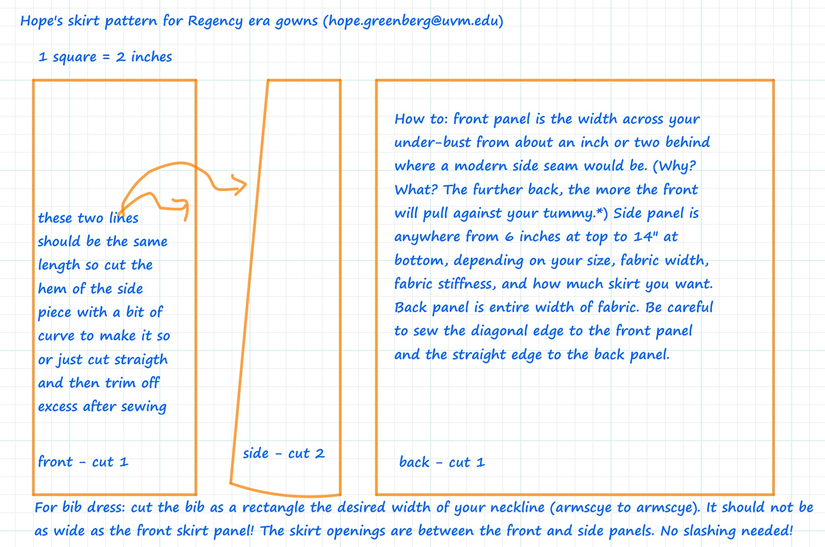

* How do you determine the width of the front panel? It depends on your figure type, the date of the gown you are making and sometimes on the amount of fabric you have. For gowns from around 1805 – 1810 a narrow silhouette predominates so you want a skirt that falls straight from the under-bust to the hem. (Think Greek column!) Sometimes you can see that the front extends far around the waist by the tell-tale ‘pull’ across the top of the skirt, as in the gown of the woman on the left in Figure 1. As we move through the 18-teens the hem begins to move outward from the body, taking a more a-line shape. (And of course day vs. evening, type of dress—bib, back fastening, etc.—and regional style all play a part in the cut of skirts.) Figure 2 shows a skirt where the front panel’s seam is quite far back. This is a very narrow person! Figure 3, a gown from about 1813, has a front panel that starts about where a modern side seam would be. Figure 4 has the front panel that is just in front of a modern side seam. This is a bib dress. The front skirt panel is wider than the bib but not too wide so that the opening between the front panel and the side panel is right in the seam, i.e. no extra slash needed for an opening (Figure 5). So, if you have a bit of tummy and don't want your skirt to pull across your abdomen, cut the front panel so that the seam is closer to, or just in front of, where a modern side seam would be.

These examples show the front panel as a rectangle. The side panels however, are trapezoids, narrower at the top than the bottom, usually with one edge straight and one diagonal edge. Many gowns from this period also cut the side panel as a rectangle and then increase the gathering or pleating at the top. Later gowns achieve the a-line look by cutting two trapezoids for each side or by (finally!) cutting the front in an a-line (Figure 6).

The back panel is usually a wider rectangle with lots of gathers or pleats. If you sew the straight edge of the trapezoid to the back panel and sew the diagonal edge to the front panel, it will push the front panel forward slightly so the skirt doesn’t pull or get tangled around your ankles. You can see the result in the pictures—the front panel seam starts behind where a modern side seam would be but by the time it reaches the hem the seam is well in front of that.

All these examples show a skirt with little or no gathering in the front, and most of the gathering or pleating drawn into the back, which is how many, perhaps even most, gowns were constructed after 1810 (or a bit earlier for some). If you like gathering in the front just remember to cut your front panel wider! How do you calculate the amount of fabric you need? I tend to like the 18-teens look so cut my trapezoids on a fairly wide diagonal, 7” at top widening to 12” at bottom, or even 9-10 at top and 13-14 at bottom. And I’m about 44” from skirt top to the floor (have to allow for the hem). With 44” wide fabric (with no nap or one-way design) that means I only need 3 yards for the skirt. 1.5 for front panel and side trapezoids, 1.5 for back panel. With wider fabrics I can usually work the bodice pieces in there as well. That just leaves the sleeves, .5 to 1.5 depending on the length.

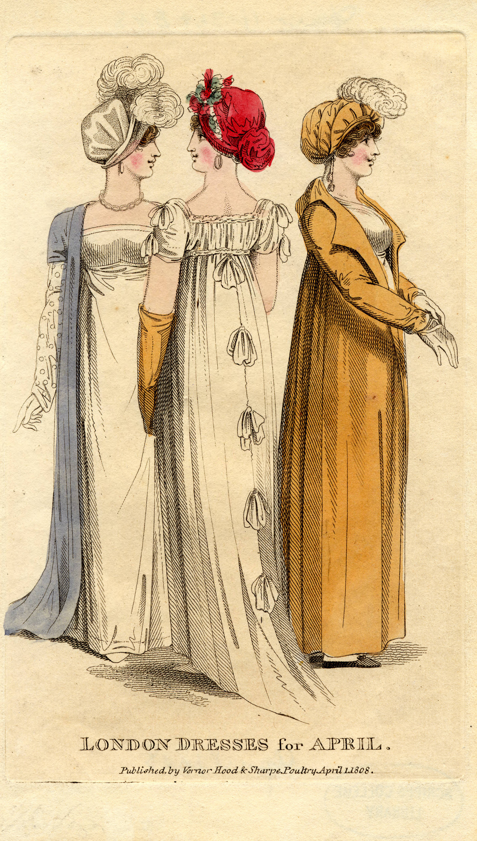  Figure 1: 1808, Vernor Hood & Sharpe Poultry, “London Dresses for April.” | 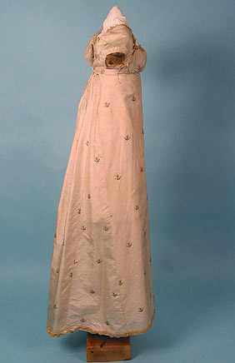  Figure 2: c. 1810 Whitaker Auctions
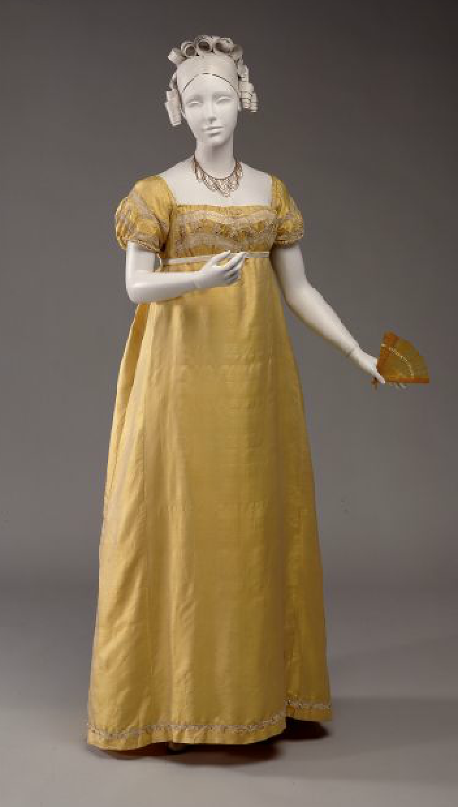  Figure 3: c. 1813, McCord Museum Accession Number M982.20.1 | 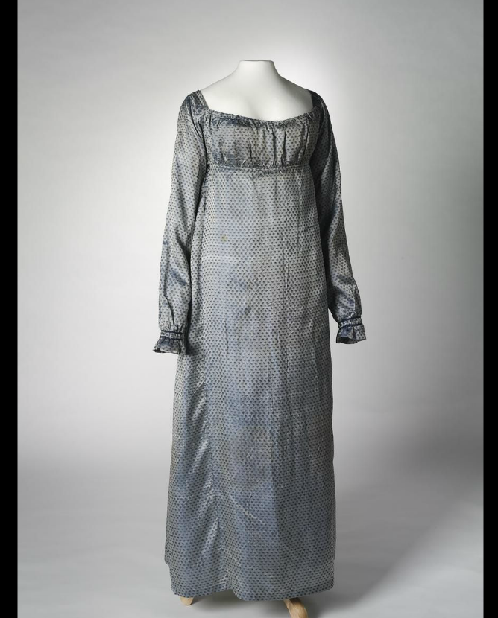  Figure 4: c. 1813 National Museum of Australia, Accession Number 2005.005.0141

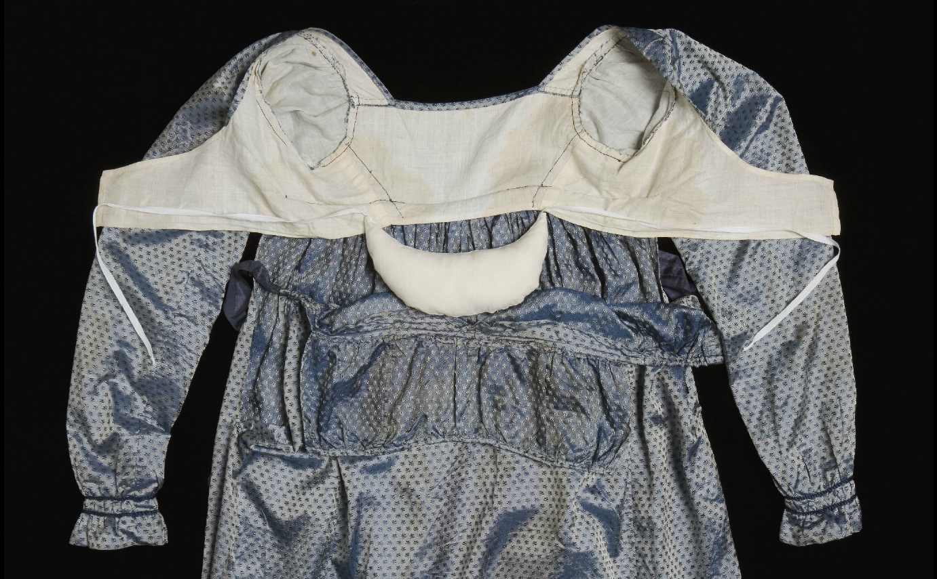

Figure 5: c. 1813 National Museum of Australia, Accession Number 2005.005.0141
This image shows many of the construction elements common in gowns of this time period. The straight back seams and dropped shoulder seams make the common ‘diamond back’ shape, although this back piece is a bit broader than many. The front skirt panel is wider than the bib itself. The crossover bodice lining ties just under the bust, and the small pad at the back makes the skirt stand out a bit from the waistline. Note also how the sleeves are flat-lined first, then set into the bodice (i.e the sleeve lining is not sewn to the bodice lining first).

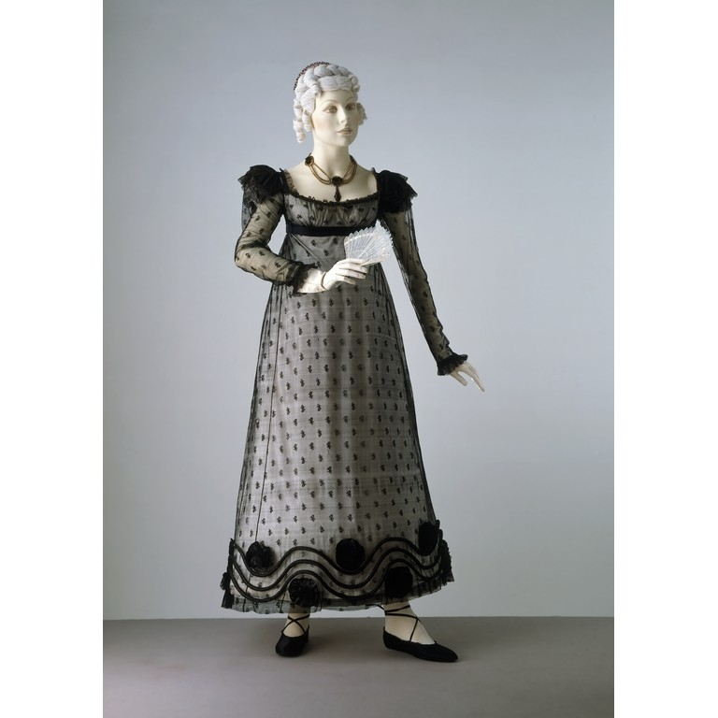 | Figure 6: 1818, Victoria and Albert Museum, Accession Number T.175-1922  This silk net gown shows the very high bust of the late 18-teens as well as a slight a-line cut of the front skirt panel.

