It's All in the Details: Making an Early 19th Century Gown
By Hope Greenberg

Preface
In 1775, the year of Jane Austen’s birth, women wore gowns with a fitted bodice, the waist at or below the natural waistline, and full skirts over a visible, often ornate, petticoat. Gowns were made in a variety of heavy silks, cotton or wool. By the time Austen had reached her late teens the ornate gowns were being replaced by simple, lightweight, often sheer cotton or silk gowns that reflected the ideals of classicism.
Though the high-waisted gown remained in fashion for almost forty years, there were still many changes during that time. When comparing a gown from 1795 with one from 1820 it is easy to see the differences. More difficult to pinpoint are the details in cut, construction, decoration, or emphasis that characterized each step in that evolution.
By focusing on the details we can see both the evolution of fashion for this period and how best to re-create it. What is the cut of the bodice, the sleeve length, or the height of the bustline? How full is the skirt, how is it cut, and where is that fullness concentrated? What colors are used? What type of fabric? Is there trim? If so, how much, what kind, and where is it placed? Based on the shape of the gown, what can we tell about the foundation garments worn under it? Looking at the women as portrayed in fashion plates how can we determine ideals of beauty? Paying attention to all these details will help you create a gown that is historically informed as well as beautiful.
But remember: fashion is flexible. Styles evolve and are adopted at a different pace depending on the wearer's age, location, and economic or social status, including her access to skilled dressmakers. When attempting to recreate a gown of this period we must rely on the examples we have. Paintings, fashion magazine images and articles, or even extant garments, provide only a small percentage of the garments that existed at the time. We cannot determine exactly how every gown was constructed but we can determine, based on the evidence we have, what were the likely designs and methods.
How, then, can we recreate a gown of a specific period and place? This guide provides images and details to consider when recreating an early 19th century gown. The emphasis is on English fashion but includes some clothing from France and the United States. The examples provide a general guide, not an exact historic timeline. The guide is primarily focused on the clothing of women of means who would have had the resources, and the social need, to stay fashionable. The examples reflect that woman’s need to include in her wardrobe a variety of gowns for different occasions: morning at home, morning visits, walking or promenade gowns, carriage gowns, evening gowns such as dinner, opera, or ball gowns, which, after all, must be designed for dancing.
enjoy…questions…etc.
Hope

1795 | 1800-1805 | 1810s | 1819
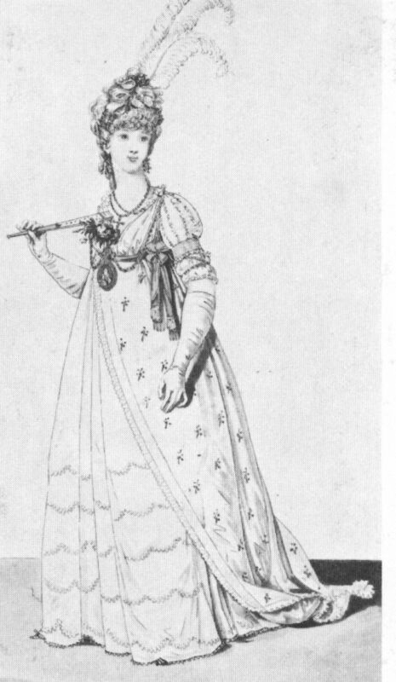 | 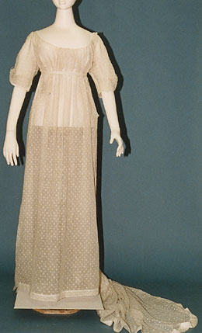 | 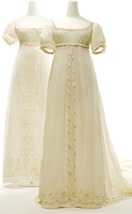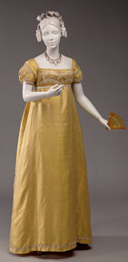 | 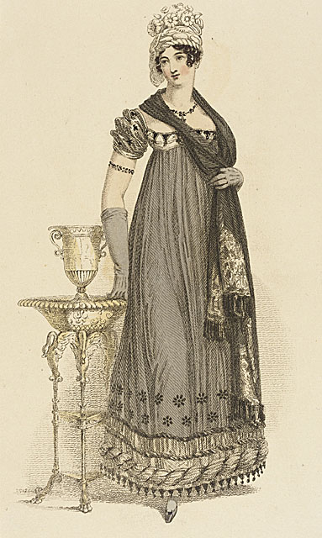
Light fabric, full, high-waisted skirt usually cut as one with the bodice, elbow length sleeves (full length for day wear), rounded bosom filled in with a large handkerchief. | Diaphanous muslins, white on white embroidery. Think Greek or Roman draperies. Gathered bodice, still cut as one with gown. Moderately high bustline, short or elbow length sleeves, train. Some overtunics. | Neckline broadens, often square, puff sleeves, bodice sometimes gathered, sometimes trimmed, bustline even higher, strong vertical embroidery on front center skirt. Silks and more color. | Late teens: bodice at it's smallest and highest. Sleeves and bodice highly decorated. Skirt cut wider, stiffened and trimmed to make it stand out. By 1820 waist drops as skirts widen.

General Silhouettes

Though all the gowns pictured here have a high waistline there are some noticeable differences in the overall look. Gowns of the mid-1790s, as portrayed in such publications as [Heideloff] show voluminous skirts, often in multiple layers, with a continuation of the elbow-length sleeve, a length that had been the norm for most of the 18th century. The neckline is often round and filled in, as it had been in earlier gowns, with a large handkerchief. Hair was generally full, curled, and powdered. A 1795 tax on hairpowder in England helped contribute to its decline as a mark of fashion.

