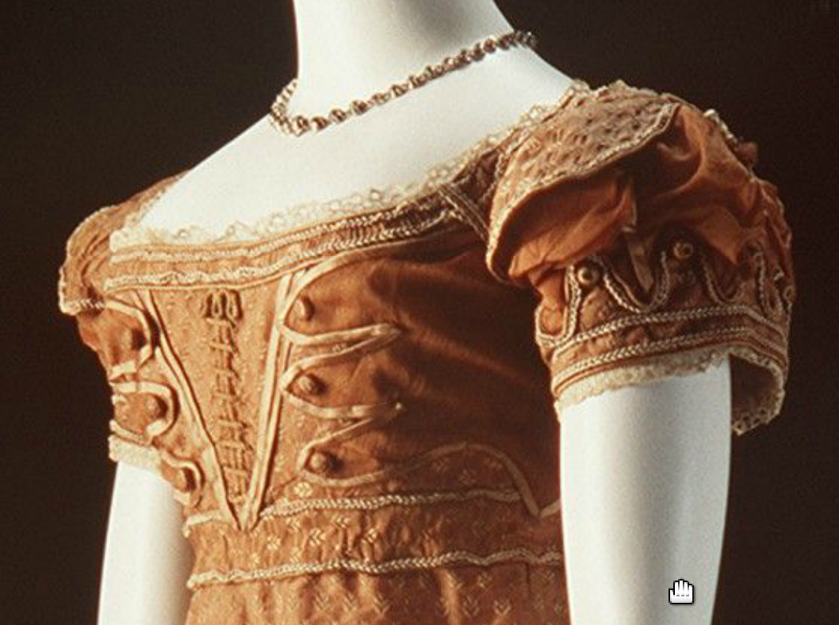
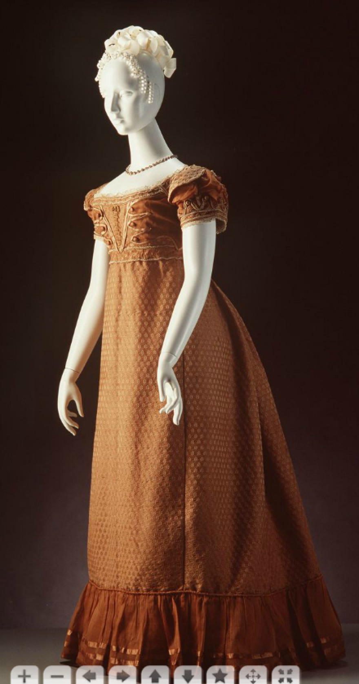

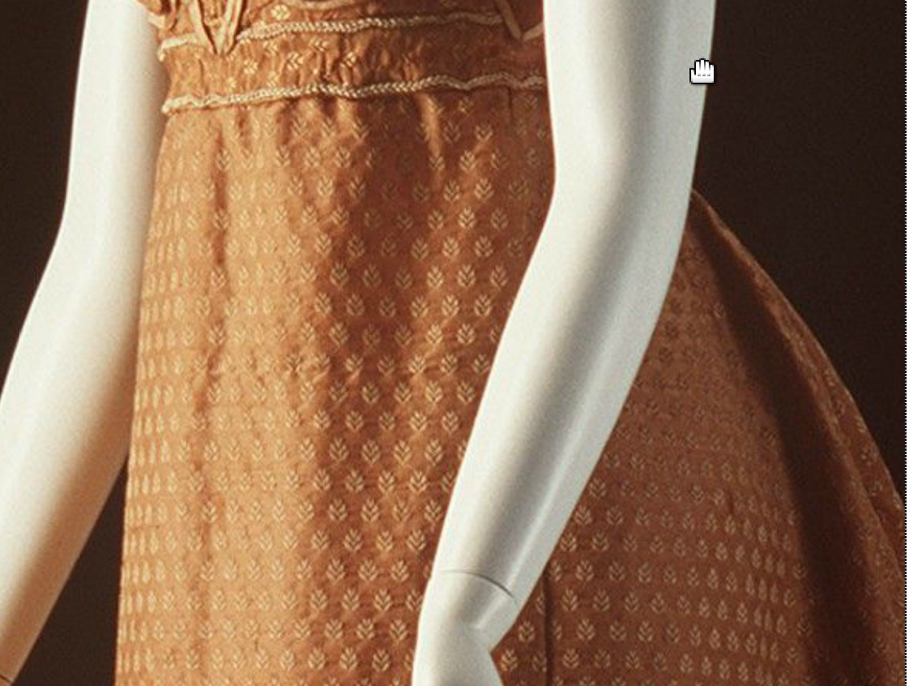

Powerhouse Museum, Sydney, Australia
A8217 Evening dress, womens, figured silk / muslin / silk passementerie (trim), maker unknown, England, c. 1820

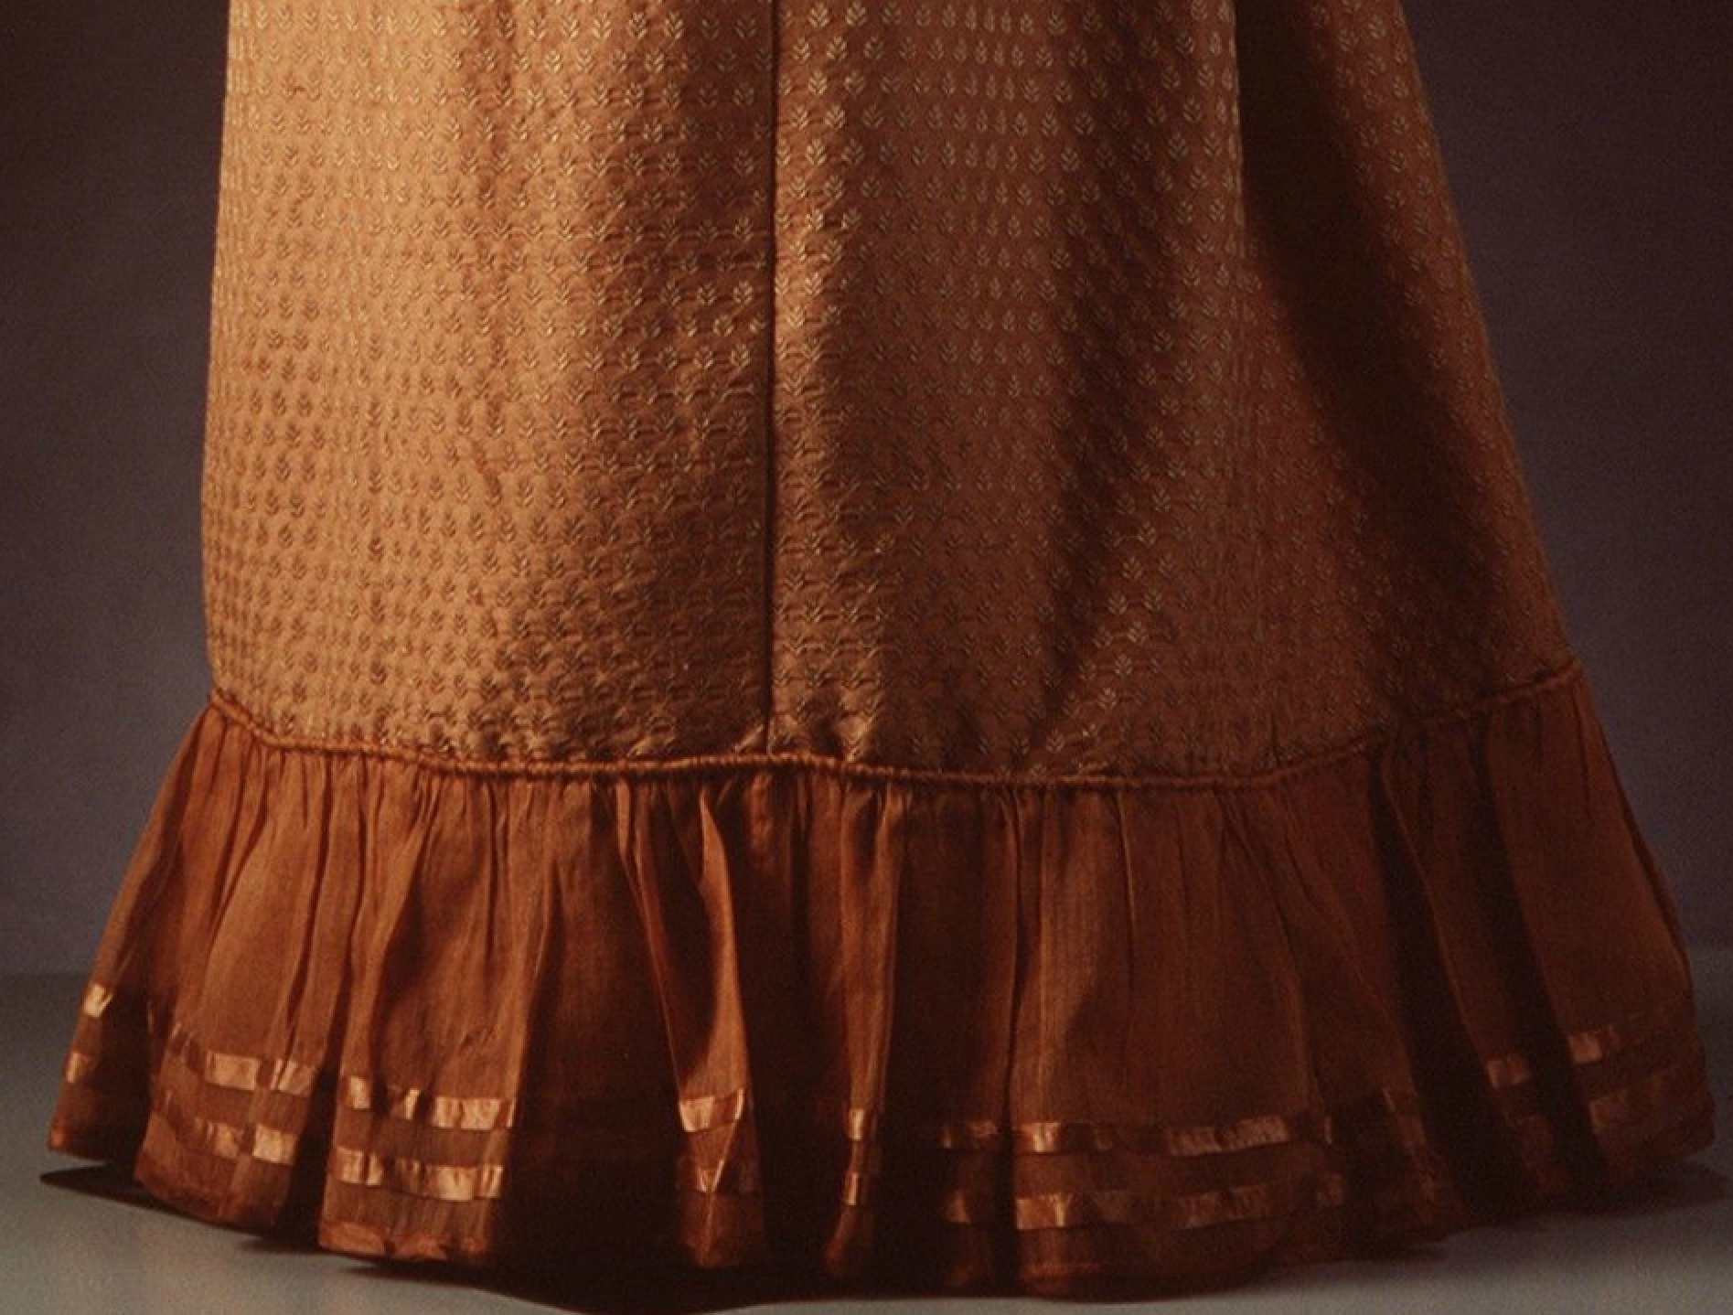

Description
Evening dress, womens, figured silk / muslin / silk passementerie (trim), maker unknown, England, c. 1820
Evening dress, womens, tobacco coloured figured silk muslin - warp float, small sprig repeat design. Dress has shallow, round neckline and short puffed sleeves above high, empire-style waistine and long tubular skirt. Bodice has narrow cream lace trim around neckline above 2cm wide band of self fabric edged with cream silk braid and brown silk taffeta piping. Front of bodice has overlay of brown silk gauze joined on at side seams and cut into 3 van dyke points down either side of centre front panel. Edges of points are bound with same silk taffeta and trimmed with ball buttons covered in brown silk floss. Centre front panel is composed of a brown silk cord lacing through 17 handworked eyelets bordered by 2 v-shaped strips of same silk taffeta rouleaus. Self fabric waistband is trimmed with cream braid and piping and ends in two van dyke points either side of centre back. Bodice is laced from neck to waistband at centre back above 20cm opening in skirt. Gauze overlay from front forms horizontally tucked band, over waistband at back, which extends over skirt to form a narrow peplym, also van dyke pointed and bound with taffeta.
Two semi-circular, self fabric epaulettes are attached at sleeve seam on each side and are trimmed with a brown silk passmenterie tassel, at shoulder and with same braid and piping. Epaulettes extend out over short sleeves which are overlaid with same brown silk gauze which is ruched between rouleaux bands stitched to sleeve lining. Cuff bands are of self fabric piped and braided and cut into 8 van dyke points above overlay. Points are trimmed with braid, piping and silk covered ball buttons.
Skirt of dress falls to the ground, slightly trained at back and trimmed with 19cm flounce of satin striped silk gauze falling from corded seam.
Bodice lined with cream cotton with silk linings at edges. handsewn throughout.
Made: England; 1815 - 1825
Read more: http://www.powerhousemuseum.com/collection/database/?irn=196541#ixzz35TLbWulh
Under Creative Commons License: Attribution Non-Commercial

