Turbans and Head Wear in Jane Austen’s World
Hope Greenberg

We typically describe the gowns worn during Jane Austen’s lifetime as high-waisted, made of light materials, and less formal than gowns of earlier or later years. While this is true, the styles of the gowns she wore and talked about in her letters were not static. Indeed, they show a decided evolutionary change. This was true of head wear as well.

First, we must not forget that fashion is regional, varied, and personal. Despite the fact that we have greater access now than ever before to a large number of extant garments and fashion prints, we should “never say always” and assume that we know exactly what was worn at any given time. Be that as it may, we can paint some broad strokes and talk about what was likely or not likely to be worn.

Generally speaking then, women in western Europe and eastern North America during the Federal/Empire/Regency period wore headwear that can be loosely grouped into several categories: 1) caps, usually of white linen or muslin, often highly ornamented with lace or embroidery, worn alone indoors or under bonnets outdoors; 2) bonnets, of straw, velvet, silk or other fabric, usually stiffened in some way; 3) turbans, of silk or cotton, and ranging from wrapped cloth to more structured forms; 4) bandeau, a more simple, smaller form of turban, i.e. wrapping around the head but not necessarily covering it; and 5) hair ornaments (ribbons, flowers, combs, etc.) meant to decorate, not cover, the head.

These types of headwear followed an evolutionary path as well. Though fewer survive than other forms of extant garments, the styles and changes can be seen in the printed fashion plates of the day. The following provides a few examples of turbans and other headwear, and how they changed during this time.

Note: The use of the word dress is somewhat confusing. Garments would be described individually as round gowns, petticoats, pelisses, etc. but labeled in fashion magazines by their function: morning dress, evening dress, full dress, ball dress, promenade dress, etc. In those cases the word “dress” does not refer to the individual garment but to the overall ensemble, what we would today call the “outfit” or “look.”

Late 1790s

Gowns characterized by volume, but lightweight compared to earlier 18th century head clothing. The chemise gown or the round gown were made of light silks and muslins. Gowns were full and high-waisted, with what looks like a gathered waist. However, these gowns were not constructed of a gathered skirt attached to a gathered bodice. Instead, they were usually cut in one piece from shoulder to hem (i.e. no separate bodice) with the neckline and high waist drawn in for fitting. Silk overgowns were also cut from shoulder to hem but in many cases narrow tucking or pleating was used to make the back fitted to the wearer. Necklines were filled in a swath of fabric, and sleeves normally followed the earlier standard of modesty by covering the elbow.

Head wear for this period followed suit: lots of volume, but lightweight fabrics (and feathers—very tall feathers!) This fashion plate from 1795 exemplifies this style. The three women, below, typify turbans of this time. They are large and light, allowing plenty of room for the powdered, curled, “big hair” style. Some are wrapped with an end hanging over the shoulder; some are probably wrapped with additional bandeau stitched on. The look is “Turkish.”

1795, April. Heideloff, “Gallery of Fashion” (Description below)

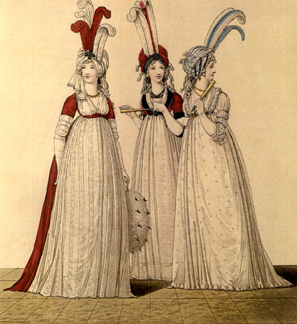

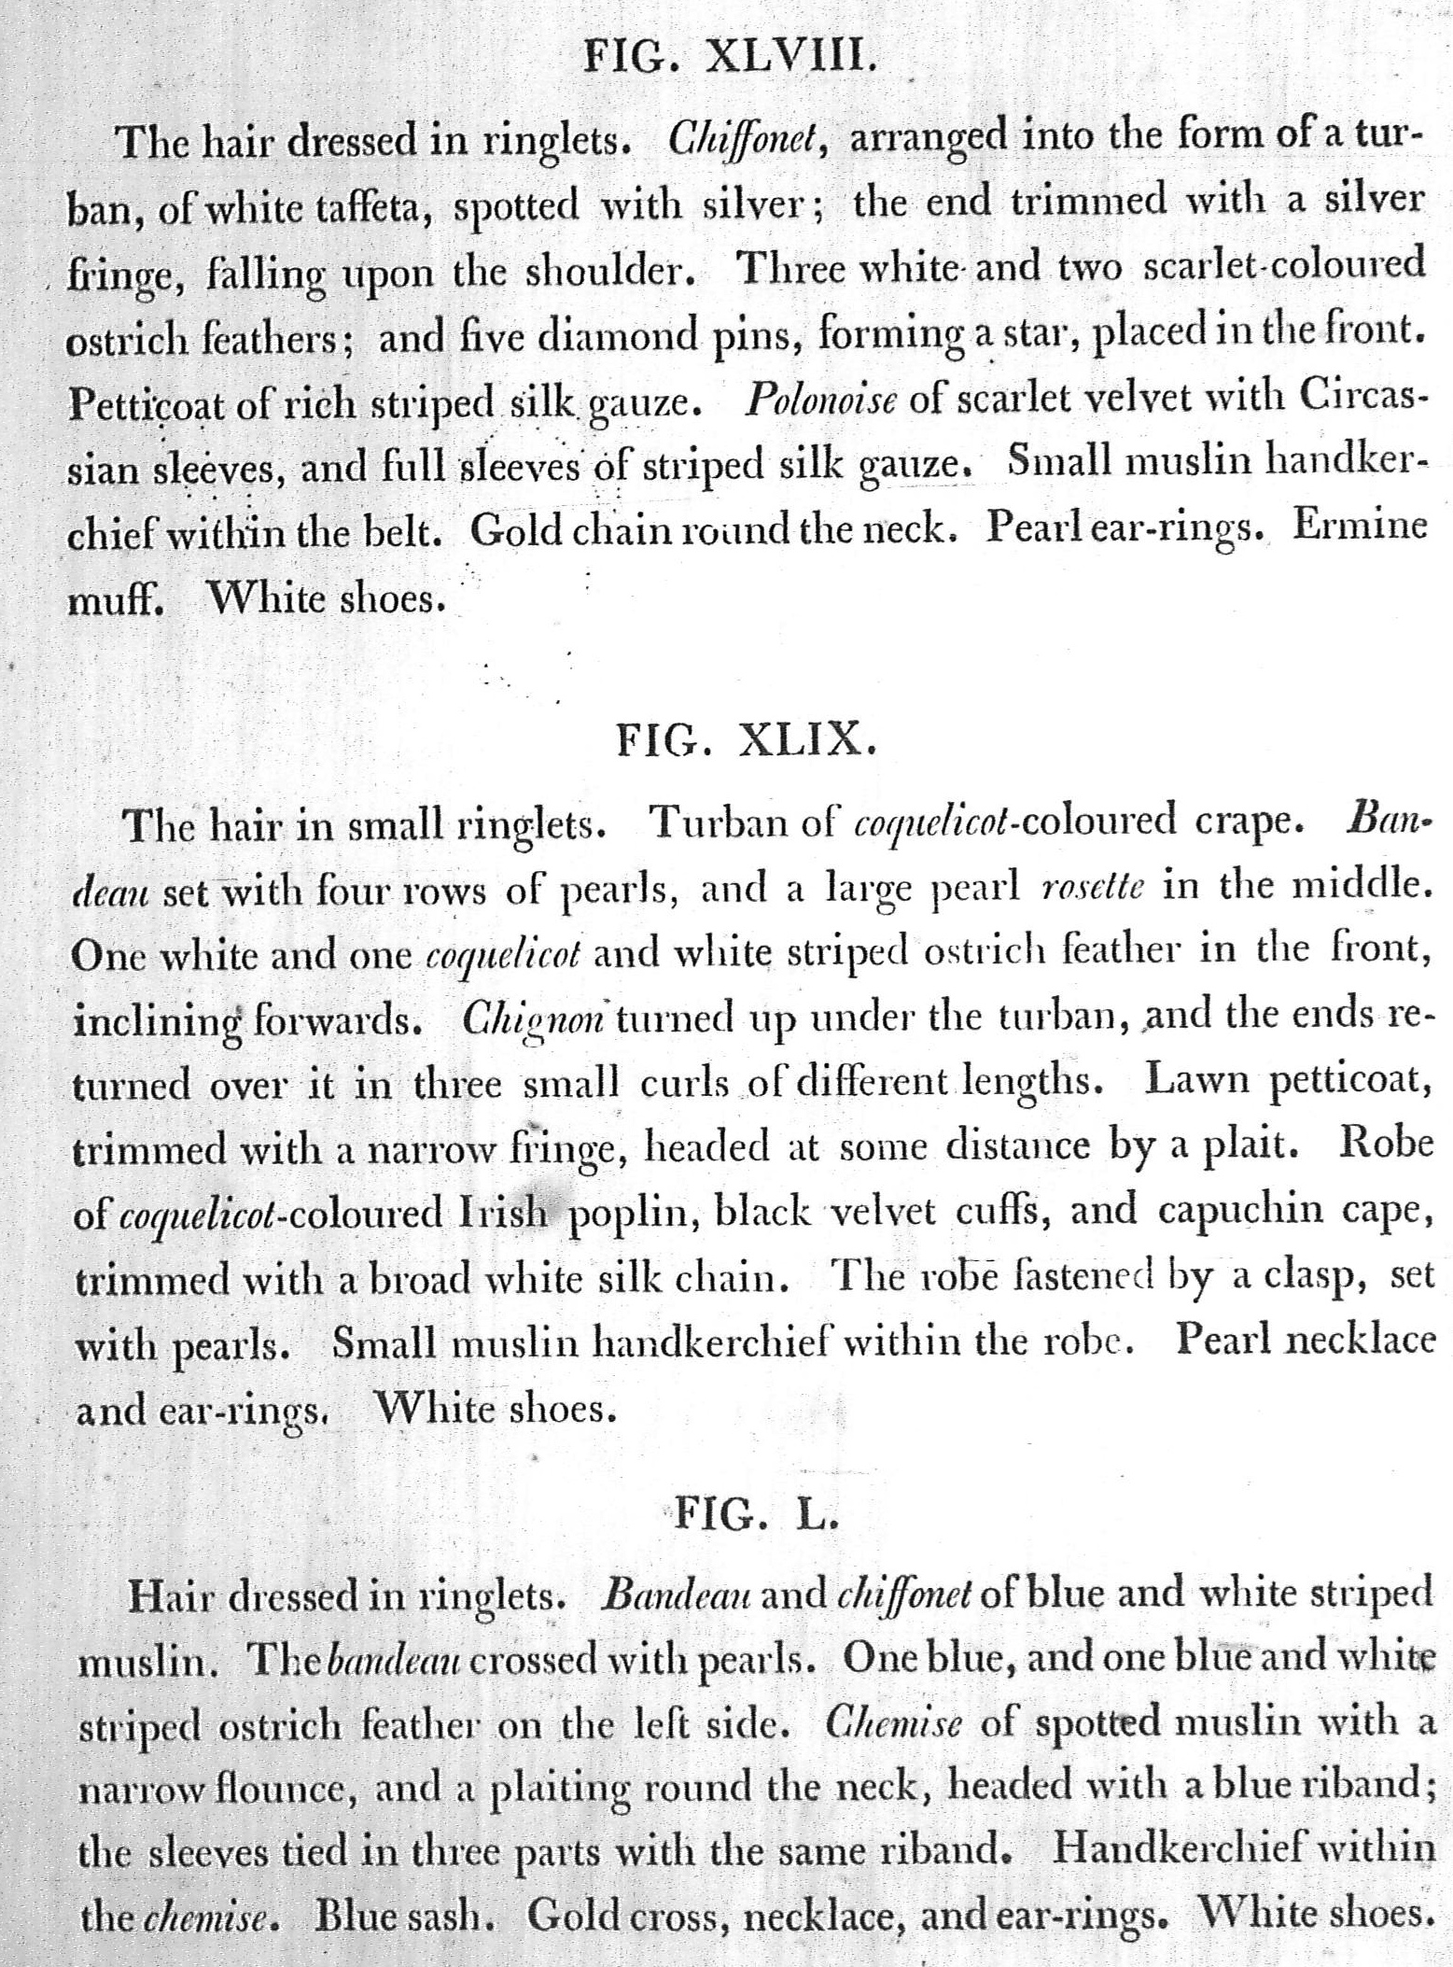

1795, April. Heideloff, “Gallery of Fashion”

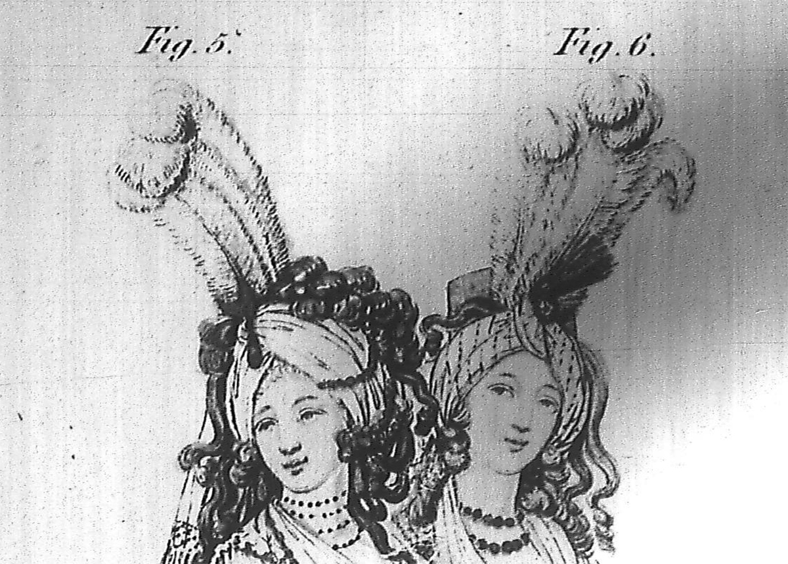

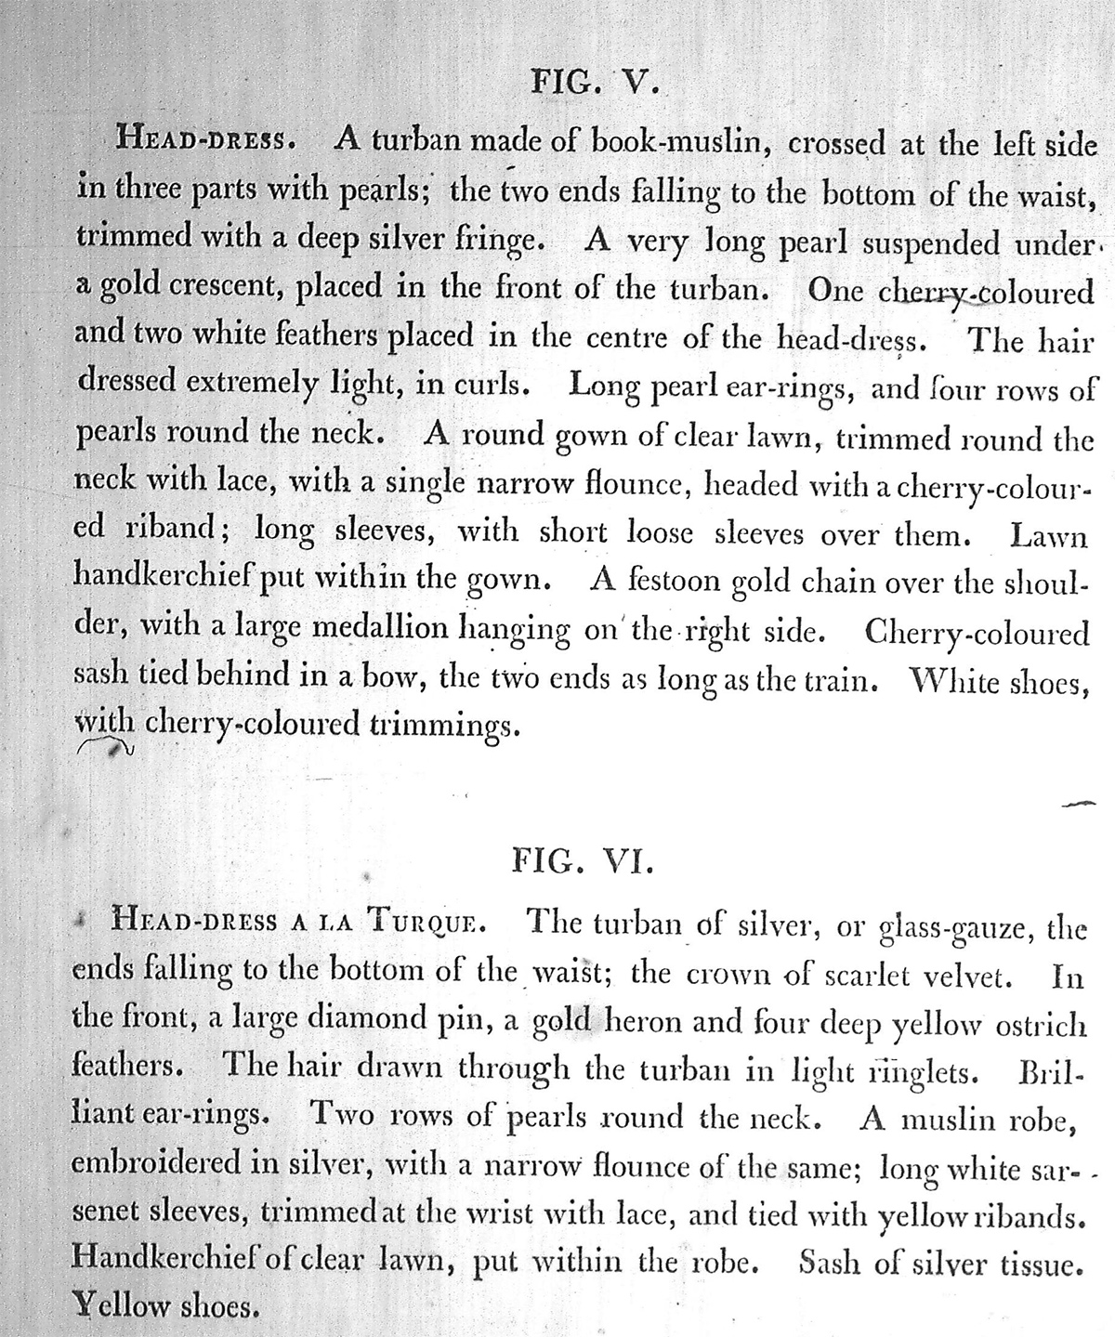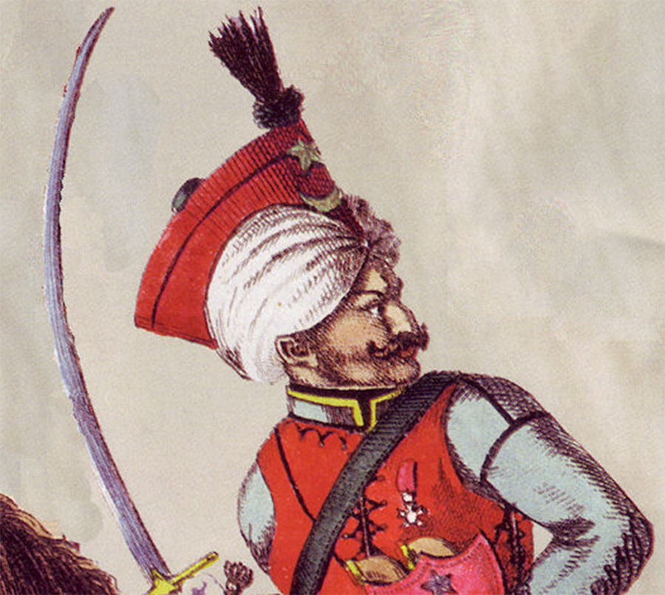

Mameluke
Jane Austen to Cassandra: Tuesday, 8 January 1799: I am not to wear my white satin cap to-night, after all; I am to wear a mamalone [mameluke] cap instead, which Charles Fowle sent to Mary, and which she lends me. It is all the fashion now; worn at the opera, and by Lady Mildmays at Hackwood balls. I hate describing such things, and I dare say you will be able to guess what it is like.

Early 1800s

The first few years of the new century saw a decided shift towards a more columnar silhouette, with narrower gowns and arms bared above the elbow. A 1795 tax on hair powder led to the quick decline of that fashion for both men and women. Hair was dressed more closely to the head. “Greek” hairstyle (hair dressed behind) was all the rage, later followed by “Roman” style with the hair dressed more on top of the head. Both styles used curls framing the face, though the size, number and style of these curls changed. Bonnets were small, round, and often with little or no brim.

1804
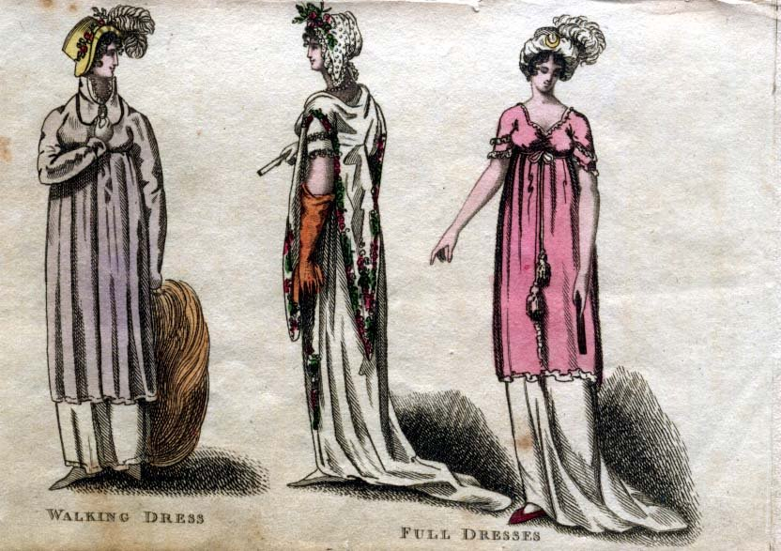

1805, Ladies Magazine, Full Dress (detail)

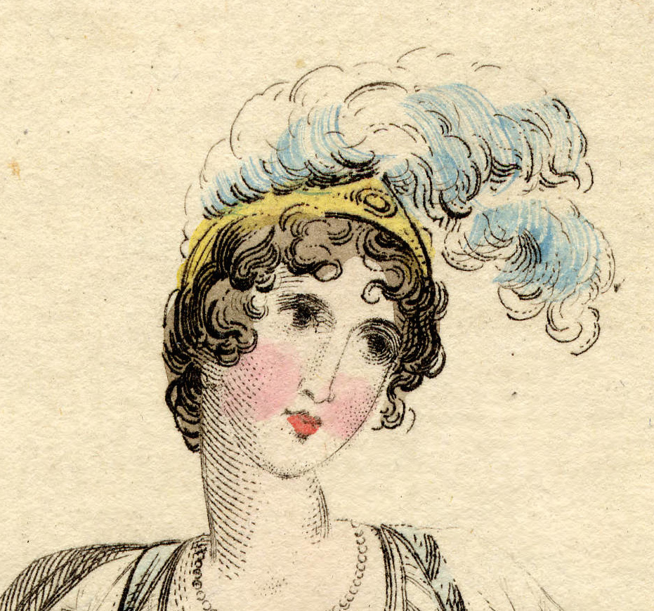

c1805, Bonnet, Metropolitan Museum of Art
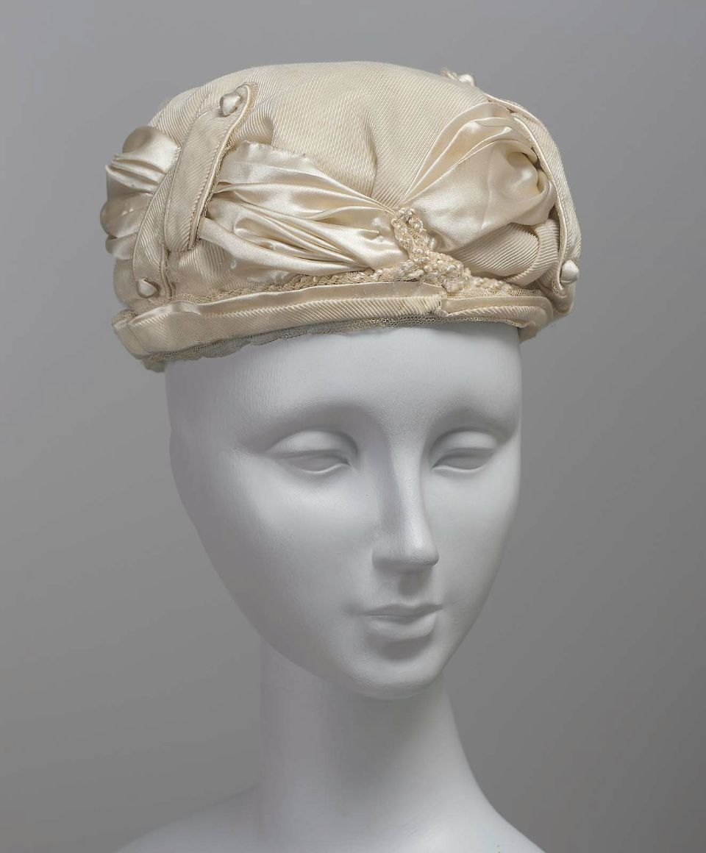
c1805, Bonnet, Museum of Fine Arts
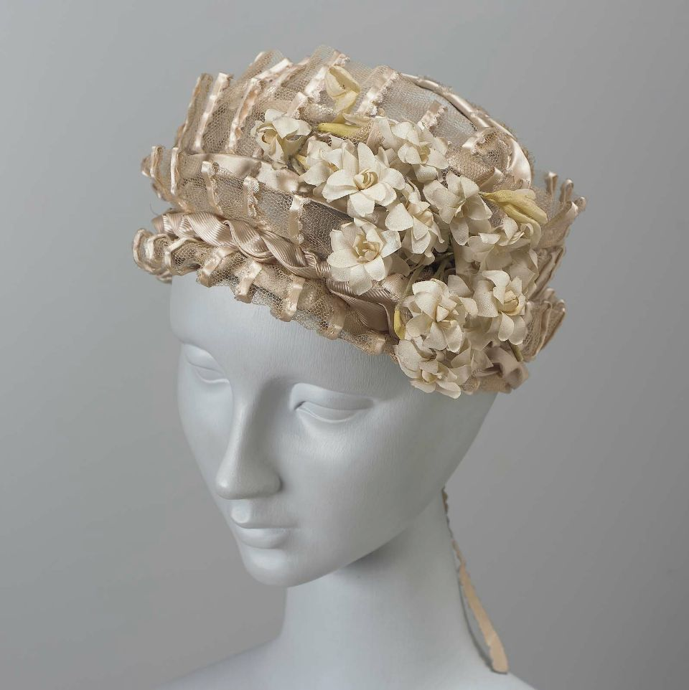

1806, from La Belle Assemblé

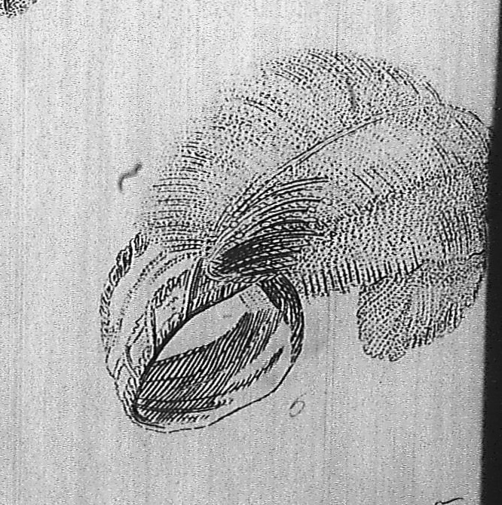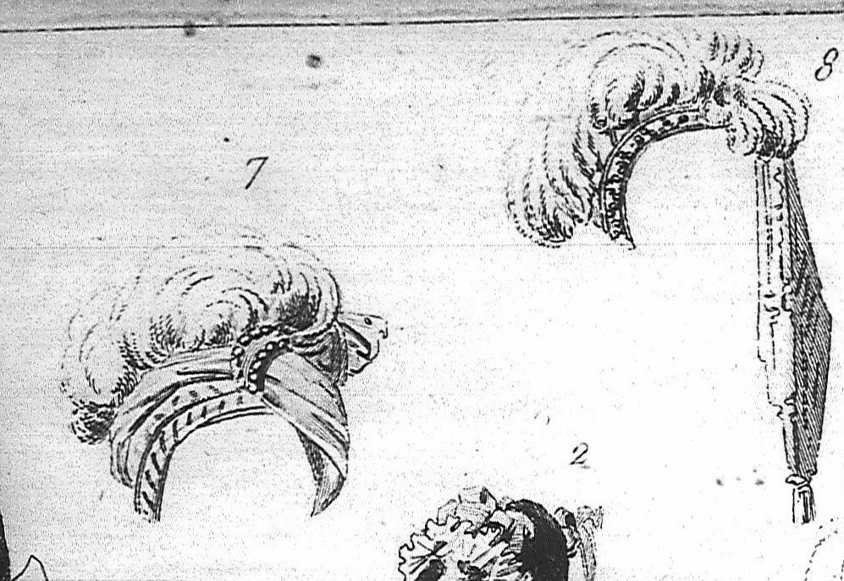

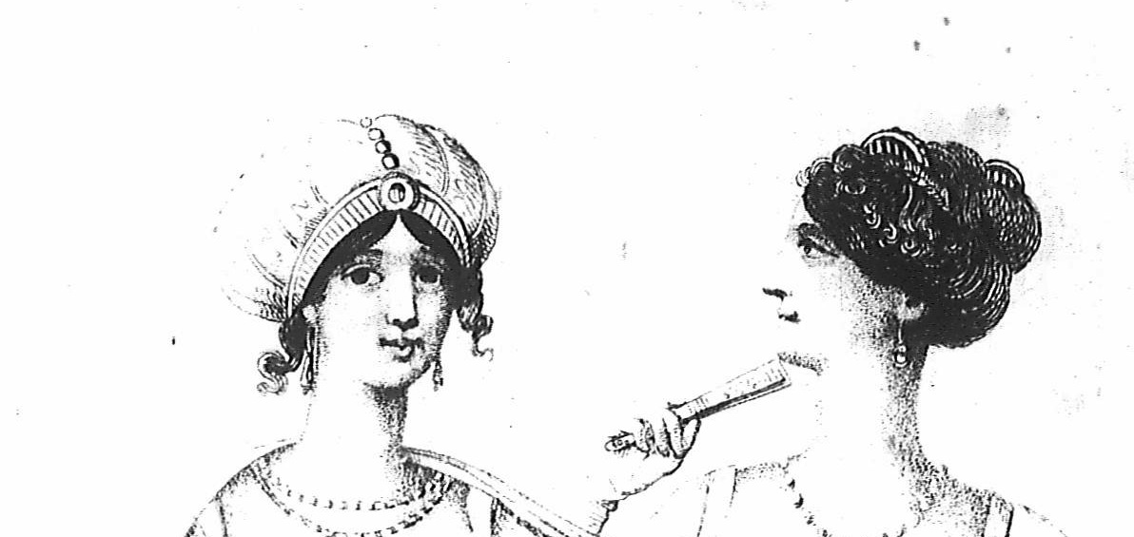

1807, Ladies Magazine, Full Dress (detail)

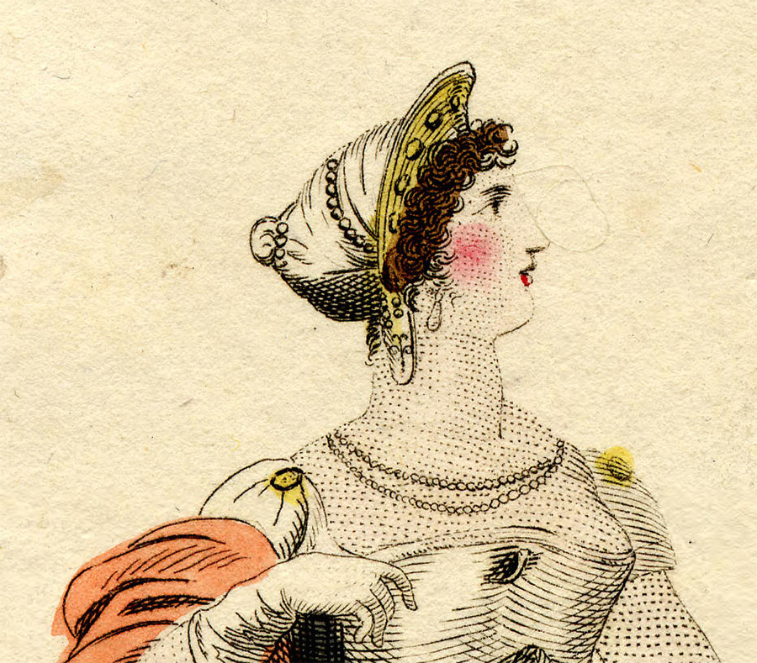

1811, source unknown, Ball (detail)

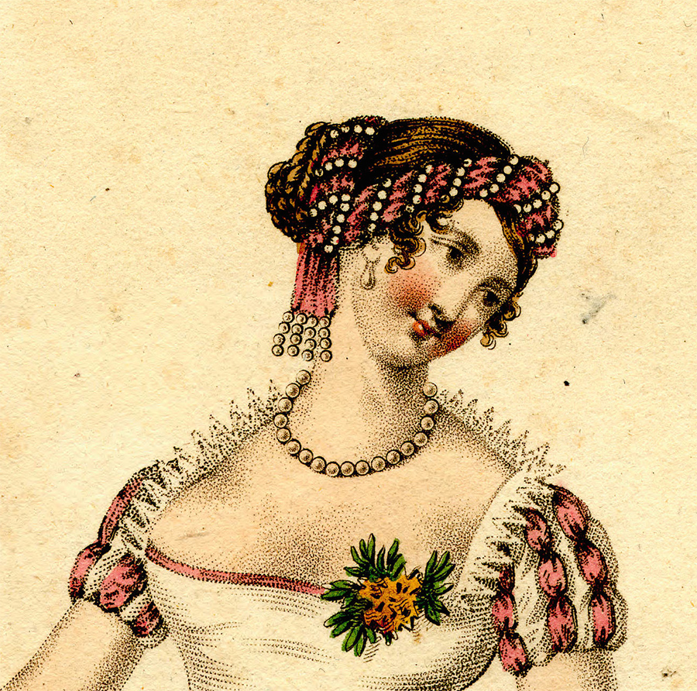

1812, Ackermann’s Repository, Ball (detail)

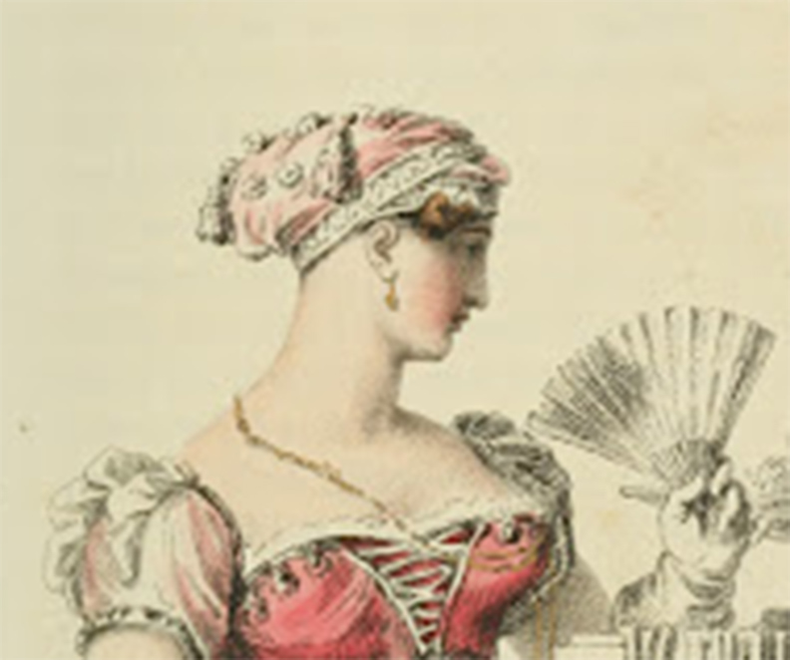
1812, Ackermann’s Repository, Evening
(detail)

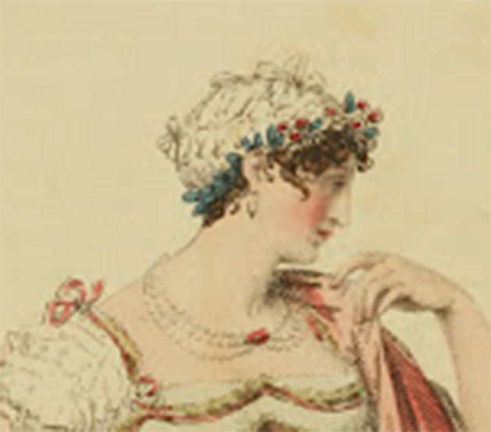
1812, Ackermann’s Repository, Evening (detail)

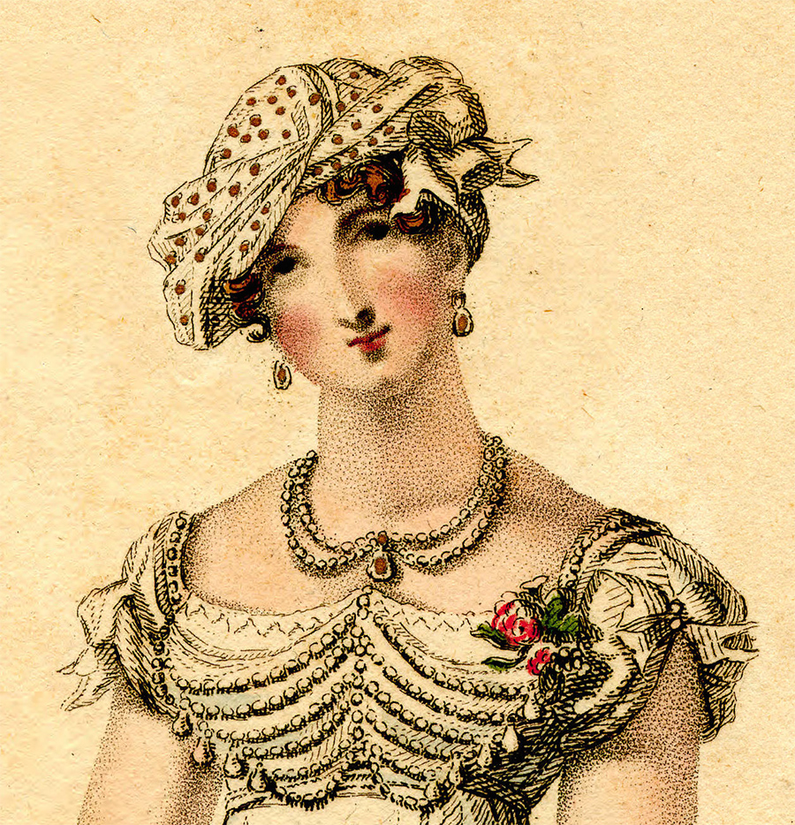

c1811, Greenwood, Portrait of Mrs. William (Sturbridge Village)

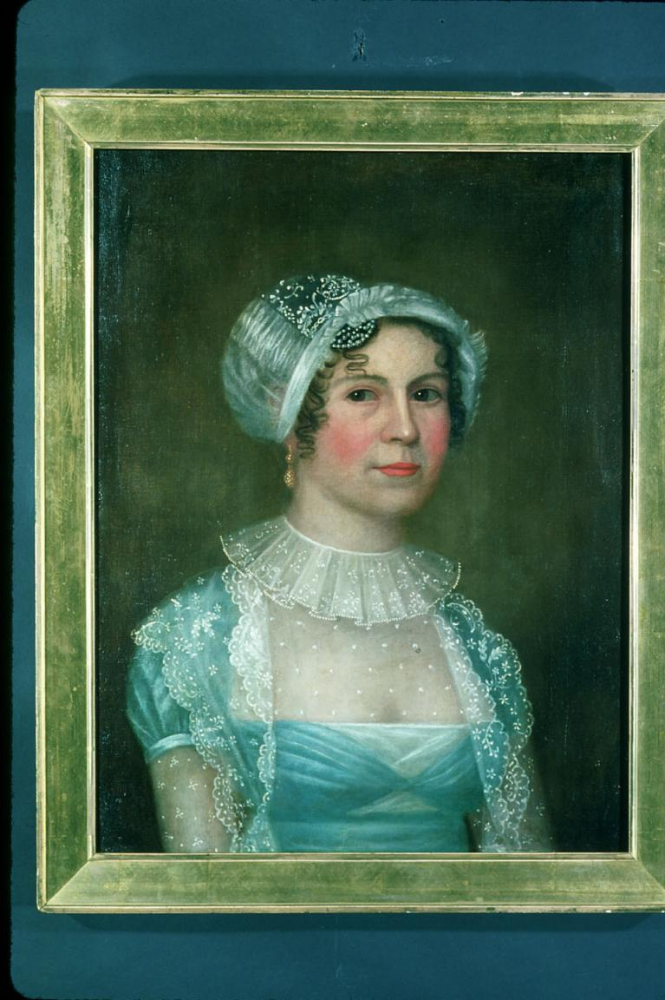

1813, Ackermann’s Repository: Ball Dress

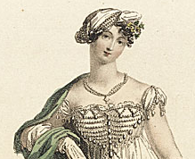

1814, December, Ackermann’s Repository, Head Dresses (detail)

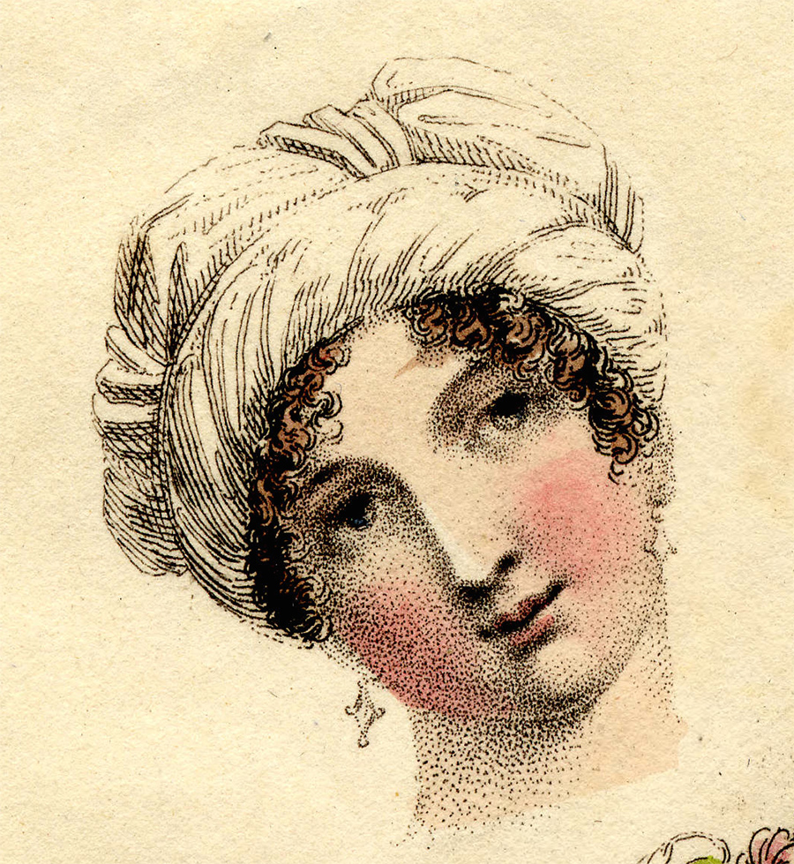
1815, February, Ackermann’s Repository, Dinner Dress

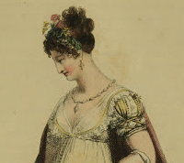

1816, April, La Belle Assemblé, Saxe Cobourg Robe (detail)

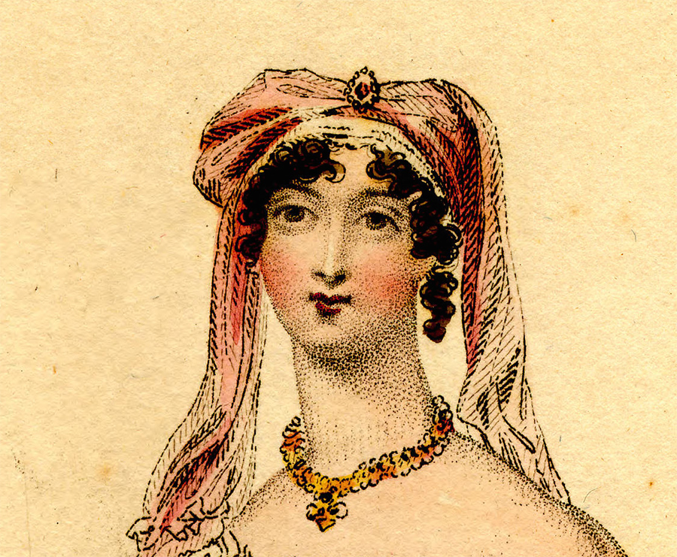
1816, Ackermann’s Repository, Ball Gown (detail)

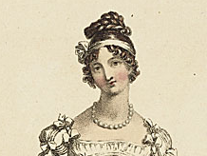

1816, Ackermann’s Repository, Evening Dress (detail)

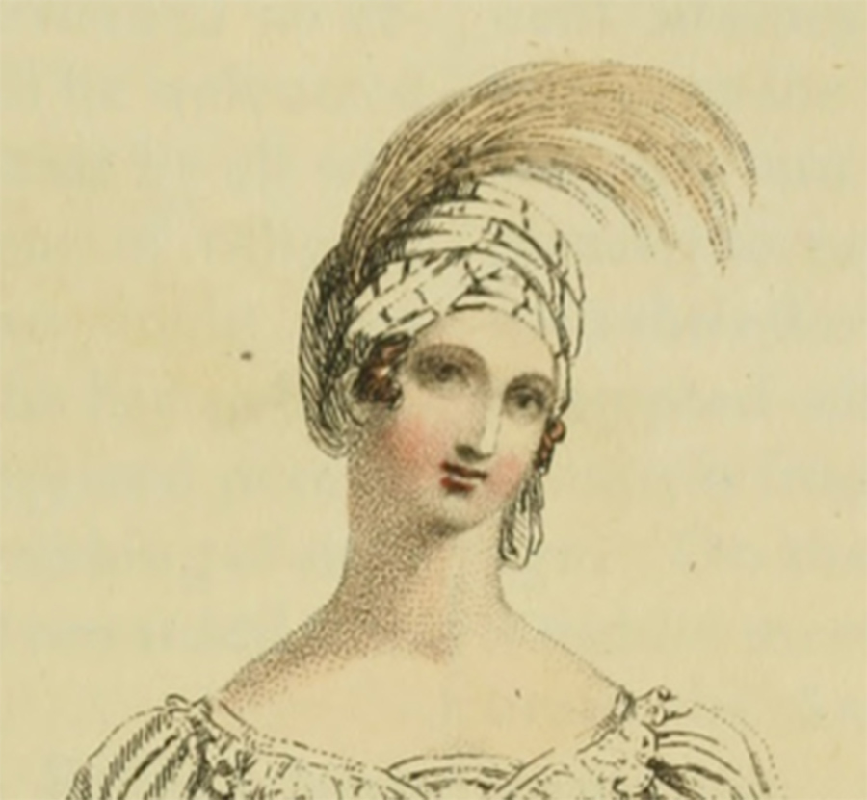
1816, Ackermman’s Repository, Ball Dress (detail)

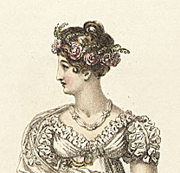

1816, Ladies Monthly Museum, Evening (detail)

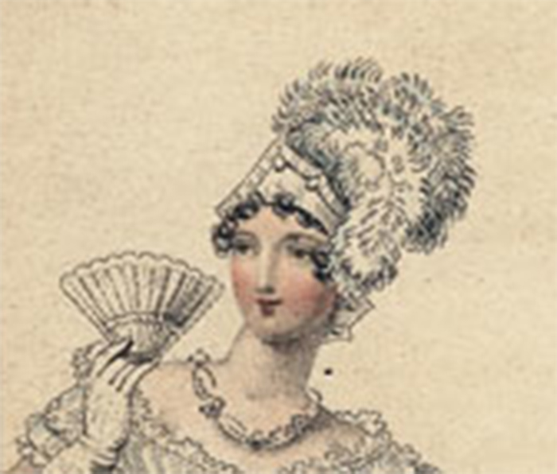
1816, Costume Parisiens, Cashmere Shawl Gown (detail)
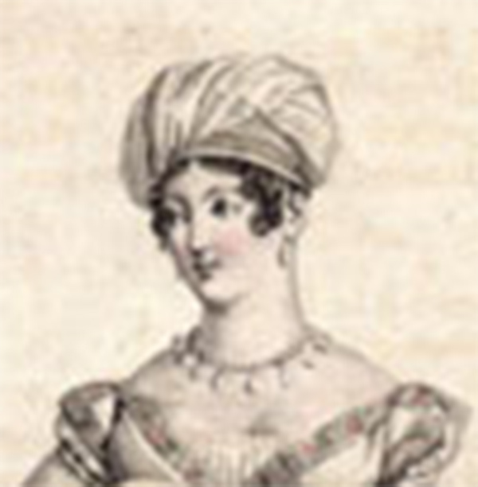
1817, Costume Parisiens, Satin Toques (details)

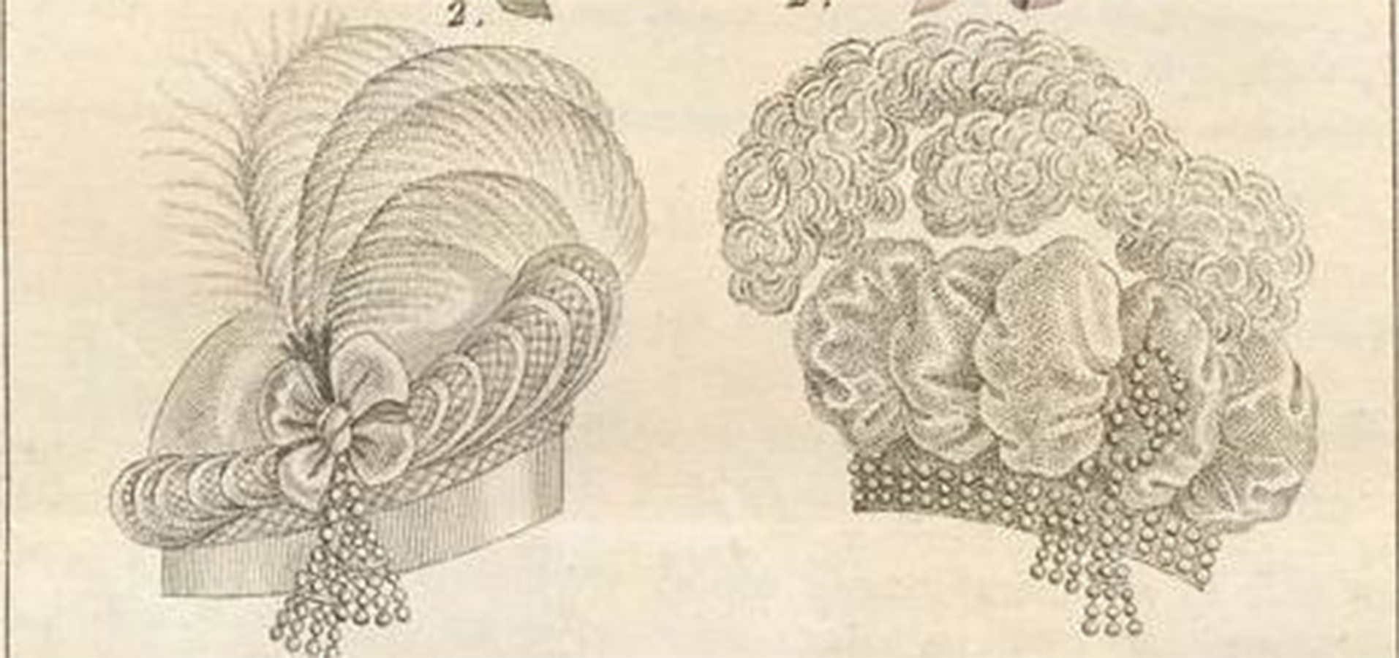

1817, Costume Parisiens, Satin Toque (detail)

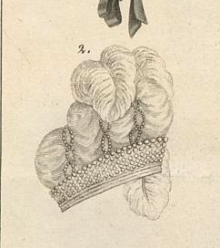

1817, Rolinda Sharples, Cloak-Room at the Clifton Assembly Rooms (details)

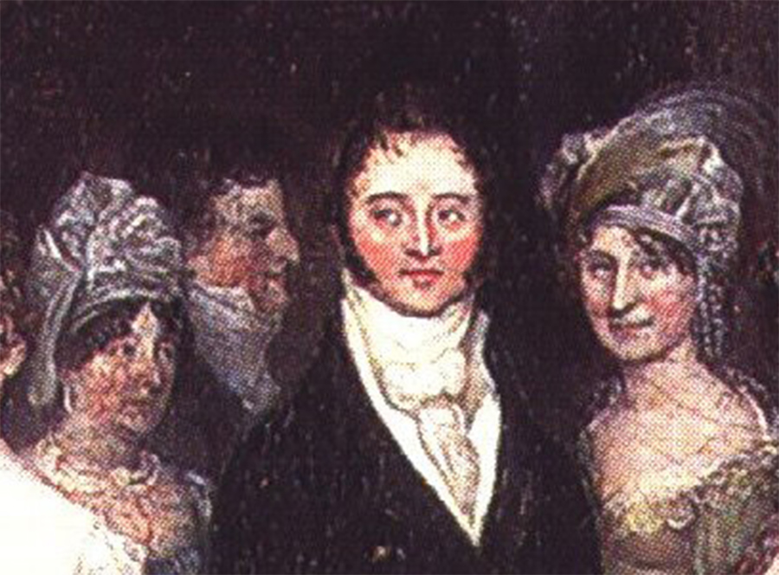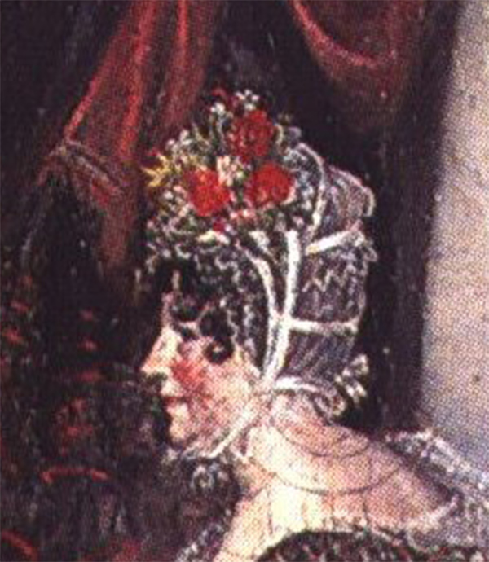

1818, Sept. Ackermann’s Repository, Dinner
(detail)

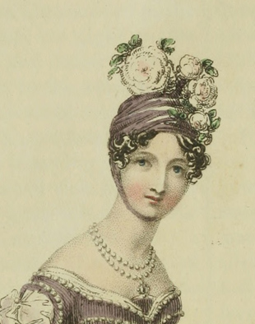
1818, Nov. Ackermann’s Repository, Evening
(detail)

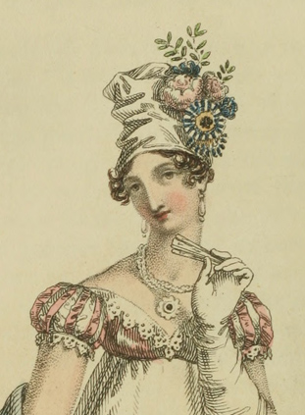

1818, Ackermann’s Repository, Evening
(detail)

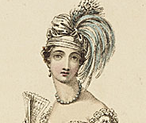
1818 Ackermann’s Repository, Evening
(detail)

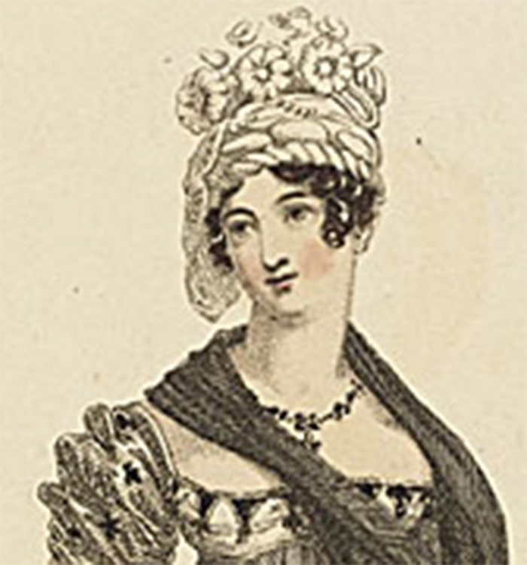

1818 Costume Parisiens, Turban de Crepe
(detail)
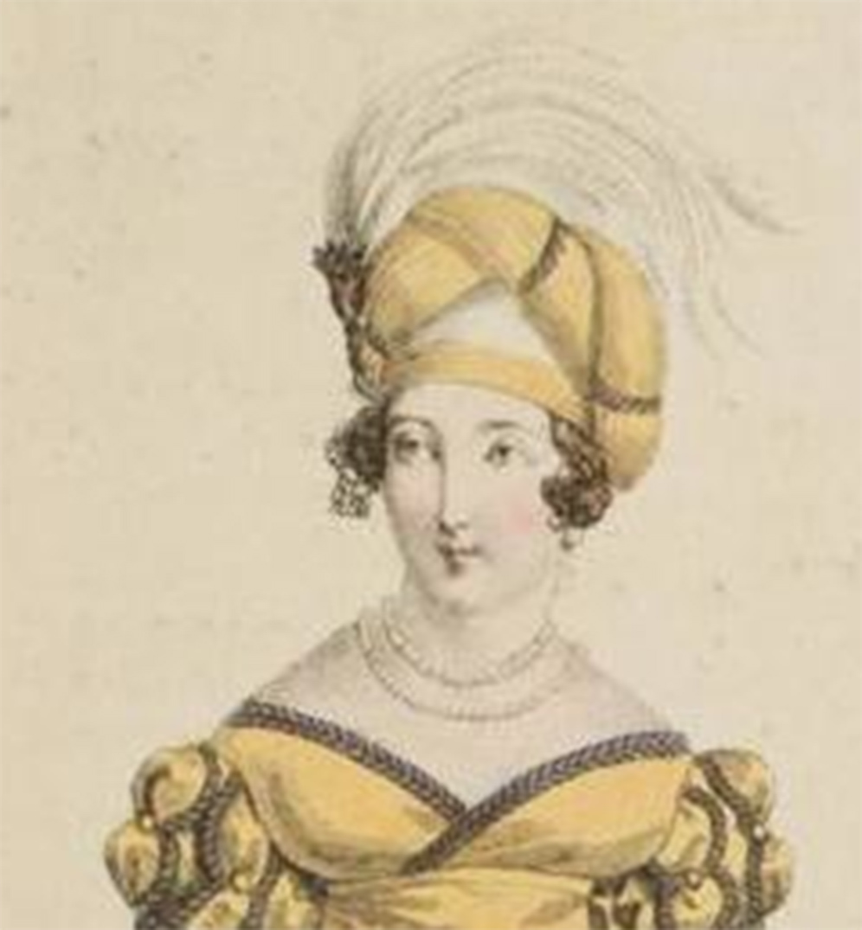

1818, Costume Parisiens, Evening (detail)

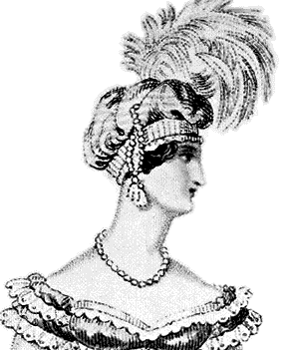
1818, La Belle Assemblé, Evening (detail)

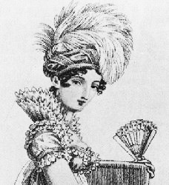

1822, source unknown, Ball (detail)

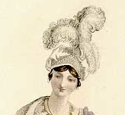

…and just for fun, here’s what
happens later in the 1820s:

