DRAFT4-2-04

The Triumph of Pareto:
How Dominant Economics Distorts Reality and Perpetrates Hidden Values

By Gary Flomenhoft

One of the goals of ecological economics is to make a transition to an economy based on qualitative development instead of quantitative growth. In order to achieve this it is important to understand current factors driving the economy to growth. These factors include the theological belief in growth, biotic potential, fixation on gdp, interest charged on money creation, bank interest, discounting, to provide jobs for labor displaced by productivity improvements, welfare economics defined by consumption, profit motive, materialism, Pareto optimality, and others. All of these factors, their origin, values behind them, and their current usage should be explored in order to devise alternatives to the growth economy. In this article I will explore Pareto optimality, the philosophies of Vilfredo Pareto, their relationship to current economic conditions, and propose some solutions.

Pillars of Neo-classical welfare economics

The three pillars of neo-classical welfare economics are Homo-economicus; utility maximizing, rational economic man, Perfect competition; independent actions of firms, no market power, constant returns to scale, perfect information, no uncertainty, and Pareto Optimality or Potential-Pareto Optimality (Kaldor-Hicks criteria). Behavioral science has pretty well undermined the premise of economic man, while the recent Nobel prize to Stiglitz for asymmetrical information demonstrated the obsolescence of perfect competition. “In empirical research neoclassical economists have by and large abandoned economic man and perfect competition but the profession is just beginning to come to grips with the policy implications of abandoning Pareto optimality.”(Gowdy and Erickson, page 1)

Pareto Optimality
Pareto Optimality is still a widely quoted and used principle of neo-classical economics. It states that any policy alternative which makes anyone worse off in their own estimation, while making other people better off in their own estimation, is not “Pareto efficient.” Economics claims to be a “value-free”, objective science. If this is the case, then widely used principles of economics such as Pareto Optimality should stand up to scrutiny as neutral and value-free principles.

Problems
Ethical
One of the primary implications of “Pareto Optimality” is that it accepts the current distribution of wealth as a given. There is no discrimination between earned or unearned income, or any question about the legitimacy of the source of wealth. Fairness or origin of the current distribution is a problem left to politicians and society. It is not considered a legitimate question for economics. As Steven Hackett points out, “Slavery was widely seen in the North as being unethical from a deontological perspective, but a policy alternative of ending slavery would make slave owners worse off than under the status quo, and thus would have failed the Pareto efficiency criterion.”

No interpersonal utility
Alfredo Pareto is known for several ideas including the 80:20 rule which states that in business 80% of the result can be obtained from 20% of the effort. In 1896-97 Pareto wrote his mathematical “Law of Income Distribution,” which tried to establish a universal formula for the distribution of income in human societies. This work presaged his later sociological writing on the “Theory of the Circulation of the Elites.”

Next Pareto wrote his theory of Optimality which I have already described. During this period Pareto, in conjunction with Edgeworth, described the idea of “indifference curves” where each person measures their own preferences between various goods. This led to the theory of marginal utility, widely used in neo-classical economics. It established the idea of ordinal rather than cardinal welfare, and eliminated comparisons of utility between people. According to Pareto and current neo-classical orthodoxy, each person can only decide how well off they are “in their own estimation.” This avoids any consideration of justice in the current social conditions. “A pinprick to Smith could be as painful as an amputation to Jones,” as Herman Daly quips.

Economics was originally based on utilitarianism, which followed the philosophy of “the greatest good for the greatest number, and thus was very concerned with issues of distribution. Maximizing the total utility of society was the goal. Following Pareto, this was abandoned in favor of ordinal measures of welfare. Interpersonal comparisons of utility are currently considered outside the bounds of neo-classical economics.

The concept of marginal utility leads directly to the idea of diminishing marginal utility: the more of something a person has, the less utility an additional unit provides. By definition, the marginal utility of money to a rich person is lower than to a poor person. Drawn below in figure 2 are indifference curves for two people, defining their choice between love and money. In this case we show that the rich person gets more utility from money and from love at every point on the curve. Despite this, the graph shows that X dollars is worth much more as measured in love to the poor person than to the rich person. A rough measurement shows it is in fact worth about 8 times as much to the poor person as to the rich person. This is so obvious as to be considered perhaps simplistic, although denied by current economic thinking. Interpersonal comparisons of utility are quite appropriate and follow directly from marginal utility analysis. The denial of interpersonal comparisons of utility in neo-classical economics based on Pareto are therefore self-contradictory.

Growth bias
By prohibiting any change in distribution which would make one person feel worse off even if 100 other people are better off, this biases the entire system toward growth. If redistribution of the pie is forbidden, the only option left is a bigger pie. Also, since the measure of welfare is entirely subjective, how could you find out who feels better or worse? It’s much safer to assume that a rising tide lifts all boats, and don’t worry about the people with no boats. George W. Bush recently was quoted that we have to, “Grow the pie higher.” It is universally believed that we can grow our way out of poverty. Does the reality support the myth? Prior to 1967 the poverty rate appeared to decline as GDP increased. However, as shown below, since 1968 there is little relationship between long term GDP growth and poverty alleviation as is commonly believed. There has basically been no change in the poverty rate in the last 35 years.
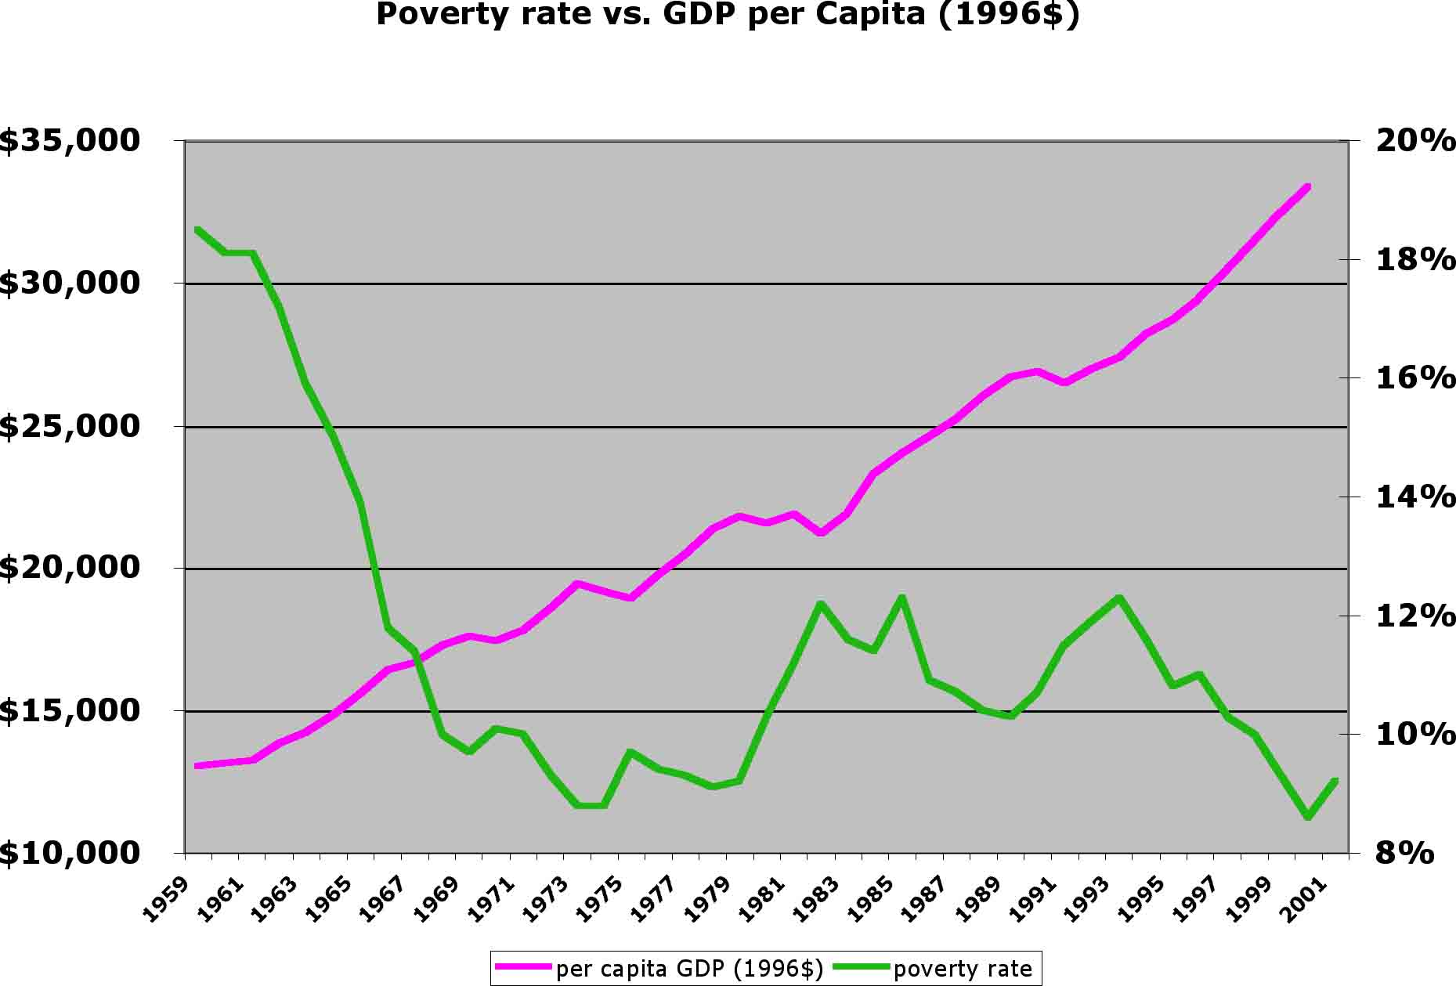
Figure 1 (Source US Census Bureau)

Even if growth did contribute to poverty alleviation it is questionable if it is a viable option any longer due to the limits of planetary growth. At current levels of US consumption of resources and emission of pollutants it is estimated that for all 6.3 billion people on the earth to live at this level of consumption would require 4-13 additional planet earths.

No one can be worse off
One of the primary implications of Pareto Optimality is that no one can supposedly be left worse off. Even this has been abandoned in favor of Potential Pareto Optimality where it is only necessary to consider, but not actually compensate the losers through transfer payments. Again, this is left to society to take care of and is out of the realm of economics. In order to understand recent economic conditions it is useful to evaluate Pareto’s other philosophies, and consider their coincidental or perhaps even surprising correlation with current trends.

Pareto’s Other Principles
In 1916 Pareto wrote what he considered his greatest work, Mind and Society. In this work he elaborated his sociological theory of the “Circulation of the Elites.” Persons of superior ability actively seek to confirm and aggrandize their social position. The best equipped members of the lower classes rise to challenge the position of the upper-class elites. This theory best captures Pareto’s beliefs, and also corresponds with recent economic history.

1980-90s
The period of the 1980’s and 1990’s was one of the longest sustained periods of economic growth in US history. It included a period of neo-liberal supremacy after the demise of the Soviet Union. A huge increase in economic and social inequality also occurred during this time.
A combination of factors led to this result. Because of the demise of the communist system, the promoters of capitalism now had proof that their system was better and celebrated the “End of History.” Free from a countervailing adversary, neo-classical economists, in conjunction with neo-liberal business and political interests, were given free reign to promote their agenda in advocating free-trade, globalization, structural adjustment, corporate downsizing, elimination of benefits, destruction of unions, privatization, etc. Through the lens of Pareto’s principles, the results of neo-classical theory in the 1980s and 1990s can be evaluated.

Pareto on SocialClass
Mason Gaffney (1994) chose some quotes to identify the views of Pareto for the modern reader:

“…no social class can for long hold its property or its power if it does not have the strength and vigor necessary to defend them. In the long run only power determines the social forms; the great error of the 19th century will be to have forgotten this principle (Pareto 1906:361).”

The first factor we can observe during the 1980’s and 90’s is the concentration of US wealth held by the top 1% of the population. It reached 40.1% in 1997, its greatest point since just before the stock market crash of 1929, when it reached 44.2% This was due in large part to stock market gains going mainly to the wealthy in the 90’s, but also correlated to increasing disparities in income and benefits, tax reductions, and other factors.

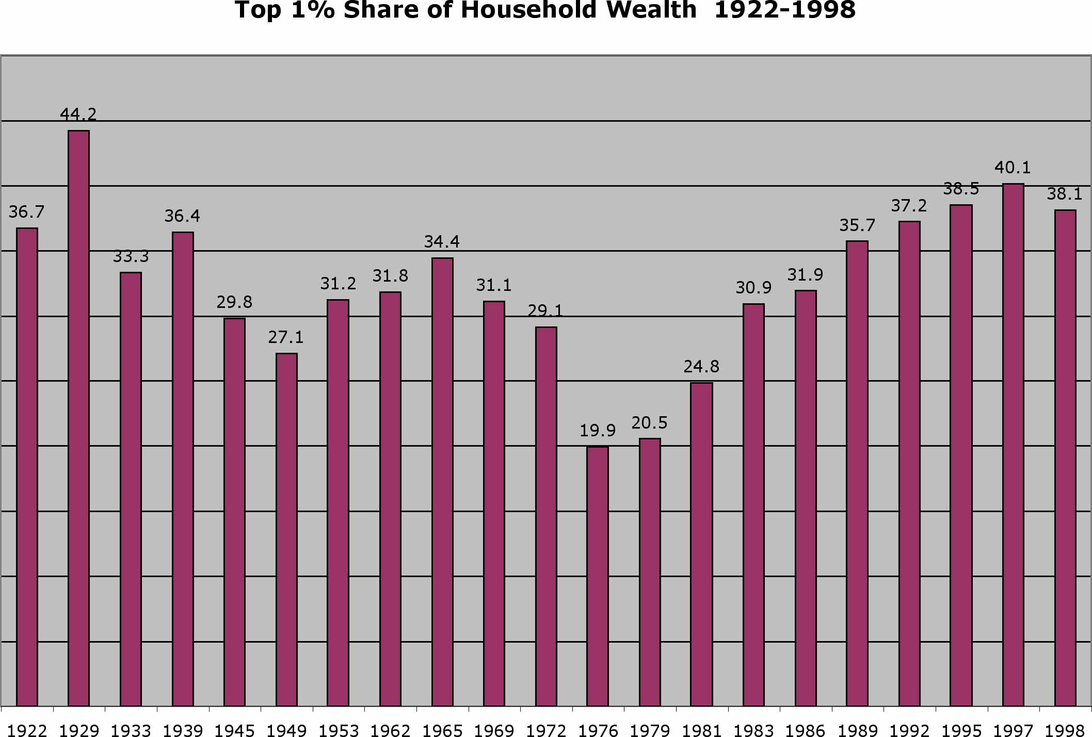
Source: Edward Wolff, Top Heavy, 1996, New Series Households date pp. 78-79 (1992-1989), “Recent Trends in Wealth Ownership”, 1998 (1992-1997). CF Economic Apartheid in America, Collins and Yeskel, 2000, P. 56.

“Circulation of the Elites”
In Pareto’s view, the dominant class A has an alpha part “still smart enough strength and energy to defend its share of authority; and a beta part “made up of degenerated individuals, with feeble intelligence and will, humanitarians, as is said today…Objectively, the struggle consists solely in the B-alpha trying to take the place of the A-alpha; everything else is subordinate and incidental.” (Pareto 1927:91).

He also somewhat admired the self-seeking B-alphas, leaders of the lower classes who seek to overthrow the upper classes. Pareto’s “Circulation of the Elites”, to anyone who has read the slightest bit about primate behavior, is nothing but a description of the dominance hierarchy of chimpanzee society. Alpha males (A-alphas) rule, and are constantly challenged by beta males (B-alphas) for dominance. Despite the wide variety of primate and human societies throughout evolutionary history, including matriarchal and matrilineal societies, Pareto holds Chimpanzee society up as the human ideal. Even among apes, chimpanzees are ill behaved compared to others such as Bonobos, Gorillas, or Orangutans.

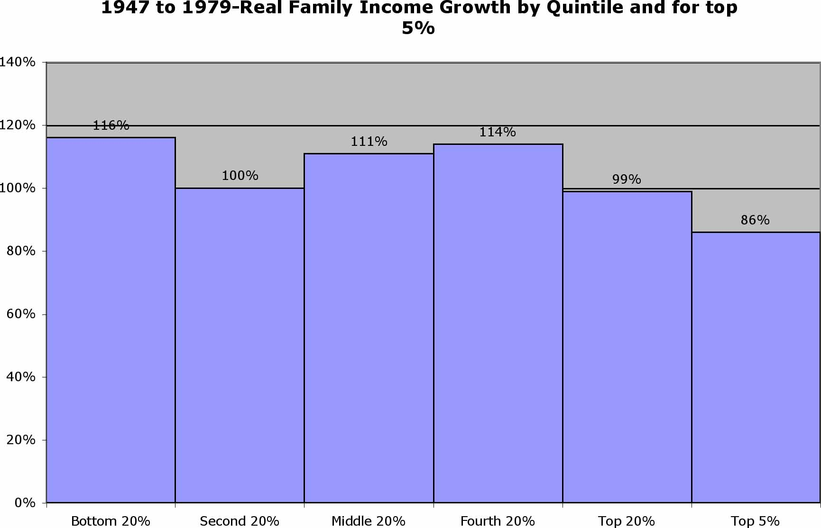

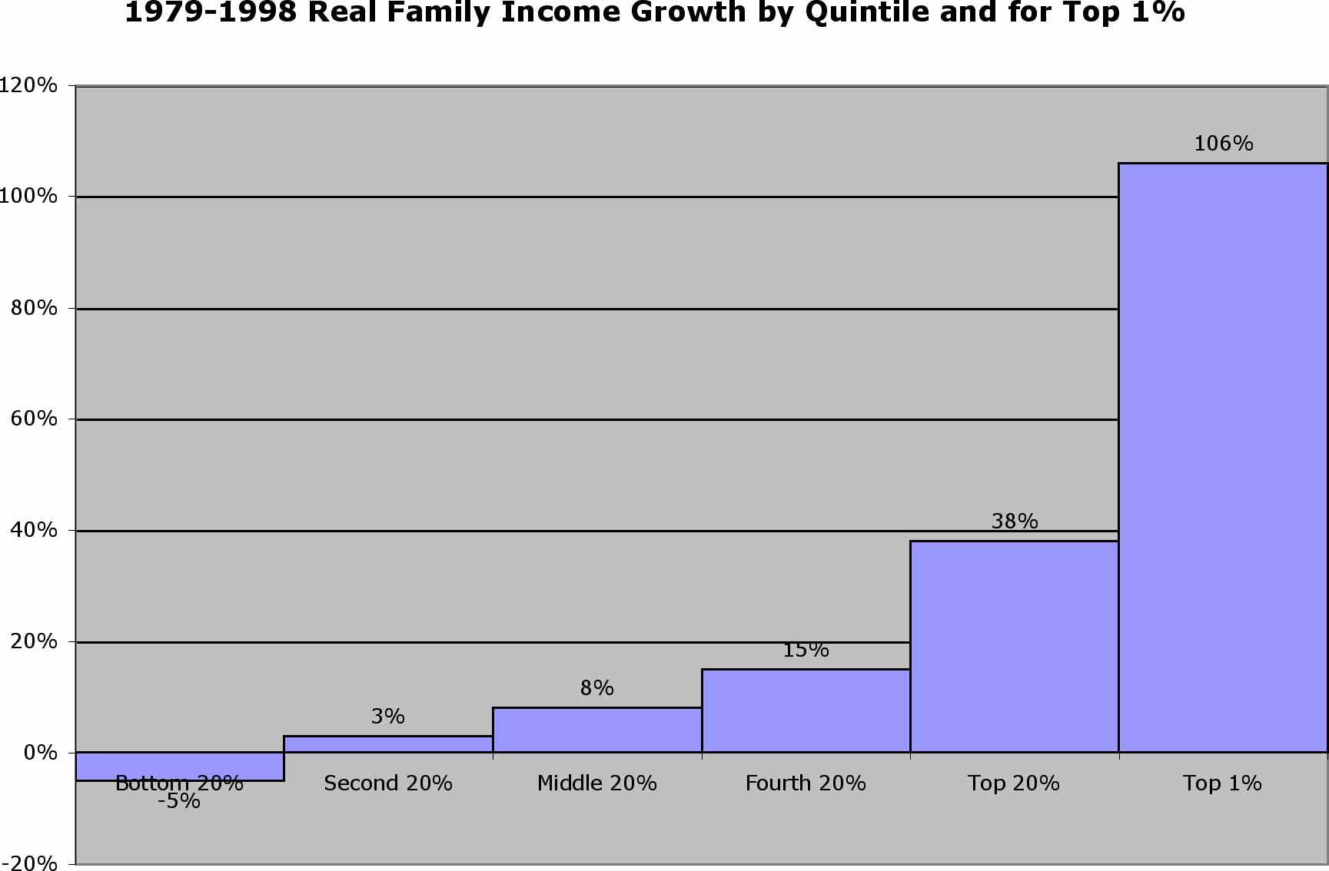

Source: Economic Apartheid in America, Collins, Yeskel, p. 42, 44.

While real family income grew fairly equally across the board from 1947-1979, in the period from 1979-1998 inequality vastly increased. The gains increased with increasing income, and those at the bottom were actually worse off. Where was the outrage from economists against this non-Pareto optimal result? During this period of time we heard much about “irrational exuberance”, and little or nothing from economists about income inequality. Perhaps this was just a slight miscalculation? Assuming that people at the bottom had their incomes remain the same, then this period would be considered Pareto optimal, despite the huge transfer of wealth to the top. Is this a desirable result for society? This appears to be exactly what Pareto had in mind. In household net worth, the situation was even worse. People at the top got better off, while people at the bottom got much worse off, therefore failing the Pareto Optimal criteria.

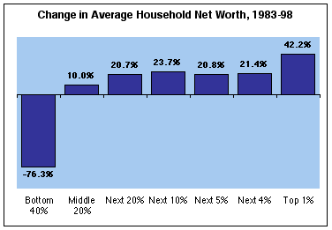

Figure X. Edward Wolff, Levy Economics Institute

Pareto on Genetic Selection
“The struggle to appropriate the goods of others may be favorable to (genetic) selection” (Pareto p. 341).

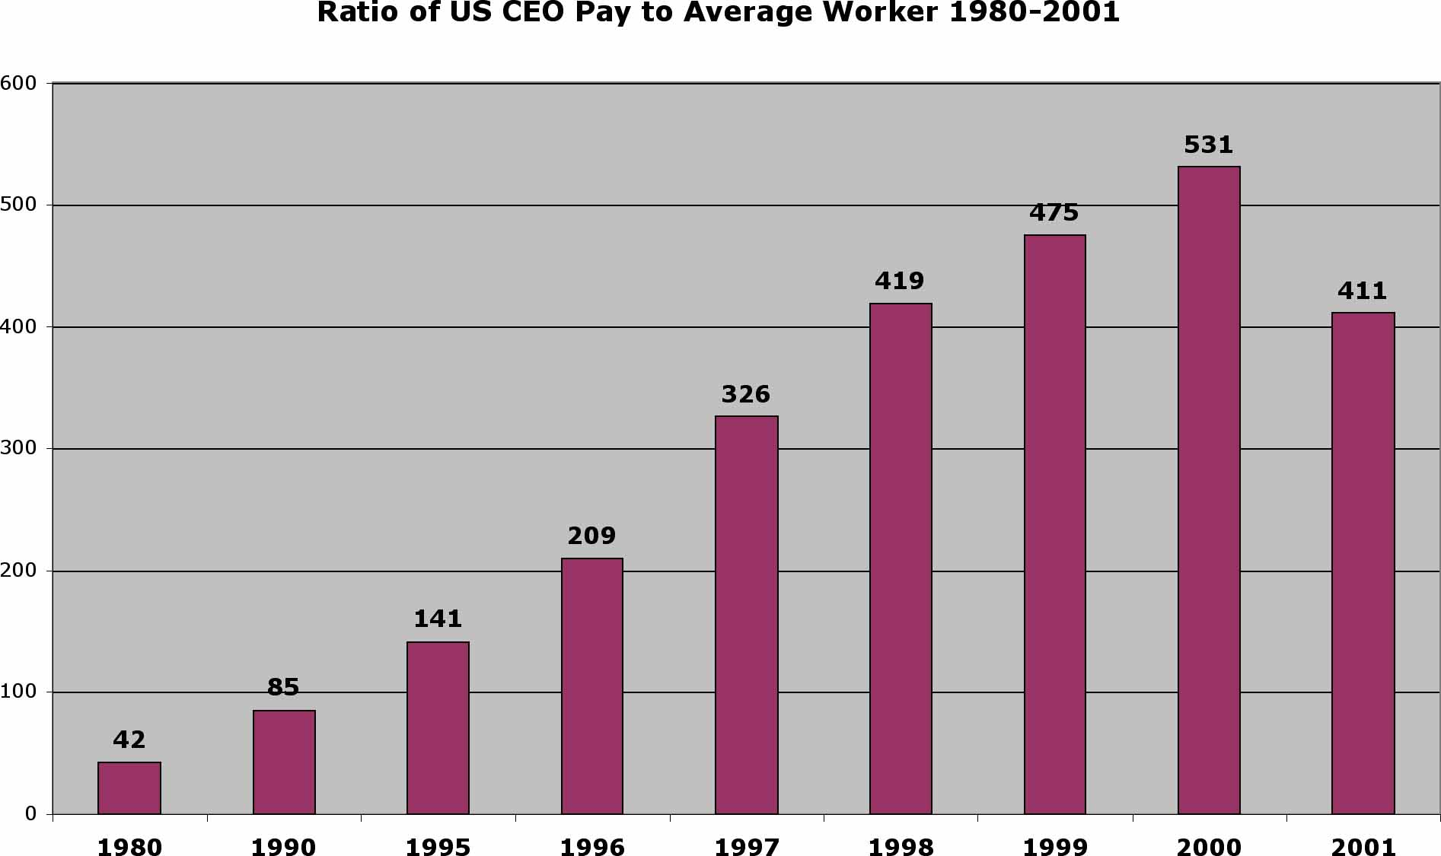
Source: Economic Apartheid in America, Collins, Yeskel, P. 50-51.

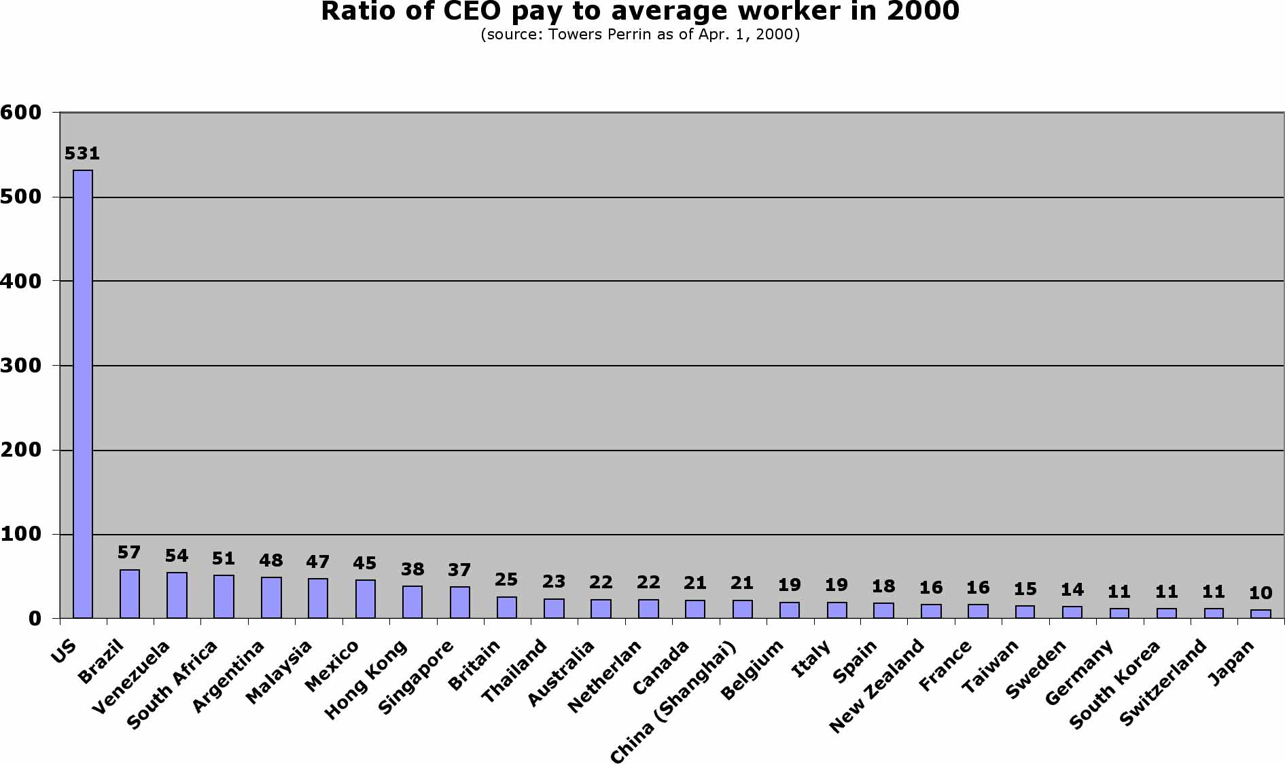

CEO pay is a very telling statistic as corporate management in the US drastically increased their share of corporate income during this period. From 1980 to 2000 the ratio of CEO pay to the average worker increased from 42:1 to 531:1. This contrasts with Germany and Japan where as of 2000 the ratio of CEO pay to the average worker remained at 11:1 and 10:1 respectively. Even in Brazil, known as a country with one of the most unequal distributions of wealth in the world, the CEO/worker ratio only reached 57:1.

Labor productivity increased 33% during this same period of time. According to NCE doctrine, wages always rise in proportion to labor productivity. From 1972 onward, there was basically no corresponding increase in wages. Real wages remained virtually unchanged or even lower:

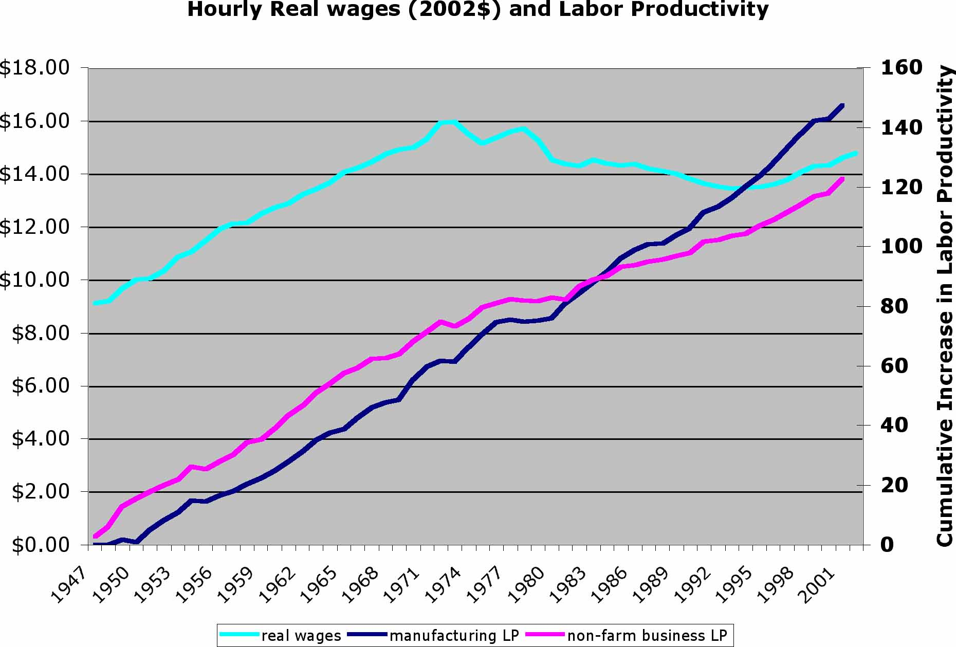
Source: The Ultimate Field Guide to the US Economy, p. 34, US Census Bureau

Pareto would exalt the CEOs position and be contemptuous of the passive masses who accepted this condition. On the passivity of the masses I find some agreement with Pareto. Several important factors led to the stagnation of real wages:
- The decline in unionization from 35% in 1948 to 14% in 1999.
- Globalization led to export of jobs resulting in a “race to the bottom” for wages. (Free-trade zones, NAFTA, WTO, etc.)
- Increased temp and contract workers with no benefits, corporate downsizing, mergers.

Pareto on Suffrage
“When suffrage has been given to all men, including madmen and criminals, when it has been extended to women, and if you like, to children, it will have to stop. One cannot go any lower, unless the suffrage is extended to animals” (Pareto p. 100).

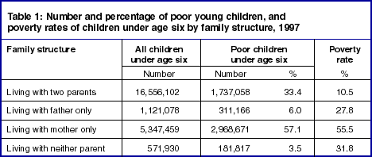

Source: http://www.nccp.org/99uptext.html

Women, children, and single parent families are most often the victims of hunger. 60% of adults seeking food assistance are women, and more than 40% of the total are children. (Thursday Nov. 29 Gazette Community News) 55% of single mothers with children under 6 are poor. Pareto’s goal of disenfranchising women and children has been achieved.

Pareto on equality
“Equality before the law is a dogma for many people…it is not at all evident a priori that such equality is advantageous to society;…the contrary appears more probable.” (Pareto p.95).

The gini coefficient is a commonly used measure of income inequality. While declining slightly prior to 1968 in the US, it has been rising dramatically since then. This trend has occurred both within most countries and also between the wealthy and poorer countries.

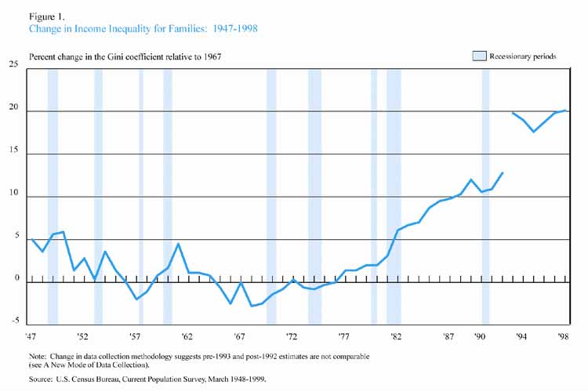

 | Population | Ratio of top 10% income to bottom 20% | Incarceration
California | 30 Million | 12:1 (US) | 200,000
Kerala | 30 Million | 3.5:1 | 5,000
Source: Source: Collins, Economic Apartheid in America

Inequality good for society?
To evaluate the statement that inequality is advantageous to society we might compare two regions of identical population, Kerala state in India, and the US state of California, both with 30 million people. In addition, Kerala is smaller and more crowded. The income ratio between the highest 10% and lowest 20% in Kerala is 3.5:1. In the US the ratio is 12:1. Kerala is also known as a society with one of the highest levels of gender equity in the world. Kerala has 5,000 people in jail, while California has an astonishing 200,000 people in jail. (Collins p. 31)

Pareto’s Triumph
In the last 20 years we have seen the implementation of Pareto’s values through laissez-faire, free-market capitalism as promoted by neo-classical economists and neo-liberal advocates. We have seen a huge transfer of wealth and income from the lower income groups to the upper income groups. The greatest poverty is among single women and children, and redistribution of any kind is considered morally repugnant. The economy grew, but inequality grew much greater. It is truly the triumph of Pareto.

Pareto Optimality, Growth, and Welfare
Since inequality has grown much worse over the last 20 years we will undoubtedly hear the call from economists for more growth to reduce poverty and inequality. I hope it is apparent from this article that economic growth and poverty reduction, in the US at least, are unrelated. Furthermore, it is debatable that growth in material throughput is sustainable for much longer. The most effective way to increase the total utility of society is to provide for the material needs of those with the greatest marginal utility from increases in income, namely those at the bottom of the economic scale. How to go about this is an essential question.

Policies to address poverty and Inequality
Many policy recommendations have been made to address poverty, that do not necessarily require additional economic growth. They include raising the taxable income level, eliminating the cap on payroll taxes, negative income tax or basic income, refundable care-giver tax credit, affordable housing, universal health care, income deductible rent, etc. Many recommendations addressing inequality are based on a Robin Hood approach, basically to steal through taxation from the rich and redistribute through transfer payments to the poor. Debates usually deteriorate into unproductive and divisive arguments between supporters and opponents. Advocates seek to remedy the injustice of the current inequality of wealth, while opponents consider it unfair to confiscate and redistribute what they consider private wealth, and consider it a deterrent to initiative and productivity.

Addressing Inequality
A better approach to inequality would be to make a distinction between those assets that are created by private effort and those resources which are inherently common property, namely those assets produced neither by labor nor by capital. Every person shares a common inheritance of natural and cultural assets. These assets contribute actual or potential dividends to everyone on Earth. My assumption will be that the contributions to welfare from natural capital and the shared cultural heritage of humankind should be equitably distributed among all, while the value added to these assets by individual or collective effort (labor or capital) should belong to the individuals who contributed that value. Actual and potential dividends can be computed on a per capita basis for ecosystem services, human and social services, and rent on natural and common assets. For the purposes of redressing inequality I will focus on rent from natural and common assets.

Equity from Common Assets
Many public goods cannot be assigned property rights and are inherently public such as the
atmosphere, ozone layer, national defense, judicial system, etc. There is a class of public goods,
that in the past had no property rights assigned, which have been termed common assets.
These include the electromagnetic broadcast spectrum, fishing rights, mineral rights, aircraft landing rights, orbital satellite slots, products of government research such as the internet, patents on genetic structure, cap and trade permits for emissions of pollutants such as sulphur dioxide, Nox, or Co2, etc. Rental values on these assets could be retained as citizen equity, instead of being privatized as many of them are being done currently.

Equity from Natural Capital
UN Resolution 1803 (XVII) of 14 December, 1962/ Declaration of Permanent Sovereignty
over Natural Resources states: “Violation of the rights of peoples and nations to
sovereignty over their natural wealth and resources is contrary to the spirit and principles of the
Charter of the UN, and hinders the development of international co-operation and the maintenance of peace.”

Another View:
“The meek shall inherit the earth... Except for the mineral rights.” J. Paul Getty

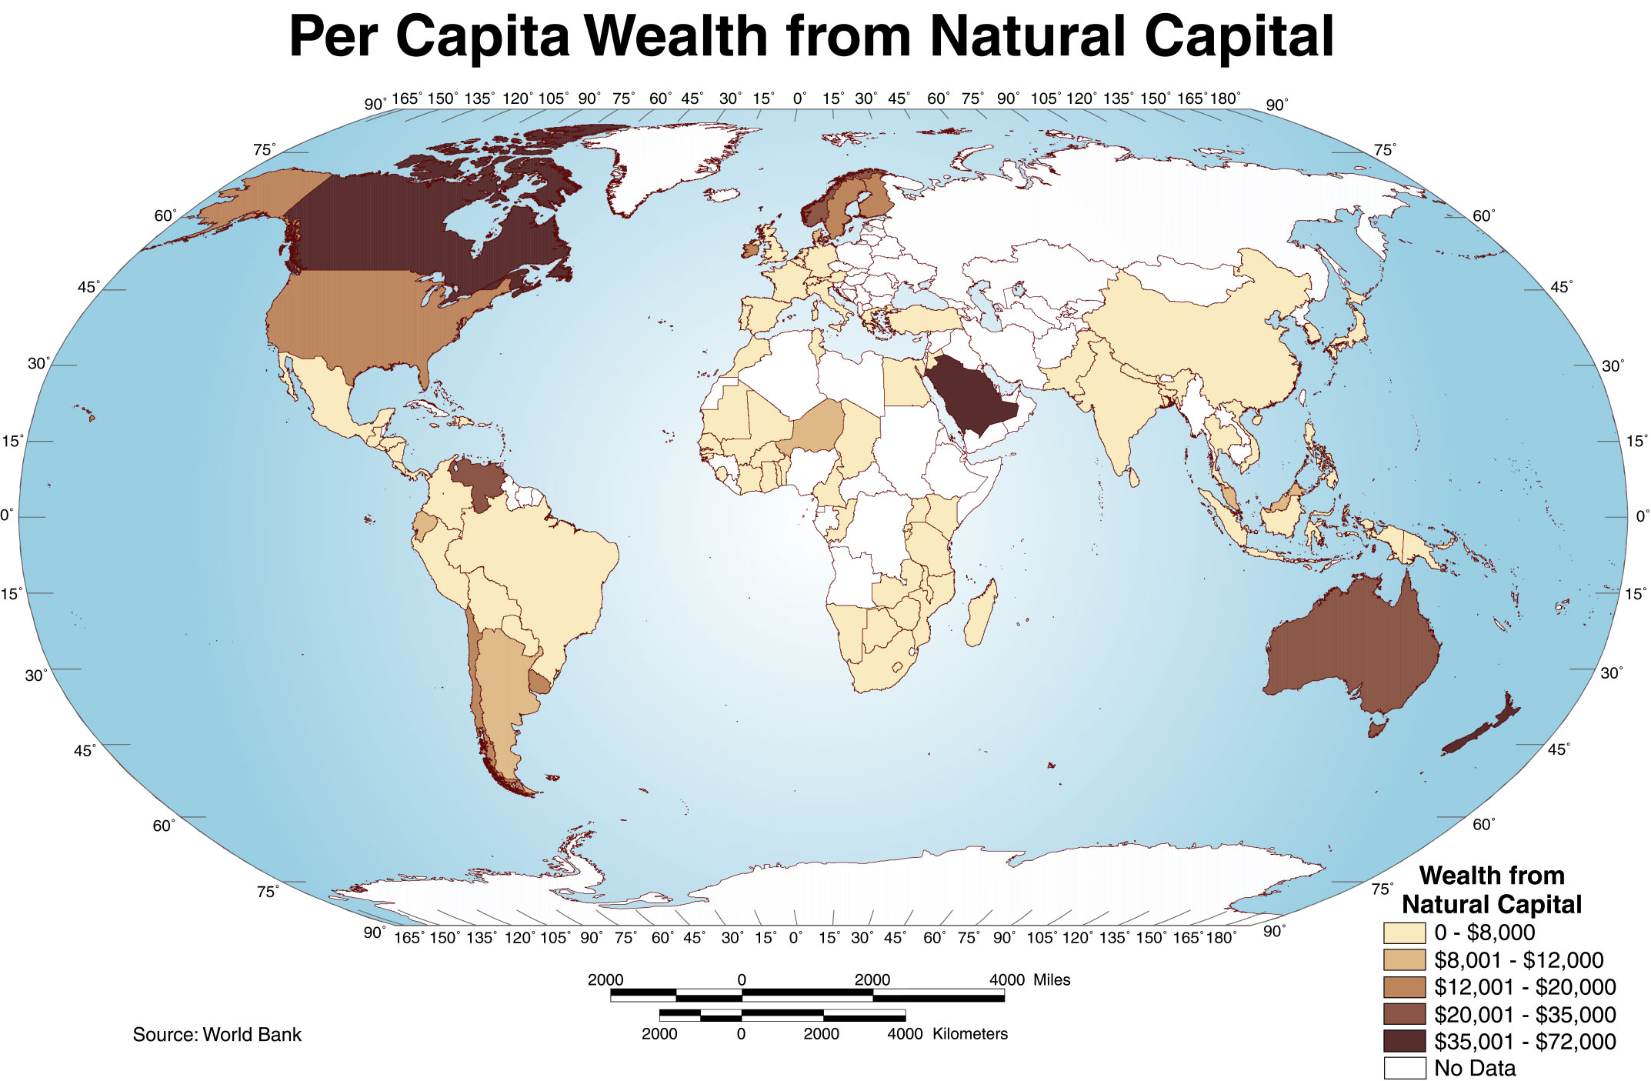

Total national wealth from natural capital has been calculated regionally by the World Bank for 1997 including pasture land, crop land, timber resources, non-timber resources, protected areas, and subsoil assets. Urban land should be included, and would add a substantial amount.

NOTE from World Bank report; "It should be mentioned at the outset that natural capital values are primarily based on instrumental or use values of the environment and that important
ecological and life support functions of natural systems have not been valued. Depleting natural capital reduces the value of ecosystems services…[Harvesting renewable natural capital at
a sustainable rate can maintain the same level of ecosystem services.] For countries rich in sub-soil assets the importance of investing, rather than consuming, returns from extraction of oil, minerals, coal, gas, and other exhaustible resources needs to be stressed."

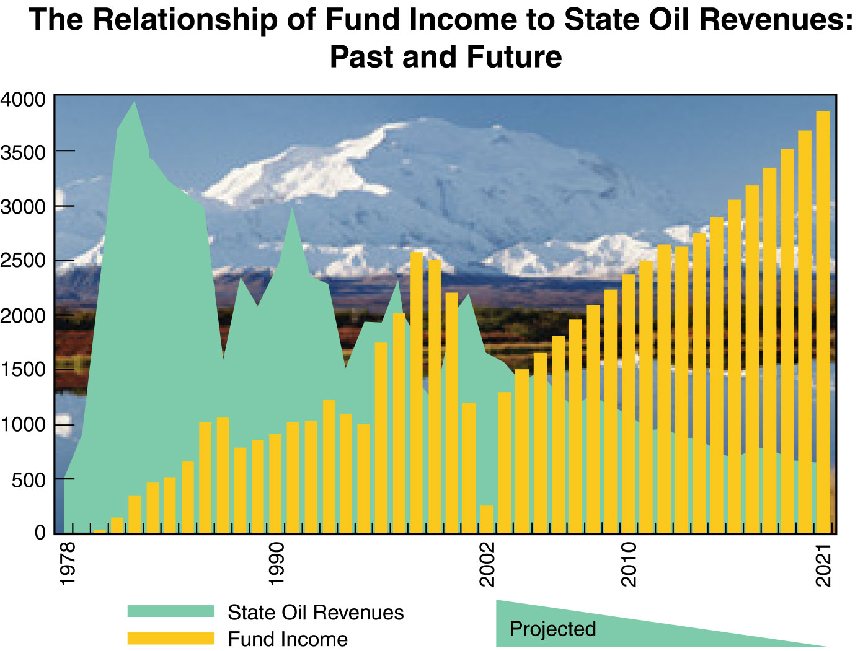

A Model for Sustainability and Citizen Equity
An existing model of citizen equity in natural capital, combined with weak sustainability
currently exists in the US state of Alaska. Oil resources in Alaska belong to the people of the
state. The severance tax rate on oil is 12.25%-15% of extraction value depending on the age of the oil field, and 10% on natural gas. Royalties paid by oil companies drilling in Alaska are partly used for state revenue, but a large portion is placed in a permanent fund (APF), which is
invested for the benefit of the citizens of Alaska.

Without depleting the capital fund, interest is paid as an annual dividend to every resident of Alaska who has lived in the state for more than one year. Payments have averaged over $1000 per year in recent years (Table above). This illustrates the transformation of natural capital into a sustainable stream of financial capital. As state oil resources are used up, the citizens of Alaska will still have a large and growing capital fund earning interest for them. This will continue indefinitely as long as the fund is managed well, and the state government is prevented from spending the funds.

The APF is one of the few cases in the world where the public has obtained property rights to natural capital. Governments usually retain rights to these resources, and revenues are used for general government expenditures, or quite often end up in the bank accounts of government officials, especially in authoritarian regimes. By establishing citizen equity to common assets and natural capital, these benefits will accrue to the population at large, rather than to government officials and their associates, or to corporate owners. What does the Alaska Oil dividend have to do with equity? It turns out that Alaska has the lowest gini ratio of any state in the US at .40217 (2000 census figure).

Other Oil States
Kuwait has an estimated oil reserve of more than 94 billion barrels, translating into a per citizen oil wealth of 142,000 barrels, which at today's levels is worth $2.1 million per person. However, mismanagement, militarization, and lack of a private market economy have resulted in a Kuwaiti budget deficit. Recent proposals for a Niger Delta fund and Iraq fund would establish oil funds in these countries paying direct dividends to the populace rather than enriching their undemocratic rulers.
1922 Proportion of phosphate royalties paid to Pacific Phosphate Co. = 99.72%
Proportion of phosphate royalties paid to Nauruans = .28%

The Case of Nauru
In 1922 residents of the pacific island of Nauru received .28% of the royalties from phosphates mined on their island. In 1968, following years of struggle, Nauru gained independence and control over their lucrative phosphate deposits. From then on, the annual income from phosphates of around $100 million was shared between The Nauru Royalties Trust Fund, Nauruan landowners and the Government. By 1976, the annual tax-free income for every Nauruan had reached $37,000. Nauru has also invested these funds for the time when phosphate runs out. By no means was this resource managed wisely or sustainably, and the island has been devastated. The people have high levels of obesity and severe health problems such as diabetes. Nevertheless, Nauru is one of the few examples where people have regained equity in their own natural assets.

Other cases
Usurious rates of rent on agricultural land paid by tenant farmers around the world has been cited by nobel prize winning economist Joseph Stiglitz as a major cause of poverty. This is another egregious case of denying citizens equity in their own resources, and allowing this equity to be privatized into a small group of hands. One of the highest sources of natural capital equity is in urban land value, which is often taxed somewhat for local public services, but the vast majority of land rent accrues to private landowners. By contrast, all land in Canberra, Australia the nation's capital, is owned by the Commonwealth of Australia. Land is leased for a term, usually 99 years. Leasehold tenure was adopted so that speculation in undeveloped land could be avoided, and future increases in the value of land remained in the public purse. Hong Kong, China also grants 50 year leases to land, subject to a 3% rental payment. Recently the islands of Eigg and Gigha in Scotland bought back the rights to all the land on the islands and put them into community ownership. Communities can collect land rent through lease payments or taxation and redistribute this common wealth directly to citizens as advocated by Thomas Paine in 1797.

Conclusion
In the past wealth from natural and common assets has flowed mostly into the hands of governments or private individuals and corporations. The trend towards privatization of unclaimed natural and common assets is accelerating. To counteract that trend citizens could reclaim equity in those assets which are not the products of labor or capital, and to democratically choose the amount paid in dividends and the proportion spent on government services. This would begin to redress the vast inequities in wealth created by the Triumph of Pareto, and would do so in a way which does not involve confiscating anyone of their rightful earned property. Distributing dividends universally from natural and common assets such as minerals, land, and EM spectrum might be relatively trivial to those at the top of the income scale. To those at the bottom who receive much greater marginal utility from small increases in income, these dividends could make a significant difference, and the reduction in inequality as demonstrated by Alaska could reduce the perceived need for economic growth.

References

Collins, Yeskel (2000), Economic Apartheid in America, NY, New Press.

Gaffney, Harrison (1994), The Corruption of Economics, London, Shepheard-Walwyn Publishers.

Gazette Community News, College Park, MD, Thursday Nov. 29, 2001.

Gowdy, John (2004), The Revolution in Welfare Economics And Its Implications For Environmental Valuation And Policy, Forthcoming in Land Economics.

Gowdy, Erickson (2002), The Approach of Ecological Economics, paper submitted to Cambridge Journal of Economics.

Hackett, Steven C (2001), Environmental and Natural Resource Econnomics, NY, ME Sharpe.

Heinz, Folbre (2000), CPE, The Ultimate Field Guide to the US. Economy, NY, New Press.

Muller, Frank G (2003), Ecological Economics As A Basis For Distributive Justice, presented at USSEE Conference.

Nelson, Robert H (2001), Economics as Religion, University Park, Pennsylvania State University.

Paine, Thomas, (1796), ‘Agrarian Justice’, in Philip S. Foner, The Life and Major Writings of Thomas Paine, NY, Citadel Press, pp 605-523.

Pareto, Vilfredo, orig. 1906 in Italian; 1927, French; 1971 translation Ann S. Schwier. Manual of Political Economy. NY: Augustus M. Kelley.

Gary Flomenhoft is a Research Associate at the Gund Institute for Ecological Economics at the University of Vermont in Burlington. [gary.flo@uvm.edu].

