Privatization of Life

“Water is essential for life. We are all aware of its necessity, for drinking, for producing food, for washing – in essence for maintaining our health and dignity. Water is also required for producing many industrial products, for generating power, and for moving people and goods – all of which are important for the functioning of modern, developed society. In addition, water is essential for ensuring the integrity and sustainability of the Earth’s ecosystems.”
- UN World Water Development Report, page 5

“Water demand is increasing three times as fast as the world's population growth rate, and poverty is the single most important factor related to meeting that demand, said officials at the 3rd World Water Forum, which wound up eight days of meetings on Sunday… Some 1.2 billion people lack a safe water supply and 2.4 billion live without secure sanitation, according to Water Forum official figures. At least five million people die yearly from water related diseases, including 2.2 million children under the age of five. An estimated one half of people in developing countries are suffering from diseases caused either directly by infection through the consumption of contaminated water or food, or indirectly by disease carrying organisms, such as mosquitoes, that breed in water.”
- Environment News Service, “100 New Commitments Pour in as Water Forum Closes,” 24 Mar 03

Crisis is a word so overused that it has perhaps lost its appropriate impact; as I suppose have the words catastrophe, disaster, emergency. Everyone coaches their particular causes in these terms. These words bring to mind images of suffering and loss, images of death and urgency. Hidden in the words is also the concept of potential hope, of renewal and change and deliverance. There are no better terms to describe the current water situation we have created for ourselves and others.
Water is one of the most life essential sources of ecological capital. Ecological capital is defined not in terms of monetary or economic wealth but as the Earth’s natural resources and the Earth’s environmental services that people alive today have inherited and upon which our survival depends. “[L]ike economic capital, they automatically generate ‘dividends’ in the form of a steady stream of services and they can ‘depreciate’ or become depleted if they are used too much and are inadequately maintained.” (Gardner 11).
Water can be either a rival or nonrival resource depending on its use; stock-flow uses are rival while fund-service uses are nonrival. Due to recycling through the hydrologic cycle, water is nonrival intergenerationally, although clean drinking water may be. Excludability depends on existing institutions, although rainfall is generally nonexcludable by nature. Substitutability is nonexistent for the most important uses. (Daly and Farley 88, 91).
How is the market dealing with this ecological capital? Is the scarcity of water appreciated and incorporated in market workings? What about privatization of global water resources? How do we value water? Are we using water on a sustainable scale? Is the distribution of water equitable? How efficient is current water allocation? What can (and should) be done about the current and persisting water crisis?

Scale - Sustainable Water:

“When the well’s dry, we know the worth of water.”
- Benjamin Franklin, quoted in UN World Water Development Report, page 325

Water, like religion and ideology, has the power to move millions of people. Since the very birth of human civilization, people have moved to settle close to it. People move when there is too little of it. People move when there is too much of it. People journey down it. People write, sing and dance about it. People fight over it. And all people, everywhere and every day, need it.
- Mikhail Gorbachev, President of Green Cross International quoted in Peter Swanson's Water: The Drop of Life, 2001

There is a serious problem with how the market values water. In the United States, drinking water costs “well under a dollar a ton, or about one cent for more than 150 eight-ounce glasses. In actuality, this does not reflect the true cost of producing the water or the fact that many sources currently being used, particularly those that are underground, will be depleted within the next few decades.” (Moeller 137). While the United States and other developed countries continue to waste large quantities of water, “more than two dozen countries do not have enough fresh water to meet the needs of their populations.” (Moeller 146).
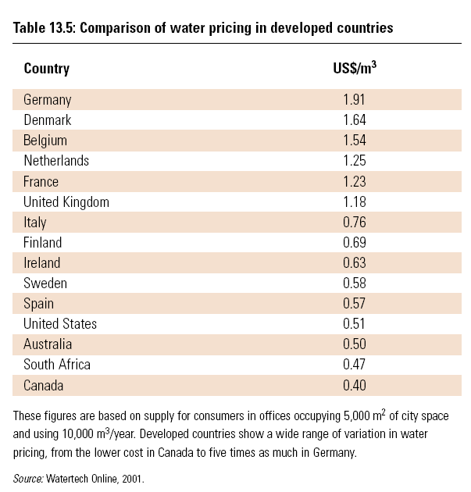
“[W]ater has traditionally been regarded as a free resource of unlimited supply with zero cost at supply point and at best, water users have been charged only a proportion of the costs of extraction, transfer, treatment and disposal. All associated externality costs of water have been ignored and users are offered very little incentive to use water efficiently and not waste it.” (UN World Water Development Report 327-28). “[L]imiting scale usually means that previously free natural resources and services have to be declared scarce economic goods.” (Daly and Farley 363). Pricing needs to reflect the actual costs of the water to promote the use of water resources at a level sustainable to the scale of their environment.
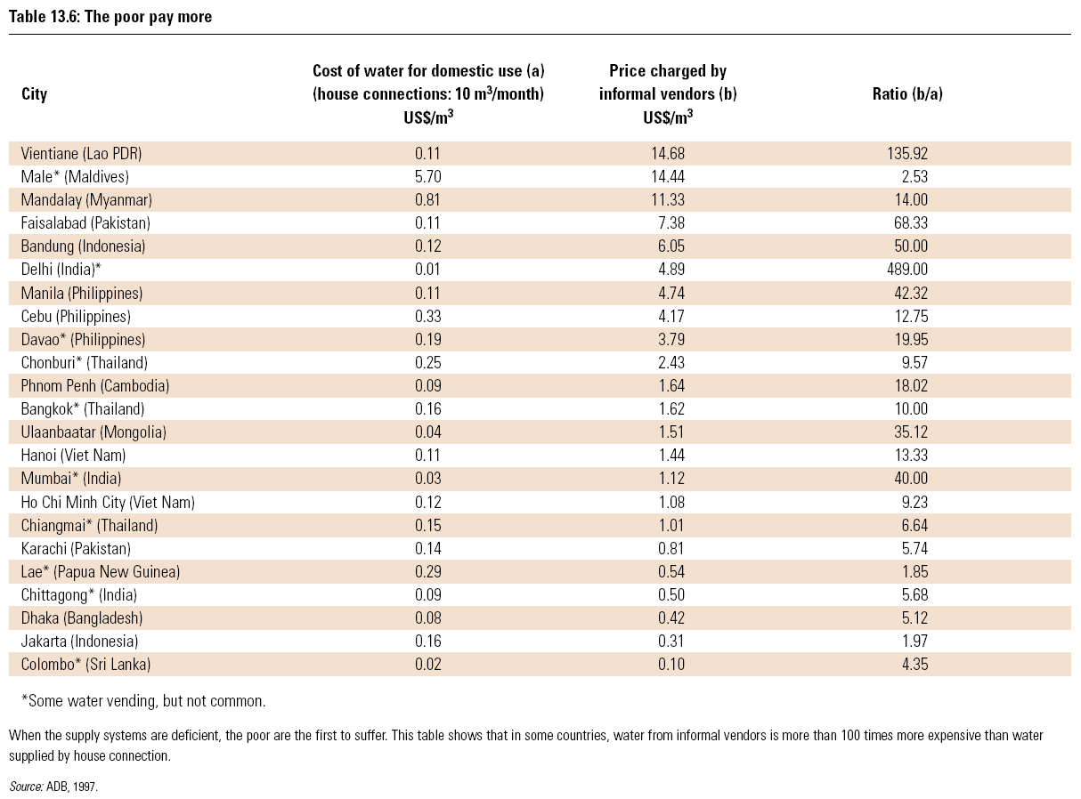
The United Nations is working on defining value in a new way. Value should incorporate “people’s perception of the world and their cultural and social traditions, as well as economic considerations and notions of full cost recovery.” (UN World Water Development Report 325). “From a utility perspective, the same quality and quantity of water provide distinctly different values to consumers in different parts of the world.” (UN World Water Development Report 326). While the UN has some great ideas about what should be considered in the valuation of water, they have yet to define a workable valuation system that can be used universally. They cite many of the barriers to developing such a tool, but have found little in the way of overcoming them.
“The goal of sustainable scale requires a social or collective limit on aggregate throughput to keep it within the absorptive and regenerative capacities of the ecosystem.” (Daly and Farley 363). There are few areas in water management where one can see such a limit on throughput. “[A]s trade expands, local limits to scale become less relevant and global limits more so. While trade may decrease the chances of surpassing sustainable scale in any one area, it also means that if we do surpass it, we are more likely to do so for the planet as a whole.” (Daly and Farley 331). In smaller communities social pressure can help limit individual use of a common good. But it is hard to apply this principle to the global community where the effectiveness of the social pressure of peers is lost in the anonymity and impersonal atmosphere provided in the large scale. This is a problem well analyzed in environmental psychology.
Right now we are not using our water resources at a sustainable level. Sustainable scale must be imposed on society because the market is obviously not creating one on its own. The first step in stabilizing water resources is to maintain a sustainable scale. A good first step in accomplishing this goal is to re-evaluate the way that we value the scarce and precious ecological capital of water.

Distribution - Just Water:

“I want to think I deserve what I get. I don't want to consider how vastly I am overly rewarded. I don't want to consider the injustices around me. I don't want any encounters with the disenfranchised. I want to say it's not my fault. But it is, it's yours and mine, and ours. We'd better figure out ways to spread some equity around if we want to go on living in a society that is at least semi-functional. It's a fundamental responsibility, to ourselves.”
-William Kittredge

A discussion of just distribution of water cannot begin without recognizing that it is “the basic right of all human beings to have access to clean water and sanitation at an affordable cost.” (UN World Water Development Report 326, quoting the Dublin Statement). This is the starting point for determining what is just in the distribution of water. Everyone needs water to live. Everyone has a right to live. Therefore, everyone has the right to the water needed to sustain life.
The current distribution of water can under no terms be considered just. “The world health agency associates 3.4 million deaths each year with inadequate water and sanitation.” (“Water for Health Declared a Human Right”). “Over 1 billion people have no access to clean drinking water, and more than 2.9 billion have no access to sanitation services. The reality is that a child dies every eight seconds from drinking contaminated water, and the sanitation trend is getting sharply worse, mostly because of the worldwide drift of the rural peasantry to urban slums.” (De Villiers). “According to the report, by the International Atomic Energy Agency (IAEA), an estimated 1.1 billion people have no access to safe drinking water, 2.5 billion lack proper sanitation and more than five million people die from waterborne diseases each year - 10 times the number of casualties killed in wars around the globe” (Kirby). Although the numbers vary slightly from report to report, the inequity of water resource distribution and its consequences are staggering.
The perversion of the concept of commensurate benefits and costs discussed in my earlier paper “The Distribution of Waste,” is seen even clearer in the management of water resources. Many authors elaborate on this discrepancy. There is an “externalization of costs from the space and time horizon of those who profit.” (Mies 500). “The economic, social and ecological costs of constant growth in the industrialized countries have been and are shifted to the colonized countries of the South, to those countries’ environment and their peoples.” (Mies 500). “[C]ountries like India do not import the benefits of industrial capitalism; those benefits are exported in the form of loan repayments to fill the coffers of the bankers and corporate vampires who read the Wall Street Journal for the latest news on their investments.” (Bradford 392). “[B]oth nature and the future have been colonized for the short-term profit motives of affluent societies and classes.” (Mies 500).

Over the last decade, the move has been made to privatize global water resources. “Multinational companies now run water systems for 7 per cent of the world's population, and analysts say that figure could grow to 17 per cent by 2015. Private water management is estimated to be a $200 billion business, and the World Bank, which has encouraged governments to sell off their utilities to reduce public debt, projects it could be worth $1 trillion by 2021. The potential for profits is staggering: in May 2000 Fortune magazine predicted that water is about to become 'one of the world's great business opportunities', and that 'it promises to be to the 21st century what oil was to the 20th'.” (Louma). “The policies of privatization imposed through the World Bank and rules of trade liberalization being negotiated in the World Trade Organization (WTO) under the General Agreement on Trade in Services (GATS) are rules and conditionalities that create corporate states-states that usurp resources from people for meeting vital needs and put them in the hands of private corporations for making profits through the privatization of essential services.” (Shiva). It is frightening to think of these faceless corporations completely in charge of that which sustains life on this planet, especially without regulation that maintains distributive justice.
The people currently most negatively affected by the privatization of water resources are those in developing countries. The “industry” is saturated with horror stories. “Developing world cities with private water-management companies have been plagued by lapses in service, soaring costs, corruption and worse. In Manila, where the water system is controlled by Suez, San Francisco-based Bechtel and the prominent Ayala family, water is only reliably available for a few hours a day, and rate increases have been so severe that the poorest families must choose each month between paying for water and two days' worth of food. In 2001 the government of Ghana agreed to privatize local water systems as a condition for an IMF loan. To attract investors, the government doubled water rates, setting off protests in a country where the average annual income is less than $400 a year and the water bill (for those fortunate enough to have running water) can run upwards of $110. In Cochabamba, the third-largest city in Bolivia, water rates shot up by 35 per cent after a consortium led by Bechtel took over the city's water system in 1999; some residents found themselves paying 20 per cent of their income on water. An initial round of peaceful street protests led to riots in which six people were killed. Eventually, the Bolivian government voided Bechtel's contract and told the company's officials it could not guarantee their safety if they stayed in town.” (Louma).
Privatization of water resources not only affects developing nations. U.S. Senate Bill 1961, “The Water Investment Act of 2002,” would require all local water providers to ‘consider’ selling off their infrastructure and water rights to private corporations or else lose vital federal funds for maintenance. Activists around the US have been protesting water privatization.
The proper distribution of water resources could go a long way to solving the world’s poverty problems. “Inadequate access to water forms a central part of people’s poverty, affecting their basic needs, health, food security and basic livelihoods. Improving the access of poor people to water has the potential to make a major contribution towards poverty eradication.” (UN World Water Development Report 6). “Many poor people in urban areas buy their water from private vendors, often at a rate well in excess of piped water supply. This means that a significant proportion of household expenditure is spent on water. Reduced water prices would have a major impact on the economic status of such people, and, with money being available for other things, may effect economic growth.” (UN World Water Development Report 8). “[B]ottled water generally costs about a thousand times as much as the public supply.” (Moeller 145).
As with sustainable scale, we can see that the market is failing to develop a just distribution of water. Currently, with the vast inequality in income distribution and the growing scarcity of water supplies, many people have a limited means to pay for an essential source that is increasing in price. “The goal of distributive fairness requires some socially limited range of inequality imposed on the market.” (Daly and Farley 363). One solution to the unjust distribution is a system of subsidies. Unlike the destructive subsidies that are now in place and lead to a de-valuation of water, these subsidies would allow for the poorest in society to receive the water that is necessary to maintain a healthy life. “In many regions, the poor already subsidize those richest in society for their water use.” (UN World Water Development Report 340). Carefully structured subsidies can “generate positive social effects such as maintaining the rural landscape and traditions, supporting local economies or contributing to food security levels.” (UN World Water Development Report 341). This is merely one small step toward tackling a complex global problem.

Allocation - Efficient Water:

Humans build their societies around consumption of fossil water long buried in the earth, and these societies, being based on temporary resources, face the problem of being temporary themselves.
- Charles Bowden, Killing the Hidden Waters, 1977

“Global water consumption has tripled over the last 50 years, and it continues to climb.” (Daly and Farley 116). According to the UN, agriculture accounts for 70 percent of water withdrawals worldwide. Industry currently accounts for 22 percent of all withdrawals. (UN World Water Development Report 331). The UN recommends a “better allocation of water among its various uses,” determined by water values. (UN World Water Development Report 333). As mentioned in the scale section of the paper, the UN has not yet worked out the details of the valuing system, so the “better allocation” recommendation is pretty far from implementation at the moment.
“[W]ater is a rival good that can be made excludable under most circumstances and therefore technically amenable to market allocation. Indeed, in recent years, more and more cities, states, and even countries are turning their water supplies over to the private sector in the name of greater efficiency, and many neoclassical economists applaud this trend.” (Daly and Farley 196). However, the UN World Water Development Report notes that many countries have “resisted liberalizing the water market, keeping a regulated form of allocation of water rights in order to secure the production of staple commodities.” (336).
An example of allocation conflicts can be seen in India. Guha, a self-proclaimed partisan of the environmental movement in India, notes that “the ecological battles presently being fought in India have as their epicenter the conflict over nature between the subsistence and largely rural sector and the vastly more powerful commercial-industrial sector.” (276). Guha describes a battle of allocation. Indian environmentalists are mainly concerned with “the use of the environment and who should benefit from it.” (Guha 276). They wish to “wrest control away from the state and the industrial sector and place it in the hands of the rural communities who live within that environment but are increasingly denied access to it.” (Guha 276).
Privatization is having a noted effect on global allocation of water. “In the late 1990s a handful of conglomerates began to quietly acquire control of the world's water systems. As the value of water began to soar, multi-billion-dollar firms such as Vivendi, Suez, Enron and Bechtel scoured the world in pursuit of lucrative business opportunities. Between 1994 and 1998 there were 139 water-related deals worth an aggregate of nearly $4 billion. In a period of six months in 1999 Vivendi bought the western American water operator US Filter for $6.2 billion, and Suez purchased the east coast company United Water Resources for $1 billion. Those two transactions came right after Enron paid $2.2 billion for the British utility Wessex Water. At the same time, electronic water auctions were launched on the internet. At sites like water2water.com and waterrights.com, individuals with excess water (such as farmers with irrigation contracts) could put their water rights up for sale to the highest private bidder. As a result of all of these different deals and ventures, hundreds of millions of people worldwide now depend on transnationals (companies based thousands of miles away) for their water supplies.” (Rothfeder). Water resources are not only distributed to the highest bidder, but allocated to the use of the highest bidder, without monitoring or regulating for ecological and human rights equity concerns.
Privatization of water rights leads to private companies determining allocation and criteria for allocation. Like the concerns for distribution, this is a scary thought. Where are the obligations for the corporations to allocate efficiently, other than to improve their own profit margin? Or to broadly define efficiency to take into consideration the finite nature of water resources? Privatization undermines the conditions required for efficient market allocation, by creating fewer, bigger firms, more negative externalities, and more monopolies. “[T]he fact that water is nonsubstitutable and 100% essential means that there are serious ethical implications to the market allocation of water.” (Daly and Farley 196).
According to Daly and Farley, once scale and distribution have been set to reflect the values of sustainability and justice, “the market will determine allocatively efficient prices. Indirectly these prices will reflect the scale and distributive limits and therefore may be thought of as ‘internalizing’ the values of sustainability and justice that have been previously decided politically, independently of prices.” (364). Therefore, the solution to efficiency problems in allocation, is to simply “impose quantitative restrictions on the market that limit the degree of inequality in distribution of income and wealth to a just range, and that limit the scale of physical throughput from and back to nature to a sustainable volume.” (Daly and Farley 365). Basically, fix scale and distribution and the market can fix allocation on its own.

Consilience - Consistent Water:

Water, water, everywhere,
And all the boards did shrink.
Water, water everywhere,
Nor any drop to drink.
- Samuel Taylor Coleridge (1772-1834), "The Rime of the Ancient Mariner" 1798
“Many water shortages stem from the widespread failure to value water at anything close to its true worth. People have yet to learn that the water resources of the world are finite. Grossly underpricing water perpetuates the illusion that it is plentiful.” (Moeller 147). Currently economic policy concerning water resources needs to be brought into agreement with biological and ecological principles. The amount of water on this planet is finite. “Approximately 70 percent of the earth is covered by water, but only 2.5 percent of the total volume on earth is not salty and therefore potentially available for consumption by plants and animals. Of this 2.5 percent, about two-thirds is unavailable, frozen in the polar icecaps and glaciers. The remaining 0.8 percent is held in aquifers, soil pores, lakes, swamps, rivers, plant life, and the atmosphere.” (Moeller 127). “Only about 0.3 percent of the total is available as surface sources.” (Moeller 127). "The simple fact is that there is a limited amount of water on the planet, and we cannot afford to be negligent in its use. We cannot keep treating it as if it will never run out.” (UN warns of looming water crisis, quoting IAEA’s director, Mohamed El-Baradei).
Many water sources are renewable through the hydrologic cycle, but many aquifers have a negligible recharge rate making them more of a “fossil” resource. (Daly and Farley 87). As an energy source, “water is a stock-flow resource that is rapidly renewed by the service (provided by solar energy) of the hydrologic cycle.” (Daly and Farley 88).
All life biologically needs water. “Water is absolutely essential to life. From 50 to 65 percent of the human body is composed of water, and variations of as little as 1-2 percent will cause thirst or pain. The loss of 5 percent of body water can cause hallucinations; a loss as large as 10-15 percent can be fatal. Although humans can live several months without food, under hot dry conditions they can survive only a day or two without drinking water.” (Moeller 128). Human health depends on water sources. Water can be a source of disease in people through at least four avenues: water-borne disease (ingestion of contaminated water, ex typhoid, cholera, infective hepatitis), water-contact disease (contact with contaminated water, ex Guinea worm), water-insect disease (where water sources serve as a habitat for disease transmitters such as mosquitoes, ex malaria, yellow fever), and water-wash disease (result from lack of sufficient water for personal hygiene and washing, ex Shigellosis, trachoma, conjunctivitis). (Moeller 128-29). In addition to drinking, humans depend on water for agriculture, industry, hydroelectricity, transportation, recreation, waste disposal, and for sustaining ecosystems. (Daly and Farley 87).
Economic water policy must also incorporate principles of human behavioral study. There are basically recognized four solution approaches to encourage individual behavior for the common good: 1) government laws, regulations, and incentives; 2) programs of education, giving people information and trying to change their attitudes; 3) informal (nongovernmental) social processes operating in small social groups and communities; and 4) moral, religious, and/or ethical appeals. (Gardner 17). Fairly extensive studies have been done on the effectiveness of each of these approaches at producing the desired prosocial behavior. Policymakers and economists should consider this vast field of knowledge when determining incentives and penalties to make more effective and reasonable choices. It is foolish to ignore this well-researched field when it can help to predict what results will come from certain policy and economic decisions, saving a great deal of time on efforts based on faulty theories of human behavior.

Looking Towards Tomorrow – Water for the Future:

“The problem with water, though, is that the shortfalls don't show up until the very end. You can go on pumping unsustainably until the day you run out. Then all you have is the recharge flow, which comes from precipitation. This is not decades away, this is years away. We're already seeing huge shortages in China, where the Yellow River runs dry for part of each year. The Yellow River is the cradle of Chinese civilization. It first failed to reach the sea in 1972, and since 1985 it's run dry for part of each year. For 1997 it was dry for 226 days.”
- Lester Brown, quoted in interview in Audubon, Nov-Dec, '99

The way that the world looks at water is changing. Instead of seeing a resource to be held in common and allocated by the public for the general good, water is being considered just another commodity to be held and traded by private investors for their own profit. Privatization has lead to dramatic increases in price rates, service shut-offs, unemployment and disease. (Shiva).

Shiva predicts, “privatization will aggravate the water crisis, because given the inequalities between rich and poor, industry and agriculture, urban and rural, water markets will take the water from the poor to the rich, from impoverished rural areas to affluent urban enclaves. It will also lead to overexploitation of water, because when access to water is determined by the market and not by limits of renewability, the water cycle will be systematically violated and the water crisis will deepen. Local community management is a precondition for both consumption and equitable use.”
Corporations aim to control vital resources necessary for survival, convert them into market goods and use public finances to underwrite their investments. A more efficient conversion of public goods into private profit would be difficult to find. “Dealing with inelastic demand, the monopoly provider knows that a 10% increase in price will lead to a less than 10% decrease in quantity demanded, leading to higher revenue and lower costs. Moreover, everyone needs water and cannot exit the market no matter how inefficient and expensive the monopoly supplier is.” (Daly and Farley 198). Water is too basic for life and survival. Privatization of water is a threat to the right to life. Water is a commons and must be managed as a commons. If our true goals are sustainable scale, just distribution, and efficient allocation, then water resources cannot be controlled and regulated solely by the market and corporations.
As articulated by the UN in their World Water Development Report, “the water sector interacts with almost all other sectors of the economy, and could potentially become a binding constraint on economic expansion and growth.” (342). Well, if the equity and the environmental arguments are not enough to make the case for a change in the economic approach to water resources, maybe the threat to expansion and growth will put a chill in the hearts of economists everywhere.
As with all environmental concerns, education is the key. Individuals need to be educated on the politics and economics of water resources. They need to know where their water comes from and where it is going. They need to understand the actual likelihoods of the water being there tomorrow or next year. They need to realize that the life they are living today is likely not a sustainable one. People everywhere need to get involved and stop leaving the problem to somebody else or to future generations. The time is now, the crisis is eminent. What are you going to do?

In the end we will conserve only what we love. We love only what we understand. We will understand only what we are taught.
- Baba Dioum, Senegalese ecologist, Speech 1968

Works Cited

Bradford, George. "We All Live in Bhopal." Environmental Ethics. Comp. Louis P. Pojman. United States: Wadsworth, 2001. 391-394.

Daly, Herman E. and Joshua Farley. Ecological Economics. Washington: Island Press, 2004.

De Villiers, Marq. Water: The Fate of Our Most Precious Resource. N.p.: Houghton Mifflin Company, 2001.

Gardner, Gerald T., and Paul C. Stern. Environmental Problems and Human Behavior. Boston: Allyn and Bacon, 1996.

Guha, Ramachandra. "Radical American Environmentalism and Wilderness Preservation: A Third World Critique." Environmental Ethics. Comp. Louis P. Pojman. United States: Wadsworth, 2001.

Kirby, Alex. "UN Warns of Looming Water Crisis." Online posting. 5 Mar. 2003. BBC News. 14 Aug. 2004 <http://news.bbc.co.uk/2/hi/science/nature/2818615.stm>.

Louma, John. "Water Thieves." The Ecologist (2004). 14 Aug. 2004 <http://www.theecologist.org/article.html?article=449>.

Mies, Maria. "Deceiving the Third World: The Myth of Catching-up Development." Environmental Ethics. Comp. Louis P. Pojman. United States: Wadsworth, 2001. 499-504.

Moeller, Dade L. Environmental Health. Cambridge, Massachusetts: Harvard UP, 1998. 126-148.

Rothfeder, Jeffery. Every Drop for Sale. N.p.: Tarcher Putnam, 2001.

Shiva, Vandana. Water Wars: Privatization, Pollution and Profit. Cambridge, Mass.: South End Press, 2002.

United Nations. World Water Assessment Programme. World Water Development Report. Paris: UNESCO, 2003.

“Water for Health Declared a Human Right." Online posting. 4 Dec. 2002. Environmental News Service. 15 Aug. 2004 <http://ens-news.com/ens/dec2002/2002-12-04-01.asp>.

