Karl Rains
Eco-Econ
Paper #2: Distribution
July 22, 2004

Unequal Distribution of Farm Subsidies

Traditional farm programs claim the goals of preserving family farms and supporting rural America. In reality, the majority of government aid flows into the pocket-books of a small percentage of, non-resident, owners of large farms. The United States national Farm Bill has provided the framework for this unequal distribution of government subsidies.
The history of the Farm Bill has provided a cumulative effect of farm programs. Both large and small changes have primarily added to the basic structure, which targets the overwhelming majority of funds at those farmers who grow a few basic farm commodities; primarily corn, soybeans, wheat, and cotton. In 2000, if 61% of funds distributed went to 10% of the participating farmers, as they did between 1997 and 1999, nearly $20 million of the total $32 million spent would have gone to one-tenth of the participating farmers (Environmental Defense, 2001). While this average assistance of $96,000 to 1 out of 10 participating farmers may not seem too inequitable, the other half of the story is that farm assistance programs generally disregard 80% of the farm production in the United States (Environmental Defense, 2001). With its heavy concentration on commodities, a majority of farm production is ignored in these programs; including ranching, dairies, production of fruits and vegetables, and most small niche markets such as organic farming. “According to USDA, two-thirds of farmers receive no direct government funding at all” (Environmental Defense, 2001).
As previously mentioned, the majority of government aid does not help small family farms. There has been a steady rise in the size of farms, while the number of farms has been in a steady decline since the Great Depression (See Figure 1). Not surprisingly, these trends correspond with the creation and accumulation of commodity subsidies. Due to economies of scale and other factors, subsidies generally favor larger-scale operations over smaller family farms.
Commodity subsidies reduce the risk associated with price variability through various programs. Such programs include direct payments, counter-cyclical payments, and marketing assistance loan programs to farmers (Westcott, etal, 2002). A primary theme of these programs is the development of a base acreage that is a percentage of the area in production during the previous five years. Programs force pressure to increase output in order to increase base acreage, which therefore increases the amount of financial protection a farmer can receive.
In a vicious cycle, commodity subsidy programs encourage more production, leading to higher crop surpluses and lower crop prices. The government’s initial purpose in subsidizing lower commodity prices was to provide an affordable domestic food supply (a majority of corn and soybeans are produced to feed beef and dairy cows, hogs, and chickens living in concentrated feedlots). American farmers reached that point long ago, but now there are strong pressures to maintain the program to ensure domestic food products enjoy a competitive advantage in the global market. American subsidies now have an impact on the global distribution of wealth, while keeping funds within the U.S.
The Farm Bill has negative affects other than just unequal distribution. It is replete with perverse incentives that encourage habitat destruction, chemical use, monoculture farming, irrigation abuse, and contract farming. Most of these abuses are driven by the “need” to increase production. Because it is in a farmer’s economic interest to raise base acreage, they may attempt to increase output at all costs. This may include encroaching on isolated wetlands and farming them during drought or refusing to rotate crops because taking a commodity crop out of production would lower base acreage.
Two potential answers to these multiple issues is to move from price income supports to conservation supports and to open programs to a broader group of users. Some of these programs were introduced in the most recent version of the Farm Bill (2002), but they need to be strengthened and broadened for the 2007 edition. Conservation programs include: Conservation Reserve Program (CRP), Wetlands Reserve Program (WRP), Wildlife Habitat Improvement Program (WHIP), Grassland Reserve Program (GRP), Conservation Security Program (CSP), and “Sod-Buster” and “Swamp-Buster” provisions. All of these programs can be used by non-farmers, such as NGOs, but for the land to be eligible in most programs, it must be land that was once associated with commodity crops.
The premise behind most of these conservation programs is that the land is preserved for something other than agriculture (wetlands, grasslands, wildlife habitat, etc.) and the land owners receive a financial subsidy for not farming the land. Many of these programs also rely on the creation of a farm conservation plan that prescribes actions to lessen environmental impacts. “In rural areas, land left in its natural state is already providing ecosystem services” (Daly, 2004). Not only would conservation programs address the environmental issues, but they would also provide participation opportunities for larger segments of the farming community.
Participation opportunities could be widened ever further with programs that assist farmers specializing in smaller niche markets, such as organic farms. “Instead of subsidizing the industrialized system, public funds would go to farmers who are making the difficult transition to alternative farming, which is both sustainable and humane but which has lower yields” (Greider, 2000). The effect of the potential radical change in participation would be a more just distribution of government aid within the United States and those changes may open global markets, therefore improving economic opportunities for farmers worldwide.

Figure 1: Farm Programs Have Not Stemmed the Decline of Family Farms
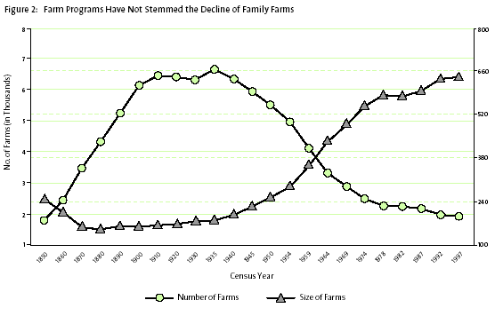
(Environmental Defense, 2001).

References

Daly, Herman E. and Farley, Joshua, 2004. Ecological Economics: Principles and Applications. Island Press, Washington DC.

Environmental Defense, 2001. “Food for Thought: The Case for Reforming Farm Programs to Preserve the Environment and Help Family Farmers, Ranchers and Foresters.” Environmental Defense, Washington DC.

Greider, William, 2000. “The Last Farm Crisis”. The Nation. http://www.thenation.com/doc.mhtml?i=20001120&s=greider

Westcott, Paul C., Young, C. Edwin, and Price, J. Michael, 2002. “The 2002 Farm Act: Provisions and Implications for Commodity Markets”. ERS Agriculture Information Bulletin No. AIB778. 67 pp.

