Wind Rent: Possibilities
Susan Skalka
April 2008

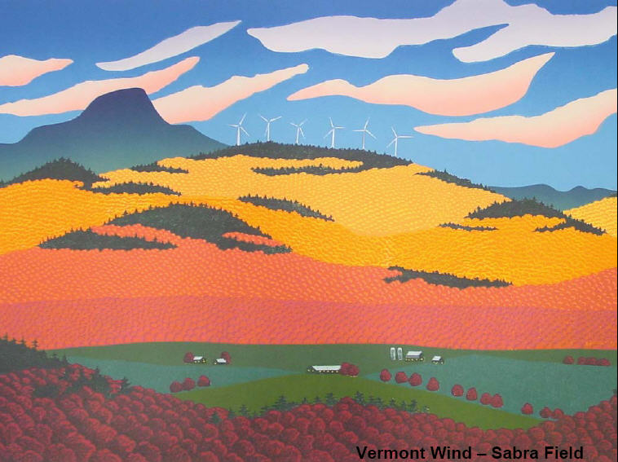

Introduction

The idea of understanding certain assets as public and part of ‘The Commons’ in order to then extract value for the public in terms of public revenue and conservation is gaining recognition in policy discussions, as the syllabus for PA 395/NR 385-Valuing Common Assets for Public Finance in Vermont states. Quantitative research on the value of common assets is needed to provide policy makers with the details needed for policy discussions.
In my last paper, I described the current state of the wind industry and the existing and proposed wind facilities in the state of Vermont. I found that public revenue is generated primarily in the form of property tax payments based on the value of the land and equipment. A new bill has been signed that will change the way that taxes are calculated on the wind industry (for new facilities). Under the new model the tax is based on the Kilowatt hours produced. In this paper, I will explore alternative methods for capturing public revenue based on the economic rent earned by the wind industry.
With the high startup costs typical of a new industry, with oil prices still relatively low, and with the existence of government price caps, there may not currently be a large profit margin in the wind industry. However, oil prices could quickly go up, laws, taxes, regulations and incentives could change to make wind energy more lucrative, or conceivably other types of events or disasters could occur which could lead to an increased demand and thus higher prices for energy produced by wind. Since there is a limited amount of oil, it is quite likely that at some point in the future, wind energy will become more valuable. Therefore, Vermont should be prepared to be in a position to take advantage of that when the time comes.

Philosophical Justification
Before turning to possible approaches to collecting ‘rent’ from the wind industry, it is important to discuss the justification for such a proposal. First, ‘economic rent’ is defined as “the financial surplus created by the exploitation of natural resources, over and above the costs of exploitation (which include ‘normal’ profits). Under the democratic theory of rent, governments should maximize their collection of rent to benefit the public, who own the resources. However, under the liberal theory of rent, public resources should be made private and rent should remain in private hands. Wind is a naturally produced asset, since no human can claim to have produced it. Likewise, ridgelines and viewscapes could be considered common assets to be shared by all, even if not owned publically. Wind flowing across or above land is comparable to water in a river or stream flowing across land, and surface water is already considered a public asset. Finally, wind is an asset that can be used to produce energy, just like oil, and if Alaska can take royalties on oil profits, taking royalties on wind profits would be analogous. Finally, if we take the analogy to an extreme, if wind energy were the only source of energy for electricity production and thus the demand was very high and all the profits went to the wind-power producers, they would be in a similar position as the oil industry is now in, where they are able to make huge profits based on the usage of common resources, which seems rather unfair. In sum, conceptually the idea of capturing economic rent from the wind industry seems to have solid justification, and there has been precedents for the similar capture of rent in other industries, namely the oil industry.

Economic Rent in the Wind and Oil Industries
Economic rent in the wind industry could be defined as the profits that would be made over and above the ‘normal’ profit, that which results from price changes that have nothing to do with the amount of effort put into the production of wind energy. For example, scarcity of favorable land or scarcity of energy for electricity could push up the price of wind power and increase profits for a wind company, even if everything else remained constant. Note that wind companies can earn money from the sale not only of the power, but also from the sale of RACs- renewable energy credits, whose value can also vary for similar reasons. This is very similar to how economic rent is conceived of in the oil industry. This quote describes rent in the oil industry:
In the context of the oil and gas industry, economic rent is the difference between the cost of exploration, field development and extraction, and the final market price. According to Mr. Warnock, "These costs include a normal rate of return on investment." In other words, oil and gas companies have already made their profits even before the calculation of rents. The remaining economic rent is extremely valuable. It's up for grabs, and who gets it and in what proportions becomes a political contest between public authorities and private interests.

Of course, there are differences between the oil and wind industries. First, wind energy is renewable and wind turbines do not deplete natural resources. Secondly, wind energy has few negative externalities unlike the oil industry. Thirdly, the wind industry is just getting started and has a lot of start-up costs right now while the oil industry has already paid off most of the big initial investments. For these reasons, Vermont and other governments may be hesitant to impose additional fees or royalty schemes on this industry which most agree should be encouraged. The new law which will tax energy production instead of profits arguably does not encourage increased production since it imposes a cost on production instead of taking royalties off of the top of profits. Vermont should encourage the production of this renewable source of energy that has few negative externalities. As this quote illustrates, we do not know exactly what the future might bring:
One can guess (based on experience with other technologies) that the eventual push to full commercialization and deployment of the technology will happen in a manner that no one can imagine today. There will be a "weather change" in the marketplace, or a "killer application" somewhere that will put several key companies or financial organizations in a position to profit. They will take advantage of public interest, the political and economic climate, and emotional or marketing factors to position wind energy technology […].

We need to be prepared for the future where the wind industry is more firmly established by having the fiscal structures in place for the State of Vermont to be ready to benefit along with the wind industry from increased profitability in the wind industry.
Methods
There are numerous fiscal structures that can be used to capture economic rent. Many of these are illustrated in the oil and gas industry. Of course, rent capture is much easier in state-owned enterprises, but that is not the direction we are going in Vermont. Royalties taken can vary, for example in Saskatchewan the Heritage fund captures less than 14% of sales yet other countries capture as much as 50% of sales in the OPEC countries. Some argue that the economic rent capture should vary based on the state that a project is in. Initially, the rent capture should be low so that the facility can become established, then after it is established the royalties collected should increase. As the facility ages, it might be necessary to drop the royalties collected in order to allow the facility to make capital investments as the equipment ages and needs replacement.
Another method that a number of counties use in the oil industry is known as a progressive profits tax (PPT) in which the percent of royalties collected rises as profits do. For example, in OPEC countries, as the international price of oil increases, the share going to the government increases, and they are thus able to capture almost all increases in economic rent, according to Petroleum Intelligence weekly. In Ecuador, the government created an excess profit tax which yields the government 50% of all gross income when the international price of oil rises faster than a threshold level set by the state. The graph below illustrates how this might look.

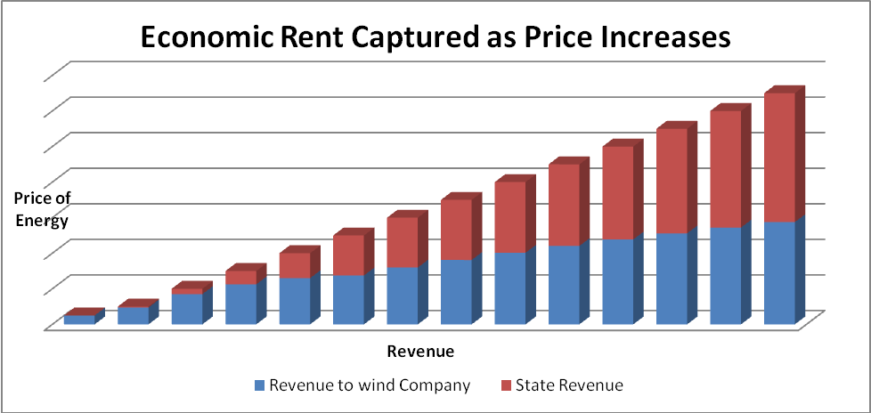

A similar model could work for the wind industry in Vermont. A fiscal structure that includes the following should be considered:
- After profitability reaches a certain level, royalties must be paid to the State or to a particular fund that is set up. The usage of this revenue/ the fund would have to be determined.
- The percent of royalties taken should increase as profits increase.
- The fiscal structure should take into account the state of the facility: new projects that are just getting started would have to pay less in royalties than those more firmly established, and those that are aging would also be given breaks.

Note that there are many mechanisms for encouraging renewable energy production, such as feed-in tariffs that force utilities to pay a higher price for renewable energy, thus increasing the income of the renewable energy generators while distributing the increased cost over all consumers. While this is a good incentive structure for increasing the production of renewable energy, it is not necessarily a method of rent-capture, which is what I am exploring in this paper.

Conclusion
Before any exact numbers could be determined, an economic analysis would be necessary to determine what constitutes normal profits, when the industry is expected to become profitable enough for the State to start capturing economic rent, the effect of price and profit caps on the electricity market, the effect of existing subsidies, and predicted future prices for other sources of electricity production. We would also need to determine how a similar setup could be applied to the sale of RACs, but again, analysis would be needed to determine the best way to do this, if is indeed feasible. In conclusion, economic rent from the wind industry does seem to be a potential source of revenue for the state or the citizens of Vermont. Given the complicated and changing nature of the energy industry, more analysis is needed. My recommendation is that more research be done by those that are familiar with the economics of the utility and energy industries.

Selling the Family Silver: Oil and Gas Royalties, Corporate Profits and the Disregarded Public.
Ibid.
Ibid.
Open Spaces. 11/29/2006. Downloaded March 28th, 2008 from http://opening-spaces.blogspot.com/2006/11/so-where-does-that-oil-and-gas-rent.html
The Future of Windpower. Downloaded April 5th, 2008 from http://www.telosnet.com/wind/future.html.
Ibid. p. 28.
Ibid. p. 30.
Ibid. p. 61.
Ibid. p. 63

