Ida Kubiszewski
03.25.2008
Draft: Current status of Internet in Vermont

Internet service providers
Wiring
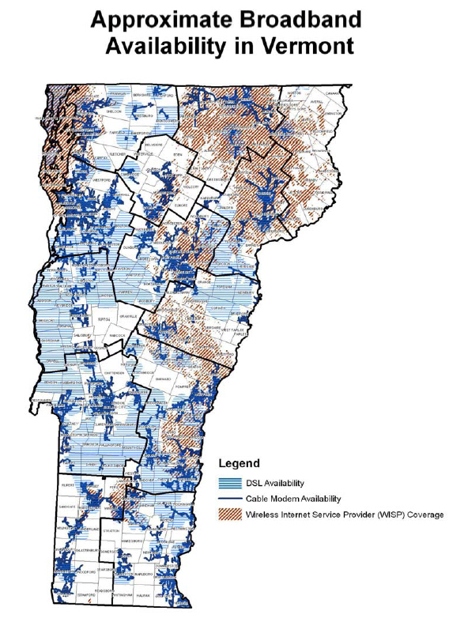
There are different scales of internet conduits. There’s the backbone of the internet which is created of national, central connection which caries large volumes of internet traffic. There are usually owned by wholesale companies. There are those connections which link the backbone to very local networks, these are known as the “middle mile.” Depending on the density of the region and size of local companies, the “middle mile” may be owned by either a wholesaler or one of the ISPs. The final span are connections from the conduits into a local area to the individual homes, called the “last mile.” These are put in by ISP companies or the government. Current price of cable placement is around $20,000 per mile.

In Vermont, access to poles is regulated to allow pole owners to only charge a rate depending of the amount of space used on the pole. In Burlington, the city only owns 33% of the poles and partially owns the rest (55% ownership) with Verizon owning the remaining percentage. Any additional cabling placed on to the poles requires negotiating with Verizon, even if that cabling is being placed by the city of Burlington.

Regulations
The Federal Communications Commission (FCC) has designated internet services as inter state information services and hence prohibit Vermont from regulating them. The Federal Cable Act also prohibits Vermont from requiring specific infrastructure investments. To encourage ISPs extend their availability, in 2006 the public service board of Vermont allowed Verizon leeway in the type of technology used and areas it provides converge in exchange for Verizon providing 80% availability by 2010. The public service board also restricts the cost an ISP company can put on a customer for each mile that the company has to extent cable.

To encourage the development of independent companies, companies in Vermont are part of the National Exchange Carrier Association (NECA) which helps independent companies pool their costs and revenues, making transition between carriers simpler. The NECA is mostly for phone companies, but broadband internet often is provided by telephone companies.

“The 1996 Telecommunication Act requires Verizon to lease its lines to competitors at whole sale rates.” However, because the act requires geographically de-averaged wholesale rates, many small competitors are still unable to afford these prices within rural areas. This act however does make competition viable in more populated areas.

Public
Many towns around the country are establishing their own telecommunication services which are privately financed but for public use. Through this network, the town of Burlington will provide its residence with internet, phone, and television cable services. However, this network is also free for use by any other company wishing to provide competing services. “This is similar to a City providing public roads while also providing basic bus service as well. Citizens and businesses can use the bus service or they can use the roads to provide their own transportation.”

Currently Burlington is the only city in Vermont with a public telecommunications network primarily due to the affordability for the city with its greater density of residents. However, communities like Montpelier and Rutland are negotiating joining the Burlington network as a means to reduce their own initial costs.

Public Revenue
Burlington has approximately 18,000 homes and 2,500 businesses. As of August 2007, approximately 1,800 Burlington subscribers signed up for Burlington Telecom. This shows that business make up about 14% of potential customers. With an average revenue of $77 from residents and $243 from business per month, and using the percentage of potential subscribers, Burlington Telecom makes approximately $61,236 from businesses and $119,196 from residents each month, for a total of $2,165,184 annually. The rate of growth at the time was approximately 40 new subscribers per week.

Burlington estimates that the revenue from the telecommunication services can eventually provide, after the debt is paid off, more than 20% (predicted to be around $15 million/yr) of the city’s general fund.

Private
Revenue
Knowing the United States and Vermont population size and the amount of internet users in the U.S. in 2005, we were able to determine that there are approximately 425 thousand internet users in Vermont. Knowing the total revenue of internet service providers (ISP) in the United States in 2006 was $10 billion, and using the percentage difference between U.S. and Vermont populations, we were able to determine that the revenue made by Vermont ISPs was approximately $21 million.

 | United States | Vermont
Population | 299,093,237 | 623,908
Internet users | 203,824,428 | 425,177
Revenue | 10,339,000,000 | 21,567,137
* numbers in blue were calculated

Expenses
There are two major expenses for an ISP within a region. First is the initial investment into the infrastructure to provide the availability to each home and business. ISPs, in certain circumstances, have to put in the “middle mile” to provide access to a region and then place the “last mile” of cables. Installation of the “last mile” may also require buying pole space or installing new ones. The other is the cost of hooking up to the backbone conduits. ISPs much buy access to the backbone from the wholesalers. The creation of the cable infrastructure, cost to customers is highly dependent on density of the population and completion between ISPs. An influx of ISPs in recent years decreased the price of high-capacity Internet access delivered to locations in Vermont from $300 per Mbps per month to about $100.

This financial structure may change as the private companies begin utilizing the already installed fiber cable infrastructure being put in by Burlington Telecom without a fee.

Domain name registration
Process
A domain name registrar is a company accredited by the Internet Corporation for Assigned Names and Numbers (ICANN) to register Internet domain names. ICANN is a non-profit corporation which oversees various internet related industries on behalf of the U.S. government, specifically the Internet Assigned Numbers Authority (IANA). Currently, approximately 1,000 accredited domain-name registrars exist. However, ICANN contracts out the management of the .net and .com domains to VeriSign, a company out of California.

Under the Shared Registration System (SRS), a user chooses which registrar they use for their domain name, and may switch any time. The domain names which are under the management of ICANN and that a registrar register are: .aero, .biz, .cat, .com, .coop, .edu, .gov, .info, .jobs, .mobi, .mil, .museum, .name, .net, .org, .pro, and .travel.

Revenue from Vermont domains name registration
Due to lack of available data, an exact number of domain names registered in Vermont for 2007, was not available. However, the number of .com domains in Vermont in July of 2001 and the number of registered domain (.biz, .info, .org, .net, .com) names in the world in 2001 and 2007 was attainable.

Table 1: Number of registered domain names
 | Total | Biz | Info | Org | Net | Com |  | Coms % of total
7/14/2001 | 30,089,731 |  |  | 2,833,781 | 4,404,308 | 22,845,079 |  | 75.7%
10/15/2007 | 96,946,506 | 1,860,669 | 4,981,597 | 6,194,878 | 10,476,009 | 73,433,353 |  | 75.9%
Jul-01 | 46,527 |  |  |  |  | 35,325
Oct-07 | 149,907 |  |  |  |  | 113,814
growth rate | 222% |  |  |  |  | 221%
* numbers in blue were calculated

This allowed us to determine the number of total domain names registered in Vermont in 2007 to be approximately 150,000. Assuming an average cost to users of registering a domain name per year is between US$10 and US$30, we can find that the total annual revenue from the registration of domain names is approximately US$3 million.

Expenses
Each ICANN-accredited registrar pays a fixed fee of US$4,000 plus a per-registrar variable fee totaling US$3.8 million divided among all registrars. For every .com registered for a user by a registrar, the registrar has to pay an annual fee of US$6.00 to VeriSign and US$0.25 administration fee to ICANN. Other expenses outside of fees that the registrars have include daily operation costs such as personnel costs, hardware and supplies, purchased services, and others.

http://www.newrules.org/info/bt.pdf
http://publicservice.vermont.gov/Broadband/Broadband%20Deployment%20in%20Vermont%20Final.pdf
http://publicservice.vermont.gov/Broadband/Act172FinalReport.pdf
http://publicservice.vermont.gov/Broadband/Broadband%20Deployment%20in%20Vermont%20Final.pdf
http://www.burlingtontelecom.net/aboutus/
http://quickfacts.census.gov/qfd/states/50000.html
http://www.internetworldstats.com/am/us.htm
http://www.census.gov/
http://en.wikipedia.org/wiki/Domain_name_registrar
http://www.icann.org/registrars/accreditation-qualified-list.html
http://en.wikipedia.org/wiki/GTLD
http://www.zooknic.com/Domains/alpha.html
http://www.zooknic.com/Domains/counts.html

