Green Taxes for the Green Mountain State-draft
Green Tax committee:
Gary Flomenhoft, Research Associate, Gund Institute
Robert Costanza, Director, Gund Institute
Deb Brighton, Legislative analyst
Janet Milne, Director, Vt. Law School Environmental Tax Policy Institute

Background
Green taxes are growing worldwide as a method to raise governmental revenues and address environmental and social issues simultaneously. It is well known that various forms of taxation have widely different incentive effects depending on what is taxed. An endless array of tax reductions in the forms of tax cuts, tax credits, subsidies, and deductions are used to stimulate various sectors of the economy. Choosing what item to tax and which to exempt from taxes allows a double policy tool of incentives. Taxes generally add to production costs, thereby raising prices and reducing consumption of the item taxed. For example, taxes on cigarettes or gasoline decrease consumption of these items by raising their price. The level of decrease depends on the sensitivity of demand to price (elasticity). Taxes on income and wages are believed to decrease the supply of jobs by increasing the cost of labor.

Since taxes decrease consumption of the item taxed, a sensible strategy is to tax undesireable activities more, and desireable activities less. This leads to the Green Tax philosophy of “taxing bads, not goods”, or “taxing waste, not work”. If work, income wages, and investments in productive activities are taxed less, these items will be encouraged. If resource use, land use, and pollution are taxed more resources will be conserved, land will be used efficiently and industry will avoid pollution. This allows taxes to be used as a precision instrument, rather than as a bludgeon.

European Green taxes
The concept of Green taxes is gaining ground worldwide, particularly in Europe. Details of the growing trend of European Green Taxes is shown in the graphs below:

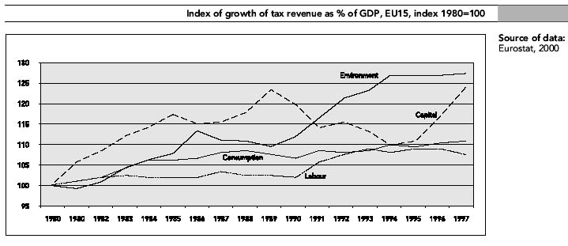
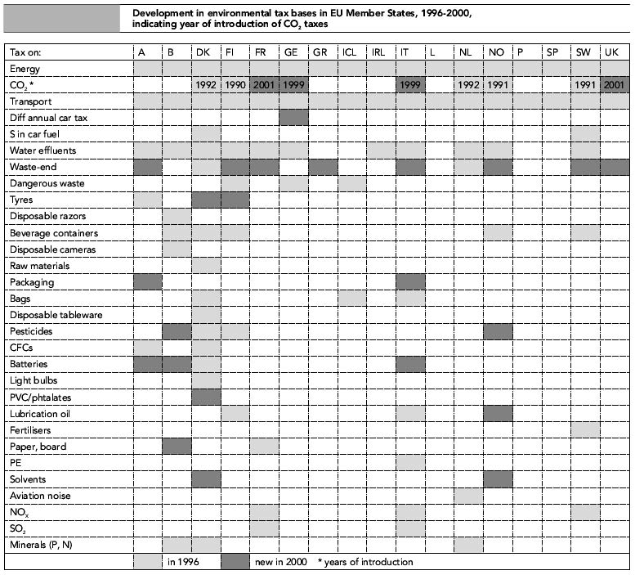

Getting prices right
A crucial aspect of green taxes is their ability to begin to include the uncounted external costs of environmentally damaging activities into the price of products. Currently many damaging externalities of pollution, such as emissions from burning gasoline in motor vehicles, are not included in the cost. This puts the burden of costs on society, rather than on the user of the product. This violates the “polluter pays” principle, and leads to distorted prices which provide false information to consumers. Even worse, many polluting activities are not only untaxed, but have large subsidies distorting the price even more. Using the example of gasoline, various studies have calculated from $3 to $15 per gallon of uncounted environmental costs. By artificially lowering the actual cost of gasoline, over-consumption results, as demonstrated by the decline in US average vehicle fuel economy since 1982. Green taxes at one level of government could compensate for subsidies at other levels. For example federal oil industry subsidies, combined with a state green tax on carbon would basically redirect lost federal revenue to the state level.

While oil industry subsidies might benefit industry in oil refining states, little or no benefit accrues to states such as Vermont, with no fossil fuel refineries or industry.
So it is appropriate that the loss of federal revenue and increase in local environmental impacts due to lower prices of fuel is compensated by a state Green tax.

An even better example might be the 80% of mercury pollution in Vermont which comes from out of state coal burning power plants. Very little or no electricity in Vermont comes from coal, yet Vermont suffers the damage. A VT carbon tax or green tax specifically targeted at coal, would make coal produced power more expensive and less used, at least in Vermont.

In Vermont, nearly 10% of state revenue is already collected from taxes that have been categorized as “green” by the Vt. Fair Tax Coalition. (See chart of VT Green taxes-attached)

Proposal
The Green tax committee proposes to calculate the details of a complete Green tax shift for Vermont. The study from the northwest US done by NW Environmental watch can serve as an example for the type of information which would be provided by this study.

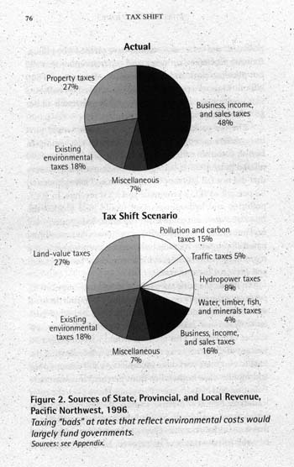

This Vermont study would provide details of a “revenue neutral” tax shift, providing exactly the same revenue, but deriving all revenue from taxes on damaging rather than productive activities. An assessment of effects and impacts could also be included.

Some of this work has already been completed in Deb Brighton’s publication “Taxing Pollution” and the Central Research Group study of a shift in Vermont property taxes to land. These studies would be integrated with additional analysis needed to provide a complete Greent Tax shift scenario for Vermont.

Purpose of Study
Many Green taxes are already in place and working well (See attached list of Vt Green taxes). Some new green taxes, such as carbon taxes, are considered inevitable. Both the Carter and Clinton administrations attempted unsuccessfully to introduce forms of national energy or carbon taxes. Other green taxes are both desireable and beneficial. Policy makers in Vermont need to have this option available to them, whether by choice or by necessity. Much good work has been done in the past by the Vermont Fair Tax Coalition and others. It is important to keep the momentum going towards green taxes in the Green Mountain state.

References

Brännlund, R., Gren, Ing-Marie (eds) Green Taxes; Economic Theory and Empirical Evidence from Scandinavia. Edward Elgar Publishing, Cheltenham, UK. 1999.

Durning, Bauman. Tax Shift. Northwest Environmental Watch. April 1998.

European Environment Agency. Environmental Taxes, Recent Developments in Tools for Integration. . Copenhagen. 2000

Hausauer, Brenda. Tax Reform that Agrees with Vermont, Vermont Fair Tax Coalition, March 1999.

Milne, Janet. "Environmental Taxation: Why Theory Matters", in Janet Milne et al., editors, Critical Issues In Environmental Taxation: International And Comparative Perspectives, Vol. 1 (Richmond Tax & Law 2003), pp. 1-26.

OECD. Environmentally related taxes in OECD countries: Issues and Strategies. Oct. 2001

OECD. Environmental Taxes and Green Tax Reform. Jun-1997

Ramos, Brighton. Taxing Pollution. Vermont Fair Tax Coalition. Winter 2000.

