PA395 Green Taxes
Prof. Flomenhoft



John Mejia

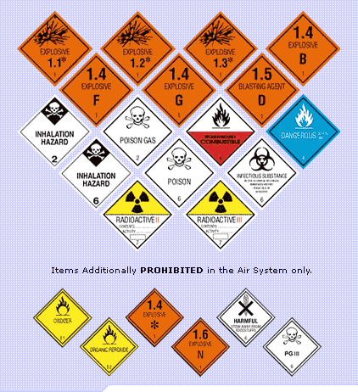

Global and Local

Use of

Hazardous Materials and Waste
Taxes and Fees

John Mejia

Hazardous Materials

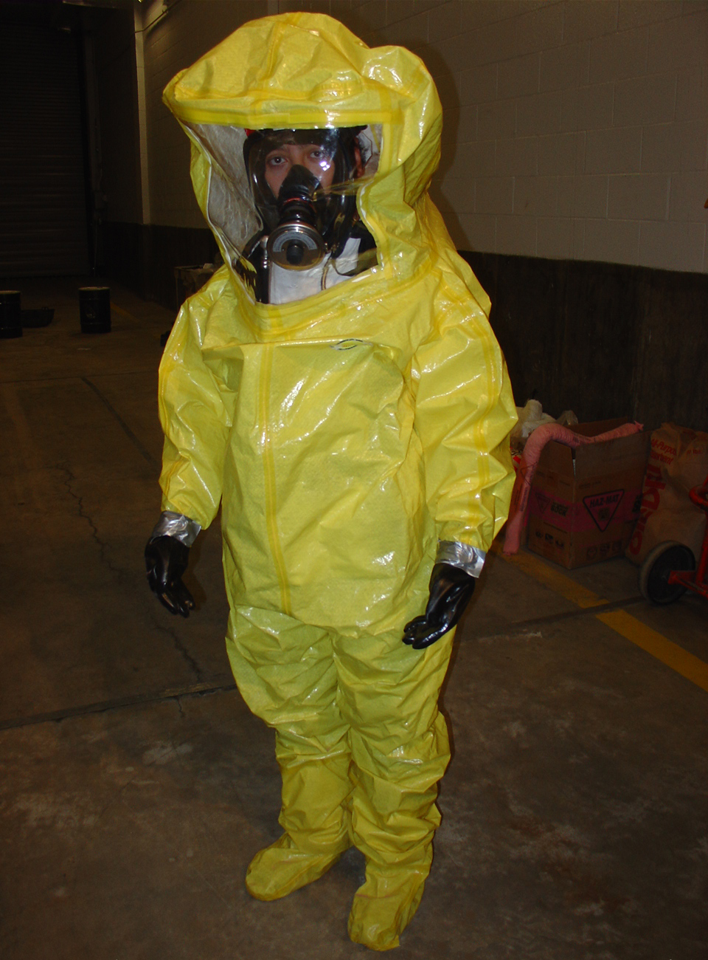
To most layman hazardous materials conjure up images of chemicals that can kill with a single drop (in fact this doomsday view was used to great advantage by Secretary of State Collin Powell in his presentation to the United Nations in the lead up to the Iraqi War). They are seen as connected directly to warfare or sabotage. The reality is that many of the industrial processes that make the modern materials, which make life comfortable (in the short term at least) use hazardous materials as important components in their manufacturing and then produce hazardous waste as a by-product. The reality is that pesticides, fertilizers, refrigerants, even something as ubiquitous as crude oil, in the wrong place or quantities, are considered hazardous materials.
This has to do with its toxicity, the ability of the substance to cause harm. Water in high enough quantities is toxic to individuals (you would have to ingest gallons for this to be true). On the other end of the spectrum are substances like dimethyl mercury, which has literally killed people with drops-worth of exposure. Thankfully the majority of hazardous materials fall somewhere between these two extremes. What this means in practical terms is that the job of protecting not only individuals but the environment from this sort of danger is extremely complicated and not without controversy.
Although different nations have different definitions of what a hazardous material is, most use simple list of chemicals that come under regulation and/or taxation. In this country the responsibility for monitoring and mitigating the danger of these materials/waste falls upon three different organizations.

John Mejia

EPA

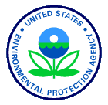
The first is the EPA, whose organization and responsibilities are listed under Code of Federal Regulations, specifically 40CFR. Section 261.3 of 40CFR defines hazardous waste and the agency’s responsibilities towards these substances. Although the mission of the EPA is “to protect human health and the environment” their focus and main activity is remediation. Although they do have regulatory authority on producers of hazardous materials and waste, the fees and fines they impose are used mainly to fund clean up activities. The most well known program administered by the EPA is the “Superfund”. Created in 1980:
The Comprehensive Environmental Response, Compensation and Liability Act (CERCLA) was passed by Congress in 1980 to provide funding to clean up these facilities and waste sites. As part of the act, a trust fund of $1.6 billion was authorized over five years. Since then, Congress has twice re-authorized CERCLA, increasing funding from $1.6 billion to $13.6 billion. These funds are to be used to help clean up abandoned and closed hazardous waste sites that are placed by the EPA on a national priority list if they meet certain conditions under a hazard ranking system. About 70 percent—more than $20.6 billion—of total cleanup costs, however, have come from the responsible parties.

This trust is what is commonly referred to as the Superfund. The reality is that it is not super at all, either in scope or in size. Rather than reauthorizing a variety of “polluter pays” fees on the purchase of chemicals and petroleum on large chemical companies to help fund the program congress allowed this source of funding to lapse. As of this year the program can only follow through on no more than 20% of their obligations with the shortfall eating away at the trust. In fact, a recent Inspector general report “found that 78 Superfund sites that had requested funding in FY 2002 received either no or partial funding”.
In fact a scarier statistic is the makeup and distribution of these superfund sites. “Industrial solvents are present at 87 percent of Superfund sites; inorganic compounds, including lead, at 87 percent; and pesticides, at 50 percent. All told, 1 in 4 people in the U.S.—including 10 million children -- live within four miles of a Superfund toxic waste site”. The reality is that the “polluter pays” fees were not a positive influence since they were used only to cleanup after these industries own pollution. These fees were not used as a deterrent to utilizing hazardous materials in the first place (or used to reward industries that minimized or eliminated their use of these materials and hence production of this waste), which is where fees/taxes would be most effective. At this point, even this cost is now being borne by the victims of industrial pollution rather than the perpetrators. The Superfund program as it exists today is a miserable failure although without it even more unregulated hazardous waste sites would be polluting the air and ground water.

DOT

The Department of Transportation looks over the transport of all hazardous materials and waste that travel on our nations roadways, rivers and railways. The DOT was established by an act of Congress on October 15, 1966. The mission of the Department is to:
Serve the United States by ensuring a fast, safe, efficient, accessible and convenient transportation system that meets our vital national interests and enhances the quality of life of the American people, today and into the future.
Within the context of this mission the DOT makes registration fees mandatory for all persons transporting hazardous materials or waste. In 1999 the fee was $300 for those who qualified as Small Businesses and $2,000 for all others. Currently fees have been reduced to $150 for Small Businesses and $300 for all others. This reduction was an effort to increase the number of people registering. Unfortunately, these fees also go into a trust that funds the National Hazardous Materials Emergency Preparedness Grants Program. In essence these haulers are simply putting aside money for the inevitable accident that will lead to an uncontrolled release of these hazardous materials. It is also interesting to note that shipments of pesticides are in many cases exempt from these provisions, especially since as noted above pesticide contamination is present at 50% of Superfund sites!
In essence the DOT has a list of forbidden materials that qualify for these regulations. These regulations include placarding shipments, detailed manifests, and especially trained drivers. Again, it does not make sense to penalize the transporters of hazardous materials/waste since they are not the ones making the most profit from these substances. In fact, it seems unfair that haulers should be charged fees, beyond those already present to discourage shipment of these materials, when the producers of these materials/waste are not charged at all. It is important to point out that again these fees are not used to encourage the use of less hazardous alternatives but rather simply to cover the cost of the physical cleanup.
And even succeeding with this objective is not possible. This is because fees do not come close to covering all of the externalities of these accidents create including: traffic delays, damage to infrastructure, health problems (both from the stress of traffic jams and from direct exposure), degradation of the environment, etc. In fact, given the EPA’s budgetary constraints even egregiously polluted sites may never be completely cleaned up. The other reality is that materials (contaminated earth, protective clothing, etc.) then must be shipped off again to an approved hazardous waste disposal site creating yet another possibility for accidental release. The answer does not lie with the regulation of the transport of these materials/wastes but with the use of fees/taxes to encourage a reduction in the utilization of the industrial processes that produce them.

OSHA


OSHA’s mission as stated on their website is “to assure the safety and health of America's workers by setting and enforcing standards; providing training, outreach, and education; establishing partnerships; and encouraging continual improvement in workplace safety and health”. OSHA’s definition of hazardous waste is adopted from the definitions used by both the DOT and EPA in an effort to lessen the confusions within the regulatory statutes passed by congress and to make complying with these standards less ambiguous. Whereas the EPA deals with the environment and DOT deals with transportation, OSHA focuses on workplace safety and regulates who can handle hazardous materials/waste and what employers must provide in terms of equipment and training. OSHA is also able to levy fines against companies or individuals that don’t follow their regulations. However these fines range from $100s to $100,000s. Given that some of these companies make millions of dollars in profit a year from cutting corners, this is not much incentive to take corrective actions when they are warranted and before accidents happen.
In addition, OSHA’s limited budget leaves an entire world of sweatshops operating with impunity throughout the US – how well could they make sure that hazardous wastes and materials are being properly used and disposed of? In fact, isn’t it this very failure that necessitates the existence of the EPA Superfund program!? Also, because their emphasis is on worker safety most of their power comes from mandating training or personal protective equipment. In fact, in most cases their most visible impact in the everyday lives is ensuring that workers know the nature of the chemicals that they are working with, if their employers do care about miniscule fines these same workers simply know what harm they are being forced to endure in order to make a living. It in no way limits the use of these highly toxic and hazardous materials in the workplace.

Vermont

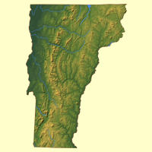
Although Vermont follows the structure of fees/taxes on Hazardous waste by taxing entities whenever hazardous waste is shipped, stored, recycled, treated, or disposed of. Again all of the revenue collected are deposited in the Environmental Contingency Fund and are used for investigation and mitigation of uncontrolled releases. What Vermont does better than the federal government is that they use part of the revenue from these taxes to fund a Hazardous Waste Management Assistance Account, which help “develop hazardous waste plans” for producers.

UVM

To gain perspective it might be useful to take UVM as a case study. The University pays hazardous waste taxes every quarter. “The University is charged $0.03/pound for wastes that are treated and $0.014 per pound for wastes that are recycled. In addition, UVM also pays about $5,000 every 5 years for a permit to be a temporary storage facility while they gather substances for shipment. UVM also pay $1,500 per year for pollution prevention reporting fees, $10 per year per vehicle for waste transporter fees, and $400 per year for hazardous waste generator notification update fees”. What is most striking is that hazardous waste charges are so low. Part of the argument is that these low fees give people incentive to participate and keep them from illegally dumping. These fees do address the issue of the cost of properly transporting, recycling, and disposing of these substances. Why isn’t there a fee associated with its original use? By taxing or imposing fees on companies that use or make these hazardous materials before they become waste we would lessen the need for special disposal sites downstream and also stop the flow of these materials out of plants and through our nation’s highways and waterways, thereby reducing the possibility of uncontrolled releases during our evening commute. Wouldn’t it make more sense to limit the processes that incorporate these substances into their manufacturing strategies rather than penalize the industries that are trying to responsibly mitigate the harmful effects of these materials and their by-products?

Conclusion

It is essential that the federal and state governments take the lead from Europe in the arena of hazardous materials taxes. In Europe these taxes are used to shift the burden from the general population to the polluters. In addition, they use the money to subsidize and encourage the growth of industrial processes that reduce the need for the use of hazardous materials and the waste they produce. This action is not unheard of in the US. In fact, the great success of this kind of “polluter pays” taxation led to the phasing out of CFCs from many manufacturing processes. These “polluter pays” fees, have led directly to the successful phase-out of CFCs on a global scale through participation in the Montreal Protocols. The list of benefits is long and noteworthy, starting with the direct aim which was protection of the ozone layer, and continuing on to direct health benefits, to the creation of new and cleaner technologies, to energy and by extension financial savings to those very industries previously employing CFCs in their industrial processes. Companies that used this destructive materials are actually now saving money after being forced to stop using these substances! Free Market Capitalists against the use of taxes/fees to address all kinds of social problems argue that the least expensive market-dictated adoption of new and cheaper technologies will take care of these concerns – they are obviously wrong because of the fundamental flaw of classical economics – which posits that individuals are rational rather than insane creatures of habit and shortsightedness.
Unfortunately, the federal and state governments have not followed up this success story with any further taxes on hazardous materials/wastes. Without fees/taxes industry and private individuals will continue to poison each and everyone of us without much affect on their bottom line and hence not much impetus to improve their production of hazardous materials/pollutants.

http://www.washingtonpost.com/wp-srv/nation/transcripts/powelltext_020503.html
http://www.ktca.org/newtons/13/hazmat.html
http://www.denison.edu/collaborations/naosmm/topics/dartmouth.html
http://www.access.gpo.gov/nara/cfr/waisidx_01/40cfr261_01.html
http://www.epa.gov/epahome/aboutepa.htm
http://www.texasep.org/html/wst/wst_5iab.html
http://www.epa.gov/superfund/action/law/cercla.htm
http://www.texasep.org/html/wst/wst_5iab.html
http://www.texasep.org/html/wst/wst_5iab.html
http://www.texasep.org/html/wst/wst_5iab.html
http://www.dot.gov/mission.htm
http://hazmat.dot.gov/rules/68fr-1341.htm
http://hazmat.dot.gov/rules/hm208c_1.htm
http://hazmat.dot.gov/cfr_forbidden.pdf
http://www.osha.gov/oshinfo/mission.html
http://www.osha.gov/pls/oshaweb/owadisp.show_document?p_table=INTERPRETATIONS&p_id=19788
http://www.osha.gov/pls/oshaweb/owasrch.new_search_results?p_text=fines&p_title=&in_clause='FULL_SITE'&p_status=CURRENT&p_category=&p_logger=1
Class resource “Fair_Tax.pdf”
Email from Francis Churchill, who is in charge of the hazardous waste disposal for UVM
http://www.epa.gov/Ozone/title6/index.html
http://www.epa.gov/ozone/geninfo/benefits.html
Class Discussion

