Carbon Taxes in Selected European Union Countries:
An Overview of Initiatives

Rachel Weston
PA 395: Green Tax VT
9/21/04

The 1997 Kyoto Protocol has set emissions targets for certain countries to reduce their greenhouse gas production. The Protocol was a response to the 1992 United Nations Framework Convention on Climate Change (UNFCC) which called for “the stabilization of greenhouse gas concentrations in the atmosphere at a level that would prevent dangerous anthropogenic interference with the climate system.” (Bahn)
There are a few policy approaches that a country may employ to meet their set emission targets. 1) A Market based approach; A) a tax may be put on things that would emit greenhouse gasses, such as gasoline, coal, and electricity. The consumption of such goods will decrease with the greater cost and create a demand for renewable non-taxed goods. Revenue from taxes can create a ‘double dividend’ (Bahn) where the environment will improve and so will the tax system. Tax revenue can be used to fund clean sources of energy. B) Emissions credits could be traded from countries that exceed their Kyoto target to countries that have not met their target.
2) Governmental Regulation; the government sets limits for consumption and emissions for industry and possibly citizens. This approach would not seem to work well in democratic countries where such regulations would come under high public and private scrutiny for their encroachment on liberty. (It must be noted that the Clean Air Act won public approval, though industry is still trying to undermine it via Bush’s Clear Skies Initiative)
3) Voluntary reductions through public education; An excellent tool for getting information to citizens. However, this approach alone will not meet the Kyoto target.
For this paper I will be focusing in on methods used to reduce CO2 emissions in Europe, primarily market based approaches.
SWEDEN
Sweden has a high per capita electricity use which is partly due to the “rapid expansion of electric space heating during the 1980’s,” and also due to electricity intensive industry. The Swedish Parliament has fifteen environmental quality objectives, one of which is “to be able to hand over a society to the next generation in which the major environmental problems have been solved.” (Johansson) Thinking into the future, Sweden has enacted a daring energy taxation system to meet this objective.
A carbon tax was introduced in Sweden in 1991. Carbon dioxide emission is taxed at a rate of $150 per ton. Sweden already had energy taxes on fossil fuels that were set up in the 1980’s; they were reduced by fifty percent when the carbon tax was set up. There also taxes on electricity consumption and production. A tax was put onto nuclear electricity production as Sweden does not want to encourage nuclear industry.
Most of the tax burden falls on the general public as Swedish industry receives many breaks from the energy and carbon tax system. (see chart below) Industry does not have to pay energy or carbon taxes on fuels used for electricity production, nor does it have to pay the electricity consumer tax. Industry is required to pay only a value added tax on all electricity consumed and it is given a 50% reduction on the carbon tax rate for fuels used in industry. From 1993 to 1997 they were only required to pay 25% of the rate.

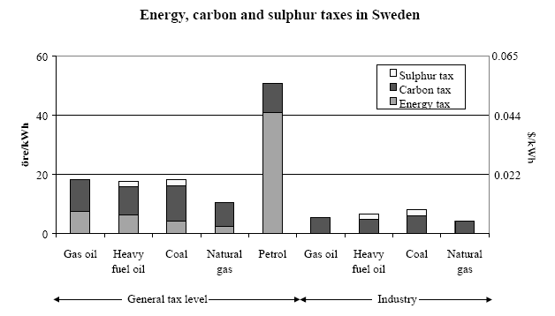
Energy, carbon and sulfur taxes in the energy sector (Swedish Energy
Administration, 1999).

As a result of the energy/carbon/electricity tax system, in 2000 Sweden had reduced its Co2 emissions by 20-25%, measured against the previous policies from 1990. Industry has not responded with large improvements, most likely because it does not feel enough economic pressure due to its exemptions from much of the tax. New technological advances in biomass extraction and the development of a biomass market in the Swedish district heating system have also been a result of the tax system. In 1998, 40% of the energy supply came from ‘clean’ sources (nuclear, hydro, biofuels), with 27% of the energy coming from the renewable sources of biofuels and hydroelectric. Oil products supplied 33% of the energy, with the remaining 7% being listed as ‘other.’ (Johansson)
GERMANY
The German government has enacted ecological tax reform in the form of taxing diesel, gasoline, electricity, and a small tax on heating oil and natural gas. The revenues from these taxes are applied to employers and employees social security benefits, reducing individual payments and allowing business to hire more people. The revenues are also applied to renewable energy. As with Sweden, the tax rate on energy will create a drive for people to conserve more energy to lower their bills. As noted in a document from the Federal Environment Ministry, this “energy saving” activity will create more jobs and economic opportunity in the form of “thermal insulation; development, production, installation, and maintenance of new highly efficient technologies with corresponding export opportunities.” (FEM)
Industry is given exemptions from part of the German eco-tax. Manufacturing, agriculture, and forestry are taxed at 20% of the regular rate and manufacturing can apply for a tax-cap if the new burden is 1.2 xs more than they would have paid out to social security under the old system. Industry is given a reduced rate due to recognition of competition and the ease at which companies may move out of Germany to a more hospitable tax area. Public transportation and public track and rail systems must only pay half of the rate increase on mineral oil tax on fuel for ecological reasons to encourage this kind of transport. Also, people who have solar panels, windmills, and other such renewable sources that generate electricity for themselves are exempt from the tax. Highly efficient gas-steam and combined heat and power plants are granted full exemption from the mineral oil tax “in order to give efficient technologies a competitive boost.” (FEM)
The results of the German ecological tax reform are as follows: Over 200 million Euros per year are spent to promote renewable energies, which is over 20% of the revenue from the taxes. At current rates Co2 emissions will have decreased 2-3% by 2005. 250,000 new jobs were added to the labor market by 2003. Diesel and gasoline consumption decreased considerably for three years in a row (2000-2002), even though the prior trend had been annual increases. Carpooling increased by 25% and rail passengers by 2%. There are more natural gas powered cars on the road. Manufacturers of solar hot water heaters have reported double digit growth.
Believe it or not, insurance companies in Germany are asking for a greater hike of the tax rate. They believe that protecting the climate will result in fewer dangerous weather patterns like hurricanes and floods, and therefore less money that they will have to pay for damages and deaths (Green Budget Germany).
ENGLAND
England began a system of carbon taxation on April 1, 2002, called Climate Change Levies. This system taxes the use of electricity, gas, and coal by industry and the public sector. The general public is not levied as it was determined that this system would be very regressive due to the poor construction and insulation of many British homes. As a result of this system, it is expected that CO2 emissions from industry and the public sector will decrease by 10% in 2010. In fact, the percent decrease may be higher as it is reported that in 2002 these sectors decreased their emissions “almost three times above target.” (Jørgensen)
IRELAND
Much debate has gone on in Ireland these past months about a carbon tax proposal that would increase household taxes by an average of 246 Euros yearly. (Europe Intelligence Wire) However, it was announced last week that plans have been scrapped for a carbon tax, and Ireland will continue on as before

DENMARK
Carbon taxes in Denmark were introduced in 1992. The charges are twice as high for households as for businesses: $14.30 per ton of CO2 vs. $7.15. Refunds are available for industry only if "reasonable" energy efficiency investments are undertaken.
Conclusion
Each country that enacts a form of carbon taxation has a set of values for what they wish to achieve through them. For some it is climate change alone, but for most it is a political/cultural mixture of fiscal reform, job creation, technological innovation, environmental protection, and looking out for future generations of humans. Finland, Sweden, the United Kingdom, Denmark, Norway, the Netherlands, Slovenia, Italy, and Germany have all enacted some form of eco-taxation that is meant to curb Co2 emissions. For comparisons sake I have included a chart (below) from the OECD to show the percentage of GDP that is revenue from eco-taxes. Denmark has the largest revenue coming from eco-taxes at five percent and the United States has the smallest at just under one percent. Armed with the above information about positive experiences and outcomes that many EU countries have had with carbon taxes, the United States can learn from them and institute similar policies using Europe’s progressive success as a model.
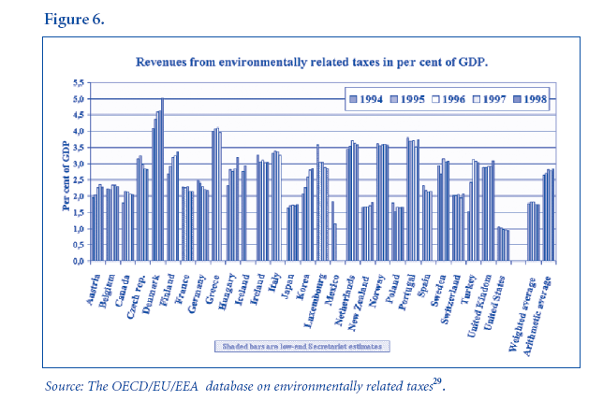

Bibliography
Bahn, Oliver. “Combining Policy Instruments to Curb Greenhouse Gas Emissions,”
European Environment, issue 11, pg. 163-171, 2001.
Dyck-Madsen, Søren, Global Environmental Problems can be Solved Using Economic
Instruments :Green Tax and Budget Reforms in Europe and Public Acceptance.
The Danish Ecological Council, 2003. www.ecocouncil.dk.
“Environmental Effects of Ecological Tax Reform,” Green Budget Germany. 1/2002
Federal Environment Ministry (Germany), “ The Ecological Tax Reform: Introduction,
Continuation, and Further Development to an Ecological Financial Reform.” 1/03
Hopkins, Philip, “ New Carbon Tax on Fuel Need Not Hurt the Poor,” Europe
Intelligence Wire. July 22, 2004 pNA.
Johansson, Bengt. “Economic Instruments in Practice 1: Carbon Tax in Sweden.”
Swedish Environmental Protection Agency.
Jørgensen, Christian Ege, Environmental Fiscal Reform: Perspectives for Progress in the
European Union. European Environmental Bureau, 2003/006, June 2003.
Symons, E.J., Speck, S., and Proops, J.L.R., “ The Distributional Effects of Carbon and Energy Taxes: The Cases of France, Spain, Italy, and UK,” European
Environment, issue 12, pages 203-212, 2002.

