The Digital Triple Bottom Line
Sustainability through Information Technology



Alex Ache
PA395 Gary Flo
Final Paper
July 6, 2003

“The World will benefit when economy supports well-being.”
- Brooklyn Bridge (NGO Mission) ¹³

INTRODUCTION
The term triple bottom line was coined by a for-profit NGO called “Sustainability”. The theory behind the triple bottom line approach is to allow corporations to grow in value in three dimensions. The idea is to allow firms to focus on not only economic value, but also environmental and social improvements as well. The firm must also consider any value lost as in these areas. Thus the ‘triple bottom line’ approach is a framework for measuring and reporting corporate performance against economic, social, and environmental parameters. Each parameter represents one of the three bottom lines. ¹⁶
It is plausible that these three parameters can conflict with one another. In this respect, the firm must make strategic or tactical decisions. For instance, we see that some companies will promote eco-efficiency, when economic and environmental goals conflict. However, there are other challenges such as environmental economics and accounting, shadow pricing, and ecological tax reforms that could also come into play. ¹⁵ When social and environmental goals overlap, we see that some businesses will work on environmental literacy and training. But challenges of environmental justice or environmental refugees are still not addressed. ¹⁶ In the economic versus social frontier, some companies are looking at the social impacts of proposed investment, but issues like business ethics, fair trade, human and minority rights, and stakeholder capitalism are still called into question. ¹⁵
This paper focuses on the triple bottom line approach and how it can flourish as a viable business model with the help of the Information Technology (IT) industry and the Natural Step method. The IT industry has provided the world with new opportunities to increase productivity, communicate globally, and process data. However none of these advancements have significantly our ability to maintain sustainability in economical, social, and environmental terms. ¹³ With the help of some NGO’s such as Sustainability, Brooklyn Bridge and The Natural Step, a social movement may be under way to transform the global capitalist economy and its mechanistic world view into a sustainable economy and process-oriented ecologically-based science.
SUSTAINABILITY THROUGH TRADITIONAL MEANS
According to the Brundtland report of 1987, sustainability is defined as “Meeting the needs of the present generation without compromising the ability of future generations to meet their needs”. ¹⁵ In this sense we see that sustainability is a middle of the road approach that appeals to many. It is conveniently centered on the impact to humans and their ability to meet their needs. However, needs are often similarly confused with wants. Table II in Appendix A shows various aspects of the environmental sustainability movement. ¹⁵
Unlike green politics and ecofeminism, which are primarily concerned with the contradiction between production and reproduction, the sustainability movement tries to address the contradiction between production and ecology by making production ecologically sustainable. The sustainability movement is rather diverse and can have a wide variety of political and ethical viewpoints. It has typically been viewed as taking into account deep ecological and socialist ecological theory. ¹⁵ (see Table I of Appendix A) However, with the triple bottom line approach we see the sustainable development movement tying directly into egocentric and self-interest goals. This is represented by the red arrow in Table I. By using sustainable methods to produce the maximization of self interest, we unite the two philosophies into the common good. ¹⁵
Orthodox methods of sustainability are used in sustainable agriculture, biological controls, restoration ecology, and bioregionalism. But in 1983, the UN created the World Commission on Environment and Development. It developed a plan in 1987 called Our Common Future. It contained issues pertaining to species preservation, energy, urbanization, industry, food, population, and peace. The report contends that economic growth depends on two things: the sustainability of ecosystems involved in exchange, and equity and an end to dominance in the basis for exchange. This focuses on the problems created with the development of “Third World” countries whose income primarily repays debt and neglects environmental issues. One interesting statement that the committee states is that “When transnational corporations introduce new technologies (IT), plants, processes, into developing countries, they should adhere to codes that deal explicitly with the objectives of environmental sustainable development.” This is basis for my “Digital Triple Bottom Line”. ¹⁵
SUSTAINABILITY THROUGH NATURAL STEP
TNS
The Natural Step Foundation is a non profit international organization whose goal is to “accelerate global sustainability by guiding companies and governments onto an ecologically, socially, and economically sustainable path.” They work with large resource users to create solutions, innovative models and tools that will lead the world to a sustainable future. The foundation was founded in 1989 by a leading Swedish Oncologist Dr. Karl-Henrik Robert. At the time he had traced a significant increase in childhood leukemia stemming from increasing environmental toxins due to human manufacturing. His primary concern surrounding environmental action was that there was too much debate surrounding the details of each case. In this respect, he founded the Natural step in hopes of addressing the systematic causes of environmental issues. ¹⁷
Dr. Robert’s first success occurred in Sweden when with the help of 50 Swedish Scientists; he developed a report describing the basic understandings of how humans interact with the earth. Respecting the thoughts and opinions of his critics, he made 21 revisions to this document to come to a general consensus among all parties. The final draft was then sent to every household in Sweden, promoted on TV, and endorsed by the King himself. From there, major Swedish companies began adopting these guidelines so that today there are over 70 municipalities and 60 corporations using the Natural Step Model. Such companies include McDonald’s, IKEA, and Scandic Hotel’s. ¹⁷
What Works
The success of the foundation focuses primarily on research, services, and education. The research group is a think tank of interdisciplinary institutions. They conduct practical, applied, and conceptual research focusing on sustainability improvements. Current project examples include the “Sustainability and Design” project which integrates environmental and social factors into product design decision making. ¹⁷
The services that are provided by the organization focus on consulting to companies interested in maintaining a sustainable vision and strategy that measures their investments by monitoring social, environmental, and financial performance. The benefits to the companies are that firm sees cost savings, product innovation, competitive advantages, customer and employee trust, and overall increased shareholder value. The Natural step attempts to transform the way companies do business by incorporating sustainability principles into their strategies, decisions, operations, and bottom line. The group can help firms better understand their impact on the world and the world’s impact on them. ¹⁷
There are several key ideas that contribute to the overall success of the organization. The first is open-mindedness. Dr. Robert was very mindful of his critics when drafting his initial report. By openly considering these views, he managed to come to a much more agreeable consensus and increased acceptance. The second key idea is that environmental issues can be organized in a tree type structure with each leaf representing individual debates. The Natural Step does not try to tackle every individual leaf. Instead, the group tries to address the issues centered on the trunk of this tree. The final key element is that of public appeal. The “consensus” and “trunk-centered” approaches have generated enormous popularity in the public eye. The “consensus” addresses people’s need for democratic solutions and the “trunk” addresses people’s need for root cause remedies.
RELEVANCE OF SUSTAINABILITY THROUGH NATURAL STEP
“Foresight is the key to survival. Managers able to perceive trends and weak signals where others see only noise or chaos can capitalize on the changing nature of the market to reposition their firms before new entrants become a serious threat…. Today’s corporations can seize the opportunity for sustainable development.”
-Stuart Hart and Mark Milstein. MIT Sloan Management Review (1999) ¹³

The best way to describe the impact of natural step is to look at specific examples where the organization has succeeded. The case surrounding the Home Depot Company shows how the Natural Step was successfully applied to the world’s largest home improvement retailer. In 1998 the company created an Environmental Council comprised of senior executives whose role was to strategize and drive the company’s goal of achieving a sustainable business practice. The first step was an intensive training program for the executives from the Natural Step team. They then helped Home Depot develop a vision for the company and a strategic plan for achieving it. This included tracing the environmental and social impact of all 40,000 different products that the company sells in its stores. This is called ‘systematic mapping’. With this new awareness and the Natural Step’s scientifically based set of decision making criteria, Home Depot created a 10-year sustainability program. This plan would reduce the environmental and social harms posed by the company’s current practices, all the while strengthening their reputation and saving money. Some of the actions include reexamining store construction and land use policies and focusing on more sustainable ways to transport products and managing waste. Also, the Home Depot decided on a procurement policy for its vendors based on a guideline for certified wood. ¹⁷
Other examples of developing sustainable business practices can be seen with Starbucks and McDonald’s. Here enormous amounts of waste are generated as a direct result of food sales. Actions have been taken to reduce the amount of bleached packaging and increase the use of recycled containers to help mitigate costs. By focusing on waste separation and packaging, product distribution, construction projects, suppliers, office operations, energy reduction, and raw materials, these companies are seeing significant improvements to their new triple bottom line. ¹⁷
SUSTAINABILITY THROUGH IT
“…Two of the most powerful drivers of change within modern economies are the explosion of digital technologies and the shift toward sustainable development.
Both require us to rethink the nature of goods and services; both have the capacity to transform the relationship between governments, companies, citizens and consumers.”
James Wilsdon and Paul Miller,
Digital Futures ¹³
After the dot com bubble had burst and the economic downturn began, companies began investing in new methods of cost savings and creative ways to increase shareholder wealth. One of these methods is the adoption of a sustainable-oriented business plan. As such, there is a globally increasing need for IT systems that can capture, manage, and integrate a complex spectrum of economic, ecological, and social operations into decision making. Currently large companies such as Ford, Hewlett Packard, and Dupont are examining sustainability factors in their supply chain and product designs. This gravitation to the triple bottom line will require the management of complex ecological, social, and economic data sets that the IT sector can or should be able to provide. ⁸
Many firms today track information in linear patterns of input and output. Through a sustainable-oriented business practice, and the help of IT systems, businesses will able to incorporate cyclical flows in their delivery methods, development, and reverse logistics (reusing products). Thus the sustainable-development movement is now dependent upon the ability of IT to provide the necessary information flows to allow cyclic industrial systems that use waste from other processes as inputs of their own.
Current IT tools to address this issue are the tracking and enforcement of regulations, reduction in social/environmental/economic risks, and decreasing life-cycle costs. Currently in development are tools to track the full life cycle of products and their impact, sustainable oriented product designs, “green chemistry” and sustainable materials databases, increasing the environmental “commons” of knowledge, “e-trading” of waste and establishing more sustainable methods for chip manufacturing. Eventually, the IT industry will be able to facilitate sustainable supply chain system decision making and create a global trading network of closed loop manufacturing. ¹

RELEVANCE OF SUSTAINABILITY THROUGH IT
“Over the next decade or so sustainable development will constitute one of the biggest opportunities in the history of commerce.”
Stuart Hart, Professor of Corporate Strategy,
University of Michigan Business School2

The best way to describe the significance of “e-sustainability” is to give example of the four basic strategies proposed by the Girshick/Shah/Waage paper. The first suggestion is to build a “Real e-business” ¹³. This is one that relies heavily on digitization. Weirton steel for example installed computerized controls and sensors which saved the firm $12 million in inefficient process costs. Xerox recycles 95% of their electronics equipment which saves several hundred million dollars annually and reduces landfill wastes. ² It also keeps e-waste from finding its way to China. Estee Lauder saved $30 million by making use of reverse logistics software to prevent damaged products from going into landfills. ⁴
The second step is the increase of efficiency. The Toyota Prius, a hybrid vehicle, uses an onboard computer that factors in inputs from the battery, accelerator pedal, engine and other parts prior to selecting the energy source that will maximize efficiency. ⁷ It is said that 50% of energy consumed in the US goes to support engine based systems. This makes it clear that computer based efficiency systems are vital to improving the triple bottom line. ¹³
The third approach is creating tools for sustainability such as logistics tracking. A study by AT Kearney estimates that supply chain inefficiencies waste up to ¼ of a companies operating costs. Home Depot uses IT in supply chain management in an interesting way. Sales associates will walk around the store and electronically record what needs to be restocked so that there is no need for warehouse space. Now 85% of Home Depot merchandise moves directly from the manufacturer to the retail store, saving transportation costs and energy consuming storage space. ¹³
The final suggestion is to “network with nature” and to redesign products into services. This approach makes use of “biomimicry”. ¹³ This takes natural occurring phenomenon and tries to incorporate it into new technology. For instance, colonies of ants will communicate among its members with chemical signals to determine the most efficient and likely source of food. This is known as “swarm intelligence” which in large numbers can solve problems. Some businesses are attempting to take this idea and make it applicable to business processes. By creating “virtual ants”, companies such as BiosGroup have developed supply network software to probe and scour the internet. ¹⁰
DISCUSSION
One other interesting application I discovered was through my employer, IBM. The company promotes the downloading of a certain screensaver for our personal desktop computers. While you are away from your computer, it will access the internet, download some information, and begin to use your unused processor capacity to crunch some data, then send it back out again. The cool part about it is that you get to choose what kind of data this is going crunch. It can be data to help find a cure for cancer through Oxford University Center for Computational Drug Discovery. Or it can be a search for extra-terrestrial life through the SETI homepage. This method provides enormous amounts of computing capability across millions of personal computers that amounts to significant cost savings to these research groups. Even if these organizations bought the most sophisticated processors available, it wouldn’t compare with the computing power they harness from these willing netizens. The point here is that this sort of application can even be applied to environmental issues such as global warming or ecological mapping.
What is great about the Natural Step approach is that there is no policy required. The government is not making controversial decisions and then having to enforce them. Instead, the free-market approach of Adam Smith allows the invisible had to address some environmental and social issues. Although it is not an end-all answer to healing the trunk of our tree, it is a legitimate first step that can be widely accepted. Would this approach stop nuclear testing? Maybe commercially produced simulators can be created to substitute physical testing. Would this approach prevent the Exxon Valdez or Santa Barbara Oil spill? Maybe companies like Exxon would invest in supply chain databases that can map more efficient routes of travel or track the integrity of hulls in their fleet. Would this approach prevent global warming? Maybe companies will find cost saving techniques through energy and emission efficiency improvements. The point is that the Natural Step model in conjunction with IT flows directly in line with capitalism and the need for a sustainable future. There are no laws or regulations that need to be enforced, no watchdogs, no international boundaries to cross, no Kyoto treaties to sign, no advocacy groups. Environmental groups can then concentrate on the other issues that are more difficult to answer and not addressed in this model. In the end, we all benefit.

APPENDIX A
Table I: Classifications of environmental ethics. With the Natural Step model, sustainable methods are integrated with self-interest goals to produce the most common good or a triple bottom line. Taken from Merchant 1992
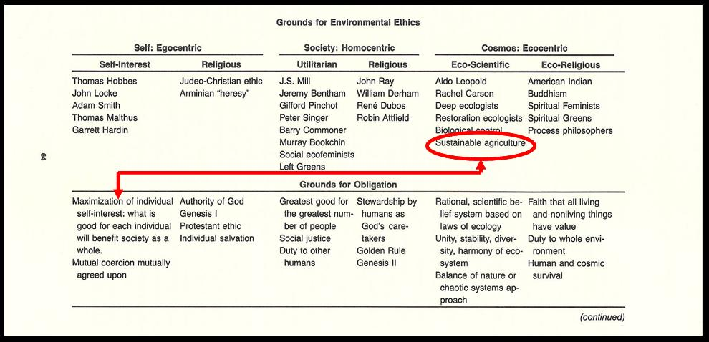
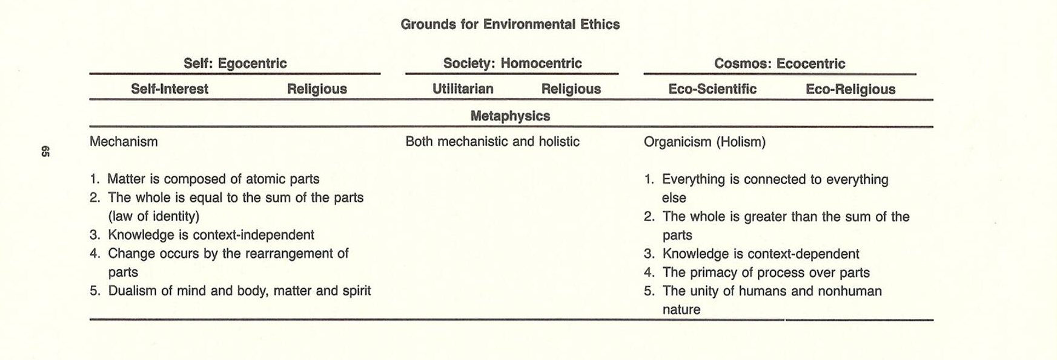

Table II: Characteristics of the Sustainability movement. Taken from Merchant 1992.
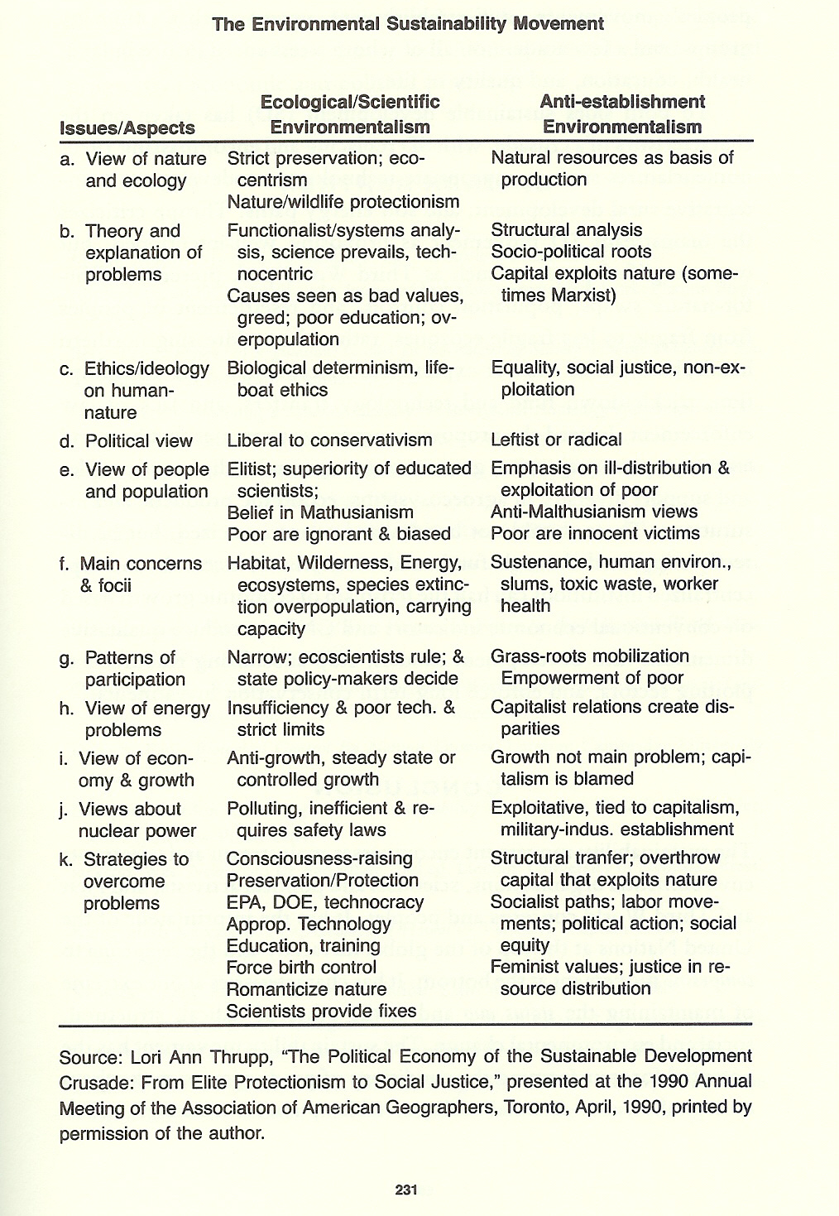
REFERENCES
- Dorf, Richard C. 2001. Technology, Humans, and Society: Toward a Sustainable
World. San Diego, California: Academic Press.

- Mazurek, Jan. 1998. Making Microchips. Cambridge, Massachusetts: The MIT Press.

- Ryan, John C. and Durning, Alan T. 1997. Stuff: The Secret Lives of Every Things.

- Seattle, Washington: Northwest Environment Watch.

- Seigel, Lenny and Markoff, John. 1985.

- Wilsdon, James and Paul Miller. 2001. “Digital Futures: An Agenda for a Sustainable Digital Economy” in Wilsdon, James (editor). Digital Futures. London, England

- Hart, Stuart. 1997. “Beyond Greening: Strategies for a Sustainable World.” Harvard
Business Review. 75(1)

- Funk, Karina. 2002. “Performance and Sustainability Over the Long Haul.” Perspectives on Business Innovation.

- Department of Energy, Office for Industrial Technologies homepage http://www.oit.doe.gov/bestpractices/motors/ 2003

- Benyus, Janine. 1997. Biomimicry. New York, New York: William Morrow and Company.

- U.S. Department of Energy, Best Practices Case Study. http://www.oit.doe.gov/bestpractices/pdfs/weirtonm.pdf

- Caldwell, Bruce. 1999. “Reverse Logistics.” Information Week. (April 12) http://www.informationweek.com/729/logistics.htm

- Sahra Girshick, Rajesh Shah and Sissel Waage; The Natural Step, San Francisco, Californi November, 2002.

- Rothman, Hal. 1998. The Greening of a Nation; Environmentalism in the United States since 1945. Harcourt Brace and Company.

- Merchant, Carolyn. 1992. “Radical Ecology: The Search for a Livable World” New York, London. Routledge Chapman and Hal Company.

- Sustainability home page. www.sustainability.com

- The Natural Step Homepage. www.naturalstep.org.

