
“Democracy Is Not a Spectator Sport”
Alex Ache
PUB395 – Instructor: Gary Flo
June 21, 2003

Introduction
The Green Party stands entrenched on issues pertaining to environmentalism, non-violence, social justice and grassroots organizing. In this sense the “Greens” are renewing democracy without any help from corporate donors. Despite a history of differing opinions within the group, the party takes the democratic approach to the extreme. The questions are; what seems to work for this political party, and what doesn’t work? To answer those questions, I have spent much time pouring through available literature to find insights and opinions about the functionality of the Green Party. It was extremely difficult to weed through the immense political stances and forums to get a good feel.

Background
The presence of the Green Party in the US traces its roots back to the European Greens centered on anti-nuke and pro-peace stances at the height of the cold war. In the US, the Greens were begun in the mid-80’s by the Green Committees of Correspondence. The first Green candidate was up for election in 1986. The US Greens was officially founded in 1996.¹

In 2000, Ralph Nader ran for president and sent a strong message; that conservative DLC-dominated Democrats are no longer good enough. A Native American, Winona LaDuke, ran alongside Nader. Together they built the campaign around grassroots that was said to give many progressives a real alternative to mainstream bi-partisan politics. The mere option of a third party appealed to many.³
In 2001, the Association of State Green Parties (now Green Party of US) attempted to merge the Green Party but failed because of internal quarrelling. Then in 2002, the renowned Cameron Spitzer was thrown out of the Party for asking the question; “What is the purpose of this organization?” Since then, he has gone on to spoof his own startup Green party across the US.⁴

Goals
The group states as an association of state green parties; “Our responsibility is to challenge conventional wisdom and create a climate of political change. As humankind approaches the beginning of a new millennium, Greens globally will continue to press for comprehensive expansion of rights, for social justice, peace and the protection of our common heritage and environment.” ¹
Themes
The platform goes into great detail about how the Green Party stands in relation to every aspect of American life. Needless to say, the majority of the stances are left to extreme left. Everything from the halting of Urban Sprawl to the education of a convicted felon is present in a severely liberal manner.¹
The party advocates ten core values that define its character which were ratified in 2000. These values are also stated in their platform. The first is grass roots democracy which encourages the participation of every individual in the democratic system that our government is founded upon. The second is not far from the first; “social justice and equal opportunity” should be granted to all citizens. Third, the aspect of being “one” with nature is established as ecological wisdom. The fourth aspect promotes non-violence. The fifth is a decentralization of power from the government and thus supports the first value with additional restructuring. The sixth is community based economics and economic justice. This is a very democratic stance focusing on decent living standards for all citizens coupled with an ecological balance. The seventh flows right along with the second value; feminism and gender equity. Respect for diversity is the eighth, followed by personal global responsibility and the focus on the future with sustainability.¹
What Works
Much of the appeal of the Green Party is that it offers a real world alternative to the normal everyday politics found in America.⁶ This could appeal to both Democrats and Republicans alike. It is often said that in America, you either drink Pepsi or you drink Coke. There are no other alternatives; just as in American politics.⁵ The party has strong liberal stances covering an enormous amount of topics. For this reason it can appeal to an enormous population of diverse people and their opinions. However we shall see in the next section that this is also their downfall.
Similarly, the party has the momentum of a more environmentally educated America behind its back. There is no question that environmental awareness has seeped into everyday US homes. Recycling bins and energy saving light-bulbs are almost impossible to miss. The masses are more receptive than they ever were. This gives the party an excellent base for a campaign platform.⁸
Currently the green party’s size is estimated somewhere between 300 and 2000 due-payers.³ This figure is not however, a measure of their popularity. It is significant since this is their primary source of campaign funding. By not allying with corporate America, the party shows its stances on campaign finance reform and environmental action without the help of the primary offenders. It seems almost impossible to believe someone running in an election without corporate sponsorship. Some other things that clearly work are publications, PR campaigns, coalitions, political connections, use of elite members, grass roots appeal, and the notion of the underdog.⁹

What Doesn’t Work
The party’s hardened leadership has a history of tossing out anyone who disagrees with them. This has led to startups of “Real Green” or “Super Green” offshoots throughout the US.² Similarly, it is said that the craze of far left “zealots” helped divide the party’s stances on a variety of environmental issues. The party wasn’t radical enough for them and it followed practices too close to main stream politics. Here we see the benefits of a diverse, action oriented group of people surfacing as conflicts. It seems almost counter intuitive that a broad focus would cause so much conflict. But it is intuitive to see the nature of the egoists emerge.⁷
Nader got just under 3% of the votes nationwide. It was thought that if moderate environmental groups and unions found truth in the Green Party’s cause, they would have been a force to recon with. The democrats are the party’s first obstacle. They must capture enough interest from liberal America to make their stance solid. This is what didn’t work with Nader’s campaign.⁵
Discussion
The platform seemed to me to be so far left that it alienates most Americans. I support the vision of the green party but the means of which they carry out this vision is too far left, unrealistic, and potentially socialist. It is encouraging to see an aggregation of dedicated people fighting the bi-partisan spoon-feeding that is America. However, I am under the conviction that most major political battles in America are long since fought. We are now merely a country focusing on petty details. Compare our situation to the developing nations in the sub-Sahara or south-east Asia. These nations face critical decisions in the future development of their countries, whereas the US politics is simply window dressing.
. The zig-zag approach to regulation and politics is a good one. Introducing radical parties like the Greens is not going to change anything. Look at Nader’s campaign. Whether the each zig and zag is large or small in its magnitude, the end result still flows with the same vector.
If the Greens can’t beat ‘em, maybe they should join ‘em. By infiltrating the ranks of democrats and republicans, maybe their voices can be more effectively carried into American government. However, with such radical oppositions in the Green Party, this “playing by the status quo rules” would most likely be unacceptable. But maybe it’s the best option.

References:

- Green Party website; www.gp.org, June 18, 2003
- Greens Commentary: www.thegreens.org, June 18, 2003
- Greens Worldwide: www.greens.org, June 18, 2003
- Campus Greens: www.campusgreens.org, June 18, 2003
- PBS newshour; http://www.pbs.org/newshour, June 18, 2003
- Spring, Joel; Political Agendas for Education: From the Religious Right to the Green Party; 2002
- Taylor, Paul; Green Gone Wrong: Ecopolitics Exposed; 2001
- Wissenburg, M.J; Green Liberalism:The Free and the Green Society; 1998
- The Green Alliance: www.thegreenalliance.org, June 18, 2003

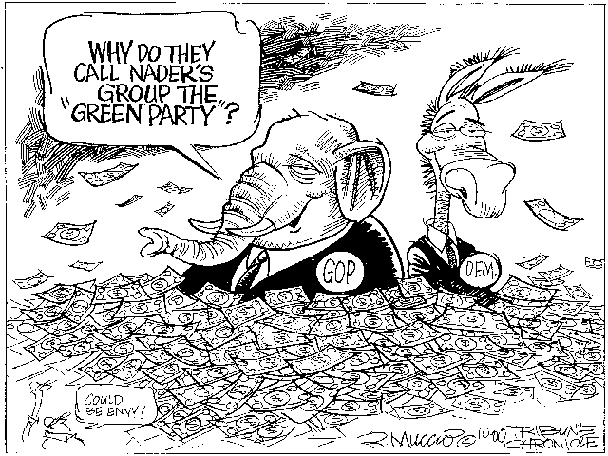
Wouldn’t be complete without satire…

