Connecting Children and Young Adults to Global Ideas
Through Information Technology Final Report

Joy M. Sylvester & Thomas Patrick DeSisto

January 25, 2008

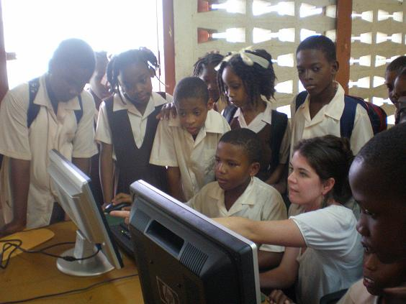

Group Information
Name | Role/responsibility | Phone | Email
Joy Sylvester | Coordinator | (802) 236-4151 | joy.sylvester@uvm.edu
Thomas DeSisto | Communicator | (802) 233-7177 | thomas.desisto@uvm.edu

Introduction & Problem Identification
Since the 1990s, there has been widespread concern regarding the existence of a digital divide. The digital divide refers to the gap between those individuals and groups of people who (a) have access to digital information and communication technology (ICT) and (b) have sufficient knowledge to make use of that access to actually benefit from this technology, and those who do not benefit (Van Dijk, 2005). Often, this divide is related to socio-economic status, geography, gender, age, and culture (Van Dijk, 2005, 2006). It has been suggested that this inability of specific individuals and groups of people to benefit from ICT results in increased social and financial inequity and isolation, during a time of increasing globalization in the realms of communication, trade, and ideas, just to name a few.
In many rural areas of Saint Lucia, access to the internet is extremely limited. For instance, at the Dugard Combined Primary school in Choiseul just fewer than half of the students indicated that they had computers in their homes, while one of the departments that we worked with in Castries hadn’t had internet access in several months. Thus, it seems that most Saint Lucians, ranging from government officials to children in primary school, will benefit from increased or more consistent access to global ideas and information. That said, school children in primary and secondary schools might have the greatest need for ICT skills in the increasingly globalized world, since they will be the future workforces of the country. The unequal access to ICT in the homes combined with the lack of ICT materials in the schools will lead to some children emerging from school with much greater opportunities than their classmates.
In order to bridge the digital divide, St Lucians needs greater access to ICT materials, such as computers, printers, and scanners. These material resources must be installed in rooms that are well maintained and have access to the Internet. In addition, it is critical that St. Lucians possess the necessary skills to properly utilize the computers or the full benefits of ICT will not be realized.
This project addressed the general development goal of universal access to education by connecting primary and secondary school children in Saint Lucia to the global marketplace of ideas and information. This will even the playing field for St. Lucian school children and ensure equal opportunities for all.

Goals & Objectives
Overall, the goal of this project was to connect children and young adults in Saint Lucian school system (also know as the stakeholders) with global ideas and information using ICT. This project addressed the Millennium Development Goal regarding education. The objectives that were set at the beginning of the project to move toward the overall goal were as follows:
- Install computers with internet connections into two designated elementary school;
- Assist with ITC skill building for teachers;
  - Conduct needs assessment;
  - Create and implement training plan;
  - Work together to develop an appropriate curriculum that will connect children with global ideas;
- Enhance usage and increase exposure to global ideas by setting up an E-Pals program with a local elementary school partner;
- Lay the groundwork for future expansion of the project by contacting other primary schools in St. Lucia as potential future project partners; and
- Investigate the feasibility of conducting community focus groups regarding knowledge and acceptance of ICT.

However it should be noted that these goals refer to the long term prospects of this project. Our immediate goals for this year’s trip to St. Lucia were limited to the following.
- Conduct assessments of other ICT situation in five regional schools to serve as a reference for future trips. This includes making contacts.
- Donate four computers with internet to two primary schools.

Project Description
Out project consisted of two parts. Perhaps the most tangible is the donation of two computers to Grace Combined Primary School and the donation of one computer to Dugard Primary School in Choiseul. However the more important for the long term goals of the project was the assessment of seven different schools in the region surrounding Veiux Fort.

School Assessments
The computer and information technology is in its infancy. This year was its first year and one of our biggest goals for the project was to learn more about the situation of computers in primary schools and explore possibilities for the future direction of the project. We succeeded in this aspect past our expectations, and are very much indebted to community leader Greta Joseph for her assistance in this aspect. We carried out seven different assessments, six primary schools and one secondary school. These assessments consisted of visiting each school and speaking with the principal and oftentimes the teachers. We gathered basic information about the number of students and teachers and the nature of the school, and then we also collected more specific information regarding the number of working computers the school owned, internet access, and any kind of computer based learning that was taking place with the children. If there was a space in which the schools hoped to put a computer lab or resource room, we gathered the information about the space and took photographs. We also exchanged contact information with the schools.
There are two purposes of these assessments. One is to provide a compiled database of information for future students in class to use a reference. This way they can choose which schools they would like to work with and the contact information is easily accessible. This will cut out the time that is often taken communicating through a middle contact. The second purpose is to gather pictures and official documentation that will be critical in securing a corporate donor for future materials. This year we installed computers that were donated by individuals in our academic community. Though they are fully functional, they were not the best that could be procured. In the future we would like to find a corporate sponsor that would donate new, state of the art equipment. In order for us to procure this donation, we need comprehensive information about where the materials are going. We now have this information for seven schools. Please see the appendix to view these assessments.

Computer Donation
The second part of our project was to actually bring down computers to install in elementary schools. Again, this is a first year project and besides the obvious goal of donating materials that will enhance the children’s education, it also allowed us to go through the process of donation and set-up and get a feeling for what challenges we may face in the future.
We packed four computers and four monitors in cardboard boxes. The monitors, keyboards, and two of the computers were donated from the University of Vermont, and the other two computers were donated by the Deschenes and the Brgant families. The packing materials and mice were paid for with class funds. We then checked the boxes as a second piece of luggage with members of the class. It should be noted that the JFK Airport had a policy of not allowing boxes. We got around this policy but it could be an issue in the future.
The names of the schools were given to us by our project partner Phillip McClauren, Director of Consumer Affairs. We were put in contact with these schools and meetings were set up by our partner in the Ministry of Education, Marcus Edwards. We visited these schools early in week and scheduled the date installation with the principals. We had some setbacks when we set up the computers at our hotel. We found that two of the monitors and one of the computers had been damaged in transit and no longer function. We were thus down to three computers and two monitors. However Mr. McClauren was able to get two new monitors to donate the schools. We thus ended up donated three complete sets.
We set-up the computers at the Grace Combine School on Wednesday. Grace formerly had one computer for administrative use only. The computers can be seen in Figure 1 below.
Figure 1. Donated Computers at Grace Combined School.
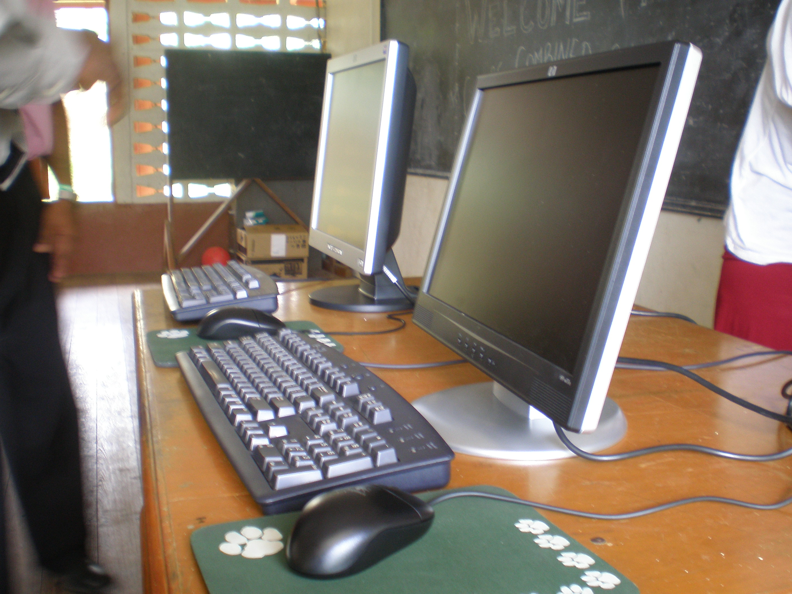

The Dugard School previously had one working computer. They also three computers that had been donated to them previously that were still in boxes. Dugard had a room which the teachers wanted to turn into a resource room. This room can be seen in Figure 2 below as we viewed it on Monday, January 7th, 2008. It can be seen the walls are bare and it is cluttered with items that were being stored. However, three days later on Thursday, January 10th, the teachers and 6th grade class at Dugard had transformed the room into what can be seen in Figures 3 and 4. It was truly an impressive feat driven by the motivation and hard work from the teachers at Dugard. The floor covering, wall decorations, learning centers, and library were completely new. Less obvious is that new electrical wiring that had been installed along the wall to accommodate four computers, the three that they had and the one that we donated.
We spent the morning at Dugard setting up the computers with the teacher’s assistance. We wanted to teachers to go through the process with us so that they could better address future problems that may arise. The teachers were all pretty knowledgeable already and this was a very easy process. It should be noted that there was some complications with electricity and transformers, and that in the future this should be considered in advance.
.

Figure 2. Dugard Resource Room, January 7th, 2008

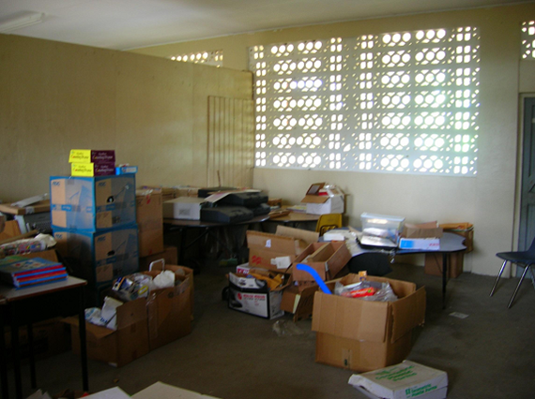

Figure 3. Renovated Resource Room at Dugard Primary, January 10th, 2008

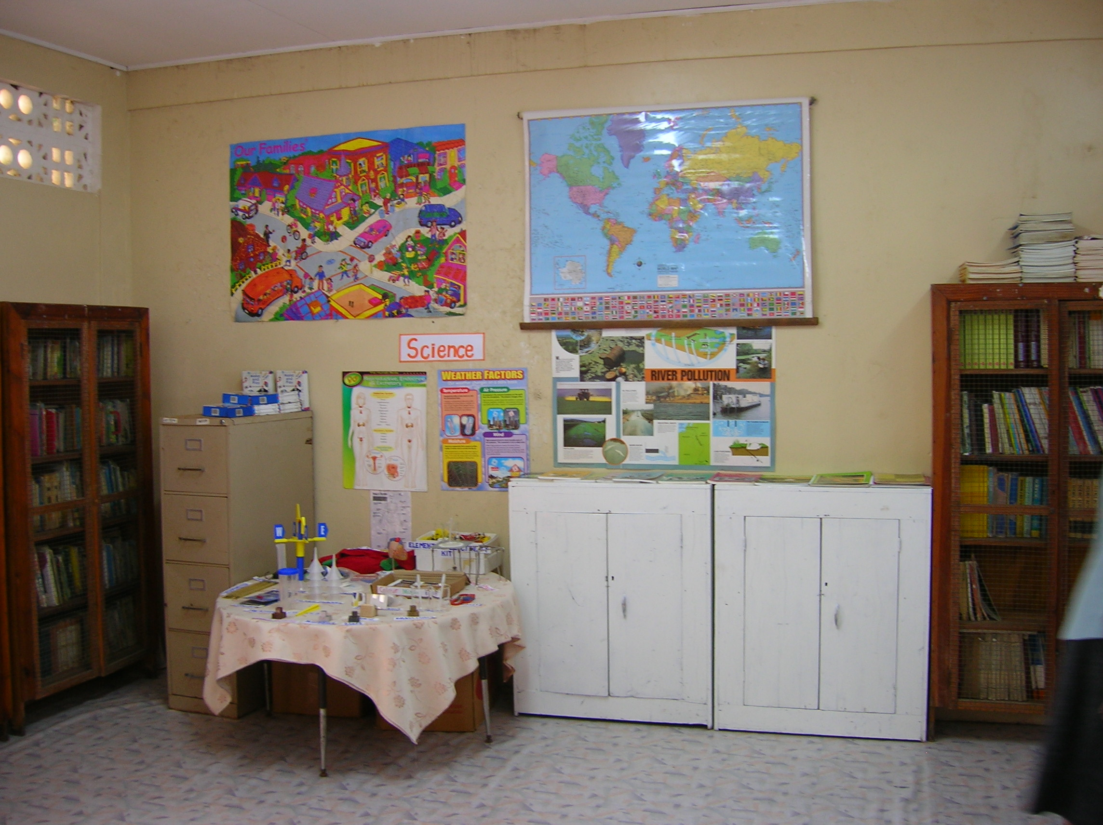

Figure 4. Renovated Resource Room at Dugard Primary, January 10th, 2008

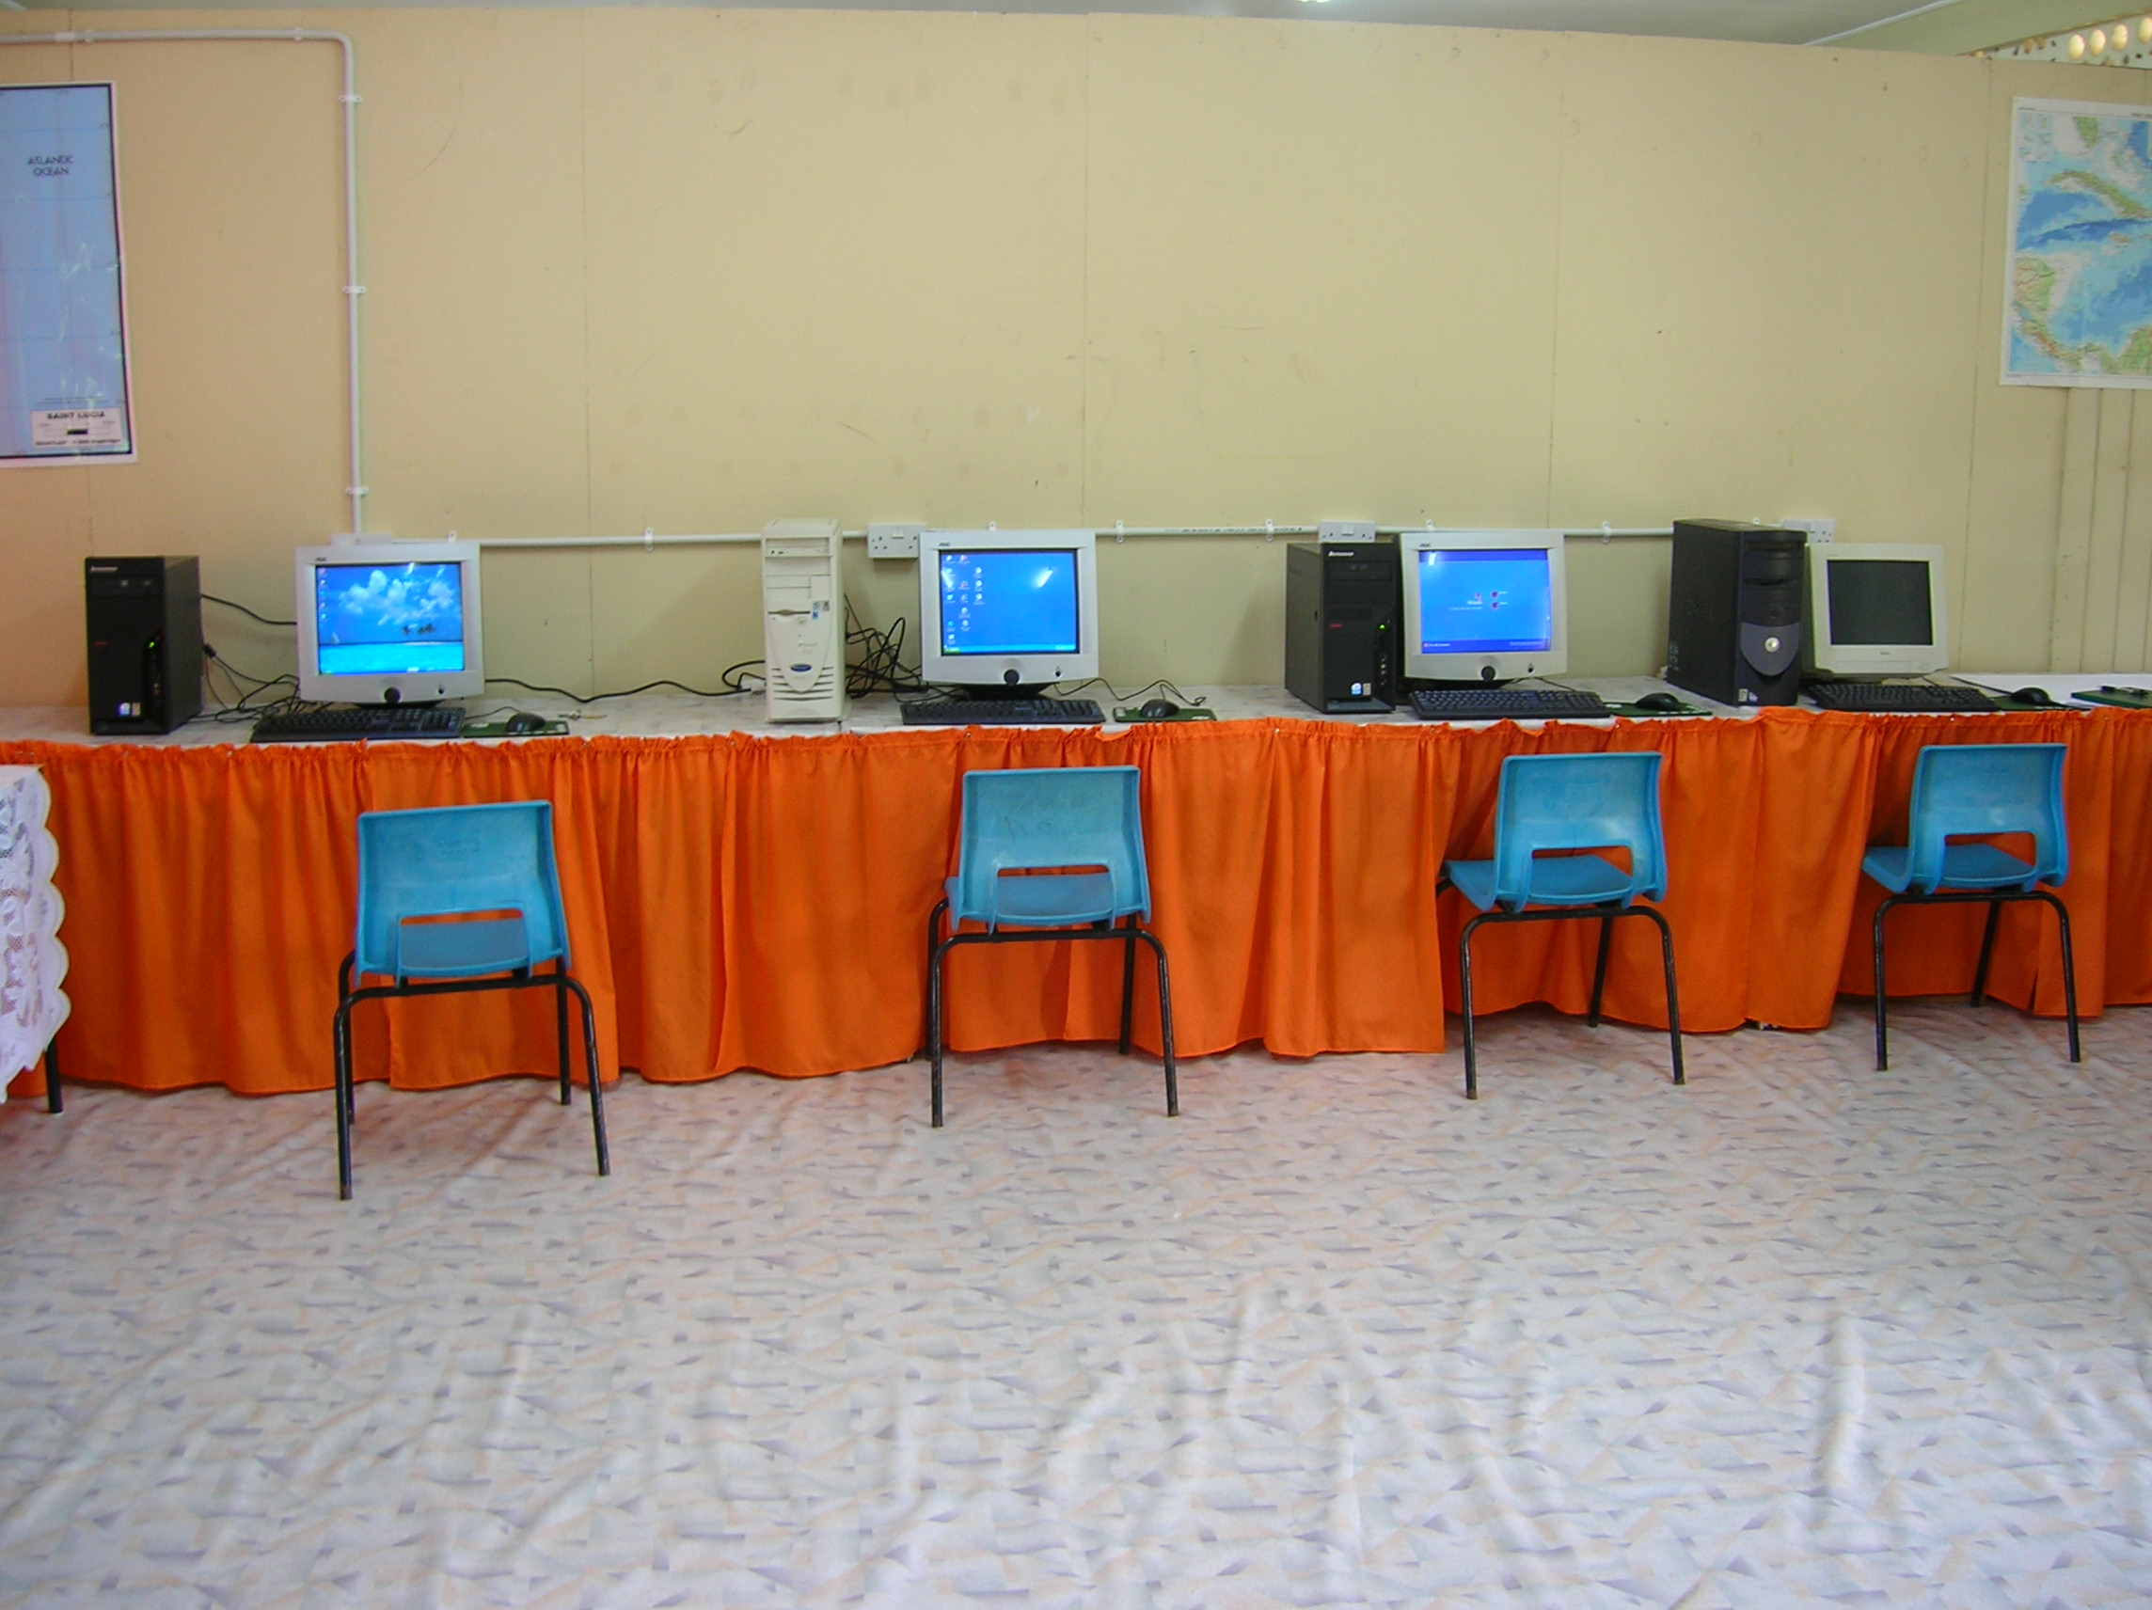

Partnerships & Obligations
At this point, we have developed a working partnership with the Department of Consumer Affairs. Staff members from this department, directed by Philip Mc Lauren, are working with us to identify schools and locations for the program. Furthermore, meetings have been held with the Permanent Secretary of the Ministry of Education and a school principal is Saint Lucia where the program may be piloted. Within the next month, we hope to more an MOU signed with the Department of Education and two local schools that will solidify our commitments and responsibilities to the project.

Our Obligations:

- Procure materials;
- Computers and assisting hardware;
- Any necessary training materials;
- Transport material from Burlington, Vermont to target school in St. Lucia;
- Assist the target school in setting up an appropriate space and ISB connection in preparation for the computers;
- Complete a needs assessment of the faculty and students;
  - Which skills already exist;
  - Which skills need further development; and
- Follow up on needs assessment with proper training materials.

Sponsor Obligations:

- Provide the physical space for the computers;
- Set-up and fund the ISP connection;
- Maintenance of computers;
- Discuss and decide upon a list of learning needs regarding ICT; and
- Follow up communication.

Outputs
After two weeks of work, our project successfully produced resource rooms with computers in two primary schools. During the setup of the resource rooms, we worked with the staff members of each school to show them how to install computers in the future. We also gave the staff basic instruction on computer maintenance.
- Successful Installation of Computers in Target School;
- Skill Development and Training of Teachers;
  - Basic computer maintenance;
  - Able to integrate computers into curriculum;
- Leave a continued program of usage in place;
- Identification of Prospective Sites and Partners;
- Presentation of Findings; and
- Final Report.
Future Steps
After setting up two resources rooms with computers and evaluating the future potential of seven other schools, we identified several steps that should be taken in the future to promote the access to global ideas. The first set of future steps examines the future of the ICT needs in the schools. The second set of steps introduces some non-ICT resources that would be helpful for the school resource rooms, which would also help students become familiar with global ideas.
Future ICT Steps
First, we would like to continue working with the Dugard Combined and Grace Combined Primary schools to further develop their resource rooms. Each school could use five to ten more computers, which would be appropriate for the size of the schools and the individual classes. Neither school has climate control in their resource rooms, but this will be necessary to maintain the computers over time. The computers at the Dugard School were already overheating when we set them up, so there is good reason to believe that they will be damaged over time from heat and humidity. There is also a need for other types of material support, such as surge protectors and power adaptors. Furthermore, the schools that we worked with need further training and technical support for the teachers and staff. Both schools had one or two teachers who were familiar with IT equipment, but the rest of the staff had little to no experience with computers.
Next, we would like to expand the program to two more schools next year. These should be primary schools, since the secondary schools already have computer and IT equipment and a fair amount of IT support. Working in more than one or two new schools next year would be a mistake, because the limited amount of time (two weeks) would mean that the project team would be spread rather thinly. The school assessments provided in the appendix of this document should offer future student groups a good starting point for schools to work with on IT projects. Working with the schools directly is advised, since the schools are very interested in getting additional resources that are not currently available. Future project groups working in schools should also be aware that, unlike many other organizations in Saint Lucia, the school administrators and staff tend to be very punctual, so being to each location for meetings on time or early is highly recommended.
Third, the “E-Pals” program that we suggested in our project proposal should be developed in St Lucia and Vermont with the direct leadership of principals and teachers in both countries. Now that we have obtained the contact information for several primary schools in Saint Lucia, future groups can work with schools in Vermont to create a network of traditional letter-based and email-based pen pals. With the support of the school principals, this should be a simple project to undertake, but one with substantial rewards for the students in both countries.
Finally, more assessments should be conducted for future years of the project. The assessment form that we used worked very well. There are only two modifications that we made to the form after using it at the schools and the copy that is included in this report has these minor modifications included in the document. We believe that the best method was to simply have people at the school help fill the form out after conversations with the staff and a tour of the school facilities.
Overall, it is important to get high quality, new or close to new 2- to 3-year-old computer equipment for the schools. Further, it is important to make sure that the schools can maintain the equipment over time, which means that they need climate controlled rooms and training. Learning software is an often forgotten need for students at the primary school level. Finally, it is important to remember that other, non-ICT resources are useful for the resource rooms.
Non-ICT Resources
In the future, there are several non-ICT resources that would be useful for the school resource rooms. These resources could include (a) wall maps, (b) age-appropriate books, and (c) learning games. These types of materials, while not as interactive as the ICT resources, connect students to important global ideas and schools of thought. There importance should not be overlooked in future years of this project.
Conclusion
In conclusion, working directly with primary schools in Saint Lucia to setup resource rooms with computers and other learning materials could be a great project for future student groups. The staff members at the primary schools were all very motivated and excited to work on this project. Any assistance that future groups of students can provide will be greatly appreciated by the school systems and will prove to be rewarding both for the St Lucian students and staff, and the UVM project members.

References
Van Dijk, J. (2005). The Deepening Divide: Inequity in the Information Society. Thousand Oaks, California: Sage Publications, Inc.
Van Dijk, J. (2006). Digital Divide Research, Achievements, and Shortcomings. Poetics, 34, 221-235.
