Ari Lejfer
CDAE 170
Solar history paper

Photovoltaic and passive solar design

The sun is an infinite source of energy for our planet. In 1839 Edmund Becquerel, a French experimental physicist, discovered the photovoltaic effect while experimenting with an electrolytic cell made up of two metal electrodes. His Discovery was never taken to a commercial level until 1950 when silicon was used in semiconductors. In 1973 there was a oil crises in the U.S. and it created huge public awareness about the limited resource of fossil fuels, and led to the emerging market of solar photovoltaic technologies. This awareness was heightened even more by nuclear accidents like Three Mile Island in 1979.
There are many different kinds of PV cells but all cells are made from silicon and have no moving parts. They convert light photons into moving electrons, which creates electricity. There are three major types of PV cells that have been developed in Germany, United Kingdom, and the United States. Using an experiment called integrated spectral response (ISR), it is possible to determine the efficiency of each cell. In a laboratory solar cells have proven to be up to 26% efficient.
In the real world, however, the efficiency can vary. The light spectrum is what determines the solar cells to be used in a certain area. In order to decide which solar cell is best, the light used must be filtered by using IRS. The cell must also be hooked up to a spectrophotometer. A spectrophotometer measures the wavelength that is used by the solar cell. In an experiment done in Cairo, Egypt the procedure above was followed. The conclusion was that the monocrystalline cell from the United States was the most efficient cell. However, due to the price of this cell it would be better to use more polycrystalline cells made in Germany. Also determined by the experiment was the fact that humidity changes the efficiency of the cells. In a desert climate the US cell was the most effective. In the presence of moisture the German cell was the most efficient (Shaltout, etc).
Photovoltaic cells are a great template for current solar panels. However, solar panels take 15 years to get back the energy it took to make them. This is not a very sustainable design. So it is not the only technology being developed. The nanotech world is opening new doors in the world of understanding photosynthesis. Plants are far more efficient in creating energy from the sun. There is work being done on harnessing the photosynthetic molecules. At Arizona State University there are a group of scientist working on this. They have mimicked molecules in chlorophyll and created something called a Pentad. This molecule is a combination of donor and acceptor molecules that transfer energy when sunlight is applied. The next step for the team is to place the molecule in a membrane to create charge separation. Once they do this they will have unlimited energy from the sun for any type of biochemical reaction (Benyus). At the University of Toronto, a man named James Guillet has mimicked the ability of a photozyme. This technology allows Guillet to use the sun to make any chemical reaction take place. His “Solaron beads“ have the ablitly to react to chemicals together in water to produce a viable product. It is only a matter of time before this technology is part of our everyday lives Many of these technologies are not far off in the future. Electric Solar technology does justify the fact most of our power is wasted in the poor construction. Buildings designed to utilize the sun, reduce our need to manufacture or even grow power for it.
If a home is designed well enough, it can be almost entirely run by passive solar heating. Some of the first solar builders are termites. They have developed huge stacks of saliva-based homes that are cooled through tubes they have created that run from the ground into the mound. During the fifth century BC, the Greeks faced severe fuel shortages. Archaeological evidence shows that a standard house plan evolved during the fifth century so that every house, whether rural or urban, could make maximum use of the sun's warm rays during winter. Mesoamerican cultures built their entire civilizations around the sun. Today our civilization can do even better. By utilizing double paned windows, heat absorbent materials, slightly pitched roofs, and slightly submerged foundations can create a greenhouse effect in a home by keeping it warm all the time. Every building has some of its heating requirements met by solar energy. Sunlight passing through windows is a source of heat, but most buildings are not specifically designed to utilize solar energy (see table 1).
In the northern hemisphere, the best strategy is to place buildings with their long axis in an east-west direction. This will maximize solar gain and efficiency in the winter, when the sun is to the south, and minimize it in summer afternoons, when the sun is in the west. Solar panel sections are generally laid out on east-west streets with lots, which are wider but less deep than traditional suburban lots. "Sunpath" charts can be used to assess the solar access of buildings in a subdivision (ICLEI 1992).
The most common method of storing passive solar heat is increasing the sunspace. Heat can be stored in concrete, brick, rock and water by simply increasing the temperature of these materials. Water can store the greatest amount of heat per unit volume (4.2 MJ/m³.°C). Other materials can store heat by changing their phase, rather than simply increasing in temperature. “Calcium chloride hexahydrate is an example of a phase change material, which has a heat storing capacity 10 times that of water” (ICLEI 1992).
The two most common methods of passive solar cooling are the use of trees, vines, and wind. Painting buildings a light color to reflect sunlight and keep them cool is also often considered to be a passive solar construction technique. Deciduous trees, planted around the outside of a building, can cool by shading a building from the sun. Trees also reduce local air temperatures by several degrees through evaporation and transpiration. An added bonus of deciduous trees is that they lose their leaves in the winter, thus allowing passive solar heating, while still providing a wind-block, which reduces heating requirements.
The sun needs to be brought back into our everyday lives. Civilization has spent far to long looking for its power underground. With climate change occurring and oil supplies running out the sun can be our knight in shining hygrogen.

Table 1

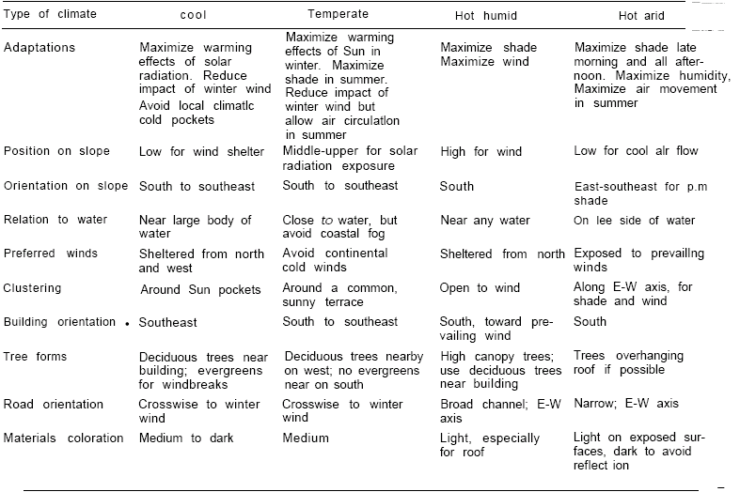

Benyus M, Janine. Biomimicry: Innovations inspired by Nature. New York, 1997

“Energy Without Fossil Fuels.” State of the World 1996, Worldwatch Institute January 1996.

Shah, A., Torres, P., Tscharner, R., Wyrsch, N., Keppner, H. “Photovoltaic Technology: The Case for Thin-Film Solar Cells.” Science 285. (July 30 1999)

Shaltout, Mosalam., El-Hadad., Fadly., Hassan., Mahrous. ”Determination of suitable types of solar cells for optimal outdoor performance in desert climate” Elsevier Science Ltd 1999

“The International Council for Local Environmental Initiatives.” (1992) http://www.ICLEI.org

