For More Information Contact:

Asian Pheonix ResourcesLtd.

2-416 Dallas Road

Victoria B.C. V8V 1A9

Canada

Phone: 1-250–361–4348 Fax: 1-250-360-9012

www.powerpal.com

Harris Hydroelectric

632 Swanton Road

Davenport, CA 95017

Phone: 1-831-425-7652

www.harrishydro.com

Energy Systems & Design
P.O. Box 4557
Sussex, NB
Canada E4E 5L7
Telephone: (506) 433-3151
Fax: (506) 433-6151
Send us an e-mail: hydropow@nbnet.nb.ca


Main Contact - Cameron MacLeod - mac@waterturbine.com
Nautilus Water Turbine
2131 Harmonyville Rd.
Pottstown, PA 19465

Voice: 610.469.1858
Fax: 610.469.1859
www.waterturbine.com

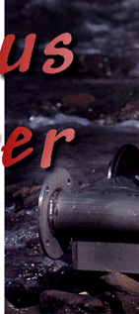
plapower@netc.net.au
www.netc.net.au/platypus/

Sahyadri Energy Systems, Ltd.

611 A 2nd Cross

3rd Main Rd

Sahakara Nagar

Bangalore 560 0-92

India 362 0583
sahyadri@xmbox.com



E-Mail
info@canyonhydro.com

Telephone
1-360-592-5552

Fax:
1-360-592-2235

Mailing Address:
Canyon Hydro
5500 Blue Heron Lane
Deming, WA 98244 USA

Prepared by Lila Spring, December 2005

