Environmental Education in Belize

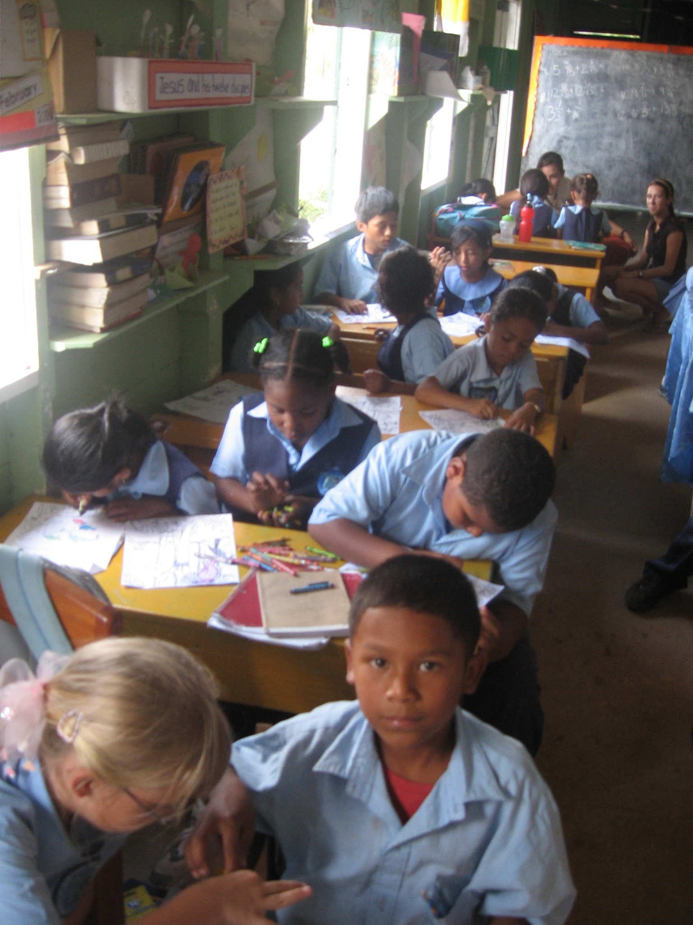

Service Learning Project
University of Vermont
Spring 2007
Melody Bessett
Kaetlyn Kerr
Kate Riley
Our Mission
Belize is blessed with rich environmental diversity and integrity; however, there is no established curriculum for environmental education in Belizean schools. Without early exposure to the importance of sustainable living, many Belizean students will never understand their connection with the natural world. Belize boasts some of the most unique ecosystems in the world. The relatively pristine condition of much of Belize’s wildlife has encouraged policies of conservation to be instituted in many parts of the country. Unfortunately industrial expansion and population growth invariably leads to environmental degradation. Without a base of environmental knowledge it is difficult for any population to recognize the extreme importance of environmental health and environmental protection is often overlooked as a priority. The introduction of environmental education at the lowest levels creates a much needed foundation for the spread of such knowledge. This project was designed to address the lack of environmental education in primary schools in Belize.
It was our aim to familiarize school students with their place in society and their environment. We also wanted to encourage exploration of environmental topics that are affecting Belize by both students and their teachers. To do this we decided to create a Belize-specific curriculum that would be appropriate and interesting to young students. The curriculum addresses some of the most pressing global issues and their relation to the specific environmental threats in Belize. The focus was on understanding basic natural concepts as well as emphasizing the responsibility humans have in preserving the environment. It is our hope that this program will be effective in classrooms all over Belize for years to come.
This project was aimed at solving one of eight the millennium development goals to ensure environmental sustainability and “integrate the principles of sustainability into country policies and programs”. This goal’s overall aim is to reverse the loss of natural resources world wide. Awareness of global environmental issues is the first step in reducing and reversing the depletion of valuable resources. Education throughout nations that are at risk of environmental damage is vital in promoting proactive policies that favor conservation.

Literature Review and Background Research
There was little background literature to explore on environmental education in Belize. A study done by SIT student, Katherine McLinn in 2005 cited the need for environmental education in Belize. She researched possibilities for programs in primary schools which was a great help for finding a focus for our project.
Another source for information was the introduction of Carolyn Merchant’s book, Radical Ecology. It discusses the place of humans in their environments and conversely the role the environment plays in society as well as in the lives of individuals. To decipher the complex relationship between humans and their environment, the author cited the work of several students who were tasked with analyzing their connection to the natural world. Many of the passages were purely reflective; they uncovered meaningful relationships between past generations and the environment in which they subsisted. Others interpreted the meaning of their own place in society and impact on the natural world.
The reflection of students on their place in the environment is essential to effective environmental education. Without this understanding, a commitment to environmental stewardship seems illogical and unnecessary. This was an important connection for us to make between the significance of environmental education and a student’s sense of belonging.
Our secondary research done was primarily to find lesson materials. We looked into some other programs that have been successful both in Belize and the United States. Plenty Belize, a project conducted mainly in the Toledo district instituted the planting of organic gardens on the campuses of primary schools. Twenty-one of the fifty schools in Toledo now grow organic produce on site. We considered a project like this, possibly involving the students in building and growing a garden, but suspected after looking into the amount of physical labor and organization that would be needed was unrealistic for primary school students.
To gain some insight into what similar programs were organized in the states we researched some of the teaching methods used by the Sustainable Schools Project in Vermont. Sustainable Schools works to help teachers incorporate ideas of sustainability into their curriculums. We based a lot of our teaching methods on those suggested by the Sustainable Schools’ model curriculums. The ideas for posters and games were incredibly applicable to the lessons we designed and added an active dimension to the otherwise lecture-dominated curriculum.

Project Partners
This being the first year of the project, the focus was on creating and continuing partner relations. We approached Belize Botanic Gardens as our initial partner. Their previous involvement with Valley of Peace School in Cayo made them an ideal partner with plenty of background in environmental education. We adapted much of the educational materials they had already compiled as a basis for much of our curriculum. Belize Botanic Gardens was also an ideal spot for the field trip conclusion to our program.
Our second partner was St. Barnabas, an Anglican primary school in Central Farms, close to Galen University. We contacted the Peace Corps volunteer who was helping to coordinate activities within the school. She suggested that we develop a curriculum for the standard I/ II class. The older classes were busy preparing for the PSE high school entrance exam and she figured the standard I/II teacher would be all too happy to have help teaching his science classes. We held a meeting with Principal Shaw who was very receptive to the ideas presented. She even asked us to teach a science class with the standard V/VI class to refresh some of the concepts they had already learned as well as to introduce information about Belize’s endangered eco systems. We planned out the dates of the lessons over the next three weeks with a lesson every Tuesday and Thursday and a final field trip on the last Thursday before Easter break. Each class was planned to take place after lunch from one until break time at two-thirty.
The curriculum developed was a pilot designed to allow further development. The lessons were taught over a three week period and were an hour and a half in length. Each lesson introduced three environmental concepts and integrated several teaching methods to keep the students engaged in the information.
We also contacted Belize Environmental Project (BENPRO) a new NGO that is looking to open an center for environmental education. We planned to give a copy of our report and lesson plans to the center to ensure that the materials we developed could be integrated into programs for the future.

The Lessons
We organized three lessons, each ninety minutes long, incorporating some environmental topics and issues. Each of the three lessons was taught to the same group of students at St. Barnabas. Lesson one involved topics such as ecosystems, biodiversity and endangered animals. Lesson two taught the students about the water cycle, pollution and global warming and lesson three was on some specific life cycles, the importance of plants and symbiosis. Each lesson incorporated worksheets, posters and other activities to help the kids visualize and receive a hands on approach to understanding the lesson. Additional to the lessons, a field trip was arranged at the Belize Botanical Garden. There was also one separate lesson we taught to the standard 5 and 6 class at St. Barnabas that taught them about ecosystems in Belize as well as a few environmental problems.

Lesson 1
We first introduced the idea of ecosystems to the students. We did this by creating asking the students questions about what types of things certain animals eat. We had them write this down so they could visualize the concept of food chains and food webs. In understanding the relationship that plants and animals have and how they work together to survive helps students begin to see how an ecosystem works. We introduced some specific ecosystems, placing emphasis on those of ecological significance in Belize; specifically mangroves, coral reefs and rainforests. We made three worksheets that had scenes of each ecosystem, and we made cut out animals where the students had to place the animals in the correct ecosystem. This was a good way to help the students recap on what they had learned from the lesson. We went around and asked individual students what they had learned and if they had any questions. This really helped instill the important ideas in the student’s minds.
To teach the class about biodiversity we created two posters, one with a very diverse scene and another with a barren landscape. We discussed habitat destruction and its implications on biodiversity. Habitat destruction can be the result of many human activities such as over fishing, exploiting for goods, any form of development, farming and extreme weather conditions. Once a habitat begins to be destroyed species are forced to find a new home, if they can’t they will go extinct. Others that rely on that extinct species will also eventually die. This idea led into the concept of endangered species and how the food chain is affected and entire ecosystem is affected by the loss of a species.
At the end of this lesson we did a game with the students that asked them to come up with the four necessities of life. They understood that every living being needs food, water, shelter and space or area to live. The game taught them that without one of those necessities an ecosystem would collapse. For example, without water, if there is a drought the ecosystem will stop functioning.

Lesson 2
For the second lesson we created a poster that explained how a water cycle works. Then we taught them about water and air pollution with another poster that had various sources of pollution incorporated into a city scene. We had the students come up individually and circle all the pollution they saw on the poster. This kept them engaged and helped each individual understand pollution and its origins. We also asked the students some ways that they thought they could eliminate pollution. They came up with ideas like public transportation, not littering, growing plants, and buying bags of water instead of bottles.
We then taught them about weather and climates. We asked them what the temperature was presently. Awe introduced the term ‘climate’ and introduced the idea that their climate is considered the tropics. They understood that there are different climates all over the world. The students learned that the climate of the world has changed in the past and that the climate is now changing at a faster pace then ever due to anthropogenic causes and pollution. Once they understood this, we mentioned global warming and some specific things that contribute to the overall warming of the earth’s climate. We gave the students worksheets to help them comprehend the different types of climates above, below and at the equator.

Lesson 3
In this lesson we informed the students about life cycles. We handed out a worksheet that had a simple life cycle of a frog and a butterfly. Also the students brainstormed the similarities and difference between plants and animals. We also discussed how plants and animals need each other. For instance, animals need plants for food, shelter, maintain temperature, for clean air to breathe and clean water. Plants need animals for spreading their seeds and for fertilizer. This led us into the introduction of symbiosis. We gave some examples of symbiotic relationships like coral reefs and the algae that live on them and how they need each other to survive.
For our third topic we had a poster that described the importance of plants. We asked the students what they need plants for in their lives. The students realized how important plants really are. The poster described some uses of plants like, shelter, medicines, they filter pollutants, and they produce oxygen and take in C02.
We had the students plant some xate palm leaves. Xate Palm is a local Belizean plant that is used for many decorative purposes. The Plant is getting exploited at a fast rate, so it helps the students contribute to the replanting local plants.

The Field Trip
We took the students to the Belize Botanical Garden, a beautiful piece of land that is home to hundreds of native plants. The students got a tour of the garden while learning about the medicinal value of many plant species. Surprisingly, many of the students knew many of these plants. When asked some recap questions on their previously taught lessons we were surprised to find that the students really did retained much of the information we had taught them. The students also went on a scavenger hunt that helped them identify some plants on their own. They also made fresh recado, a traditional Belizean spice, from one of the local achiote tree. The field trip was a great supplement to our curriculum because it served as an reward for the students and it exposed them to a natural area that many of them had never seen.
Teaching Methods
As a group, we found our teaching methods very effective. Switching between interactive visual aids, verbal instruction (lecture), worksheets, group work and discussions, and outdoor games helped to keep the students interested in the topic being taught. We found that the posters we created help them visualize what we were discussing in our lectures and it engaged the students even more when they were able to contribute to the posters, like coloring or circling items on the posters. The group projects, such as the ecosystem worksheets, let them collaborate on a task and explore ideas in small groups. This also made it for us to walk around and hold one-on-one or small group discussions which helped the students better understand the main ideas of the lessons. Constantly changing the activities kept the students interested in the topics we were teaching. We made sure that all of the worksheets we handed out assigned a different task while still allowing creativity by the individual student.
We feel our service learning project has been incredibly successful in many ways. We have created a preliminary environmental education curriculum for primary schools in Belize. The program and lesson plans we have constructed can be expanded upon and new ones can be composed along our guide lines. This will make it easier for future service learning groups to start off where we ended and continue the education program. They will be able to adjust the lesson plans for different age groups and tailor the programs appropriately. More importantly, we have established valuable partnerships with schools and other environmental educators that can help UVM continue the environmental education in the future. All of our partners are great resources that will be a great help incorporating environmental programs into schools.
The students were introduced to new ideas relating to the environment, biological processes, ecosystems, and pollution. The students did very well retaining the information they were taught week to week which helped us gauge how effective our teaching methods were. We noticed that the students retained the most information when that information had been introduced with a worksheet that involved coloring and filling in blanks. Also, the poster we used which required students to circle different types of pollution was helpful in having students identify and remember different types of pollution. They were also very enthusiastic for our lessons which demonstrated how eager these students were to learn when taught in an interactive manner.
As the lessons progressed, we began devising the easiest ways to create lessons plans by delegating the planning, as well as working together to create lesson materials. We also developed budgeting skills which played a large role when purchasing supplies. We also learned how to create partnerships and work with organizations on a common goal. The students taught us a lot about teaching and being patient with young students.
Future Suggestions
There are several suggestions we have for future service learning groups. First, we suggest expanding on our curriculum but delving deeper into topics we taught so it can be used for older students. Older age groups should be taught more in depth about the same topics. This way it will reinforce what they were taught at younger ages and learn new ideas.
We took the students to at the Belize Botanic Gardens was a rewarding way to end the curriculum for both the students and educators. It is also a great opportunity for the students to see more of Belize’s unique environment that they may otherwise never see. The Belize Botanic Garden was a wonderful and accommodating facility for the field trip and we definitely recommend it for the future. Yet, we would like to see field trips elsewhere as well. Santa Familia Environmental Education Center and other national parks are good options. If we had more time we would have liked to do two field trips, one in the middle of the curriculum and one at the end. If a future group has the time and resources it would be a good opportunity for the students to be exposed to more of their surroundings.
We also suggest more lesson plans over a longer period of time. Two lesson plans a week for three weeks worked out well but we suggest limiting it to one a week for six to eight weeks. More weeks also allows time for more field trips as suggested above.
Below are some additional recommended paths for future lesson plans. Some of these subjects can be broken up into separate lesson plans to last the semester, like climatology because the more in depth, the longer it will take to teach, and others can be shortened. They can be geared to younger or older students; it is up to the service learning group and what ages they want to target.

Program Binder
The program binder we have created serves as a guide for future service learning class groups, as well as for our partners, like St. Barnabas and BENPRO. We hope this binder helps them continue the environmental education program we have started even if there is no service learning projects initiating the program. The binder includes an introduction and mission statement, this written report summarizing our project, a list of partners and contacts, the lesson plans we have created, including our worksheets and game descriptions, suggested future topics for lessons, and a CD that has our PowerPoint presentations, pictures, as well as pictures of the posters we used.

Budget
Gitz | 8.25
 | 1.98
 | 16.39
 | 40.80
 | 30.31
 | 9.86
 | 28.88
 | 3.61
 | 13.20
Farm and garden supplies | 24.64
Market | 4.00
Angelus Press | 14.97
 | 57.81
Ceasar Quartz Taxi | 15.00
Savanah Taxi | 10.00
Prosser | 2.40
Bismilla Novelties | 39.50
Phone Card | 110.00
Celina's | 29.25
 | 24.24
Hanna's | 66.95
Galen | 6.00
Bus | 250.00
Field Trip | 375.00
BZ | 1183.04

Conclusion
We truly enjoyed our time in Belize, especially working with our partners. It was rewarding to see the immediate effects from our hard work and dedication. We feel our project has laid the foundation for future environmental education projects and we hope they are continued in the future.

Merchant, Carolyn. Radical Ecology: The Search for a Livable World. Introduction: What is Radical Ecology? New York, NY; Routledge, Chapman and Hall, Inc., 1992.

