GEOL 235 Gas equilibrium and diffusion homework Fall 2011
1. (15 points) Given the table of Henry’s Law constants below, calculate the equilibrium concentration (assuming activity coefficient for each = 1) in mg/l for each gas at the average temperature of Missisquoi Bay bottom water (5°C). and determine the change in O₂ equilibrium solubility during the height of summer when the water column can get up to 25°C. In air: N₂=78%, O₂=21%, CO₂=390 ppmv, CO=1 ppmv, H₂S=0.001ppmv, SO₂=0.1 ppmv, NO=0.01 ppmv.
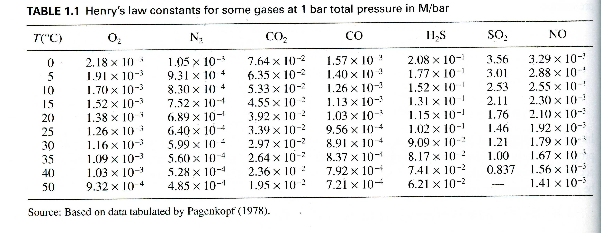
2. Transport of oxygen across the water column is determined largely by diffusion under low wind conditions. Calculate the flux of O₂ across a 4 meter water column where the top of the water column is saturated (at equilibrium) with respect to O₂ at 25C and the O₂ is below detection at the sediment-water interface. Here assume the diffusion coefficient for O₂ is 1.97x10⁻⁵ cm² sec⁻¹.
3. The following table lists soluble reactive phosphorus concentrations (ug/l) in space. Using this data determine the flux of P from the sediment to the water column at each season. D= 1.0x10⁻⁵ cm² sec⁻¹.
Depth (feet) | 25-Jun-2008 | 29-Jul-2008 | 27-Aug-2008 | 1-Oct-2008
11.5 | 1.69 | 33.43 | 11.89 | 0.50
11.5 | 2.10 | 32.77 | 8.66 | 1.75
11.5 | 1.36 | 33.59 | 9.79 | 0.50
8 | 1.36 | 6.87 | 3.66 | 1.26
8 | 1.20 | 6.70 | 3.50 | 1.59
8 | 2.02 | 6.87 | 4.31 | 2.90
5 | 1.85 | 7.03 | 2.69 | 0.50
5 | 2.67 | 7.20 | 2.53 | 1.59
5 | 1.69 | 7.20 | 4.15 | 3.23
2 | 1.85 | 7.03 | 3.82 | 0.50
2 | 1.52 | 7.03 | 3.66 | 1.92
2 | 2.02 | 7.03 | 3.82 | 0.50
1 | 2.34 | 6.54 | 3.50 | 1.10
1 | 1.69 | 6.87 | 3.82 | 1.92
1 | 1.85 | 6.70 | 3.66 | 1.10

