BOTANY 241 TROPICAL PLANT SYSTEMATICS FALL 2021

Instructor David S. Barrington dbarring@uvm.edu. Work: 656-0431, Cell: (802)338-0313
241 Website: http://www.uvm.edu/~dbarring/241/

Regular Class Meetings (Tuesday and Thursday at 1:15 PM, Jeffords 326)

Texts (if you want one or more – order on line):
Judd, W.S., C.S. Campbell, E.A. Kellogg, P.F. Stevens, and M.J. Donoghue. 2016. Plant systematics: a phylogenetic approach. 4th edition. Sunderland, Massachisetts: Sinauer Press.
Mabberley, D.J. 1997. The Plant-Book: A Portable Dictionary of the Vascular Plants. Cambridge, England. 2nd. ed. Cambridge Univ. Press.
Zomlefer, W.B. 1993. Guide to Flowering-Plant Families. Chapel Hill: Univ. of North Carolina Press.

Course Abstract: This is the most exciting time in the history of plant systematics and evolution. Modern analytic tools (inferring phylogeny using cladistic methods) combined with DNA sequence characters have revolutionized the science. At the same time, the lure of the deep forests of the tropics remains irresistible, at least to some of us. My goals are three:
- to acquaint you with the diversity and biology of key tropical flowering-plant families
- give you substantial insight into the morphological diversity and evolution of flowering plants
- provide an introduction into the rich terrain of flowering-plant biogeography, pollination and dispersal ecology, and chemical and mechanical defenses
- introduce the ethnobotany of the plants as time permits

Approach: Al Gentry, one of the truly great 20th-century tropical field botanists, provided insights into which flowering-plant families are the most common in the New World tropics. Twenty-two families that emerge from this analysis provide the backbone for the course. As we consider these families, all of the most interesting modern problems, methodologies, and ideas will come up for our consideration. To bring you into the course fully, I will ask each of you to 1) help the class learn the recognition characters for one of the families and 2) to lead a literature reading for one of the families. I will do the first few families as a model.
Doing these two things will take the form of an oral presentation, which I will explain in greater deal in the coming lectures and which is part of your graded work for the course.

My central learning objectives for you:
To learn the spot characters and diagnostic features of the Gentry families.
To explore central questions about diversity and evolution relating to the Gentry families
To gain a working knowledge of current angiosperm phylogeny and its history.
To expand understanding of current research through readings in the recent literature.

Things you need to know that I will make sure we include in the course:
How phylogenetic inference works.
Basic biogeography.
Basic structure of flowering plants with knowledge of terminology.
Basic molecular biology.
How plants grow.

Evaluation: Evaluation of your work in this course comprises three elements, midterm, an oral presentation, and a final. More details in class.
KINDS OF INFORMATION AND QUESTIONS FOR BOTANY 241

(A definition of the intellectual landscape)

Systematists and other people interested in plant diversity are interested in a wide variety of information about plants, but the information all relates to a fairly defined set of questions. These form the substance of Botany 241. The most prominent questions we will address in the course relate to phylogeny, ecology, and biogeography – but the other questions always seem to crop up as well.

KIND OF INFORMATION | QUESTIONS RELATED TO THIS KIND OF INFORMATION | THINGS PEOPLE DO TO ANSWER THESE QUESTIONS
- place in forest | What is this family’s ecological role in the forest (as canopy or understory tree, herb, epiphyte, liana, or parasite)? | Look at family members in their forest setting.
- pollination and dispersal | How is pollen moved, how dedicated are the pollinators, how does the typical morphology of the family lend itself to pollination? | Watch the behavior of visitors to flowers, watch the behavior of fruit dispersers.
- morphology | What are the typical features of members of this family? | Study the anatomy and morphology of family members, look for constant and varying features.
- spot characters | How do you tell members of this family when you are in the forest? | Figure out what characters are constant for the family that can be seen in the forest with a 10x lens or no help.
- biogeography | What historical and ecological factors determine the current distribution of members of this family? | Chart the distributions of family members, especially genera, and infer history and ecological constraints.
- phylogeny and origins | What is this family related to and how can you tell in the forest? What is the most primitive flowering plant? | Score characteristics of the plant groups and compare them.
- phytochemistry | What is the medicinal importance of these plants, and what do these plants use these compounds for, usually in defense? | Identify chemical constituents, look for patterns of utility and relationship to herbivores.
- non-medical economics (food and fiber etc.) | What do people use these plants for besides medicinally? | Identify non-medicinal uses of the plants through observation and literature review.

THE MOST PROMINENT FLOWERING-PLANT FAMILIES IN THE AMERICAN TROPICS

In 1988, the legendary Al Gentry listed the most common families of plants in three forests in tropical America (Annals Missouri Botanical Garden 75:1-34.). Here are his lists (order is from most to least important in each forest type:

low (hot), moist and wet low (hot), dry mid-elevation (cool), wet

(0-1000m, 0.5+m rain) (0-1000m, < 0.5m rain) (1000-2000m, >1m rain)

legumes legumes Lauraceae
Annonaceae Bignoniaceae Rubiaceae
Moraceae Rubiaceae Melastomataceae
Bignoniaceae Sapindaceae Euphorbiaceae
Lauraceae Capparaceae Moraceae
Rubiaceae Salicaceae Clusiaceae
Sapotaceae Euphorbiaceae legumes
Palmae Nyctaginaceae ferns
Euphorbiaceae Boraginaceae Araceae
Myristicaceae Cactaceae Palmae
Meliaceae Malpighiaceae
Sapindaceae

Considering these lists and the plants I find most prominently in the American tropics and including a couple of groups out of enthusiasm yields an arbitrary list of the 22 most important families in the American tropics. The families, in the APG classification order, constitute the order of discussion for this course.

ALPHABETICAL ORDER APG CLASSIFICATION ORDER

Annonaceae
Apocynaceae
Araceae
Arecaceae(Palmae)
Bignoniaceae
Bromeliaceae
Cactaceae
Clusiaceae(Guttiferae)
Ericaceae
Euphorbiaceae
Fabaceae(Leguminosae)
Lauraceae
Loranthaceae etc.
Malpighiaceae
Malvaceae
Melastomataceae
Meliaceae and Sapindaceae
Moraceae and Urticaceae
Myristicaceae
Orchidaceae
Piperaceae
Rubiaceae

MAGNOLIIDS
Magnoliales
1. Annonaceae
2. Myristicaceae
Laurales
3. Lauraceae
Piperales
4. Piperaceae
MONOCOTS
Alismatales
5. Araceae
Asparagales
6. Orchidaceae
COMMELINIDS
Arecales
7. Arecaceae (Palmae)
Poales
8. Bromeliaceae
EUDICOTS
ROSIDS
ROSIDS I (Fabidae)
Malpighiales
9. Clusiaceae (Guttiferae)
10. Malpighiaceae
11. Euphorbiaceae
Fabales
12. Fabaceae (Leguminosae)
Rosales
13. Moraceae and Urticaceae
ROSIDS II (Malvidae)
Myrtales
14. Melastomataceae
Sapindales
15. Meliaceae and Sapindaceae
Malvales
16. Malvaceae
ASTERIDS
Santalales
17. Loranthaceae etc.
Caryophyllales
18. Cactaceae
Ericales
19. Ericaceae
ASTERIDS I
Gentianales
20. Rubiaceae
21. Apocynaceae
Lamiales
22. Bignoniaceae

THE CURRENT APG TREE OF ANGIOSPERM ORDERS, FROM THE APG WEBSITE
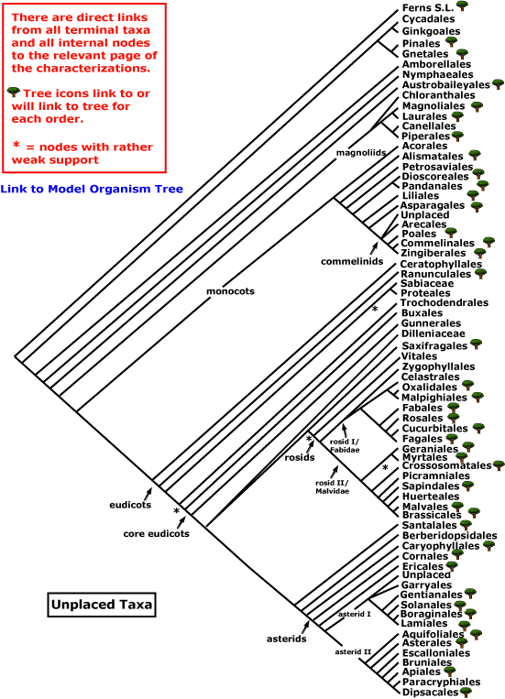
August, 2020
http://www.mobot.org/MOBOT/research/APWeb/welcome.html

CRITICAL CHARACTERS

Botany 241, Tropical Plant Systematics

This is a list of characters that are likely to be useful in identifying plant families in the tropics, in situations where you have fresh material and a hand lens. I have purposely chosen the characters that also relate to the discussions of the phylogeny of angiosperm families as a whole, so that as you look for characters you can start to think about relationships. There are many more characters, many of which we will mention; these are just the common ones.

27 CRITICAL CHARACTERS FOR LEARNING
FAMILIES OF FLOWERING PLANTS

- life form
- leaf position
- leaf dissection
- leaf design/venation
- stipules
- secondary and tertiary vein patterns
- latex presence and color
- odor of crushed leaves
- sepal number
- calyx symmetry
- sepal fusion
- calyx estivation
- petal number
- corolla symmetry
- petal fusion
- corolla estivation
- stamen number relative to petal number
- stamen fusion
- anther dehiscence
- disc
- hypanthium
- carpel number
- carpel connation
- gynoecium symmetry
- placentation
- ovary position
27. fruit type

