

February 2, 2009

Master Sonics
77 Whiting Street
Plainville, CT 06062
Tel: 800-737-2198
Fax: 860-410-1704

To Whom It May Concern:

Please find enclosed our Branson 8210 unit.

It appears that at least the heater and we suspect the sonicator are not properly functioning.

Can you please inspect and test the unit and make whatever repairs are needed?

Please note that the unit has been modified for continuous operation (we control the unit with an external timer). Please do not change this configuration.

Please fax the estimate and work authorization to:

Paul Bierman
Department of Geology
802 656 0045

Thank you.

Sincerely,

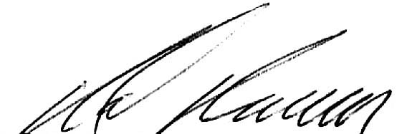

Professor Paul Bierman
pbierman@uvm.edu
802 656 4411 (voice)
802 238-6826 (cell)

