Learn Genetics at Ant Camp 2013!
24-28 June 2013, University of Vermont
What is genetics? How do genes affect what we look like? How can genetics tell us who our relatives are? How genetically different are individuals, populations, and species? What can genetics tell us about their evolutionary history?
In this week-long immersion course, we will take a hands-on approach to explore these questions using a common, ecologically important and fascinating group of organisms: the ants. Using the scientific method, we will observe ant colonies in the lab and field to develop ideas about their genetic makeup and relationships. We will then test our ideas in the genetics laboratory, learning about the types of genetic markers and experiments that biologists use to ask real-life scientific questions. By the end of the week, students and teachers will come away with a better understanding of genetics concepts, practical experience with the cutting-edge tools scientists use to address current problems, and the scientific skills to lead their biology class through a research challenge project.
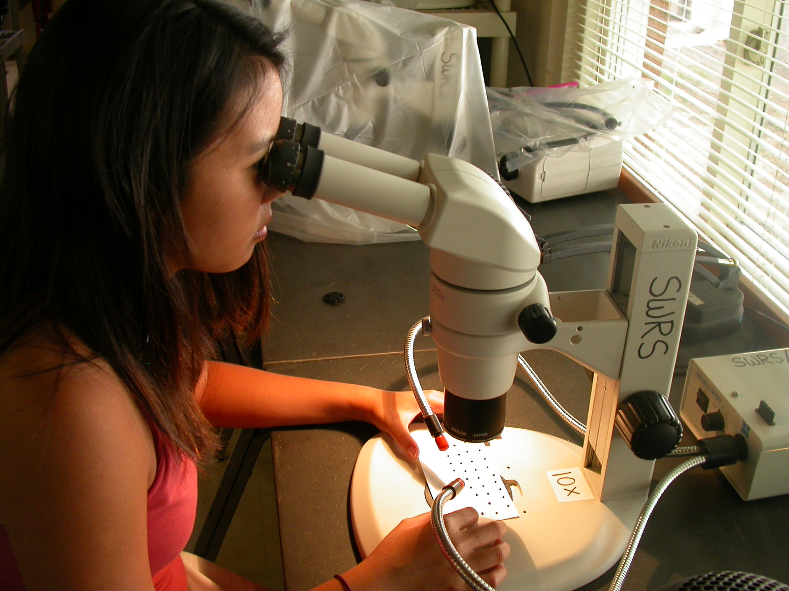

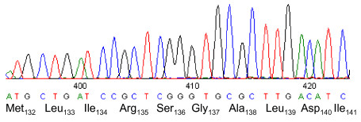
Concepts Covered

DNA structure
Mendelian Inheritance
Family relationships
Phylogenetics

Genetics Techniques

DNA extraction
Polymerase Chain Reaction (PCR)
Microsatellite genotyping
DNA sequencing
Computer analysis software

Want more information? Take a look at our website (http://www.uvm.edu/~antcamp/), or contact Dr. Sara Helms Cahan at antcamp@uvm.edu (802) 656-2962
Teams for Ant Camp should include one teacher and two or more students from your high school, either before or after taking high school Biology.
All costs for Ant Camp (travel, room and board) for all participants are covered by the National Science Foundation.

