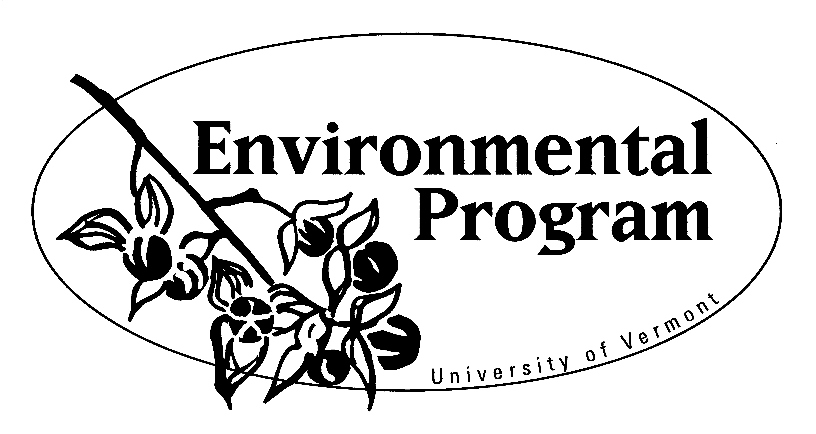
The ENVS Senior Capstone Internship:
Thinking Strategically About Your Choices
Much consideration and planning should go into designing what you are do for your capstone. Take time to read the guidelines for all of the capstone options. Read, especially, all the forms and information for the capstone internship. Then read these questions and try to answer them as you begin to develop a plan for what you are going to do for your capstone internship. Page 3 offers helpful guidance for securing your internship.

SELF-EVALUATION AND ACADEMIC REVIEW
1) It is best if you are excited and highly motivated for your capstone work. Each option has its particular challenges, responsibilities, and benefits. It may be that one capstone option is better for you to pursue for one reason or another. Think through the options and your reasons for choosing a capstone internship.
Why do you feel that the Capstone Internship is the best choice for you out of the three capstone options?

2) Your Capstone Internship should relate well to your ENVS major course work. The courses in your IDP should offer foundational knowledge, skills and experience you can apply in an internship setting as you continue to learn more about those topics, and others. You should not choose an internship for which you have no college-level background learning. Given the courses you have taken thus far, or plan to take, what internship activities are you considering?

3) Think through your high-impact learning experiences from high school, college courses, extracurricular activities, summer jobs, internships, study abroad, service learning, etc.
What particular skills, realms of knowledge and experience do you have to offer as an intern? How might you serve an organization with them?
Skills:

Knowledge:

Experience:

4) This internship should be at the advanced level and consist of high-impact learning opportunities.
What skills, knowledge, and/or experience do you still want or need before you graduate that could come from your internship? What would you want to learn or do as a part of this ENVS 202 experience?

5 ) To support you in your internship you are to select a 200-level Capstone Course that aligns with your internship to offer skills, knowledge and experience that will serve you in your internship and that will help you be a better intern. What 200-LEVEL courses might you choose for internship activities you’re considering?

GETTING STARTED
SOME CONSIDERATIONS BEFORE SECURING AN INTERNSHIP
1) It is possible for you to earn credit and get paid for your senior capstone internship.
How important is it for you to get a paid internship?
2) You may have previously done an introductory- or intermediate-level internship that could be developed into one at a more rigorous senior-level with increased responsibility and greater reward? Any experience to draw from?
3) Timing is important. Consider when you are taking your 200-level Capstone Course. Doing your internship after completing your capstone course is best. You may take it at the same time. Also consider when your course load can accommodate extra work for an internship. Sometimes it’s a practical matter. For example, farming internships are often best done during the summer months, whereas teaching internships are best undertaken during the traditional school year.
Is there a particular semester, or time of year, that is best to do your 200 hours of internship work?

4) You may do an internship here in Burlington, or elsewhere. You might have some flexibility, or constraints, due to housing, transportation, timing, or other considerations. Due the relatively short nature of this experience, might you be able to live with a friend or relatives to open up your range of possibilities for the internship location? Think outside the box for some new, unexplored options. If you could be anywhere, where would you like to intern?

5) Consider how an internship could strategically enhance your future possibilities. What is your personal/academic/ professional trajectory after college? How could this internship assist you to network and realize your goals?

6) Your senior internship should be enjoyable and inspiring.
What kind of work would you most enjoy doing? Inside or Outside? With kids? Very hands-on? Etc…

7) Mentoring and supervision you receive during an internship can be valuable, and even life-changing. It may be that an activity that allows you to test and practice your own decision-making and creativity would be best. Or, you may prefer more structure and guidance. What kind of mentoring would best serve you at this point in your life?

8) This capstone internship should be a challenging, and rewarding experience that fits with your interests and education.
What organizations and internship activities would serve you well? What would bring the most satisfaction?

SECURING AND PROPOSING YOUR INTERNSHIP
HELPFUL GUIDANCE
1) It takes effort to explore possibilities with potential organizations. Rarely does an opportunity simply land in your lap—but it does happen on occasion. Keep your eyes open for those lucky breaks. And, meet with people who can help you consider ideas and suggest people, organizations, and possibilities for you to consider: your academic advisor, Career Services staff, ENVS staff, faculty members who teach relevant courses, people on- and off-campus who know about what you would like to do. Of course, search thoroughly on the internet.

2) Network as much as possible with people whom you know and who know you. Talk through your ideas.
3) Informational interviewing, as you did in ENVS 101 APW, can be helpful to find a fitting internship for you.
4) Research the organization thoroughly before you interview. Go with prepared questions. Be ready to answer questions of you. Be clear about the capstone internship responsibilities. Do your homework.
5) Interview them as they interview you. Is this where you would want to work, with that person/those people, doing the kinds of work they do?
6) Be sure you know what you are getting into with them, and vice versa. Give your prospective Site Supervisor the Guidelines and Support for Organization Supervisors. Read it yourself before you do.
7) Follow-up after you apply and/or interview. Email them, thank them, call them, keep in touch, as appropriate.
Don’t go too long without checking in with your prospective Site Supervisor.
8) After you interview take some time to think through the reality of working with them for 200 hours in the capacity you have discussed with them.
9) Keep options on the table. Even if there’s one “perfect” internship you really, want, keep pursuing possibilities.
10) Examine personalities. You will be working closely with your Site Supervisor. As you explore and interview and develop a relationship with your prospective Site Supervisor, be sure you’re a good match, that you will get along well, with good communication.
11) Just because an organization is interested in having you work with them doesn’t necessarily mean you ought to take that opportunity. Be discriminating. Be sure it’s what you want to do, that it fits your ideas of what you want your capstone experience to be.
12) Don’t take the first offer you get just because you need an offer. Be sure there’s a reasonable fit with your ENVS major courses, that the work will be rewarding and enjoyable, that you will feel confidently challenged by it, without too much challenge.
13) When you and your prospective Site Supervisor come to an agreement that you will be working there, have a discussion about the specific tasks, projects, and learning. Get really clear with them. Be sure you can write your proposal with all of the necessary pieces. If you can and need to, ask for adjustments so that you will be as happy, challenged, and rewarded with the situation as you can be, and so that the organization will get the most from the service you provide them. This should be a mutually beneficial contract.
14) For your internship Faculty Advisor/Evaluator, choose the ENVS full-time or affiliated faculty member whose expertise best fits your internship. Check to be sure this person is a suitable. choice. The Site Supervisor should be the person with whom you will work most closely.
15) Be sure you understand the Capstone Internship Guidelines. Seek advising if you need it. Write your proposal and seek approval from your Faculty Advisor/Evaluator and Site Supervisor before you begin your internship work.
16) Be sure you understand the ENVS 202 Internship Capstone Credit Agreement. Register for the credits appropriately.

