Economics of Gully Erosion and Stabilization: Last Resort Farm
Spring 2018

Name: Last Resort Farm
Type: Certified organic diversified farm with maple syrup, berries, vegetables, eggs, and hay
Location: Monkton, VT
Size: 15 acres under produce cultivation, 80 acres of hay, and 1,200 maple taps
In business: Since 1986
Farm Owners/Managers: Sam Burr, Eugenie Doyle, Silas Doyle-Burr

Introduction

Located at the northeast corner of Addison County Vermont, the Doyle-Burrs operate a 272 acre diversified family farm. They purchased what had previously been a dairy farm for over 140 years in 1986. The Doyle-Burrs started the conversion to organic certification by selling the dairy herd and moving to hay and produce operations in 1993.

The farm operates a pick-your-own berries operation, an on-site farmstand and a CSA program. They also sell their produce at local farmers markets and wholesale to schools, restaurants, and food stores in Burlington, Williston, Winooski and Bristol, Vermont.

Over the past 15 years, Last Resort Farm (LRF) has experienced an increase in extreme weather with heavy precipitation. Farm co-owner Eugenie says, “Storms have been worse, causing soil erosion. In June 2015, we had 20 inches of rain as measured by our rain gauges on the farm and that was also confirmed by the Addison weather station.”

The farm’s gully erosion occurred in a 10-20% forested slope through part of the farm’s sugarbush (sugar maple stand tapped for syrup) and adjacent to Pond Brook. The gullies have been enlarging over the recent years sending soil, leaf litter, plant debris, soil sediment, and nutrients into the nearby stream, Pond Brook. Pond Brook is a tributary to Lewis Creek, a watershed that flows into Lake Champlain in Ferrisburgh, Vermont.

In 2012, the non-profit Lewis Creek Association (LCA) expanded its water monitoring and sampling sites in the Pond Brook tributary. They detected increased nutrient loading in sections of Pond Brook, including the stream reach near Last Resort Farm. The LRF gullies were important contributors of sediment and phosphorus to Pond Brook (South Mountain Research and Consulting, SMRC, 2013). SMRC field assessments identified six gullies of various dimensions with drainage areas between 0.2 and 3.8 acres starting in LRF’s fields. This case study evaluates the costs and benefits of remediating these gullies. Because this region of the country is seeing increasing rainfall intensity with a changing climate, stabilization of these gullies can be considered a climate change adaptation strategy.

LRF began working with a number of partners to reduce sediment discharge from the gullies. Partners included Lewis Creek Association, the local and state offices of the USDA Natural Resource Conservation Service (NRCS), Vermont Department of Environmental Conservation, and LCA’s contracted engineering firm, Milone & MacBroom, Inc. (MMI). NRCS technical assistance professionals studied the erosion process and associated gullies. They then provided designs for rock-lined “hard practice” waterway for stabilization of the two largest gullies. LCA engineers MMI examined the remaining four gullies and provided log and stone “soft practice” designs for the treatment practices.

Table 1. Summary of Gully Characteristics (Milone & MacBroom, 2014)

Gully | Length (ft) | Drainage Area (acres) | Depth (ft) | Width (ft) | Avg Slope (% from LiDAR)
1 (LCA) | 350 | 3.8 | 1 | 2 | 15.3
2 (LCA) | 240 | 1.6 | 2 | 2 | 18.3
3 (NRCS) | 460 | 3.5 | 8 | 5 | 13.3
4 (NRCS) | 200 | 3.0 | 5 | 5 | 18.8
5 (LCA) | 150 | 1.2 | 5 | 4 | 13.3
6 (LCA) | 80 | 0.2 | 1 | 2 | 21.3

The NRCS soil survey shows the farm’s soil to have highly erodible Raynham silt loam in the wooded area. Potentially highly erodible Melrose fine sandy loam soils are found at the upper area of the gullies in the agricultural fields. The gullies had been cutting through the erodible soil in the forested area and appeared over time to be moving uphill into adjacent agricultural lands. This is due to what is known as an erosive “head-cut” when the energy of surface runoff exceeds the capacity of the downslope soil to resist the erosive force.

“These gullies were starting to eat into the fields. Plus you could see when there was a weather event, the brook was sullied,” explained farm co-owner Sam Doyle. The Doyle-Burr’s awareness of water quality degradation in Lake Champlain and its relationship to agricultural runoff spurred the family to do something to protect Pond Brook and the soil on their farm.

After an alternatives analysis was completed, MMI, LCA VT DEC and LRF reviewed alternative treatments to determine the preferred gully treatment plan. See Figure 1 for gully locations and summaries of gully characteristics and treatment.

Figure 1. Map of Gullies on Last Resort Farm (South Mountain Research & Consulting)

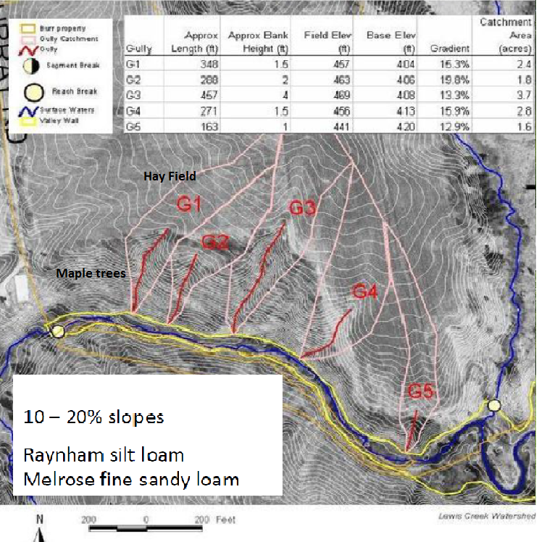

Gully 1: With the largest drainage area of the six gullies, the inlet of this gully at the farm edge was stabilized with rock to prevent erosion from continuing uphill into the farm field and reduce water flow energy. Downhill and near the end of the gully, minor erosion had occurred near Pond Brook. The portions of the gully showing active erosion were stabilized using tree trunk sections and branch piles at the gully’s base.

Gully 2: The upper portion of this gully was stable due to a naturally lower slope and trees and branches placed there by the landowner four to five years previously while working to improve the sugarbush. The top of the gully does not extend all the way to the farm field. The lower section had minor active erosion 2-feet deep by 2-feet wide, but no sediment accumulation. This lower portion of the gully was stabilized using tree trunk sections and branch piles.

Gully 3: The longest at 460 feet and deepest at 8 feet, this gully had eroded into Last Resort Farm’s hayfield. The severity of this gully changes along its length with 1 foot deep, 1 foot wide erosion at the top, a stable lower slope sections in the middle, and a 60-foot long section downstream closest to Pond Brook where the gully was deep with an active clay and silt erosion face nearly 10 feet deep. The rock-lined channel was recommended and installed by NRCS as the gully was larger and actively eroding. Some grading of the hayfield was also necessary to slow runoff velocity and prevent further erosion.

Gully 4: One of the wider gullies at 5 feet, this gully began at the edge of the hayfield and extended to Pond Brook. The upper portion was stabilized with rock riprap armoring to dissipate runoff energy. NRCS installed a rock-lined channel the entire length of the gully.

Gully 5: Upstream of this gully, rill erosion has formed in the farm field for 100 feet due to concentrated runoff. The upper section of the gully at the farm field had two eroded flow paths, both 5 feet deep by 4 feet wide and they were both treated with inlet armor to prevent erosion from continuing uphill into the farm field and dissipate energy. A series of log check dams and log stacks were installed along the length to trap soil and dissipate energy. Additional brush and small logs were also installed around the check dams and log stacks to catch sediment.

Gully 6: Located between gullies 4 and 5, was a small gully identified late in the planning process. It showed minor signs of erosion with gully erosion beginning to form in a 1-foot deep and 2-foot wide channel. Treatment with brush and small logs was recommended to prevent erosion from increasing and becoming a problem.

In general, two different conservation practice methods were used at the farm to restore Pond Brook water quality and reduce erosion and nutrient flows from the farmland. The NRCS practice used 100% rock-lined armor methods, imported material (rock and fill) and heavy equipment to transport and install and grade the stone along the gullies. The LCA/MMI practice methods used wood from onsite, all of which was harvested from the property to improve the sugarbush, and some stone from offsite was used to stabilize the head of the gullies. All gullies were deemed worthy of treatments so as to prevent further erosion wherever possible.

Both gully repair practices had the same objectives of reducing water velocity, soil loss, and eliminating gully erosion. However, the two practices have different upfront costs, expected life spans and annual operation, maintenance and replacement costs.

The NRCS rock-lined gully treatment method is well tested and documented, while the MMI design is an innovative approach that aims to have a lighter impact on the natural environment while reducing treatment costs, but lacks such documentation. Marty Illick, Executive Director, LCA, described the approach, “Here at Last Resort Farm, we are starting with treating the symptoms before considering addressing root causes of pollution. With gully repairs, we must slow the rate of pollution right away. Slowing the sedimentation is like stopping the bleeding.”

Table 2. Two Approaches to Gully Stabilization for Soil Loss Control

Type | Description | Advantages | Disadvantages
“Hard” engineering | Riprap, stones | Tried & Tested  Potential longer life  Lower and less frequent maintenance | Higher Cost  Heavy Equipment used  Potential soil compaction
Alternative  “Soft”  engineering | Engineered log and wood placement with minimal rock application | Mostly on-site materials  Lighter impact on environment | Lower Cost,  Likely higher maintenance  Unproven, but likely shorter life  More manual labor

Lewis Creek Association’s “Ahead of the Storm” Approach

LCA received funding from Vermont Agency of Natural Resources (ANR) Ecosystem Restoration Program, to install ‘soft engineering’ practices for four of the gullies (Gullies 1, 2, 5 & 6). Also referred to as ‘engineering with nature,’ it is an alternative to more conventional materials, such as stone (rock-lined). LCA believes that this approach offers landowners the option of treating smaller gullies before they become a bigger problem, which if left untreated, may need more expensive (rock) treatment in the future. These gullies were treated with on-site softer, hand-placed natural materials, including brush and logs, and grading and gully shaping to accept the wood and reduce water velocity. In addition to repairing the majority of all of the gullies with natural log materials, stone was installed at the top of Gully 1 and Gully 5. Stone was installed at the top of a third gully (Gully 1) to stop the gully’s head-cut. Stone was limited to the steep entrance of the gully to make the steep transition from the field elevation to the lower part of the gully and dissipate high water velocities coming from the field. MMI engineers provided technical and construction oversight from 2014 to 2015.

Figure 2. Photo of Gully 1 and Engineering Design for “Soft Practice” Gullies.
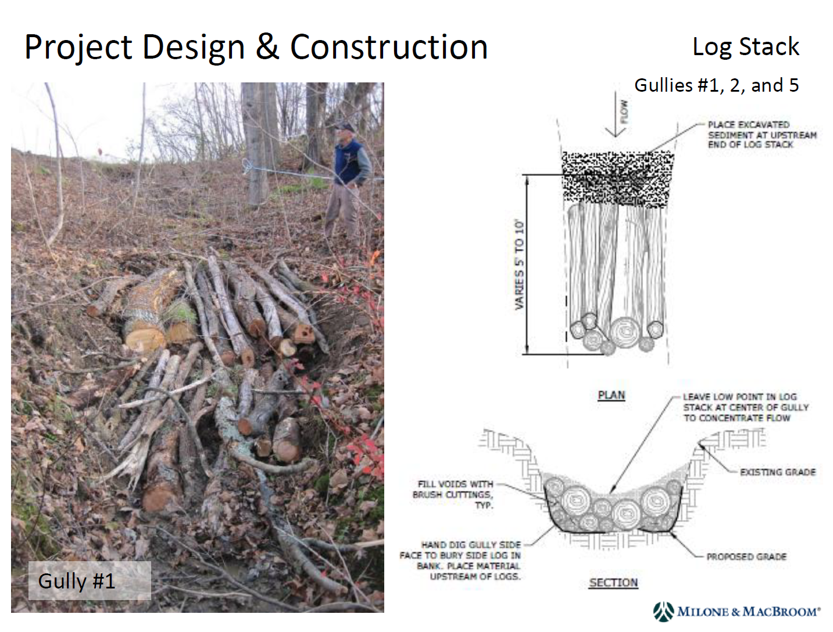

The benefits of this approach include a more natural appearance, reduced initial cost, cooler surface waters flowing to Pond Brook, and less soil compaction and disturbance. However, with log decomposition, soft practice gullies may require more frequent maintenance. Although maintenance may be required more frequently, the maintenance cost and technical knowledge needed is very low. The building and maintenance of these practices meshes well with ongoing sugarbush improvements, as extra limbs or culled trees can be added to the gullies to refresh the wood. The intent is for these gullies to naturalize over time by capturing and holding sediment and allowing vegetation to begin to grow.

The USDA Natural Resources Conservation Service (NRCS) provided technical and financial assistance to help stabilize two of the gullies using the more traditional engineering practices and materials. These two gullies had the most immediate impact on the fields above. Through NRCS’ Environmental Quality Incentives Program (EQIP), rock-lined waterways were installed along the length of two most critical gullies (Gullies 3 & 4). The benefits to this approach include proven success in combating erosion, and a longer life span due to the durability of the materials. In addition, rock riprap lined waterways are better at withstanding increasing occurrence of high intensity/low probability storm events (less frequent than once in a hundred years).

Figure 2. Photo of Gully 3 and Design Specifications for “Hard Practice” Gullies.

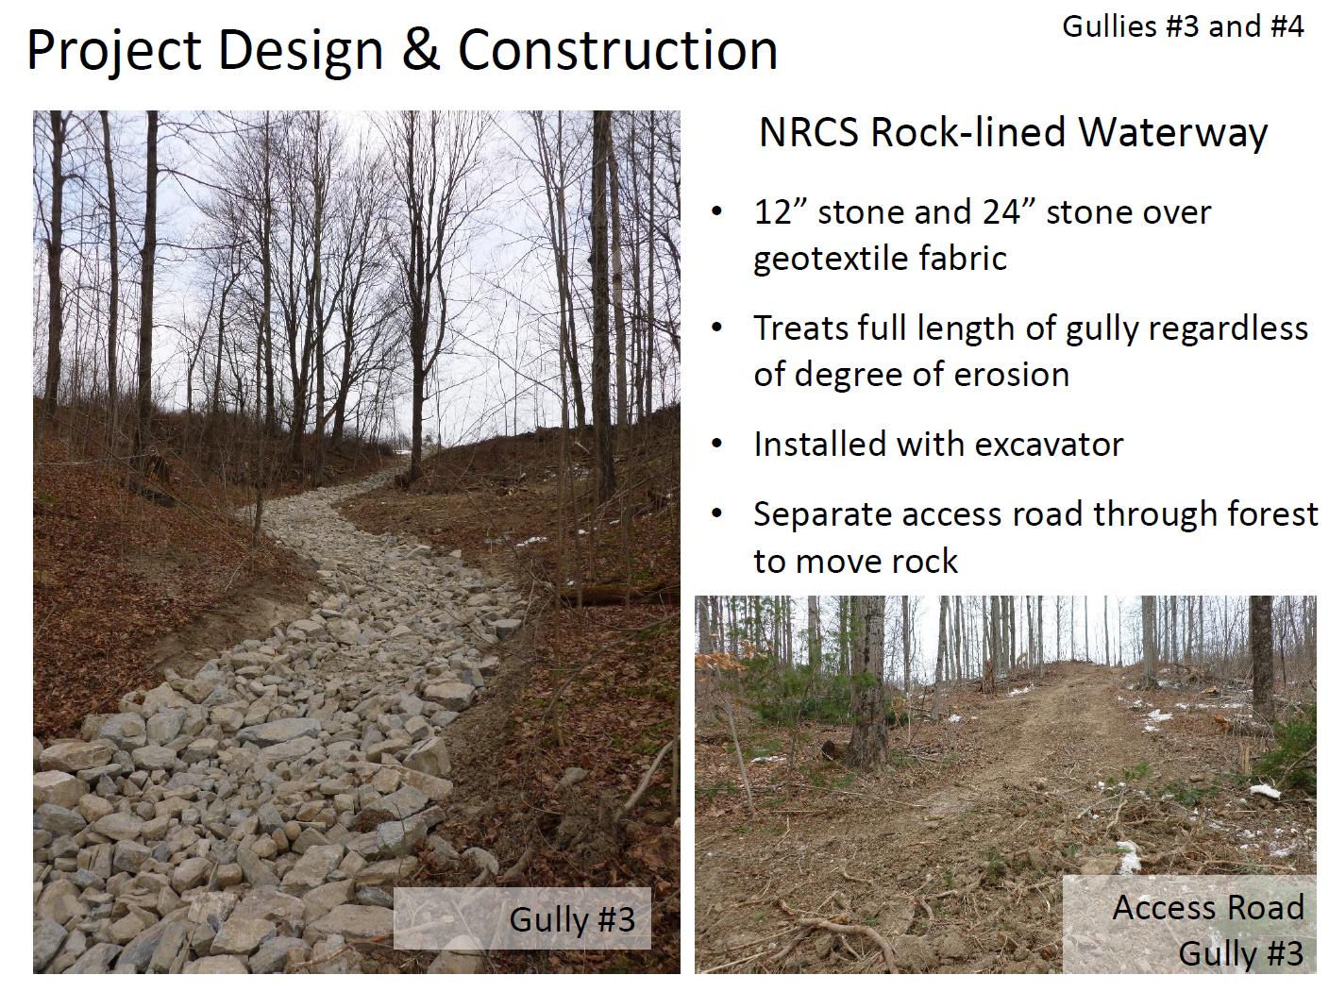

Both approaches to the gully stabilization are currently monitored by NRCS, VT DEC, MMI and LCA through site visits and photographic documentation over a 10-year period. This monitoring includes one to two site visits each year.

Table 3. Last Resort Farm Gully size (in cubic ft) and Installation Cost ($) by Funding Source, 2014

 | Gully 1 | Gully 2 | Gully 3 | Gully 4 | Gully 5 | Gully 6
Cubic feet | 352 | 960 | 3,685 | 1,005 | 3,000 | 160
ANR ERP | $ 5,187 | $ 5,416 | $ 1,019 | $ 1,069 | $ 9,211 | $ 4,778
NRCS EQIP | $ 34 | $ 34 | $ 15,957 | $ 6,815 | $ 34 | $ 34
LRF | $ 146 | $ 146 | $ 2,937 | $ 734 | $ 146 | $ 146
TOTAL | $ 5,367 | $ 5,596 | $ 19,913 | $ 8,618 | $ 9,391 | $ 4,958
Total Cubic Feet treated: |  | 9,162 | ERP: VT ANR Ecosystem Restoration Program  EQIP: NRCS Environmental Quality Incentives Program, which includes professional engineering staff time.  LRF: Last Resort Farm
Project total cost: |  | $ 53,843

Table 3 summarizes the total installation costs by gully. The total cubic feet listed give a sense of the gully size and/or depth and sediment that has been exported to Pond Brook. Labor, technical assistance costs and future O&M costs from all parties are included. Although NRCS funded the majority of the installation cost for gullies 3 & 4, the owners of Last Resort Farm contributed a greater proportion of the cost relative to the remaining gullies.

Some practices required excavator and truck use, though LRF timed all truck work to occur in December on frozen ground to minimize damage and compaction to soils. Gullies 2 and 6 did not require any mechanized machinery, excavators, or trucks to access the sites. Gullies 1 and 5 only required an excavator and truck access to deliver rock at the field edge and no access or disturbance caused by access of machinery in the wooded part of the gullies.

Maintenance will depend on how well the gully treatments function over time. Monitoring of sediment mobilization, movement of stone and wood, decomposition in the soft treatment gullies, and storm events frequency will be documented for 10 years. All funding organizations have some monitoring responsibilities and those costs are included in Table 3. Upon site inspection in 2017 (year 3) several of the soft treatment gullies were showing signs of decomposition and trapped sedimentation on top of the log materials, as was a goal of the design. Although the landowner was mowing the vegetation at the heads of the gullies, there were some signs of a need to regrade the head of one of the gullies and some of the woody material in the soft treatment gullies will need to be replaced.

Economic Benefits to Last Resort Farm and the General Public

The direct benefits to Last Resort in terms of avoided product revenue losses are difficult to quantify. There remain some questions as to what extent, if at all, the repaired gullies affect either hay or maple sap revenues for the farmer. Last Resort Farm expressed concern that their hay field would have been negatively impacted if the gullies had not been repaired and also their sugarbush would have been affected by limited access and soil loss. At most, the quantifiable benefits of gully repair to Last Resort Farm include reducing damage to the hay fields and reducing soil loss impact on maple tree mortality. LCA and VTDEC estimated the soil loss from the six gullies to be 504 tons over a 15-year period. Without gully repair, the rate of soil loss would have also increased from the field drainage area of 13 acres above the gullies and could range from 1,000 to 5,000 tons in future years based on 21,780 cubic feet to 87,120 cubic feet of soil loss with a conversion factor of 110 lbs. per cubic foot of soil. Pond Brook water quality and stream geomorphology are being monitored by LCA over time to document expected improvement.

The gully and field soil loss values are based on a USDA publication (Economic Measures of Soil Conservation Benefits: Regional Values for Policy Assessment, 2008, Appendix, Table 2) and adjusted to current value in Table 4. The benefits of gully restoration are assessed in terms of stream water quality and the avoided soil loss over the next 15-year period, which is the expected life of the “hard” gully treatment. According to Milone & MacBroom, the shape and layout of the gullies at Last Resort Farm suggest that without treatment, it’s likely that more soil erosion would occur. Without treatment the gullies would likely expand and extend up the slope into the adjacent hayfield. They estimated a 50% expansion of the gullies over time, which amounts to an additional 250 tons of soil loss over the next 15 years.

The estimated Hay and Maple Sap benefits relate to the farmer’s estimation and perception of avoided costs. These consist of reduced revenues from the hay field affected by the soil loss and avoided costs due to erosion impact on maple tree health and mortality and hence, some sap reduction. As Sam Burr described. “The nutrient and soil loss causes problems for the tree too both in lost sap, general health, longevity, regeneration, and quality of sawlogs produced. We have been doing forest practices to encourage the growth of maples and other good species. The gullies were making it more difficult to do the work. Also more difficult to hang and maintain sap lines.”

The four types of monetized benefits for gully soil loss, field soil loss, hay production impacts, and maple sap impacts are presented in Table 4.

Table 4. Net Benefits of Gully Restoration over 15 years (2017 dollars rounded to nearest $100).

Benefit Categories | Low Benefit  (Net Benefits to Farmer) | High Benefit  (Net Benefits to Farmer & Public)
Gully Soil | $500 | $4,200
Field Soil | $2,200 - $8,600 | $80,600
Hay | $0 -$700 | $1,100
Maple Sap | $0-$1,000 | $2,000
TOTAL | $2,700 - $10,800 | $87,900

The total benefits range from $2,700 to almost $88,000 depending on the type of benefits estimated. The low benefit estimates are due to the avoided costs of lost productivity from continued gully erosion for the producer. The high benefit estimates are those benefits to both the producer and to society in terms of avoided cost to the producer and reduced sedimentation to Lewis Creek and ultimately Lake Champlain. For field soil benefits to the farmer, the difference between the two lownumbers accounts for the difference in opinion of expected acreage affected between the engineers (lower estimate) and the farmer (higher estimate).

Over 15 years, the maple trees located next to the gullies would likely be affected by soil erosion if the gullies had not been repaired. With 14 acres of sugar maples and 600 taps, the farmer estimated that about 100 taps could be affected. As the effects of soil erosion and extreme weather events on maple tree health and mortality are difficult to predict over a 15 year period, the low and high value estimates relate to a range of impacts on maple tree mortality and sap production. In addition, if some maple trees were lost due to increased gully erosion, there would likely be a salvage value in either firewood or lumber. This was not accounted for in this study.

In any given year, there are possible external factors (extreme or catastrophic events), which could significantly affect these benefit estimates. It is also important to note that since 2008 when the USDA ERS study was published, the public recognition of protecting soil from erosion and improving water quality has grown. It is therefore likely that the monetary values associated with soil conservation and water quality have increased accordingly. Moreover, the 2008 report stated that “the monetary values derived from applications of these data are likely to be lower-bound estimates of the benefits or costs of changes in soil erosion.”

Despite that, the total economic benefits to the producer and society (Table 4) exceed the total project cost (Table 3) by 40%.

Some key issues in cost and benefit assessment for environmental/conservation values

The concept and key question of cost/benefit analysis is straightforward; do a project’s benefits exceed the project’s costs? If so, it makes economic sense to proceed with the project. The difficulties emerge when the total project (or practice) benefits do not fully accrue to the individual bearing the project costs. In this case study, the initial investment cost burden falls partially on the farmer, given the EQIP subsidy, but future operation, maintenance and replacement costs for the protected gullies will fall completely on the farmer. On the benefits side, some of the benefits will accrue to the farmer, however, other public benefits associated with improved water quality accrue to the downstream beneficiaries who enjoy use of Lewis Creek and Lake Champlain. In these cases, publicly-funded financial incentives are warranted to encourage farmers to avoid degradation of public assets. USDA NRCS and Vermont’s Agency of Natural Resources provide this pivotal role of incentivizing farmers to manage private properties in ways that prevent degradation of public assets.

In this case of soil erosion and impaired water quality, the benefits of gully repair on the farm are not sufficient to warrant treating the gullies when looking strictly at economic benefits to the farmer alone. However the impacts of the gully erosion do extend beyond the private property boundaries of Last Resort Farm. Benefits extend to the wider community in terms of reduced soil erosion and improved water quality. Without gully repair on the farm, soil erosion from agricultural fields could have continued to accelerate. An increasing rate of erosion would result in greater amounts of sediment transported via Pond Brook to Lewis Creek and ultimately to Lake Champlain. Thus, how land including farmer fields, woods, and sloped areas are managed has a direct bearing on the water quality of Lake Champlain, which is a significant resource for the benefit of the whole state.

For this reason, when the practice treatment costs exceed the farmer’s benefits while greater benefits are shared among the wider public, the burden of costs to the farmer should be shared by public entities - (e.g., partial financial assistance or grants). It is here that VT ANR and USDA NRCS fill the gap between the private costs to farmers and the public benefits and goals the State determines. In this case, the approach to costs and benefits is to choose the method which is the most “cost effective” or “least cost” which achieves Vermont’s conservation goals of reduced stream sedimentation and water quality protection.

Cost-Effectiveness Analysis

Cost-effective analysis is a preferred analytical method to determine which treatment alternative has the least overall costs to achieve a given objective. Two economic techniques are used for this analysis: the first is present value analysis – or bringing all future payments to the present (today); and the second technique is amortizing payments over an established (consistent) time period, creating an average annual cost. Present value analysis answers the question: “How do I objectively compare alternatives with differing up-front installation costs, and future Operation, Maintenance and Replacement (O, M&R) costs?” Amortization (average annual) answers the question: “If I had to borrow money up front to install and maintain the various alternatives, how much would I need to borrow, how long might the loan be, and what would the annual loan payments be to retire the loan?” A corollary consideration would be an assessment of one’s opportunity cost when deciding if one’s own money, if available, should be used, or if taking out a loan were preferable. The key to this question is what rate of return can you expect with your own money and how does it compare to the cost of borrowing?

Installation costs were collected for each gully based on information obtained from Lewis Creek Association, NRCS, Milone & MacBroom and the Doyle-Burrs as discussed in Table 3. Additional Operation and Maintenance costs include annual inspection, minor repairs and mowing the vegetation at the head of the gullies. These costs were estimated based on information from NRCS and Milone & McBroom. The NRCS rock-lined waterway has a design life of 15 years. In order to compare the hard and soft designs, both alternative treatments were compared using a 15-year period of analysis.

There is a general lack of knowledge regarding how long the soft treatment gullies will last, as they have been in place for only three years. Much of this will depend upon assumptions and visual verification of how quickly the woody material would degrade and remain effective. Periodic regular maintenance extends the useful life of any conservation investment, regardless of whether or not the soft or hardened engineering approach is used.

The economic analysis here assumes that for the log installations, a small amount of maintenance to check and possibly rearrange brush occurs every year and a larger replacement of a portion of logs will occur every 5 years. These assumptions are in keeping with observations from the NRCS engineer and Milone & MacBroom design engineers. Hence this analysis looks at a “High” cost assumption and a “Low” cost assumption. Appendix 1 provides the full Cost-effectiveness tables for the Landowner and the total cost, for both High and Low cost assumptions over 15 years at 3% interest. Table 5 summarizes the results of the cost-effectiveness analysis on a per cubic foot basis.

This assessment shows that gully stabilization has a net benefit when the private and public economic benefits are included. Over a 15-year period, the evaluation also shows that there is not a significant cost difference between the two methods of gully stabilization (i.e., hard and soft). Both stabilization methods merit consideration as a climate adaptation practice. Future monitoring of Last Resort’s gully performance will help in this consideration.

Table 5. Comparing “High” and “Low” Cost Alternatives for Total Project Cost and Landowner’s Costs. Net Present Value and Average Annual Costs per Cubic Foot (15 years, 3% interest)

 | "High" Cost Alternative |  |  |  | "Low Cost" Alternative
 | Total Cost |  | Landowner Cost |  | Total Cost |  | Landowner Cost
Gully | Net Present Value/Cubic Ft. | Average Annual Cost/Cubic Ft. | Net Present Value/Cubic Ft. | Average Annual Cost/Cubic Ft. | Net Present Value/Cubic Ft. | Average Annual Cost/Cubic Ft. | Net Present Value/Cubic Ft. | Average Annual Cost/Cubic Ft.
1 | $19.03 | $1.68 | $4.19 | $0.37 | $17.47 | $1.55 | $2.64 | $0.23
2 | $7.97 | $0.71 | $2.29 | $0.20 | $7.20 | $0.64 | $1.53 | $0.14
3 | $6.09 | $0.54 | $1.48 | $0.13 | $6.09 | $0.54 | $1.48 | $0.13
4 | $9.29 | $0.82 | $1.44 | $0.13 | $9.29 | $0.82 | $1.44 | $0.13
5 | $6.06 | $0.54 | $2.98 | $0.26 | $4.80 | $0.43 | $1.72 | $0.15
6 | $34.89 | $3.09 | $4.81 | $0.43 | $33.52 | $2.97 | $3.44 | $0.30

Overall, the Present Value analysis shows that larger gullies (Gullies 2-5) were cheaper per cubic foot to treat than the smaller gullies (Gullies 1 & 2). Overall, both treatments had relatively small ranges of costs in either Present Value or Average Annual terms. It is interesting to note that while the hard treatments had higher initial costs to the landowner, when compared in both Present Value and Average Annual terms, the hard treatments are less expensive to the landowner than the soft treatments in both the High and Low scenarios. This is due to the cost of maintenance of the soft treatments being significantly greater than the “hard” treatments over time.

Conclusion

Heavy rain events in Vermont are projected to increase. Adaptation approaches to minimize soil erosion and soil loss from farms is critical for meeting Vermont’s conservation and water quality objectives. The two approaches to gully repair at Last Resort Farm are estimated to be comparable in costs over the 15-year project time horizon. However, the predicted timing of required maintenance and related costs are significantly different. The hard engineering rock-lined approach incurs almost all the costs upfront for construction. In contrast, the soft engineering approach with logs and branches has the costs distributed over the entire evaluated time period. The soft engineering approach requires regular and periodic maintenance to replace the logs and branches that are decomposing to ensure that runoff and soil loss is minimized. This is contrasted to the hard engineering approach, where the rocks remain intact, thus decreasing future maintenance and associated costs.

Making the decision between these two approaches depends on the level of involvement of the farmers. The soft approach requires farmers to check the gullies each year and maintain them when required, for example, after a major storm event. However the soft approach may provide an alternative treatment that may allow farmers to prevent a potential problem before it becomes a crisis situation. Farmers may prefer to have a gully problem solved through harder engineered practices and not have increased monitoring and maintenance requirements of the softer practices.

The support of organizations such as NRCS in funding the higher upfront costs of rock-line waterways is also critical in ensuring the project is financially feasible for the farmer. Without NRCS support, the ability of the farmer to take on rock-lined gully repair would be limited if not cost prohibitive.

Other factors may also influence the choice in methods of gully repair. These include aesthetics, availability of materials, and impact on the local environment. A farmer may prefer logs and branches because these organic materials may be available on site and blend with the landscape.

Regardless of the approach undertaken, it is clear that the benefits of gully repair reach beyond the farmers’ fields and their decision-making. Reduced transport of sediment to Vermont’s water courses and improved water quality is a benefit shared by the wider community.

Sources and References:

Conversation with Jessica Clark Louisos, PE, Milone & MacBroom, December 6, 2017

Milone & MacBroom,. Memorandum, June 20, 2014. “Pond Brook Gully Stabilization Alternatives Analysis, Last Resort Farm, Monkton, Vermont, MMI #3452-21

NRCS, Addison County Field Office, Pete Lossmann, phone, email and site visit

Lewis Creek Association, Marty Illick martylewiscreek@gmavt.net

http://smallfarms.cornell.edu/2016/04/04/a-vermont-farmers-last-resort/

http://www.watershedsunitedvt.org/about/members/profilearchive/lca

http://www.lewiscreek.org/news/ahead-of-the-storm-project-takes-off

Interview with Eugenie Doyle and Sam Burr, February 21, 2017 and e-mail correspondence 2018

Last Resort Farm Gully site visit with Pete Lossmann, NRCS Civil Engineer, September 6, 2017

http://www.burlingtonfreepress.com/story/news/politics/2015/01/25/uphill-battle-clean-lake-champlain/22243483/

Appendix 1. Cost-Effectiveness tables for Last Resort Farm.
Table A1. Economic Analysis of 6 Gully Treatment Alternatives with Varying Costs, Annual Maintenance and Replacement - Landowner Cost – High Assumptions
 |  |  |  |  |  |  |  | discount/interest rate: |  |  | 3.0%
Landowner Cost (woody debris re-constructed every 5 years)
 | ALTERNATIVES
 | G1 |  |  | G2 |  |  | G3 |  |  | G4 |  |  | G5 |  |  |  | G6 |  | TOTAL
NET PRESENT VALUE: |  |  | $1,476 |  |  | $2,198 |  |  | $5,468 |  |  | $1,449 |  |  | $8,941 |  |  | $770 |  |  | $20,303
NET PRESENT VALUE/CF: |  |  | $4.19 |  |  | $2.29 |  |  | $1.48 |  |  | $1.44 |  |  | $2.98 |  |  | $4.81 |  |  | $2.22
AVERAGE ANNUAL: |  |  | $131 |  |  | $195 |  |  | $484 |  |  | $128 |  |  | $792 |  |  | $68 |  |  | $1,797
AVERAGE ANNUAL/CF: |  |  | $0.37 |  |  | $0.20 |  |  | $0.13 |  |  | $0.13 |  |  | $0.26 |  |  | $0.43 |  |  | $0.19
YEAR | Install-ation | Ann. Maint. | TOTAL | Install-ation | Ann. Maint. | TOTAL | Install-ation | Ann. Maint. | TOTAL | Install-ation | Ann. Maint. | TOTAL | Install-ation | Ann. Maint. | TOTAL | Install-ation | Ann. Maint. | TOTAL | Install-ation | Ann. Maint. | TOTAL
2014 | $146 | $0 | $146 | $146 | $0 | $146 | $2,937 | $0 | $2,937 | $734 | $0 | $734 | $146 | $0 | $146 | $146 | $0 | $146 | $4,256 | $0 | $4,256
2015 | $0 | $24 | $24 | $0 | $61 | $61 | $0 | $224 | $224 | $0 | $63 | $63 | $0 | $127 | $127 | $0 | $19 | $19 | $0 | $518 | $518
2016 | $0 | $24 | $24 | $0 | $61 | $61 | $0 | $224 | $224 | $0 | $63 | $63 | $0 | $127 | $127 | $0 | $19 | $19 | $0 | $518 | $518
2017 | $0 | $24 | $24 | $0 | $61 | $61 | $0 | $224 | $224 | $0 | $63 | $63 | $0 | $127 | $127 | $0 | $19 | $19 | $0 | $518 | $518
2018 | $0 | $24 | $24 | $0 | $61 | $61 | $0 | $224 | $224 | $0 | $63 | $63 | $0 | $127 | $127 | $0 | $19 | $19 | $0 | $518 | $518
2019 | $682 | $0 | $682 | $911 | $0 | $911 | $0 | $224 | $224 | $0 | $63 | $63 | $4,706 | $0 | $4,706 | $273 | $19 | $292 | $6,573 | $306 | $6,879
2020 | $0 | $24 | $24 | $0 | $61 | $61 | $0 | $224 | $224 | $0 | $63 | $63 | $0 | $127 | $127 | $0 | $0 | $0 | $0 | $499 | $499
2021 | $0 | $24 | $24 | $0 | $61 | $61 | $0 | $224 | $224 | $0 | $63 | $63 | $0 | $127 | $127 | $0 | $19 | $19 | $0 | $518 | $518
2022 | $0 | $24 | $24 | $0 | $61 | $61 | $0 | $224 | $224 | $0 | $63 | $63 | $0 | $127 | $127 | $0 | $19 | $19 | $0 | $518 | $518
2023 | $0 | $24 | $24 | $0 | $61 | $61 | $0 | $224 | $224 | $0 | $63 | $63 | $0 | $127 | $127 | $0 | $19 | $19 | $0 | $518 | $518
2024 | $682 | $0 | $682 | $911 | $0 | $911 | $0 | $224 | $224 | $0 | $63 | $63 | $4,706 | $0 | $4,706 | $273 | $0 | $273 | $6,573 | $287 | $6,860
2025 | $0 | $24 | $24 | $0 | $61 | $61 | $0 | $224 | $224 | $0 | $63 | $63 | $0 | $127 | $127 | $0 | $19 | $19 | $0 | $518 | $518
2026 | $0 | $24 | $24 | $0 | $61 | $61 | $0 | $224 | $224 | $0 | $63 | $63 | $0 | $127 | $127 | $0 | $19 | $19 | $0 | $518 | $518
2027 | $0 | $24 | $24 | $0 | $61 | $61 | $0 | $224 | $224 | $0 | $63 | $63 | $0 | $127 | $127 | $0 | $19 | $19 | $0 | $518 | $518
2028 | $0 | $24 | $24 | $0 | $61 | $61 | $0 | $224 | $224 | $0 | $63 | $63 | $0 | $127 | $127 | $0 | $19 | $19 | $0 | $518 | $518

Table A2. Economic Analysis of 6 Gully Treatment Alternatives with Varying Costs, Annual Maintenance and Replacement –Total Installation Cost – High Assumptions

Total Cost (woody debris re-constructed every 5 years)
 | ALTERNATIVES
 | G1 |  |  | G2 |  |  | G3 |  |  | G4 |  |  | G5 |  |  |  | G6 |  | TOTAL
NET PRESENT VALUE: |  |  | $6,697 |  |  | $7,647 |  |  | $22,455 |  |  | $9,333 |  |  | $18,186 |  |  | $5,582 |  |  | $69,890
NET PRESENT VALUE/CF: |  |  | $19.03 |  |  | $7.97 |  |  | $6.09 |  |  | $9.29 |  |  | $6.06 |  |  | $34.89 |  |  | $7.37
AVERAGE ANNUAL: |  |  | $593 |  |  | $677 |  |  | $1,987 |  |  | $826 |  |  | $1,610 |  |  | $494 |  |  | $6,187
AVERAGE ANNUAL/CF: |  |  | $1.68 |  |  | $0.71 |  |  | $0.54 |  |  | $0.82 |  |  | $0.54 |  |  | $3.09 |  |  | $0.66
YEAR | Install-ation | Ann. Maint. | TOTAL | Install-ation | Ann. Maint. | TOTAL | Install-ation | Ann. Maint. | TOTAL | Install-ation | Ann. Maint. | TOTAL | Install-ation | Ann. Maint. | TOTAL | Install-ation | Ann. Maint. | TOTAL | Install-ation | Ann. Maint. | TOTAL
2014 | $5,367 | $0 | $5,367 | $5,596 | $0 | $5,596 | $19,913 | $0 | $19,913 | $8,618 | $0 | $8,618 | $9,391 | $0 | $9,391 | $4,958 | $0 | $4,958 | $53,843 | $0 | $53,843
2015 | $0 | $24 | $24 | $0 | $61 | $61 | $0 | $224 | $224 | $0 | $63 | $63 | $0 | $127 | $127 | $0 | $19 | $19 | $0 | $518 | $518
2016 | $0 | $24 | $24 | $0 | $61 | $61 | $0 | $224 | $224 | $0 | $63 | $63 | $0 | $127 | $127 | $0 | $19 | $19 | $0 | $518 | $518
2017 | $0 | $24 | $24 | $0 | $61 | $61 | $0 | $224 | $224 | $0 | $63 | $63 | $0 | $127 | $127 | $0 | $19 | $19 | $0 | $518 | $518
2018 | $0 | $24 | $24 | $0 | $61 | $61 | $0 | $224 | $224 | $0 | $63 | $63 | $0 | $127 | $127 | $0 | $19 | $19 | $0 | $518 | $518
2019 | $682 | $0 | $682 | $911 | $0 | $911 | $0 | $224 | $224 | $0 | $63 | $63 | $4,706 | $0 | $4,706 | $273 | $19 | $292 | $6,573 | $306 | $6,879
2020 | $0 | $24 | $24 | $0 | $61 | $61 | $0 | $224 | $224 | $0 | $63 | $63 | $0 | $127 | $127 | $0 | $0 | $0 | $0 | $499 | $499
2021 | $0 | $24 | $24 | $0 | $61 | $61 | $0 | $224 | $224 | $0 | $63 | $63 | $0 | $127 | $127 | $0 | $19 | $19 | $0 | $518 | $518
2022 | $0 | $24 | $24 | $0 | $61 | $61 | $0 | $224 | $224 | $0 | $63 | $63 | $0 | $127 | $127 | $0 | $19 | $19 | $0 | $518 | $518
2023 | $0 | $24 | $24 | $0 | $61 | $61 | $0 | $224 | $224 | $0 | $63 | $63 | $0 | $127 | $127 | $0 | $19 | $19 | $0 | $518 | $518
2024 | $682 | $0 | $682 | $911 | $0 | $911 | $0 | $224 | $224 | $0 | $63 | $63 | $4,706 | $0 | $4,706 | $273 | $0 | $273 | $6,573 | $287 | $6,860
2025 | $0 | $24 | $24 | $0 | $61 | $61 | $0 | $224 | $224 | $0 | $63 | $63 | $0 | $127 | $127 | $0 | $19 | $19 | $0 | $518 | $518
2026 | $0 | $24 | $24 | $0 | $61 | $61 | $0 | $224 | $224 | $0 | $63 | $63 | $0 | $127 | $127 | $0 | $19 | $19 | $0 | $518 | $518
2027 | $0 | $24 | $24 | $0 | $61 | $61 | $0 | $224 | $224 | $0 | $63 | $63 | $0 | $127 | $127 | $0 | $19 | $19 | $0 | $518 | $518
2028 | $0 | $24 | $24 | $0 | $61 | $61 | $0 | $224 | $224 | $0 | $63 | $63 | $0 | $127 | $127 | $0 | $19 | $19 | $0 | $518 | $518

Table A3. Economic Analysis of 6 Gully Treatment Alternatives with Varying Costs, Annual Maintenance and Replacement - Landowner Cost – Low Assumptions

Landowner Cost (woody debris re-constructed every 5 years)
 | ALTERNATIVES
 | G1 |  |  | G2 |  |  | G3 |  |  | G4 |  |  | G5 |  |  |  | G6 |  | TOTAL
NET PRESENT VALUE: |  |  | $928 |  |  | $1,465 |  |  | $5,468 |  |  | $1,449 |  |  | $5,161 |  |  | $551 |  |  | $15,022
NET PRESENT VALUE/CF: |  |  | $2.64 |  |  | $1.53 |  |  | $1.48 |  |  | $1.44 |  |  | $1.72 |  |  | $3.44 |  |  | $1.64
AVERAGE ANNUAL: |  |  | $82 |  |  | $130 |  |  | $484 |  |  | $128 |  |  | $457 |  |  | $49 |  |  | $1,330
AVERAGE ANNUAL/CF: |  |  | $0.23 |  |  | $0.14 |  |  | $0.13 |  |  | $0.13 |  |  | $0.15 |  |  | $0.30 |  |  | $0.14
YEAR | Install-ation | Ann. Maint. | TOTAL | Install-ation | Ann. Maint. | TOTAL | Install-ation | Ann. Maint. | TOTAL | Install-ation | Ann. Maint. | TOTAL | Install-ation | Ann. Maint. | TOTAL | Install-ation | Ann. Maint. | TOTAL | Install-ation | Ann. Maint. | TOTAL
2014 | $146 | $0 | $146 | $146 | $0 | $146 | $2,937 | $0 | $2,937 | $734 | $0 | $734 | $146 | $0 | $146 | $146 | $0 | $146 | $4,256 | $0 | $4,256
2015 | $0 | $24 | $24 | $0 | $61 | $61 | $0 | $224 | $224 | $0 | $63 | $63 | $0 | $127 | $127 | $0 | $19 | $19 | $0 | $518 | $518
2016 | $0 | $24 | $24 | $0 | $61 | $61 | $0 | $224 | $224 | $0 | $63 | $63 | $0 | $127 | $127 | $0 | $19 | $19 | $0 | $518 | $518
2017 | $0 | $24 | $24 | $0 | $61 | $61 | $0 | $224 | $224 | $0 | $63 | $63 | $0 | $127 | $127 | $0 | $19 | $19 | $0 | $518 | $518
2018 | $0 | $24 | $24 | $0 | $61 | $61 | $0 | $224 | $224 | $0 | $63 | $63 | $0 | $127 | $127 | $0 | $19 | $19 | $0 | $518 | $518
2019 | $341 | $0 | $341 | $456 | $0 | $456 | $0 | $224 | $224 | $0 | $63 | $63 | $2,353 | $0 | $2,353 | $137 | $19 | $156 | $3,287 | $306 | $3,593
2020 | $0 | $24 | $24 | $0 | $61 | $61 | $0 | $224 | $224 | $0 | $63 | $63 | $0 | $127 | $127 | $0 | $0 | $0 | $0 | $499 | $499
2021 | $0 | $24 | $24 | $0 | $61 | $61 | $0 | $224 | $224 | $0 | $63 | $63 | $0 | $127 | $127 | $0 | $19 | $19 | $0 | $518 | $518
2022 | $0 | $24 | $24 | $0 | $61 | $61 | $0 | $224 | $224 | $0 | $63 | $63 | $0 | $127 | $127 | $0 | $19 | $19 | $0 | $518 | $518
2023 | $0 | $24 | $24 | $0 | $61 | $61 | $0 | $224 | $224 | $0 | $63 | $63 | $0 | $127 | $127 | $0 | $19 | $19 | $0 | $518 | $518
2024 | $341 | $0 | $341 | $456 | $0 | $456 | $0 | $224 | $224 | $0 | $63 | $63 | $2,353 | $0 | $2,353 | $137 | $0 | $137 | $3,287 | $287 | $3,574
2025 | $0 | $24 | $24 | $0 | $61 | $61 | $0 | $224 | $224 | $0 | $63 | $63 | $0 | $127 | $127 | $0 | $19 | $19 | $0 | $518 | $518
2026 | $0 | $24 | $24 | $0 | $61 | $61 | $0 | $224 | $224 | $0 | $63 | $63 | $0 | $127 | $127 | $0 | $19 | $19 | $0 | $518 | $518
2027 | $0 | $24 | $24 | $0 | $61 | $61 | $0 | $224 | $224 | $0 | $63 | $63 | $0 | $127 | $127 | $0 | $19 | $19 | $0 | $518 | $518
2028 | $0 | $24 | $24 | $0 | $61 | $61 | $0 | $224 | $224 | $0 | $63 | $63 | $0 | $127 | $127 | $0 | $19 | $19 | $0 | $518 | $518

Table A4. Economic Analysis of 6 Gully Treatment Alternatives with Varying Costs, Annual Maintenance and Replacement –Total Installation Cost – Low Assumptions

Total Cost (woody debris partially reconstructed every 5 years)
 | ALTERNATIVES
 | G1 |  |  | G2 |  |  | G3 |  |  | G4 |  |  | G5 |  |  |  | G6 |  | TOTAL
NET PRESENT VALUE: |  |  | $6,149 |  |  | $6,915 |  |  | $22,455 |  |  | $9,333 |  |  | $14,406 |  |  | $5,362 |  |  | $64,610
NET PRESENT VALUE/CF: |  |  | $17.47 |  |  | $7.20 |  |  | $6.09 |  |  | $9.29 |  |  | $4.80 |  |  | $33.52 |  |  | $6.81
AVERAGE ANNUAL: |  |  | $544 |  |  | $612 |  |  | $1,987 |  |  | $826 |  |  | $1,275 |  |  | $475 |  |  | $5,720
AVERAGE ANNUAL/CF: |  |  | $1.55 |  |  | $0.64 |  |  | $0.54 |  |  | $0.82 |  |  | $0.43 |  |  | $2.97 |  |  | $0.61
YEAR | Install-ation | Ann. Maint. | TOTAL | Install-ation | Ann. Maint. | TOTAL | Install-ation | Ann. Maint. | TOTAL | Install-ation | Ann. Maint. | TOTAL | Install-ation | Ann. Maint. | TOTAL | Install-ation | Ann. Maint. | TOTAL | Install-ation | Ann. Maint. | TOTAL
2014 | $5,367 | $0 | $5,367 | $5,596 | $0 | $5,596 | $19,913 | $0 | $19,913 | $8,618 | $0 | $8,618 | $9,391 | $0 | $9,391 | $4,958 | $0 | $4,958 | $53,843 | $0 | $53,843
2015 | $0 | $24 | $24 | $0 | $61 | $61 | $0 | $224 | $224 | $0 | $63 | $63 | $0 | $127 | $127 | $0 | $19 | $19 | $0 | $518 | $518
2016 | $0 | $24 | $24 | $0 | $61 | $61 | $0 | $224 | $224 | $0 | $63 | $63 | $0 | $127 | $127 | $0 | $19 | $19 | $0 | $518 | $518
2017 | $0 | $24 | $24 | $0 | $61 | $61 | $0 | $224 | $224 | $0 | $63 | $63 | $0 | $127 | $127 | $0 | $19 | $19 | $0 | $518 | $518
2018 | $0 | $24 | $24 | $0 | $61 | $61 | $0 | $224 | $224 | $0 | $63 | $63 | $0 | $127 | $127 | $0 | $19 | $19 | $0 | $518 | $518
2019 | $341 | $0 | $341 | $456 | $0 | $456 | $0 | $224 | $224 | $0 | $63 | $63 | $2,353 | $0 | $2,353 | $137 | $19 | $156 | $3,287 | $306 | $3,593
2020 | $0 | $24 | $24 | $0 | $61 | $61 | $0 | $224 | $224 | $0 | $63 | $63 | $0 | $127 | $127 | $0 | $0 | $0 | $0 | $499 | $499
2021 | $0 | $24 | $24 | $0 | $61 | $61 | $0 | $224 | $224 | $0 | $63 | $63 | $0 | $127 | $127 | $0 | $19 | $19 | $0 | $518 | $518
2022 | $0 | $24 | $24 | $0 | $61 | $61 | $0 | $224 | $224 | $0 | $63 | $63 | $0 | $127 | $127 | $0 | $19 | $19 | $0 | $518 | $518
2023 | $0 | $24 | $24 | $0 | $61 | $61 | $0 | $224 | $224 | $0 | $63 | $63 | $0 | $127 | $127 | $0 | $19 | $19 | $0 | $518 | $518
2024 | $341 | $0 | $341 | $456 | $0 | $456 | $0 | $224 | $224 | $0 | $63 | $63 | $2,353 | $0 | $2,353 | $137 | $0 | $137 | $3,287 | $287 | $3,574
2025 | $0 | $24 | $24 | $0 | $61 | $61 | $0 | $224 | $224 | $0 | $63 | $63 | $0 | $127 | $127 | $0 | $19 | $19 | $0 | $518 | $518
2026 | $0 | $24 | $24 | $0 | $61 | $61 | $0 | $224 | $224 | $0 | $63 | $63 | $0 | $127 | $127 | $0 | $19 | $19 | $0 | $518 | $518
2027 | $0 | $24 | $24 | $0 | $61 | $61 | $0 | $224 | $224 | $0 | $63 | $63 | $0 | $127 | $127 | $0 | $19 | $19 | $0 | $518 | $518
2028 | $0 | $24 | $24 | $0 | $61 | $61 | $0 | $224 | $224 | $0 | $63 | $63 | $0 | $127 | $127 | $0 | $19 | $19 | $0 | $518 | $518

Phone conversation, November 1, 2017
Vermont Agency of Natural Resources Department of Environmental Conservation Grant Program. http://dec.vermont.gov/watershed/cwi/grants#Ecosystem Restoration
USDA Natural Resources Conservation Program Environmental Quality Incentives Program. https://www.nrcs.usda.gov/wps/portal/nrcs/main/vt/programs/financial/eqip/
Hansen, L. & Ribaudo, M. (2008) Economic Measures of Soil Conservation Benefits: Regional Values for Policy Assessment Technical Bulletin no. (TB-1922) USDA ERS, Addison County VT values, adjusted to 2017 dollars using the consumer price index (CPI).
E-mail correspondence, April 6, 2018
Melillo, J.M., 2014. Climate change impacts in the United States: the third national climate assessment. Government Printing Office

