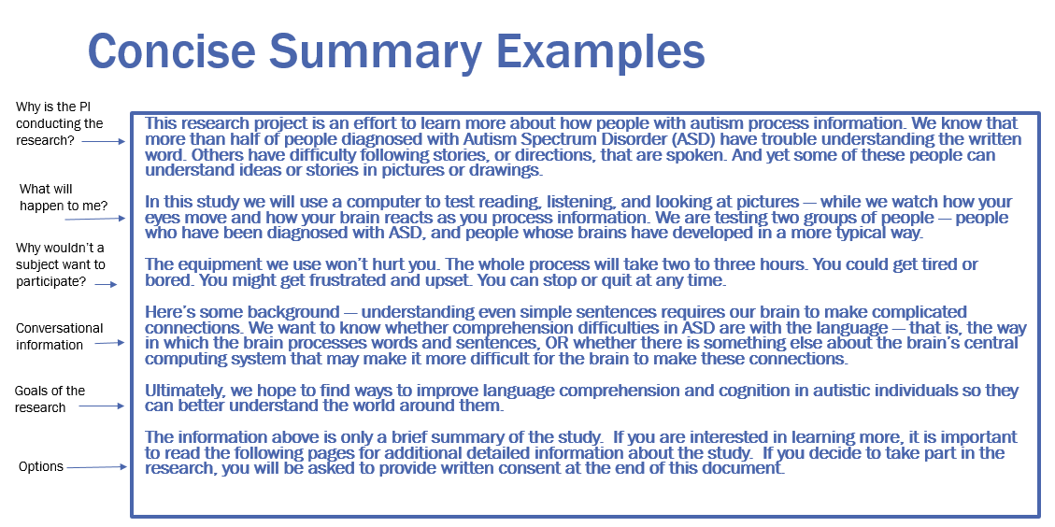

*Concise Summary*

This is a research study to find out if a drug called ABC-123 is safe and to determine the safest, most effective dose of the drug.

Depending on when you enroll in this study, you will receive higher doses of ABC-123 until the safest and best tolerated dose is reached. ABC-123 is given via *i.v.* infusion in the clinic at Duke. You will have tests, exams and procedures that are part of your standard care and for study purposes. Each clinic visit will last 4-5 hours. Infusions of study drug will be given during week 1 of each 3-week cycle. After two cycles, you will be evaluated and you may be able to continue receiving ABC-123 if you have had no bad reactions to the study drug or disease progression.

There are risks to this study drug that are described in this document. Some risks include: nausea, diarrhea, low white & red blood cell count, being tired & weak, fever, muscle pain and radiation risks from CT scans.

The information above is only a brief summary of the study. If you are interested in learning more, it is important to read the following pages for additional detailed information about the study. If you decide to take part in the research, you will be asked to provide written consent at the end of this document.

*Concise Summary*

The purpose of this research study is to determine the effectiveness of physical therapy in the treatment of patients with ABC. Participants will undergo a 2-day screening that includes a blood draw, exercise testing, and completion of quality-of-life surveys. Once screening is complete, participants will complete a physical therapy program that will require visits to Duke’s fitness center three times each week for 16 weeks, for a total of 48 visits. Each visit will take about 2 hours. Participants will also be asked to complete a pain diary and have blood draws every 4 weeks throughout the study. Follow-up phone calls from the study team will occur at 4 weeks and 8 weeks after completion of the physical therapy program. Total study duration is about 6 and one-half months.

The greatest risks of this study include the possibility of injury during the physical therapy program and loss of confidentiality.

The information above is only a brief summary of the study. If you are interested in learning more, it is important to read the following pages for additional detailed information about the study. If you decide to take part in the research, you will be asked to provide written consent at the end of this document.