Blood Collection Consent Template with Guidance – 1/19/18

This template provides guidance and examples of text to be used within each section. Please customize each section in accordance with your protocol.

Consent to Participate in Research – Blood Collection for a Laboratory Protocol

Title of Research Project: title

Principal Investigator: name

Sponsor: List all agencies or companies that are supporting this research. If internally sponsored, list the department. Do not list the sponsor here until you have obtained funding.

Introduction
You are being invited to participate in this blood sample donation study. This study is being conducted by the University of Vermont [if any of the research is being conducted at the hospital or any of its campuses include] and at the UVM Medical Center.

We encourage you to ask questions and take the opportunity to discuss the study with anybody you think can help you make this decision.

Key Information to Help You Decide Whether or Not This Study Is Right for You

- All consent forms should provide a concise and focused presentation of key information that is most likely to assist in understanding the reasons why one might or might not want to participate in the research.
  - Use this section of the consent form to summarize the study using plain, non-technical language.
  - Highlight that the person has a choice to make. The consent form should be used as a decision making tool, not a sales pitch.
  - Include a brief description about why the study is being conducted and what is being asked of the participant (e.g. time commitment, procedures involved).
  - When deciding what risks or side effects to include in the summary, consider whether a potential participant would attach significance to the risk in deciding whether or not to participate. If applicable, state that “A complete list of the risks is given in the following pages.”
  - This summary should be limited to one page.
  - Though not a regulatory requirement, consent forms are recommended be at an 8th grade reading level to be appropriate for the general population. Microsoft Word has a readability program which can be found by:
    - Click the File tab, and then click Options.
    - Click Proofing.
    - Under “When correcting spelling and grammar in Word”, make sure the “Check grammar with spelling” check box is selected.
    - Select Show readability statistics.
    - After you enable this feature, open a file that you want to check, and check the spelling. When Word finishes checking the spelling and grammar, it displays information about the reading level of the document or just the highlighted section.

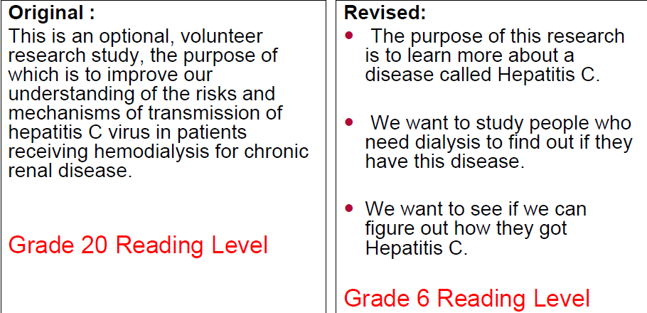
To improve subject comprehension the RPO office encourages researchers to use:
- Headings
- Bolded type
- Pictures
- Tables
- Consider using bulleted points to highlight key information.
- Keep sentences short and simple.
- Do not use fractions or %. Instead, state “1 out of 10 people will…”
- Use lay language – see plain language dictionary

Include the below statement at the end of the concise summary:
The information above is only a brief summary of the study. If you are interested in learning more, it is important to read the following pages for additional detailed information about the study. If you decide to take part in the research, you will be asked to provide written consent at the end of this document.

Examples of model summary statements are available on the IRB website and may be found Here.

Donation of blood for research is voluntary and you should not be placed under any pressures to do so. You do not have to agree to give a blood sample nor need to explain why you should choose not to donate. Any personal information provided by you in connection with the donation will be held in confidence. For reasons of safety, you should not donate if:

- You know, or think that you might be infected with hepatitis B or hepatitis C.
- You know, or think that you might be infected with HIV – the AIDs virus
- You have a sexual partner who is infected with hepatitis or HIV
- You are unwell at the moment
- You are anemic or receiving treatment for anemia or iron deficiency
- You are, or may be, pregnant
- You have given blood in the last 1 month (if more than 100 ml is requested)

Study Purpose
In this study, the researchers are collecting blood samples to learn more about … [Try to limit explanation to one or two sentences.] About [total accrual goal] people will give blood samples for this research.

What will happen if you take part in this study?
If you agree to be in this study, you will go to [clinic or lab location] and give a blood sample. You will be seated and blood will be drawn by putting a needle into a vein in your arm. One small tube of blood will be taken. This will take about five minutes.

[If there will be multiple blood draws over time, describe the frequency and include the total amount of blood to be drawn in the course of the study.]

Are there risks?
The needle stick may hurt. There is a small risk of bruising, a rare risk of infection, and you may feel lightheaded.

Are there benefits?
There is no benefit to you. The blood will be used only for laboratory research.

Can I say “No”?
Yes, you do not have to donate a blood sample for this study. If you decide not to donate, it will not affect your job standing, class standing, grades or status on an athletic team.

Will my personal/medical information be kept confidential?
We will do our best to protect the information we collect from you and/or your medical record. Information which identifies you will be kept secure and restricted. However, your personal information may be given out if required by law. If information from this research is published or presented at scientific meetings, your name and other identifiers will not be used. Information which identifies you will be destroyed when this research is complete. The following organizations may look at information about you in your medical and research records: [List relevant organizations, e.g. study sponsor, UVM’s Committee on Human Research]
Are there any costs or payments?
You will be paid [$] for taking the time to donate a blood sample. You will be paid in cash immediately after the blood draw. You will not be charged for the blood sample.

[For studies that include reimbursement in any form include]
You may be requested to provide your name, social security number, and address. This information will be disclosed one time to either the University of Vermont’s Procurement Services Department or UVM Medical Center’s Accounts Payable Department for purposes of reimbursing you for participation in this study. If you are not a US Citizen or Permanent Resident Alien you will be required to complete additional paperwork for payment.

Who can answer my questions about the study?
You can talk to the study doctor about any questions or concerns you have about this study. Contact the study doctor(s) __________________ [name(s)] at __________________ [telephone number(s)].
If you have any questions about your rights as a participant in a research project or for more information on how to proceed should you believe that you have been injured as a result of your participation in this study you should contact the Director of the Research Protections Office, at the University of Vermont at 802-656-5040.

Statement of Consent
You have been given and have read or have had read to you a summary of this research study. Should you have any further questions about the research, you may contact the person conducting the study at the address and telephone number given below. Your participation is voluntary and you may refuse to participate or withdraw at any time without penalty or prejudice.

You agree to participate in this study and you understand that you will receive a signed copy of this form.

___________________________________________ ____________
Signature of Subject Date

_________________________________________
Name of Subject Printed

____________________________________________________ __________
Signature of Principal Investigator or Designee Date

___________________________________________________
Name of Principal Investigator or Designee Printed

Name of Principal Investigator:
Address:
Telephone Number:

